SignTalk: Indian Sign Language Phrase Translator on Raspberry Pi

IoT Project Report

Submitted in Partial Fulfilment of the requirements
for
IoT laboratory course
of

BACHELOR OF TECHNOLOGY

in

COMPUTER SCIENCE & ENGINEERING

by

NAME OF STUDENT

(Roll No.)

Under the Guidance of

PROF. (LAB INSTRUCTOR NAME)



Department of Computer Science & Engineering,
School of Technology,
Pandit Deendayal Energy University, Gandhinagar 382 426
Nov 2026

Certificate of Originality of Work
I hereby declare that the B. Tech. IoT Project entitled “SignTalk: Indian Sign Language Phrase Translator on Raspberry Pi” submitted by me for the partial fulfilment of the IoT laboratory course of Bachelor of Technology to the Dept. of Computer Science & Engineering at the School of Technology, Pandit Deendayal Energy University, Gandhinagar, is the original record of the project work carried out by me under the supervision of Prof. XXXX.

I also declare that this written submission adheres to the university guidelines for originality and includes proper citations and references wherever required.

I also declare that I have maintained high academic honesty and integrity and have not falsified any data in my submission.

I also understand that violation of any guidelines in this regard will attract disciplinary action by the institute.

Signature of the Student Signature of the Supervisor

Name of the Student Name of the Supervisor

Roll Number of the Student Designation of the Supervisor

Place:

Date:

Acknowledgement
(Below is an exemplary Acknowledgement)

A journey is easier when you travel together. Interdependence is certainly more valuable than independence. This thesis is the result of work whereby I have been accompanied and supported by many people. It is a pleasant aspect that I now have the opportunity to express my gratitude to all of them.

With immense pleasure, I express my sincere gratitude, regards and thanks to my supervisor Dr. H. M. Gupta for his excellent guidance, invaluable suggestions and continuous encouragement at all the stages of my research work. His interest and confidence in me were the reason for all the success I have achieved. I have been fortunate to have him as my guide, as he has been a great influence on me, both as a person and as a professional.

It was a pleasure to be associated with the Embedded Systems and Information and Technology Laboratory of IIT Delhi, and I would like to thank the entire Laboratory Staff. To acknowledge help taken from friends is always a joy. I take this opportunity to convey sincere thanks to my class fellows for their smiles and friendship, making life at IIT Delhi enjoyable and memorable.

The chain of my gratitude would be definitely incomplete if I were to forget to thank the first cause of this chain, using Aristotle's words, the Prime Mover, for showering His blessings on me always.

(Name of the Student)

INDEX

Topic No. | Title |  | Page No.
 | Certificate of Originality of Work |  | i
 | Acknowledgement |  | ii
 | Index |  | iii
1 | Introduction |  | 1
 | 1.1 | Introduction/ Prologue/Background | 1
 | 1.2 | Motivation | 3
 | 1.3 | Objective | 3
 | 1.4 | Problem Statement | 4
 | 1.5 | Approach | 4
 | 1.6 | Scope of the Project | 5
 | 1.7 | Organization of the Rest of the Report | 5
2 | Literature Review |  | 6
 | 2.1 | Previous Approaches to Solve the Problem | 6
3 | Hardware Design |  | 7
4 | Software Design |  | 8
5 | Results and Discussion |  | 9
6 | Conclusions and Future Scope |  | 10
 | References (as per the prescribed format) |  | 12
 | Appendix

1. Introduction
1.1 Introduction / Prologue / Background
People who are deaf or hard of hearing and use sign language face a daily communication barrier, because most hearing people do not know it. In India the standard language is Indian Sign Language (ISL), which has its own vocabulary and grammar and is different from American Sign Language (ASL). The Indian Sign Language Research and Training Centre (ISLRTC) publishes an ISL dictionary and teaching videos [1]. This project builds a small Internet of Things (IoT) system that recognises a fixed set of ISL phrases and speaks them aloud, so that a person who signs can be understood by someone who does not.
The system is built around a Raspberry Pi 5 that acts as an edge server. A smartphone, using only its web browser, is the sensing node (rear camera) and the output node (speaker). The phone finds the hand and body landmarks of the signer with MediaPipe [2]-[4] and sends only those numbers over the local Wi-Fi network to the Pi. On the Pi, a neural network that we trained ourselves on ISL phrases recorded for this project decides which phrase was signed and returns it. The phone then speaks the phrase with its text-to-speech voice.
The project started with pretrained American Sign Language word models (PopSign-250 and an ASL Citizen ST-GCN with 2,731 signs) [5]-[7]. They were run successfully on the Raspberry Pi, but they recognise ASL, not ISL, and they could not be made to work reliably on live camera input. We therefore changed the goal to ISL phrases and trained our own model, which is the work reported here.
1.2 Motivation
- A deaf person is often unable to say simple everyday phrases such as greetings, thanks or an apology to a person who does not know sign language.
- Most sign-language research and public models are for ASL. Very little ready-to-use material exists for ISL, so a model for ISL has to be built from new recordings.
- A low-cost Raspberry Pi can serve many phones on a local network, without an internet connection and without sending any video to a cloud service, which is attractive for privacy and for places with poor connectivity.
1.3 Objective
- Record a small ISL phrase data set and train a phrase-recognition model on it.
- Deploy the trained model on a Raspberry Pi and serve it as a web application on the local network.
- Let any phone use the system through its browser: rear camera in, spoken phrase out, without installing an app.
- Make it easy to add more words and phrases later and retrain on top of the existing data.
1.4 Problem Statement
To design and implement an IoT system in which a person signs a phrase in front of a camera, and the corresponding ISL phrase is recognised on a Raspberry Pi and spoken through a speaker in near real time, using low-cost hardware, a local network and no cloud service.
1.5 Approach
We compared two ways of building the system (Figure 3.1). In Option A the camera and speaker are connected directly to the Raspberry Pi, and the Pi does everything. In Option B, which we adopted, the phone provides the camera and the speaker and the Pi is the edge server. Option A works as a stand-alone device, but Option B is the more practical and effective solution for real use, as explained in Chapter 3.
The steps followed were:
- Data collection. ISL phrases were recorded as short 3-second clips using a web-based recorder running on the Pi and a USB webcam.
- Landmark extraction. MediaPipe hand and pose landmarks were extracted from every frame, so the model sees body movement and not faces or backgrounds.
- Training. A DTW template-matching baseline and a 1D-CNN + bidirectional GRU network were trained, compared by cross-validation, and the network was exported to ONNX.
- Deployment. An HTTPS web server on the Pi serves the web page and runs the model. The page works hands-free: the phone detects when a hand is raised, sends the window of landmarks and speaks the answer.
- Extension. A Teach mode in the page records new clips from the phone and retrains the model on the Pi, so new phrases can be added later.
1.6 Scope of the Project
The system recognises eight isolated ISL phrases: Hello, Hi, Thank you, Welcome, Good morning, Good afternoon, Please and Sorry. It recognises one phrase at a time and not continuous sentences. The model was trained on recordings of a single signer, who learned the phrases from the ISLRTC reference videos [1]; the signs have not yet been verified by an ISL expert or tested with deaf users. More phrases can be added with the Teach mode.
1.7 Organization of the Rest of the Report
Chapter 2 reviews related work. Chapter 3 describes the hardware and compares the two deployment options. Chapter 4 describes the software: data collection, features, models, the web server and the phone page. Chapter 5 presents the results and their limits. Chapter 6 concludes and lists future work. References and a short appendix follow.
2. Literature Review
2.1 Previous Approaches to Solve the Problem
Sensor gloves and wearables. Early sign-language systems used instrumented gloves with flex sensors or accelerometers. They can be accurate, but the signer must wear special hardware, which makes them costly and inconvenient for daily use.
Vision-based recognition from landmarks. Modern systems use a camera and a pose or hand tracker. MediaPipe provides real-time hand tracking [3] and body-pose tracking [4] inside a common framework [2] that also runs in a web browser. Using landmarks instead of raw pixels makes the classifier small and less dependent on lighting, background and clothing, and it avoids sending images away from the user's device.
Datasets and models for isolated signs. ASL Citizen [5] is a community-sourced data set of isolated ASL signs with 2,731 signs, and its authors publish a skeleton-based ST-GCN [7] baseline. PopSign [6] is an ASL data set collected with smartphones. Both are for ASL. We tested the PopSign-250 and ASL Citizen models on the Raspberry Pi as a starting point, but no comparable public ready-to-use model exists for ISL, so we collected our own ISL phrase clips.
Template matching and sequence models. Dynamic Time Warping (DTW) [8] compares a new gesture to stored examples and needs very few recordings, which makes it a useful baseline. Recurrent networks such as the GRU [9] and 1D convolutions can learn the temporal pattern of a sign from landmark sequences with a small number of parameters, which suits a Raspberry Pi.
What this project adds. (i) an ISL phrase model trained on our own recordings, (ii) an IoT architecture in which the Raspberry Pi is a local edge server and any phone browser is the camera and speaker, (iii) a browser-based way to record new clips and retrain, so the vocabulary can grow, and (iv) a hands-free mode that needs no button presses.
3. Hardware Design
3.1 Components
Component | Specification / use | Role
Raspberry Pi 5 | 4 GB RAM, quad-core Arm Cortex-A76, onboard Wi-Fi and Bluetooth, 32 GB microSD | Edge server: web server, trained ISL model, retraining
Smartphone | Any phone with a rear camera, speaker and a modern browser (Chrome or Safari) | Camera input, landmark tracking, speech output
USB webcam | Logitech Brio 100, 1280x720 at 30 fps (MJPEG) | Recording the training clips; also used for Option A
Wi-Fi network | Home Wi-Fi LAN, or the Pi's own access point for demonstration | Link between phone and Pi (HTTPS)
Speaker (optional) | USB or Bluetooth speaker | Only needed for Option A; the Pi 5 has no 3.5 mm audio jack

Table 3.1: Hardware used in the project
3.2 Two Possible Designs
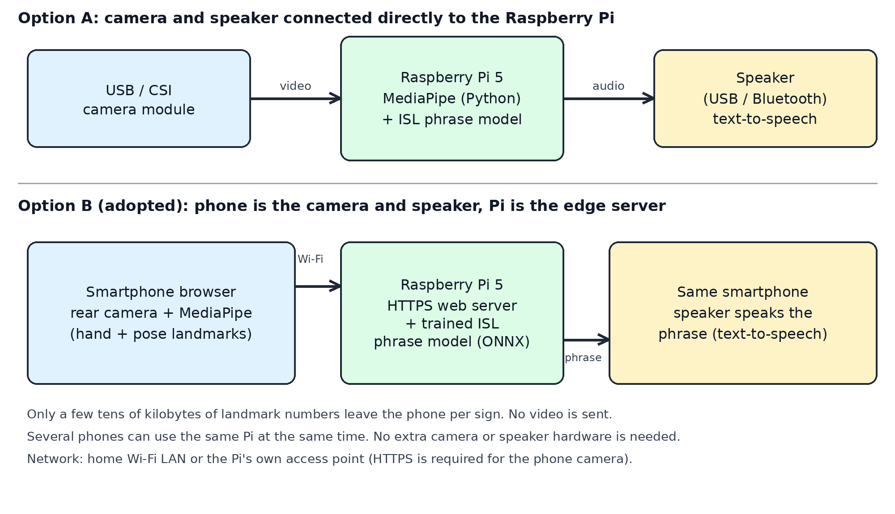
Figure 3.1: Option A (camera and speaker on the Pi) and Option B (phone as camera and speaker, Pi as server)
Option A: camera module and speaker connected directly to the Raspberry Pi. A USB or CSI camera module is attached to the Pi, the Pi runs MediaPipe and the model locally, and a speaker connected by USB or Bluetooth speaks the phrase. This makes a self-contained device and also works without any phone. It is simple and we used the same USB webcam for recording our data set.
Option B: phone as camera and speaker, Raspberry Pi as the edge server (adopted). The phone opens a web page served by the Pi. The browser opens the rear camera, finds the hand and pose landmarks, and sends them to the Pi, which returns the recognised phrase. The phone speaks it. We chose Option B because it is the better and more effective solution for real-world use:
- No extra hardware. The camera, speaker, screen and battery of a phone that the user already owns are used. Option A needs a camera, a speaker, a stand and a power supply.
- Portable and flexible. The phone can be placed or held wherever the signer is, while the Pi stays in one place. A fixed camera on the Pi limits the position of the signer.
- Multiple users. Several phones can use one Pi at the same time. The Pi only runs the small model (about 2-3 ms per sign) and does not process video.
- Privacy and bandwidth. Only a few tens of kilobytes of landmark numbers are sent per sign. Video never leaves the phone.
- Speech without a speaker on the Pi. The Raspberry Pi 5 has no 3.5 mm audio jack, so Option A needs a USB or Bluetooth speaker. The phone already has a loudspeaker and a text-to-speech voice.
- Light load on the Pi. Running MediaPipe on the Pi itself took about 62-90 ms per frame (about 11 frames per second in recording), which is acceptable for one camera but is the bottleneck that Option B removes.
The trade-off is that Option B needs a phone and a network link, and that the camera must be accessed over HTTPS, so the Pi creates a self-signed certificate that the user accepts once. Both options use the same trained model and the same software on the Pi.
3.3 Network Configuration
The server listens on HTTPS port 8443 and redirects plain HTTP from port 8080. Phones reach it at the Pi's IP address. The system has been tested on a home Wi-Fi LAN. For demonstration without an external router, the Pi's Wi-Fi can be run as its own access point, because the model, web page and MediaPipe files are all stored on the Pi and no internet connection is needed.
4. Software Design
4.1 Overview
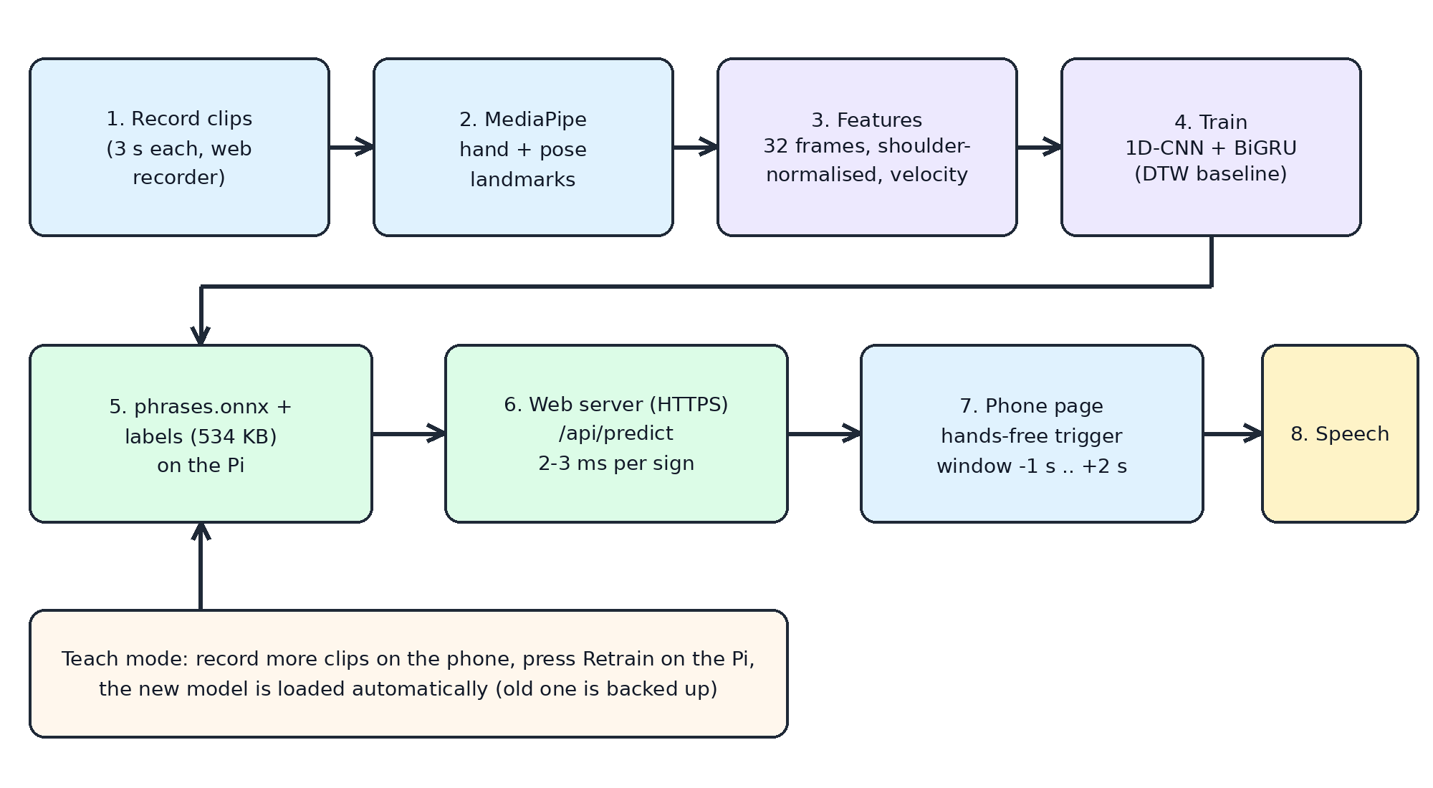
Figure 4.1: Software pipeline from recording to speech, and the Teach loop for adding phrases
The software has two parts: an offline part that records clips and trains the model (all of it runs on the Pi), and an online part with the web server on the Pi and the page in the phone browser.
4.2 Data Collection
A small web recorder on the Pi shows the USB webcam in a browser, gives a 3-second countdown, records a 3-second clip, and saves the MediaPipe landmarks of every frame together with a video and a metadata file. The phrases were learned from the ISLRTC reference videos [1]. The webcam was used at 1280x720 and downscaled to 640x360. Because MediaPipe runs on the Pi while recording, the effective frame rate was about 11 frames per second, so each clip has about 34 frames.
Phrase | Clips recorded | Notes
Hello | 20
Hi | 30 | recorded as 'hii' in the data set
Thank you | 20
Welcome | 20
Good morning | 19 | weakest phrase in testing
Good afternoon | 20
Please | 20
Sorry | 23
Total | 172 | one signer, several recording sessions

Table 4.1: ISL phrase data set
4.3 Landmark Extraction and Features
Each frame is converted into 543 landmark positions (468 face, 21 for each hand, 33 body points) and missing parts are marked as not detected. For the classifier only the body points that matter for signing are kept: 7 pose points (nose, shoulders, elbows and wrists) and 21 points for each hand, which are 49 points with x and y coordinates. The coordinates are shifted to the centre of the shoulders and divided by the shoulder width, so the result does not depend on how far the signer is from the camera. Every clip is resampled to 32 frames. For the neural network the input of each frame has 198 values: 98 positions, 98 velocities (frame-to-frame differences) and 2 flags that tell whether the left and right hand were detected.
4.4 Models
DTW baseline. A new sign is compared with all stored clips using Dynamic Time Warping [8], and the score of a phrase is the average of its three nearest clips. It needs no training and works with very few examples. It is used as a baseline for the neural network.
Neural network. The network has two 1D-convolution layers (64 channels, kernel size 5, batch normalisation, ReLU), one bidirectional GRU layer with 64 units [9], mean and max pooling over time, dropout 0.3 and a final linear layer with one output per phrase. It was trained for 80 epochs with the AdamW optimiser, a one-cycle learning-rate schedule and label smoothing of 0.1. Data augmentation during training included small random rotation (+/-8 degrees), scaling (0.9-1.1), shifting, Gaussian noise, random time cropping and stretching, and brief loss of the hands. The trained model is exported to ONNX (534 KB) and is run on the Pi with ONNX Runtime [10]. The exported model matches the PyTorch model to within 2x10^-6.
4.5 Web Server on the Raspberry Pi
The server uses only the Python standard library and ONNX Runtime, to keep the load on the Pi small. It serves the web page and the MediaPipe files (compressed with gzip and cached by the browser), and offers these functions:
- /api/predict receives a window of landmarks, rejects windows where no body or hands are seen, runs the network and returns the best three phrases with their probabilities. A phrase is accepted if its probability is above the confidence threshold. The threshold is 55 % by default and can be changed on each phone.
- /api/teach saves a new clip taught from a phone into the data set, and /api/retrain trains a new model on all clips in the background at low priority. The old model is backed up, and the new one is loaded automatically without restarting the server.
- HTTPS with an automatically generated self-signed certificate, because browsers allow camera access only on secure pages.
4.6 Phone Web Page
The page is written in plain HTML, CSS and JavaScript with a flat dark theme and a high-definition (1280x720) camera view. It runs MediaPipe Tasks Vision [2] in the browser, using the same MediaPipe version as the training pipeline. The hand and pose landmarks are drawn on the video so that the user can see how they are tracked.
Hands-free mode. The page watches whether a hand is raised above the lap. When a hand is raised for a quarter of a second, a sign is assumed to have started. The window from 1 second before to 2 seconds after the start is sent to the Pi, which matches the layout of the training clips (a rest, then the sign). The answer is spoken, and the hands must be lowered before the next sign. A Tap to sign mode with a countdown is also available. Speech uses the browser's text-to-speech [11], and the camera uses the browser's media-capture interface [12].
Teach mode. The user selects or types a phrase, records clips with the phone camera, and presses Retrain. This is how new words are added later: the new clips are added to the old data and the model is retrained on everything.
5. Results and Discussion
5.1 Offline Accuracy
The model was evaluated with 5-fold stratified cross-validation on the 172 clips, and compared with the DTW baseline on the same folds (Table 5.1). The neural network classified 167 of 172 clips correctly (97.1 %), and the DTW matcher 161 of 172 (93.6 %).
Phrase | Clips | Network correct | Network accuracy
Hello | 20 | 20 | 100 %
Hi | 30 | 29 | 97 %
Thank you | 20 | 20 | 100 %
Welcome | 20 | 19 | 95 %
Good morning | 19 | 16 | 84 %
Good afternoon | 20 | 20 | 100 %
Please | 20 | 20 | 100 %
Sorry | 23 | 23 | 100 %
All phrases | 172 | 167 | 97.1 %

Table 5.1: Cross-validation result of the neural network (DTW baseline: 161/172 = 93.6 %)
The errors were Good morning mistaken for Thank you (2 clips) and for Hi (1), Hi mistaken for Hello (1) and Welcome mistaken for Good afternoon (1). The network's average top probability was 0.91 when it was right and 0.66 when it was wrong, which is why a confidence threshold removes many wrong answers. It also means that lowering the threshold lets more wrong answers through.
5.2 System Performance on the Raspberry Pi
Measurement | Result
Model prediction time on the server | about 2-3 ms per sign
Model size (ONNX) | 534 KB
Training time for the final model (172 clips, 80 epochs) | about 105 s on the Pi
MediaPipe on the Pi (when the Pi does the tracking) | about 62-90 ms per frame at 640x480
Pi temperature while serving | about 55 C (observed, no throttling seen)
Landmark data sent per sign | a few tens of kilobytes (no video)

Table 5.2: Performance measurements
5.3 Hands-free Mode and Web Application Tests
- Server test. Each recorded clip was sent to the server exactly as the phone page sends its landmarks. All 24 clips tested (three per phrase) were answered correctly. These are training clips, so this checks the wiring and not the accuracy.
- Raised-hand trigger. On the recorded clips, a raised hand was detected in 165 of 172 clips (96 %). The few misses were clips where the hand never rose above the trigger height.
- Replay of all clips as one stream. The 172 clips were joined with rest periods and passed through the same hands-free logic. A sign was triggered for 150 clips: 144 were recognised correctly, 3 wrongly and 3 were rejected. This is on training clips and is optimistic.
- Browser test. The web page was run in a browser on the Pi with a recorded video as the camera. It detected the raised hand, sent the window to the Pi and received the correct phrase (Hello, probability 0.94-0.95).
- Trial on a phone. The web page was tried on a phone over the home Wi-Fi network and worked well. The first confidence threshold of 80 % was found to be too high, so it was lowered to 55 % and a slider was added to the settings.
5.4 Discussion and Limitations
- The cross-validation clips come from the same recording sessions and the same signer, so the 97 % figure is optimistic. Accuracy for a new person, a new day or a different camera is expected to be lower and has not yet been measured.
- The phrases were learned from ISLRTC reference videos by a student who is not a signer. They have not been checked by an ISL expert or tried with deaf users, so correctness of the signs must be confirmed before real use.
- The model has no class for 'no sign'. The hands-free trigger and the confidence threshold reduce false answers, but random movements can still be recognised as a phrase.
- Only eight isolated phrases are supported. Continuous signing and sentences are not recognised.
- The earlier approach, which used pretrained ASL models for live recognition, was not reliable and was replaced by the ISL phrase model described here.
6. Conclusions and Future Scope
6.1 Conclusions
We built an IoT system in which a Raspberry Pi hosts a trained Indian Sign Language phrase model and serves a web application on the local network. A phone browser uses its rear camera to track the signer, the Pi recognises one of eight ISL phrases (97.1 % in cross-validation on our recordings) in a few milliseconds, and the phone speaks the phrase. The model was trained by us on ISL phrase recordings and can be extended with new phrases through the Teach mode.
Two designs were considered. Connecting a camera module and a speaker directly to the Raspberry Pi gives a stand-alone device and is a valid option. The phone-based design is the better and more effective solution for real-world use, because it needs no extra hardware, works with the user's own phone, supports several users, protects privacy by keeping the video on the phone, and keeps the load on the Pi very low.
6.2 Future Scope
- Record more signers, sessions and phones, and test with people who know ISL, to measure accuracy for unseen users.
- Have the signs verified by an ISL expert or the ISLRTC material, and extend the vocabulary with more useful phrases.
- Add a 'no sign' class so that random movements are not recognised as phrases.
- Continuous recognition of several phrases in a row, and Hindi or Gujarati speech output.
- Run the Pi as its own Wi-Fi access point that starts automatically at boot, for use without any other network.
- Run the model inside the phone browser for fully offline use, and add the direct camera-and-speaker option (Option A) as a ready-made stand-alone kit.

References
[1] Indian Sign Language Research and Training Centre (ISLRTC), Dept. of Empowerment of Persons with Disabilities, Govt. of India, “Indian Sign Language dictionary and learning videos.” [Online]. Available: https://www.islrtc.nic.in
[2] C. Lugaresi et al., “MediaPipe: A framework for building perception pipelines,” arXiv:1906.08172, 2019.
[3] F. Zhang et al., “MediaPipe Hands: On-device real-time hand tracking,” arXiv:2006.10214, 2020.
[4] V. Bazarevsky et al., “BlazePose: On-device real-time body pose tracking,” arXiv:2006.10204, 2020.
[5] A. Desai et al., “ASL Citizen: A community-sourced dataset for advancing isolated sign language recognition,” in Proc. NeurIPS Datasets and Benchmarks Track, 2023.
[6] T. Starner et al., “PopSign ASL v1.0: An isolated American Sign Language dataset collected via smartphones,” in Proc. NeurIPS Datasets and Benchmarks Track, 2023.
[7] S. Yan, Y. Xiong, and D. Lin, “Spatial temporal graph convolutional networks for skeleton-based action recognition,” in Proc. AAAI Conf. Artif. Intell., 2018.
[8] H. Sakoe and S. Chiba, “Dynamic programming algorithm optimization for spoken word recognition,” IEEE Trans. Acoust., Speech, Signal Process., vol. 26, no. 1, pp. 43-49, Feb. 1978.
[9] K. Cho et al., “Learning phrase representations using RNN encoder-decoder for statistical machine translation,” in Proc. EMNLP, 2014, pp. 1724-1734.
[10] ONNX Runtime developers, “ONNX Runtime.” [Online]. Available: https://onnxruntime.ai
[11] W3C, “Web Speech API.” [Online]. Available: https://webaudio.github.io/web-speech-api/
[12] W3C, “Media Capture and Streams.” [Online]. Available: https://www.w3.org/TR/mediacapture-streams/

Appendix
A. Project software (Raspberry Pi)
All code is in the signtalk folder on the Raspberry Pi and in the project GitHub repository.
webapp/server.py - HTTPS web server, prediction, Teach and Retrain functions
webapp/static/ - phone web page (index.html, app.js, style.css)
record_clips.py - web recorder for the training clips (USB webcam)
train_phrases.py - trains and compares the network and the DTW baseline, exports ONNX
fewshot.py, live_phrases.py - DTW matcher and a guided live test
phrase_model.py - model loading and input features shared by the server and tests
B. Commands
python webapp/server.py
python train_phrases.py --person nishu,phone --no-cv
python webapp/test_server.py
C. ISL phrases in the model
Hello, Hi, Thank you, Welcome, Good morning, Good afternoon, Please, Sorry.

