SignTalk: Indian Sign Language Phrase Translator on Raspberry Pi

IoT Project Report

Submitted in Partial Fulfilment of the requirements
for
IoT laboratory course
of

BACHELOR OF TECHNOLOGY

in

COMPUTER SCIENCE & ENGINEERING

by

NISHU SHUKLA (23BCP262)

AYAAN GOEL (23BCP264)

HARSH BHAVSAR (23BCP251)

Under the Guidance of

DR. KETAN SABLE


Department of Computer Science & Engineering,
School of Technology,
Pandit Deendayal Energy University, Gandhinagar 382 426
Nov 2026

Certificate of Originality of Work
We hereby declare that the B. Tech. IoT Project entitled “SignTalk: Indian Sign Language Phrase Translator on Raspberry Pi” submitted by us for the partial fulfilment of the IoT laboratory course of Bachelor of Technology to the Dept. of Computer Science & Engineering at the School of Technology, Pandit Deendayal Energy University, Gandhinagar, is the original record of the project work carried out by us under the supervision of Dr. Ketan Sable.

We also declare that this written submission adheres to the university guidelines for originality and includes proper citations and references wherever required.

We also declare that we have maintained high academic honesty and integrity and have not falsified any data in our submission.

We also understand that violation of any guidelines in this regard will attract disciplinary action by the institute.

Signature of the Students:  Names and Roll Numbers of the Students:  Nishu Shukla (23BCP262)  Ayaan Goel (23BCP264)  Harsh Bhavsar (23BCP251) | Signature of the Supervisor:  Name of the Supervisor:  Dr. Ketan Sable

Place:

Date:

Acknowledgement
A journey is easier when you travel together. This project is the result of work in which we have been accompanied and supported by many people, and it is a pleasure to express our gratitude to all of them.

With immense pleasure, we express our sincere gratitude, regards and thanks to our supervisor, Dr. Ketan Sable, for the guidance, valuable suggestions and continuous encouragement received at all stages of this IoT project. The interest and feedback shown helped us to take the project from a simple idea to a complete working system that combines machine learning, a web application, an MQTT broker and an ESP32 node.

We thank the Department of Computer Science & Engineering, School of Technology, Pandit Deendayal Energy University, for the IoT laboratory facilities and the components used in this project, and we thank the laboratory staff for their support. To acknowledge help taken from friends is always a joy, and we thank our class fellows for their friendship and help.

Finally, we thank our families for their constant support and encouragement throughout this work.

Nishu Shukla (23BCP262)
Ayaan Goel (23BCP264)
Harsh Bhavsar (23BCP251)

INDEX

Topic No. | Title |  | Page No.
 | Certificate of Originality of Work |  | i
 | Acknowledgement |  | ii
 | Index |  | iii
1 | Introduction |  | 1
 | 1.1 | Introduction/ Prologue/Background | 1
 | 1.2 | Motivation | 2
 | 1.3 | Objective | 2
 | 1.4 | Problem Statement | 2
 | 1.5 | Approach | 3
 | 1.6 | Scope of the Project | 4
 | 1.7 | Organization of the Rest of the Report | 4
2 | Literature Review |  | 5
 | 2.1 | Previous Approaches to Solve the Problem | 5
3 | Hardware Design |  | 7
4 | Software Design |  | 15
5 | Results and Discussion |  | 22
6 | Conclusions and Future Scope |  | 27
 | References (as per the prescribed format) |  | 29
 | Appendix |  | 30

1. Introduction
1.1 Introduction / Prologue / Background
People who are deaf or hard of hearing and use sign language face a daily communication barrier, because most hearing people do not know it. In India the standard language is Indian Sign Language (ISL), which has its own vocabulary and grammar and is different from American Sign Language (ASL). The Indian Sign Language Research and Training Centre (ISLRTC) publishes an ISL dictionary and teaching videos [1]. This project builds a small Internet of Things (IoT) system that recognises a fixed set of ISL phrases and speaks them aloud, so that a person who signs can be understood by someone who does not.
The system is built around a Raspberry Pi 5 that acts as an edge server. A smartphone, using only its web browser, is the sensing node (rear camera) and the output node (speaker). The phone finds the hand and body landmarks of the signer with MediaPipe [2]-[4] and sends only those numbers over the local Wi-Fi network to the Pi. On the Pi, a neural network that we trained ourselves on ISL phrases recorded for this project decides which phrase was signed and returns it. The phone then speaks the phrase with its text-to-speech voice.
The project started with pretrained American Sign Language word models (PopSign-250 and an ASL Citizen ST-GCN with 2,731 signs) [5]-[7]. They were run successfully on the Raspberry Pi, but they recognise ASL, not ISL, and they could not be made to work reliably on live camera input. We therefore changed the goal to ISL phrases and trained our own model, which is the work reported here.
In the second phase the system was extended into a complete IoT solution. An MQTT broker (Eclipse Mosquitto [14]) runs on the Pi, and the web server publishes every recognised phrase, every uncertain sign, its own status and its telemetry as MQTT messages [13]. An ESP32 microcontroller node [15] with a 0.96-inch OLED display, three LEDs, a buzzer and an emergency push-button joins the same Wi-Fi network, subscribes to these messages and shows the result locally. The button publishes an alert message back through the broker. The project therefore combines several IoT technologies: Wi-Fi (IEEE 802.11), TCP/IP, HTTPS, MQTT, I2C and GPIO.
1.2 Motivation
- A deaf person is often unable to say simple everyday phrases such as greetings, thanks or an apology to a person who does not know sign language.
- Most sign-language research and public models are for ASL. Very little ready-to-use material exists for ISL, so a model for ISL has to be built from new recordings.
- A low-cost Raspberry Pi can serve many phones on a local network, without an internet connection and without sending any video to a cloud service, which is attractive for privacy and for places with poor connectivity.
1.3 Objective
- Record a small ISL phrase data set and train a phrase-recognition model on it.
- Deploy the trained model on a Raspberry Pi and serve it as a web application on the local network.
- Let any phone use the system through its browser: rear camera in, spoken phrase out, without installing an app.
- Make it easy to add more words and phrases later and retrain on top of the existing data.
- Run an MQTT broker on the Pi and publish every recognised phrase, uncertain sign, system status and telemetry as MQTT messages.
- Build an ESP32 node with an OLED display, LEDs and a buzzer that shows the result locally, using only low-cost components.
- Add an emergency button on the ESP32 that raises an alert for all subscribers through MQTT.
1.4 Problem Statement
To design and implement an IoT system in which a person signs a phrase in front of a camera, and the corresponding ISL phrase is recognised on a Raspberry Pi and spoken through a speaker in near real time, using low-cost hardware, a local network and no cloud service. The result must also be published to other IoT devices through a lightweight messaging protocol (MQTT), so that a separate low-power node can display the phrase on an OLED, indicate the state with LEDs and a buzzer, and send an emergency alert.
1.5 Approach
We compared two ways of building the system (Figure 3.1). In Option A the camera and speaker are connected directly to the Raspberry Pi, and the Pi does everything. In Option B, which we adopted, the phone provides the camera and the speaker and the Pi is the edge server. Option A works as a stand-alone device, but Option B is the more practical and effective solution for real use, as explained in Chapter 3. On top of this, an MQTT publish/subscribe layer connects the Pi to an ESP32 node (Figure 3.2).
The steps followed were:
- Data collection. ISL phrases were recorded as short 3-second clips using a web-based recorder running on the Pi and a USB webcam.
- Landmark extraction. MediaPipe hand and pose landmarks were extracted from every frame, so the model sees body movement and not faces or backgrounds.
- Training. A DTW template-matching baseline and a 1D-CNN + bidirectional GRU network were trained, compared by cross-validation, and the network was exported to ONNX.
- Deployment. An HTTPS web server on the Pi serves the web page and runs the model. The page works hands-free: the phone detects when a hand is raised, sends the window of landmarks and speaks the answer.
- Extension. A Teach mode in the page records new clips from the phone and retrains the model on the Pi, so new phrases can be added later.
- Messaging (IoT layer). A Mosquitto MQTT broker runs on the Pi. The web server publishes the recognised phrase, uncertain signs, its online/offline status and telemetry (temperature, load, counters) with suitable QoS levels, retained messages and a last-will message.
- ESP32 node. An ESP32 board with a 0.96-inch OLED, three LEDs, a buzzer and a push-button joins the same Wi-Fi network, subscribes to the topics and shows the result. The button publishes an emergency alert to the broker.
1.6 Scope of the Project
The system recognises twelve isolated ISL phrases: Hello, Hi, Thank you, Welcome, Good morning, Good afternoon, Please, Sorry, How are you, I am fine, Nice to meet you and Have a good day. It recognises one phrase at a time and not continuous sentences. The model was trained on recordings of a single signer, who learned the phrases from the ISLRTC reference videos [1]; the signs have not yet been verified by an ISL expert or tested with deaf users. More phrases can be added with the Teach mode. The IoT part is implemented for one ESP32 node on a private Wi-Fi network; the MQTT broker is protected by a user name and password but does not use TLS (Section 5.5).
1.7 Organization of the Rest of the Report
Chapter 2 reviews related work. Chapter 3 describes the hardware, compares the two deployment options, presents the IoT architecture, the ESP32 node wiring and the communication protocols used. Chapter 4 describes the software: data collection, features, models, the web server, the phone page, the MQTT messaging layer and the ESP32 firmware. Chapter 5 presents the results of the model and of the IoT layer, and their limits. Chapter 6 concludes and lists future work. References and a short appendix follow.
2. Literature Review
2.1 Previous Approaches to Solve the Problem
Sensor gloves and wearables. Early sign-language systems used instrumented gloves with flex sensors or accelerometers. They can be accurate, but the signer must wear special hardware, which makes them costly and inconvenient for daily use.
Vision-based recognition from landmarks. Modern systems use a camera and a pose or hand tracker. MediaPipe provides real-time hand tracking [3] and body-pose tracking [4] inside a common framework [2] that also runs in a web browser. Using landmarks instead of raw pixels makes the classifier small and less dependent on lighting, background and clothing, and it avoids sending images away from the user's device.
Datasets and models for isolated signs. ASL Citizen [5] is a community-sourced data set of isolated ASL signs with 2,731 signs, and its authors publish a skeleton-based ST-GCN [7] baseline. PopSign [6] is an ASL data set collected with smartphones. Both are for ASL. We tested the PopSign-250 and ASL Citizen models on the Raspberry Pi as a starting point, but no comparable public ready-to-use model exists for ISL, so we collected our own ISL phrase clips.
Template matching and sequence models. Dynamic Time Warping (DTW) [8] compares a new gesture to stored examples and needs very few recordings, which makes it a useful baseline. Recurrent networks such as the GRU [9] and 1D convolutions can learn the temporal pattern of a sign from landmark sequences with a small number of parameters, which suits a Raspberry Pi.
IoT messaging protocols. MQTT [13] is an OASIS standard that runs over TCP and uses a central broker, such as Eclipse Mosquitto [14]. Publishers and subscribers do not know each other, so a new display or actuator can be added without changing the sender. MQTT offers three quality-of-service levels, retained messages that give a new subscriber the last known value, and a last-will message that announces a client that has disappeared. Its small header makes it popular on microcontrollers such as the ESP32 [15] with client libraries such as PubSubClient [16]. Other options are CoAP, which is request/response over UDP, and plain HTTP polling, which wastes power and bandwidth on small devices. We chose MQTT because the same event (a recognised phrase) has to reach several listeners.
Microcontroller display and alert nodes. Small I2C OLED modules based on the SSD1306 controller [17] and simple GPIO outputs such as LEDs and buzzers are the usual way to give an IoT node a local user interface. The I2C bus [18] needs only two signal wires for the display. Our ESP32 node uses these parts to show the phrase and the system state without a phone.
What this project adds. (i) an ISL phrase model trained on our own recordings, (ii) an IoT architecture in which the Raspberry Pi is a local edge server and any phone browser is the camera and speaker, (iii) a browser-based way to record new clips and retrain, so the vocabulary can grow, (iv) a hands-free mode that needs no button presses, (v) an MQTT messaging layer on the Pi, and (vi) an ESP32 node with OLED, LEDs, buzzer and emergency button that follows the Pi through MQTT.
3. Hardware Design
3.1 Components
Component | Specification / use | Role
Raspberry Pi 5 | 4 GB RAM, quad-core Arm Cortex-A76, onboard Wi-Fi and Bluetooth, 32 GB microSD | Edge server: web server, ISL model, retraining, MQTT broker
Smartphone | Any phone with a rear camera, speaker and a modern browser (Chrome or Safari) | Camera input, landmark tracking, speech output
USB webcam | Logitech Brio 100, 1280x720 at 30 fps (MJPEG) | Recording the training clips; also used for Option A
Wi-Fi network | Home Wi-Fi LAN, 2.4 GHz (needed by the ESP32), or the Pi's own access point | Link between phone, Pi and ESP32 (HTTPS and MQTT)
Speaker (optional) | USB or Bluetooth speaker | Only needed for Option A; the Pi 5 has no 3.5 mm audio jack
ESP32 development board | Dual-core 32-bit microcontroller, Wi-Fi 802.11 b/g/n (2.4 GHz), 3.3 V logic, programmed with the Arduino framework | IoT node: MQTT client that drives the OLED, LEDs, buzzer and button
0.96-inch OLED display | SSD1306 controller, 128 x 64 pixels, I2C address 0x3C | Shows the phrase, confidence, Wi-Fi/MQTT state and Pi temperature
LEDs (green, amber, red) | Three LEDs, each with a series resistor of about 330 ohm | Phrase recognised / sign not accepted / alert or Pi offline
Buzzer | Active buzzer or buzzer module (a passive type can be selected in the firmware) | Short beep for a phrase, alarm tone for an emergency
Push button | Normally-open momentary switch, internal pull-up resistor | Emergency button on the ESP32
Breadboard and jumper wires | Solderless breadboard, male-to-male and male-to-female jumper wires | Connecting the ESP32 node without soldering

Table 3.1: Hardware used in the project
3.2 Two Possible Designs
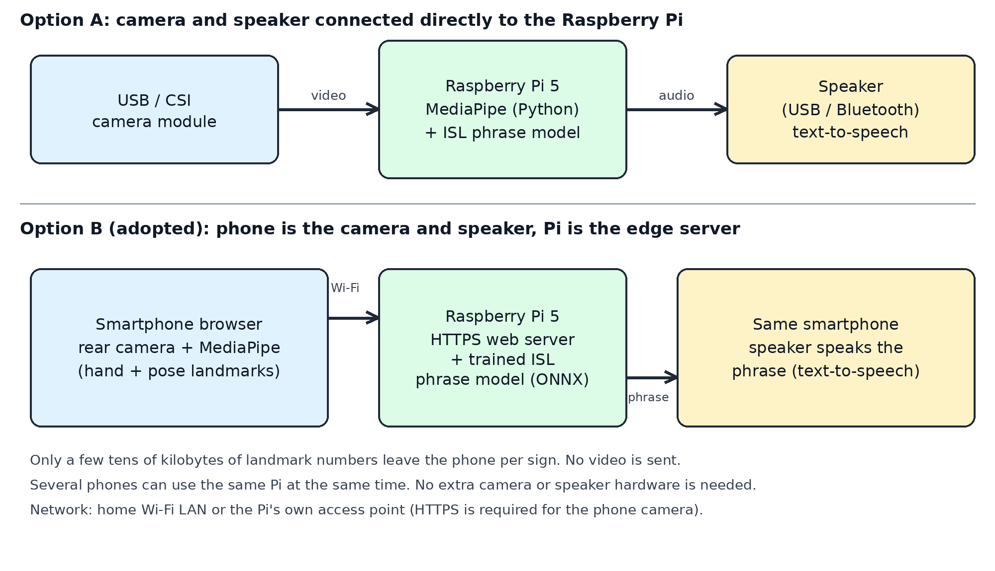
Figure 3.1: Option A (camera and speaker on the Pi) and Option B (phone as camera and speaker, Pi as server)
Option A: camera module and speaker connected directly to the Raspberry Pi. A USB or CSI camera module is attached to the Pi, the Pi runs MediaPipe and the model locally, and a speaker connected by USB or Bluetooth speaks the phrase. This makes a self-contained device and also works without any phone. It is simple and we used the same USB webcam for recording our data set.
Option B: phone as camera and speaker, Raspberry Pi as the edge server (adopted). The phone opens a web page served by the Pi. The browser opens the rear camera, finds the hand and pose landmarks, and sends them to the Pi, which returns the recognised phrase. The phone speaks it. We chose Option B because it is the better and more effective solution for real-world use:
- No extra hardware. The camera, speaker, screen and battery of a phone that the user already owns are used. Option A needs a camera, a speaker, a stand and a power supply.
- Portable and flexible. The phone can be placed or held wherever the signer is, while the Pi stays in one place. A fixed camera on the Pi limits the position of the signer.
- Multiple users. Several phones can use one Pi at the same time. The Pi only runs the small model (about 2-3 ms per sign) and does not process video.
- Privacy and bandwidth. Only a few tens of kilobytes of landmark numbers are sent per sign. Video never leaves the phone.
- Speech without a speaker on the Pi. The Raspberry Pi 5 has no 3.5 mm audio jack, so Option A needs a USB or Bluetooth speaker. The phone already has a loudspeaker and a text-to-speech voice.
- Light load on the Pi. Running MediaPipe on the Pi itself took about 62-90 ms per frame (about 11 frames per second in recording), which is acceptable for one camera but is the bottleneck that Option B removes.
The trade-off is that Option B needs a phone and a network link, and that the camera must be accessed over HTTPS, so the Pi creates a self-signed certificate that the user accepts once. Both options use the same trained model and the same software on the Pi.
3.3 Network Configuration
The server listens on HTTPS port 8443 and redirects plain HTTP from port 8080. Phones reach it at the Pi's IP address. The MQTT broker listens on TCP port 1883 of the same Pi, and the ESP32 reaches it at the Pi's IP address. The ESP32 supports only the 2.4 GHz band, so the network must provide 2.4 GHz Wi-Fi. The system has been tested on a home Wi-Fi LAN. For demonstration without an external router, the Pi's Wi-Fi can be run as its own access point, because the model, web page and MediaPipe files are all stored on the Pi and no internet connection is needed. For administration the Pi can also be reached over SSH and a Tailscale VPN; the application itself does not use them.
3.4 IoT Architecture
Figure 3.2 shows the complete system in the four layers that are usual in IoT. The sensing layer is the phone camera and the emergency button. The network layer is the Wi-Fi LAN with TCP/IP, HTTPS and MQTT. The edge layer is the Raspberry Pi, which runs the ISL model, the web server and the MQTT broker, so the data are processed close to where they are produced and no cloud service is needed. The application and actuation layer is the phone speaker and the ESP32 node with its OLED, LEDs and buzzer.
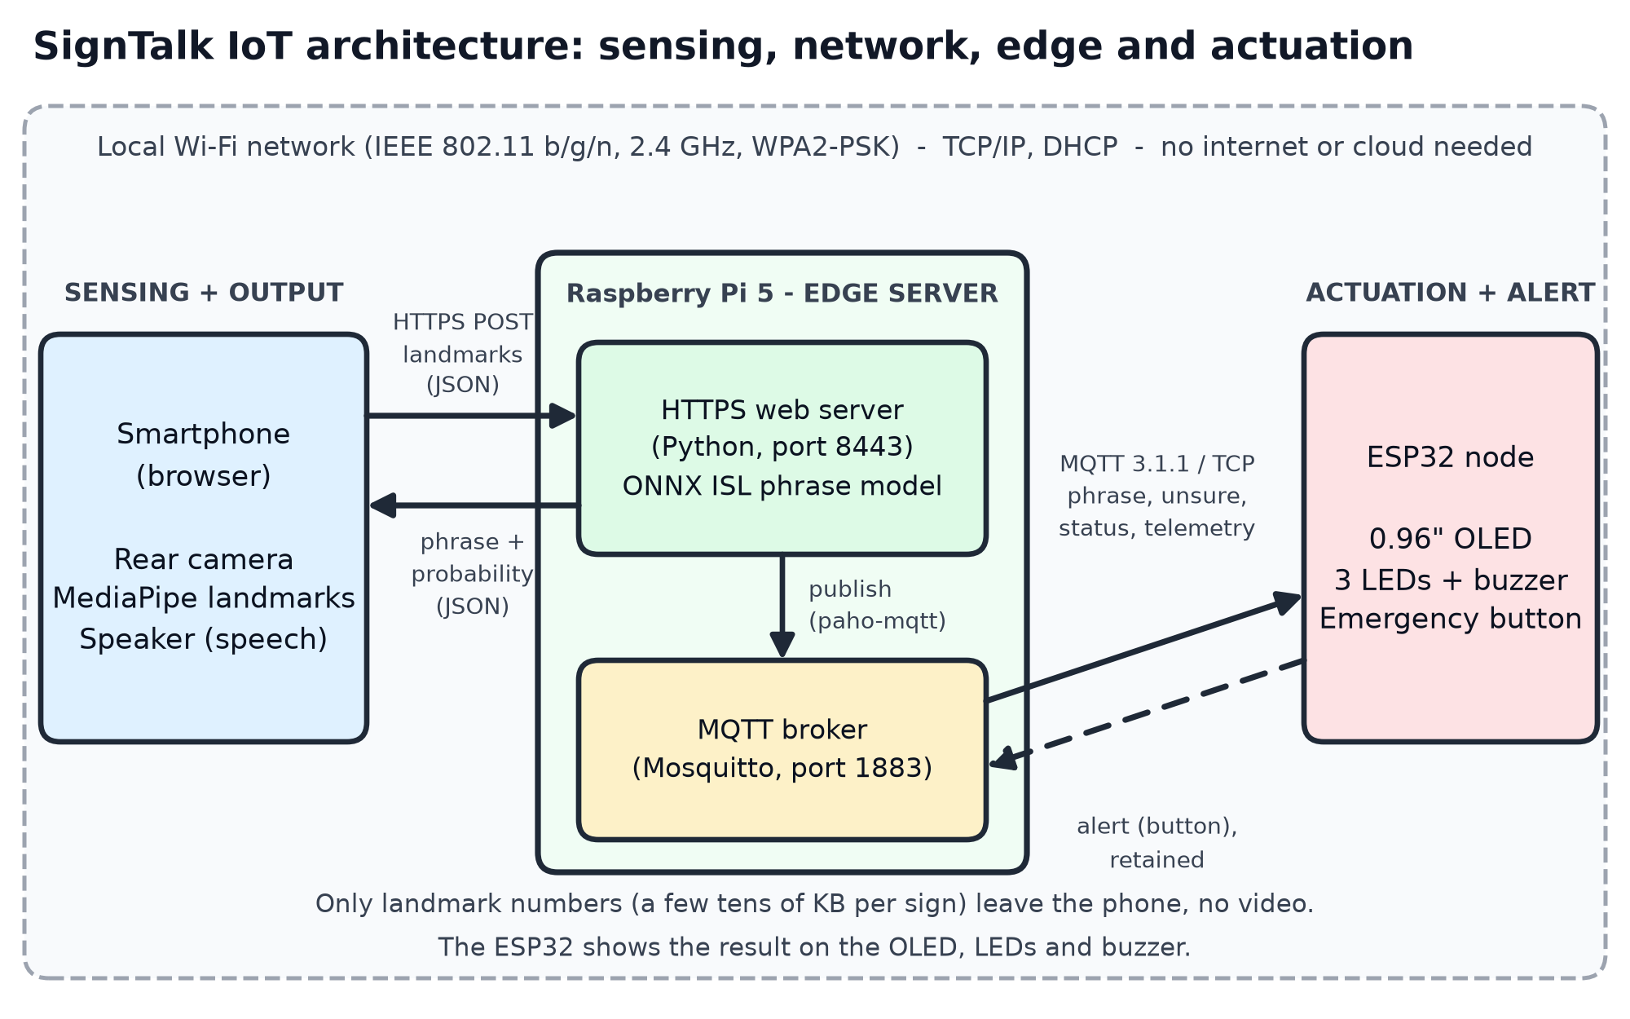
Figure 3.2: IoT architecture of SignTalk (sensing, network, edge and actuation layers)
Two communication styles are used on purpose. The phone talks to the Pi with request/response HTTPS, because it sends a window of landmarks and needs the answer for the same request. The Pi talks to the ESP32 with publish/subscribe MQTT, because one event has to reach one or more listeners that may start, stop or restart at any time, and because MQTT is light enough for a microcontroller.
3.5 ESP32 Node Hardware and Wiring
All the output devices are connected to the ESP32, not to the Pi. The first version of the project drove the LEDs and the buzzer from the Pi's own GPIO pins through a small bridge program. We moved them to the ESP32 so that the output node is a separate wireless device that can be placed near the user, the Pi needs no extra wiring, and the project shows a real distributed IoT system with two devices that only communicate through MQTT. Table 3.2 and Figure 3.3 give the connections.
Part | ESP32 pin | Connection
0.96-inch OLED (I2C) | 3V3, GND, GPIO21, GPIO22 | VCC to 3V3, GND to GND, SDA to GPIO21, SCL to GPIO22
Green LED | GPIO25 | GPIO25 through about 330 ohm to the LED anode, cathode to GND
Amber LED | GPIO26 | same, through its own resistor
Red LED | GPIO27 | same, through its own resistor
Buzzer | GPIO32 | signal to GPIO32, other terminal to GND (a bare buzzer uses a transistor)
Push button | GPIO33 | one leg to GPIO33, the other leg to GND; internal pull-up, no external resistor

Table 3.2: ESP32 pin connections
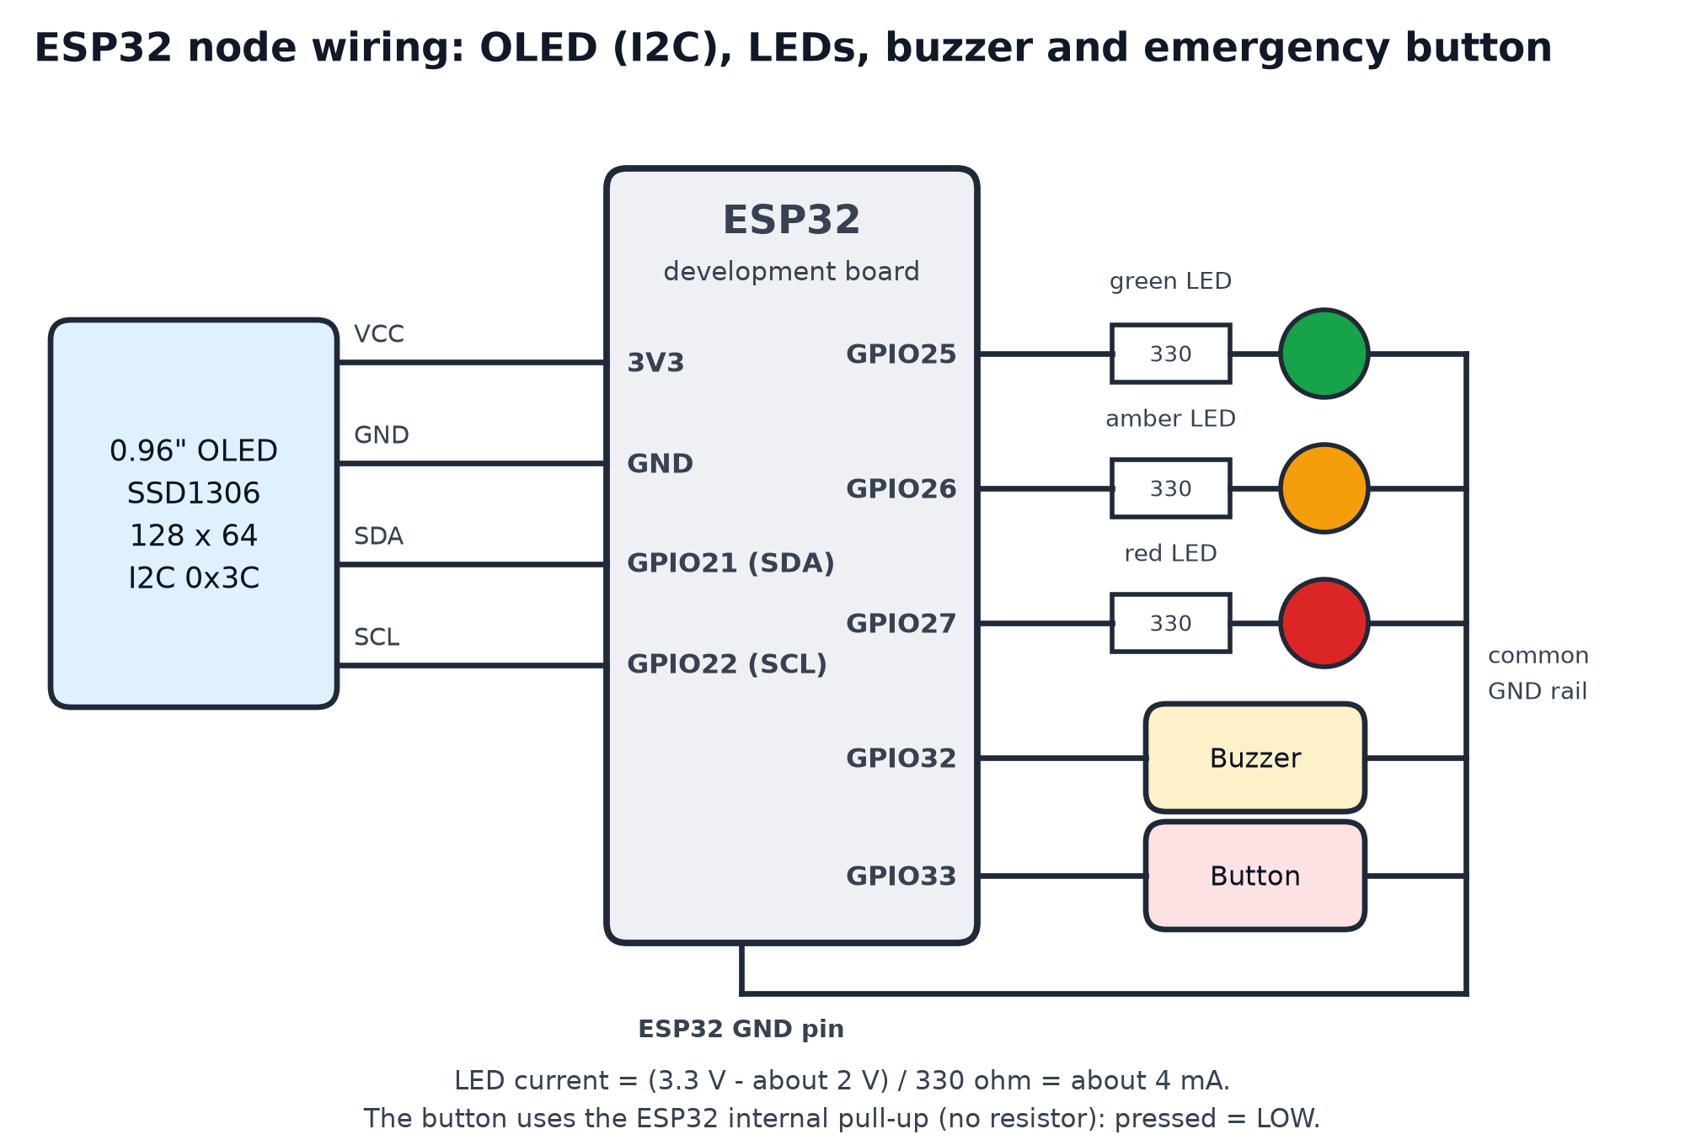
Figure 3.3: Wiring of the ESP32 node (OLED, LEDs, buzzer and emergency button)
The pins were chosen so that they are normal input/output pins and not pins that the ESP32 uses while booting. Each LED draws about (3.3 V - 2 V) / 330 ohm = 4 mA, which is well within the limit of an ESP32 pin. The OLED module has its own I2C pull-up resistors. The button is read with the internal pull-up, so a press gives a LOW level, and it is debounced in software for 50 ms. A buzzer module can be driven directly from GPIO32; a bare buzzer needs a transistor so that the pin is not overloaded, and a passive buzzer needs a tone, which can be selected in the firmware. The ESP32 board is powered from USB and uses its on-board regulator for 3.3 V.
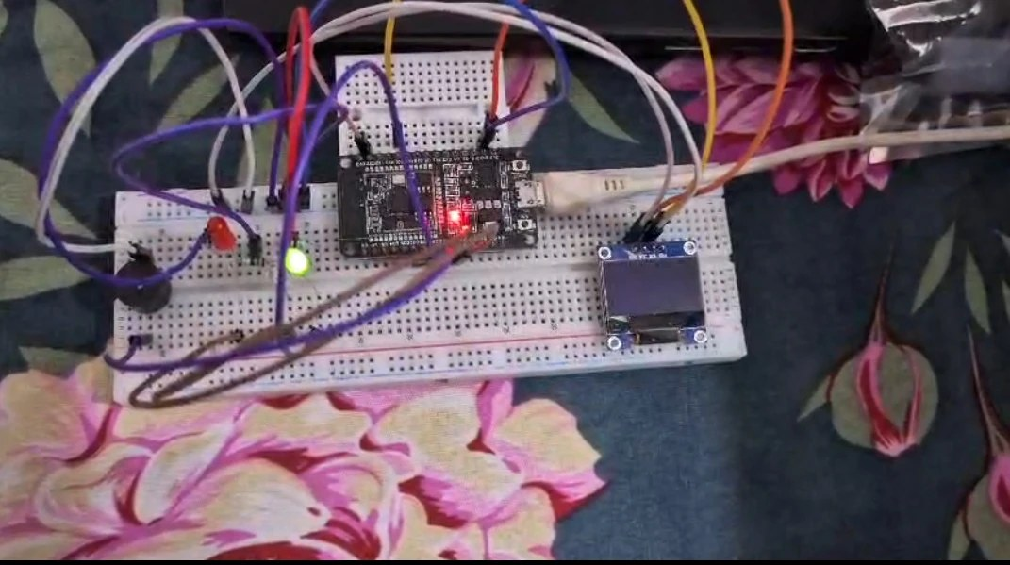
Figure 3.4: The assembled ESP32 node on a breadboard (OLED, LEDs, buzzer and wiring)
3.6 Communication Protocols and Standards Used
The project uses several protocols at different layers. Table 3.3 lists them, where they are used and the main settings.
Protocol / standard | Where it is used | Main settings and reason
Wi-Fi, IEEE 802.11 b/g/n [22] | Phone, Pi and ESP32 on one LAN | 2.4 GHz band, WPA2-PSK security. The ESP32 supports 2.4 GHz only.
TCP/IP and DHCP | All device-to-device traffic | Addresses come from the router by DHCP; the ESP32 is configured with the Pi's address.
HTTP/1.1 over TLS (HTTPS) [20][21] | Phone to the web server, port 8443; plain HTTP on 8080 is redirected | Self-signed EC certificate, because browsers allow camera access only on secure pages. REST API with JSON, gzip compression and ETag caching.
MQTT 3.1.1 over TCP [13][14] | Web server to broker to ESP32 (phrase, unsure, status, telemetry); ESP32 to broker (alert) | Port 1883, user name and password, keep-alive 30 s on the server, QoS 0 and 1, retained messages, last-will message, JSON payloads.
I2C [18] | ESP32 to the OLED display | Two wires (SDA GPIO21, SCL GPIO22), device address 0x3C, up to 400 kHz.
GPIO digital input/output | ESP32 to LEDs, buzzer and button | Outputs for LEDs and buzzer; input with internal pull-up and 50 ms debounce for the button.
USB (UVC video class) | USB webcam to the Pi for recording the data set | 1280 x 720 at 30 fps, MJPEG.
Serial (UART over USB) | ESP32 to a PC for flashing and debugging | 115200 baud; prints Wi-Fi and MQTT state and failure reasons.
Browser APIs | Phone browser | Media Capture and Streams for the camera [12], Web Speech API for text-to-speech [11].
SSH and Tailscale (WireGuard VPN) | Administration of the Pi | Not used by the application itself.

Table 3.3: Communication protocols and standards used in SignTalk
4. Software Design
4.1 Overview
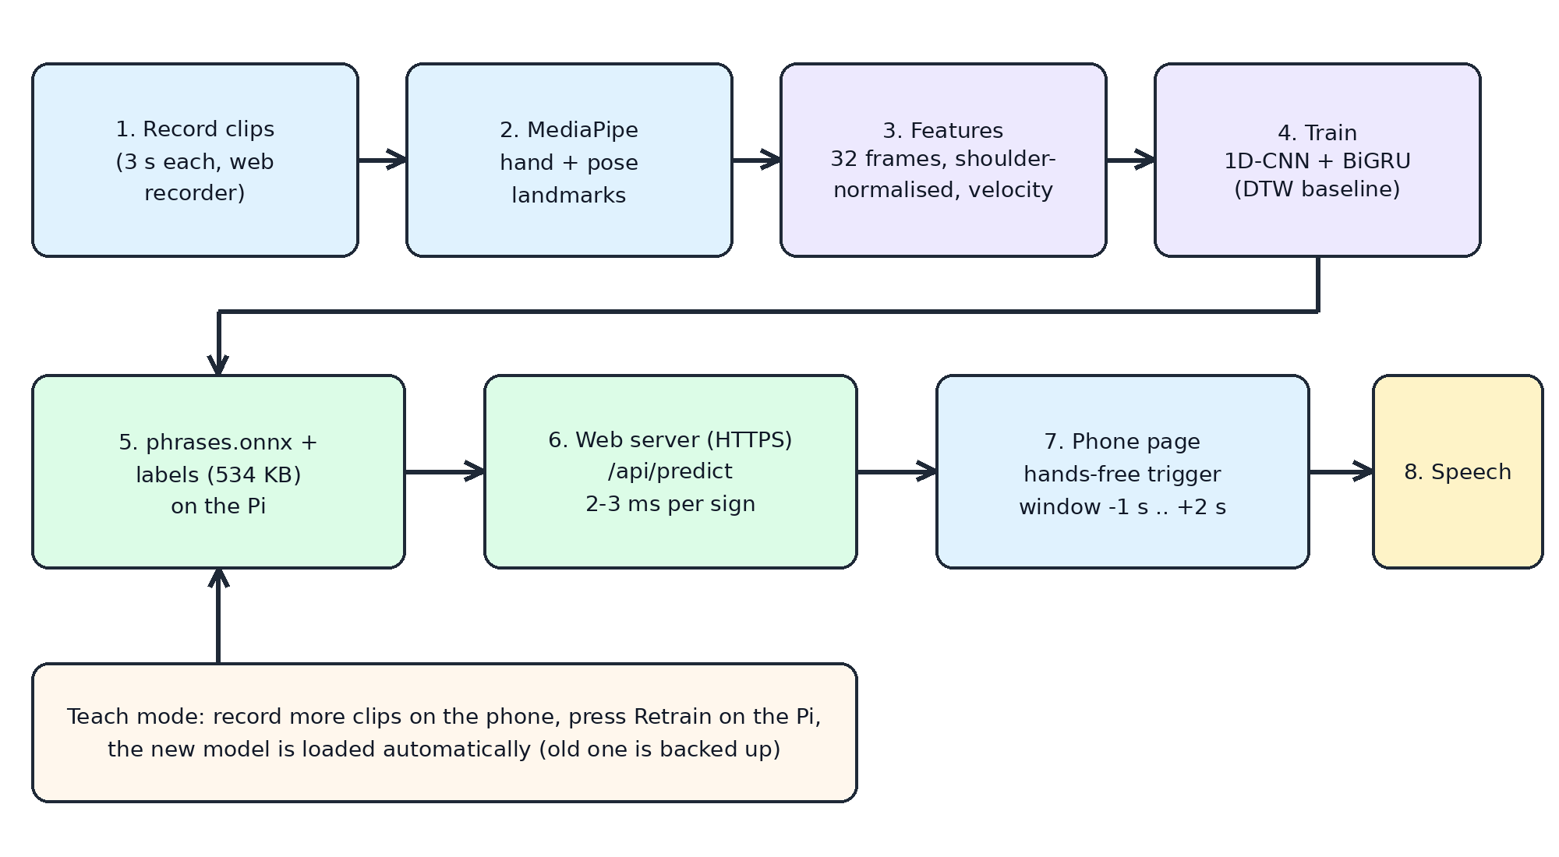
Figure 4.1: Software pipeline from recording to speech, and the Teach loop for adding phrases
The software has three parts: an offline part that records clips and trains the model (all of it runs on the Pi), an online part with the web server on the Pi and the page in the phone browser, and an IoT messaging part made of the MQTT broker and publisher on the Pi (Section 4.7) and the firmware of the ESP32 node (Section 4.8).
4.2 Data Collection
A small web recorder on the Pi shows the USB webcam in a browser, gives a 3-second countdown, records a 3-second clip, and saves the MediaPipe landmarks of every frame together with a video and a metadata file. The phrases were learned from the ISLRTC reference videos [1]. The webcam was used at 1280x720 and downscaled to 640x360. Because MediaPipe runs on the Pi while recording, the effective frame rate was about 11 frames per second, so each clip has about 34 frames. The first eight phrases were recorded first and later extended to 50 clips each; four more phrases (How are you, I am fine, Nice to meet you and Have a good day) were then added with 50 clips each, using the same recorder.
Phrase | Clips recorded | Notes
Hello | 50
Hi | 50 | recorded as 'hii' in the data set
Thank you | 50
Welcome | 50
Good morning | 50 | weakest phrase in testing
Good afternoon | 50
Please | 50
Sorry | 53 | three extra clips
How are you | 50 | added later
I am fine | 50 | added later
Nice to meet you | 50 | added later
Have a good day | 50 | added later
Total | 603 | one signer, several recording sessions

Table 4.1: ISL phrase data set
4.3 Landmark Extraction and Features
Each frame is converted into 543 landmark positions (468 face, 21 for each hand, 33 body points) and missing parts are marked as not detected. For the classifier only the body points that matter for signing are kept: 7 pose points (nose, shoulders, elbows and wrists) and 21 points for each hand, which are 49 points with x and y coordinates. The coordinates are shifted to the centre of the shoulders and divided by the shoulder width, so the result does not depend on how far the signer is from the camera. Every clip is resampled to 32 frames. For the neural network the input of each frame has 198 values: 98 positions, 98 velocities (frame-to-frame differences) and 2 flags that tell whether the left and right hand were detected.
4.4 Models
DTW baseline. A new sign is compared with all stored clips using Dynamic Time Warping [8], and the score of a phrase is the average of its three nearest clips. It needs no training and works with very few examples. It is used as a baseline for the neural network.
Neural network. The network has two 1D-convolution layers (64 channels, kernel size 5, batch normalisation, ReLU), one bidirectional GRU layer with 64 units [9], mean and max pooling over time, dropout 0.3 and a final linear layer with one output per phrase. It was trained for 80 epochs with the AdamW optimiser, a one-cycle learning-rate schedule and label smoothing of 0.1. Data augmentation during training included small random rotation (+/-8 degrees), scaling (0.9-1.1), shifting, Gaussian noise, random time cropping and stretching, and brief loss of the hands. The trained model is exported to ONNX (538 KB) and is run on the Pi with ONNX Runtime [10]. The exported model matches the PyTorch model to within 5x10^-7.
4.5 Web Server on the Raspberry Pi
The server uses only the Python standard library and ONNX Runtime, to keep the load on the Pi small. It serves the web page and the MediaPipe files (compressed with gzip and cached by the browser), and offers these functions:
- /api/predict receives a window of landmarks, rejects windows where no body or hands are seen, runs the network and returns the best three phrases with their probabilities. A phrase is accepted if its probability is above the confidence threshold. The threshold is 55 % by default and can be changed on each phone.
- /api/teach saves a new clip taught from a phone into the data set, and /api/retrain trains a new model on all clips in the background at low priority. The old model is backed up, and the new one is loaded automatically without restarting the server.
- HTTPS with an automatically generated self-signed certificate, because browsers allow camera access only on secure pages.
- MQTT publishing. After every prediction the server publishes the result to the MQTT broker (Section 4.7). If the broker is not available the server keeps working and retries in the background.
4.6 Phone Web Page
The page is written in plain HTML, CSS and JavaScript with a flat dark theme and a high-definition (1280x720) camera view. It runs MediaPipe Tasks Vision [2] in the browser, using the same MediaPipe version as the training pipeline. The hand and pose landmarks are drawn on the video so that the user can see how they are tracked.
Hands-free mode. The page watches whether a hand is raised above the lap. When a hand is raised for a quarter of a second, a sign is assumed to have started. The window from 1 second before to 2 seconds after the start is sent to the Pi, which matches the layout of the training clips (a rest, then the sign). The answer is spoken, and the hands must be lowered before the next sign. A Tap to sign mode with a countdown is also available. Speech uses the browser's text-to-speech [11], and the camera uses the browser's media-capture interface [12].
Teach mode. The user selects or types a phrase, records clips with the phone camera, and presses Retrain. This is how new words are added later: the new clips are added to the old data and the model is retrained on everything.
4.7 MQTT Messaging Layer
An Eclipse Mosquitto 2.0 broker [14] runs on the Pi. It was installed in the user's home folder because administrator rights were not available, and it is started and stopped with a small script (broker.sh). The broker listens on TCP port 1883, anonymous access is switched off and every client must log in with a user name and password. Persistence is on, so retained messages survive a restart of the broker. The web server publishes with the Python client paho-mqtt [19]; its connection is asynchronous with automatic reconnection and publishing never raises an error, so a broker failure cannot stop the recognition. The ESP32 uses the PubSubClient library [16].
The topics and their settings are in Table 4.2. The quality-of-service (QoS) levels were chosen according to how important each message is. An accepted phrase is sent with QoS 1, so that it is delivered at least once. A sign that was not accepted and the telemetry are only informative and use QoS 0. The status and the alert messages are retained, so that a client that starts later (for example an ESP32 that was just switched on) immediately learns the current state. The server registers a last-will message, so that the broker itself publishes "offline" on the status topic if the web server stops without saying goodbye. The ESP32 publishes the alert with the retained flag, but with QoS 0, because the PubSubClient library can only publish with QoS 0.
Topic | Publisher to subscriber | QoS | Retained | Payload
signtalk/phrase | web server to ESP32 | 1 | no | {"id":"hello","label":"Hello","p":0.93,"ms":2.4,"ts":...}
signtalk/unsure | web server to ESP32 | 0 | no | {"reason":"unsure","label":"Hi","p":0.41,"ts":...}
signtalk/status | web server to ESP32 | 1 | yes | online / offline (the last-will message)
signtalk/telemetry | web server to ESP32 | 0 | yes | {"temp":49.0,"load":0.4,"uptime":...,"predictions":...,"spoken":...,"phrases":12} every 5 s
signtalk/alert | ESP32 to all subscribers | 0 | yes | {"state":"on","source":"button"}

Table 4.2: MQTT topics used by SignTalk
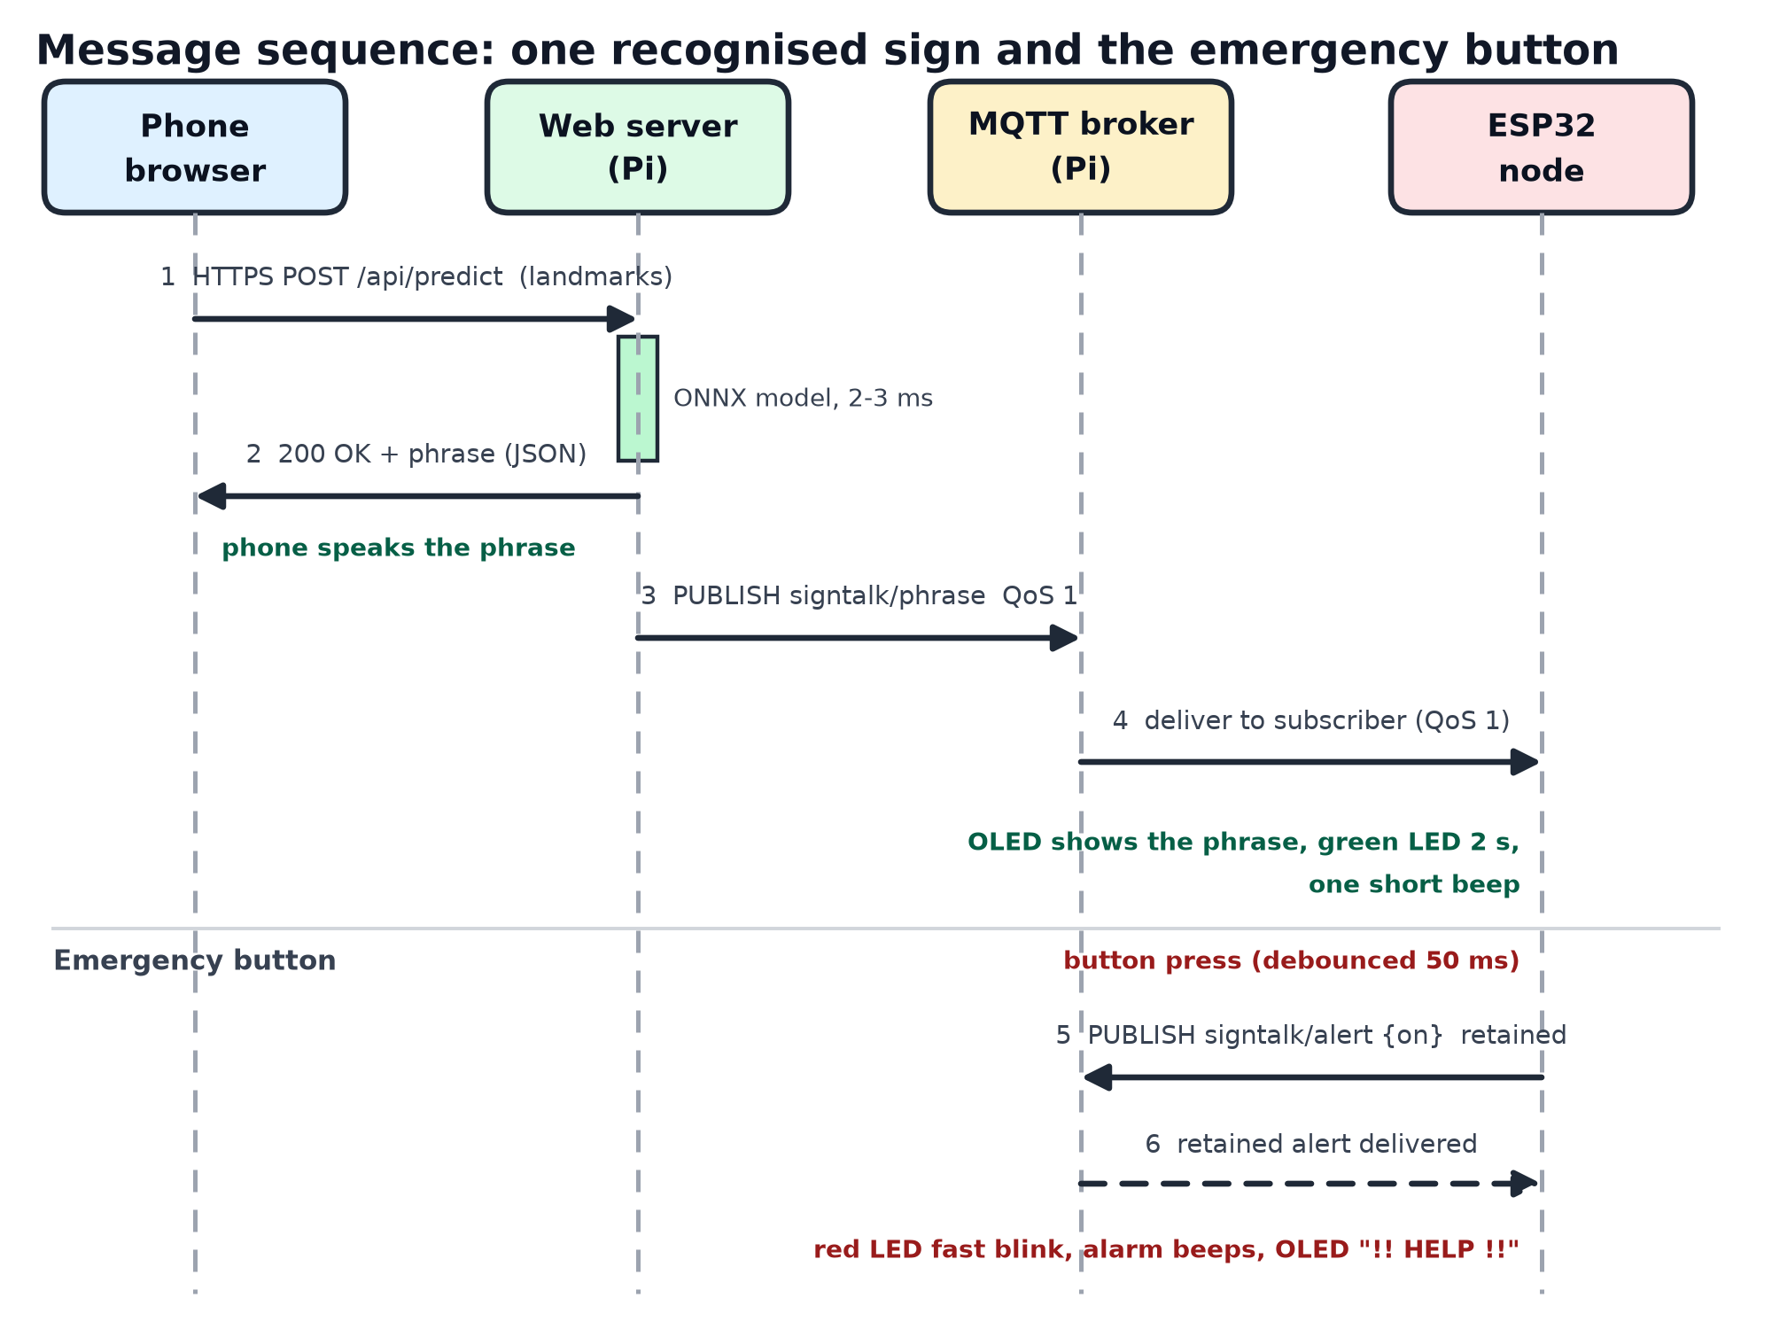
Figure 4.2: Message sequence for a recognised sign and for the emergency button
The broker is protected by a password but the connection is not encrypted, because the ESP32 side was kept simple. It is therefore meant for a private Wi-Fi network, and port 1883 must not be exposed to the internet (Section 5.5).
4.8 ESP32 Firmware
The firmware is written with the Arduino framework for the ESP32 and uses the libraries PubSubClient [16], Adafruit SSD1306 and Adafruit GFX [23]. The main loop never blocks: all timing is done by comparing millis() with stored deadlines, so the LEDs, buzzer, button, MQTT connection and display are all served in turn. At power-up the firmware flashes each LED once and beeps once as a wiring check, shows a start-up screen and starts the Wi-Fi connection. In the loop it (1) keeps the Wi-Fi connected, (2) connects to the broker, with one attempt every 3 seconds, and subscribes to the topics, (3) handles incoming MQTT messages, (4) reads the debounced button, (5) updates the LEDs and the buzzer and (6) redraws the OLED every 50 ms.
Wi-Fi is started once and the ESP32's own auto-reconnect is used. An event handler prints the reason for every failed attempt on the serial monitor (for example reason 201 for a network that is not found, and 204 or 15 for a failed security handshake) and the OLED shows a matching message. Wi-Fi sleep is switched off, because it can make the connection and MQTT unreliable. Table 4.3 gives the behaviour of the node.
Event | Source | Response of the ESP32 node
Phrase recognised | signtalk/phrase | Phrase in large letters with a confidence bar on the OLED for 8 s; green LED for 2 s; one 120 ms beep
Sign not accepted | signtalk/unsure | Amber LED for 1.5 s; OLED shows "Not sure..."
Pi server or network lost | status = offline, or Wi-Fi / MQTT connection lost | Red LED blinks slowly (1 Hz); OLED shows "Pi server offline" or the connection state
Pi telemetry | signtalk/telemetry | Pi temperature in the OLED status bar
Button pressed | GPIO33 goes LOW (debounced 50 ms) | Toggles the alert and publishes signtalk/alert (retained); red LED blinks fast (2 Hz), alarm beeps, OLED flashes "!! HELP !!"
Alert message received | signtalk/alert | Same alarm as for the button, so that the alert state is shared; clears itself after 60 s
Power-up | - | Self-test: each LED flashes once and the buzzer beeps once

Table 4.3: Behaviour of the ESP32 node
5. Results and Discussion
5.1 Offline Accuracy
The model was evaluated with 5-fold stratified cross-validation on all 603 clips of the twelve phrases, and compared with the DTW baseline on the same folds (Table 5.1). The neural network classified 598 of 603 clips correctly (99.2 %), and the DTW matcher 594 of 603 (98.5 %).
Phrase | Clips | Network correct | Network accuracy
Hello | 50 | 50 | 100 %
Hi | 50 | 50 | 100 %
Thank you | 50 | 50 | 100 %
Welcome | 50 | 50 | 100 %
Good morning | 50 | 46 | 92 %
Good afternoon | 50 | 49 | 98 %
Please | 50 | 50 | 100 %
Sorry | 53 | 53 | 100 %
How are you | 50 | 50 | 100 %
I am fine | 50 | 50 | 100 %
Nice to meet you | 50 | 50 | 100 %
Have a good day | 50 | 50 | 100 %
All phrases | 603 | 598 | 99.2 %

Table 5.1: Cross-validation result of the neural network (DTW baseline: 594/603 = 98.5 %)
The five errors were Good morning mistaken for Good afternoon (2 clips) and for Sorry (2), and Good afternoon mistaken for Sorry (1). The four newly added phrases were all classified correctly. The network's average top probability was 0.91 when it was right and 0.55 when it was wrong, which is why a confidence threshold removes many wrong answers; it also means that lowering the threshold lets more wrong answers through. The first data set (eight phrases, 20 clips each) gave 97.1 %; the higher figure now comes with more clips per phrase and more phrases, so the two numbers are not directly comparable.
5.2 System Performance on the Raspberry Pi
Measurement | Result
Model prediction time on the server | about 2-3 ms per sign
Model size (ONNX) | 538 KB
Training time for the final model (603 clips, 80 epochs) | about 95 s on the Pi (the full 5-fold cross-validation plus final training took about 11.5 minutes)
MediaPipe on the Pi (when the Pi does the tracking) | about 62-90 ms per frame at 640x480
Pi temperature while serving | about 47-55 C (observed, no throttling seen; 47.4 C was shown on the ESP32 display)
Landmark data sent per sign | a few tens of kilobytes (no video)
MQTT telemetry interval | 5 s (retained message)

Table 5.2: Performance measurements
5.3 Hands-free Mode and Web Application Tests
- Server test. Each recorded clip was sent to the server exactly as the phone page sends its landmarks. All 36 clips tested (three per phrase, twelve phrases) were answered correctly, in about 2.4 ms each. These are training clips, so this checks the wiring and not the accuracy.
The next three tests were run on the first data set (eight phrases, 172 clips), before the data set was extended, and were not repeated afterwards.
- Raised-hand trigger. On the recorded clips, a raised hand was detected in 165 of 172 clips (96 %). The few misses were clips where the hand never rose above the trigger height.
- Replay of all clips as one stream. The 172 clips were joined with rest periods and passed through the same hands-free logic. A sign was triggered for 150 clips: 144 were recognised correctly, 3 wrongly and 3 were rejected. This is on training clips and is optimistic.
- Browser test. The web page was run in a browser on the Pi with a recorded video as the camera. It detected the raised hand, sent the window to the Pi and received the correct phrase (Hello, probability 0.94-0.95).
- Trial on a phone. The web page was tried on a phone over the home Wi-Fi network and worked well. The first confidence threshold of 80 % was found to be too high, so it was lowered to 55 % and a slider was added to the settings.
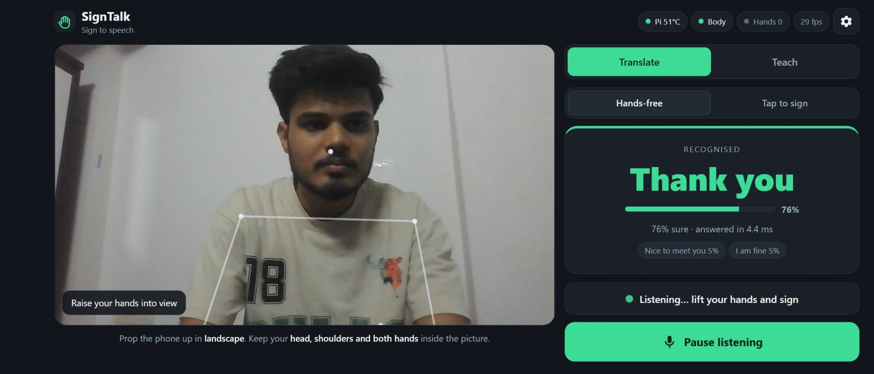
Figure 5.1: The phone web page recognising “Thank you” (hands-free mode, 76 % confidence, 4.4 ms)
5.4 IoT Layer Tests
An automated test (test_iot.py) runs against the real Mosquitto broker with a separate topic prefix, so that it does not disturb the running system. It checks that a client with a wrong password is refused, that the publisher announces its status as a retained message and that a late subscriber still receives it, that an accepted phrase is published with the correct label and probability while empty windows are not published, that uncertain signs and the telemetry reach subscribers, and that the counters are correct. All checks passed. The same test also checked the LED, buzzer and button logic of the first version, which ran on the Pi's GPIO pins with simulated pins: green LED and a beep for a phrase, amber LED for an uncertain sign, a blinking red LED while the server is offline, and an alert that is switched on and off by the button and published as a retained message. The ESP32 firmware implements the same behaviour (Table 4.3); it has no automated test.
The ESP32 node was checked on the real hardware (Table 5.3 and Figure 5.2).
Check | Result
ESP32 joins the Wi-Fi network and gets an IP address | Passed. The first network tried refused the connection (reason code 204, security handshake); the node joined another 2.4 GHz network.
ESP32 logs in to the broker on the Pi with user name and password | Passed ("MQTT: connected to the Pi" on the serial monitor)
OLED shows the connection state, the Pi temperature and the idle screen | Passed: "WiFi MQTT", 47.4 C and "Waiting for sign" (Figure 5.1)
Pi telemetry reaches the ESP32 through the broker | Passed: the temperature on the display comes from signtalk/telemetry

Table 5.3: Checks of the ESP32 node on the hardware
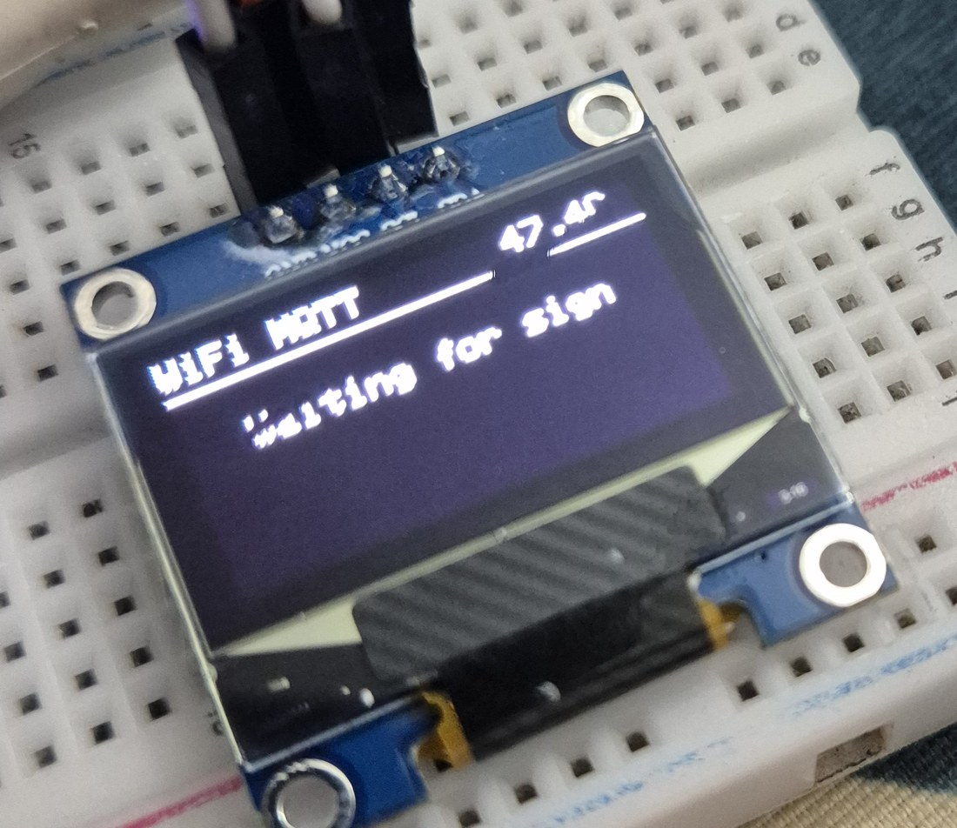
Figure 5.2: ESP32 OLED showing Wi-Fi and MQTT connected, the Pi temperature and the idle screen
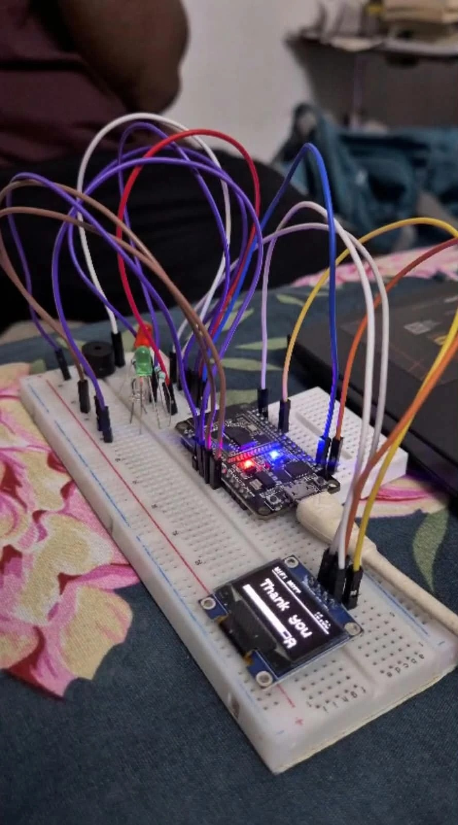 | 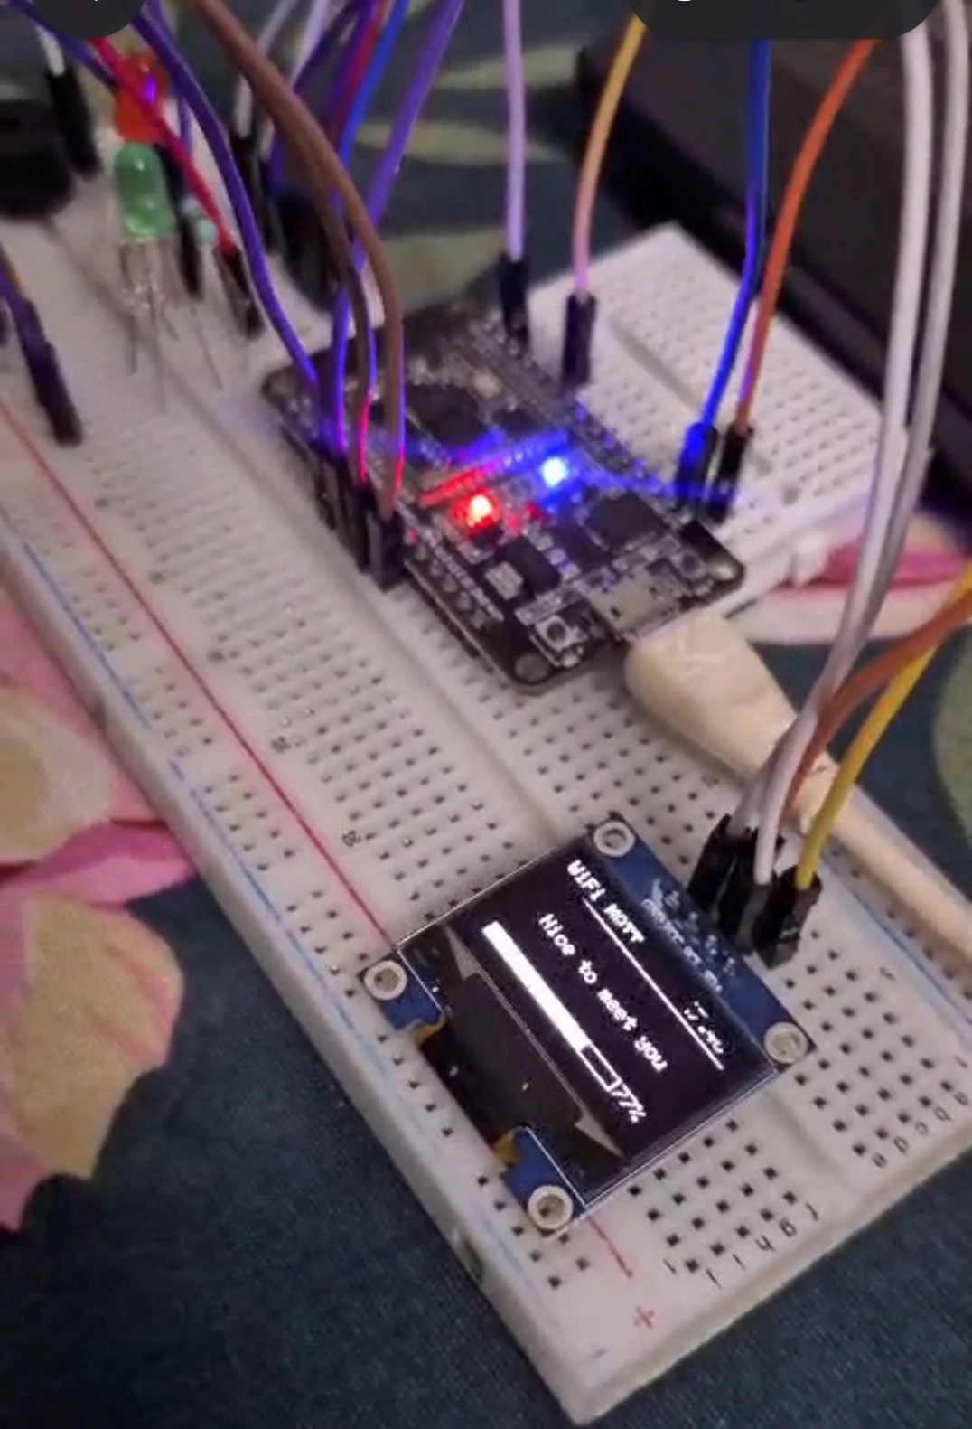
Figure 5.3: The ESP32 node showing recognised phrases: “Thank you” (left) and “Nice to meet you” with the 77 % confidence bar (right)
5.5 Discussion and Limitations
- The cross-validation clips come from the same recording sessions and the same signer, so the 99 % figure is optimistic. Accuracy for a new person, a new day or a different camera is expected to be lower and has not yet been measured.
- The phrases were learned from ISLRTC reference videos by a student who is not a signer. They have not been checked by an ISL expert or tried with deaf users, so correctness of the signs must be confirmed before real use.
- The model has no class for 'no sign'. The hands-free trigger and the confidence threshold reduce false answers, but random movements can still be recognised as a phrase.
- Only twelve isolated phrases are supported. Continuous signing and sentences are not recognised.
- The earlier approach, which used pretrained ASL models for live recognition, was not reliable and was replaced by the ISL phrase model described here.
- MQTT security. The broker uses a user name and password, but the connection is not encrypted (no TLS), and it listens on all interfaces of the Pi. It is meant for a private Wi-Fi network. TLS on port 8883 and per-device accounts would be needed for a public deployment.
- IoT limits. The ESP32 publishes the alert with QoS 0, because of the PubSubClient library, so an alert could be lost on a very poor Wi-Fi link. Only one ESP32 node was built and tested, and the end-to-end delay from the sign to the OLED was not measured.
- Network. The ESP32 supports only 2.4 GHz Wi-Fi, and the node and the Pi must be on the same network. Running the Pi as its own access point that starts at boot has not been done yet. Commissioning problems with the Wi-Fi connection were solved with the failure reason codes printed on the serial monitor.
- User tests. The LEDs, buzzer and button have not yet been evaluated with users, and the alert has not been tested with a real receiver other than the ESP32 itself.
6. Conclusions and Future Scope
6.1 Conclusions
We built an IoT system in which a Raspberry Pi hosts a trained Indian Sign Language phrase model and serves a web application on the local network. A phone browser uses its rear camera to track the signer, the Pi recognises one of twelve ISL phrases (99.2 % in cross-validation on our recordings) in a few milliseconds, and the phone speaks the phrase. The model was trained by us on ISL phrase recordings and can be extended with new phrases through the Teach mode. Every result is also published through an MQTT broker on the Pi to an ESP32 node, which shows the phrase on a 0.96-inch OLED, signals the state with LEDs and a buzzer, and has an emergency button that raises an alert for all subscribers.
Two designs were considered. Connecting a camera module and a speaker directly to the Raspberry Pi gives a stand-alone device and is a valid option. The phone-based design is the better and more effective solution for real-world use, because it needs no extra hardware, works with the user's own phone, supports several users, protects privacy by keeping the video on the phone, and keeps the load on the Pi very low.
The project uses the main IoT building blocks: sensing (phone camera and button), connectivity (Wi-Fi, TCP/IP, HTTPS and MQTT), edge processing on the Raspberry Pi, a publish/subscribe message broker, and actuation and display on a microcontroller node (I2C and GPIO). It was built from a Raspberry Pi, a phone, an ESP32 and a few low-cost parts, and it needs no cloud service.
6.2 Future Scope
- Record more signers, sessions and phones, and test with people who know ISL, to measure accuracy for unseen users.
- Have the signs verified by an ISL expert or the ISLRTC material, and extend the vocabulary with more useful phrases.
- Add a 'no sign' class so that random movements are not recognised as phrases.
- Continuous recognition of several phrases in a row, and Hindi or Gujarati speech output.
- Run the Pi as its own Wi-Fi access point that starts automatically at boot, for use without any other network.
- Run the model inside the phone browser for fully offline use, and add the direct camera-and-speaker option (Option A) as a ready-made stand-alone kit.
- Add TLS to MQTT (port 8883) with a separate account and access rules for each device.
- Add more ESP32 nodes, for example a vibration motor or a second display, which only need to subscribe to the same topics; the Pi does not have to change.
- Add a dashboard for the telemetry and a history of the recognised phrases.

References
[1] Indian Sign Language Research and Training Centre (ISLRTC), Dept. of Empowerment of Persons with Disabilities, Govt. of India, “Indian Sign Language dictionary and learning videos.” [Online]. Available: https://www.islrtc.nic.in
[2] C. Lugaresi et al., “MediaPipe: A framework for building perception pipelines,” arXiv:1906.08172, 2019.
[3] F. Zhang et al., “MediaPipe Hands: On-device real-time hand tracking,” arXiv:2006.10214, 2020.
[4] V. Bazarevsky et al., “BlazePose: On-device real-time body pose tracking,” arXiv:2006.10204, 2020.
[5] A. Desai et al., “ASL Citizen: A community-sourced dataset for advancing isolated sign language recognition,” in Proc. NeurIPS Datasets and Benchmarks Track, 2023.
[6] T. Starner et al., “PopSign ASL v1.0: An isolated American Sign Language dataset collected via smartphones,” in Proc. NeurIPS Datasets and Benchmarks Track, 2023.
[7] S. Yan, Y. Xiong, and D. Lin, “Spatial temporal graph convolutional networks for skeleton-based action recognition,” in Proc. AAAI Conf. Artif. Intell., 2018.
[8] H. Sakoe and S. Chiba, “Dynamic programming algorithm optimization for spoken word recognition,” IEEE Trans. Acoust., Speech, Signal Process., vol. 26, no. 1, pp. 43-49, Feb. 1978.
[9] K. Cho et al., “Learning phrase representations using RNN encoder-decoder for statistical machine translation,” in Proc. EMNLP, 2014, pp. 1724-1734.
[10] ONNX Runtime developers, “ONNX Runtime.” [Online]. Available: https://onnxruntime.ai
[11] W3C, “Web Speech API.” [Online]. Available: https://webaudio.github.io/web-speech-api/
[12] W3C, “Media Capture and Streams.” [Online]. Available: https://www.w3.org/TR/mediacapture-streams/
[13] OASIS, “MQTT Version 3.1.1,” OASIS Standard, Oct. 2014. [Online]. Available: https://docs.oasis-open.org/mqtt/mqtt/v3.1.1/os/mqtt-v3.1.1-os.html
[14] Eclipse Foundation, “Eclipse Mosquitto: an open source MQTT broker.” [Online]. Available: https://mosquitto.org
[15] Espressif Systems, “ESP32 Series Datasheet.” [Online]. Available: https://www.espressif.com
[16] N. O’Leary, “PubSubClient: a client library for Arduino for simple publish/subscribe messaging with MQTT.” [Online]. Available: https://github.com/knolleary/pubsubclient
[17] Solomon Systech, “SSD1306: 128 x 64 dot matrix OLED/PLED segment/common driver with controller,” datasheet.
[18] NXP Semiconductors, “UM10204: I2C-bus specification and user manual,” Rev. 7.0, 2021.
[19] Eclipse Paho, “Paho Python client for MQTT.” [Online]. Available: https://eclipse.dev/paho/
[20] E. Rescorla, “The Transport Layer Security (TLS) Protocol Version 1.3,” RFC 8446, IETF, Aug. 2018.
[21] R. Fielding, M. Nottingham, and J. Reschke, “HTTP Semantics,” RFC 9110, IETF, Jun. 2022.
[22] IEEE, “IEEE Standard for Information Technology - Telecommunications and Information Exchange between Systems - Local and Metropolitan Area Networks - Part 11: Wireless LAN MAC and PHY Specifications,” IEEE Std 802.11-2020.
[23] Adafruit Industries, “Adafruit SSD1306 and Adafruit GFX libraries for Arduino.” [Online]. Available: https://github.com/adafruit

Appendix
A. Project software (Raspberry Pi)
All code is in the signtalk folder on the Raspberry Pi and in the project GitHub repository.
webapp/server.py - HTTPS web server, prediction, Teach and Retrain functions
webapp/static/ - phone web page (index.html, app.js, style.css)
record_clips.py - web recorder for the training clips (USB webcam)
train_phrases.py - trains and compares the network and the DTW baseline, exports ONNX
fewshot.py, live_phrases.py - DTW matcher and a guided live test
phrase_model.py - model loading and input features shared by the server and tests
webapp/mqtt_bus.py - MQTT publisher used by the web server (paho-mqtt)
iot/broker.sh - starts, stops and tests the Mosquitto broker on the Pi
iot/esp32_oled/esp32_oled.ino - ESP32 firmware: Wi-Fi, MQTT client, OLED, LEDs, buzzer and emergency button
iot/WIRING.md - wiring instructions for the ESP32 node
iot/test_iot.py - automated test of the MQTT layer
iot/gpio_bridge.py - first version that drove the LEDs and buzzer from the Pi's GPIO pins (not used now)
nishu-start, nishu-stop - commands that start and stop the broker and the web server
B. Commands
python webapp/server.py
python train_phrases.py --person nishu,phone --no-cv
python webapp/test_server.py
nishu-start
nishu-stop
iot/broker.sh start | stop | status
mosquitto_sub -h <pi-ip> -u signtalk -P <password> -t 'signtalk/#' -v
python iot/test_iot.py
C. ISL phrases in the model
Hello, Hi, Thank you, Welcome, Good morning, Good afternoon, Please, Sorry, How are you, I am fine, Nice to meet you, Have a good day.
D. ESP32 node (Arduino IDE)
Board: ESP32 Dev Module. Libraries: PubSubClient, Adafruit SSD1306, Adafruit GFX. Before uploading, set the Wi-Fi name and password and the Pi's IP address at the top of iot/esp32_oled/esp32_oled.ino. The serial monitor runs at 115200 baud.

