Assignment 2

Question 1 :

The given data can be formed as an over determined system as follows

A= 1 0 0 0 X= x1 B= 2.95
0 1 0 0 x2 1.74
0 0 1 0 x3 -1.45
0 0 0 1 x4 1.32
1 -1 0 0 1.23
1 0 -1 0 4.45
1 0 0 -1 1.61
0 1 -1 0 3.21
0 1 0 -1 0.45
0 0 1 -1 -2.75

The system was solved using normal equation method for least squares ( i.e. A^{T}AX = A^{T}B )

Calculated x1 = 2.9600
x2 = 1.7460
x3 = -1.4600
x4 = 1.3140

The values calculated is comparable with the given measured values with more accuracy.

Question 2 :

a) Solved unknowns with B = [0.26 0.28 3.31]

x =
1.0000
1.0000

b) Solved with B = [0.27 0.25 3.33]

x =
7.0089
-8.3957

c)
The condition number of matrix A was calculated as 1.097539e+03, which is too high. This is the reason why very small perturbation in matrix B resulted in significant change in calculated values for unknowns.

Questioen 3 : Image Processing with OpenMP

Implemented Image warping and median filtering and evaluated the performance gain by using OpenMP.

Image Warping (twist transformation)

Input Image Transformed Image

Graph ploted with image transformation time on images with different number of pixels:
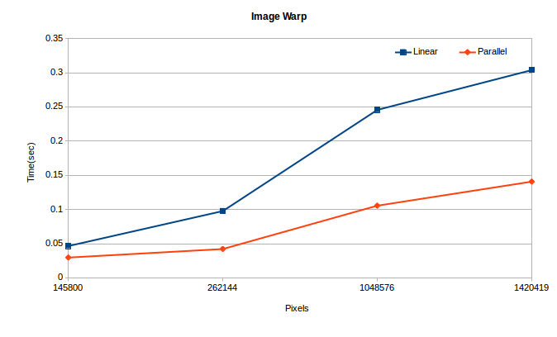

Median Filtering

Input Image Transformed Image Transformed Image
(Half Width = 3) (Half Width = 7)

Graph ploted with transformation time on various images with half width 3 and 7 respectively :

