PROGRAMMING ASSIGNMENT-4

Problem 7.5
a)

The polynomial is : 0.0057x^5 + -0.1348x^4 + 1.1208x^3 + -3.8559x^2 + 4.8643x + 0.0000 = 0

b)
The cubic polynomials were:

0.0 – 0.5: 0.0000 + 3.7999x + -0.0000x^2 + -2.3996x^3 = 0
0.5 – 1.0: -0.5997 + 7.3983x + -7.1967x^2 + 2.3982x^3 = 0
1.0 – 6.0: 1.8060 + 0.1811x + 0.0205x^2 + -0.0075x^3 = 0
6.0 – 7.0: -0.5063 + 1.3373x + -0.1722x^2 + 0.0032x^3 = 0
7.0 – 9.0: -5.4684 + 3.4638x + -0.4760x^2 + 0.0176x^3 = 0

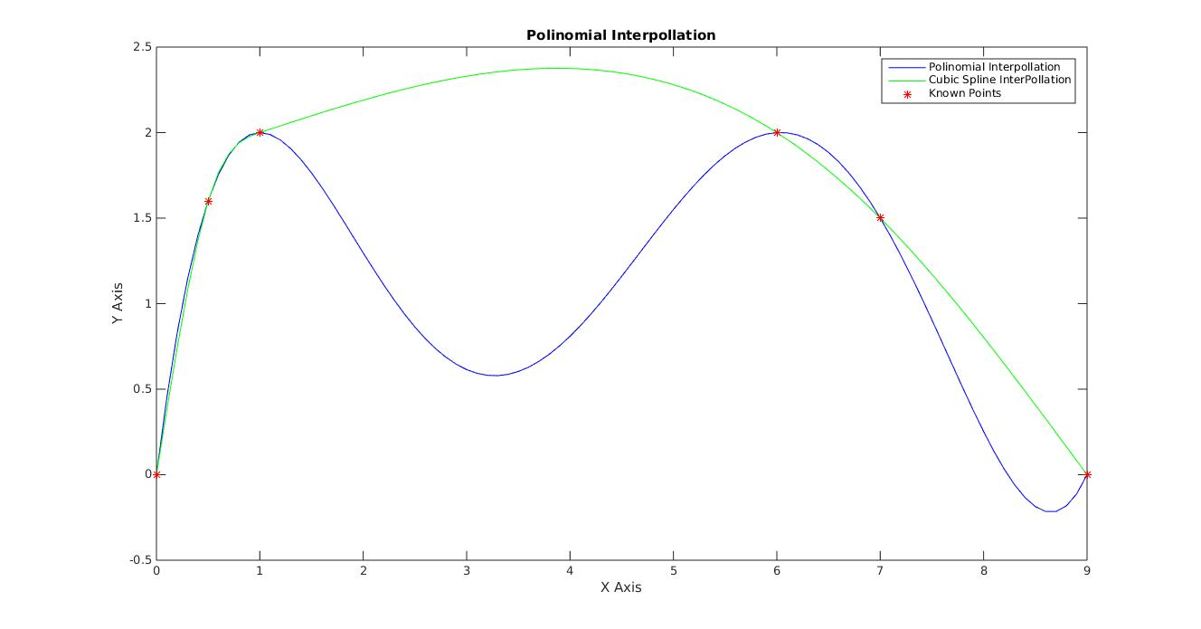
c)
Cubic Spline interpolation gives a better approximation of the required funtion than monomial interpolation. This is because cubic spline interpolation doesnt form unnecessary local minima's as ploted by monomial interpolation.

d)
Since many of the given data points are almost collinear, i.e., difference in slope between adjascent lines formed by adjascent points are near to zero. Hence piecewise linear interpolation will be a better choice.

Problem 8.4
Simpson rule is used to evaluate the integrals.
a) 0.400000
b) 0.399876
c) 0.197913
d) 0.499363
e) 26.018098
f) 1.000000
g) -1.000007

Problem 8.18

Used yp = [1.0 2.7 5.8 6.7 7.5 9.9] as pertubated y.

Output

a) With Original y's derivatives at different t's:
degree=0 0.000 0.000 0.000 0.000 0.000 0.000
degree=1 1.706 1.706 1.706 1.706 1.706 1.706
degree=2 2.179 1.990 1.800 1.611 1.422 1.232
degree=3 3.156 2.111 1.494 1.304 1.543 2.209
degree=4 0.120 2.839 2.162 0.637 0.814 5.245
degree=5 -3.178 3.880 1.822 0.297 1.855 1.947

With perturbated y's(y(4) = 6.7) derivatives at different t's:
degree=0 0.000 0.000 0.000 0.000 0.000 0.000
degree=1 1.709 1.709 1.709 1.709 1.709 1.709
degree=2 2.217 2.014 1.810 1.607 1.403 1.200
degree=3 3.144 2.129 1.520 1.316 1.518 2.126
degree=4 -0.011 2.886 2.214 0.622 0.761 5.280
degree=5 -2.845 3.780 1.922 0.330 1.655 2.447
b) With Original y's derivatives at different t's:
-0.798 2.002 3.549 5.982 13.342 18.112

With Perturbated y's derivatives at different t's:
-0.716 2.084 2.858 7.024 17.504 24.564

c) With Original y's derivatives at different t's:
2.112 1.796 1.586 4.856 -1.586 -4.313

With Perturbated y's derivatives at different t's:
2.117 1.828 1.454 5.035 -1.670 -4.440
d) With Original y's derivatives at different t's:
1.000 1.272 3.535 8.644 -3.600 -9.941

With Perturbated y's derivatives at different t's:
1.000 1.395 2.951 9.953 -5.200 -12.800

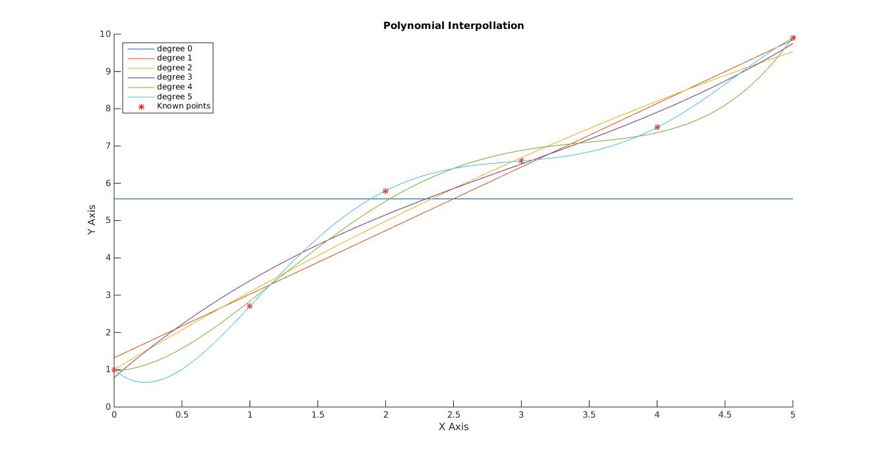
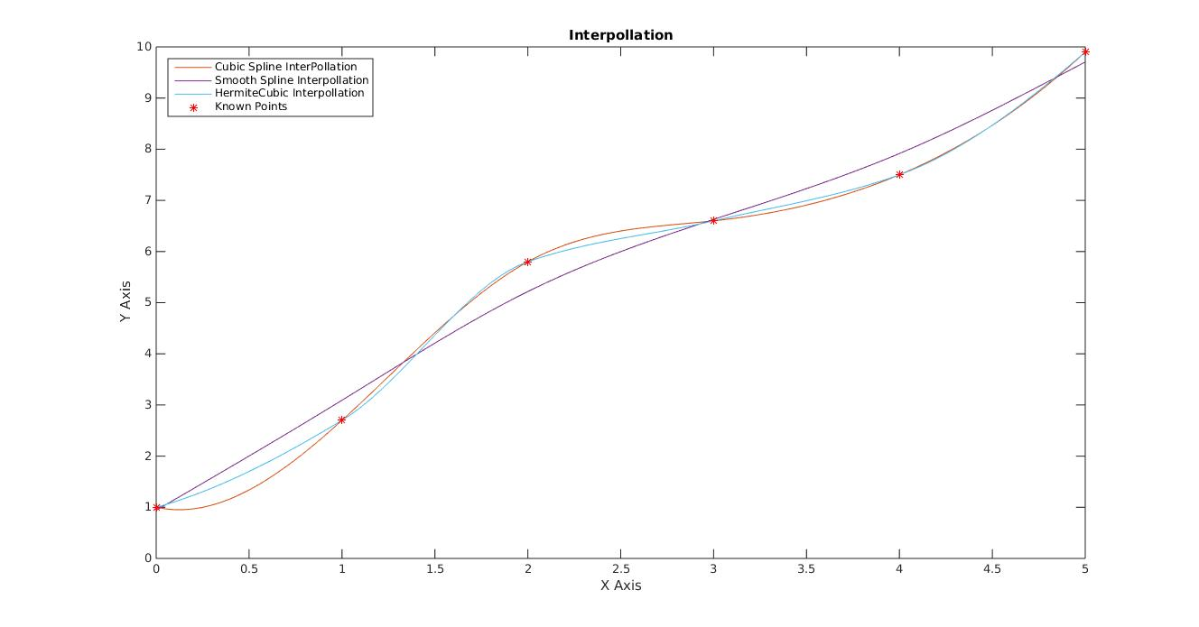

Problem CUDA 1)

The estimated time taken for each operation at different data size was noted.

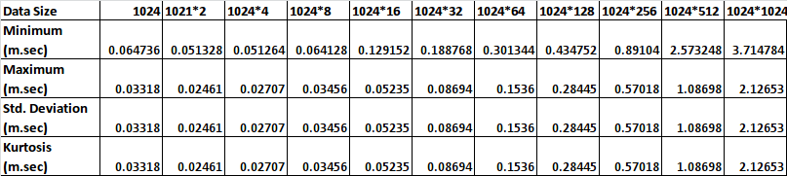
It was found that with increase in data size exponentially the execution time increases linearly.

