Programming Assignment 3

Problem 4.2:

a)

Power iteration method was used to find the dominant Eigen Vector and corresponding Eigen Value. Following result was obtained:

Dominent eigen value : 11.000000

Eigen Vector:

0.500000

1.000000

0.750000

b)

The found Eigen value was removed from matrix A by deflation. Matrix A was updated by A – xUT, where x is the dominant Eigen Vector found. U = ATek , if x is normalized so that ||x||∞ = 1 and kth component of x is 1, and ek is a vector with all 0 except for the kth position, which is 1. The output obtained:

Next Dominent eigen value: -2.000000

c)

Used Matlab to find real Eigen Values and Vectors of matrix A. The result was comparable with that found by power iteration and deflation methods.

EigenVector =

0.3714 0.0000 0.1826

0.7428 -0.5547 0.3651

0.5571 0.8321 -0.9129

EigenValue =

11.0000 0 0

0 -3.0000 0

0 0 -2.0000

Problem 4.5:

There is a large relative change in Eigen Values from the original, [ -1, 1, 0 ]. The values were found as follows:

A[3][3] = 18.95

-0.2500 0 0

0 0.2000 0

0 0 0.0000

A[3][3] = 19.05

1.4216 0 0

0 -1.3716 0

0 0 0.0000

The reason for this large relative change in Eigen values with very small perturbation in matrix A is due to the large condition number of Eigen values of matrix A. Condition numbers were found as:

55.6709

21.5928

41.7373

Problem 4.12:

1. Probability distribution vector after 3 steps is found by A3 as:

0.534700

0.277800

0.187500

1. Long term probability distribution vector is found from A∞. A was multiplied by itself until there wasn’t any significant change. The vector is:

0.450000

0.350000

0.200000

1. The long term probability distribution vector depends on a specific starting vector. Consider a case where multiple long term probability distribution vectors occur. In that case the calculated vector converges to nearest long term probability distribution vector to the starting vactor.
2. The value of limk→∞ Ak:

0.450000 0.450000 0.450000

0.350000 0.350000 0.350000

0.200000 0.200000 0.200000

Since all columns of the result are same the rank of obtained matrix is 1.

1. The matrix limk→∞ Ak has its Eigen vector [0.450000 0.350000 0.200000]T corresponding to Eigen value 1 as its columns.
2. Yes. 1 will always be an Eigen value of transition matrix of Markov Chain. This is because the Eigen vector will have the property that its components add up to 1. This will happen only if corresponding Eigen value is 1.
3. Since A is a transition matrix of Markov chain, it will have an Eigen value 1. Hence with corresponding Eigen vector, say y, we could say

Ay = λy

Since λ = 1 Ay = y

For stationary probability distribution vector to be x, Ax = x must be satisfied. Hence we could say y = x. i.e., stationary probability distribution vector is the Eigen vector corresponding to Eigen value 1 for transition matrix of Markov chain.

1. Stationary distribution vector x can be calculated by x = limk→∞ Ak \* x(0)
2. In this case previous distribution vector won’t occur. But Markov chain can have repeated distribution vectors which cycles with a period greater than 1. Such Markov chains are periodic.

Consider the example of single knight’s random walk in an empty chess board. We could form a transition matrix with all positions in board as states. Each entry (i,j) will be non-zero if there exist a possible move from i to j. The value will be 1/(total moves from i). In such case we could find that it can return to same state in multiple of 2 steps. This results in cycling of distribution vector of this Markov chain.

1. There can be more than one stationary distribution for a Markov chain. Consider the example:

1 0

A =

0 1

This has multiple stationary distribution such as [0.5 0.5]T, [0.25 0.75]T, etc.

1. This is a lot similar to power iteration method

Problem 5.6:

Convergence equation is

limk→∞ {(||ek+1||)/(||ek||r)} = c

where ek is error in value found at iteration k wrt original value

Simplifying this will result in:

r = {log((ek+1)/ek)} / {log((ek)/(ek-1))}

This equation was used in solving r and c in each case.

a) r = 1 and c = 0.5 hence it is linearly convergent.

Number of iterations required = 24

The following plot shows value with each iteration.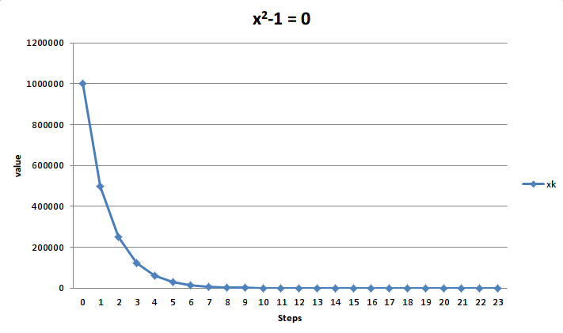

It is seen that values with large error converges faster than with those with smaller error

b) r = 1 and c = 0.75 hence it is is linearly convergent.

Number of iterations required = 52

The following plot shows value with each iteration for equation (x - 1)4 = 0.

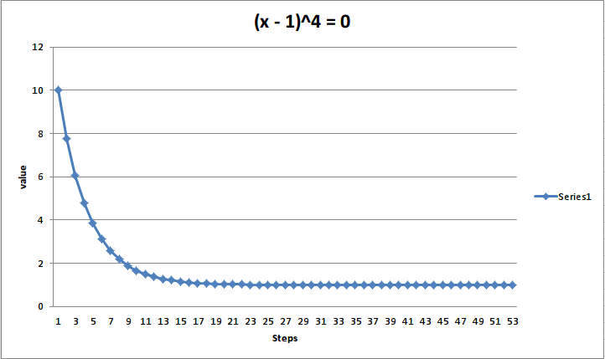

Here the plot is somewhat similar but it take comparatively longer steps get converged. This can be explained by larger value of c compared to the previous one.

Problem 5.9:

a) E was found as 1.498701 by fixed iteration

Substituting M = 1 and e = 0.5

E = M + e\*sin(E)

= 1.49870112

g’(E) = e\*cos(E)

Substituting calculated E

g’(E) = 0.036

Since g(E) = E and g’(E) < 1 fixed point iteration is locally convergent.

b) Fixed point iteration method gives solution: 1.498701

c) Newton’s method resulted in: 1.498701

d) Used Matlab to solve this using zero finder library function.

value =

1.4987