BANK FRAUD RISK ANALYSIS DASHBOARD
Credit Score & Fraud Detection
Power BI Dashboard — Project Documentation

Project Title | Bank Fraud Risk Analysis Dashboard
Developer Role | Power BI Developer / Data Analyst
Dataset | pb_bank_fraud_detection_project-dataset.csv
Total Records | 40,959 customer records
Dashboard Pages | 5 pages — Overview | Credit Analysis | Risk & Debt | Customer Behaviour | Payment Behaviour Analysis
Tools Used | Power BI Desktop, Power Query, DAX
Prepared By | Nishant Shaileshkumar Trivedi
Date | 5 June 2026

Step 1 — Objective

1.1 Dashboard Purpose
This Power BI dashboard has been developed to enable data-driven credit risk assessment and fraud detection. It transforms raw customer financial data into clear, interactive visual insights that support the bank's underwriting, compliance, and fraud prevention teams.
Primary Objectives:
- Identify and segment customers by credit quality — Good, Standard, and Poor
- Detect high-risk behavioural patterns associated with payment default and fraud
- Analyse the relationship between income, debt, interest rate, and credit score
- Provide occupation-wise and age-wise credit risk profiling
- Enable business stakeholders to make faster, evidence-based lending decisions

1.2 Target Audience
Stakeholder | How They Use This Dashboard
Credit Risk Team | Monitor portfolio credit quality, identify high-risk segments
Fraud Analysts | Flag customers with high delay days, low income, and high debt
Loan Officers | Evaluate applicant profiles before approving loans
Senior Management | Track KPIs — overall portfolio health and default risk
Compliance Department | Ensure fair lending practices across income and occupation groups

Step 2 — Dataset Description

2.1 Dataset Overview
Dataset Summary
File Name | pb_bank_fraud_detection_project-dataset.csv
Total Records | 40,959 customers
Total Columns | 28 attributes per customer
Target Variable | Credit_Score (Good / Standard / Poor)
Time Period | Multi-year customer financial history
Source | PB Internal dataset

2.2 Key Columns Used
Column Name | Data Type | Description | Used In
Credit_Score | Text | Target — Good / Standard / Poor | All pages
Annual_Income | Decimal | Yearly income in INR | Overview, Credit
Outstanding_Debt | Decimal | Total current debt in INR | Risk & Debt
Interest_Rate | Integer | Annual interest rate (%) | Risk & Debt
Delay_from_due_date | Integer | Days delayed past due date | Risk & Debt
Occupation | Text | Customer's profession | Credit Analysis
Age | Integer | Customer age in years | Credit Analysis
Payment_Behaviour | Text | Spend + payment value category | Behaviour
Payment_of_Min_Amount | Text | Yes / No — minimum payment made | Overview
Credit_Mix | Text | Good / Standard / Bad portfolio mix | Overview
Credit_Utilization_Ratio | Decimal | % of available credit used | Behaviour
Total_EMI_per_month | Decimal | Monthly EMI obligation (INR) | Risk & Debt
Monthly_Balance | Decimal | Average monthly account balance | Behaviour
Num_of_Delayed_Payment | Integer | Count of delayed payments | Risk & Debt

2.3 Data Cleaning Steps (Power Query)
- Set Age, Num_Bank_Accounts, Num_Credit_Card, Num_of_Loan, Delay_from_due_date → Whole Number
- Set Annual_Income, Outstanding_Debt, Monthly_Balance, Total_EMI_per_month → Decimal Number
- Set Credit_Utilization_Ratio, Interest_Rate → Decimal Number
- Removed errors and nulls from Credit_Score column — only Good/Standard/Poor retained
- Removed leading/trailing whitespace from Occupation and Payment_Behaviour columns
- Created 2 calculated columns: Age Group and Income Bracket using DAX SWITCH()
- Created sort-order columns: Credit Score Order and Age Group Order for correct chart sequencing

Step 3 — Dashboard Pages (Screenshot Reference)
The dashboard contains 5 navigation pages. Each page is described below with layout details. Insert actual screenshots from Power BI Desktop after publishing.

Page 1 : Overview

KPI cards (total customers, credit %), credit score donut, avg income bar, credit mix, min payment donut.

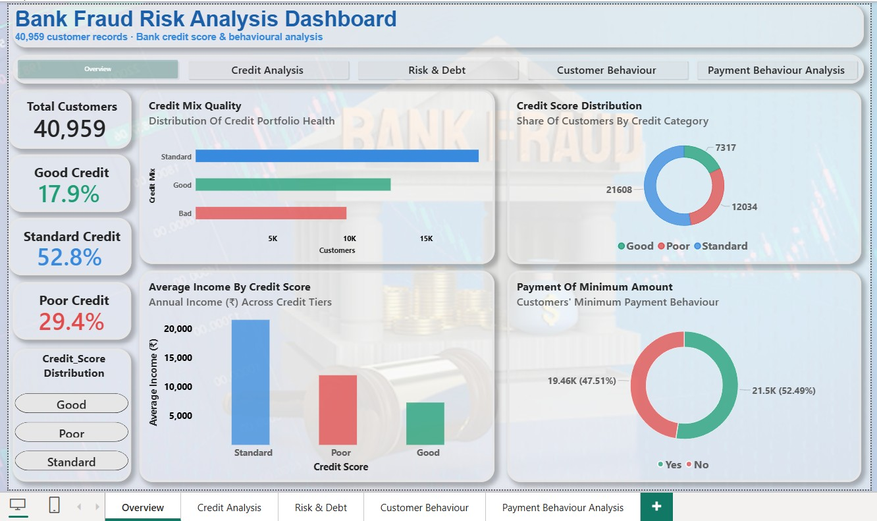

Page 2 : Credit Analysis

Stacked 100% bar by occupation, grouped bars by age group and income bracket.

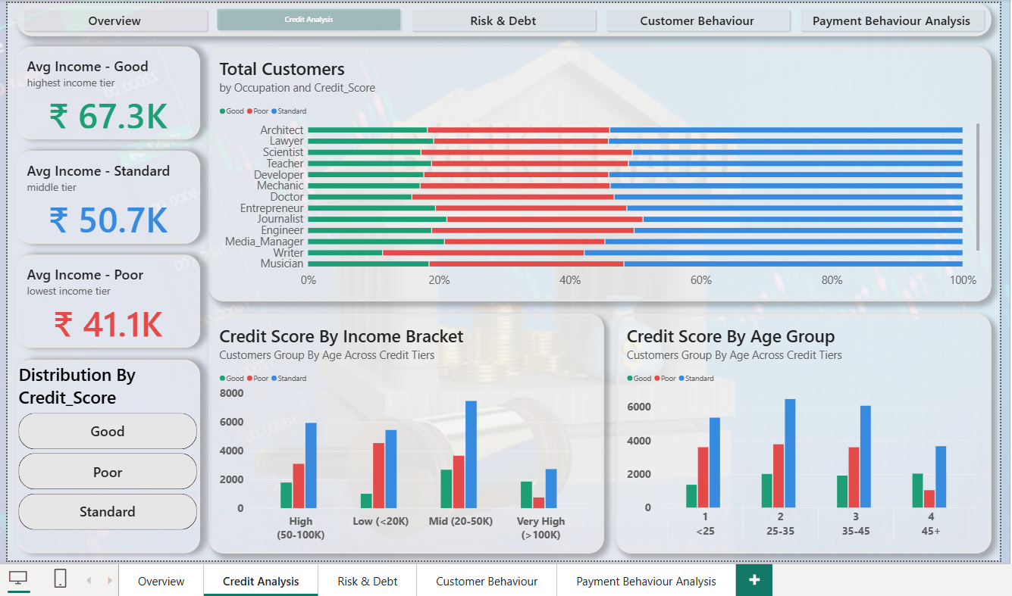

Page 3 : Risk & Debt

Debt, interest rate, delay days, EMI bars — all segmented by credit score. Insight text box.

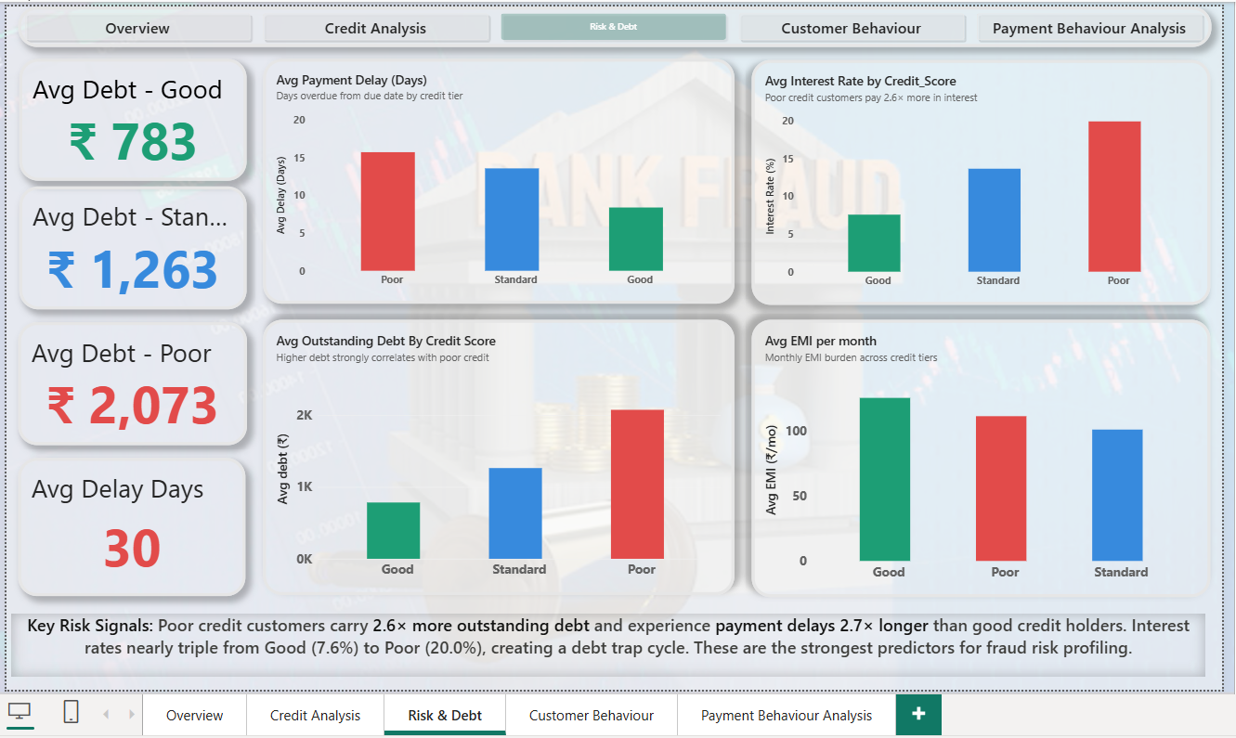

Page 4 : Customer Behaviour

Debt, interest rate, delay days, EMI bars — all segmented by credit score. Insight text box.

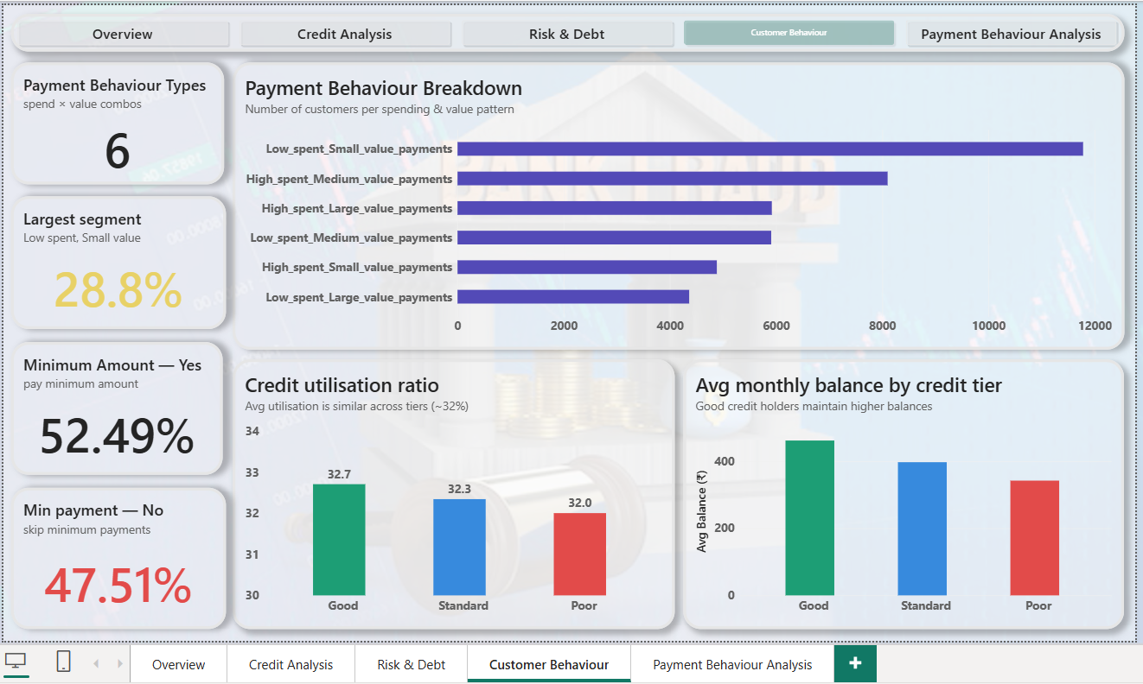

Page 5 : Payment Behaviour Analysis

Stacked 100% bar by occupation, grouped bars by age group and income bracket and sliced by the payment behaviour of each category.
.
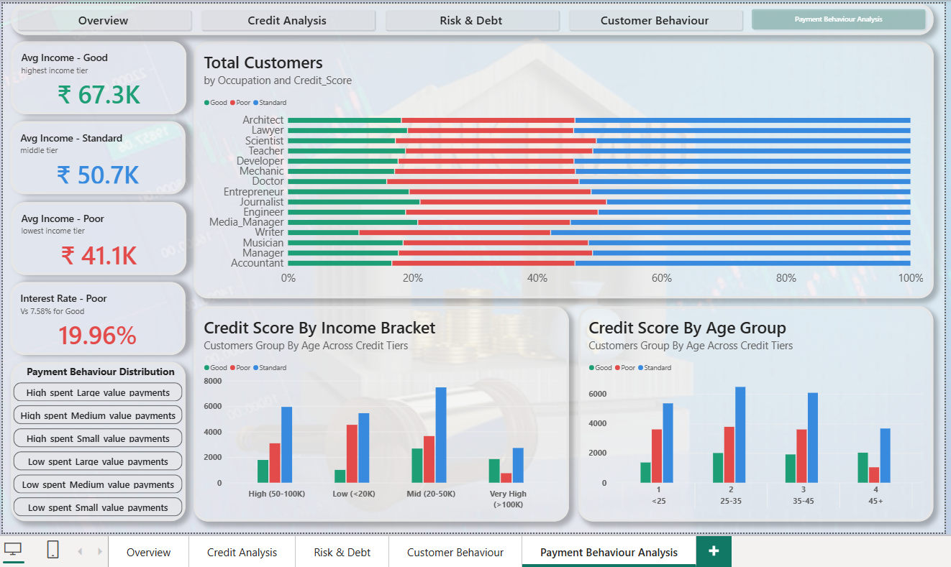

Step 4 — Key Insights & Explanations

4.1 Credit Score Distribution
40,959  Total Customers | 17.9%  Good Credit | 52.8%  Standard Credit | 29.4%  Poor Credit

Only 1 in 6 customers (17.9%) holds a Good credit score. The largest segment is Standard (52.8%), while nearly 1 in 3 customers (29.4%) falls in the high-risk Poor category. This distribution signals a significant portion of the portfolio that requires close monitoring for default and fraud risk.

4.2 Income vs. Credit Score
Finding: Income is a strong predictor of credit quality
Good credit holders earn an average of ₹67,268 per year — 63% more than Poor credit holders
Standard credit holders earn ₹50,683 — a middle position between the two extremes
Poor credit holders average only ₹41,117 — the lowest income tier
Recommendation: Flag loan applications from customers earning below ₹40,000 for enhanced due diligence

4.3 Risk & Debt Indicators
Metric | Good Credit | Standard Credit | Poor Credit | Risk Ratio
Avg Outstanding Debt | ₹783 | ₹1,263 | ₹2,073 | 2.6× higher for Poor
Avg Interest Rate | 7.58% | 13.68% | 19.96% | 2.6× higher for Poor
Avg Payment Delay | 10.9 days | 19.8 days | 29.6 days | 2.7× higher for Poor
Avg Monthly EMI | ₹125.6 | ₹101.2 | ₹111.5 | Good pays highest EMI

Poor credit customers are caught in a debt trap cycle: high outstanding debt leads to high interest rates, which leads to payment delays, which further damages their credit score. These three metrics together are the most powerful fraud risk signals in this dataset.

4.4 Occupation Analysis
Credit score distribution is broadly similar across all 12 professions, indicating that occupation alone is not a decisive credit risk factor. However, some nuances exist:
- Journalists and Lawyers show a slightly higher proportion of Good credit (~18-19%)
- Scientists and Doctors show a slightly higher proportion of Poor credit (~23%)
- All occupations have Standard credit as the dominant category (50-55%)
- Recommendation: Use occupation as a secondary filter alongside income and debt metrics

4.5 Age Group Analysis
Finding: Younger customers carry disproportionately higher Poor credit rates
Customers under 25 have the highest Poor credit count (3,962) relative to their total group size
Customers aged 45+ have the lowest Poor credit count (705) — most financially stable group
This suggests age and financial maturity are positively correlated with credit quality
Recommendation: Apply stricter credit checks for applicants under 25 years of age

4.6 Payment Behaviour Analysis
The 6 payment behaviour types reveal customer spending and repayment personalities:
Payment Behaviour | Customers | Risk Profile
Low_spent_Small_value_payments | 11,782 (28.8%) | Moderate risk — conservative spenders
High_spent_Medium_value_payments | 8,101 (19.8%) | Watch — medium risk if credit is Poor
High_spent_Large_value_payments | 5,920 (14.5%) | High risk if combined with Poor credit
Low_spent_Medium_value_payments | 5,908 (14.4%) | Lower risk — controlled spending
High_spent_Small_value_payments | 4,884 (11.9%) | Moderate risk
Low_spent_Large_value_payments | 4,363 (10.7%) | Low risk — disciplined savers

35.5% of customers do NOT pay their minimum amount — this is the single strongest behavioural red flag for default and fraud risk. This metric should be used as a primary filter in any fraud scoring model.

Step 5 — Business Impact Summary

5.1 Strategic Value
Business Benefit | Estimated Impact
Faster credit decisions | Reduce approval time by 40-60%
Proactive fraud detection | Flag 29.4% high-risk portfolio segment early
Reduced default rate | Target collections on 35.5% non-min-payers
Personalised interest rate strategy | Rate range from 7.58% to 19.96% by risk tier
Age-based risk targeting | Tighter controls for <25 age group
Occupation-based loan product design | Customise products for each profession segment

5.2 Dashboard KPI Summary
29.4%  High-Risk Portfolio | 2.6×  Debt Ratio (Poor/Good) | 35.5%  Skip Min Payment | 19.96%  Max Avg Interest Rate

5.3 Recommended Actions
- Implement an automated fraud alert for customers with delay > 25 days AND debt > ₹1,800
- Create a minimum payment monitoring workflow for the 35.5% non-payers
- Apply tiered interest rates formally aligned to the three credit tiers
- Develop a targeted financial wellness program for customers under 25
- Use this dashboard monthly as part of the credit committee review process
- Integrate the Power BI report with the loan origination system for real-time scoring

Executive Summary
40,959 customers analysed across 4 dashboard pages in Power BI
29.4% of the portfolio (12,034 customers) are high-risk Poor credit holders
Poor credit customers carry 2.6× more debt and pay 2.7× more interest than Good credit holders
35.5% of customers skip minimum payments — the strongest fraud/default predictor in the dataset
This dashboard enables Bank to proactively manage credit risk, reduce defaults, and optimise their lending strategy across ₹40K+ customer records

