6G Wireless Networks: A Technical Study
By Nishant Tyagi (Jan 2026)

Abstract
The sixth generation of mobile communication (6G) is currently in its pre-normative study phase within 3GPP Release 20, under the overarching International Telecommunication Union (ITU-R) IMT-2030 framework. This study examines what 6G is, how it differs from 5G, and — with particular attention to the needs of UE and eNodeB/gNB test engineering — the technical foundations most likely to shape conformance, interoperability, and validation work over the coming standardization cycle. The study draws on ITU-R recommendations, 3GPP technical reports, O-RAN Alliance specifications, and current industry and academic literature. It finds that while 6G retains much of 5G's layered protocol architecture and RU/DU/CU-based radio access network design, it introduces several genuinely new testable surfaces: native artificial-intelligence (AI) integration in the air interface, integrated sensing and communication (ISAC), ambient/zero-energy Internet of Things (IoT) devices, and an expanded spectrum footprint reaching into the upper mid-band and sub-terahertz range. The study concludes with an overview of the application use cases driving these requirements and the current state of 3GPP standardization.

1. Introduction: What Is 6G?
6G is the sixth generation of mobile communication technology, and as of mid-2026 it remains in 3GPP's pre-normative study phase (Release 20), expected to run until approximately June 2027, with the first normative specifications anticipated in Release 21. Unlike 5G, whose principal design pillars were relatively well established early in its development, 6G's detailed technical content is still being actively debated across 3GPP working groups. Nonetheless, a set of recurring themes has emerged with reasonable consistency across the International Telecommunication Union's IMT-2030 framework, 3GPP study items, and industry research.
Three pillars are repeatedly emphasized. The first is an extreme increase in achievable data rate, targeting terabit-per-second-class peak throughput through the exploitation of new spectrum — principally the upper mid-band (3GPP's Frequency Range 3, or FR3) and the sub-terahertz range above existing millimeter-wave allocations. The second is a shift toward AI-native network design, in which artificial intelligence and machine learning are embedded as foundational elements of the air interface and network management rather than layered on afterward, as has largely been the case in 5G-Advanced. The third is Integrated Sensing and Communication (ISAC), in which the radio access network doubles as a sensing instrument — detecting, locating, and tracking objects in its environment using largely the same waveforms and hardware already deployed for communication.
No normative 6G specification exists at the time of writing. 3GPP's RAN1 working group is still actively studying whether the physical layer should retain an OFDM-like waveform, modify it, or adopt something new — a decision with direct downstream implications for RF and protocol test-tool design. The Release 21 timeline is expected to be finalized no later than June 2026, and commercial deployment is broadly targeted for the 2028–2030 window, aligned with the ITU-R's own IMT-2030 timeline.

2. From 5G to 6G: Evolutionary Drivers and Key Differences

2.1 Why 6G: Limitations of 5G
Several limitations of the current 5G system motivate 6G's development. First, existing sub-6 GHz and millimeter-wave spectrum, combined with today's MIMO and channel-coding techniques, is approaching diminishing returns for further capacity gains without access to new frequency bands. Second, artificial intelligence in 5G-Advanced remains fundamentally an add-on capability — for example, the two-sided AI models used for channel state information (CSI) feedback enhancement in 3GPP TR 38.843 — layered onto an air interface that was itself designed without AI as a first-order consideration. Third, 5G was never designed with native sensing in mind; any radar-like functionality must be retrofitted rather than co-designed alongside communication. Fourth, 5G network operations continue to depend substantially on human-configured policy and reactive troubleshooting rather than closed-loop, predictive automation. Finally, several emerging application classes — fully immersive holographic telepresence, industrial tactile control, and terabit-scale bulk data transfer — exceed the practical latency and throughput envelope that 5G's Ultra-Reliable Low-Latency Communication (URLLC) and Enhanced Mobile Broadband (eMBB) service classes were designed to deliver.

2.2 The Shift Toward AI-Native, Distributed Intelligence
Where 5G treats AI/ML as an optional enhancement to specific, narrowly scoped functions, 6G proposes distributing intelligence throughout the network rather than concentrating it in a small number of centralized locations. Building on the O-RAN Alliance's RAN Intelligent Controller (RIC) model — which already separates near-real-time control applications (xApps) from non-real-time optimization applications (rApps) — 6G envisions AI inference and decision-making occurring simultaneously at multiple tiers: on the device itself, at the radio access network edge, in regional edge cloud infrastructure, and in the centralized core. Each tier is expected to handle decisions at the timescale and data locality appropriate to it, with millisecond-scale beam-management decisions handled at the edge and longer-horizon capacity planning handled centrally. This distributed model is what makes closed-loop, intent-based network automation feasible at the scale 6G envisions.

2.3 Integration of Sensing, Communication, and Control
Beyond ISAC's core convergence of sensing and communication, a further integration step under active research closes the loop with control systems directly — for example, a factory robot adjusting its path in response to network-derived object detection, or a vehicle receiving a network-sensed hazard warning without a human or a separate, slower system mediating the response. This sensing–communication–control triad recurs throughout the industrial automation and autonomous mobility use cases discussed in Section 4, and depends on the ultra-low, deterministic latency described in Section 3.

2.4 Summary of Key Differences
Table 1 summarizes the principal quantitative and architectural differences between 5G and the current 6G research direction. These figures should be read as targets under active study rather than finalized specification values; the ITU-R explicitly treats them as evaluation targets of equal priority rather than fixed thresholds each use case must meet.
Aspect | 5G (current) | 6G (target direction)
Peak data rate | Up to ~20 Gbps (mmWave) | Terabit-per-second class, via FR3 and sub-THz spectrum
Air-interface latency | ~1 ms (URLLC) | 0.1–1 ms; sub-millisecond for tactile/haptic use cases
Reliability | 10⁻⁵ (typical) | 10⁻⁵ to 10⁻⁷
Connection density | 10⁶ devices/km² | 10⁶–10⁸ devices/km²
Positioning accuracy | Meter-level (typical) | 1–10 cm target
AI/ML role | Add-on (e.g., CSI feedback, TR 38.843) | Native across air interface and orchestration
Sensing | Not natively supported | ISAC — near-term target: UAV detection via gNB
Architecture | CU/DU/RU split, O-RAN 7.2x | Same split extended; cell-free MIMO, AI-RAN compute convergence
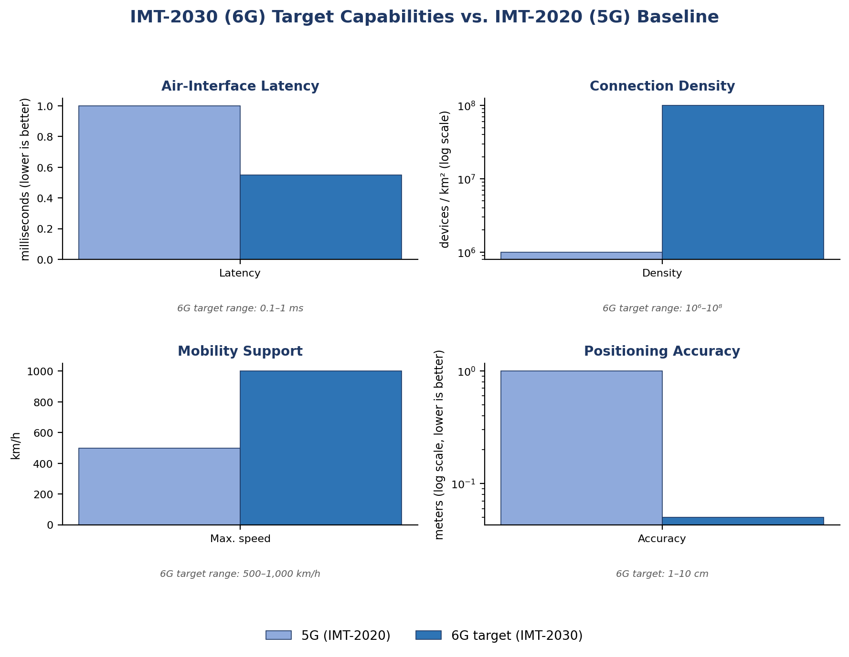
Figure 1. IMT-2030 target capabilities plotted against the IMT-2020 (5G) baseline for four representative KPIs. Note the logarithmic scale used for connection density and positioning accuracy.

2.5 IMT-2030 Usage Scenarios
The ITU-R's IMT-2030 framework organizes 6G around six usage scenarios, three of which are direct evolutions of the three IMT-2020 (5G) usage scenarios and three of which are entirely new. Enhanced Mobile Broadband (eMBB) evolves into Immersive Communication, extending high-data-rate broadband toward fully immersive experiences such as virtual and augmented reality. Massive Machine-Type Communication (mMTC) evolves into Massive Communication, scaling IoT connectivity to even larger device densities. Ultra-Reliable Low-Latency Communication (URLLC) evolves into Hyper-Reliable and Low-Latency Communication (HRLLC), pushing reliability and latency requirements further for mission-critical applications such as remote surgery and autonomous systems.
The three new scenarios have no direct 5G predecessor. Ubiquitous Connectivity aims to deliver reliable, high-quality connectivity to underserved and remote regions rather than concentrating capacity in dense urban areas. AI and Communication integrate artificial intelligence within the network infrastructure itself to optimize operations and personalize services. Integrated Sensing and Communication, discussed in detail in Section 3.7, uses the communication infrastructure as a sensing instrument in its own right. Figure 2 illustrates the relationship between the three evolved and three new scenarios.
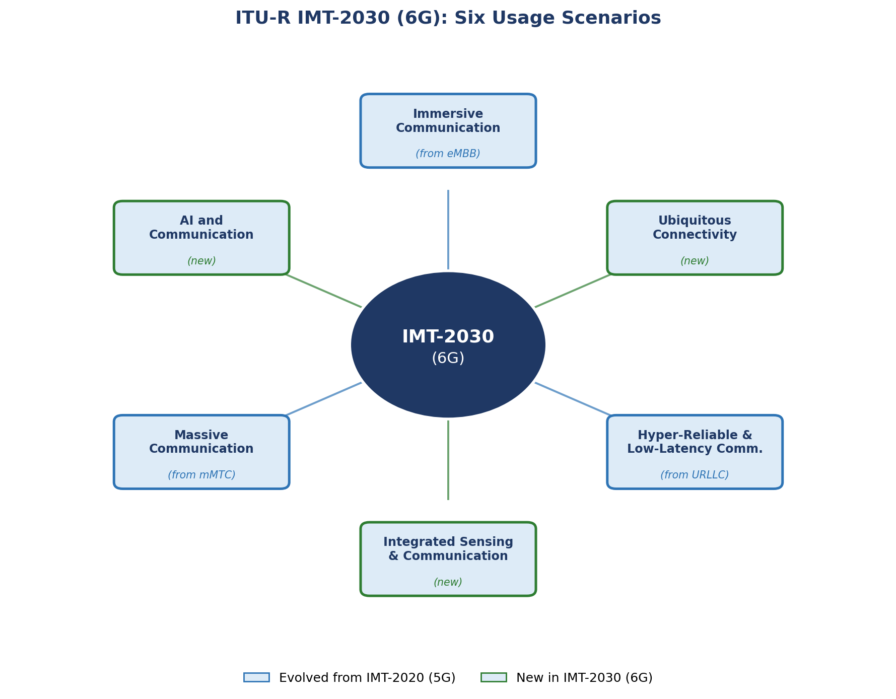
Figure 2. The six IMT-2030 usage scenarios: three evolved from IMT-2020 (5G) service classes and three newly introduced for 6G. Reconstructed from the ITU-R IMT-2030 usage-scenario framework (Recommendation M.2160).

3. Technical Foundations Relevant to Test Engineering
This section addresses the technical detail most directly relevant to UE and eNodeB/gNB test and validation planning, organized from the protocol stack outward through the radio access network architecture, spectrum, and the newer capabilities — ISAC, AI-native air interface, and ambient IoT — that introduce genuinely new test dimensions beyond conventional RF and protocol conformance testing.

3.1 Protocol Architecture
6G is expected to retain the layered radio protocol architecture established in 5G: the Radio Resource Control (RRC) layer handling connection setup, mobility, and configuration signaling; the Service Data Adaptation Protocol (SDAP) mapping Quality-of-Service flows onto Data Radio Bearers, directly relevant to network-slicing validation; the Packet Data Convergence Protocol (PDCP) handling ciphering, integrity protection, header compression, and sequencing; the Radio Link Control (RLC) layer handling segmentation and automatic repeat request; the Medium Access Control (MAC) layer handling scheduling, hybrid ARQ, and logical-channel multiplexing; and the physical layer (PHY) handling waveform generation, coding, and modulation. RAN1 and RAN2 study items are evaluating incremental evolution of this stack — new waveform and frame-structure options at the physical layer, AI/ML hooks introduced at the MAC and RLC layers — rather than a clean-slate redesign. This continuity is a meaningful consideration for planning the reuse of existing protocol-analyzer and test-tool infrastructure.

3.2 Physical-Layer Research Areas
3GPP's RAN1 working group has organized its Release 20 physical-layer study around thirteen principal areas: waveform and numerology (whether OFDM is retained, modified, or replaced); frame structure; downlink and uplink physical channel design (successors to PDSCH, PUSCH, PDCCH, PUCCH, and PBCH); reference and synchronization signal design, which must now also support channel estimation, beam management, CSI acquisition, positioning, and sensing simultaneously; initial and random access procedures; MIMO, beamforming, and CSI feedback, including distributed and cell-free MIMO architectures; mobility support at the physical layer, particularly for high-frequency, beam-based deployments; duplexing and spectrum aggregation, including flexible and full-duplex operation; AI/ML application to air-interface functions such as beam management and channel prediction; ISAC feasibility for range, velocity, and angle estimation; energy efficiency and reduced-complexity operation; and scalable UE design across device tiers from high-end broadband devices to low-power, low-complexity devices. A further, foundational study area — evaluation methodology — defines the common simulation assumptions used to compare competing technical proposals, and is worth tracking early since it determines the channel models, deployment scenarios, and KPI measurement definitions that later conformance and interoperability specifications will inherit.

3.3 Radio Access Network Architecture
The base station function split established in 5G — dividing the gNB into a Radio Unit (RU) handling RF front-end and lowest physical-layer functions at the cell site, a Distributed Unit (DU) handling upper physical-layer, MAC, and RLC functions at or near the cell site, and a Centralized Unit (CU) handling PDCP, SDAP, and RRC functions in regional cloud infrastructure — is expected to carry forward into 6G with further extension. The most common RU–DU functional split in current deployments, the O-RAN Alliance's 7.2x split, keeps RF and the lowest physical-layer functions at the RU while moving digital beamforming, channel coding, and modulation/demodulation to the DU.
Around this radio architecture, the O-RAN Alliance defines open, standardized interfaces enabling multi-vendor interoperability: a RAN Intelligent Controller (RIC) hosting near-real-time control applications and non-real-time optimization applications; a Service Management and Orchestration (SMO) layer coordinating configuration across the RU, DU, CU, and RIC; and an O-Cloud compute platform, typically built on Kubernetes-based container orchestration, hosting the DU and CU software functions. The AI-RAN Alliance's more recent proposal extends this further by co-hosting radio access network processing and AI inference workloads on shared accelerated compute infrastructure, collapsing the traditional operational boundary between radio infrastructure and AI/edge compute infrastructure. An architectural variant under active 6G research — cell-free, or user-centric, MIMO — lets many distributed RUs jointly serve a device simultaneously rather than assigning it to a single serving cell, eliminating hard cell boundaries and the handover overhead associated with them; this has direct implications for handover test design, since conventional single-serving-cell handover test cases do not directly translate to a cell-free deployment. No single, formally agreed end-to-end 6G reference architecture yet exists: 3GPP's system architecture study (TR 23.801-01) is targeting roughly 80 percent completion by mid-2026, with a final freeze expected by September 2026.
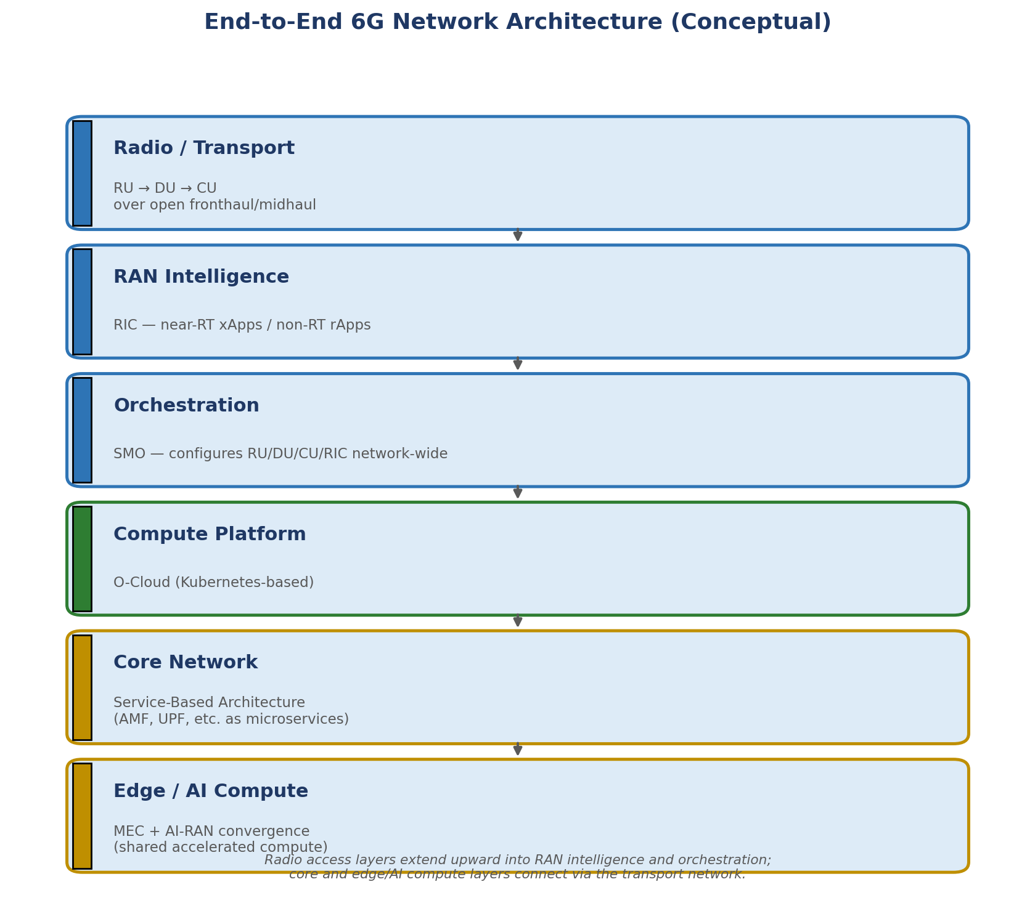
Figure 3. Conceptual end-to-end 6G network architecture, from the radio/transport layer through RAN intelligence, orchestration, compute, core, and edge/AI layers.
Table 2 collects several further architectural and radio features that distinguish current 6G research direction from 5G, beyond those already summarized in Table 1.
Feature | 5G | 6G (research direction)
Duplexing | TDD / FDD, fixed per band | TDD/FDD retained; flexible and in-band full-duplex under study
MIMO | Massive MIMO, single/multi-cell | Extreme massive MIMO; cell-free/distributed MIMO; movable-antenna concepts
Fronthaul interface | eCPRI over Ethernet (from CPRI) | Same base; tighter TSN/deterministic transport integration
Device power model | Battery-powered UE classes (eMBB/URLLC/mMTC) | + Ambient/zero-energy backscatter devices (no battery)
Coverage extension | Small cells, repeaters | + Reconfigurable Intelligent Surfaces (passive, no amplifier)
Non-terrestrial access | 5G NTN as an add-on extension | Tighter integration; direct handset-to-satellite
Security model | Perimeter-based + service-based core security | Zero-trust architecture; post-quantum cryptography under study

3.4 Transport, Fronthaul, and Timing Synchronization
The connection between the RU and DU — the fronthaul — has historically been the most bandwidth- and timing-sensitive segment of the transport network, since it may carry raw or lightly processed radio samples. The original Common Public Radio Interface (CPRI), developed in 2003, carries digitized radio samples over a dedicated, constant-bitrate time-division-multiplexed fiber link; it is simple but inefficient, reserving peak capacity at all times and scaling poorly with massive MIMO's much larger number of antenna streams. The enhanced Common Public Radio Interface (eCPRI), introduced in 2017, replaces this with a packet-based interface over standard Ethernet or IP, reducing fronthaul bandwidth requirements roughly tenfold by transmitting compressed IQ data and essential control information rather than a constant raw sample stream, and by supporting more efficient lower-layer functional splits. As 6G moves toward denser small-cell deployments and cloud-native radio access network design, fronthaul is expected to integrate more tightly with Time-Sensitive Networking and other deterministic Ethernet/IP mechanisms, allowing fronthaul, midhaul, and general data-center traffic to share a common transport fabric.
Precise timing underpins all of this: without it, distributed radio units cannot coordinate transmissions, measure distances for positioning or sensing purposes, or hand over users cleanly between cells. Three complementary mechanisms are used together. The IEEE 1588 Precision Time Protocol (PTP) distributes precise time-of-day and phase information across a packet network, using boundary and transparent clocks at intermediate switches to minimize the timing error introduced at each hop. Synchronous Ethernet (SyncE) distributes an accurate frequency reference — not absolute time — through the Ethernet physical layer itself, improving PTP's own accuracy by providing a clean, low-wander frequency baseline. Global Navigation Satellite System (GNSS) receivers commonly serve as the ultimate, highly accurate time source feeding into the PTP hierarchy; because GNSS signals can be jammed, spoofed, or blocked indoors, resilient deployments typically include holdover capability so that a cell site can maintain accurate timing for a period even without satellite reception. Distributed radio units in a coordinated deployment — cooperating cell-free MIMO nodes, or ISAC sensing nodes that must jointly localize a target — typically require timing alignment within a few microseconds of one another, which drives the need for hardened, redundant timing architectures with automatic failover if a primary timing source is lost.

3.5 Spectrum Landscape
6G is expected to operate across a considerably broader and more layered spectrum landscape than 5G. Existing 5G Frequency Range 1 (FR1, roughly 410 MHz to 7.125 GHz) continues to provide the core coverage and capacity backbone, and existing Frequency Range 2 (FR2, 24.25 to 52.6 GHz) continues to provide high-capacity hotspot coverage. The principal new layer for 6G is Frequency Range 3 (FR3), spanning approximately 7.125 to 24.25 GHz, with the sub-band around 7.125 to 13.25 GHz particularly favored as a near-term “golden band” offering a strong balance of coverage and capacity. Beyond FR3, industry literature has begun using informal FR4, FR5, and FR6 designations — spanning roughly 71 to 330 GHz and encompassing the W-, D-, G-, and H/J-bands — though these are not yet formally agreed 3GPP or ITU-R terminology, and their numeric boundaries vary somewhat between sources. This heuristic reflects a widely cited industry rule of thumb: each mobile generation has historically required roughly five times more usable spectrum than its predecessor to deliver its targeted capacity gains, a figure existing sub-6 GHz and mmWave allocations alone cannot supply for 6G.
Regulatory harmonization proceeds in parallel with the technical work. The World Radiocommunication Conference of 2023 (WRC-23) identified portions of the 6425–7125 MHz range for International Mobile Telecommunications (IMT) use in several regions, and flagged several sub-terahertz ranges of interest for future study. The ITU-R's 2024 Report M.2541 confirmed the technical feasibility of IMT operation above 100 GHz. The upcoming WRC-27 is expected to study further upper mid-band candidates. Sub-terahertz deployment nonetheless faces a distinct cluster of engineering challenges beyond simple propagation loss: strict line-of-sight dependency requiring dense small-cell deployment or reflective intelligent surfaces; unfavorable local-oscillator phase-noise scaling; reduced power-amplifier efficiency at high frequencies; fast, fine-grained beamforming requirements; amplified Doppler sensitivity; and channel models that require extension beyond their original sub-100 GHz validation range.
Table 3 summarizes the frequency ranges relevant to 6G alongside their current standardization status.
Range | Approx. frequency | Status
FR1 (sub-6) | 410 MHz – 7.125 GHz | Existing 5G coverage/capacity band; carries forward unchanged
FR2 (mmWave) | 24.25 – 52.6 GHz | Existing 5G high-capacity band; carries forward unchanged
FR3 (upper mid-band) | 7.125 – 24.25 GHz | New for 6G; leading “golden band” candidate, ~7.125–13.25 GHz favored
FR4 (informal) | 71 – 114.25 GHz | Research stage; W-band; not yet official 3GPP/ITU-R terminology
FR5 (informal) | 114.25 – 275 GHz | Research stage; D-band/G-band
FR6 (informal) | 275 – 330 GHz | Research stage; H/J-band, edge of recognized sub-THz range
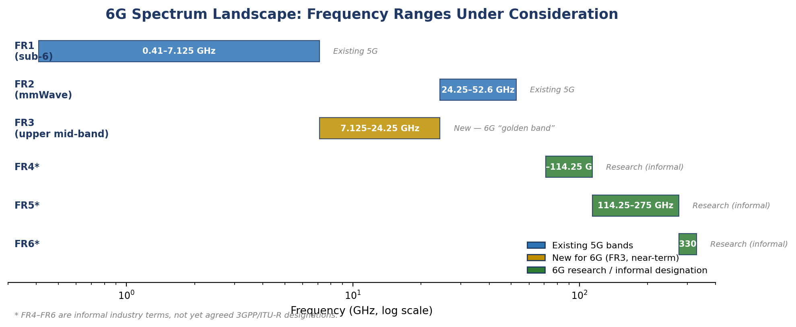
Figure 4. 6G spectrum landscape shown on a logarithmic frequency scale, spanning existing 5G allocations (FR1–FR2) through the near-term FR3 upper mid-band and the longer-horizon FR4–FR6 sub-terahertz research bands.

3.6 Performance Targets
The IMT-2030 framework's headline performance targets — summarized in Table 1 — span latency, reliability, mobility, connection density, and positioning accuracy. What is arguably more consequential for test planning than the specific numeric targets is the introduction of entirely new KPI categories that did not exist as first-class metrics in the IMT-2020 (5G) framework: sensing accuracy, AI/ML model performance and inference latency, positioning accuracy at centimeter scale, and energy efficiency per bit. In this sense, 6G's KPIs represent an evolutionary extension along familiar axes and a more revolutionary expansion along the new axes introduced by native sensing and AI.
Latency in particular is not a single figure but a family of related requirements that vary by use case, summarized in Table 4.
Use case / layer | 5G | 6G target
Generic air-interface latency (URLLC) | ~1 ms | 0.1–1 ms
Tactile internet / haptic control | Not formally targeted (theoretical ~1 ms under ideal conditions) | < 1 ms round-trip; 0.1 ms in some 6G-era proposals
XR motion-to-photon latency | Tens of ms typical (5G-assisted) | < ~10 ms (cybersickness threshold)
ISAC sensing-to-application latency | Not applicable (no native sensing) | Under active study; no fixed target yet
AI/ML inference latency (CSI, beam mgmt.) | Not a tracked KPI in 5G | Emerging KPI; figures not yet standardized
Note the distinction, developed further in Section 3.12, between a low air-interface latency figure and the end-to-end latency actually experienced once transport and edge-processing delay are included — the two are frequently conflated in public 6G discussion.

3.7 Integrated Sensing and Communication
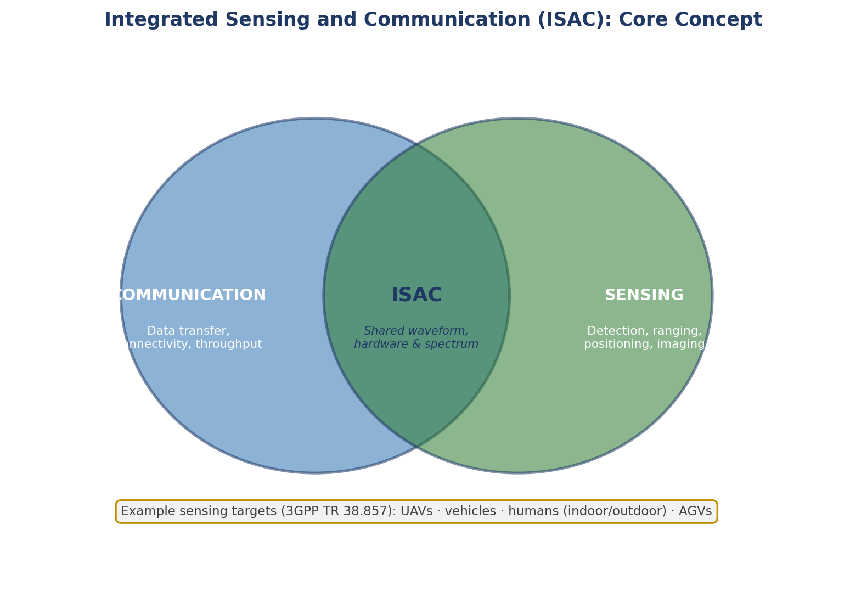
Figure 5. ISAC combines communication and sensing functions within a shared waveform, hardware, and spectrum allocation, rather than operating them as separate systems.
3GPP's Release 20 near-term ISAC target is gNB-based mono-static sensing for uncrewed aerial vehicle (UAV) detection and tracking, reusing the existing 5G downlink waveform and reference signals rather than introducing new dedicated hardware; as of the most recent RAN plenary reporting, this study item stands at roughly 58 percent completion. Responsibility is split cleanly along existing architectural lines: the radio access network handles sensing-signal transmission, measurement, and reception, while the core network handles sensing-data processing and exposes results to third-party applications through the same style of service-based interface used elsewhere in the 5G/6G core.
The foundational service-requirements work is documented in 3GPP TR 22.837, a Release 19 feasibility study that catalogs thirty-two distinct candidate use cases for wireless sensing spanning autonomous and assisted driving, vehicle-to-everything communication, UAV detection, three-dimensional map reconstruction, smart city and smart home applications, factory automation, healthcare, and maritime operations. These use cases were subsequently translated into normative Stage 1 service requirements in 3GPP TS 22.137, which defines a set of KPIs unique to sensing rather than communication: positioning accuracy, typically specified in the range of one to ten meters; velocity accuracy, typically one to ten meters per second; sensing resolution; latency; and, notably, missed-detection and false-alarm probability — the conditional probabilities of failing to detect a genuine target or erroneously reporting one that is not present — evaluated against defined thresholds at a 90 percent confidence level.
On the physical layer, RAN1's channel-modeling work (documented in TR 38.857) extends the standard 3GPP stochastic channel model of TR 38.901 with three distinct ISAC sensing topologies: base-station monostatic sensing, where the same base station both transmits and receives the sensing signal; base-station-to-UE bistatic sensing, where transmission and reception occur at different network nodes; and UE-to-UE bistatic sensing. This extended model currently covers 0.5 to 52.6 GHz, with a stated path toward extension up to 100 GHz. The model further distinguishes Sensing Targets (STs) — the objects of actual interest, principally UAVs of varying size, vehicles, humans in both indoor and outdoor settings, and automated guided vehicles in industrial settings — from Environmental Objects (EOs), non-target objects at known, typically fixed locations whose presence nonetheless affects the propagation channel and must be accounted for in accurate sensing performance evaluation.
Whether currently standardized 5G NR signal structures can, in fact, meet the accuracy thresholds specified in TS 22.137 remains an open research question rather than a settled matter: at least one recent analysis applies the Cramér–Rao lower bound to the monostatic UAV sensing scenario and finds that achievable range- and velocity-estimation accuracy is fundamentally constrained by the structure of existing standardized signals, with reference signals purpose-designed for sensing offering measurably better performance. For test and validation purposes, this points to a near-term dependency worth tracking closely: sensing accuracy, range, velocity, and angle estimation constitute a validation dimension distinct from, and potentially in resource contention with, standard communication throughput and latency, and the specific reference-signal design ultimately adopted will materially affect what accuracy is achievable in practice, not just what is specified on paper.

3.8 AI-Native Air Interface
The current basis for AI/ML in the air interface is the two-sided model framework introduced for CSI feedback enhancement in 3GPP TR 38.843, pairing a UE-side encoder with a gNB-side decoder trained together. 6G research extends this model toward beam management and channel prediction. This introduces test problems with limited precedent in prior generations: model interoperability, ensuring a UE-side model trained by one vendor functions correctly with a gNB-side model from another; and performance-validation methodology for AI-driven functions, which likely requires its own conformance framework rather than fitting neatly into existing RF and protocol test suites.

3.9 Ambient IoT and Zero-Energy Devices
Studied under 3GPP TR 38.848, TR 22.840, and TR 38.769, ambient or zero-energy devices harvest ambient energy from RF, light, or motion sources and communicate via backscatter — reflecting and modulating an existing ambient RF carrier rather than generating their own transmit signal. This eliminates the need for batteries in large classes of sensors and tags, but it also means conventional link-budget and transmit-power test methodology does not directly apply; backscatter detection sensitivity depends heavily on the burstiness and availability of the ambient illuminating carrier, so test setups require a controlled illuminator signal and a methodology for characterizing detection probability as a function of harvested-energy state rather than signal-to-noise ratio alone.

3.10 Full-Duplex Radios and Reconfigurable Intelligent Surfaces
Full-duplex radios transmit and receive simultaneously on the same time-frequency resource, roughly doubling spectral efficiency for a given link, but only insofar as the device can adequately cancel its own self-interference — a signal typically many orders of magnitude stronger than the intended received signal at the same antenna. Self-interference cancellation performance is consequently expected to become a primary measured test parameter in its own right, alongside conventional RF conformance metrics such as error vector magnitude and adjacent-channel leakage ratio. Reconfigurable Intelligent Surfaces (RIS) — passive, phase-shifting metamaterial panels that reshape incoming radio waves without generating any signal of their own — are being studied both as standalone coverage-extension elements and jointly with full-duplex systems, where a nearby RIS can help shape a self-interference-cancellation signal in the analog domain. Where a RIS is present in a test environment, channel-sounding and measurement procedures may need to log the RIS's configuration state alongside conventional RF measurements, since the propagation channel itself becomes a controllable, mid-test variable rather than a fixed background condition.

3.11 Non-Terrestrial Network Integration
6G continues 5G's non-terrestrial network extension work toward tighter integration between terrestrial and satellite, high-altitude-platform, and UAV-based coverage, including direct handset-to-satellite connectivity for unmodified consumer devices. This introduces substantially larger and more variable propagation delay and Doppler shift than terrestrial links present, and mobility/handover test cases must account for satellite-to-terrestrial and satellite-to-satellite handover scenarios in addition to conventional cell-to-cell handover.

3.12 Downlink and Uplink Throughput Expectations
It is worth distinguishing peak data rate from user-experienced data rate when interpreting 6G's headline throughput claims, since the two are frequently conflated in public discussion. Peak data rate is a link-layer theoretical ceiling achieved only under ideal conditions — the best available band, full channel bandwidth, and maximum MIMO rank — and it is this figure that gives rise to 6G's terabit-per-second-class claims, driven by the combination of FR3 and sub-terahertz bandwidth with higher-order spatial multiplexing. Where 5G's theoretical peak downlink rate reaches approximately 20 Gbps under millimeter-wave, wide-bandwidth, high-order-MIMO conditions, 6G's equivalent ceiling is expected to reach into the terabit range. User-experienced throughput, by contrast, reflects what a typical device sees in a loaded, real-world deployment, and is considerably lower than the peak figure in both generations; 5G mid-band deployments today typically deliver on the order of 100 to 900 Mbps to an individual user, and 6G's realistic target is better understood as a multi-gigabit-class typical experience rather than a routine terabit-per-second one. Actual throughput observed in any given test will depend heavily on the operating band, channel bandwidth, MIMO configuration, and cell loading — none of which are finalized for 6G at the time of writing — and test plans should track peak and user-experienced figures as distinct quantities rather than a single number.

4. Application Domains and Testing Implications
6G's technical requirements are ultimately driven by a set of application domains, each of which implies a distinct emphasis for UE and eNodeB/gNB validation work.

4.1 Extended Reality and Immersive Telepresence
Virtual-, augmented-, and mixed-reality headsets and glasses, holographic communication, and immersive remote collaboration together define one of 6G's principal use-case families, with rendering increasingly offloaded to network edge compute to keep client devices light and power-efficient. The relevant performance envelope spans motion-to-photon latency below roughly ten milliseconds, the threshold commonly associated with cybersickness; air-interface latency down to 0.1 millisecond; and bandwidth ranging from tens of megabits per second for streamed virtual reality up to multi-gigabit or terabit rates for volumetric or holographic content. For test purposes, the emphasis shifts toward jitter and latency variance under load rather than average latency alone, since extended-reality applications are highly sensitive to variability; correct behavior when discarding stale, late-arriving frames; correctness of viewport-dependent or foveated rendering offload between the device and the network edge; and capacity behavior when many simultaneous sessions compete for resources in a dense venue.

4.2 Industrial Automation and the Tactile Internet
Factory robotics, remote and teleoperated control, and haptic feedback systems together define the most demanding simultaneous latency-and-reliability combination among 6G's use cases, requiring round-trip latency below one millisecond — with a target as low as 0.1 millisecond — and reliability approaching one failure in a billion transmissions for safety-critical actuation, alongside tight synchronization across multiple concurrent data streams carrying video, audio, force, torque, and position information. Test emphasis correspondingly shifts toward end-to-end latency-budget validation spanning the full path from radio through transport to edge compute, since a low air-interface latency figure in isolation can still fail if backhaul or edge-processing delay is added back into the overall budget; synchronization and jitter across the multiple concurrent data streams a haptic application requires; well-defined failure-mode behavior when a control-loop packet is missed or arrives late; and demonstrable isolation of the relevant network slice from best-effort traffic sharing the same underlying infrastructure.

4.3 Autonomous Mobility and Vehicle-to-Everything Communication
Self-driving vehicles, uncrewed aerial vehicle traffic management, and vehicle-to-everything safety messaging are frequently combined with ISAC for hazard and object detection, and depend on ultra-reliable low-latency safety messaging, high-mobility support reaching the 500-to-1,000-kilometer-per-hour range — sufficient to cover high-speed rail as well as road vehicles — and centimeter-scale positioning accuracy. Test emphasis includes handover performance under high relative velocity and correspondingly high Doppler shift; the latency and accuracy of ISAC-derived hazard detection alongside conventional communication performance; the reliability of vehicle-to-everything messaging under dense, mobile interference conditions; and cross-vendor interoperability for safety-critical messaging given the open, multi-vendor architecture described in Section 3.3.

4.4 ISAC-Enabled Smart City and Public Safety Applications
Beyond the near-term UAV-detection target described in Section 3.7, ISAC's broader application space includes automated-guided-vehicle collision avoidance in smart factories, pedestrian and traffic sensing at blind intersections, weather and precipitation sensing using existing network infrastructure, and contactless gesture recognition. Test emphasis centers on validating sensing accuracy against a controlled, known ground-truth target trajectory; characterizing resource contention between communication and sensing functions sharing the same waveform and hardware; and, given that a sensing-capable network can in principle detect non-subscriber objects and people, exercising the privacy- and consent-relevant behavior expected of the system in a realistic test environment.

4.5 Massive and Zero-Energy Internet of Things
Population-scale sensor deployments, including battery-free ambient and backscatter-powered tags described in Section 3.9, target connection densities of 10⁶ to 10⁸ devices per square kilometer, with energy-per-bit and harvested-energy sufficiency replacing transmit power as the governing resource constraint. Test emphasis includes detection probability as a function of ambient-carrier availability rather than signal-to-noise ratio alone, scalability under high device density per cell, and coexistence behavior between ambient IoT backscatter traffic and conventionally scheduled UE traffic sharing the same carrier.

4.6 Digital Twins and Industry 4.0
Continuously updated digital replicas of physical facilities and production lines, built from fused sensing, positioning, and operational data, extend the ISAC and industrial-automation use cases already discussed into a persistent, model-based representation of a physical environment. Test emphasis includes end-to-end data-pipeline validation from radio-frequency or sensing capture through edge processing to digital-twin update; drift detection, verifying that the twin remains accurate as underlying physical conditions change over time; and timing alignment across the multiple data sources — sensing, positioning, and communication — being fused into a single model.

5. Standardization Landscape
6G standardization follows a broadly consistent lifecycle: use-case and requirements gathering, technical studies producing non-normative technical reports, normative specification once study conclusions are agreed, and a final freeze and implementation phase. As of mid-2026, 6G sits within Release 20's technical-study phase, running in parallel with the completion of 5G-Advanced normative work and expected to conclude around June 2027. Release 19 (2024–2025) laid groundwork in AI/ML, non-terrestrial-network integration, energy-saving enhancements, and the first ISAC study items. Release 21's timeline is to be finalized no later than June 2026 and is expected to produce the first normative 6G specifications, with protocol-level freeze not anticipated before March 2029; commercial deployment is broadly targeted for the 2028–2030 window.
3GPP itself is a collaboration of seven regional standards development organizations — ARIB, ATIS, CCSA, ETSI, TSDSI, TTA, and TTC — rather than a single body, and its formal specification work is fed by parallel regional pre-standardization research programs: Hexa-X and Hexa-X-II in the European Union, the Next G Alliance in North America, the IMT-2030 Promotion Group in China, the XG Mobile Promotion Forum in Japan, the Telecommunications Technology Association in South Korea, and the Bharat 6G Alliance in India.
Underlying the radio access network and core architecture discussed in Section 3.3 is a virtualization and cloud foundation carried forward and extended from 5G: Network Functions Virtualization (NFV), which reimplements network functions as software running on standard servers rather than dedicated hardware appliances; Software-Defined Networking (SDN), which centralizes network control-plane logic into a programmable controller; and telco cloud, a carrier-grade cloud computing environment meeting stricter latency, availability, and distributed-edge requirements than general-purpose enterprise cloud platforms. On the core network side, 6G continues 5G's Service-Based Architecture, in which functions such as the Access and Mobility Management Function and User Plane Function operate as modular, API-connected microservices, moving toward more dynamic, intent-driven, AI-orchestrated automation and network slicing.
Security work for 6G centers on several parallel threads: zero-trust architecture, which eliminates implicit trust based on network location and instead requires continuous verification of every user, device, and application; post-quantum cryptography, preparing cryptographic protocols for eventual quantum-capable adversaries; Trusted Execution Environments, hardware-isolated compute regions increasingly used to secure federated learning and multi-tenant edge AI workloads; privacy-by-design principles, made necessary by ISAC's ability to sense non-subscriber objects and people; and heightened attention to supply-chain risk, a consequence of 6G's open, multi-vendor, software-defined architecture introducing many more potential points of compromise than a smaller number of vertically integrated vendor stacks would.

6. Conclusion
6G remains, as of mid-2026, a technology under active study rather than a finalized specification, and the most defensible statements about it concern direction rather than fixed numbers. It retains substantial continuity with 5G at the protocol and radio-access-network architectural level — the same layered protocol stack, the same RU/DU/CU functional split, the same broad O-RAN ecosystem — which is a meaningful consideration for planning test-infrastructure reuse. At the same time, it introduces several genuinely new testable surfaces without direct precedent in prior generations: native AI/ML integration with its attendant model-interoperability and validation-methodology questions; Integrated Sensing and Communication, which adds sensing accuracy as a KPI class distinct from conventional throughput and latency; ambient and zero-energy IoT devices, which require rethinking conventional link-budget test methodology; and an expanded spectrum footprint reaching into the upper mid-band and sub-terahertz range, each with distinct propagation and hardware characteristics. For UE and eNodeB/gNB test engineering specifically, the most productive near-term focus is likely to be tracking the RAN1 evaluation methodology and channel-modeling decisions described in Section 3.2, since these will shape the assumptions underlying later conformance and interoperability test specifications, well before any individual physical-layer feature is finalized.

