**FOODIE EXPRESS**

**(Food Delivery Website)**

**A PROJECT REPORT**

**for**

**Mini Project (KCA353)**

**Session (2023-24)**

**Submitted by**

**NISHANT TYAGI**

**(2200290140100)**

**Submitted in partial fulfilment of the**

**Requirements for the Degree of**

**MASTER OF COMPUTER APPLICATION**

**Under the Supervision of**

**Dr. Amit Kumar Goyal**

### (Professor)



**Submitted to**

**Department OF Computer Applications**

**KIET Group of Institutions, Ghaziabad**

**Uttar Pradesh-201206**

**(2023-2024)**

**CERTIFICATE**

Certified that **Nishant Tyagi has** carried out the project work having **Food Delivery Website** (**Mini Project-KCA353**) for **Master of Computer Application** from Dr .A.P.J. Abdul Kalam Technical University (AKTU**) (**formerly UPTU), Lucknow under my supervision. The project report embodies original work, and studies are carried out by the student himself and the contents of the project report do not form the basis for the award of any other degree to the candidate or to anybody else from this or any other University/Institution.

**Date: Nishant Tyagi**

**University Roll. No: 2200290140100**

This is to certify that the above statement made by the candidate is correct to the best of my knowledge.

Date:

**Dr. Amit Kumar Goyal Dr. Arun Tripathi**

**Associate Professor Head**

**Department of Computer Applications Department of Computer Applications**

**KIET Group of Institutions, Ghaziabad KIET Group of Institutions, Ghaziabad**

**ACKNOWLEDGEMENTS**

Success in life is never attained single-handedly. My deepest gratitude goes to my project supervisor, **Dr Amit Kumar Goyal** for his guidance, help, and encouragement throughout my project work. Their enlightening ideas, comments, and suggestions.

Words are not enough to express my gratitude to Dr. Arun Kumar Tripathi, Professor and Head, the Department of Computer Applications, for his insightful comments and administrative help on various occasions.

Fortunately, I have many understanding friends, who have helped me a lot on many critical conditions.

Finally, my sincere thanks go to my family members and all those who have directly and indirectly provided me with moral support and other kind of help. Without their support, completion of this work would not have been possible in time. They keep my life filled with enjoyment and happiness.

**Nishant Tyagi**

**University Roll. No: 2200290140100**

**INDEX**

**Content Page. No**

Certificate 2

Acknowledgement 3

Abstract 8

1. Introduction 9-11

1.1 Objective 9

1.2 Need for Online Order 10

1.3 Modules 11

2. Literature and Review 12-14

2.1 Challenges in food ordering System 13

2.2 Future Direction & Innovations 14

3. Feasibility Study 15- 21

3.1 Technical Feasibility 15

3.1.1 Resource Availability 16

3.1.2 Technology Requirement 16

3.1.3 Compatibility 16

3.1.4 Safety 17

3.2 Economical Feasibility 18

3.2.1 Cost Benefit Analysis 19

3.2.2 Market Demand 19

3.2.3 Risk Assessment 19

3.3 Operational Feasibility 20

3.3.1 Compatibility with Existing Process 20

3.3.2 Acceptance by Stakeholders 21

4. Screenshots 22-30

4.1 Register New User 22

4.2 Login Page 23

4.3 Profile Management Page 24

4.4 Database 25

4.5 Homepage 26

4.6 Category Page 27

4.7 Cart Page 28

4.8 Payment Page 30

5. Modules And Design 31-36

5.1 Start 31

5.2 User Registration 31

5.3 User Login 31

5.4 Home Screen 31

5.5 Menu Selection 31

5.6 Order Check Out 32

5.7 Payment Processing 32

5.8 Flowchart 33

5.9 E-R Diagram 34

5.10 Use Case Diagram 35

5.11 Data Flow Diagram 36

6. Testing 35-47

6.1 Unit Testing 35

6.2 Problems Early 37

6.2.1 Facilitates Changes 37

6.2.2 Simplifies Integration 37

6.2.3 Documentation 38

6.3 Integration Testing 39

6.3.1 Big Bang 40

6.4 Top Down Down And Bottom Up 40

6.5 Black Box Testing 41

6.6 White Box Testing 43

5.7 System Testing 46

5.8 Integration Testing 47

7. References 48

**List of Figure**

**Figure Page. NO**

Fig: 4.1 Register New User 22

Fig: 4.2 Login Page 23

Fig: 4.3 Profile Management 24

Fig: 4.4 Database Tables 25

Fig: 4.5 Home Page 26

Fig: 4.6 Category 27

Fig: 4.7 Cart Page 28

Fig: 4.8 Location 29

Fig: 4.9 Payment Page 30

Fig: 5.8 Flow Chart 33

Fig: 5.9 ER- Diagram 34

Fig: 5.10 Use Case Diagram 35

Fig: 5.11 Data Flow Diagram 36

**ABSTRACT**

Luxuriate your taste buds with our seamless food delivery platform, where culinary delights are just a click away. Discover a diverse array of delectable cuisines from local favourites to international treasures, all delivered to your doorstep quickly and conveniently. Our user-friendly interface ensures a hassle-free ordering experience, while our commitment to quality ensures that every bite is a celebration of flavour. Elevate your dining experience with our food delivery website, where satisfaction is always on the menu.

An Online Food Ordering System is proposed here which simplifies the food ordering process. The proposed system shows an user interface and update the menu with all available options so that it eases the customer work. Customer can choose more than one item to make an order and can view

order details before logging off. The order confirmation is sent to the customer. The order is placed in the queue and updated in the database and returned in real time. This system assists the staff to

go through the orders in real time and process it efficiently with minimal errors.

**Chapter - 01**

**INTRODUCTION**

Online food ordering is the process of ordering food from a website. The product can either be food that has been specially prepared for direct consumption (such as vegetables straight from a farm or garden, frozen meats, etc.) or food that has not been (such as direct from a certified home kitchen, or restaurant). The effort to create an online food ordering system aims to replace the manual method of taking orders with a digital one. The ability to rapidly and correctly create order summary reports whenever necessary is a key factor in the development of this project.

The potential of an online food ordering system is enormous. Any restaurant or fast-food chain can use this MERN project to keep track of customer orders. This project is simple, quick, and precise. There is less disk space needed. MongoDB is used as the backbone of the online food ordering system, eliminating the risk of data loss and ensuring data security. A customer starts by scanning the menu, picks an item, and then orders the food, you can pay with cash at the restaurant or with UPI payment. The customer is informed by the website about the food's quality, how long it takes to prepare, and when it will be ready for pick-up or delivery.

**1.1 OBJECTIVES**

The management of the information regarding item category, food, delivery address, order, and shopping cart is the system's primary goal. It oversees the management of all customer, shopping cart, and item category information. Since the project was entirely developed on the administrative end, only the administrator is assured access. The goal is to develop an application program to simplify managing the food consumer item category. It keeps note of every delivery address requested.

**1.2 NEED FOR ONLINE FOOD ORDER**

Needs of Online Food Orders Helping customers place meal orders whenever they want. Customers will be able to order their preferred foods at any time, but as we've already mentioned, this is only a limited option. As a result, restaurants need to have a specific system in place that will allow them to serve a large number of customers while streamlining operations. One of the best platforms is ordering, which offers all of these services in addition to a host of cutting-edge features that have helped countless small and large enterprises establish themselves as market leaders.

**1.3 MODULES**

A food ordering website typically consists of several key modules to ensure its functionality and user-friendliness.

1. **User Registration and Authentication**: This module allows users to create accounts, log in securely, and manage their profiles. It is essential for personalizing the user experience and ensuring order history.
2. **Menu Management**: Restaurants can manage their menus through this module, including adding, editing, and deleting dishes, along with setting prices and descriptions.
3. **Order Placement**: Users can select items from menus, customize orders (e.g., choosing toppings or specifying cooking preferences), and place orders.
4. **Shopping Cart**: Users can view and edit their orders in a virtual cart before finalizing the purchase. This module calculates the total cost, including taxes and delivery fees.
5. **Rating and Reviews**: Users can rate and write reviews for restaurants and dishes they've ordered. This feedback helps other users make informed decisions. 10 7. Admin Dashboard: Administrators can manage the platform, including user accounts, restaurant partnerships, menu approval, and resolving disputes.

**1.4 FUNCTIONALITIES**

• Provides search options based on a variety of criteria. like Food Item, Customer, Order, and Order Confirmation.

• Online food ordering systems also manage payment information for order details, order confirmation details, and food items online.

• It keeps track of all the data regarding Categories, Payments, Orders, etc. • Manage the category's details.

It keeps track of all the data regarding Categories, Payments, Orders, etc.

• Manage the category's details.

• Displays the food item's information and description for the customer. Easy to manage the Food Item, Category more effectively.

• It focuses on keeping track of order's data and transactions.

• Manage the food item's information.

**CHAPTER-02**

**LITERATURE REVIEW**

The research papers we considered while doing our analysis are listed below. A wireless meal ordering system was designed and implemented together with consumer feedback for a restaurant. It makes it simple for restaurant operators to change menu presentations and set up the system in a WIFI setting. The configurable wireless meal ordering system has linked a smart phone with real-time customer feedback implementation to enable real-time contact between patrons of restaurants and business owners. The goal was to investigate the variables that affect internet users' perceptions of online food ordering among university students in Turkey. Davis’s Technology Acceptance Model (TAM), which he created in 1986, was used to analyse how the Web environment for ordering food was adopted. Along with TAM, three additional primary factors—Trust, Innovation, and External Influences—are included in the paradigm.

This research examines the initiatives made by restaurant owners to implement ICTs—such as PDAs, wireless LANs, and pricey multi-touch screens—to improve the dining experience. In order to address some of the drawbacks of the traditional paper-based and PDA-based food ordering systems, a low-cost touchscreen-based restaurant management system that uses an Android smartphone or tablet is suggested in this study.

The study's objective was to determine whether the application is user-centred and based on user requirements. This system developed all problems pertaining to every user that it includes. Almost anyone may use the program if they know how to use an Android smartphone. The various problems with the Mess service will be resolved by this system. The implementation of an online food ordering system is done to assist and resolve significant issues for consumers. Based on the application, it can be said that: This system makes placing orders simple; it gives customers the information they need to place orders.

The evolution of food ordering systems can be traced back to traditional methods such as phone orders and walk-in orders at restaurants. However, the emergence of the internet and mobile technologies has revolutionized the way people order food. Online food ordering platforms like Seamless, Grub hub, and Uber Eats have gained immense popularity, offering convenience and variety to consumers. These platforms utilize web and mobile applications to connect users with nearby restaurants, enabling them to browse menus, place orders, and track deliveries in real-time.

**2.1 Challenges in Food Ordering System**

Despite the numerous benefits offered by food ordering systems, several challenges persist. One of the primary challenges is ensuring food safety and quality during the delivery process. Maintaining the temperature integrity of perishable items and preventing contamination require robust logistics and packaging solutions.

Moreover, the reliance on third-party delivery services introduces concerns regarding commission fees, delivery times, and quality control. Restaurant owners often face pressure to maintain profitability while navigating the complexities of commission structures imposed by delivery platforms.

From a technological perspective, ensuring the security of online transactions and protecting user data against cyber threats remains a critical challenge. With the increasing prevalence of online payment methods, safeguarding sensitive information such as credit card details is paramount to building trust and credibility among consumers.

**2.2 Future Directions and Innovations**

Looking ahead, several trends and innovations are poised to shape the future of food ordering systems. One notable trend is the rise of ghost kitchens, also known as virtual kitchens or cloud kitchens, which operate solely for delivery and catering to the growing demand for off-premises dining options.

Additionally, advancements in augmented reality (AR) and virtual reality (VR) have the potential to enhance the online ordering experience by allowing users to visualize menu items in a simulated

environment before making a purchase. This immersive technology can help address concerns related to food presentation and portion sizes, ultimately improving customer satisfaction.

Furthermore, the integration of blockchain technology holds promise for enhancing transparency and traceability within the food supply chain. By leveraging blockchain's decentralized ledger, consumers can verify the origin and authenticity of ingredients, thereby fostering trust and accountability in the food industry.

**CHAPTER-03**

# **FEASIBILITY STUDY**

A feasibility study is a detailed analysis that considers all of the critical aspects of a proposed project in order to determine the likelihood of it succeeding.

Success in business may be defined primarily by return on return on investment, meaning that the project will generate enough profit to justify the investment. However, many other important factors may be identified on the plus or minus side, such as community reaction and environmental impact.

A feasibility study is an important step in any project, including an emotion detection project. It helps to determine the technical, economic, operational, and legal feasibility of the project. Here are some key aspects to consider in a feasibility study for an emotion detection project:

Based on the results of the feasibility study, the project team can make informed decisions about the viability and scope of the emotion detection project. If the feasibility study indicates that the project is viable and has potential benefits, the team can proceed with the project planning and implementation. If the study indicates that the project is not feasible or has significant risks and limitations, the team can consider alternative approaches or abandon the project altogether.

Before starting the project, feasibility study is carried out to measure the viable of the system. Feasibility is necessary to determine is creating a new or improved system is friendly with the cost, benefits, operation, technology and time. Following feasibility is given below:

Feasibility studies are important for a communications service provider to determine whether your broad band project will succeed or not. It should be the first action taken when wanting to begin a new project. It is one, if not the most important factor in determining whether the project can and should move forward. Also, if you are applying for broadband loans and grants, a feasibility study is normally required.

**3.1 TECHNICAL FEASIBILITY**

The technical feasibility of the Food Delivery Website project involves assessing the availability of resources, technology requirements, compatibility, scalability, and security considerations. Here are the key factors to consider:

* + 1. **Resource Availability**
* Evaluate the availability of skilled developers, UI/UX designers, and testers for web development.
* Assess the availability of infrastructure, servers, and hosting resources for the backend components.
* Consider the availability of devices and browsers for testing the website on various platforms.
  + 1. **Technology Requirements**
* Determine the tech stack: MongoDB for the database, Express.js for the backend, React for the frontend, and Node.js for server-side scripting.
* Evaluate the compatibility of the chosen technologies with different web browsers.
* Consider the integration capabilities of the MERN stack with external services or APIs for features like location services.
  + 1. **Compatibility**
* Ensure the website is compatible with a wide range of web browsers (Chrome, Firefox, Safari, etc.).
* Perform testing on different devices and screen sizes to ensure a responsive and consistent user experience.
* Adhere to web standards and guidelines to ensure compatibility across platforms.
* Scalability and Performance:
* Design the website architecture to handle a large number of users, restaurants, and menu items.
* Optimize database queries and backend processes for efficient performance.
* Conduct load testing to simulate a high number of concurrent users and ensure the website's responsiveness.
  + 1. **Security**
* Implement robust authentication and authorization mechanisms to protect user data and prevent unauthorized access.
* Use encryption methods for sensitive data, such as user credentials and payment information.
* Follow best practices for secure communication protocols (HTTPS) and data storage.
* Integration of different modules.
* Evaluate integration requirements with external services for features like maps, reviews, and payment gateways.
* Implement APIs or web services for seamless integration with external systems.
* Ensure compatibility with relevant APIs and adhere to their usage policies and limitations.
  + 1. **Testing and Quality Assurance**
* Develop a comprehensive testing strategy that includes functional testing, usability testing, and compatibility testing across different browsers.
* Perform rigorous testing to identify and fix any bugs or issues before deploying the website.
* Conduct security testing and vulnerability assessments to protect against potential threats.
  + 1. **Documentation and Training**
* Prepare technical documentation that outlines the website's architecture, features, and deployment instructions.
* Provide user manuals and guides for restaurant owners, customers, and administrators to understand and use the website effectively.
* Conduct training sessions or provide training resources to familiarize users with the website's functionalities.
* Considering these technical feasibility factors will ensure the successful development, deployment, and performance of the Food Delivery Website meeting requirements.

### 3.2 ECONOMICAL FEASIBILITY

For economic feasibility, Economic analysis or cost/benefits analysis is the most frequently used technique for the effectiveness of a proposed system. it is a procedure to determine the benefits and saving that are expected from the proposed system and compare them with cost if the benefits out weight the costs, a decision is taken to design and implement the system. Otherwise, further justification oral tentative in the proposed system will have to be made if it is to have a chance of being approved this is an ongoing effort that improves in accuracy at each phase of a system life cycle.

* **Cost-Benefit Analysis:** Assessing the potential costs involved in implementing a food ordering system against the anticipated benefits such as increased revenue, improved operational efficiency, and customer satisfaction.
* **Return on Investment (ROI):** Determining the expected return on investment over a specific period, considering factors like initial setup costs, ongoing maintenance expenses, and projected revenue growth.
* **Market Demand**: Analyzing the demand for online food ordering services in the target market, including factors like demographics, consumer preferences, and competitor analysis to gauge the revenue potential.
* **Scalability**: Evaluating the scalability of the food ordering system to accommodate future growth and expansion, while minimizing additional investment and operational costs.
* **Cost Reduction**: Identifying opportunities to reduce costs through automation, streamlining processes, and optimizing resource allocation within the food ordering system.
* **Revenue Generation**: Exploring various revenue streams such as transaction fees, subscription models, advertising, and partnerships to maximize revenue generation potential.
* **Risk Assessment**: Conducting a thorough risk assessment to identify potential economic risks such as market volatility, regulatory changes, competitive pressures, and technological disruptions, and developing mitigation strategies accordingly.

### 3.3 OPERATIONAL FEASIBILITY

No doubt the technically growing world needs more enhancement in technology, this apps is very user friendly and all inputs to be taken all self-explanatory even to a layman. As far our study is concerned, the clients will be comfortable and happy as the system has cut down their loads and bring the young generation to the same virtual world they are growing drastically.

Operational feasibility covers two aspects.one technical performance aspects and the other is acceptance within the organization.

Operation feasibility determine how the proposed the system will fit in with the current operation and what needs to implement the system.

* **Alignment with Organizational Objectives**: The proposed system should align with the strategic goals and objectives of the organization to ensure its successful implementation.
* **Compatibility with Existing Processes**: The system should be compatible with the existing business processes, infrastructure, and technologies to minimize disruptions and facilitate integration.
* **Resource Availability**: Assess the availability of necessary resources such as financial, human, and technical resources required for system development, implementation, and maintenance.
* **Skills and Training Requirements**: Evaluate whether the organization has the necessary skills and expertise to develop, operate, and maintain the proposed system. Determine if additional training or hiring is required.
* **Acceptance by Stakeholders**: Consider the level of acceptance and support from key stakeholders, including management, employees, customers, and external partners, as their buy-in is essential for successful implementation.
* **Risk Assessment**: Identify potential risks and challenges associated with system implementation, such as technological barriers, resistance to change, and regulatory compliance issues. Develop mitigation strategies to address these risks effectively.
* **Scalability and Flexibility**: Assess the system's scalability and flexibility to accommodate future growth, changes in business requirements, and emerging technologies without significant disruptions or costly modifications.
* **Impact on Operations**: Analyze the potential impact of the new system on day-to-day operations, productivity, efficiency, and customer service. Minimize negative impacts through careful planning and stakeholder engage

**Chapter – 04**

**Project Screenshots**

4.1 Register New User

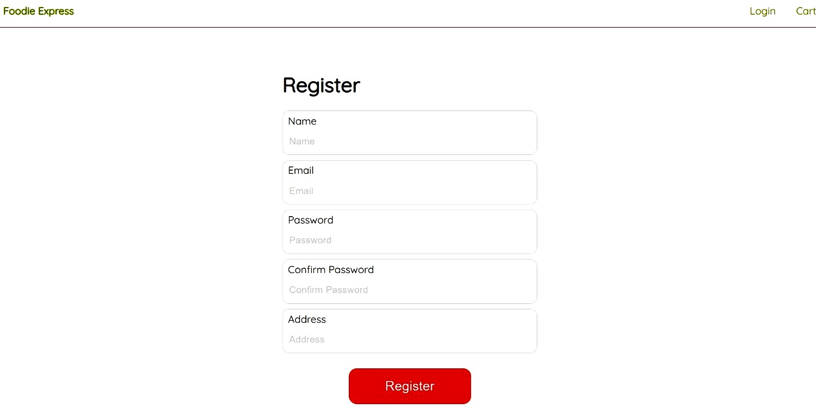

**Fig: 4.1 Register New User**

4.2 Login Page

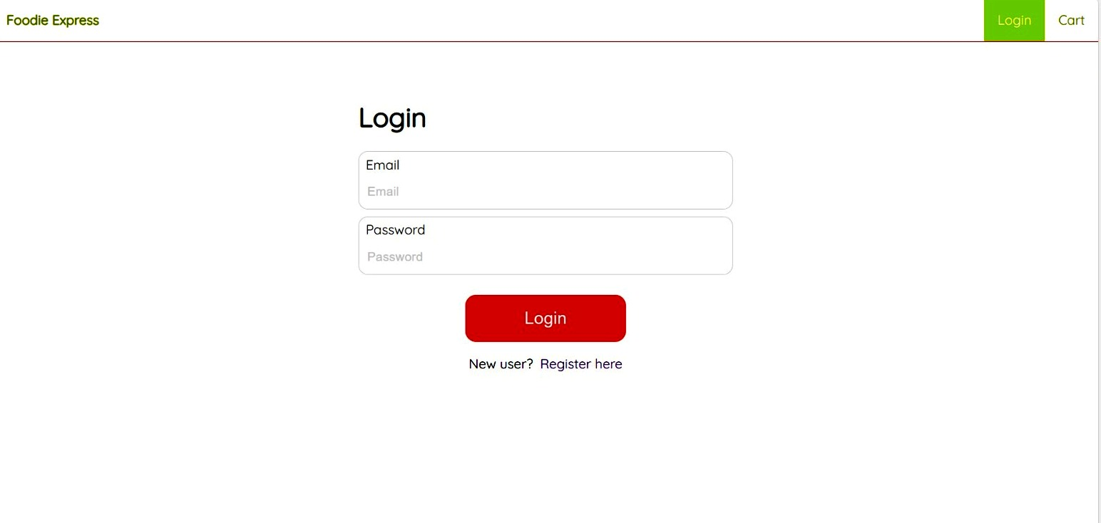

**Fig: 4.2 Login Page**

4.3 Profile Management

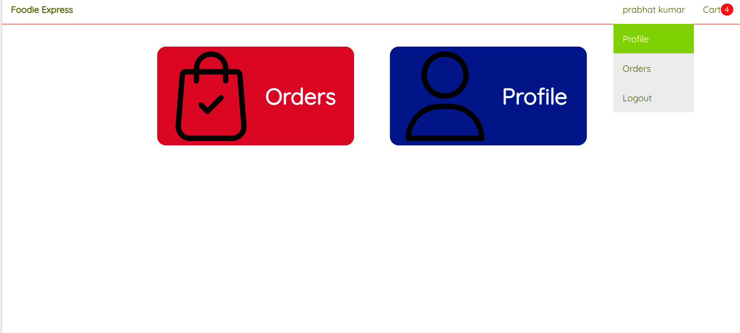

Fig: 4.3 Profile Management

4.4 Database Tables

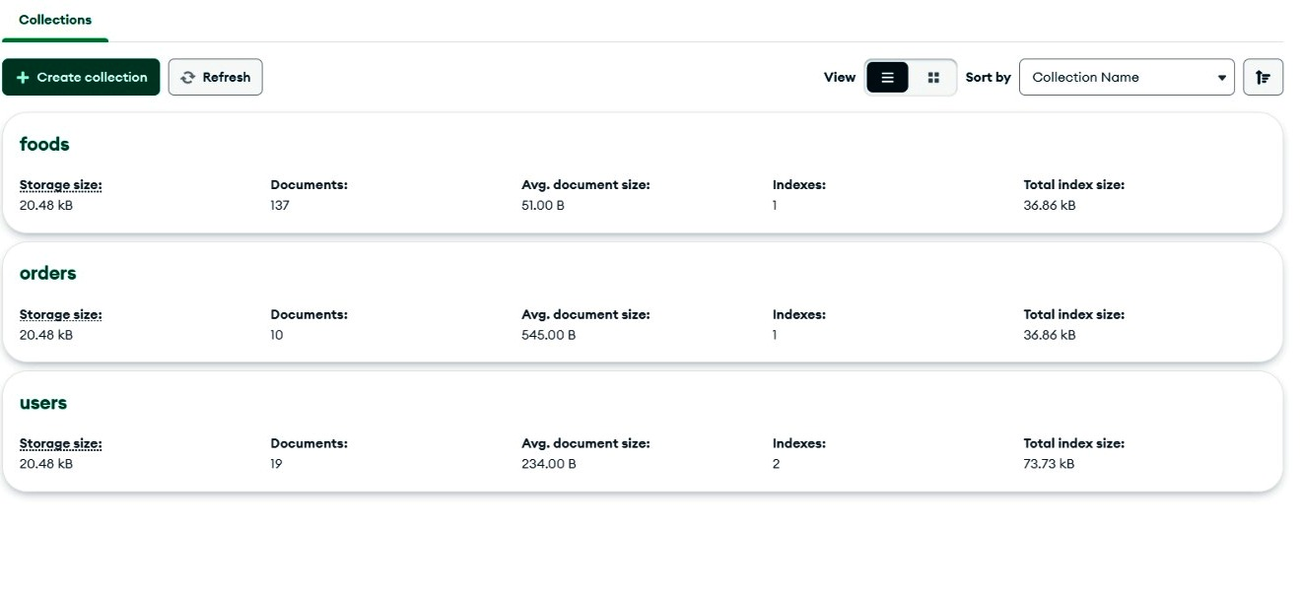

Fig: 4.4 Database Tables

**4.5 Home page**

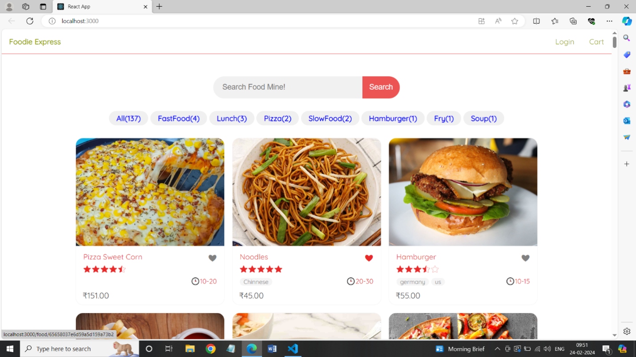

**Fig: 4.5 Home Page**

4.6 Category Page

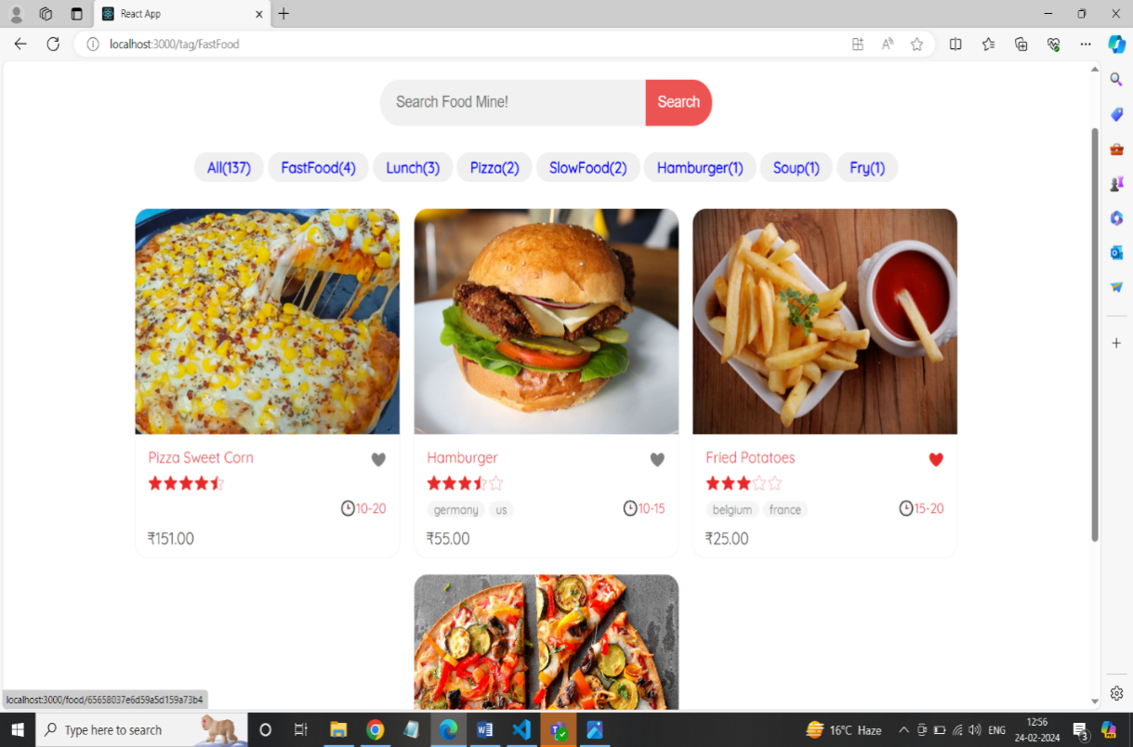

**Fig: 4.6 Category Page**

**4.7 Cart Page**

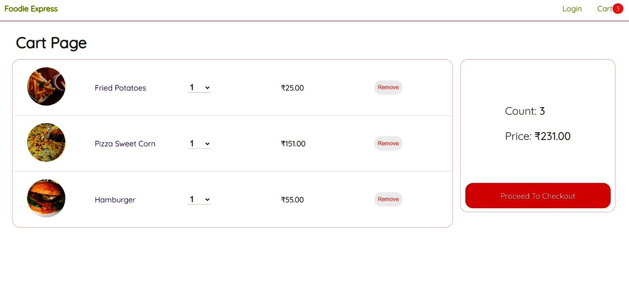

**Fig: 4.7 Cart Page**

**4.8 Location**

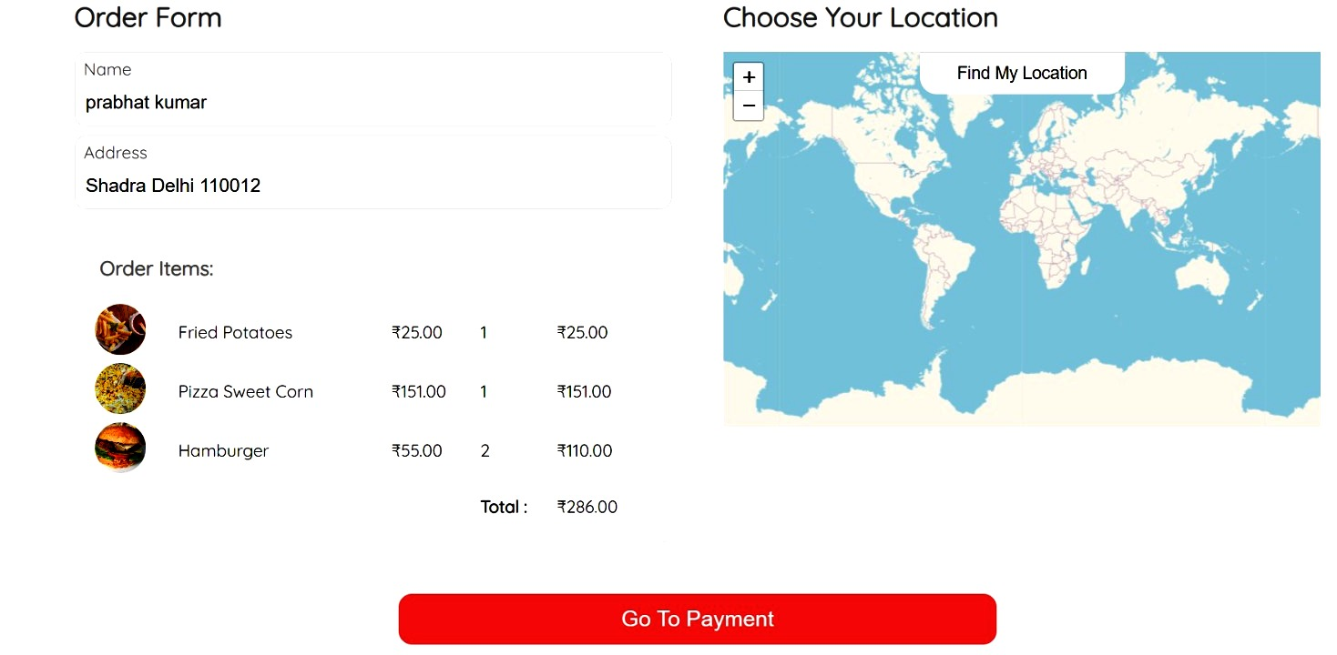

**Fig: 4.8 Locations**

**4.9 Payment Page**

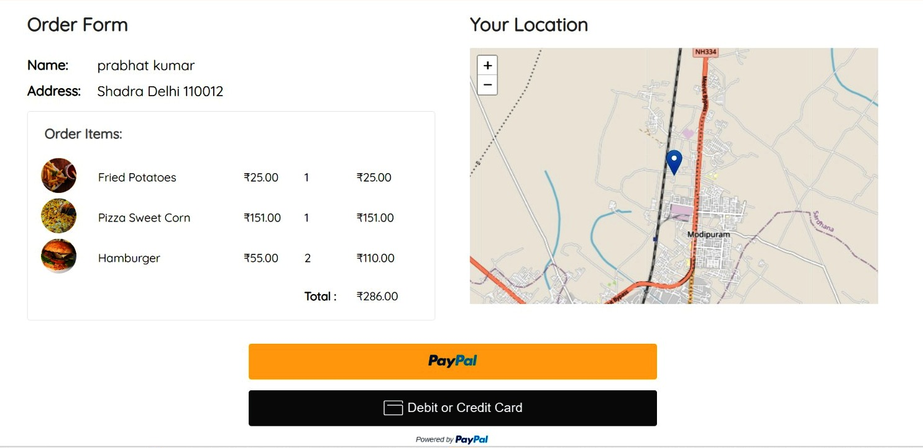

**Fig: 4.9 Payment Page**

# **CHAPTER - 05**

**MODULES AND DESIGN**

A flowchart is a visual representation of the steps in a process, commonly used by programmers to plan and illustrate algorithms. Here's a flowchart for a food ordering website, incorporating key symbols:

**5.1 Start**

* The flowchart begins with the start symbol.

**5.2 User Registration and Login**

* Users are prompted to register or log in to the food ordering website.
* If registered, users can proceed to log in.
* If not registered, they can complete the registration process.

**5.3 Home Screen**

* After successful login, users are directed to the home screen.
* The home screen provides an overview of available restaurants, ongoing promotions, and navigation options.

**5.4 Menu Selection and Customization**

* Users can explore the restaurant menu and select items for their order.
* Customization options such as quantity, size, and additional preferences are available
* Users can add items to their cart before proceeding to checkout.

**5.5 Menu Selection and Customization**

* Users can explore the restaurant menu and select items for their order.
* Customization options such as quantity, size, and additional preferences are available.
* Users can add items to their cart before proceeding to checkout.

**5.6 Order Checkout**

* Users can review their selected items in the cart.
* They provide delivery details, select payment methods, and apply any discounts or promo codes.
* Users confirm the order and proceed to payment.

**5.7 Payment Processing**

* The website processes the payment securely.
* Users receive confirmation of the successful transaction

**5.8 Flow Chart**

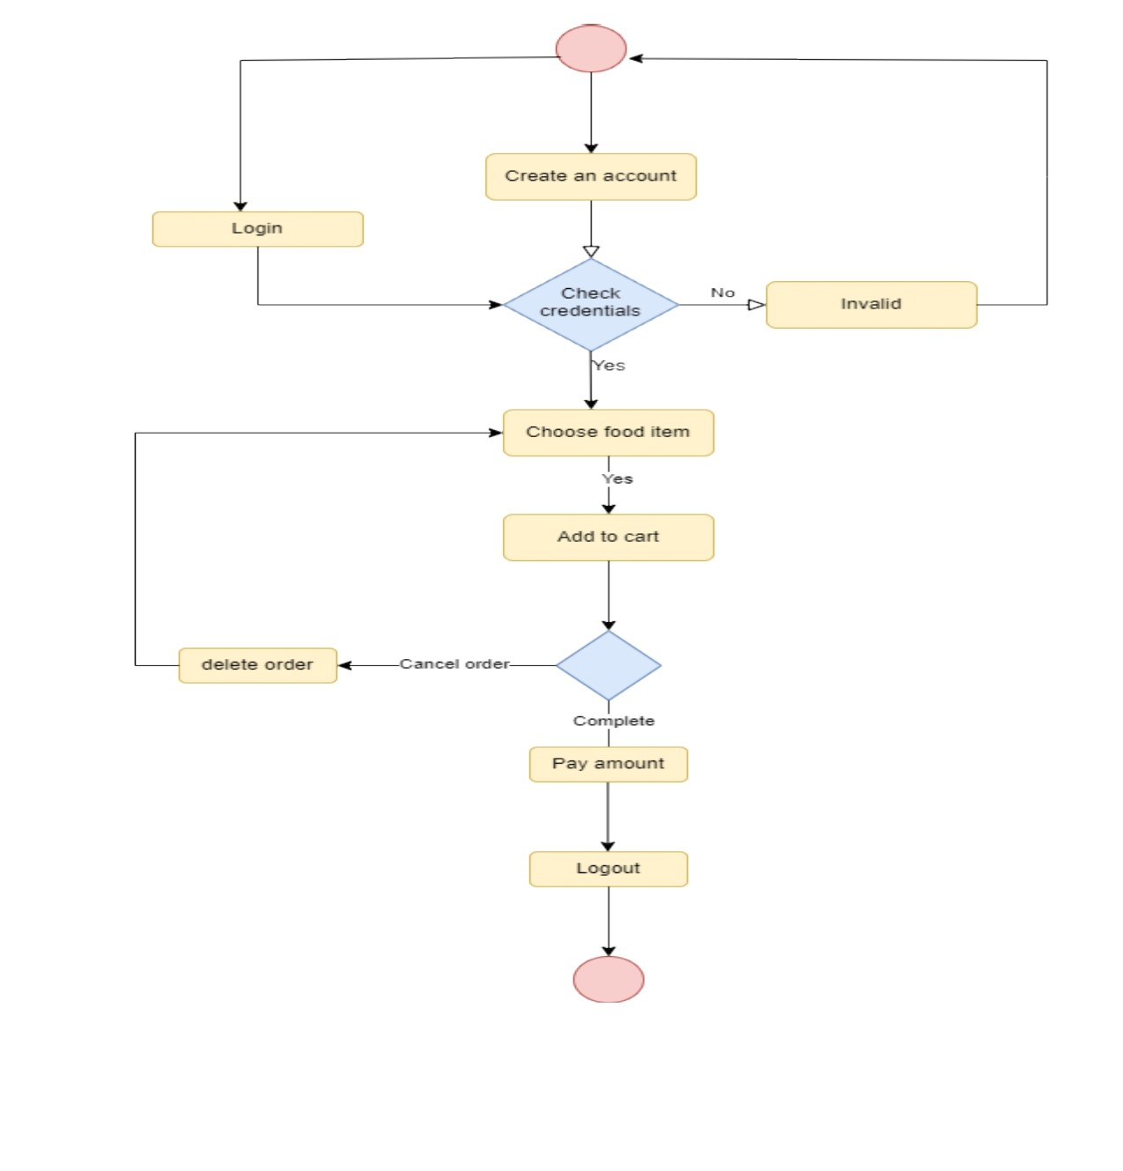

**Fig: 5.8 Flow Chart**

**5.9 ER-Diagram**

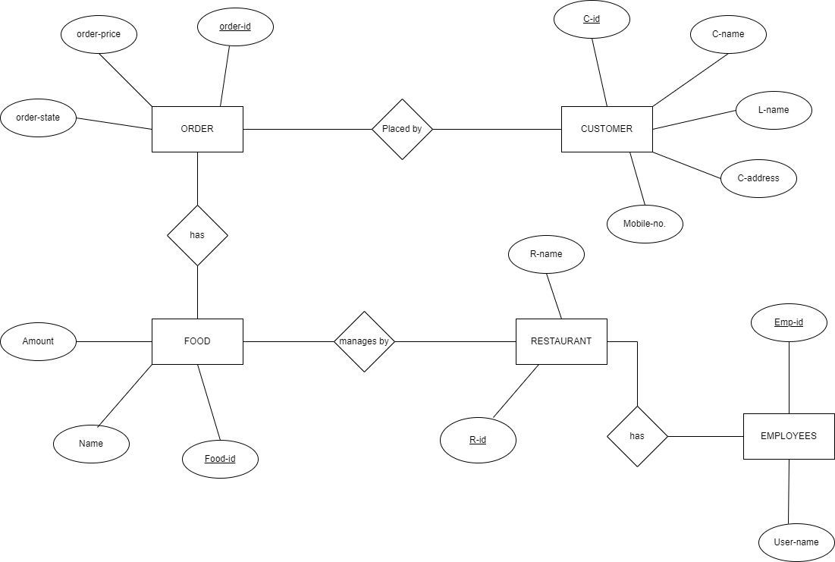

**Fig: 5.9 ER-Diagrams**

**5.10 Use Case Diagram**

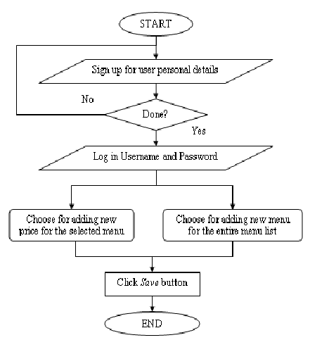

**Fig: 5.10 Use Case Diagram**

**5.11 Data Flow Diagram**

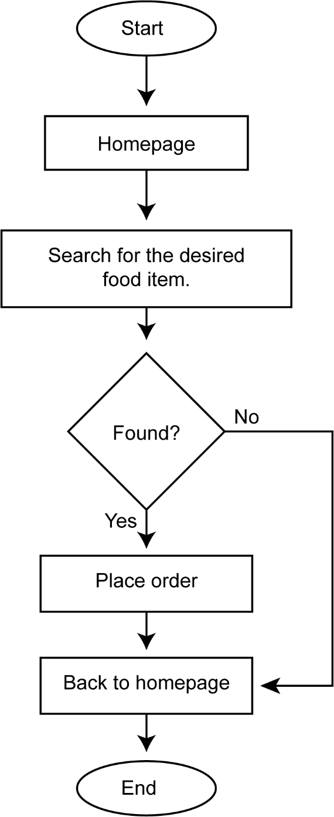

**Fig: 5.11 DFD**

**CHAPTER – 06**

**TESTING**

**6.1 UNIT TESTING**

In computer programming, unit testing is a software testing method by which individual units of source code, sets of one or more computer program modules together with associated control data, usage procedures, and operating procedures, are tested to determine whether they are fit for use. Intuitively, one can view a unit as the smallest testable part of an application. In procedural programming, a unit could be an entire module, but it is more commonly an individual function or procedure. In object-oriented programming, a unit is often an entire interface, such as a class, but it could be an individual method. Unit tests are short code fragments created by programmers or occasionally by white box testers during the development process. It forms the basis for component testing. Ideally, each test case is independent from the others. Substitutes such as method stubs, mock objects, fakes, and test harnesses can be used to assist in testing a module in isolation. Unit tests are typically written and run by software developers to ensure that code meets its design and behaves as intended.

**BENEFITS OF UNIT TESTING -**

The goal of unit testing is to isolate each part of the program and show that the individual parts are correct. A unit test provides a strict, written contract that the piece of code must satisfy. As a result, it offers several benefits.

**6.2 PROBLEMS EARLY**

Unit testing finds problems early in the development cycle. In test-driven development (TDD), which is frequently used in both extreme programming and scrum, unit tests are created before the code itself is written. When the tests pass, that code is considered complete. The same unit tests are run against that function frequently as the larger code base is developed either as the code is changed or via an automated process with the build.

If the unit tests fail, it is a bug either in the changed code or the tests themselves.

The unit tests then allow the location of the fault or failure to be easily traced. Since the unit tests alert the development team of the problem before handing the code off to testers or clients, it is still early in the development process.

**6.2.1 FACILITATES CHANGE**

Unit testing allows the programmer to refactor code or upgrade system libraries later, and make sure the module still works correctly (e.g., in regression testing). The procedure is to write test cases for all functions and methods so that whenever a change causes a fault, it can be quickly identified. Unit tests detect changes that may break a design contract.

* + 1. **SIMPLIFIES INTEGRATION**

Unit testing may reduce uncertainty in the units themselves and can be used in a bottom-up testing style approach. By testing the parts of a program first and then testing the sum of its parts, integration testing becomes much easier.

* + 1. **DOCUMENTATION**

Unit testing provides a sort of living documentation of the system. Developers looking to learn what functionality is provided by a unit, and how to use it, can look at the unit tests to gain a basic understanding of the unit's interface (API). Unit test cases embody characteristics that are critical to the success of the unit. These characteristics can indicate appropriate/inappropriate use of a unit as well as negative behaviours that are to be trapped by the unit. A unit test case, in and of itself, documents these critical characteristics, although many software development environments do not rely solely upon code to document the product in the development unit. A unit test case, in and of itself, documents these critical characteristics, although many software development environments do not rely solely upon code to document the product in development.

**6.3 INTEGRATION TESTING**

Integration testing (sometimes called integration and testing, abbreviated I&T) is the phase in software testing in which individual software modules are combined and tested as a group. It occurs after unit testing and before validation testing. Integration testing takes as its input modules that have been unit tested, groups them in larger aggregates, applies tests defined in an integration test plan to those aggregates, and delivers as its output the integrated system ready for system testing.

The purpose of integration testing is to verify the functional, performance, and reliability requirements placed on major design items. These "design items", i.e., assemblages (or groups of units), are exercised through their interfaces using black-box testing, with success and error cases being simulated via appropriate parameter and data inputs. Simulated usage of shared data areas and inter-process communication is tested and individual subsystems are exercised through their input interface.

Test cases are constructed to test whether all the components within assemblages interact correctly, for example across procedure calls or process activations, and this is done after testing individual modules, i.e., unit testing. The overall idea is a "building block" approach, in which verified assemblages are added to a verified base which is then used to support the integration testing of further assemblages. Software integration testing is performed according to the software development life cycle (SDLC) after module and functional tests. The cross-dependencies for software integration testing are schedule for integration testing, strategy and selection of the tools used for integration, define the cyclomatic complexity of the software and software architecture, reusability of modules and life cycle and versioning management. Some different types of integration testing are big-bang, top- down, and bottom-up, mixed (sandwich) and risky- hardest. Other Integration Patterns are collaboration integration, backbone integration, layer integration, client-server integration, distributed services integration and high-frequency integration.

* + 1. **BIG BANG**

In the big-bang approach, most of the developed modules are coupled together to form a complete software system or major part of the system and then used for integration testing. This method is very effective for saving time in the integration testing process. However, if the test cases and their results are not recorded properly, the entire integration process will be more complicated and may prevent the testing team from achieving the goal of integration testing. A type of big-bang integration testing is called "usage model testing" which can be used in both software and hardware integration testing. The basis behind this type of integration testing is to run user-like workloads in integrated user-like environments. In doing the testing in this manner, the environment is proofed, while the individual components are proofed indirectly through their use. Usage Model testing takes an optimistic approach to testing because it expects to have few problems with the individual components. The strategy relies heavily on the component developers to do the isolated unit testing for their product. The goal of the strategy is to avoid redoing the testing done by the developers, and instead flesh-out problems caused by the interaction of the components in the environment. For integration testing, Usage Model testing can be more efficient and provides better test coverage than traditional focused functional integration testing. To be more efficient and accurate, care must be used in defining the user-like workloads for creating realistic scenarios in exercising the environment. This gives confidence that the integrated environment will work as expected for the target customers.

**6.4 TOP-DOWN AND BOTTOM-UP**

Bottom-up testing is an approach to integrated testing where the lowest level components are tested first, then used to facilitate the testing of higher-level components. The process is repeated until the component at the top of the hierarchy is tested. All the bottom or low-level modules, procedures or functions are integrated and then tested. After the integration testing of lower-level integrated modules, the next level of modules will be formed and can be used for integration testing. This approach is helpful only when all or most of the modules of the same development level are ready.

This method also helps to determine the levels of software developed and makes it easier to report

testing progress in the form of a percentage. Top-down testing is an approach to integrated testing

where the top integrated modules are tested, and the branch of the module is tested step by step until the end of the related module. Sandwich testing is an approach to combine top-down testing with bottom-up testing.

**6.5 BLACK-BOX TESTING**

Black box testing is a technique used to test the functionality of a software application without having knowledge of its internal structure or implementation details. It focuses on the inputs and outputs of the system and verifies if the expected outputs match the desired results. Here are some examples of black box testing techniques that can be applied to the KIET Event Management App:

1. Equivalence Partitioning:
   * + Identify different categories of inputs for the app, such as valid and invalid inputs, and divide them into equivalence classes.
     + Test representative values from each equivalence class to ensure the app behaves consistently within each class.

2 .Boundary Value Analysis:

* + - Identify the boundaries or limits for inputs in the app, such as minimum and maximum values, and test values at those boundaries.
    - Test values just above and below the boundaries to verify the app's behaviour at critical points.

3. Decision Table Testing:

* + - Identify the different conditions and rules that govern the behaviour of the app.
    - Create a decision table with combinations of conditions and corresponding expected results.
    - Test different combinations of conditions to validate the app's decision-making process.

1. State Transition Testing:
   * + Identify the different states that the app can transition between.
     + Define the valid and invalid transitions between states.
     + Test different sequences of state transitions to verify the app's behaviour.
2. Error Guessing:
   * + Use experience and intuition to guess potential errors or issues in the app.
     + Create test cases based on those guesses to verify if the app handles the errors correctly.
3. Compatibility Testing:
   * + Test the app on different platforms, browsers, or devices to ensure compatibility.
     + Verify that the app functions correctly and displays appropriately across different environments.
4. Usability Testing:
   * + Evaluate the app's user interface and interactions from the perspective of an end-user.
     + Test common user scenarios and assess the app's ease of use, intuitiveness, and overall user experience.
5. Security Testing:
   * + Test the app for potential security vulnerabilities or weaknesses.
     + Verify if the app handles user authentication, data encryption, and access control appropriately.

9. Performance Testing:

* + - Test the app's performance under different load conditions, such as a high number of concurrent users or large data sets.
    - Verify if the app responds within acceptable time limits and performs efficiently.

During black box testing, test cases are designed based on the app's specifications, requirements, and user expectations. The focus is on validating the functionality, user interactions, and expected outputs without considering the internal implementation details of the app.

**6.6 WHITE-BOX TESTING**

White box testing, also known as structural testing or glass box testing, is a software testing technique that examines the internal structure and implementation details of the application. It aims to ensure that the code functions as intended and covers all possible execution paths. Here are some examples of white box testing techniques that can be applied to the KIET Event Management App:

1. Unit Testing:

* Test individual units or components of the app, such as functions or methods, to verify their correctness.
* Use techniques like code coverage analysis (e.g., statement coverage, branch coverage) to ensure that all code paths are exercised.

1. Integration Testing:

* Test the interaction between different components or modules of the app to ensure they work together seamlessly.
* Verify the flow of data and control between the modules and check for any integration issues or errors.

3. Path Testing:

* Identify and test different paths or execution flows through the app, including both positive and negative scenarios.
* Execute test cases that cover all possible paths within the code to ensure complete coverage.

4. Decision Coverage:

* + - Ensure that every decision point in the code (e.g., if statements, switch cases) is tested for both true and false conditions.
    - Validate that the app makes the correct decisions based on the specified conditions.

5. Code Review:

* + - Analyse the code and its structure to identify any potential issues or vulnerabilities.
    - Review the adherence to coding standards, best practices, and potential optimizations.

6. Performance Testing:

* + - Assess the app's performance from a code perspective, such as identifying any bottle necks or inefficient algorithms.
    - Measure the execution time of critical code sections and evaluate resource usage.

1. Security Testing:
   * + Review the code for potential security vulnerabilities, such as SQL injection, cross-site scripting (XSS), or authentication weaknesses.
     + Verify the implementation of secure coding practices, data encryption, and access control mechanisms.

8 .Error Handling Testing:

* + - Test how the app handles and recovers from unexpected errors or exceptions.
    - Validate that error messages are clear, meaningful, and do not expose sensitive information.

9. Code Coverage Analysis:

* + - Use tools to measure the code coverage achieved by the tests, such as statement coverage, branch coverage, or path coverage.
    - Aim for high code coverage to ensure that all parts of the code are exercised.

During white box testing, the tester has access to the application's internal code, allowing for a more detailed examination of its behaviour.

**6.7** **SYSTEM TESTING**

System testing is a level of software testing that evaluates the complete system as a whole, rather than focusing on individual components or modules. It ensures that all components of the KIET Event Management App work together seamlessly and meet the specified requirements. Here are some examples of system testing techniques that can be applied to the app:

**6.7.1. Functional Testing:**

* + - Verify that all functional requirements of the app are met.
    - Test various functionalities such as event creation, registration, club directory search, user log in and registration, event notifications, etc.
    - Validate that the app behaves as expected and produces the correct outputs based on different inputs.

**6.7.2 .User Interface Testing:**

* + - Test the graphical user interface (GUI) of the app for usability, consistency, and responsiveness.
    - Check the layout, navigation, buttons, forms, and other UI elements to ensure they are visually appealing and intuitive.
    - Validate that the app adheres to the design guidelines and provides a seamless user experience.

**6.7.3. Performance Testing:**

* + - Evaluate the performance of the app under different load conditions.
    - Measure response times, throughput, and resource utilization to ensure the app can handle the expected user load without significant degradation.
    - Identify and address any performance bottlenecks or scalability issues.
* Compatibility Testing:
  + - Test the app on different devices, platforms, and browsers to ensure compatibility.
    - Verify that the app works correctly on various operating systems (e.g., iOS, Android) and different screen sizes.
    - Validate that the app functions properly on different web browsers (if applicable).
* Security Testing:
  + - Assess the app's security measures to protect user data and prevent unauthorised access.
    - Perform vulnerability scanning, penetration testing, and authentication testing to identify and address any security vulnerabilities.
    - Test the app's resilience against common security threats, such as cross-site scripting (XSS) and SQL injection.
    1. **Usability Testing:**
    - Evaluate the app's usability and user-friendliness.
    - Conduct user tests and gather feedback to assess the ease of use, intuitiveness, and overall user satisfaction.
    - Identify areas of improvement and make necessary adjustments to enhance the user experience.

**6.8. Integration Testing:**

* + - Test the integration of the app with external systems, such as databases, mapping services, or notification services.
    - Validate that data is exchanged correctly between the app and external systems.
    - Verify that the app's functionality remains intact when integrated with other systems.

**6.9. Recovery Testing:**

* + - Simulate system failures or interruptions and evaluate the app's ability to recover and resume normal operation.
    - Test scenarios such as unexpected shutdowns, network failures, or interrupted database connections.
    - Ensure that the app can gracefully handle such situations and recover without data loss or integrity issues.

**6.10. Regression Testing:**

* + - Re-test previously tested features and functionalities to ensure that recent changes or additions did not introduce new bugs or regressions.
    - Execute a set of comprehensive test cases to cover critical areas of the app and ensure that no existing functionality is compromised.

**REFERENCES**

[1] Introduction to HTML CSS JavaScript from W3Schools

<https://www.w3schools.com/html/>

<https://www.w3schools.com/css/>

<https://www.w3schools.com/js/>

[2] Introduction to MongoDb from javatpoint

<https://www.javatpoint.com/mongodb-tutorial>

[3] Concept of react by reactjs tutorial

<https://legacy.reactjs.org/tutorial/tutorial.html>

[4] NodeJs by W3Schools

<https://www.w3schools.com/nodejs/>