**NETWORKING AND DATA SECURITY**

**Assignment 1**

**Student Name** : Nishant Upadhyay

**Student ID** : 110059612

1. Complete the lab environment setup. You can set up on your computer or cloud (if your computer is not possible). Provide a screen shot as a proof of completing your task. Here is an example of setup on my own computer.

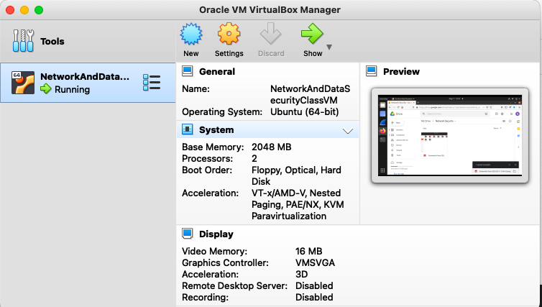

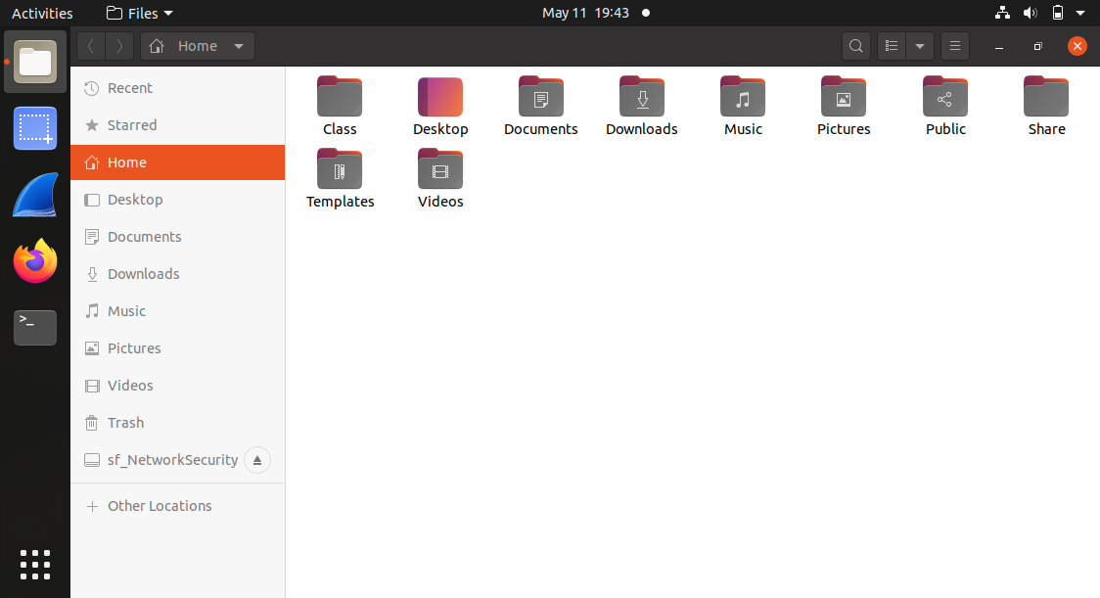

a. In order to access the selected website, your browser will first issue DNS query to find out the ip address of this website. Find this query packet and the response packet. What is the ip address of the website? You can apply filter dns to restrict the packet list to DNS packets only.

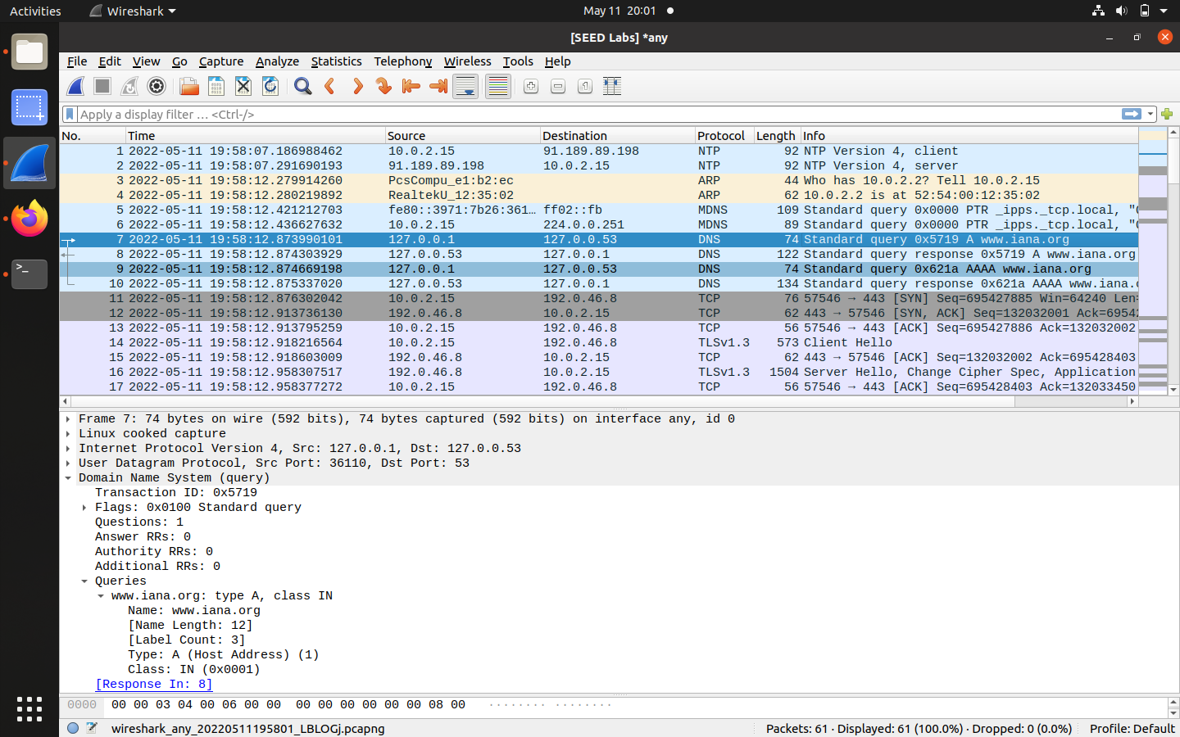

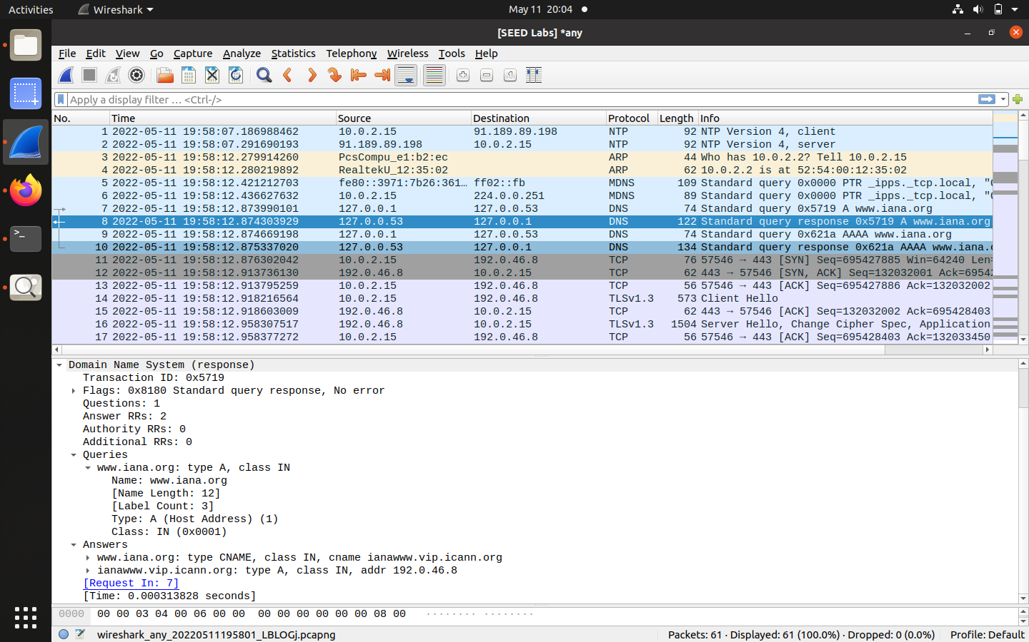

**Answer:**

**As seen in the above screenshot the IP address of the website(www.iana.org) is 192.0.46.8**

b. The source IP address of the query packet will be your IP address and the destination IP address of the query packet will be the DNS server’s IP address. What is the ip address of this DNS server? What is the ip address of your machine?

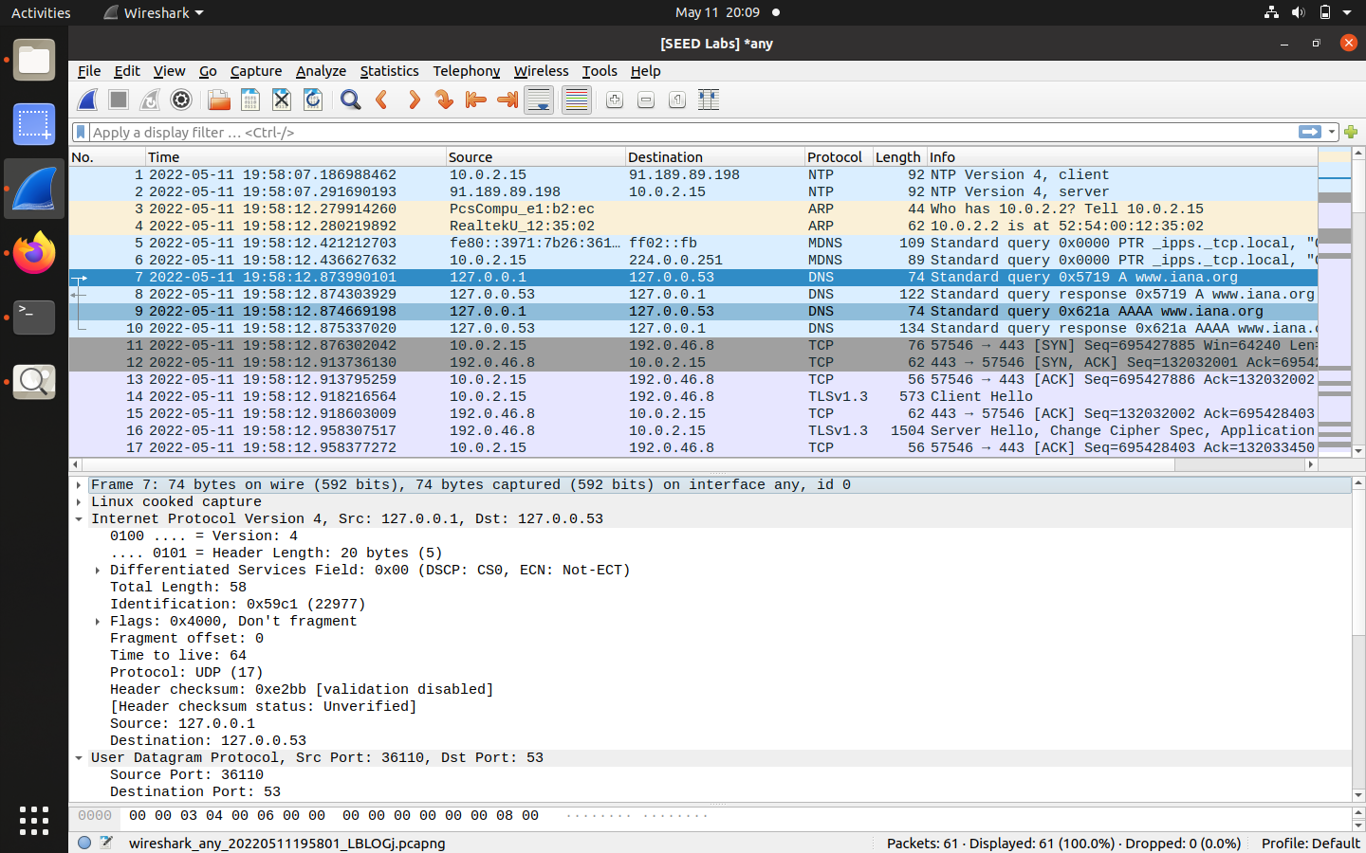

**Answer:**

**The IP address of my machine is : 127.0.0.1**

**The IP address of DNS Server is: 127.0.0.53**