Industry Project | Customer Churn Prediction
Submitted by: Nishant Umang
Objective and Scope
The primary objective of this industry project is to predict customer churn using machine learning techniques. Customer churn prediction helps organizations identify customers who are likely to discontinue using a service, enabling proactive retention strategies.
The scope of this project includes analyzing structured customer data, handling class imbalance, training machine learning classification models, and evaluating them using appropriate performance metrics with a focus on recall.
Problem Statement
Customer churn poses a significant challenge to businesses as acquiring new customers is more expensive than retaining existing ones. High churn rates negatively impact revenue, growth, and customer lifetime value.
The challenge addressed in this project is to accurately identify customers who are at risk of churning from an imbalanced dataset where churn cases are significantly fewer than non-churn cases.
Existing Approaches
Traditional churn analysis relies on manual data analysis and basic statistical methods, which are insufficient for large and complex datasets. Many machine learning approaches focus primarily on overall accuracy, which can be misleading in imbalanced datasets.
Such approaches often fail to detect minority churn cases effectively, leading to poor business outcomes despite seemingly high accuracy scores.
Approach / Methodology – Tools and Technologies Used
This project follows a structured machine learning pipeline involving data preprocessing, exploratory data analysis, model training, and evaluation.
Tools and technologies used include Python, Jupyter Notebook, Pandas, NumPy, Scikit-learn, Matplotlib, and Seaborn.
Workflow
Data Loading → EDA → Preprocessing → Train/Test Split → Model Training → Model Evaluation → Results Interpretation
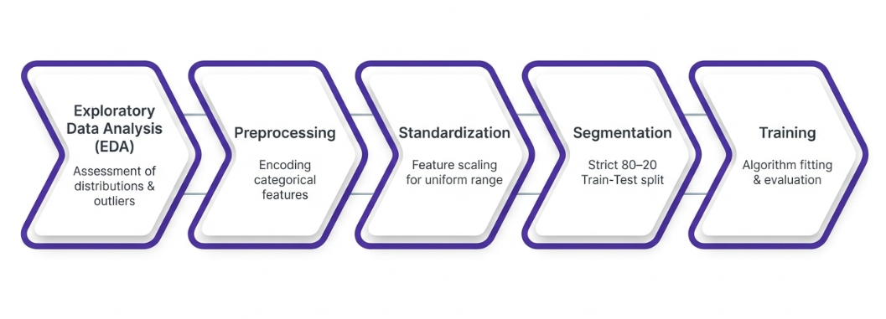
Fig: Machine Learning Workflow Diagram
Assumptions
The project assumes that the historical customer data is representative of real-world behavior. It is also assumed that the churn labels are accurate and that there is no data leakage between training and testing datasets.
Implementation
The dataset contains 10,000 customer records with 32 features including demographic, behavioral, and engagement metrics. The target variable is churn, where 0 indicates non-churn and 1 indicates churn.
Exploratory Data Analysis revealed a significant class imbalance in the dataset.
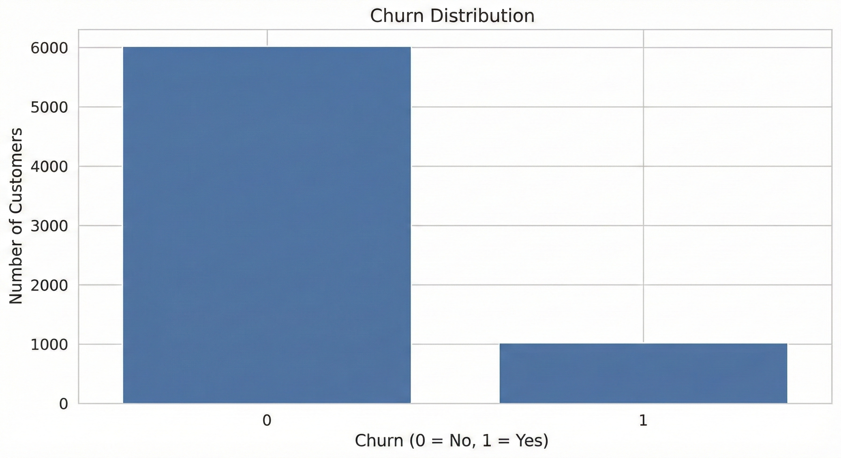
Fig: Churn Distribution Plot
Categorical variables were encoded using Label Encoding, and feature scaling was performed using StandardScaler. The dataset was split into training and testing sets using an 80–20 stratified split.
Two models were implemented: Logistic Regression with class_weight set to balanced, and Random Forest Classifier.
Solution Design
Logistic Regression was selected for its interpretability and ability to incorporate class balancing, making it suitable for churn prediction. Random Forest was used as a benchmark ensemble model.
The solution prioritizes recall over accuracy to minimize the risk of missing churn customers.
Results and Comparison
Logistic Regression achieved an accuracy of 66.8% with a recall of 66% for churn customers, correctly identifying 134 out of 204 churn cases.
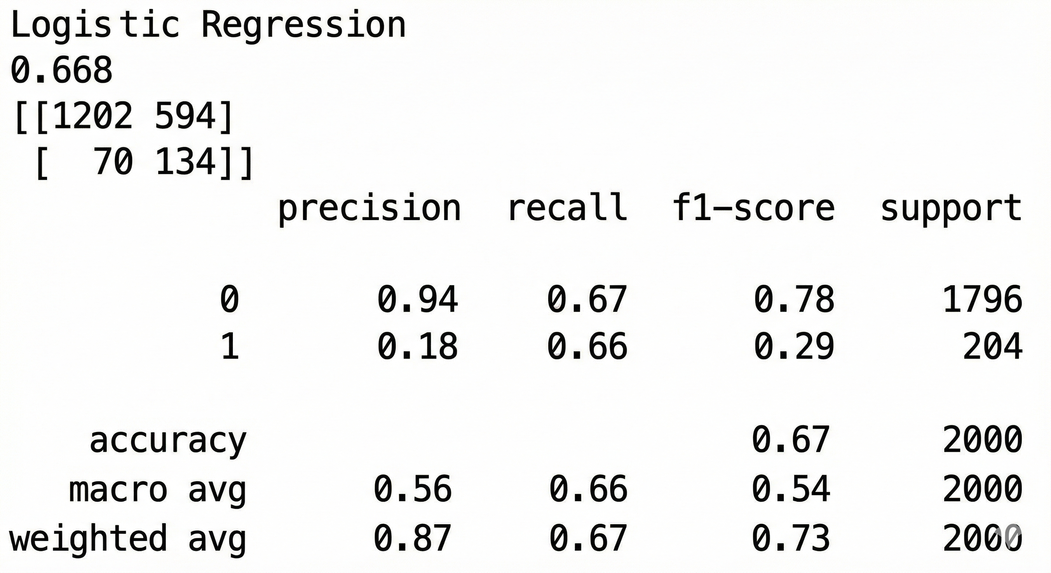
Fig: Logistic Regression Output
Random Forest achieved a high accuracy of 89.75% but showed a recall of only 2%, identifying just 4 churn customers.
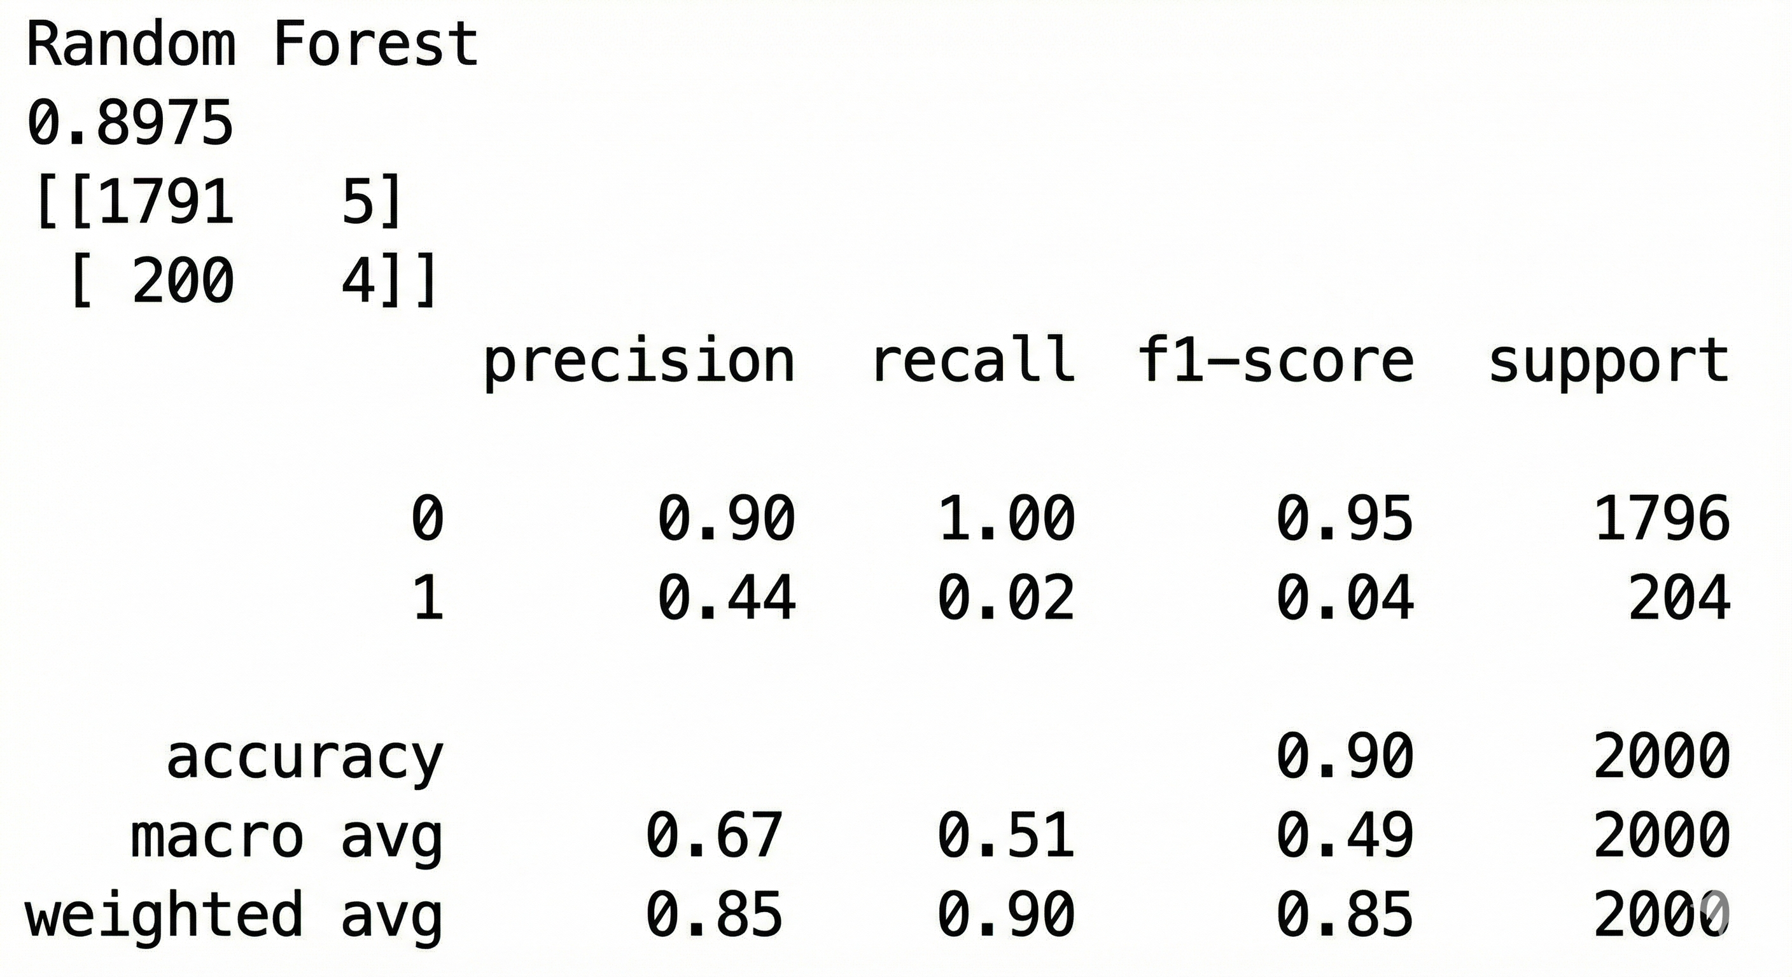
Fig: Random Forest Output
Challenges and Opportunities
The main challenge was handling class imbalance, which caused misleading accuracy results. An opportunity exists to improve performance through advanced feature engineering and ensemble methods with proper imbalance handling.
Reflections on the Project
This project emphasized the importance of selecting appropriate evaluation metrics based on business objectives. It reinforced the need for business-oriented thinking in machine learning applications.
Recommendations
Organizations should prioritize recall-based models for churn prediction and continuously monitor customer behavior to enable timely retention actions.
Outcome / Conclusion
Logistic Regression with class balancing proved more effective for churn prediction compared to Random Forest. The project demonstrates a practical application of machine learning with a focus on real-world business impact.
Enhancement Scope
Future enhancements include advanced feature engineering, hyperparameter tuning, use of boosting algorithms, and deployment of the model as a real-time prediction system.
Link to Code and Executable File
Project code can be made available upon request.
Research Questions and Responses
1. Why is recall prioritized over accuracy?
Recall is prioritized to minimize missed churn cases, which are more costly to the business.
2. Why Logistic Regression?
It provides interpretability and supports class balancing.
3. What is the impact of class imbalance?
Class imbalance can lead to misleading accuracy and poor churn detection.
References
Scikit-learn Documentation
Customer Churn Prediction Literature

