Django Framework

- It is a powerful, fully featured web framework written in python.
- High level python web framework that enables rapid development of secure and maintainable websites.
- Takes care of hassle in web development.

Framework
- Structure you can build software on.
- Associated with some programming language.
- Saves time, reduce error.
- More secure code.
- Simpler testing and debugging.

Django framework helps us to write software that is:
- Secure
- Maintainable
- Versatile
- Complete
- Portable, etc.

Django provides set of components to handle web development tasks and one or two ways to use them.

Django supports mySQL, Oracle, mariaDB, etc.

Django development environment is the installation of django that you can use for developing and testing django prior to deploying them to production environment.

Django web application typically groups the code that handles each of these steps separately.
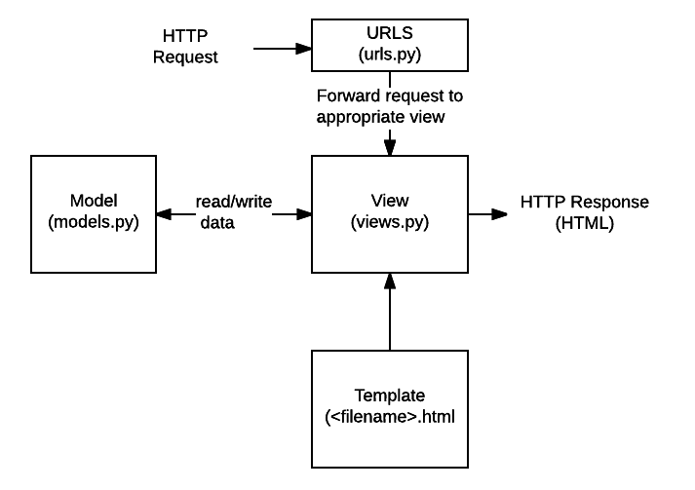

- URLS:- A URL mapper is used to redirect HTTP requests to the appropriate view based on the request URL. The URL mapper can also match particular patterns of strings or digits that appear in a URL and pass
these to a view function as data.
The mapper (url patterns) defines a list of mappings between routes(specific URL patterns) and corresponding view functions.

- View:- It has request handler function that receives TTP requests and returns HTTP responses. Views access the data needed to satisfy requests via models.

- Model:- Models are Python objects that define the structure of an application's data, and provide mechanisms to manage (add, modify, delete) and query records in the database.

- Template:- A template is a text file defining the structure or layout of a file.

