Create a Virtual Private Cloud (VPC), which is a virtual network dedicated to your AWS account.

First How to create a VPC with the corresponding subnets.

Contents of this article
- VPC Definition and security model
- Visual Representation of the Demo Network
- How to create a VPC in Amazon AWS
- Create an AWS VPC
- Create AWS VPC Subnets

VPC Definition and security model ^
A VPC is a network logically separated and isolated from other virtual networks inside the AWS cloud. In the same manner an administrator would secure servers behind a firewall and access control lists on premise, you can also isolate instances (virtual servers) inside your VPC.

The Shared Responsibility Model is a term that AWS uses to define “security of the cloud” in addition to “security in the cloud.” Because “security in the cloud” is our responsibility, we need to protect our own content, platform, applications, systems, and networks. A VPC with multiple logical networks is a good start in securing your AWS network resources.
This will be a multi-part series of articles. In this first article, we describe our demo network with a diagram, create a new VPC, and build two subnets in separate availability zones. Our second article here demonstrates how to create an Internet Gateway, build both Private and Public Route Tables, Private and Public Network Access Control Lists, and Private and Public Security Groups, as well as set associations among these components. Lastly, in our third article here, we show how to set up an instance in each of our networks (Public and Private), test connectivity, and ensure only our Bastion instance has the ability and keys necessary to connect to our Private instance, via SSH and Pageant.

Visual Representation of the Demo Network ^
The following diagram outlines how our VPC network will look when we complete our task.

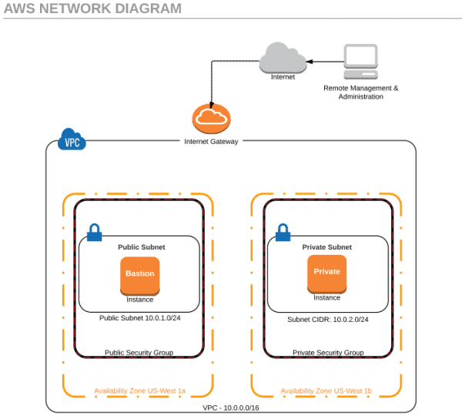
AWS network diagram

As displayed in the diagram, by creating a second Security Group and subnet, 10.0.2.0/24, we effectively isolate the instances in that subnet from the outside world. Our Private instance will not have any public IP addresses or ports open to the outside. Our Bastion instance is used much like a management gateway and is the only point of entry for the management of our Private instances. While inbound traffic is secured, our Internet Gateway allows Private instances to connect to the Internet and make outbound requests for updates and patches.

How to create a VPC in Amazon AWS ^
If you want to follow along with this tutorial, go ahead and sign up for a new Free Tier account with AWS here. The free tier is good for 12 months and allows you to run one instance per month or two instances for half of a month. If you leave both instances running all month, you may be charged a nominal amount of money on your credit card (a credit card is required to sign up for the free account). Should you not want to run this setup in production, either shut down your instances after completing your testing or delete your second instance. With only one instance running all month, or two instances running for half of a month, you probably won’t see a bill for a year.
After signing up and providing your credit card information, go ahead and sign in to the console. The default AWS console look and feel has changed recently. The first thing to do in the console is change your Availability Zone to U.S. West (N. California). There may be other availability zones closer to you that have multiple zones in the location, but I recommend you keep both zones in the same location. Do this by changing the default option in the location drop-down menu, next to your name, in the upper-right corner of the console. Next, browse down to the Networking section, and click on VPC.

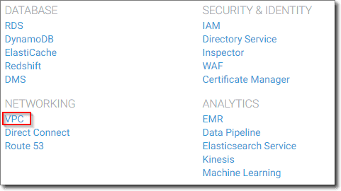
AWS Console select VPC

While we could use the VPC wizard, we are going to create one from scratch. You can disregard the default VPC for now.

Create an AWS VPC ^
Click on Create VPC.
Provide the Name Tag of your choice. We’ll use 4sysopsVPC.
Give it the CIDR block 10.0.0.0/16. This CIDR will give you 65k hosts. If you think you may reach this limit, by all means, plan ahead by providing more hosts than you think necessary, and set the CIDR to /8.
Leave Tenancy as default and click Yes, Create.

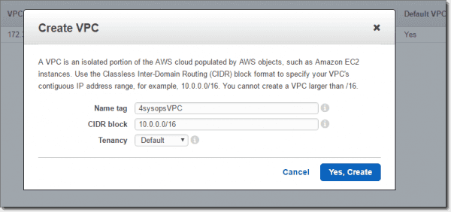
Create VPC

That’s all we need to do for our VPC.

Create AWS VPC Subnets ^
Next, we’ll create and name our two subnets, place them in the appropriate VPC, select the Availability Zone, and define the CIDR blocks.
Select Subnets, then Create Subnet.

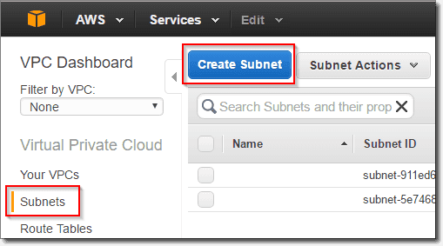
Create first subnet

We’ll give our first subnet a Name tag: Public-Subnet.
Next, select the VPC we previously created, named vpc-xxxxxxxx (10.0.0.0/16) | 4sysopsVPC.
Choose the first availability zone, us-west-1a.
Provide the CIDR block 10.0.1.0/24.

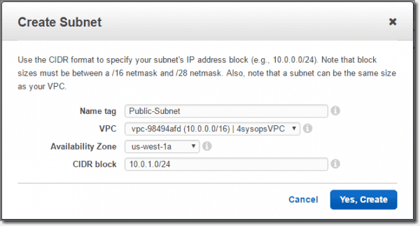
AWS Public Subnet settings

When complete, we’ll find the new subnet listed with our other two default subnets:

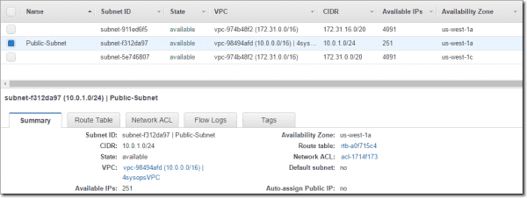
AWS Public Subnet information

Now, create another subnet by clicking on Create Subnet again. However, this time, we will change the Name tag to Private-Subnet, the VPC to vpc-xxxxxxxx (10.0.0.0/16) | 4sysopsVPC, the Availability Zone to us-west-1c, and the CIDR block to 10.0.2.0/24. The result should look similar to the following:

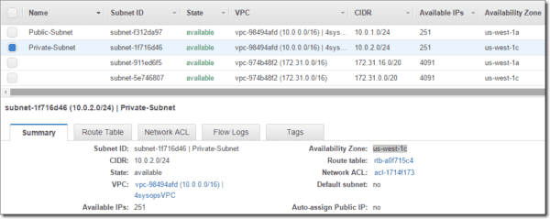
AWS Private Subnet information

We now have two subnets, and a VPC has been created. In the next article, we’ll build an Internet Gateway, Route Tables, NACLs, and Security Groups, and set associations between the components.

Create an Internet Gateway and VPC Route Tables and associate the routes with subnets. T
Create Network Access Control Lists (NACLs) and Rules, as well as AWS VPC Security Groups.

Contents of this article
- Create an AWS VPC Internet Gateway
- Create AWS VPC Routes
- Create AWS VPC Network Access Control Lists and Rules
- Create AWS VPC Security Groups
In the previous article, we provided an overview of Amazon AWS VPC security, created an initial VPC, and built two subnets. We now have a good foundation for moving into the core of a Virtual Private Cloud on the Amazon AWS platform. If you haven’t already done so, go back to the first article in the series and make sure you’ve caught up for the following steps.

Create an AWS VPC Internet Gateway ^
We want to provide our upcoming instances with a way to get out to the Internet by creating an Internet Gateway (IGW). If you would like to learn more about VPC Internet Gateways, you can find an informative document here.
In the VPC Dashboard, click on Internet Gateways, followed by Create Internet Gateway. Provide the Name tag with something similar to IGW-4sysops, and then click Yes, Create.

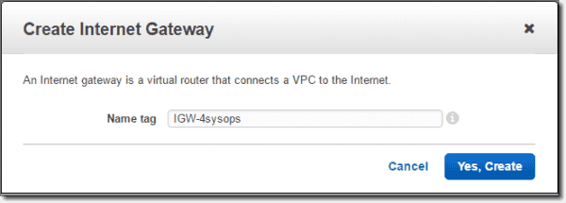
Create Internet Gateway

After we create the IGW, you will see that the state of the IGW is detached. So, we now need to attach a VPC to our new IGW. Do this by clicking on the Attach to VPC button, select the VPC you created previously (4sysopsVPC), and then hit Yes, Attach.

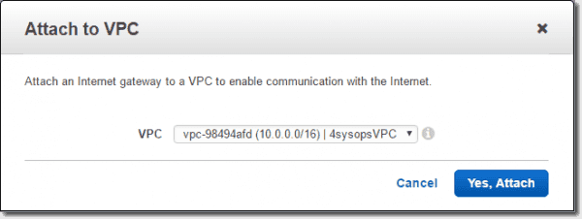
Attach IGW to VPC

Create AWS VPC Routes ^
Now that we have our Internet Gateway attached to our Virtual Private Cloud, we want to create some route tables. We’ll define two Route Tables, as shown in red in the following diagram. The first will be a Public Route Table from the Public-Subnet to the IGW, which will allow our Public-Subnet to reach the Internet. The second route will be a Private Route Table that will allow both our Public and Private subnets to communicate with one another.

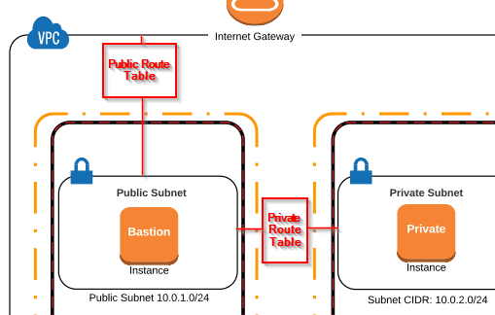
Public and private route table diagram

To create our first Public Route Table, go to the VPC Dashboard, then click on Route Tables> Create Route Table. Provide the Name Tag: Public-Route, select the 4sysops VPC, and then click Yes, Create.

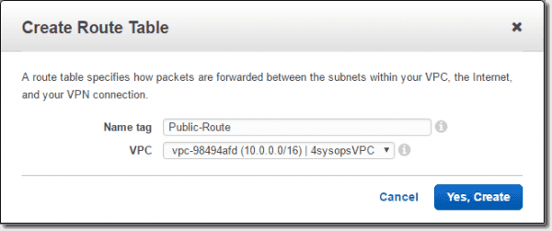
Create public route table

Next, with the Public-Route selected, click on the Routes tab and click Edit.

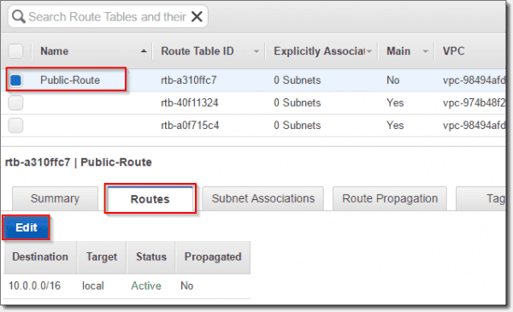
Edit public routes

Click Add Another Route for traffic going outside of our VPC.
Enter the following: Destination: 0.0.0.0/0 target: igw: 4sysops, and then click Save.

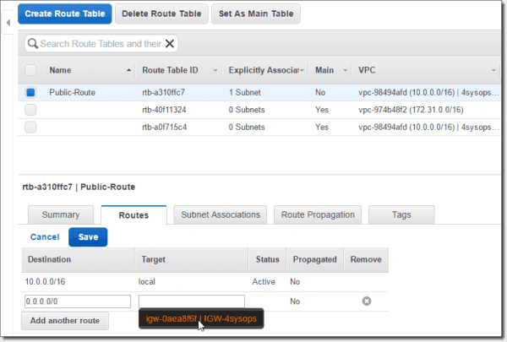
Create public route

The 0.0.0.0/0 subnet says that any traffic not bound for our local network will go out the Internet Gateway.
Next, we need to associate the Public-Route with our Public-Subnet. With Public-Route selected, click on the Subnet Associations tab, click Edit, place a checkmark next to the 10.0.1.0/24 | Public-Subnet, and then click Save.

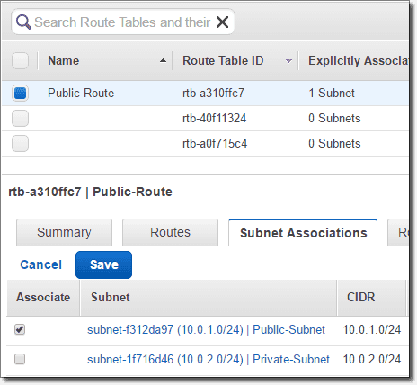
Create Public Subnet Public Route association

In addition to the Public-Route Table, we now want to create a Private-Route Table. So, again, go to Route Tables > Create Route Table. Provide the Name Tag: Private-Route, select the 4sysops VPC, and then click Yes, Create.
There is no need to edit or add any additional routes under the Route Tab for the Private-Route. This is a private route only within our VPC, so all traffic is okay to communicate with any other subnet inside 10.0.0.0/16. However, we do need to associate the Private-Route with our Private-Subnet. To do this, again,with the Private-Route selected, on the Subnet Associations tab, click Edit, place a checkmark next to the 10.0.2.0/24 | Private-Subnet, and then click Save.

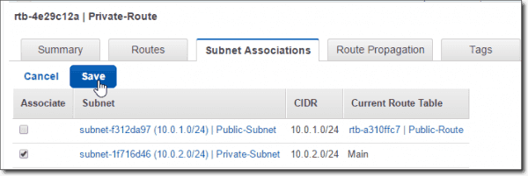
Create Private Subnet Private Route association

When we’ve created our Route Tables, we should see the following tables listed, as well as an explicit subnet association for each of them (Public-Route to Public-Subnet and Private-Route to Private-Subnet):

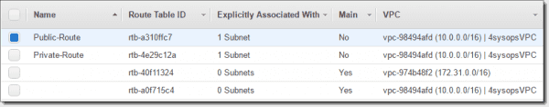
Completed Route Tables

Create AWS VPC Network Access Control Lists and Rules ^
Next, we’ll create our Network Access Control Lists: Private-NACL and Public-NACL. If you’re unfamiliar with NACLs, they are similar to Security Groups in that you can shape traffic defined by rules. Unlike Security Groups, NACLs operate at the subnet level and are stateless, whereas Security Groups operate at the instance level and are stateful. You can find some useful information about NACLs here and how they compare to Security Groups here. I found the following diagram helpful in regard to NACLs.

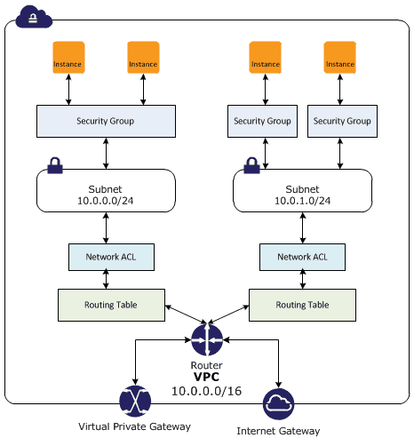
NACL vs. Security Group diagram

In the main VPC menu, go to Security > Network ACLs > Create Network ACL, add the Name tag: Private-NACL, select the 4sysops VPC, and then click Yes – Create.

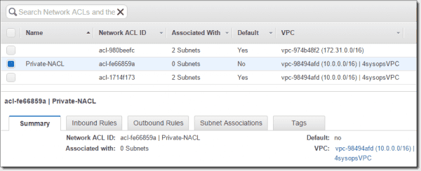
Create network ACL Private NACL

Create a new inbound rule by first clicking on the Inbound Rules tab and then Edit. Add Rule # “100” > All TCP coming from Public-Subnet source 10.0.1.0/24, we select Allow and then Save.

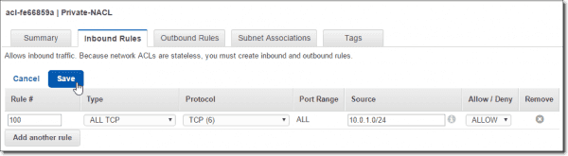
Create Private NACL inbound rule

Because NACLs are stateless, do the same in the Outbound Rules: ALL TCP destination: 10.0.1.0/24 Allow (Public-Subnet).

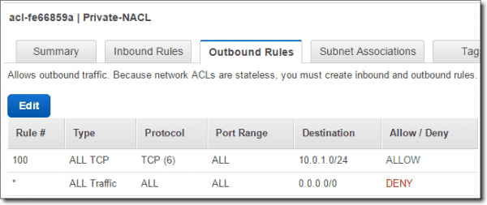
Create Private NACL outbound rule

Next, go to the Subnet associations tab and associate the Private-NACL with the Private-Subnet.

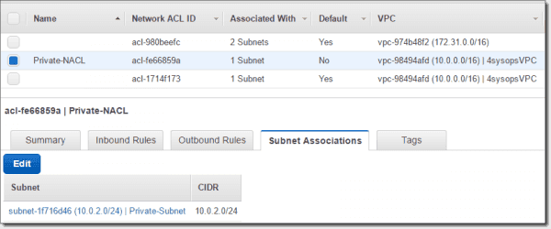
Private NACL and Private Subnet association

So, now our Private-NACL has a traffic policy with our Public-Subnet, within our VPC, and is associated with our Private-Subnet.
We will now essentially replicate our Private-NACL to a new Public-NACL, with similar rules.
In the main VPC menu, go to Security > Network ACLs > Create Network ACL, add the Name tag: Public-NACL, select the 4sysops VPC, and then click Yes – Create.

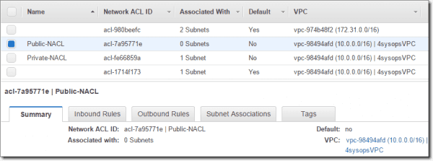
Create network ACL Public NACL

Again, create a new inbound rule for the Public-NACL. However, since I will be managing this network from my home computer, I will want to allow all TCP traffic from my external IP address. Replace this address with your own external IP address.
Edit > Rule #: 100, Type: All TCP, Protocol TCP (6), Port Range: ALL, Source: x.x.x.x/32, Allow/Deny: ALLOW. > Save. Doing this creates a rule to allow traffic coming from my IP address with a /32 CIDR to access the Bastion instance. If you wanted to, you could limit this to just port 22 or 3389 for remote administration.

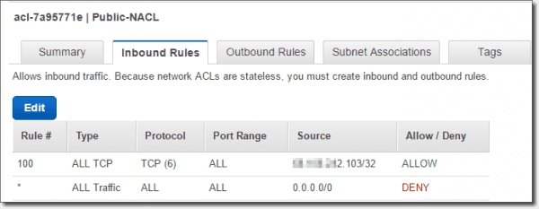
Create Public NACL inbound rule

Add another rule for the Private-Subnet to communicate with the Public-Subnet.
Inbound Rules > Edit / Add another rule > Rule #: 200, Type: All TCP, Protocol TCP (6), Port Range: ALL, Source: 10.0.2.0/24, Allow/Deny: ALLOW > Save.

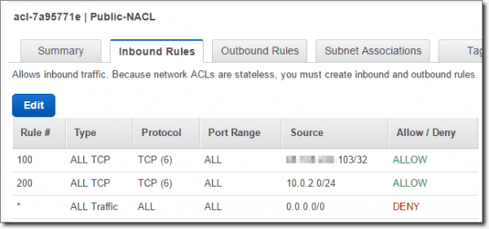
Create Public NACL inbound Private Subnet rule

Similar to our inbound rules, because we are modifying stateless connection traffic, we need to do the same for outbound traffic.
Outbound Rule tab > Edit > Rule #: 100, Type: All TCP, Protocol TCP (6), Port Range: ALL, Source: x.x.x.x/32, Allow/Deny: ALLOW. > Save
Outbound Rule tab > Edit > Rule #: 200, Type: All TCP, Protocol TCP (6), Port Range: ALL, Source: 10.0.2.0/24, Allow/Deny: ALLOW. > Save

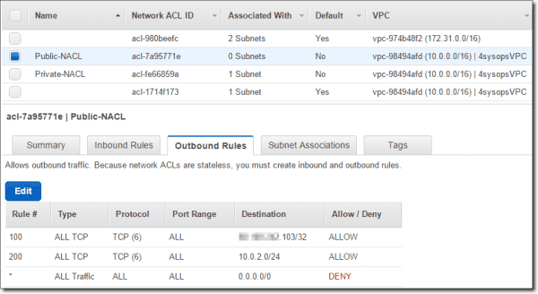
Create Public NACL outbound rules

We’ll now associate the Public-NACL to the Public-Subnet by clicking Subnet Associations > Edit and select Public-Subnet > Save.

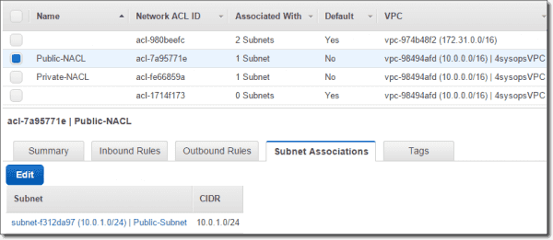
Associate Public NACL with Public Subnet

Now we have our NACLs set up to allow all TCP traffic to and from our home IP address to the Public-Subnet and, also, all TCP traffic between the two subnets is allowed.

Create AWS VPC Security Groups ^
Here, we’ll create two Security Groups for the instances which we will create shortly. Go to VPC Dashboard > Security > Security Groups > Create Security Group > Name tag: Public-SG, Group name: Public-SG, Description: To be used by the bastion instance, VPC: 4sysopsVPC.

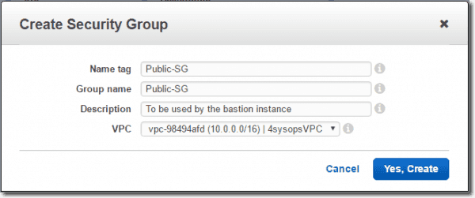
Create Public SG security group

Along the same lines as the other security measures, we’ll create a second security group named Private-SG.
Go to VPC Dashboard > Security > Security Groups > Create Security Group > Name tag: Private-SG, Group name: Private-SG, Description: Used for private instances, VPC: 4sysopsVPC.
Next, we’ll configure the inbound rules for the Security Groups, and we’ll narrow down the traffic to just the management protocols we’ll use to access the instances. First, we’ll start with the Private-SG and go to the Inbound Rules tab > Edit > Type: SSH (22) Protocol: TCP (6) Source: Public > Save. Creating this rule will allow port 22 from the public security group to access the private security group.
For the Public-SG inbound, we want SSH traffic coming from the Private-SG and also SSH coming from my IP address. Public-SG > Inbound Rules tab > Edit > Type: SSH (22)Protocol: TCP (6) Source: x.x.x.x/32. > Save.

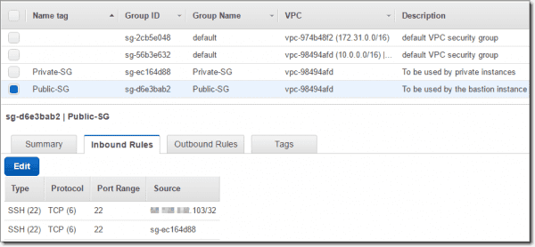
Public SG inbound rules

With the majority of our work complete, our next article in the three-part series here will show how to create two AWS instances in our VPC, how to securely connect to the Bastion instance, and, finally, how to use Pageant and SSH to connect through our Bastion host to our Private Instance.
In parts one and two of this three-part series, we demonstrated the creation of a VPC, IGW, Route Tables, NACLs, and Security Groups, coupled with associations and rules. In this third article, we demonstrate how to set up an instance in each of our networks (Public and Private), test connectivity, and ensure only our Bastion instance has the ability and keys necessary to connect to our Private instance via SSH and Pageant. We also utilize our existing Subnets and Security Groups when building our instances.

Contents of this article
- Create AWS Public and Private Instances
- Remote SSH Console Connections with PuTTY
- Final Considerations

Create AWS Public and Private Instances ^
Instances are, of course, Amazon Machine Images (servers) that are part of the EC2 section of AWS. We’ll start with creating the Bastion host. Go to the AWS Dashboard > EC2 > Create Instance > Launch Instance > Choose Amazon Machine Image: (Free Tier Eligible)Amazon Linux AMI HVM > Select > Instance Type: Free Tier t2.micro > Configure Instance Details:

Network: 4sysopsVPC
Subnet: Bastion is in Public-Subnet
Auto-assign Public IP: Enable (because we want a public IP address for the Bastioninstance)

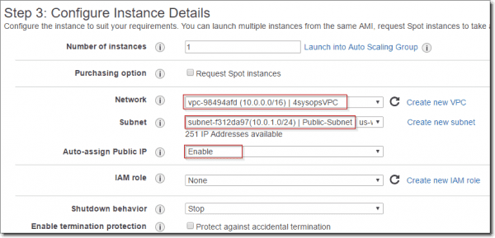
Configure Bastion instance details

Next: Add Storage (leave defaults here) > Next: Tag Instance > Name = Bastion > Next: Configure Security Group.
Step 6: Configure Security Group > Assign SG > Select an existing SG > Public-SG > Review and Launch.

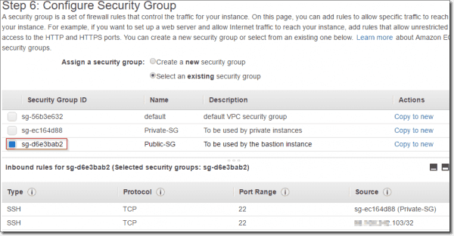
Configure Bastion instance with Public SG

Review and Launch > Launch
As with most AMI Linux instances, we’ll now need to either use an existing key pair or create a new key pair. Select Create a new key pair, and then provide a key pair name: such as bastion4sysopskp > Download Key Pair > Launch Instances.
We’ve now created the Bastion instance, as displayed in the following diagram, which is nested inside our Public Subnet, the Public Security Group, the Availability Zone US-West 1a, and our VPC.

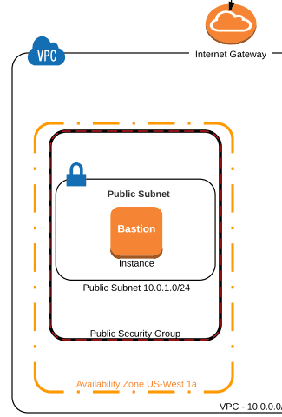
Bastion instance diagram

Next, we’ll create the private instance. Go to the AWS Dashboard > EC2 > Create Instance > Launch Instance > Choose Amazon Machine Image: (Free Tier Eligible) Amazon Linux AMI HVM > Select > Instance Type: Free Tier t2.micro > Configure Instance Details:
Network: 4sysopsVPC
Subnet: The PrivateInstance will live in the Private-Subnet. When we select this subnet, our instance is automatically created within the Availability Zone US-West 1c
Auto-assign Public IP: Use subnet setting (Disable) (because we do not want a public IP address for the PrivateInstance)
Next: Add Storage (leave defaults here) > Next: Tag Instance > Name = PrivateInstance > Next: Configure Security Group.
Step 6: Configure Security Group > Assign SG > Select an existing SG > Private-SG (this will allow SSH from the Public Security Group) > Review and Launch.

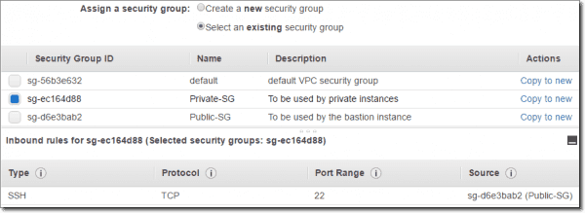
Private instance Security Group

Note: If you receive a warning here that 0.0.0.0 allows all IP addresses to access your instance, it’s okay to proceed, because our subnet and NACL rules contain security, and our PrivateInstance will not have a Public IP.
We’re almost finished with our PrivateInstance host, so click Review and Launch > Launch > Choose an existing key pair > Select a key pair: bastion4sysopskp > Acknowledge > Launch Instances > View Instances.
With both of our instances built, we can see that our Bastion has a public IP address, and our PrivateInstance (selected in the following screenshot) only has a Private IP address:

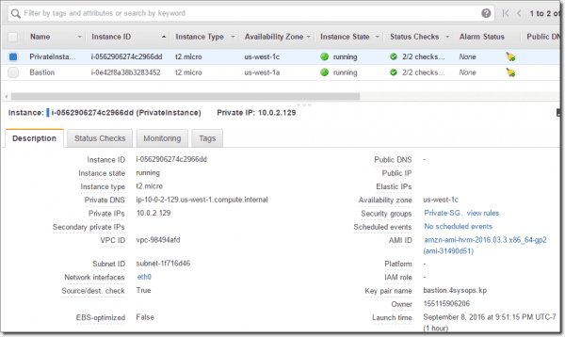
Bastion and Private instances

Remote SSH Console Connections with PuTTY ^
Now we can test logging in to our Bastion remotely with PuTTY and, secondly, connect to the Private instance. First, we want to ensure that we can at least connect to the Bastion from our home IP, and then we can move on to agent forwarding to connect to our Private instance.
Hopefully, you’re familiar with connecting to an AWS Linux instance with PuTTY. If not, you can review the procedure by right-clicking on the Bastion instance, then click Connect. Further information about how to connect to an instance with PuTTY can be found here. Convert the key you previously downloaded into a .ppk file with PuTTYGen, and add that private key to PuTTY for your Bastion session. For the Bastion hostname or IP, get the public IP address from your list of running AWS Instances, and also save the hostname or public IP into the session settings within PuTTY:

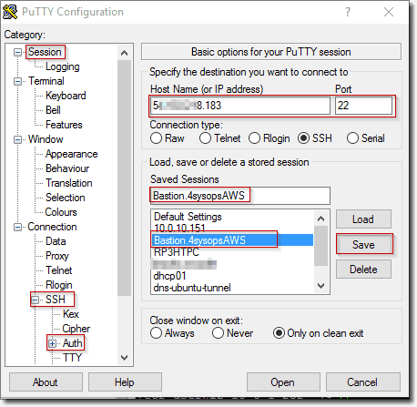
Bastion PuTTY settings

When connecting for the first time, you may receive a warning about the key, and then you’ll be prompted to log in with a username. The default username for an Amazon Linux AMI is ec2-user.
If you’re greeted with the following session, you’re in!

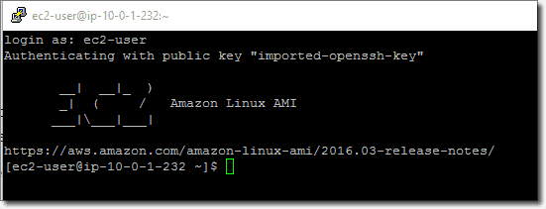
Successful AWS PuTTY session connection

Now that we’ve been authenticated into our Bastion host, we want to connect via SSH into our PrivateInstance. To do this, first we need to close our connection and then use PuTTYGen, Pageant, and PuTTY to allow agent forwarding. Essentially, Pageant runs as a service in Windows and forwards our key over to our PrivateInstance without having to set up a new key with SSH-keygen (never keep your private key for your Private Instances on your Bastion Host). If you’re unfamiliar with connecting to Linux instances running in a private Amazon VPC with PuTTY, there is a good AWS Security Blog post explaining the concepts and procedure here.
After you’ve imported and converted your key with a passphrase, re-connect back to your Bastion host. You can now issue the following command to SSH into your PrivateInstance:
ssh ec2-user@<PrivateInstance-IP-address or DNS-entry>
Once connected, you should be greeted with the PrivateInstance’s shell prompt:

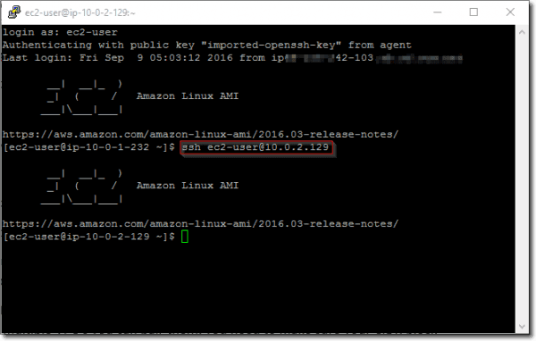
Successful Private Instance SSH session from Bastion

Final Considerations ^
With our connection to our PrivateInstance complete, we may want to create an Elastic IP address for our Bastion host, which currently only has an AWS-issued DHCP address. An Elastic IP will ease the pain by protecting a single IP address for us (the first one is free, I believe,) and, no matter which address our Bastion host receives upon reboot, we can still get to the Bastion by connecting to our Elastic IP. I won’t go over the Elastic IP procedure here, but it’s a great feature to be aware of in case you want a consistent connection experience.
Lastly, our Linux instances could just as easily have been replaced with Windows Server hosts and, as such, we would have opened things up for RDP traffic as well as decrypt Administrator passwords.

