**SCREENSHOTS  
Course End Project 2: Real-time Data Management**

**Steps for Implementation:**

**Step 1: Create Producer Lambda function  
**

**Step 2: Create Kinesis Data Stream  
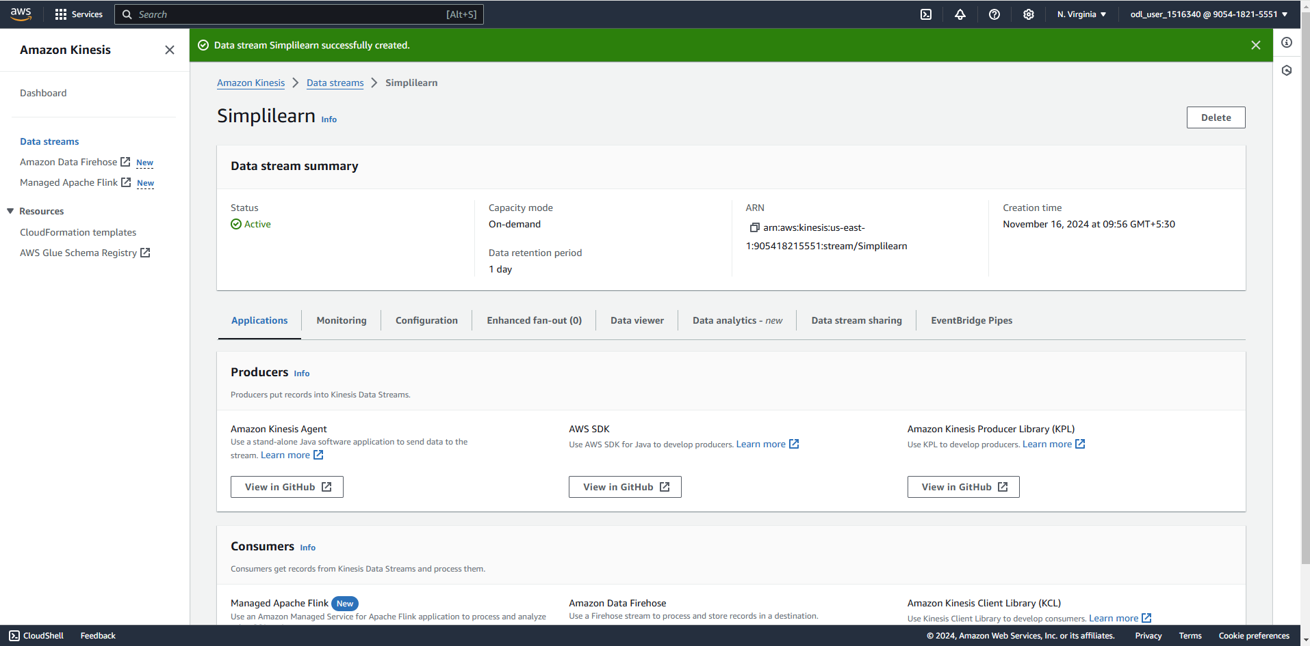**

**Step 3: Create Consumer Lambda function**

****

**Step 4: Create DynamoDB Database  
**

**Step 5: Perform Tests  
**