**Unit 2 | Assignment - The VBA of Wall Street**

**Multi Year Stock Data Result _2016**

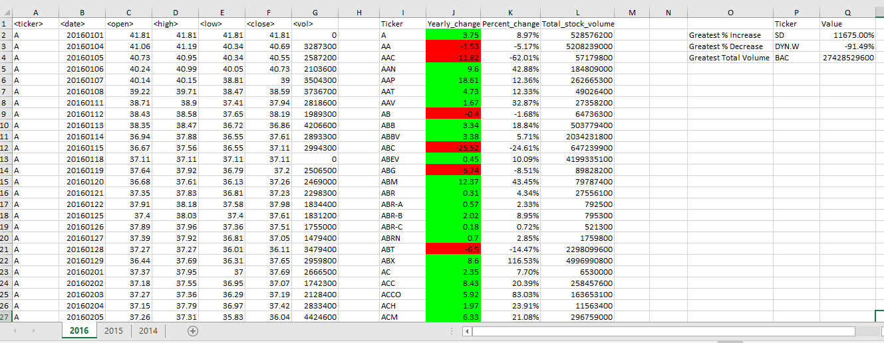

**Multi Year Stock Data Result_2015**

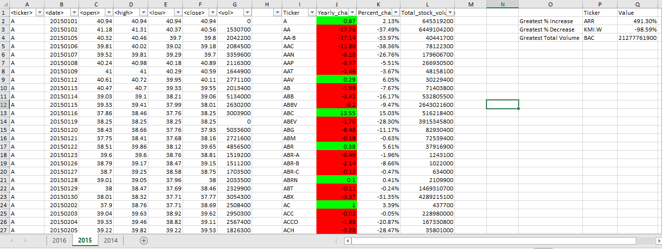

**Multi Year Stock Data Result_2014**

