**Practical :-11**

**Aim:-** Write a program that demonstrates asynchronous behavior using a callback function. For example, create a function that simulates fetching data from an API and invokes a callback with the fetched data.

**Code:-**

function fetchDataFromAPI(callback) {

    setTimeout(() => {

      const data = { message: "Data fetched from API is as bellow",data:{Name:"Nishar Khorajiya",Id:"21CE057"} };

      callback(null, data);

    }, 2000);

  }

  function handleFetchedData(error, data) {

    if (error) {

      console.error("Error fetching data:", error);

    } else {

        console.log("Fetched data:", data);

        console.log("My name is:",data.data.Name);

        console.log("My Id No is:",data.data.Id);

    }

  }

  console.log("Fetching data from API...");

  fetchDataFromAPI(handleFetchedData);

  console.log("Fetching process initiated, waiting for response...");

**output:-**

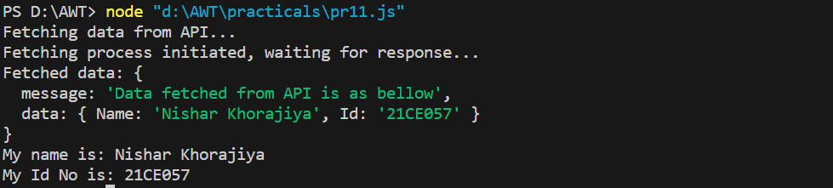

**Practical :-12**

**Aim:-** Create a program that reads a file asynchronously using callbacks and displays its contents.

**Code:-**

const fs = require("fs");

function readFileAsync(filename, callback) {

  fs.readFile(filename, "utf8", (err, data) => {

    if (err) {

      callback(err, null);

      return;

    }

    callback(null, data);

  });

}

function displayFileContents(err, data) {

  if (err) {

    console.error("Error reading the file:", err.message);

  } else {

    console.log("File contents:");

    console.log(data);

  }

}

const filename = "./practicals/pr12/example.txt";

console.log(`Reading file: ${filename}`);

readFileAsync(filename, displayFileContents);

console.log("Reading file process initiated...");

**output:-**

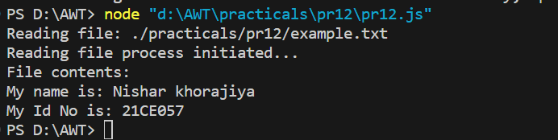

**Practical :-13**

**Aim:-** Write a program that uses Promises to handle asynchronous operations. For example, create a function that returns a Promise to fetch data from an API and resolve it with the fetched data. Implement error handling using Promises by rejecting a Promise with an error message in case of failure.

**Code:-**

const fetchFromAPI = () => {

    return new Promise((resolve, reject) => {

      const success = true;

      setTimeout(() => {

        if (success) {

          const data = { message: "Data fetched from the API" };

          resolve(data);

        } else {

          reject(new Error("Failed to fetch data from the API"));

        }

      }, 2000);

    });

  };

  fetchFromAPI()

    .then((data) => {

      console.log("API call successful:", data);

    })

    .catch((error) => {

      console.error("API call failed:", error.message);

    });

**output:-**

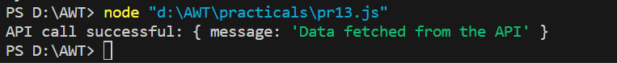

**Practical :-14**

**Aim:-** Convert a Promise-based asynchronous function into an async/await style function. For example, rewrite a function that fetches data from an API using async/await. Write a program that utilizes multiple async/await functions to fetch data from different APIs sequentially and display the combined results.

**Code:-**

const fetchFromAPI = () => {

    return new Promise((resolve, reject) => {

      const success = true;

      setTimeout(() => {

        if (success) {

          const data = { message: "Data fetched from the API" };

          resolve(data);

        } else {

          reject(new Error("Failed to fetch data from the API"));

        }

      }, 2000);

    });

  };

  const fetchFromAnotherAPI = () => {

    return new Promise((resolve, reject) => {

      const success = true;

      setTimeout(() => {

        if (success) {

          const data = { message: "Data fetched from another API" };

          resolve(data);

        } else {

          reject(new Error("Failed to fetch data from another API"));

        }

      }, 1500);

    });

  };

  const fetchDataSequentially = async () => {

    try {

      const apiData = await fetchFromAPI();

      console.log("API 1 data:", apiData);

      const anotherApiData = await fetchFromAnotherAPI();

      console.log("API 2 data:", anotherApiData);

    } catch (error) {

      console.error("Error:", error.message);

    }

  };

  fetchDataSequentially();

**output:-**

