Title : Convert any numeric value input by the user to its English currency
Prerequisites:
- .net Core SDK (version 3.1)
- Visual Studio
Get Started
- Clone the repository from visual code using below comment.
  - Git clone https://github.com/nisharafic001/AccessPracticleTest.git
- Navigate to the project directory “Access.Web.API”
- Click on the “Access.Web.API.sln”
- Right Click on the solution and click to build
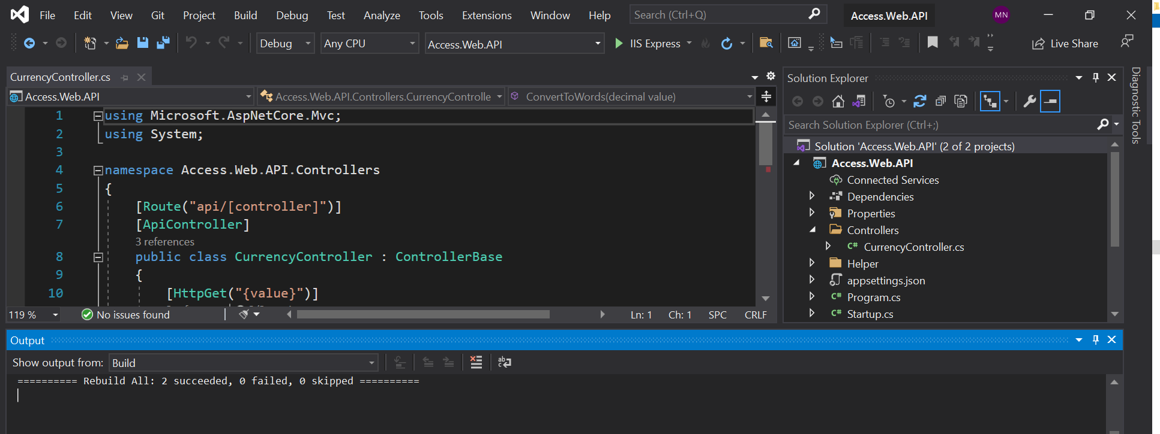
- Upon successful build. Click on the IIS Express Icon to launch the project in browser. (below is the screenshot of swagger to test the currency to English words.
The Api now be running on https://localhost:44383 and to test the API use https://localhost:44383/swagger/index.html
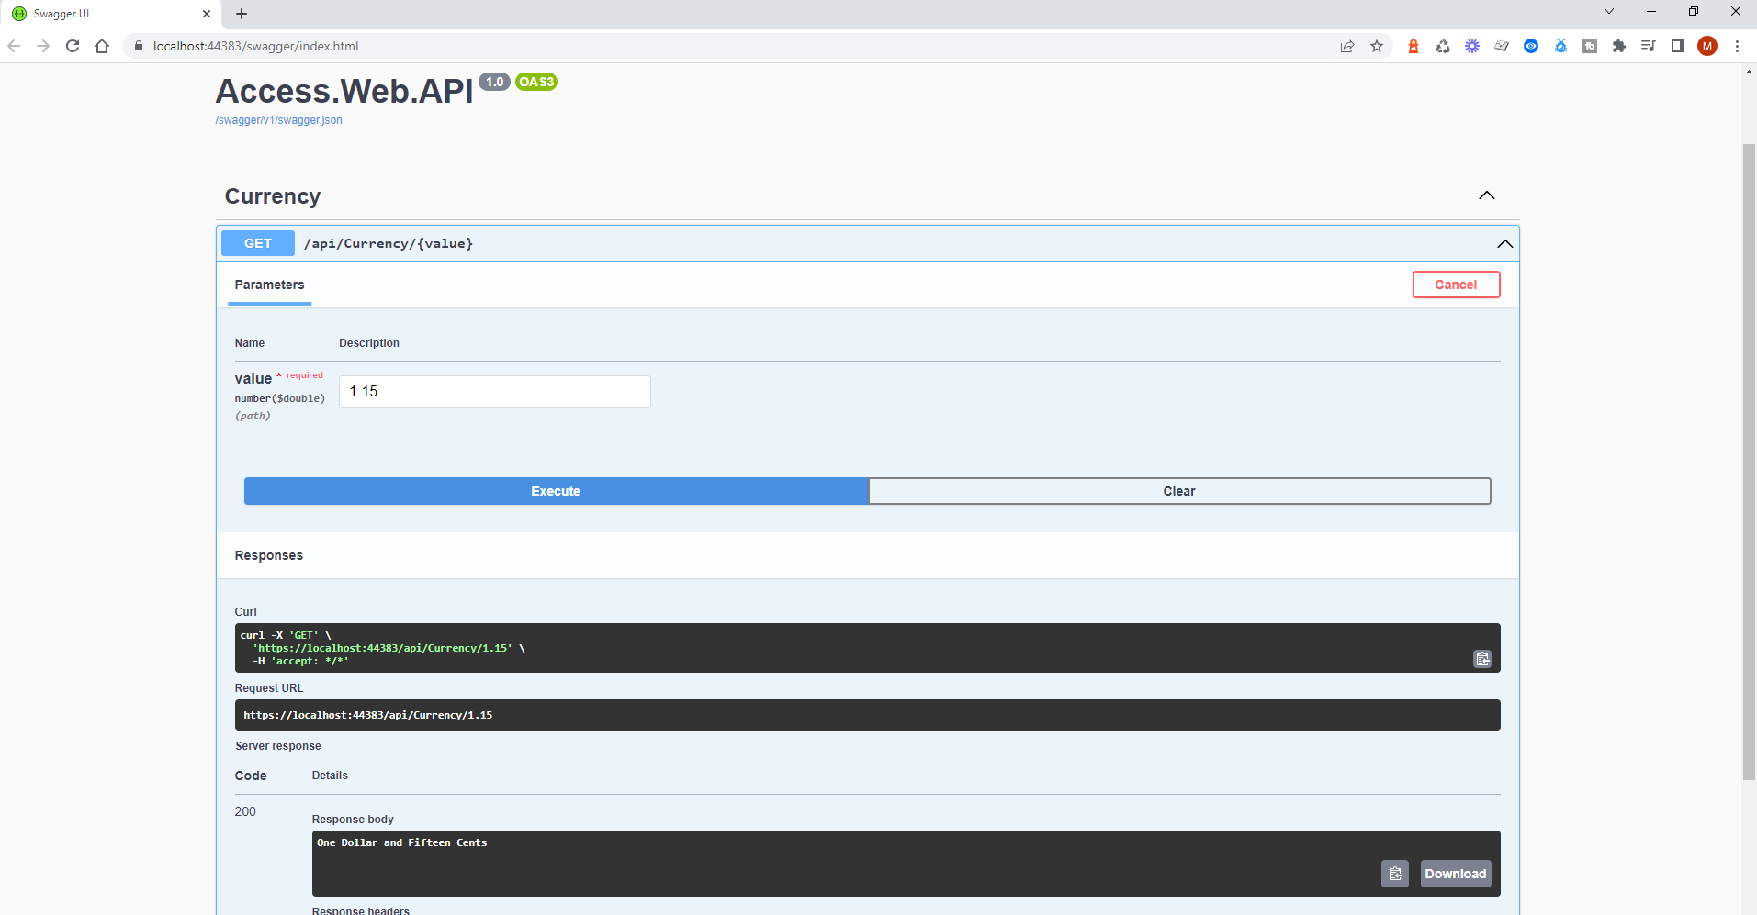
Enter the value and click on the execute button to view the expected output.

Running the Tests

- Navigate to the test project directory or select the test project.
- On successful build. Click on the Test menu and select Test Explore.
- Right click on any test case and choose “Run Test”.
