Inventory Reservation System
Reviewer Guide: Setup, Run and Test

Candidate | [Your name]
Position | [Role you are applying for]
Submitted | [Date]
Repository / archive | [Link or file name]
Stack | .NET 9 · ASP.NET Core · EF Core 9 · MySQL 8 · JWT · Serilog · xUnit · Docker

This guide takes you from a fresh download to a running, tested app in about 15 minutes. Follow sections 2 to 4 in order. Sections 7 onwards explain how the app works.
Section | What you will do | Time
2. Set up and start the app | Install Docker, create the settings file, start everything with one command | 5 min
3. Try it in Swagger | Log in, create a product, reserve, confirm, cancel, see expiry and errors | 5 min (+2 min wait)
4. Run the automated tests | Run all 248 tests, including the 500-request test | 3 min
5–6. Stop, reset, troubleshoot | Only if you need them | —

1. What the app does
An API for reserving products. A user reserves some stock, and it is held for 2 minutes. In that time they can confirm it (buy it) or cancel it. If they do neither, the reservation expires and the stock goes back on sale.
The main promise: you can never sell more than you have, even when hundreds of people try to buy the last item at the same moment, and even when several copies of the API are running.
Proof: 500 people, 1 item
Stock: 1
Requests: 500 at the same moment
Success: 1
Rejected: 499
Overselling: 0
This test runs against a real MySQL database every time the tests run, and it has never oversold. You can run it yourself in section 4.

2. Set up and start the app
You do not need to install MySQL or create a database. Docker starts MySQL, creates the database and tables, and creates the admin user for you.

2.1 What you need
Tool | Needed for | Check it with
Docker Desktop (running) | Starting the app | docker --version
.NET 9 SDK | Running the automated tests only | dotnet --version (shows 9.x)
Free ports 8080 and 3306 | The API and MySQL | If one is taken, see step 2 below

2.2 Start it
- Open a terminal in the project folder (the folder that contains docker-compose.yml).
- Create your settings file by copying the example:
# macOS / Linux / Git Bash
cp .env.example .env

# Windows PowerShell
Copy-Item .env.example .env

- Open .env in any text editor and replace every change-me value with your own. Remember the admin password: you will use it to log in.
MYSQL_ROOT_PASSWORD=<choose a password>
MYSQL_PASSWORD=<choose another password>
JWT_SIGNING_KEY=<any random text, at least 32 characters>
DEMO_ADMIN_USERNAME=admin
DEMO_ADMIN_PASSWORD=<choose the admin password>
SWAGGER_ENABLED=true

If port 3306 or 8080 is already used on your computer, change MYSQL_PORT (for example to 3307) or API_PORT in the same file.
- Start the app:
docker compose up --build

- Wait about 1 minute the first time. In a second terminal, check that both parts are ready:
docker compose ps # both lines should say (healthy)

- Open these links in your browser:
Link | What you should see
http://localhost:8080/health/ready | Healthy (the API can reach the database)
http://localhost:8080/swagger | The Swagger page listing all endpoints

That is it: the app is running. Continue with section 3 to try it.

3. Try it in Swagger (step by step)
Follow these steps in order to try every feature: log in, create a product, reserve, buy, cancel, watch a reservation expire, and see the main errors. It takes about 5 minutes, plus a 2-minute wait for the expiry step. Your ids and times will differ from the screenshots.
Before you start: the app is running (section 2), and you know the admin username and password you put in .env.
How to use Swagger
Expand an endpoint | Click its coloured row (e.g. the green POST bar).
Enable editing | Click Try it out (top right of the expanded endpoint).
Send the request | Edit the request body or the id field, then click Execute.
Read the result | Scroll to Server response: status code and response body.

Step 0. Open Swagger UI
Browse to http://localhost:8080/swagger. Protected endpoints show a padlock; login and health do not.
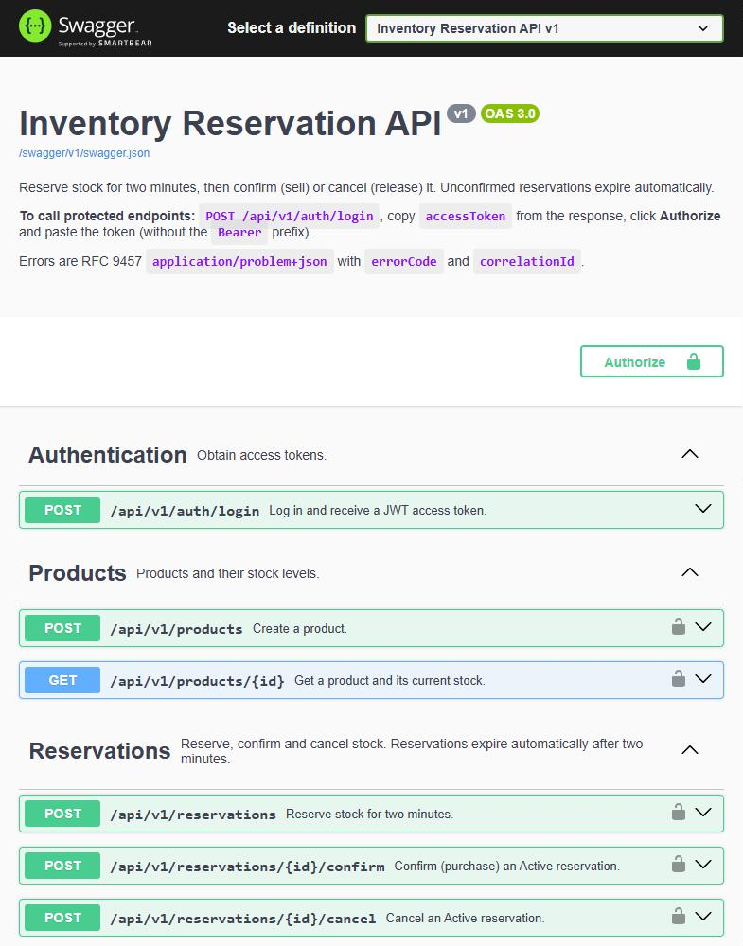
Figure 1: Swagger UI with the Authorize button and padlocked endpoints

Step 1. Log in and get a JWT
Endpoint: POST /api/v1/auth/login
- Expand the endpoint → Try it out → replace the body with your credentials → Execute.
{
"username": "admin",
"password": "<DEMO_ADMIN_PASSWORD from .env>"
}

Expected: 200 OK the body contains accessToken, tokenType: "Bearer" and expiresAtUtc (60 minutes).
- Copy the value of accessToken (without the quotes). You need it in Step 2.
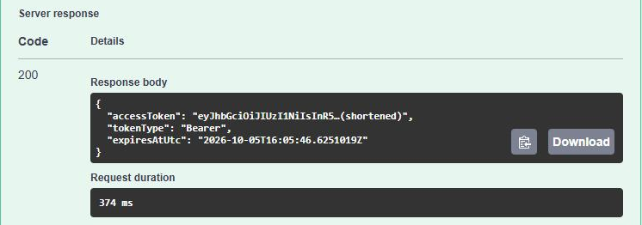
Figure 2: Login response (token shortened in this image)

Step 2. Authorize Swagger with the token
- Scroll to the top and click Authorize.
- Paste the token into Value. Do not type the word Bearer; Swagger adds it.
- Click Authorize, then Close. The padlocks now appear closed.
Expected: Authorized the dialog shows "Authorized" and the value is masked.
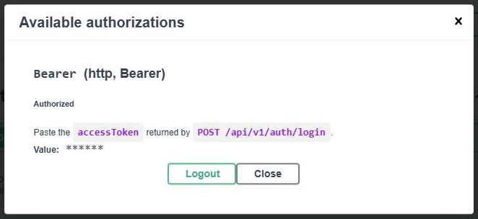
Figure 3: Authorize dialog after a successful authorization

Step 3. Create a product (Admin only)
Endpoint: POST /api/v1/products
{
"sku": "DEMO-PHONE-001",
"name": "Demo Phone",
"totalQuantity": 3
}

Expected: 201 Created reservedQuantity: 0, soldQuantity: 0, availableQuantity: 3. A Location header points to the new product.
- Copy the product id for the next steps. (Running it twice returns 409 DUPLICATE_SKU; use another SKU.)
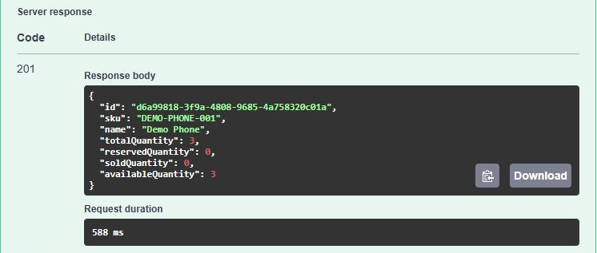
Figure 4: Product created

Step 4. Reserve stock
Endpoint: POST /api/v1/reservations
{
"productId": "<product id from Step 3>",
"quantity": 2
}

Expected: 201 Created status: "Active", and expiresAtUtc is 2 minutes after createdAtUtc.
- Copy the reservationId. Complete Step 6 within 2 minutes, otherwise the reservation expires.
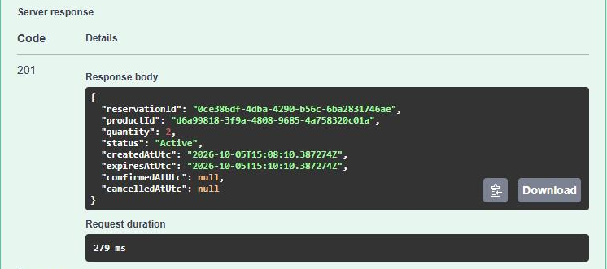
Figure 5: Active reservation holding 2 units

Step 5. Try to oversell (insufficient stock)
Endpoint: POST /api/v1/reservations (same body, quantity 2)
The product has 3 in stock and 2 are already reserved, so only 1 is left. Asking for 2 more must fail.
Expected: 409 Conflict ProblemDetails with title: "Insufficient inventory" and errorCode: "INSUFFICIENT_STOCK". Nothing is reserved.
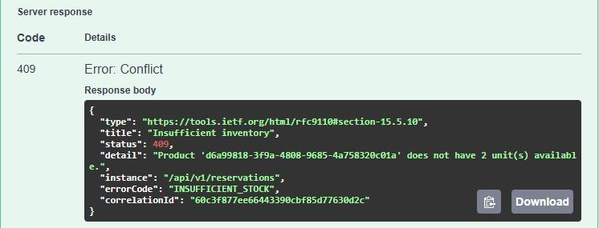
Figure 6: Overselling is rejected

Step 6. Confirm the reservation (purchase)
Endpoint: POST /api/v1/reservations/{id}/confirm
- Paste the reservationId from Step 4 into the id field → Execute (no body).
Expected: 200 OK status: "Confirmed" with confirmedAtUtc set. The 2 reserved units are now sold.
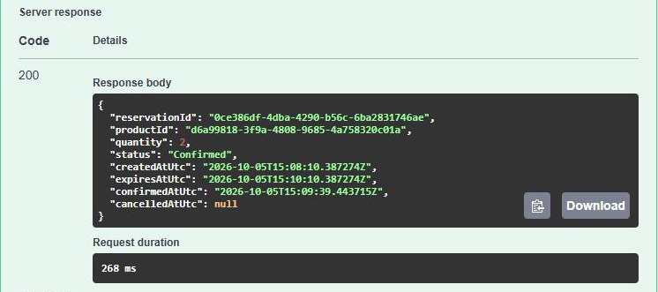
Figure 7: Reservation confirmed

Step 7. Confirm the same reservation again
Endpoint: POST /api/v1/reservations/{id}/confirm (same id)
Expected: 409 Conflict errorCode: "INVALID_RESERVATION_STATE" and the message "…is already Confirmed." The same item cannot be bought twice.
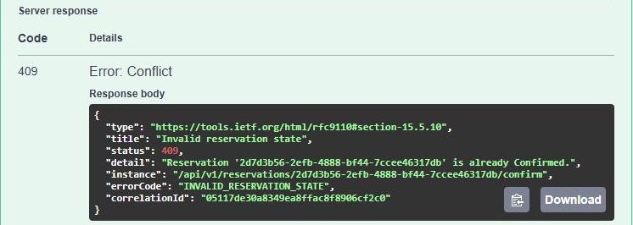
Figure 8: Second confirm is rejected

Step 8. Check the product stock
Endpoint: GET /api/v1/products/{id}
- Paste the product id from Step 3 → Execute.
Expected: 200 OK totalQuantity: 3, reservedQuantity: 0, soldQuantity: 2, availableQuantity: 1.
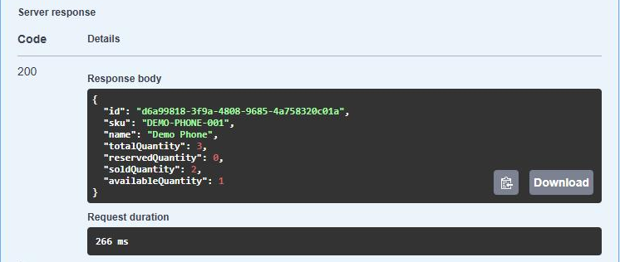
Figure 9: Stock after the sale

Step 9. Reserve and cancel
- POST /api/v1/reservations with { "productId": "<product id>", "quantity": 1 } → 201. Copy the new reservationId.
- POST /api/v1/reservations/{id}/cancel with that id → Execute.
Expected: 200 OK status: "Cancelled" with cancelledAtUtc set. The unit is released (Step 8 again shows availableQuantity: 1).
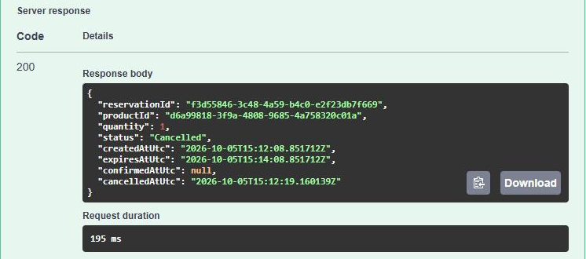
Figure 10: Reservation cancelled and stock released

Step 10. Automatic expiry after 2 minutes
- Reserve again: POST /api/v1/reservations with quantity: 1. Copy the reservationId and note expiresAtUtc.
- Wait about 2 minutes 15 seconds (the background worker sweeps every 15 seconds).
- Run GET /api/v1/products/{id}: reservedQuantity is back to 0 and availableQuantity to 1.
- Try to confirm the expired reservation: POST /api/v1/reservations/{id}/confirm.
Expected: 409 Conflict errorCode: "RESERVATION_EXPIRED". A reservation older than 2 minutes can never be bought.
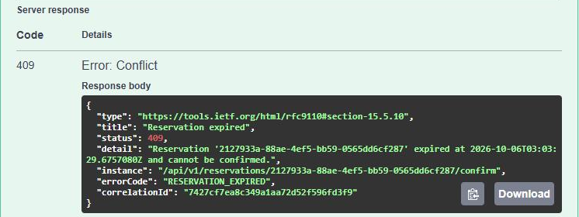
Figure 11: An expired reservation cannot be confirmed

Step 11. Validation error
Endpoint: POST /api/v1/reservations
{
"productId": "<product id>",
"quantity": 0
}

Expected: 400 Bad Request errorCode: "VALIDATION_FAILED" with a per-field message under errors.quantity.
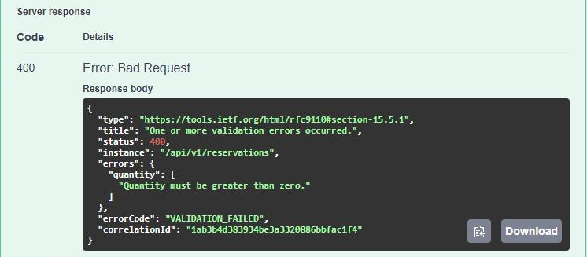
Figure 12: Validation error

Step 12. Call a protected endpoint without a token
- Click Authorize → Logout → Close. The padlocks open again.
- Run GET /api/v1/products/{id} again.
Expected: 401 Unauthorized errorCode: "UNAUTHORIZED", detail "A valid bearer token is required." Authorize again (Step 2) to continue.
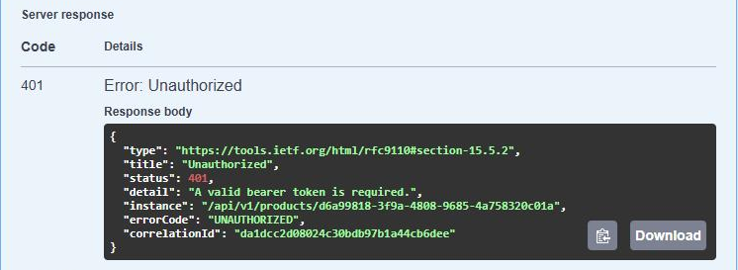
Figure 13: Request without a token is rejected

Checklist
Tick each row as you go. Every error has the same JSON shape, with an errorCode and a correlationId.
# | Action | Expected | Result
1 | Login | 200, JWT returned | ☐
2 | Authorize | Padlocks closed | ☐
3 | Create product (stock 3) | 201, available 3 | ☐
4 | Reserve 2 | 201, Active, expires in 2 minutes | ☐
5 | Reserve 2 more | 409 INSUFFICIENT_STOCK | ☐
6 | Confirm | 200, Confirmed | ☐
7 | Confirm again | 409 INVALID_RESERVATION_STATE | ☐
8 | Get product | 200, reserved 0 / sold 2 / available 1 | ☐
9 | Reserve 1 + cancel | 200, Cancelled, stock released | ☐
10 | Reserve 1, wait 2 min, confirm | 409 RESERVATION_EXPIRED, stock released | ☐
11 | Reserve quantity 0 | 400 VALIDATION_FAILED | ☐
12 | No token | 401 UNAUTHORIZED | ☐

Optional: a normal (non-admin) user who tries to create a product gets 403 FORBIDDEN. Only the admin is created by default, so this case is checked by the automated tests instead.

4. Run the automated tests
You need the .NET 9 SDK for this. Run the commands from the project folder.

4.1 Quick run (no database needed)
dotnet test

Expected: 248 tests: 197 passed, 51 skipped, 0 failed (about 30 seconds). The skipped tests are the ones that need MySQL; 4.2 runs them too.

4.2 Full run, including MySQL and the 500-request test
- Make sure MySQL is running:
docker compose up -d mysql

- Tell the tests how to reach MySQL. Use the MYSQL_ROOT_PASSWORD from your .env, and its MYSQL_PORT if you changed it from 3306.
# macOS / Linux / Git Bash
export INVENTORY_TEST_MYSQL=\
"Server=localhost;Port=3306;User=root;Password=<MYSQL_ROOT_PASSWORD>"

# Windows PowerShell
$env:INVENTORY_TEST_MYSQL = `
"Server=localhost;Port=3306;User=root;Password=<MYSQL_ROOT_PASSWORD>"

- Run the tests in the same terminal:
dotnet test

Expected: 248 tests: 248 passed, 0 failed (about 2 minutes).
Your app data is safe: each test creates its own temporary database and deletes it afterwards.

4.3 Run only the concurrency tests
Handy for running the race tests several times in a row (keep INVENTORY_TEST_MYSQL set):
dotnet test tests/Inventory.IntegrationTests \
--filter "FullyQualifiedName~Concurren|FullyQualifiedName~Race"

4.4 What the concurrency tests prove
Scenario | Result
500 requests for 1 item | 1 success, 499 rejected, no overselling
500 requests for 100 items | 100 successes, 400 rejected, no overselling
Same, through the full HTTP API with 500 different users | 100 × 201, 400 × 409, none rate limited
20 confirms of the same reservation | Exactly 1 succeeds, sold once
20 cancels of the same reservation | Exactly 1 succeeds, stock returned once
Confirm and cancel at the same moment | Exactly one wins each time
8 expiry jobs running at once | Each reservation expired once
Expiry vs confirm, expiry vs cancel | Exactly one wins, stock returned at most once

After every run the test also checks the stock numbers stored in the database.

5. Stop or reset
Command | What it does
docker compose down | Stops the app. Your data is kept for next time.
docker compose down -v | Stops the app and deletes all data. Next start is completely fresh.

6. Troubleshooting
Problem | Fix
docker compose says a value must be set in .env | You skipped step 2 or 3 of section 2.2. Create .env and fill in every value.
Port 3306 or 8080 is already in use | Change MYSQL_PORT or API_PORT in .env, then run docker compose up -d again.
Swagger page does not open | Check SWAGGER_ENABLED=true in .env, then run docker compose up -d again.
Login fails with the correct password | The admin user is only created on the very first start. If you changed the password later, run docker compose down -v and start again.
All MySQL tests are skipped | Set INVENTORY_TEST_MYSQL in the same terminal where you run dotnet test.
Tests time out on a slow machine | Give Docker Desktop more CPU and memory, and close other heavy programs.

7. How it works

7.1 The idea in plain words
Each product stores three numbers: total stock, how many are reserved, and how many are sold. What is still available is simply whatever is left over.
- Reserve: move some units from available to reserved.
- Confirm: move them from reserved to sold.
- Cancel or expire: give them back to available.
A reservation starts as Active and can end only once: Confirmed, Cancelled or Expired. A confirmed reservation can never be cancelled, and an expired one can never be confirmed.

7.2 How overselling is prevented
The app never does "read the stock, check it in C#, then save". Between the read and the save, someone else could take the same unit. Instead, the check and the change happen together, in one database statement:
Reserving stock
UPDATE Products
SET ReservedQuantity = ReservedQuantity + @quantity
WHERE Id = @productId
AND (enough stock is still available);

- If the row was updated, the stock was available and is now held. The reservation is saved in the same transaction, so both are saved, or neither is.
- If no row was updated, there was not enough stock, and the user gets 409 INSUFFICIENT_STOCK.
When 500 requests arrive at once, MySQL lines them up on that product and checks each one against the latest numbers. Only as many succeed as there is stock.
Confirm, cancel and expire work the same way: each one only succeeds if the reservation is still Active. If two requests race, exactly one wins and the other gets a 409.
Why not a C# lock? A lock only works inside one running copy of the API. With two copies, each has its own lock and overselling comes back. The database is shared by every copy, so that is where the rule is enforced.
If the database is very busy, MySQL may occasionally abort a transaction. The API retries it up to 3 times; that is safe because each step can only apply once. If all tries fail, nothing was changed and the user gets 503 TEMPORARILY_UNAVAILABLE and can try again.

7.3 Expiry
- Every reservation expires 2 minutes after it is created.
- A background job checks every 15 seconds, marks overdue reservations as Expired, and puts their stock back.
- Confirming after 2 minutes is always refused with 409 RESERVATION_EXPIRED, even if the job has not run yet.
- Several copies of the API can run the job at once safely; each reservation is still expired only once.

7.4 Security
- Login returns a JWT token, valid for 60 minutes. Send it on other requests as Authorization: Bearer <token>.
- Every endpoint needs a token except login, health and Swagger.
- Only an Admin can create products. Users can confirm or cancel only their own reservations (otherwise 403 FORBIDDEN).
- Passwords are stored as strong one-way hashes, never as plain text. Secrets come from .env, never from the code, and are never logged.

7.5 Errors, logging and rate limiting
- Every error has the same JSON shape with a clear errorCode (for example INSUFFICIENT_STOCK) and a correlationId.
- Every request is logged as structured JSON with that correlation ID, so a reported error can be found in the logs.
- Each user has a request limit (for example 10 login attempts per minute). Going over it returns 429.

7.6 Project structure
Project | What lives there
Inventory.Domain | The business objects (Product, Reservation, User) and their rules. No database or web code.
Inventory.Application | The use cases: create, confirm, cancel and expire reservations; create products; log in.
Inventory.Infrastructure | Talking to MySQL (EF Core), password hashing, creating JWT tokens.
Inventory.Api | Controllers, login checks, error responses, logging, rate limiting, Swagger, the expiry job.
Inventory.UnitTests / IntegrationTests | 84 unit tests and 164 integration tests.

7.7 API endpoints
Endpoint | Who can call it | What it does
POST /api/v1/auth/login | anyone | Log in and get a token
POST /api/v1/products | Admin | Create a product
GET /api/v1/products/{id} | logged-in user | See a product and its stock
POST /api/v1/reservations | logged-in user | Reserve stock for 2 minutes
POST /api/v1/reservations/{id}/confirm | owner or Admin | Buy the reserved stock
POST /api/v1/reservations/{id}/cancel | owner or Admin | Give the stock back
GET /health · /health/ready | anyone | Is the API (and database) up?

8. Files to read first
The important logic is in a few files:
Topic | Files (in reading order)
Create Reservation | ReservationsController.cs → ReservationService.cs → Reservation.cs
Overselling protection | ReservationRepository.cs, TransientMySqlRetry.cs
Confirm / Cancel | Reservation.cs, ReservationService.cs, ReservationRepository.cs
Expiry | ReservationExpiryWorker.cs → ReservationExpiryService.cs
Login / JWT | AuthService.cs, JwtTokenGenerator.cs, AuthenticationSetup.cs
The 500-request test | tests/.../Reservations/ReservationConcurrencyTests.cs

9. Settings reference (.env)
Setting | What it is | Required
MYSQL_ROOT_PASSWORD | MySQL admin password (also used by the tests) | yes
MYSQL_PASSWORD | Password the app uses to connect to MySQL | yes
JWT_SIGNING_KEY | Secret used to sign login tokens, at least 32 characters | yes
DEMO_ADMIN_USERNAME / DEMO_ADMIN_PASSWORD | The admin user created on first start | no
MYSQL_PORT / API_PORT | Ports on your computer (default 3306 / 8080) | no
MYSQL_DATABASE / MYSQL_USER | Database and user names (default inventory / inventory) | no
SWAGGER_ENABLED | Show the Swagger page (true in the example file) | no

.env holds your secrets. It is never committed to git and never copied into the Docker image.

10. Assumptions and future improvements

Assumptions
- A reservation is for one product and a quantity of at least 1. Ids are GUIDs.
- Users are created from configuration; there is no sign-up endpoint.
- An expired reservation may wait up to 15 seconds for the background job, but it can never be confirmed in that time.
- In production, HTTPS is handled by a reverse proxy in front of the API.

Future improvements
- Very popular products: all requests for one product wait in line for it. Stock stays correct, but in a big flash sale requests get slower. Fixes: fail fast after a short wait, or limit requests per product.
- Idempotency keys, so a client that retries a request does not create two reservations.
- Shared rate limits across all API copies (for example, with Redis).
- Let expiry jobs on different API copies split the work instead of overlapping.

The repository README.md has the same information in a shorter form.

