OUTPUT PAGES

Home.jsp

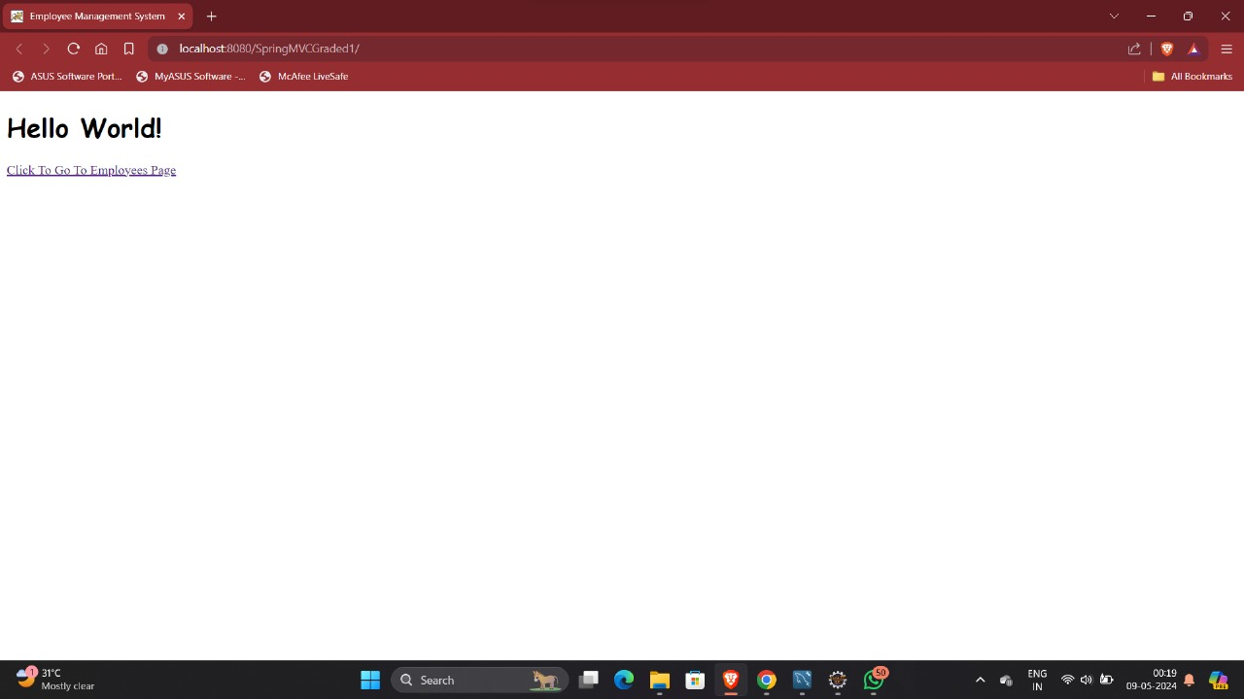

Employeelist.jsp

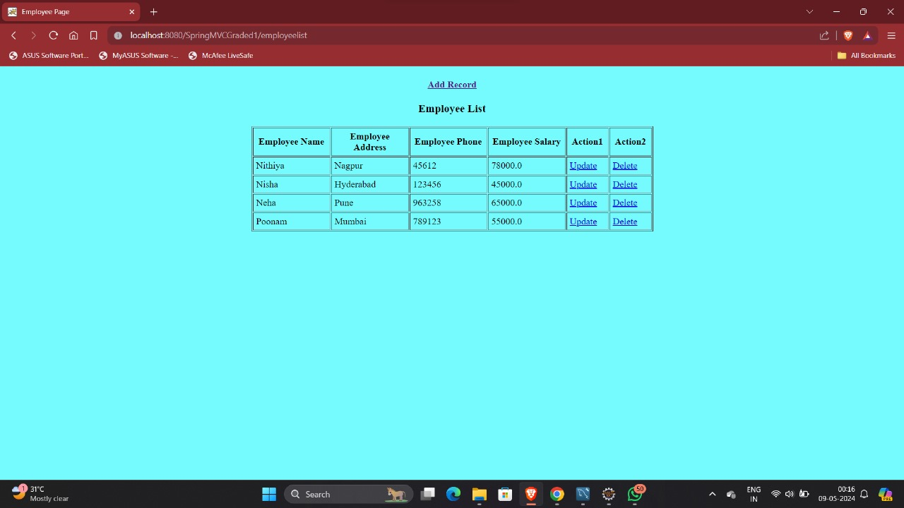

After deletion

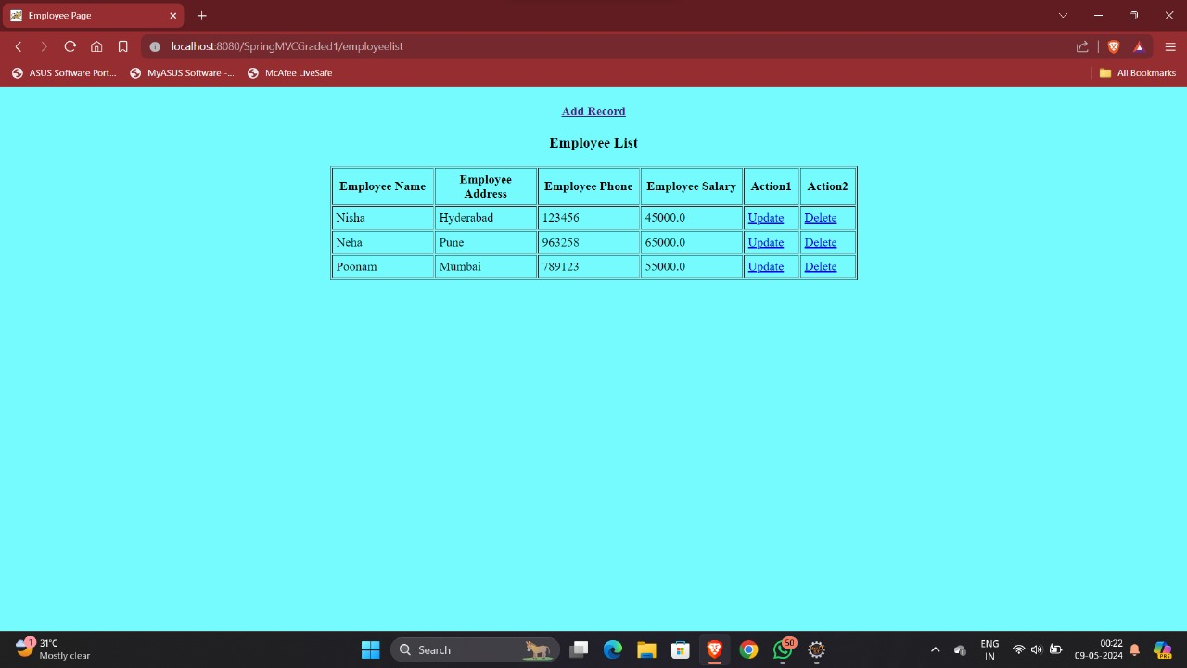

The second record “Nithya” is deleted successfully.

s