**OUTPUT SCREENSHOTS**

1. Ticket Tracker Application

* Home Page:

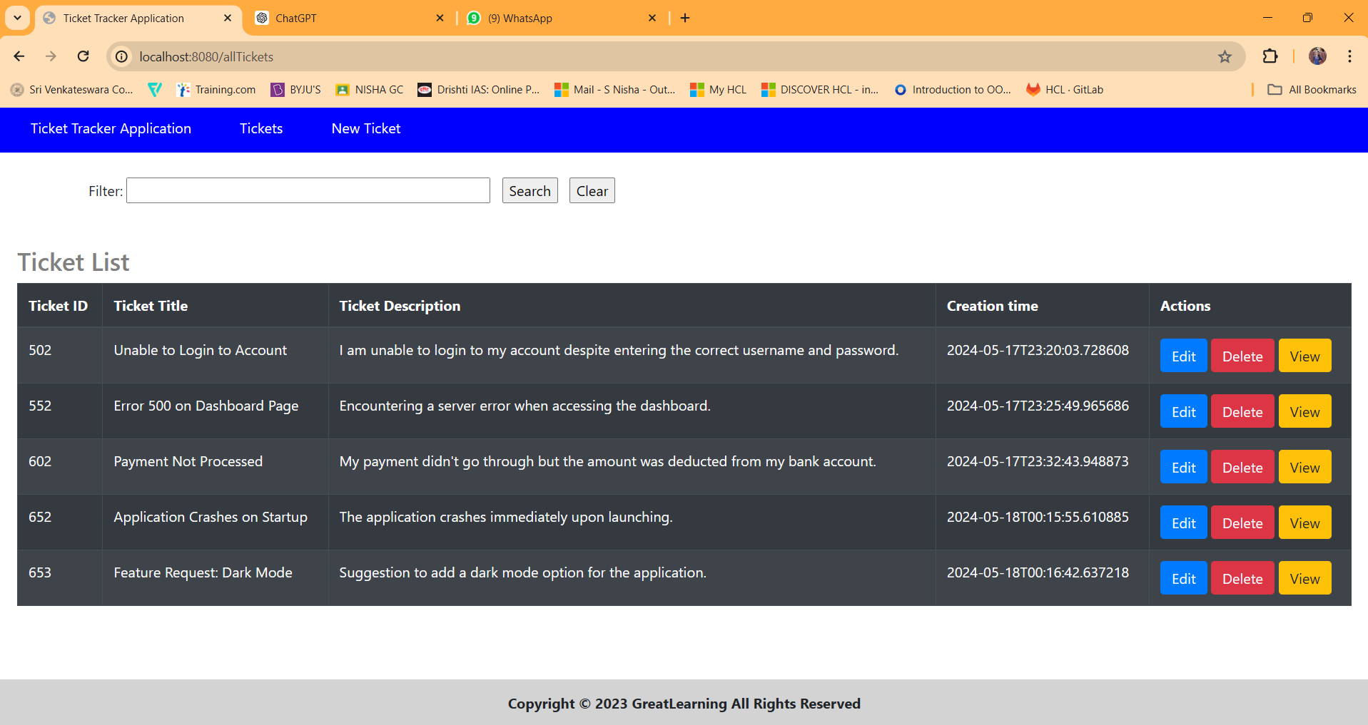

* Add New Ticket:

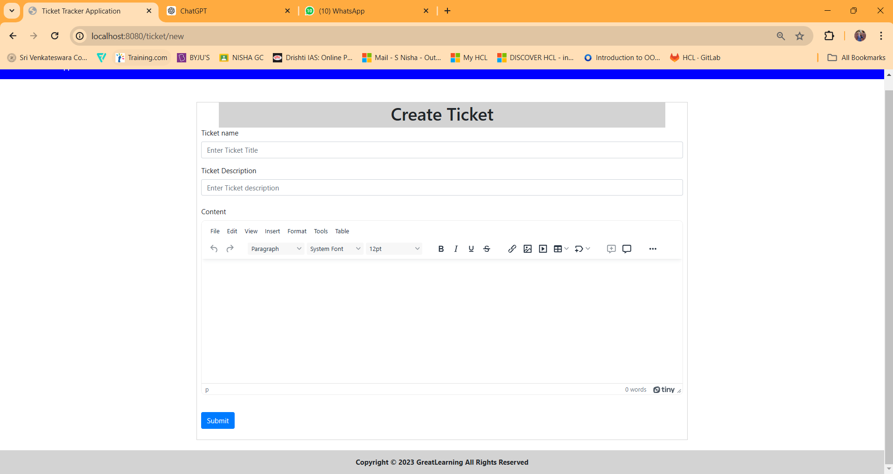

* Edit Existing Ticket:

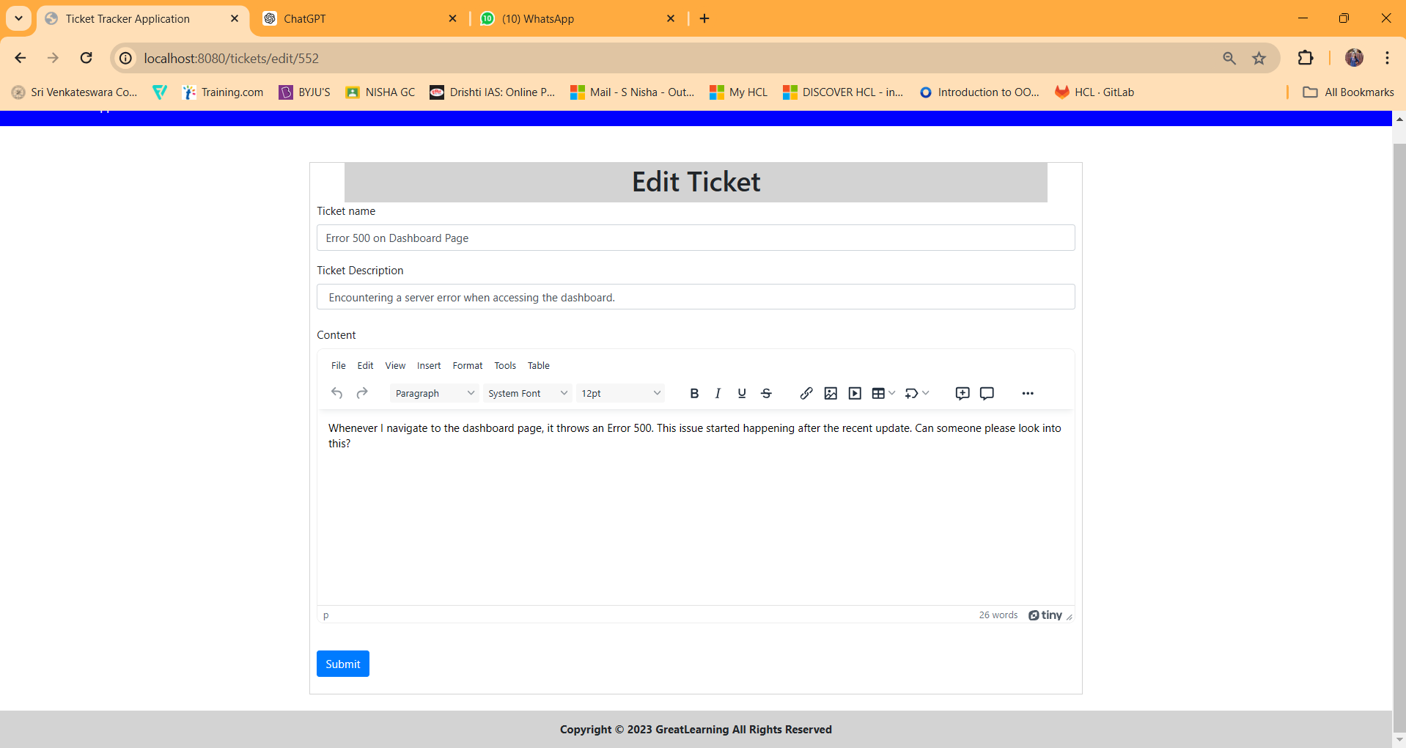

* View Existing Ticket:

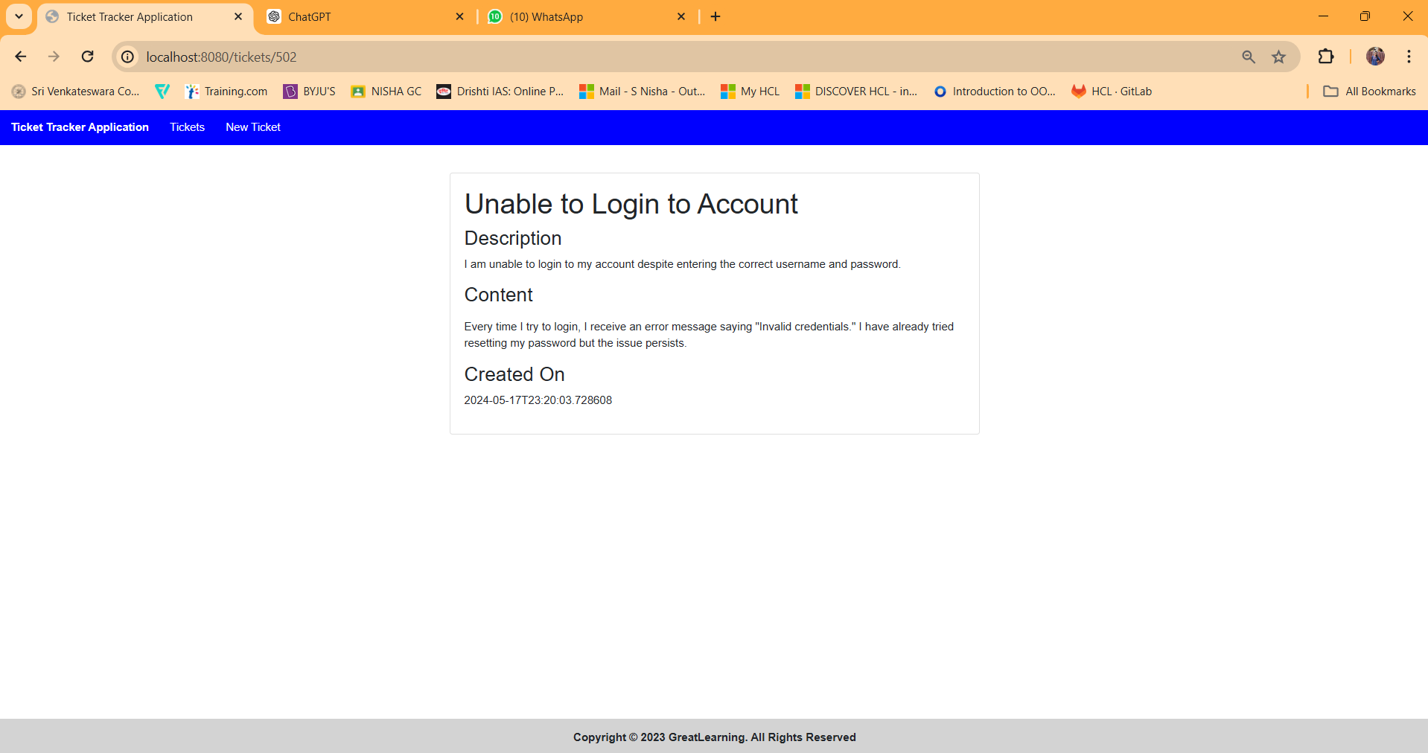

* Delete Existing Ticket:

I am deleting the last two records.

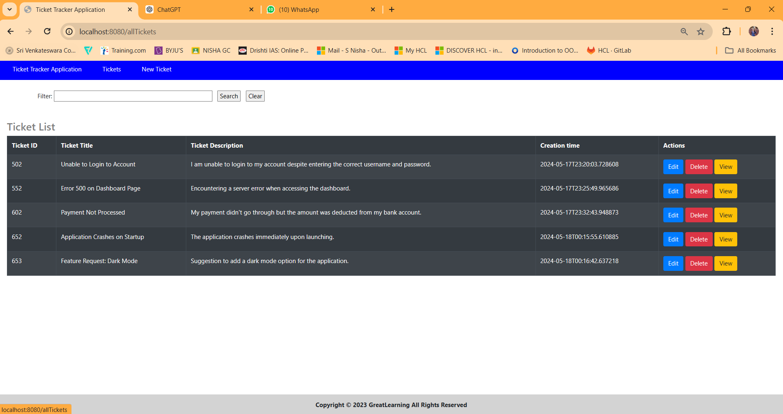

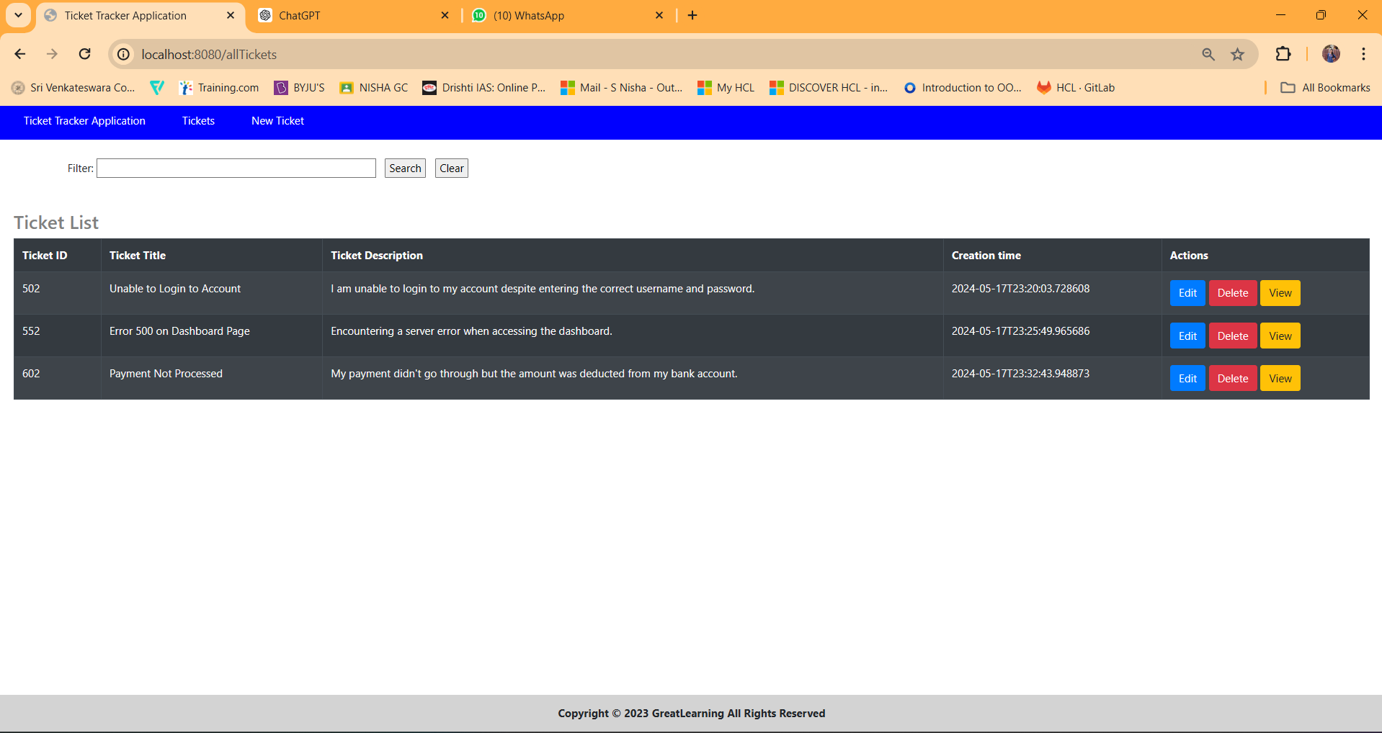

For my text editor I have used TinyMCE.

sTinyMCE is a rich-text editor that allows users to create formatted content within a user-friendly interface.