*Nishat Salsabil Rainy 1812620042*

*nishat.rainy@northsouth.edu*

**Problem 1: Audit Task**

**EDA:**

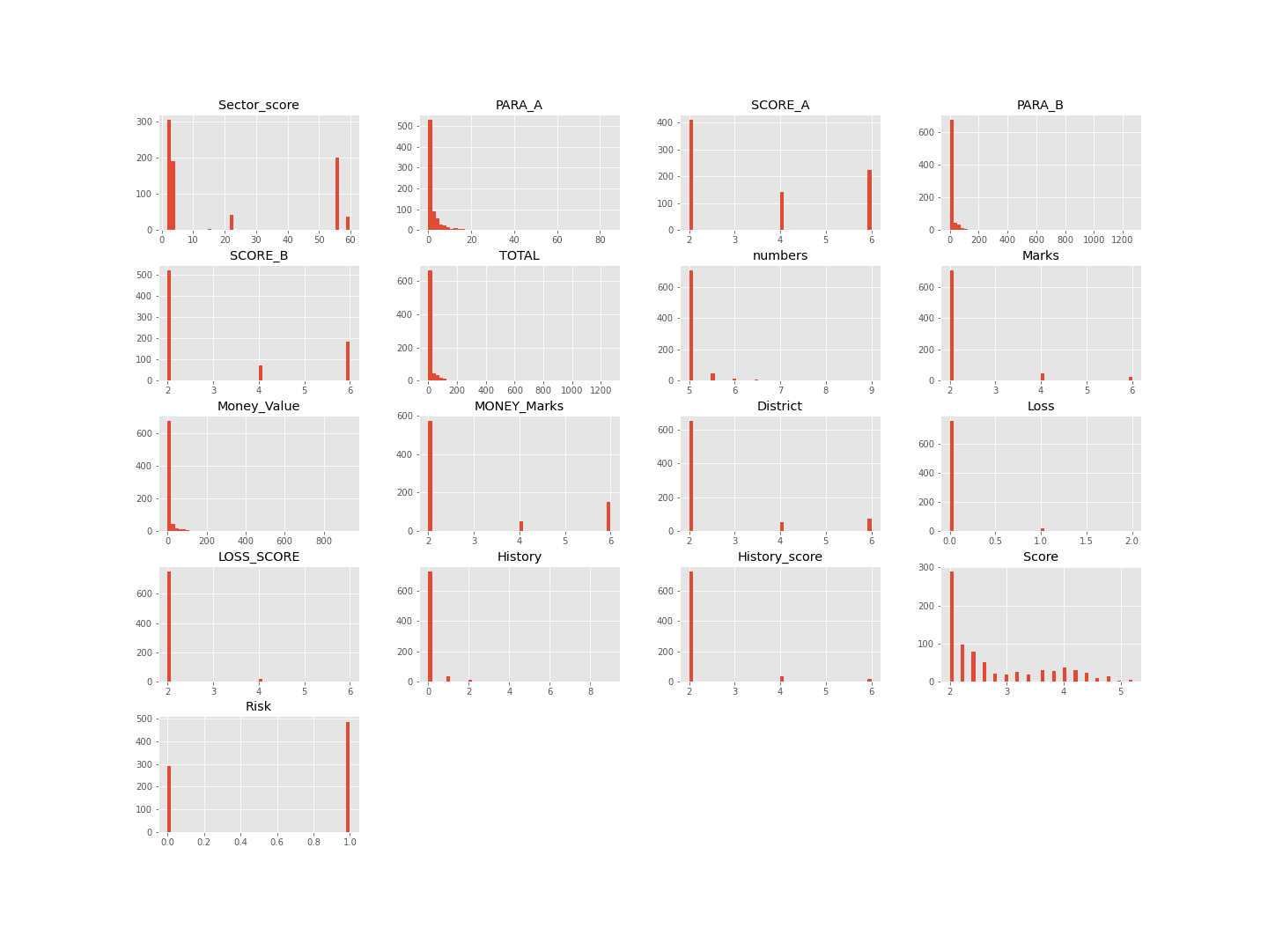

**Correlation matrix**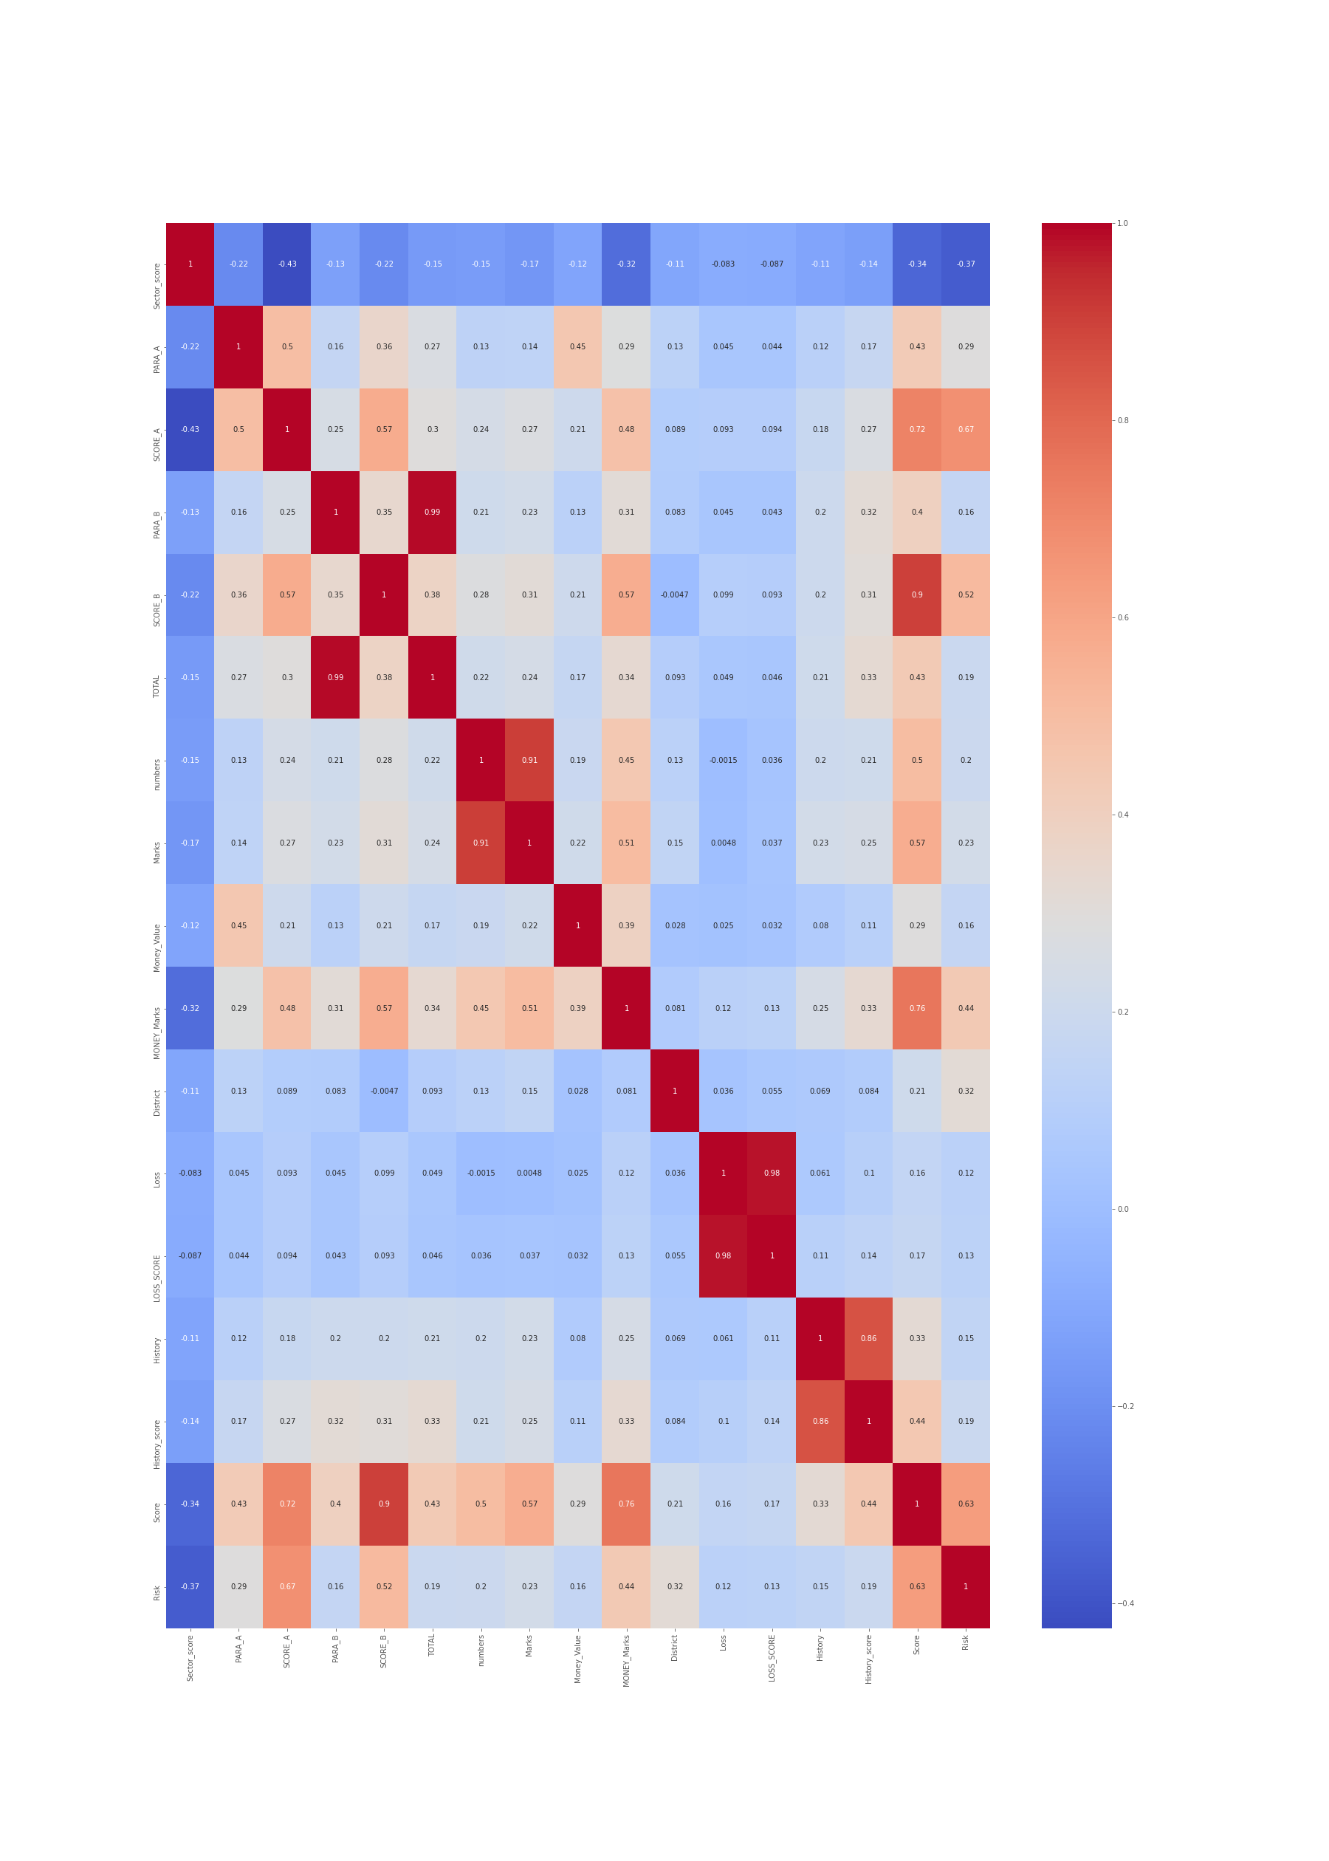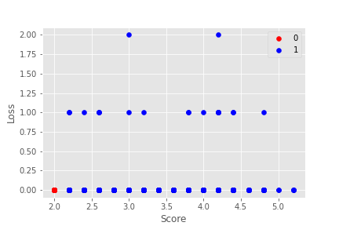

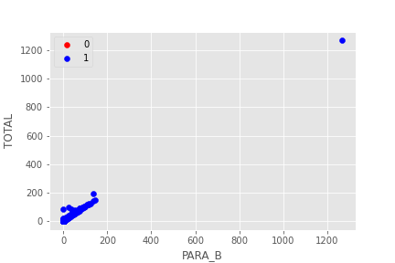

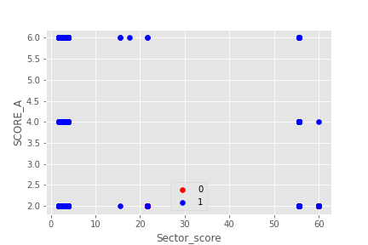

**Classifiers used –**

1. Logistic Regression
2. Decision Tree

**Table –**

|  |  |  |  |  |  |
| --- | --- | --- | --- | --- | --- |
| Model | Training accuracy | precision | recall | F1 | F2 |
| Logistic regression | 99.358974358 | 1.0 | 0.9897959183673 | 0.9979423868312757 | 0.9979423868312757 |
| Decision tree | 100.0 | 1.0 | 1.0 | 1.0 | 1.0 |

**ROC:**

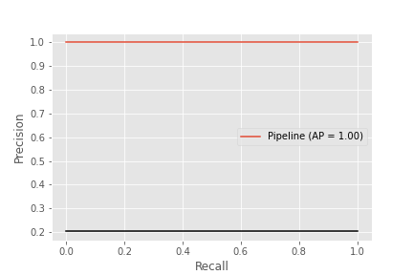

**Logistic Regression**



**Decision Tree**

**Problem 2: Forecasting Sales**

**EDA:**

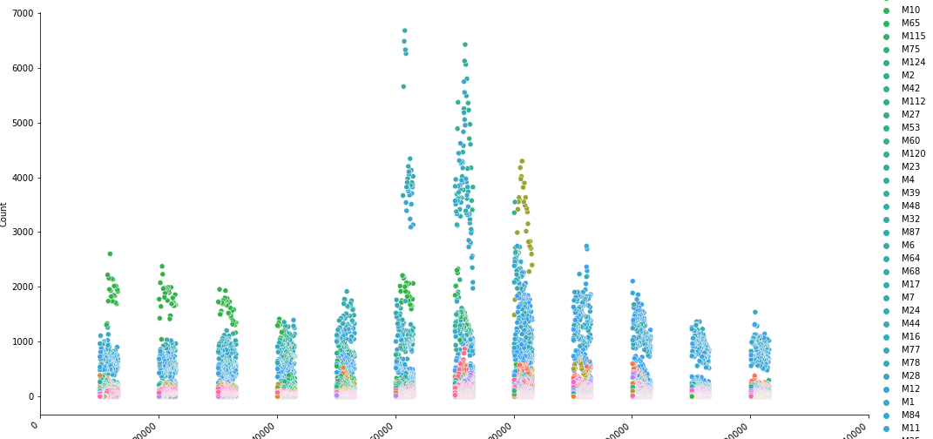

**Classifiers used -**  
  
  
1.Linear regression

2.Lasso regression

**Table -**  
Model, Training accuracy, sensitivity, precision, recall ( All the parameters of Confusion matrix)

|  |  |  |
| --- | --- | --- |
| Model | Training Accuracy | R2_Score |
| Linear regression | 65.36052502947108 | 0.6536052502947108 |
| Lasso regression | 49.578059156086084 | 0.49578059156086085 |