# Sheet Metal Section

In Charge: Mr. Hanjala SSAE (M)
---

What the section does is repairing and replacing of these following major components of locomotives:
1. Traction motor + Axle box -> build up
2. radiator repair
3. fuel tank repair
4. water tank repair
5. Main air reservoir
6. Hood repair
7. Hood repair
8. Chassis
9. Paint work
---

Arc welding is used for build up process

CaO is used for cooling of built up axle motor.
(because if water used -> cracks... if naturally cooeld -> hardness so high that boring machines cannot bore it to standard size)

---

Radiator

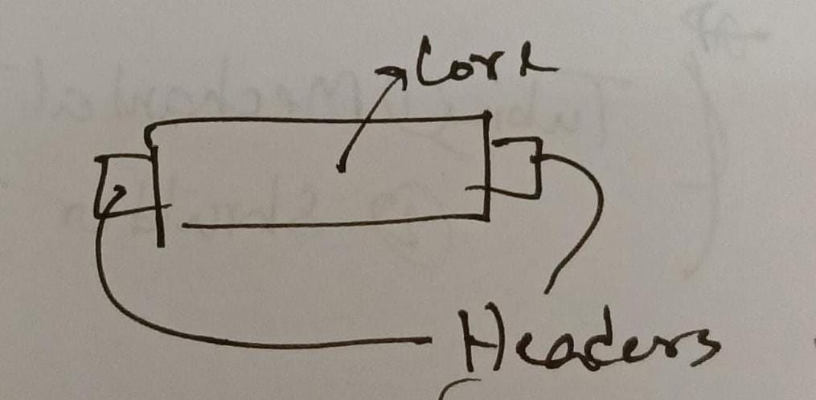after separating the core, 24hrs dipped inside a mix of water, sodium triphosphate, soda, soft soap.

then jet cleaning of the core

headed fitted to the core

then, radiator leakage test.
(30-35 psi water pressure)

tubing can be of x2 types:
1. mechanical type
2. shoulder type

---

Fuel Tank

upper part cut off then jet cleaning of the tank.

after that, upper part welded.
---

Water Tank
two types
2600, 2700, 2900
vs
6400, 6500

cleaning process:
first put water
then soda mix

basically cleaning and leakage test of water tank are the only two task done at this section.

If there is any leakage detected, have to weld or do anything to make it leakproof

For cleaning purpose Nalco (a type of cleaning agent) is mixed in the water.

## Main air reservoir

Compressed air produced by the compressor is stored here.

cleaning and leakage test are done

compressed air is required in the locomotive for braking, horn, functioning of the window wiper

## Hood

Hood of the locomotive has door leaves and window sashes
Those, and overall everything in the hood has certain standard measurements for every class of locomotive, these standard measurements have to be maintained.

If any part of the metal superstructure is bent as such that normal hammering process cannot fix it, we use hydraulic press machines.

## Chassis
most frequent work done in this section.

Doors change, windows change, hand rail change

buffer, pedestal, engine bed, compressor bed, alternator bed standard measurements are maintained.

## Painting
Three stage process.

First stage:
after entering the section, sandpaper is used to strip the paint off.
Then zinc chromate paint is applied to the body (the most basic foundational colour of the locomotive)

Second stage:
- dent is filled with putty
- primer colour applied
- then a foundation colour applied also

third stage:
after trial run, spray paint all over the locomotive, just before handover

we do have a Sand Blast plant... but because of manpower shortage, cannot be run.

Some names of paints:
1. paint light stone finishing
2. rail blue finishing
3. light blue finishing
4. black finishing
5. red signal
6. aluminium

60% to 70% manpower deficiency.
material shortage issue.

