Loco Repair Mechanical Section
Section InCharge: Mr. Moshiur, SSAE

This section of the CLW basically:
- Receives the incoming locomotives
- Disassembles their parts
- Sends the parts to relevant sections
- Makes a list of defects in the locomotives (called DD list == Defects and Deficiencies list)
- Sends information down to the PNP (Planning and ?) section (@CEX administration building)
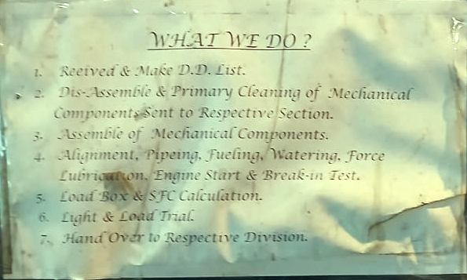
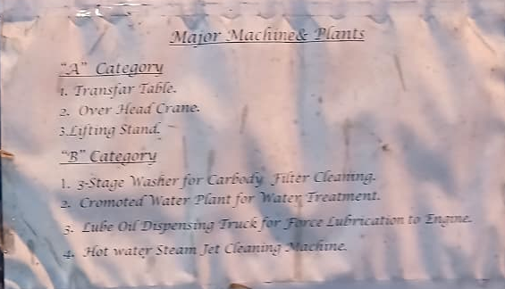
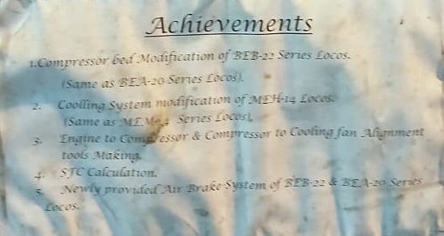
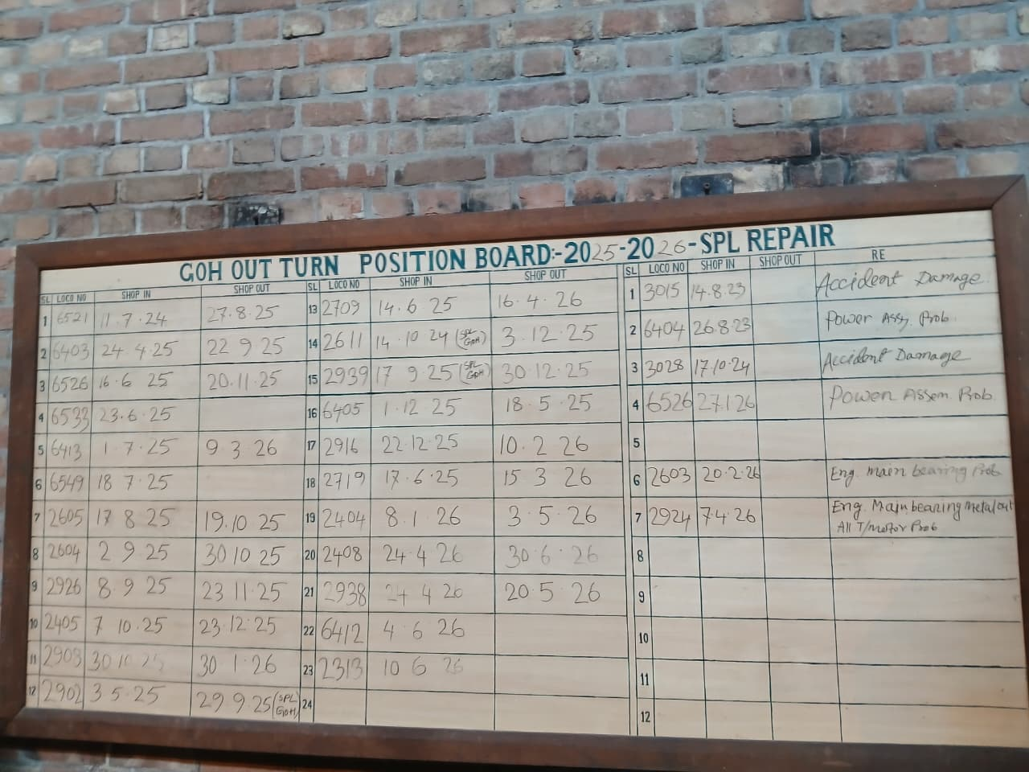
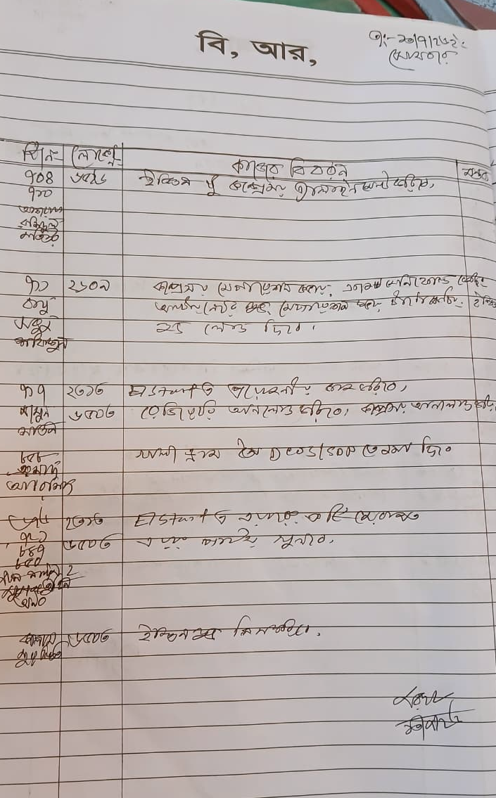

After all the components comes back after repairing to this section, it reassembles all parts into a fully fitted locomotive again. Important works done during this period include:
- Engine-compressor and engine-alternator shaft coupling alignment
(alignment er ekta chobi tulte hobe)
- Check alignment by using alignment gauge (shown is compressed type gauge)
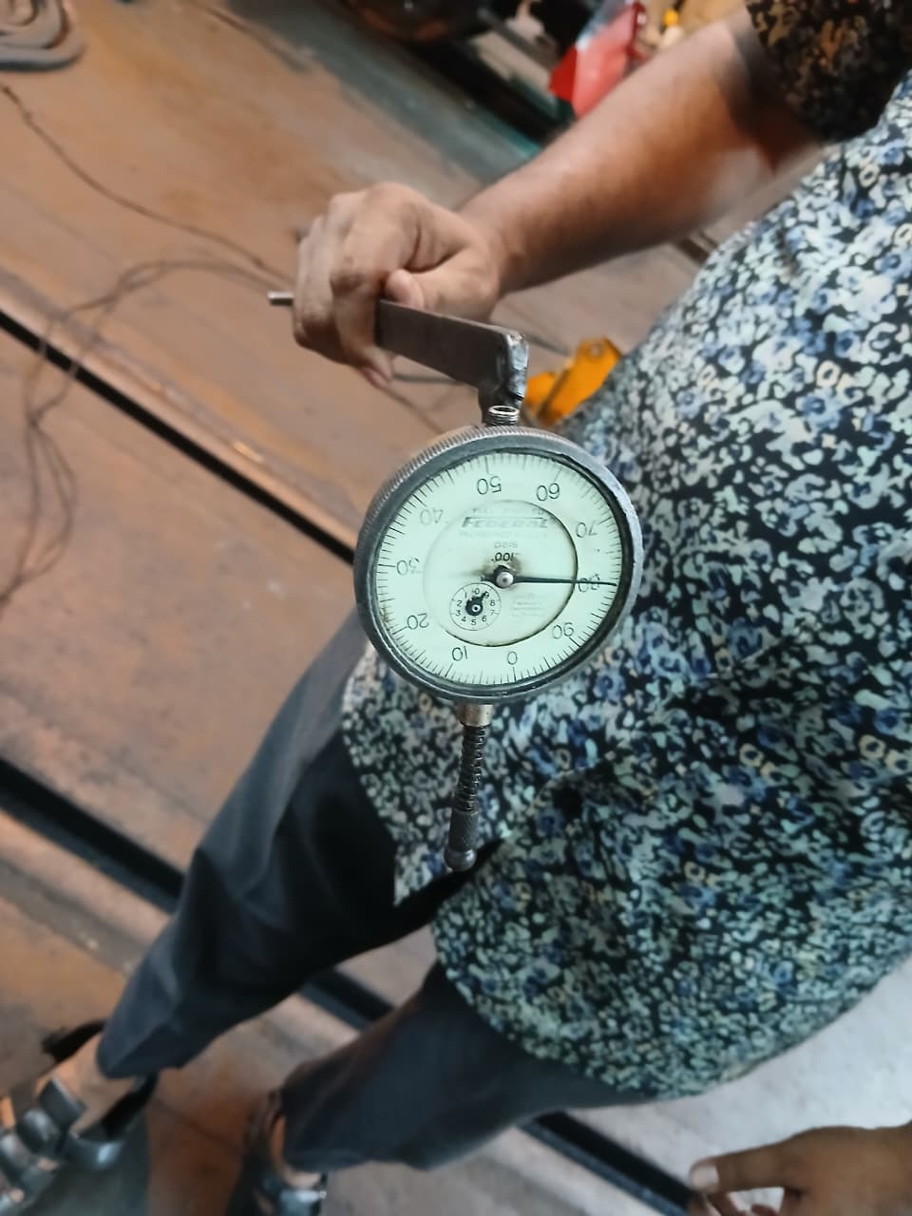
- Piping connection works (lube oil, cooling, water)
- Radiator and air blower installation (coming from sheet metal section)
- Piping check for fuel dilution, water leakage
- Torquing for piston, cylinder cleaning

After fully assembling the locomotive, during the startup, again piping leakage and oil pressure levels are checked.

If everything alright, then the locomotive is let to run 24hrs (intermittently, 8 hrs daily, 3 days) -> process is called lapping.
During this lapping period, checks are done for:
- Performance
- Rpm
- Burnt gas (exhaust), whether there is unburnt fuel in high amount or not
- Traction motors

Then the locomotive is sent to the load-box testing plant for HP measurement.
Then light trial (ie, without load) run.
Then loaded trial (in smaller sections such as PBT-DJP with 6/12 load)
Speed of the locomotive is maxed at 45/50 kmph
Troubleshooting, if necessary, during these trials
Then to paint shop for paint job
Then handover (outturn).

Lube Oil we use: Diol 13 RD 40 (https://www.exxonmobil.com/en/apps/pds/mobil/commercial-vehicle-lube/2019/09/29/16/43/glxxdiol-13-rd-and-diol-17-rd)

Currently in schedule locos:
- 6503
- 2609 (special)

2600, 2700, 2800 series locomotives are of same technology – GM locomotives.

