Online Seminar Library Management System

**Prepared By**

Abrar Hossain Asif

Nishat Tasnim Tamanna

Al Jaber Nishad

Table of Contents

**1.Introduction** 4

**1.1** **Purpose** 4

**1.2** **Project Scope** 4

**5 Non-Functional Requirements** 10

**5.1 Usability Requirement** 10

**5.2 Availability Requirement** 11

**5.3 Efficiency Requirement** 11

**5.5 Performance Requirement** 11

**5.5.1 Speed and Latency Requirements** 11

**5.5.2 Precision and Accuracy Requirements** 11

**5.5.3 Capacity Requirements** 12

**5.5.4 Reliability Requirement** 12

**5.6 Data Requirements** 12

**6.** **Use case Diagram** 14

7 **Use Case Description** 15

**Table 7.1 Search Book** 15

**Table 7.2 Add Book** 16

**Table 7.3 Edit Book** 17

**Table 7.4 Remove Book** 18

**Table 7.5 Request Book** 19

**Table 7.6 Collect Requested Book** 20

**Table 7.7 Return book** 21

**Table 7.8 Receive book** 22

**Table 7.9 Calculate fine** 23

**Table 7.10 Show current availability of Books** 24

**8 Activity Diagram** 24

**8.1 Search Book** 25

**8.2 Add Book** 26

**8.3 Edit Book** 27

**8.4 Remove Book** 28

**8.5 Request Book** 29

**8.6 Collect requested book** 30

**8.7 Return Book** 31

**8.8 Receive Book** 32

**8.10 Show current availability of books** 34

**9. ER Diagram** 35

**10 Requirements traceability matrix** 35

**10.1 Test Case** 35

**11 Appendix** 36

**11.1 Prioritization of requirements** 36

# **1.Introduction**

The introduction of the Software Requirements Specification (SRS) provides an overview of the entire SRS with purpose, scope, definitions, acronyms, abbreviations, references and overview of the SRS. The aim of this document is to gather and analyze and give an in-depth insight of the complete Online Seminar Library Management System of IIT (Institute of Information Technology) by defining the problem statement in detail. The detailed requirements of the Online Seminar Library Management System are provided in this document. It helps to increase in the number of readers, better management of seminar libraries of IIT.

## **Purpose**

The purpose of the project is to maintain the details of books and library members of both IIT students and Teachers. The main purpose of this project is to maintain an easy circulation system between students and the libraries. Online Seminar Library Management System basically an online platform base library which help student that student can easily request for a book, collect book from library, show their info like (fine, address, phone number) etc. They can also see the availability of books by using book details. IIT Officer maintain the library, collect fine which is auto calculated in this system, see students all details easily. Moreover, the user can check all these features from their home and overall maintenance online library is easier and more reliable.

## **Project Scope**

* Manually updating the library system into an android based application so that the user can know the details of the books available and maximum limit on borrowing from their computer and also through their phones.
* The ILM System provides information's like details of the books, insertion of new books, deletion of lost books, limitation on issuing books, fine on keeping a book more than one month from the issued date.
* Also, online security ensures for all library user

**1.3. Glossary**

This subsection contains definitions of all the terms, acronyms, and abbreviations used in the document. Terms and concepts from the application domain are defined.

* SRS – Software Requirement Specifications
* UI – User Interface
* SDLC – Software Development Life Cycle
* GUI – Graphical User Interface
* API – Application Programming Interface
* JAVA -> platform independence
* SQL -> Structured query Language
* DFD -> Data Flow Diagram

**1.4. References**

IEEE. IEEE Std 830-1998 IEEE Recommended Practice for Software Requirements Specifications. IEEE Computer Society, 1998

**1.5. Overview**

Online Seminar library management of IIT is a subpart of Boolean automation project that manages and stores books information electronically according to student’s needs. It is all about organizing, managing the seminar library and seminar library-oriented hole tasks. The system helps both students and IIT Officer to keep a constant track of all the books available in the library. It allows both the admin and the student to search for the desired book. It becomes necessary for any library to keep a continuous check on the books issued and returned and even calculate fine. Student, teacher both are member in this system, IIT Officer maintain this system. Member and admin see hole info about students and book list. IIT officer add, remove and delete book if needed. They add student list into Database. They receive fine from student, if its late from their return date. Both user and admin update their profile easily. Student borrow a book for 3 days. Student show their issue information easily, they can delete their pending book request etc.

Overall, this Online seminar Library Management system reduce the maintenance efforts and also help students and teacher use library in easy way.

**2. User Classes and Characteristics:**

There are two types of stakeholders in our project, such as:

1. **IIT Officer**

IIT officer one of the actors in our project. He acts like as an admin. In our project the admin has unique id, unique email, username and password. He is responsible for full system. Officer update books, approve book, edit book, receive book from student and others library-oriented tasks. He can also maintain books in a stack, means record the availability at regular time interval.

**2. Library User (Student, Teacher)**

Library user can student or IIT teachers. They are also primary actor in our project. Admin panel provide email password to student for library uses. They use this information and logged in our online library management system. A student can search books, issue books, see return books date, see his own dashboard and also see his fine.

**3. Design and Implementation**

Constraints Design and implementation constraints are those that we have used to implement this project make successful. It also describes tool that enables developers and testers to view and interact with the user interface (UI) elements of this application.

**3.1 User Interface Technology**

User interface (UI) is everything designed into a system view that which person’s associates with this system may like the interface of this system.

**3.1.1 Programming Language**

For developing this system, we will use Java as a programming language. Java is a widely used open-source general-purpose programming language that is especially suited for Android application development. Java is a programming language, and a powerful tool for making dynamic and interactive mobile applications based on Android operating system.

**3.1.2 XML**

XML stands for Extensive Mark-up Language. It is a mark-up language that describes the style of a mobile application based on Android operating system. XML describes how elements of the application should be displayed. Build responsive, mobile-first projects on with the world's most popular component library.

**3.2 Implemented Tools and Platform**

Every business plan, campaign, or project comes down to Tactics, Tools, and Strategies. To conceive, develop, and implement a sound social media marketing strategic plan that will be successful needs to have those three critical components.

**3.2.1 Web Server**

A Web server is a program that uses HTTP (Hypertext Transfer Protocol) to serve the files that form Web pages to users, in response to their requests, which are forwarded by their computers' HTTP clients. Dedicated computers and appliances may be referred to as Web servers as well. We will use the Apache HTTP server to implement this project. We will use RESTful API to retrieve data from our server to mobile application. RESTful stands for Representational State Transfer. And API stands for Application Programming Interface.

**3.2.2 Database Server**

We will use MySQL database server to store all of the information of this system. The reason behind to choose the database server are given below:

1. Data Security
2. High performance
3. Reporting and Data Mining
4. Complete workflow control
5. Reduce total cost of ownership

**4. Requirement Specification**

We have 3 levels of users :

• User module:

In the user module, user will check the availability of the books.

* Issue book
* Request book
* Return book
* Fine details
* Edit profile

• Administration module: The following are the module in the administration/admin module:

* Add student
* Entry book details
* Add new book
* Remove books
* Update details of book
* Approve book
* Fine collection

The complete requirement specification based on the elicitation process is described in this section.

**4.1 Functional Requirement**

Functional requirements refer to the functions which are mandatory of our system. Functional requirements must be able to perform on the software system. Every system must have some functional requirements and non-functional requirements. Here Library user will be student or teacher, admin will be IIT Officer.

**4.1.1 IIT Officer and seminar library user show the book list and search book.**

|  |  |
| --- | --- |
| **Requirement 1** | **IIT Officer and library user show the book list and search book** |
| **Description** | In our system admin panel and also user like students and teachers show the book list and search book using book identification number or book name or year wise etc. Both actors see the book list and find book sing search option. |
| **Stakeholder** | Library users, IIT Officer |
| **Priority** | High |

**4.1.2 user view their dashboard**

|  |  |  |
| --- | --- | --- |
| **Requirement 2** | | **IIT Officer and library user view their dashboard** |
| **Description** | | After login successfully IIT officer or library user view their dashboard. In admin dashboard add/delete books, book request, issue details, registered students and other information will be showed. In library user dashboard issue book, book list, account, fine will showed. |
| **Stakeholders** | | IIT Officer, Library user |
| **Priority** | High |

**4.1.3 Student and admin can edit their profile**

|  |  |
| --- | --- |
| **Requirement 3** | **Librarian and library user can edit their profile** |
| **Description** | In this system librarian and library user can edit their profile, username, password and other information. If they want to edit their profile first, they should login the system and they should go to their profile and then they can update their profile. |
| **Stakeholders** | IIT Officer, library user |
| **Priority** | Low |
|  | |

**4.1.4 IIT Officer add/delete books**

|  |  |
| --- | --- |
| **Requirement 4** | **IIT Officer add/delete/edit books** |
| **Description** | In this system, IIT Officer is a primary actor and he/she can add, delete, edit books. He/she first logged in, the system and then add/ delete/edit book. Beside of this books database automatically update. |
| **Stakeholder** | IIT Officer |
| **Priority** | High |
|  | |

**4.1.5 IIT Officer approve new book and update database details**

|  |  |
| --- | --- |
| **Requirement 5** | **IIT Officer approve new book and update details** |
| **Description** | If a student sends book request, then officer approve the books for 3 days and finally update the book details. |
| **Stakeholder** | Library user, IIT Officer |
| **Priority** | High |

**4.1.6 Library User request for one book at a time using book identification number**

|  |  |
| --- | --- |
| **Requirement 6** | **Library User request for one book at a time using book identification number** |
| **Description** | A library user request for one book at a time to admin. He/She can delete his/her pending book request from user dashboard. |
| **Stakeholder** | Library user |
| **Priority** | High |

**4.1.7 IIT Officer search a student by student first name or username**

|  |  |
| --- | --- |
| **Requirement 7** | **IIT Officer search a student by student first name or username** |
| **Description** | Librarian can see all student’s information. If librarian search a student for any purpose, he can use student first name, username for search a specific student and see his/ her information |
| **Stakeholder** | IIT Officer |
| **Priority** | High |

**4.1.8 Librarian and student change their username**

|  |  |
| --- | --- |
| **Requirement 11** | **Librarian and student change their username** |
| **Description** | Student and admin ca change their username successfully. |
| **Stakeholder** | Library user, IIT Officer |
| **Priority** | High |

**4.1.9 Library user see their expired date and fine in user dashboard**

|  |  |
| --- | --- |
| **Requirement 12** | **Library user see their expired date and fine in user dashboard** |
| **Description** | A student can issue book bye send book request. He/she can see issue date and expired date of book and see his/her fine. |
| **Stakeholder** | Library user, IIT Office |
| **Priority** |  |
|  | |

**4.1.10 Library user & admin can recover their password**

|  |  |
| --- | --- |
| **Requirement 13** | **Library user & admin can recover their password** |
| **Description** | In this system admin and a student can login by their username or email and password. If they forget their password, they can recover password by click forget password and then get e link in their mail to recover the password. |
| **Stakeholder** | Library user, admin |
| **Priority** |  |

**4.1.11 IIT Officer can see student’s details**

|  |  |
| --- | --- |
| **Requirement 15** | **Librarian (IIT Officer) can see student’s details** |
| **Description** | An admin (librarian) can see all student’s details. First, he/she need to login this system and then he/she can see all registered student’s details. |
| **Stakeholder** | Library user, Librarian (IIT Officer) |
| **Priority** |  |
|  | |

# **5 Non-Functional Requirements**

## **5.1 Usability Requirement**

The system shall allow the users to access the system from the phone using web application. The system uses web application as an interface. Since all users are familiar with the general usage of library website, no special training is required. The system is user friendly which makes the system easy.

## **5.2 Availability Requirement**

The system is available 100% for the user and is used 24 hours a day and 365 days a year. The system shall be operating some operation open days of university.

## **5.3 Efficiency Requirement**

Mean Time to Repair (MTTR) - Even if the system fails, the system will be recovered back up within an hour or less.

**5.4 Accuracy**

The system should accurately provide real time information taking into consideration various concurrency issues. The system shall provide 100% access reliability.

## **5.5 Performance Requirement**

The information is refreshed depending upon whether some updates have occurred or not in the application. The system shall respond to the member in not less than two seconds from the time of the request submittal. The system shall be allowed to take more time when doing large processing jobs. Responses to view information shall take no longer than 5 seconds to appear on the screen.

## **5.5.1 Speed and Latency Requirements**

Speed and latency requirements must be ensured while retrieving data from the cloud server.

|  |  |
| --- | --- |
| **SLR-1** | Search must be faster |
| **Description** | Admin or library user search book others info within faster and easity |
| **Stack Holders** | Admin and Library Users |
| **Priority** | High |

## **5.5.2 Precision and Accuracy Requirements**

Student and admin search many info, and they must be accurate.

|  |  |
| --- | --- |
| **PAQ-1** | Search must be accurate |
| **Description** | Admin or library user search book others info and these are accurate |
| **Stack Holders** | Admin and Library Users |
| **Priority** | High |

## **5.5.3 Capacity Requirements**

The developed system by us must be capable to handle user data, provide accurate information, handling database, manage http request etc.

|  |  |
| --- | --- |
| **CR-1** | Search Thousands of data within 5 second |
| **Description** | Admin or library user search book others information with a little of time |
| **Stack Holders** | Admin and Library Users |
| **Priority** | High |

## **5.5.4 Reliability Requirement**

The system has to be 100% reliable due to the importance of data and the damages that can be caused by incorrect or incomplete data. The system will run 7 days a week, 24 hours a day.

# **5.6 Data Requirements**

For defining data requirements, we need to build the model. For our application maximum data would be loaded from remote user. And for that purpose, we need to focus on some major points. Such as:

• Types of entity of the system

• Capacity and resources of the data requirements

• Data source sequence

• Data availability schedules

• Quantity of data

• Availability of data

**5.7 Performance Requirements**

It is very important to maintain performance of any software system. To ensure performance, weneed to maintain some steps. Now, I will explain some perspective by which we are going to enhance the performance of our project.

**5.8 Security Requirements**

Making software security as a requirement is very important. Software security requirements should be its functional requirement. Software security enforces security of an application system. Functionality related to software security can either be directly tested or observed. Some security related requirements are given below:

* Get access according to logged in user
* Fine calculation must be correct
* Signing out from system
* Handling encrypted passwords
* Keep our database in secure

**5.9 Integrity Requirements**

Integrity requirements refers to a security system which ensures an expectation of data quality. It also ensures that all data of the system would never be exposed to the malicious modification or accidental destruction. For that reason, we will store our user passwords as encrypted format which is impossible to decrypt. It is also called hashed password. Also our database must be protected from sql injection , penetration test.

**5.10 Privacy Requirements**

It is very important to ensure privacy of the system users. Privacy requirements enhances to protect stakeholder’s privacy. In this way, all data or a partial part of data are going to be disclosed according to system’s privacy policy. To ensure privacy, the central database should be protected by the anonymous. Users are permitted to get access to those data which are being associated by them which can be ensured by the user log in system.

**5.11 Usability and Human-Interaction Requirements**

The main target of developing any system is to make the system user friendly and easy to usable for the end users like student and teacher.

**6 Requirement Engineering Process**

Requirement’s engineering refers to the process of defining, documenting and maintaining requirements in the engineering design process. It is a common role in systems engineering and software engineering.

**6.1 Requirement Elicitation Techniques**

Requirement elicitation is the process of collecting and refining stakeholder’s requirements. That’s means IIT Office seminar library’s requirements. Projects are garbage-in-garbage-out meaning that poor quality requirements typically lead to project issues and failure.

**5.1.1 Hold Elicitation Interviews**

Our team hold an interview with iit seminar library management officer. We discuss of the seminar library

**6.1.2 System Interface Analysis**

The first thing to do is to identify which systems the system-to-be shall communicate with. It could be a server on the Internet, a piece of software on the same host as the system-to-be, some hardware or something completely different. The following is an incomplete list of types of interfaces that we have considered:

* Relational Databases
* Protocols
  + For Communication on the internet
  + For communication via a specific port on the computer
* Specific addressing RAM

# **Use case Diagram**

Use case diagram comprises actors and use cases, where actors perform several cases or one. This also shows which actors have access to which use case. Here is the use case diagram for house management system.

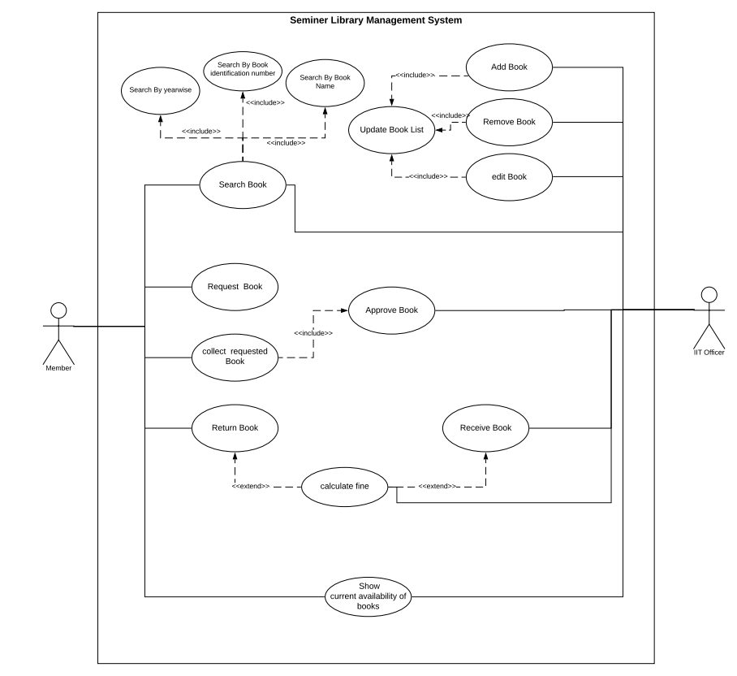

Figure 1.1 Use case diagram

# 

# 7 **Use Case Description**

All use cases from use case diagram are explained here.

## **Table 7.1 Search Book**

|  |  |  |
| --- | --- | --- |
| **Use Case** | Search Book | |
| **Goal** | Find book successfully. | |
| **Precondition** | Search book | |
| **Success End condition** | Show book details (book identification number, name, author, quantity, available status) | |
| **Failed End Condition** | Book isn’t available. | |
| **Primary Actor**  **Secondary Actor** | Student, Teacher | |
| N/A | |
| **Trigger** | Press Search Button | |
| **Main Success Flow** | **Step** | **Action** |
| 1 | Student/teacher can search book using book identification number |
| **Alternative Flow** | **Step** | **Action** |
| 1.a | Student/Teacher can search book using book name |
| **Quality Requirements** | Student/Teacher find book within 5 seconds | |
|  | |

## **Table 7.2 Add Book**

|  |  |  |
| --- | --- | --- |
| **Use Case** | Add Book | |
| **Goal** | Add book successfully into seminar library database | |
| **Precondition** | Must to be logged in. | |
| **Success End condition** | Add new book successfully. | |
| **Failed End Condition** | Books don’t add into database | |
| **Primary Actor**  **Secondary Actor** | IIT officer | |
| N/A | |
| **Trigger** | Click add book option | |
| **Main Success Flow** | **Step** | **Action** |
| 1 | IIT Officer(admin) give all the information details about book. |
| 2 | Click add button |
| 3 | update the book list add new book successfully |
| **Alternative Flow** | **Step** | **Action** |
|  | N/A |
| **Quality Requirements** | Admin add book into database within 5 seconds after clicking add button. | |
|  | |

## **Table 7.3 Edit Book**

|  |  |  |
| --- | --- | --- |
| **Use Case** | Edit Book | |
| **Goal** | Edit book successfully and upgrade existing book info. | |
| **Precondition** | Must to be logged in. | |
| **Success End condition** | Edit book successfully. | |
| **Failed End Condition** | Can’t edit book information | |
| **Primary Actor**  **Secondary Actor** | IIT officer | |
| N/A | |
| **Trigger** | Click edit book option | |
| **Main success flow** | **Step** | **Action** |
| 1 | Find book using book identification number |
| 2 | Click update button. |
| 3 | IIT Office(admin) update some information about book |
| 4 | Click edit book |
| 5 | Update exiting book info |
| **Alternative Flow** | **Step** | **Action** |
| 1.a | Find book using book name |
| **Quality Requirements** | Admin edit book into database within 5 seconds after clicking edit button. | |
|  | |

## **Table 7.4 Remove Book**

|  |  |  |
| --- | --- | --- |
| **Use Case** | Remove Book | |
| **Goal** | Remove book successfully and Remove existing book from database. | |
| **Precondition** | Must to be logged in. | |
| **Success End condition** | Remove book successfully from database | |
| **Failed End Condition** | Can’t Remove book information from database | |
| **Primary Actor**  **Secondary Actor** | IIT officer | |
| N/A | |
| **Trigger** | Click delete book button | |
| **Main Success Flow** | **Step** | **Action** |
| 1 | Find book using book identification number. |
| 2 | Click Remove/delete button. |
| 3 | Click ok button |
| **Alternative Flow** | **Step** | **Action** |
| 1.a | Find book using book name |
| **Quality Requirements** | Admin Remove book from database within 5 seconds after clicking ok button. | |
|  | |

## **Table 7.5 Request Book**

|  |  |  |
| --- | --- | --- |
| **Use Case** | Request Book | |
| **Goal** | Request book successfully and save request info into database | |
| **Precondition** | Must to be logged in. | |
| **Success End condition** | Book request send successfully | |
| **Failed End Condition** | Can’t send the book request | |
| **Primary Actor**  **Secondary Actor** | Student/Teacher | |
| N/A | |
| **Trigger** | Click request button | |
| **Main Success Flow** | **Step** | **Action** |
| 1 | Find book using book identification number. |
| 2 | Click request button. |
| 3 | Request send successfully, click ok. |
| **Alternative Flow** | **Step** | **Action** |
| 1.a | Find book using book name |
| 3.a | You have already a pending book request |
| 3.b | This book is not available in our library |
| 3.c | Request failed |
| **Quality Requirements** | Student/Teacher send book request successfully within 5 second | |
|  | |

## **Table 7.6 Collect Requested Book**

|  |  |  |
| --- | --- | --- |
| **Use Case** | Collect request book | |
| **Goal** | Collect requested book successfully from seminar library | |
| **Precondition** | Must to be logged in. | |
| **Success End condition** | Collect requested book successfully | |
| **Failed End Condition** | Can’t Collect requested book successfully | |
| **Primary Actor**  **Secondary Actor** | Student/teacher | |
| IIT officer | |
| **Trigger** | Click show requested info. | |
| **Main Success Flow** | **Step** | **Action** |
| 1 | Show the requested book details, like approve date , return date |
| **Alternative Flow** | **Step** | **Action** |
|  | N/A |
| **Quality Requirements** | Student/teacher collect book with sort time | |
|  | |

## **Table 7.7 Return book**

|  |  |  |
| --- | --- | --- |
| **Use Case** | Return Book | |
| **Goal** | Return Book successfully | |
| **Precondition** | Must to be logged in. | |
| **Success End condition** | Return book successfully | |
| **Failed End Condition** | Can’t return book successfully | |
| **Primary Actor**  **Secondary Actor** | Student/teacher | |
| IIT officer | |
| **Trigger** | N/A | |
| **Main Success Flow** | **Step** | **Action** |
| 1 | If added fine, pay your fine give the book . |
| **Alternative Flow** | **Step** | **Action** |
|  | N/A |
| **Quality Requirements** | Student/teacher return book within sort time | |
|  | |

## **Table 7.8 Receive book**

|  |  |  |
| --- | --- | --- |
| **Use Case** | Receive Book | |
| **Goal** | Receive Book successfully | |
| **Precondition** | Must to be logged in. | |
| **Success End condition** | Return book successfully | |
| **Failed End Condition** | Can’t return book successfully | |
| **Primary Actor**  **Secondary Actor** | IIT officer | |
| Student/teacher | |
| **Trigger** | Show issue information option | |
| **Main Success Flow** | **Step** | **Action** |
| 1 | Click issue information |
| 2 | Click take book |
| 3 | Click ok |
| **Alternative Flow** | **Step** | **Action** |
| 3.a | Add fine |
| 3.b | Collect fine from student |
| 3.c | Click paid fine option |
| **Quality Requirements** | Received book from student/teacher within 5 second. | |
|  | |

## 

## **Table 7.9 Calculate fine**

|  |  |  |
| --- | --- | --- |
| **Use Case** | Calculate fine | |
| **Goal** | Collect fine from student | |
| **Precondition** | Must to be logged in. | |
| **Success End condition** | Collect fine successfully | |
| **Failed End Condition** | Technical error show | |
| **Primary Actor**  **Secondary Actor** | IIT officer | |
| Student/teacher | |
| **Trigger** | Take book from expired info option | |
| **Main Success Flow** | **Step** | **Action** |
| 1 | Click expired book info |
| 2 | Click take book |
| 3 | Take accurate fine |
| 4 | Click paid button |
| 5 | Click ok |
| **Alternative Flow** | **Step** | **Action** |
|  | **N/A** |
| **Quality Requirements** | Received fine from student within 5 second. | |
|  | |

## **Table 7.10 Show current availability of Books**

|  |  |  |
| --- | --- | --- |
| **Use Case** | Show current availability of Books | |
| **Goal** | Show current availability of Books successfully | |
| **Precondition** | Must to be logged in. | |
| **Success End condition** | Collect fine successfully | |
| **Failed End Condition** | Don’t show the current availability of book | |
| **Primary Actor**  **Secondary Actor** | IIT officer, Student/teacher | |
| N/A | |
| **Trigger** | Select book option | |
| **Main Success Flow** | **Step** | **Action** |
| 1 | Show the current availability of books. |
| **Alternative Flow** | **Step** | **Action** |
| 1.a | Books isn’t available in seminar library database |
| **Quality Requirements** | Show available within 5 second | |

# **8 Activity Diagram**

An activity diagram is a graphical representation of an executed set of procedural system activities and considered a state chart diagram variation. Activity diagrams describe parallel and conditional activities, use cases and system functions at a detailed level. Activity diagram for house rental management system is given below.

## **8.1 Search Book**

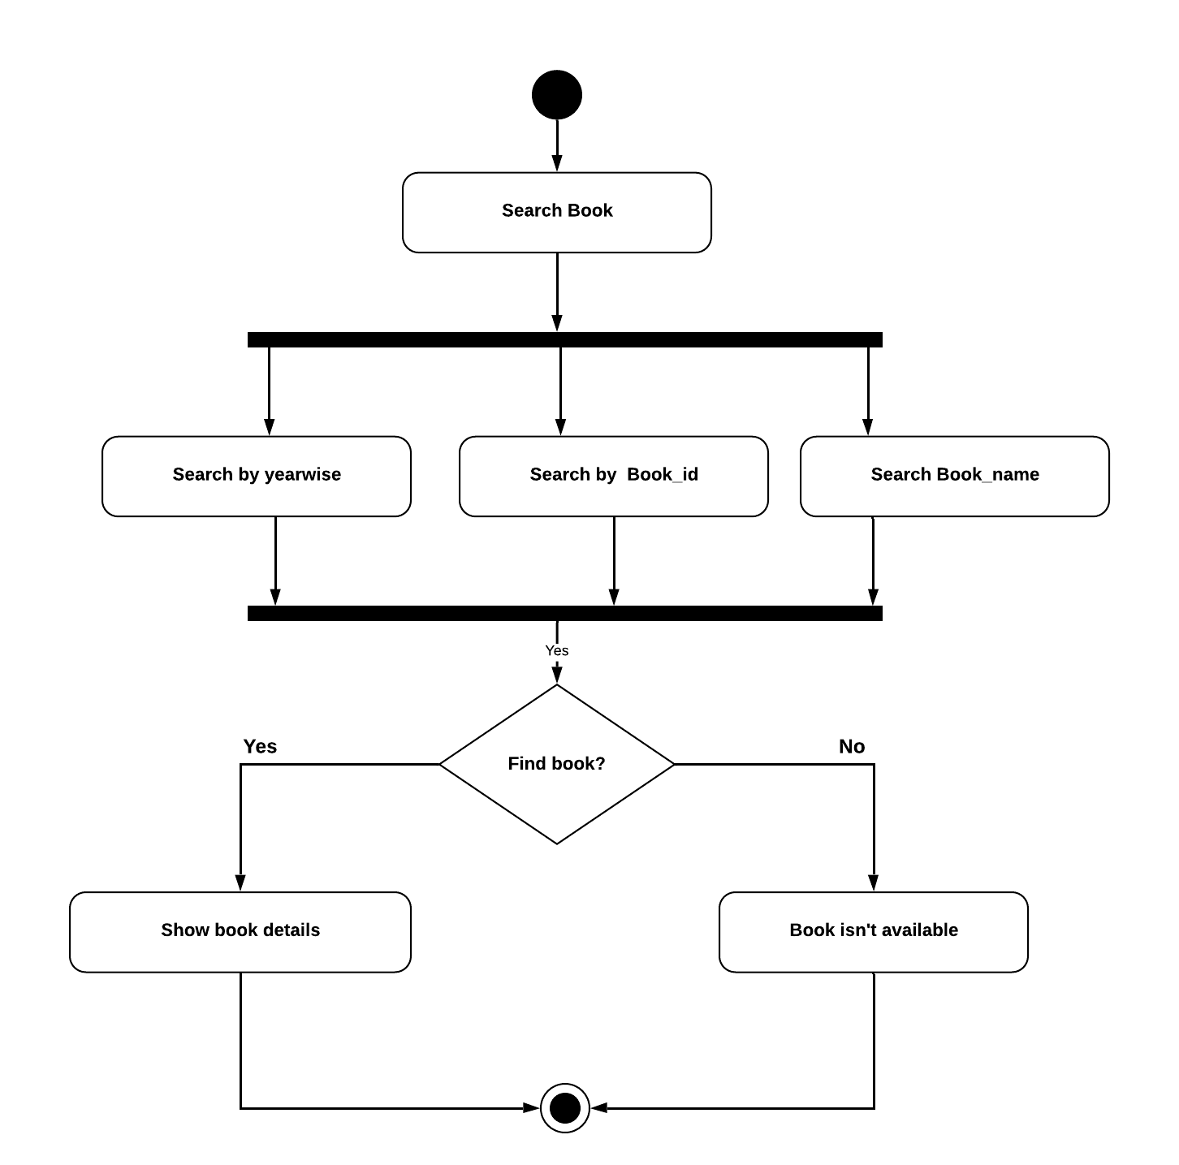

Figure 8.1 Search Book

## **8.2 Add Book**

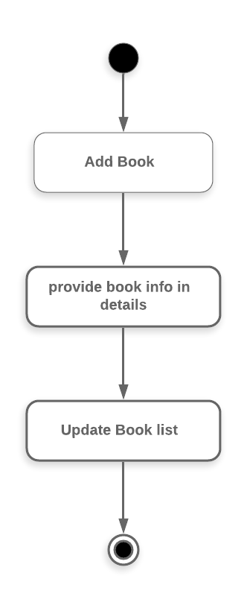

Figure 8.2 Add Book

## **8.3 Edit Book**

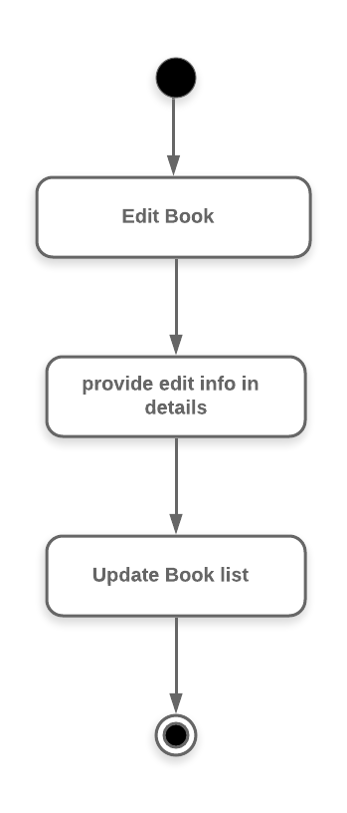

Figure 8.3 Edit Book

## **8.4 Remove Book**

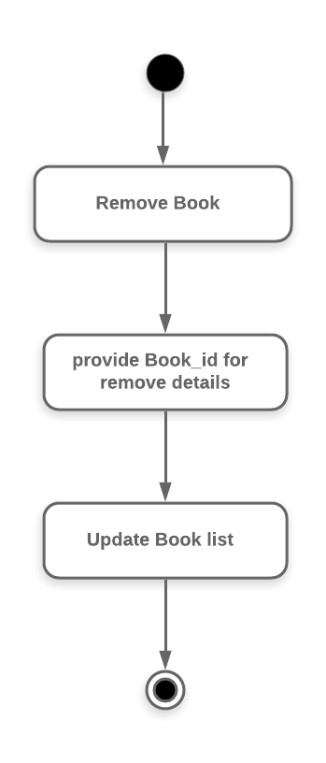

Figure 8.4 Remove Book

## **8.5 Request Book**

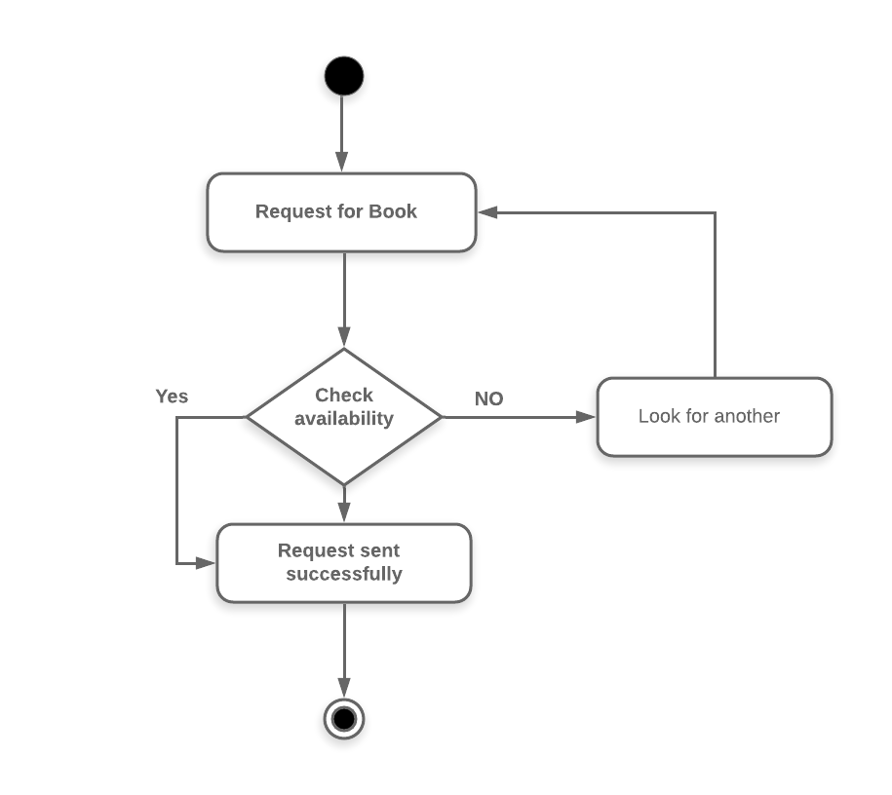

Figure 8.5 Request Book

## **8.6 Collect requested book**

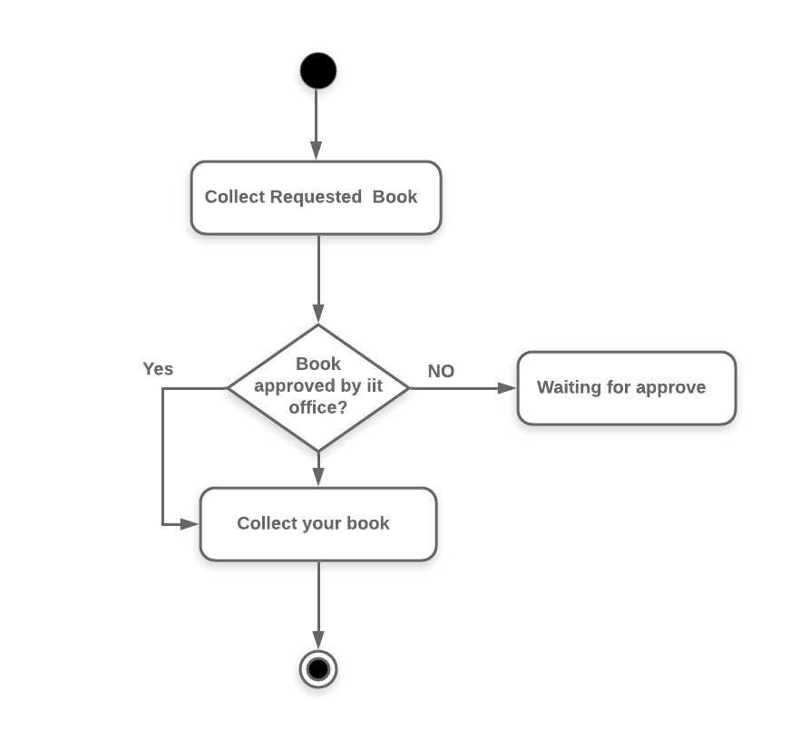

Figure 8.6 Collect requested book

## **8.7 Return Book**

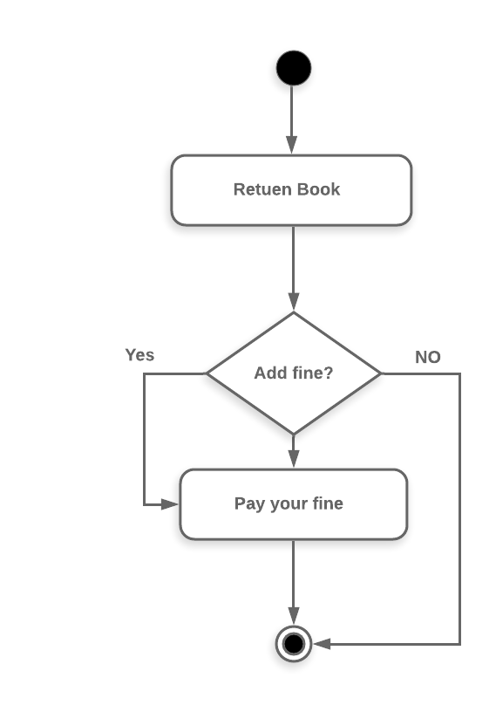

Figure 8.7 Return book

## **8.8 Receive Book**

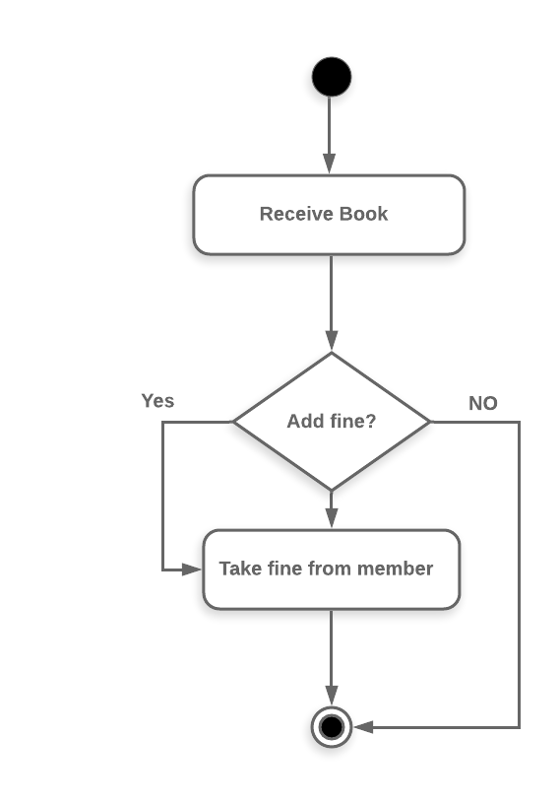

Figure 8.8 Receive book

**8.9 Calculate fine**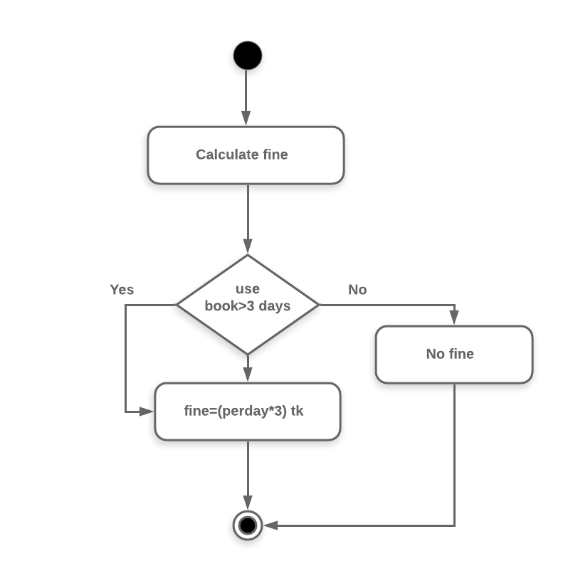

Figure 8.9 Calculate fine

## **8.10 Show current availability of books**

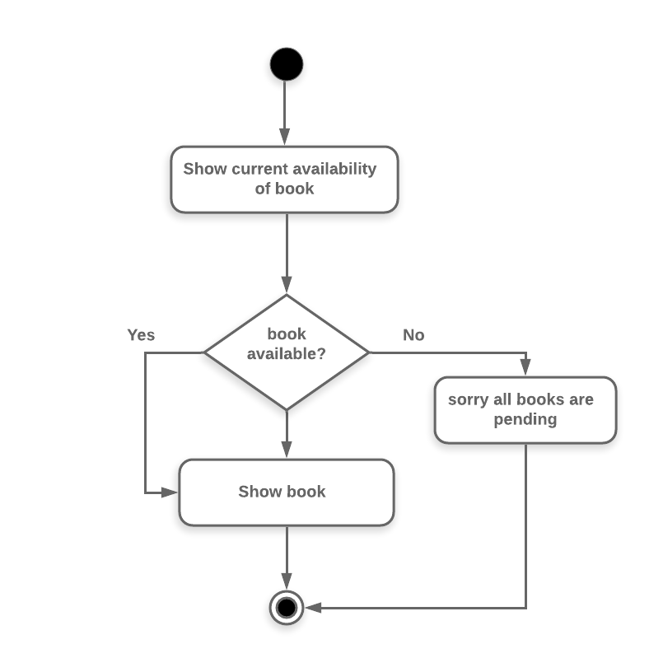

Figure 8.10 Show current availability of book

# **9. ER Diagram**

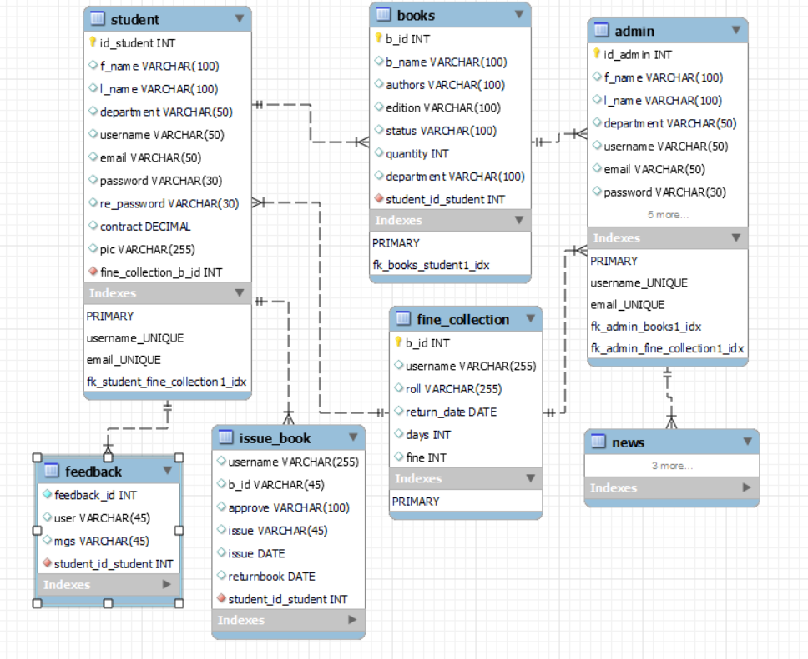

# **10 Requirements traceability matrix**

A traceability matrix is a document, usually in the form of a table, used to assist in determining the completeness of a relationship by correlating any two baselined documents using a manytomany relationship comparisons. It is often used with high-level requirements (these often consist of marketing requirements) and detailed requirements of the product to the matching parts of high-level design, detailed design, test plan, and test cases.

## **10.1 Test Case**

|  |  |
| --- | --- |
| Test No | Test Case |
| TC1 | Login with valid user name/email & password. |
| TC2 | Search book by book identification number |
| TC3 | Search book using book name |
| TC4 | Edit username successfully |
| TC5 | Edit password successfully |
| TC6 | Return book successfully |
| TC7 | Add student using student information |
| TC8 | Add book using book information |
| TC9 | Edit Book successfully |
| TC10 | Delete book from database successfully |
| TC11 | Approve pending book using approve button |
| TC12 | Collect Fine from student successfully |
| TC13 | Update profile successfully |

# **11 Appendix**

## **11.1 Prioritization of requirements**

We’ve prioritized the functional requirements by following Three-level Scale technique.

11.1.1 Three-level Scale

With the numbering on the different sections of the diagram, the priority of the sections is implicit. Important items have the highest preference, while urgent items have lower preference.

1. High Priority – These requirements are urgent and important. These are requirements that are generally with respect to compliance or contract that cannot be left out. These requirements need to be implemented in the current release and not implementing the same will have some adverse effect on the business.

2. Medium Priority – These requirements are important but not as urgent. Implement these after you implement the high priority items. If you see closely there is a line that splits this quadrant into 2 parts. Implement the items that are on the right side of the line first as they are relatively of higher medium priority.

3. Do these later – These items are urgent but do not have a lot of effect on the business. Hence do it after completing the more important medium priority items. Similar to the medium priority items, this quadrant has also been split into two; the items on the right side have a higher priority relatively to the items on the left.

4. Low Priority – These items are neither important nor are they urgent. The items on the right-hand side of the diagonal have higher priority. Start with the bottom-right corner of the high-priority quadrant and work your way up and left.