Project Features:

1. On Page Load. Also added a spinner until checks are displayed.

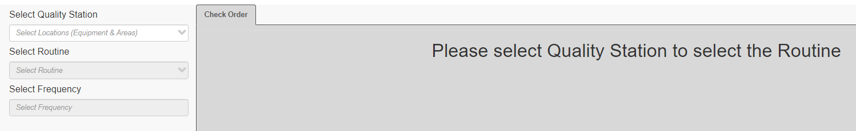

1. Get Quality Stations from Database.

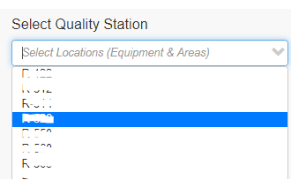

1. Return routines based on the selected station. And also show affected stations.

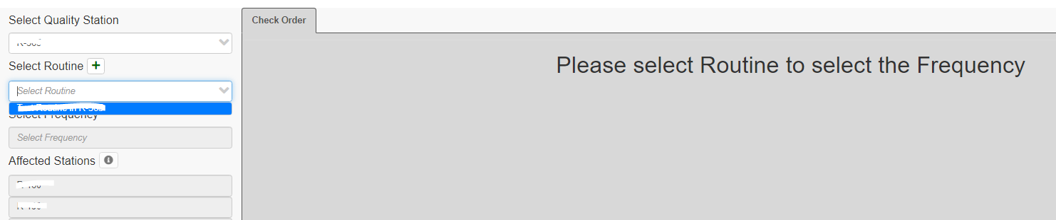

1. When user selects an existing routine, they should see the frequencies and orders associated with the selected routine.

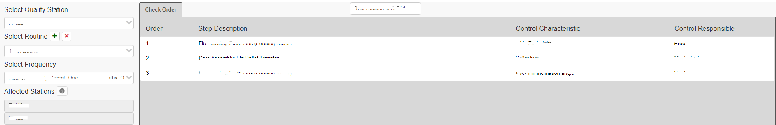

1. User should also have the ability to add, update, and delete routine anytime.
   1. Add

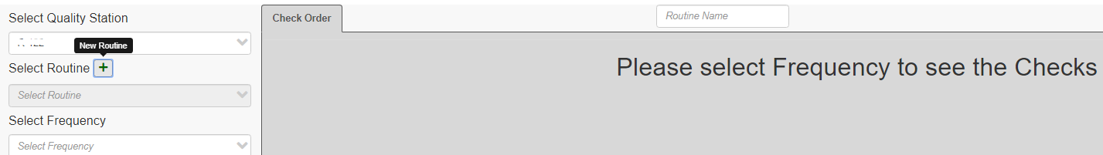

* 1. Update

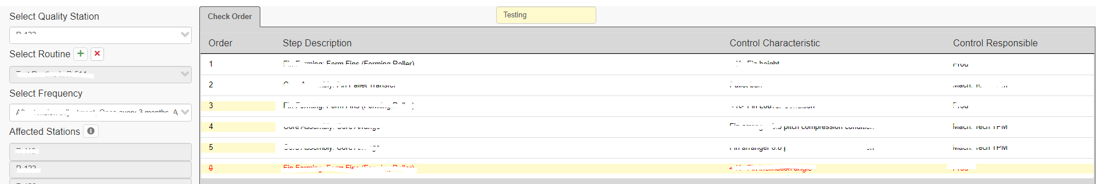

* 1. Remove

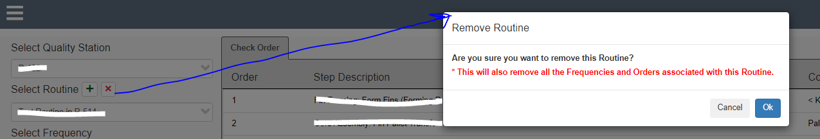

1. If needed user can add or remove frequencies from the filter list and as they add or remove order checks will also get updated respectively. Added HTML classes to make it clearly visible when the frequency has been added and when its deleted.



1. User have the ability to drag and reorder the checks and the order number gets updated accordingly. Added HTML class to make the updated order number visible.

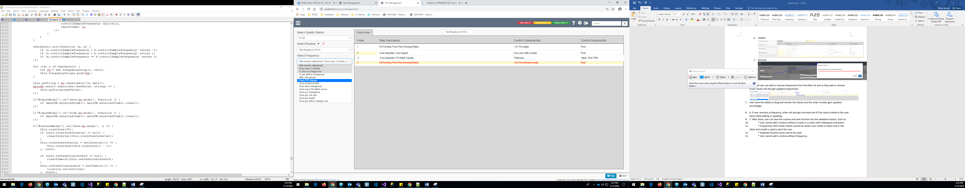

1. After done, user can save the routine and save function has the validation factors. Such as:

\* User cannot add a routine without a name or a name with whitespace characters

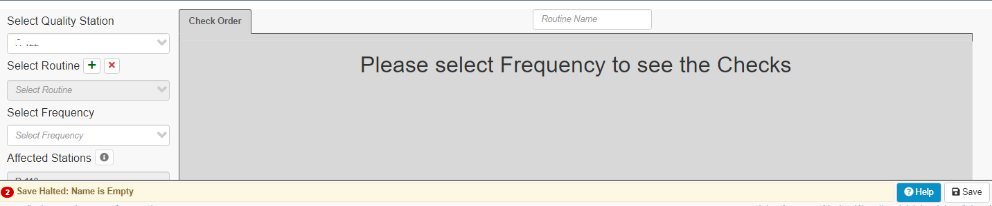

\* Frequencies with similar checks cannot be saved. User needs to select one or the other and modal is used to alert the user.

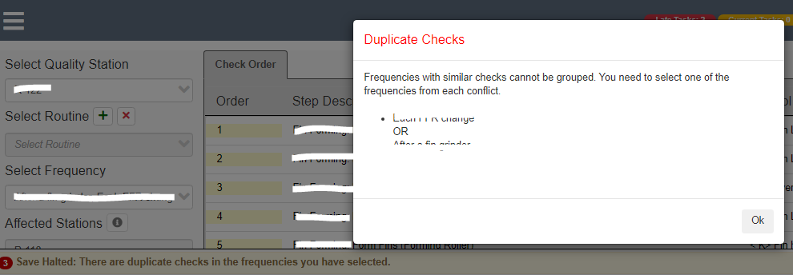

\* Duplicate Routine name cannot be used.

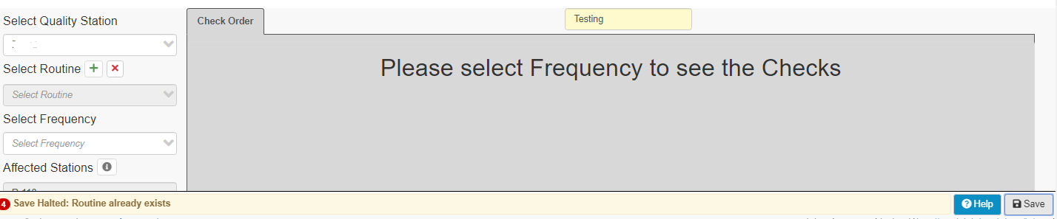

\* User cannot add a routine without frequency.

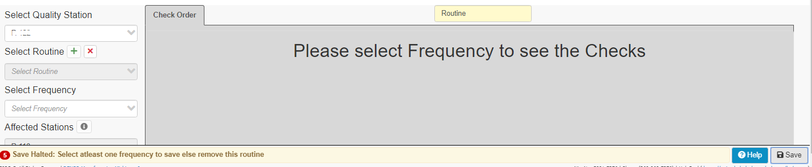

\* Save Success.

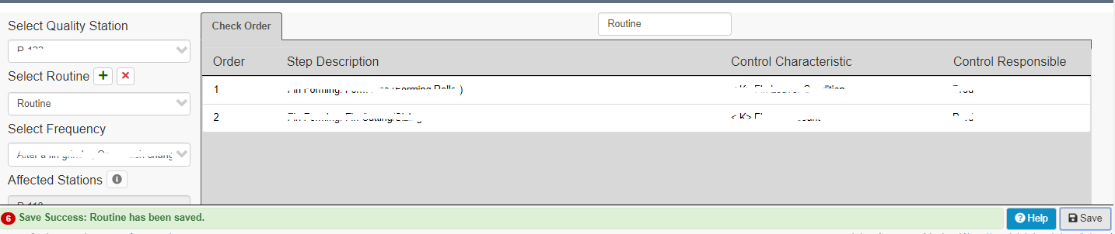

\* Remove Success.

