Project Features:

1. Added Select a Routine Filter

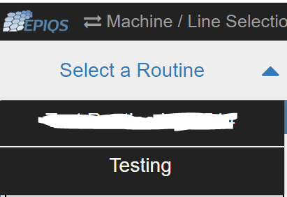

1. When user selects a routine, execute button appears

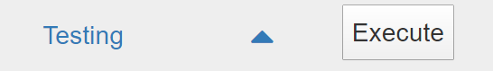

1. Executing routine without part number selected will alert the user

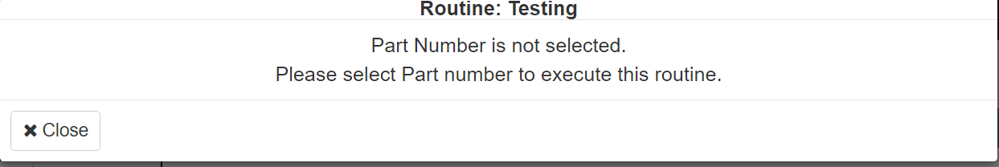

1. Part Number filter

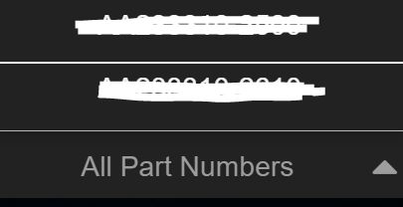

1. After selecting a routine and part number, execute button will force click on the related check grabbing the first one to display. 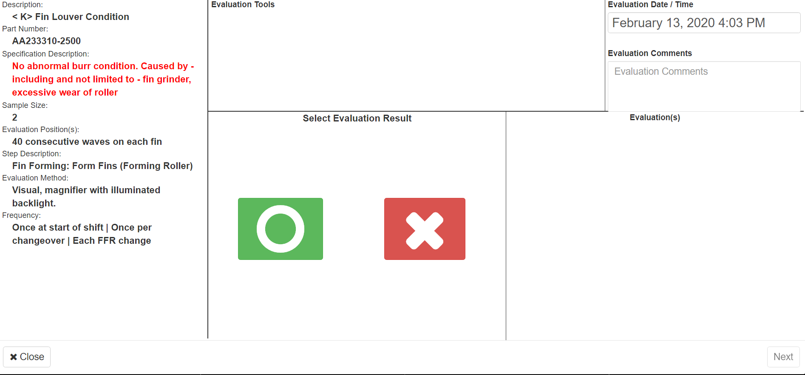
2. A user can also cancel the execution of a routine only at the first check and cancel/close button will force the page load so that it get the checks removing all filter. When user is at the last check “Next” Button text will change to “Save” and it will also force page load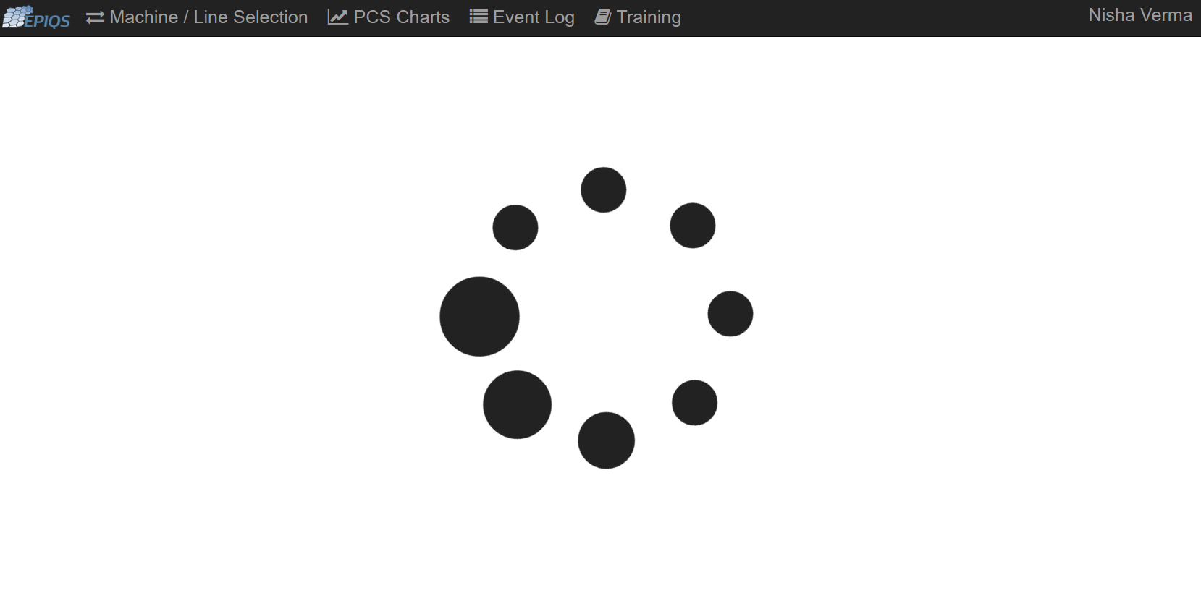
3. Once user starts the routine and click on Next, they cannot go back until the execution finishes and all checks are filled out.

