STUDENT PERFORMANCE PREDICTOR
A Machine Learning Based Web Application to Predict Student Academic Performance
Project Report
Course: Fundamentals of AI/ML
Submitted by: Nishchal Soni
Submission Platform: VITyarthi
Date: September 2026

1. Introduction
Educators and academic mentors often lack an early, data-driven way to identify students who may underperform before final exams. Manual tracking of study habits, attendance, and assignment completion across many students is time-consuming and inconsistent.
This project applies core Fundamentals of AI/ML concepts — supervised regression, feature engineering, model comparison, and evaluation metrics — to build a Student Performance Predictor: a Streamlit web application that predicts a student's final exam score from seven behavioral and academic indicators, classifies the result into a performance band, and gives the user a dashboard to manage records and review trends.

2. Problem Statement
Given a set of measurable student indicators — study hours per week, attendance percentage, previous grade, percentage of assignments completed, average sleep hours, participation in extracurricular activities, and level of parental support — predict the student's final exam score (0–100) and classify it into one of four performance bands: Poor, Average, Good, or Excellent.

Scope
- In scope: single-student prediction via a web form, CRUD management of student records, comparison of two ML models with automatic selection, and visual analytics.
- Out of scope: subject-wise grade prediction, integration with real institutional student information systems, and user authentication.

Target Users
- Teachers and academic advisors seeking an early-warning signal for at-risk students
- Students who want to see how specific habits project onto expected performance
- The course instructor evaluating this project

3. Functional Requirements
The application is built around three major functional modules, each with a clear input/output structure:

Module 1: Predict
Input: a student profile entered via sliders/dropdowns. Output: a predicted final score and performance band, automatically logged.

Module 2: Data Management (CRUD)
Input: new or edited student records. Output: create, read, update, and delete operations against the SQLite-backed student database, reflected immediately in the UI.

Module 3: Analytics Dashboard
Input: the stored dataset and prediction log. Output: score distribution histogram, feature correlation heatmap, model feature-importance chart, and a running plot of predictions made in the app.
A supporting Model Info page displays which model was selected and its evaluation metrics, satisfying the 'demonstrating understanding through documentation and evaluation' objective.

4. Non-Functional Requirements
Requirement | How it's met
Performance | Model cached with st.cache_resource; predictions return in under 1 second.
Reliability | validate_student_input() rejects out-of-range or missing values before they reach the model.
Usability | Single sidebar-navigated app; sliders and dropdowns replace free-text entry wherever possible.
Maintainability | Modular package (modules/) with docstrings; each concern (data, model, DB, charts) isolated.
Scalability | SQLite layer is swappable for a server database without touching UI or model code.
Error Handling | Try/except around prediction and DB transactions, with rollback and logging on failure.
Logging / Monitoring | All key events (DB init, model load, training, errors) written to data/app.log.

5. System Architecture
The application follows a three-layer architecture separating UI, business logic, and persistence, so the storage mechanism or ML model can be changed without touching the other layers.
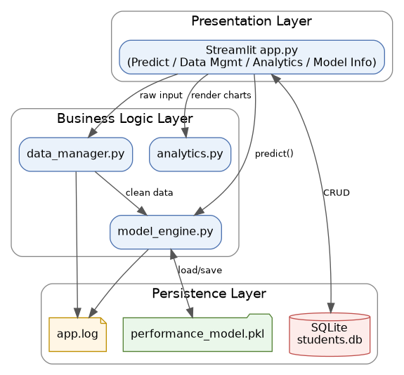
Figure 1: System Architecture

6. Design Diagrams

6.1 Process / Workflow Diagram
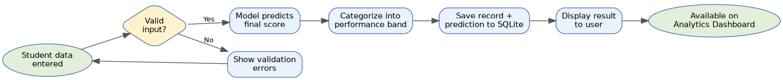
Figure 2: End-to-end prediction workflow

6.2 Use Case Diagram
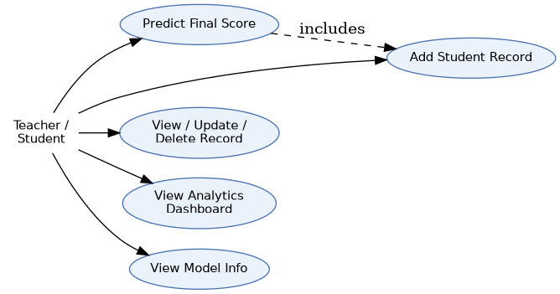
Figure 3: Use Case Diagram

6.3 Class / Component Diagram
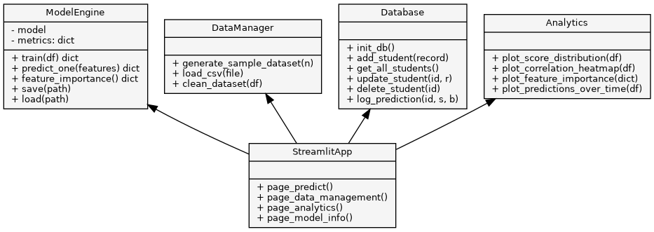
Figure 4: Class / Component Diagram

6.4 Sequence Diagram — Prediction Flow
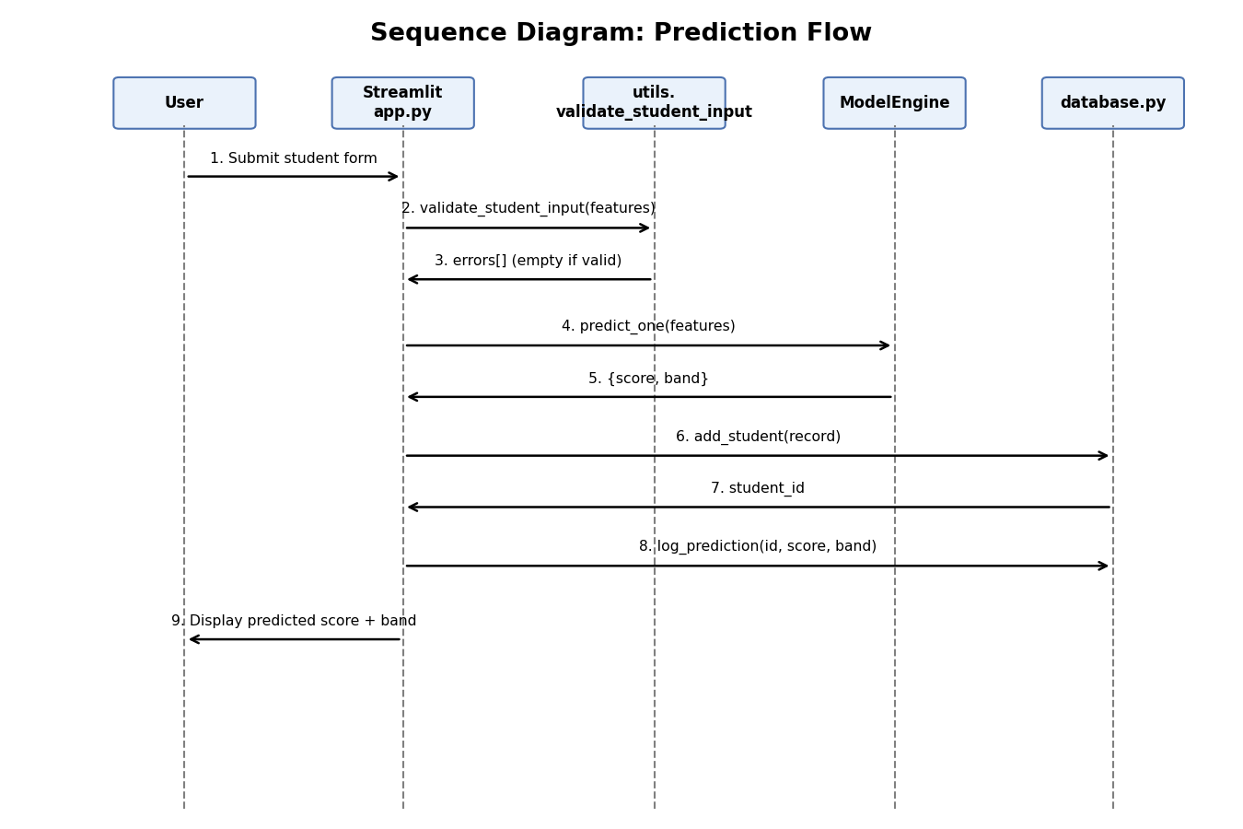
Figure 5: Sequence Diagram for a single prediction request

6.5 Entity-Relationship Diagram
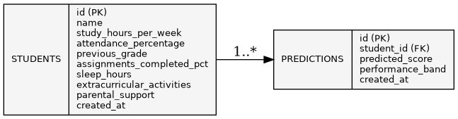
Figure 6: ER Diagram — students and predictions tables

7. Design Decisions & Rationale

Model Selection
Two candidate regressors were trained and compared: Linear Regression as an interpretable baseline, and Random Forest Regressor to capture potential non-linear interactions (e.g. diminishing returns on study hours, threshold effects in attendance). Both were evaluated with 5-fold cross-validation on the training split using Mean Absolute Error (MAE); the model with the lower cross-validated MAE was automatically selected and persisted.

Dataset
A synthetic dataset of 800 records is generated at training time (modules/data_manager.py), with the target built as a weighted, noisy combination of the seven features. This keeps the project fully reproducible without depending on an external download, while still giving both models genuine, non-trivial signal to learn from. A load_csv() function is also provided so real institutional data matching the same schema can be substituted directly.

Why SQLite
SQLite requires no separate server and ships with Python, which fits a single-user academic project, while still exercising real CRUD and transactional logic (with rollback on failure) that would carry over to a production database.

8. Implementation Details
The project is organized as nine Python files across three concerns:
- app.py — Streamlit UI and page routing only; contains no business logic.
- modules/data_manager.py — synthetic dataset generation, CSV loading, and data cleaning.
- modules/model_engine.py — preprocessing, model training/comparison, evaluation, persistence, and inference.
- modules/database.py — SQLite connection handling and CRUD operations for students and predictions, using a context manager that commits on success and rolls back on error.
- modules/analytics.py — chart-generation functions, independently testable since they do not import Streamlit.
- modules/utils.py — shared constants, logging setup, and input validation.
- train_model.py — standalone script to generate data, train, evaluate, and save the model.
- tests/test_model_engine.py — automated unit tests (see Section 10).
Technologies used: Python 3.13, Streamlit, scikit-learn, pandas, numpy, matplotlib, seaborn, SQLite, and pytest. Version control was maintained with Git, and the project is hosted on GitHub.

9. Screenshots / Results

9.1 Predict Module
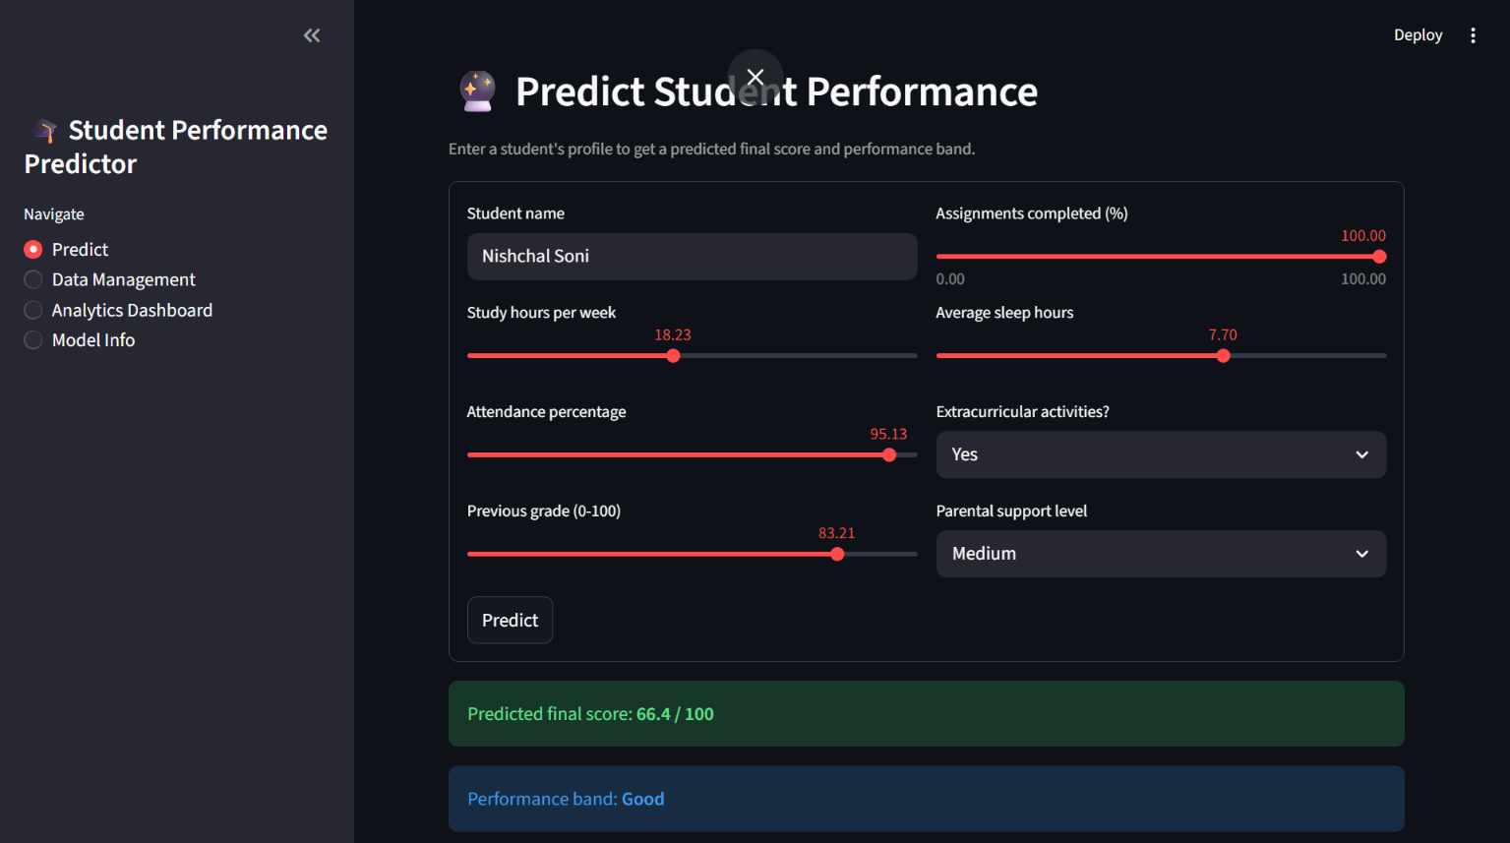
Figure 7: Predicting a student's score — result: 66.4/100, band "Good"

9.2 Data Management Module (CRUD)
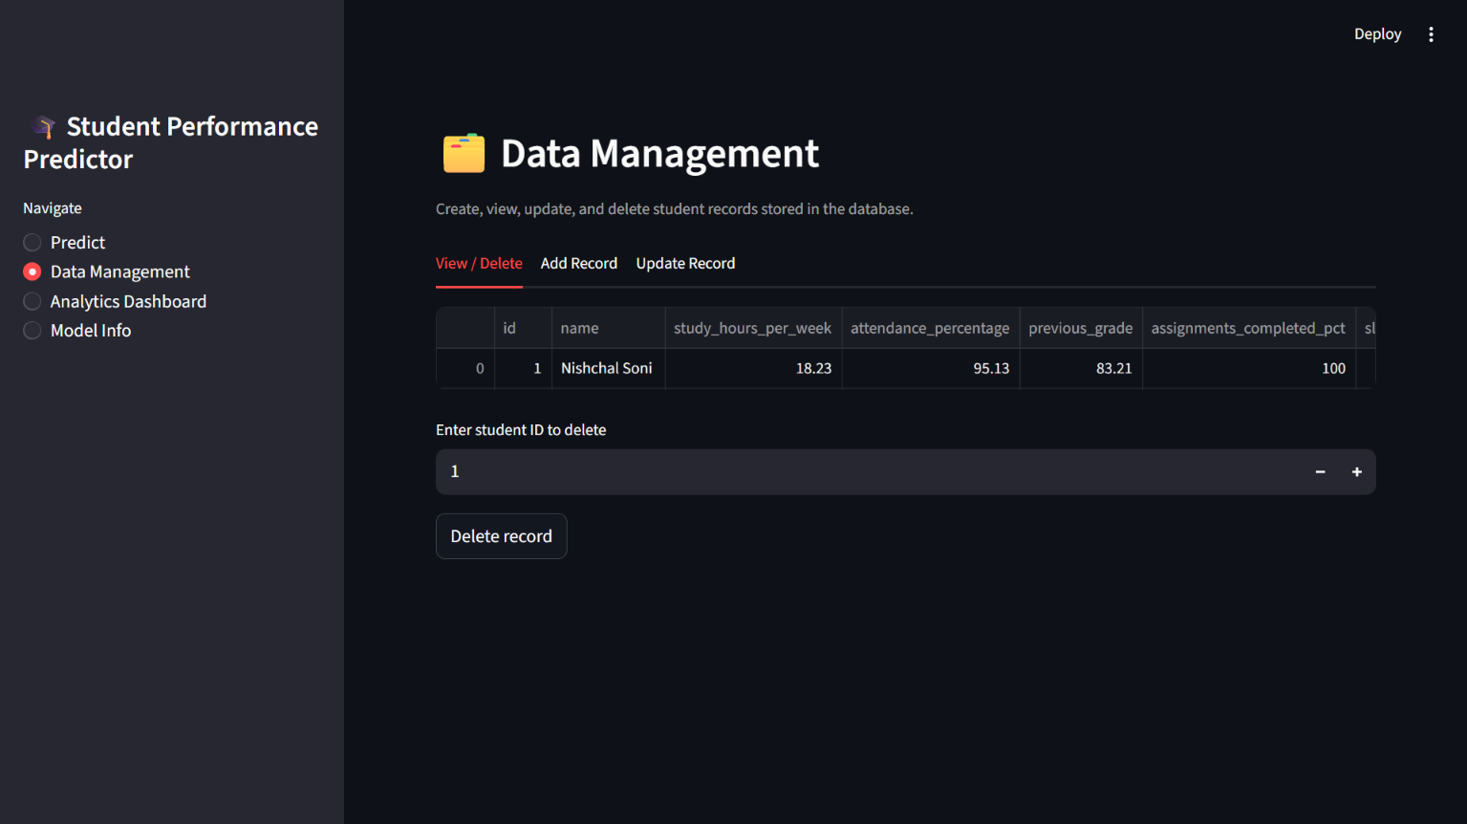
Figure 8: Viewing and deleting stored student records

9.3 Analytics Dashboard
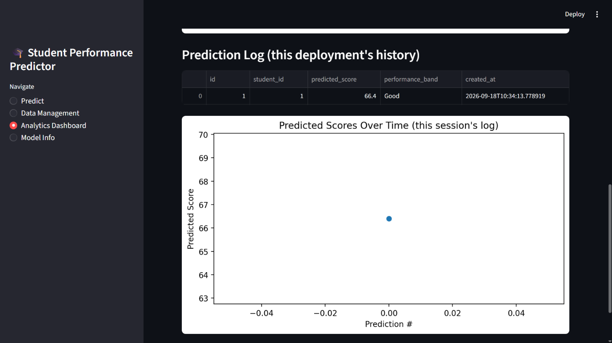
Figure 9: Prediction log and predicted-scores-over-time chart

9.4 Model Info
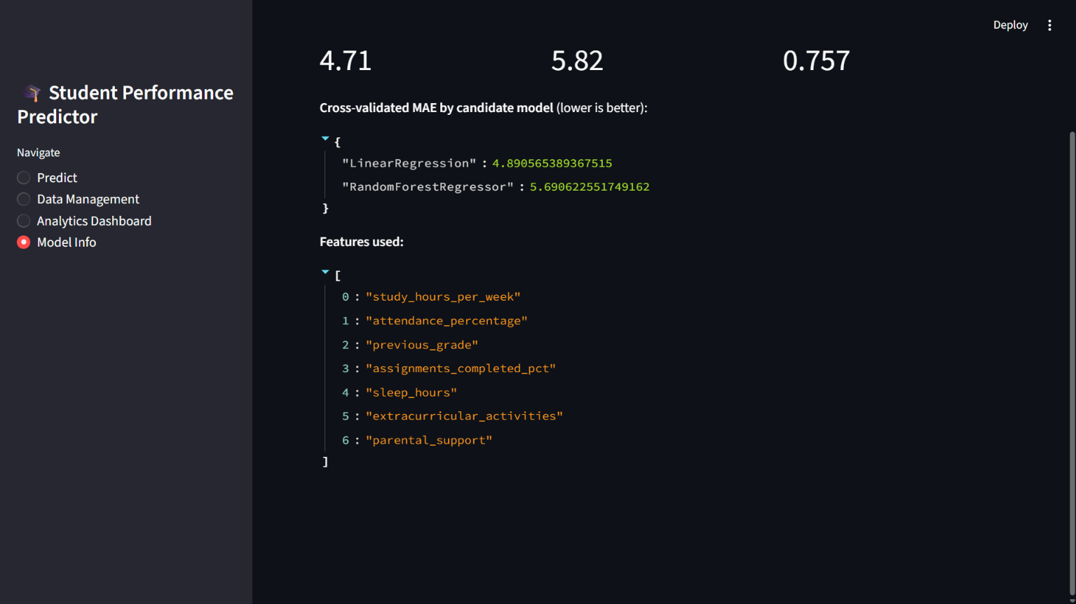
Figure 10: Selected model, evaluation metrics, and feature list

9.5 Summary of Evaluation Metrics
Metric | Value (test set)
Selected model | Linear Regression
Mean Absolute Error (MAE) | 4.71
Root Mean Squared Error (RMSE) | 5.82
R² Score | 0.757
Cross-val MAE — Linear Regression | 4.89
Cross-val MAE — Random Forest | 5.69

10. Testing Approach
Nine automated unit tests (pytest) cover dataset generation, data cleaning, input validation, score categorization, and end-to-end model training/inference (tests/test_model_engine.py). All nine passed on both the development machine and the student's own machine, confirming the code is reproducible across environments.
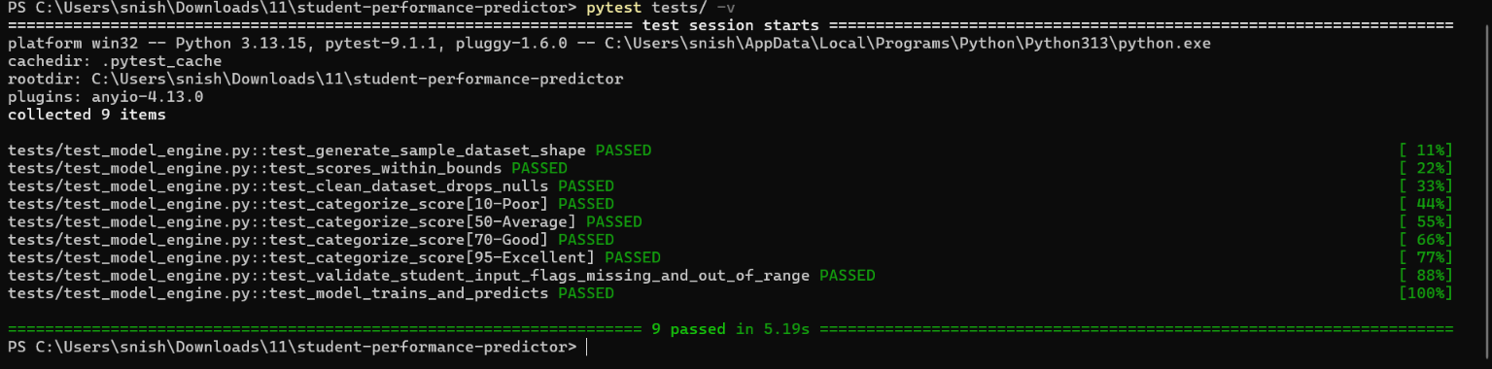
Figure 11: pytest run — 9 passed in 5.19s
In addition, every page of the application (Predict, Data Management, Analytics Dashboard, Model Info) was manually exercised end-to-end, including adding, updating, and deleting a student record, to confirm the CRUD and prediction flows work together correctly.

11. Challenges Faced
- Initial confusion around a Streamlit "missing ScriptRunContext" warning, traced to the app being launched with a stray [ARGUMENTS] placeholder from an IDE run task rather than through the plain `streamlit run app.py` command.
- A path mismatch when running the project under a different Windows user account than the one the folder was originally downloaded to, resolved by locating the correct path with File Explorer's "Copy as path."
- Balancing model interpretability against capturing non-linear feature interactions, addressed by training and cross-validating two different model families rather than committing to one upfront.

12. Learnings & Key Takeaways
- Practical experience comparing regression models using cross-validated error metrics rather than a single train/test split.
- Reinforced the value of separating UI, business logic, and persistence layers, which made the code independently testable without a running Streamlit server.
- Hands-on debugging of environment/tooling issues (Python environments, IDE run configurations) that are common in real-world ML deployment, not just model-building.

13. Future Enhancements
- Add further candidate models (Gradient Boosting, XGBoost) to the comparison step in train_model.py.
- Support CSV bulk upload for batch prediction across an entire class roster.
- Add basic authentication for multi-teacher use.
- Deploy the app publicly via Streamlit Community Cloud.

14. References
- Streamlit Documentation — https://docs.streamlit.io
- scikit-learn Documentation — https://scikit-learn.org/stable/
- Python sqlite3 Documentation — https://docs.python.org/3/library/sqlite3.html
- VITyarthi — Build Your Own Project: General Project Instructions & Submission Guidelines

Appendix: Evaluation Rubric (as provided)
Component | Weightage
Problem Understanding & Requirements | 10%
Design & Documentation | 20%
Implementation Quality | 25%
Innovation, Depth & Complexity | 15%
GitHub Repository & Version Control | 10%
Project Report | 20%
Total | 100%

