**Appendix:**

To execute the program, please follow the below instruction.

For our analysis we have used python 3.0+ version. In the environment the previously described library should be installed that can be done using simple command – pip install ‘library_name’.

Please follow the below commands to install libraries.

1. If you don’t have python installed, download python 3.0+ version and install it. Also put it under the path variable.
2. Install NumPy with **pip install numpy.**
3. Install Pandas with **pip install pandas**.
4. Install missingpy with **pip install missingpy**.
5. Install sklearn with **pip install sklearn**.
6. To install library for smote use this command: **pip install imblearn**.

Next, if any IDE is used like PyCharm or Anaconda just open Project.py file and hit the run button, else type the command – python Project.py that will run the code from command prompt.

Our dataset is divided into five years, so if you want to get results for just the first year enter 1 in the prompt question asked for which year dataset you want to take. As mentioned in the below image, if Input is taken as 0 so it will perform on all_years dataset and 1 – 5 it will perform analysis on that respective year’s dataset.



For the user input for K fold stratified cross validation, the prompt will ask for K value which is for cross validation to mention how many folds you want to run e.g. if you want 5 - fold cross validation, just enter 5 as shown in below prompt.

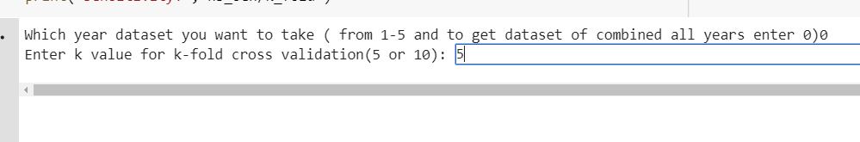

So as per above given example, it will start performing on the all_years dataset with 5 - fold stratified cross validation for all three classifiers and will show the accuracy, sensitivity and specificity on the console.

For SVM, polynomial kernel gives the best result and only that kernel is kept active in our codebase but, if you want to check the results for linear and radial kernel just uncomment corresponding code and comment other. More details are mentioned in the code.

**Note:** Before it shows some results, it will give some library warnings, please ignore those warnings.