**Exercise 1**

**Predict agent availability**

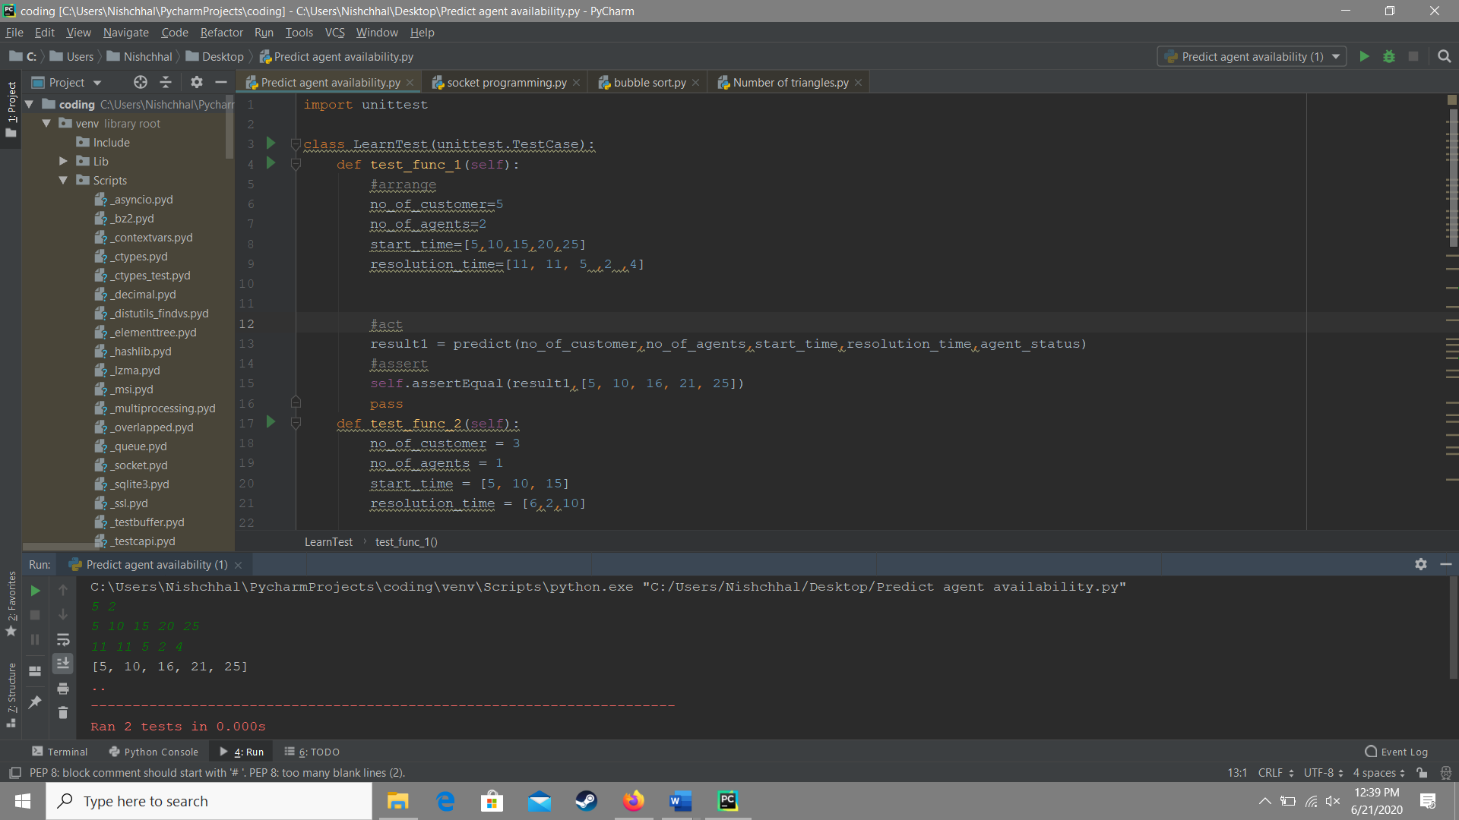

**Input format-**

The first line contains two space-separated integers Number of customers and Number of agents.

The second line contains an array start_time of integers where start_time[i] denotes the arrival time of the  ith customer.

The third line contains an array resolution_time of integers where resolution_time[i] denotes the time it takes for preparing an order of a person i.

**Output Format-**

N space-separated integers denoting that the customer’s request is picked up for preparation at time t by one of the free chefs. If no chef is available at that time, the prediction of the completed task has been printed.

Ans1- I have programmed Sockets to maintain the connection for client and servers. It included two programs one the server sided and other client sided.

Ans2- No I have a bit theoretical knowledge of SIP but haven’t practically coded or programmed it’s implementation.

Ans3- I am pretty confident in SQL and can create the queries to get the specified work done.

Ans4-No I have not worked with ORM.

Ans5-I have basic implementation of Django like using inbuilt classes, creating basic stuctues using buttons and including onclick functions.

Ans6-No sir I haven’t implemented any of the following frameworks.