

Practical 3: Sorting Algorithms: Comparison-Based, Counting-Based, and Digit-Based Strategies
Practical Aim
To implement and compare multiple sorting algorithms and develop the ability to reason about which sorting strategy suits a given situation.

Problem 1
A teacher has a stack of student answer sheets with marks written on them and needs to arrange them in order before entering grades. She tries three different methods: in the first, she repeatedly compares adjacent sheets and swaps them if they are out of order; in the second, she finds the lowest-marked sheet each time and places it at the front; in the third, she picks each sheet one by one and inserts it into its correct position among the already-arranged sheets. Implement all three methods and for each one, print the sorted order of marks. Describe how each of the three methods works in your own words. If the sheets were already in order before the teacher started, which method would finish the fastest and why?
Code:
https://github.com/nishee166/FDSA-Batch--B-SHP-.git

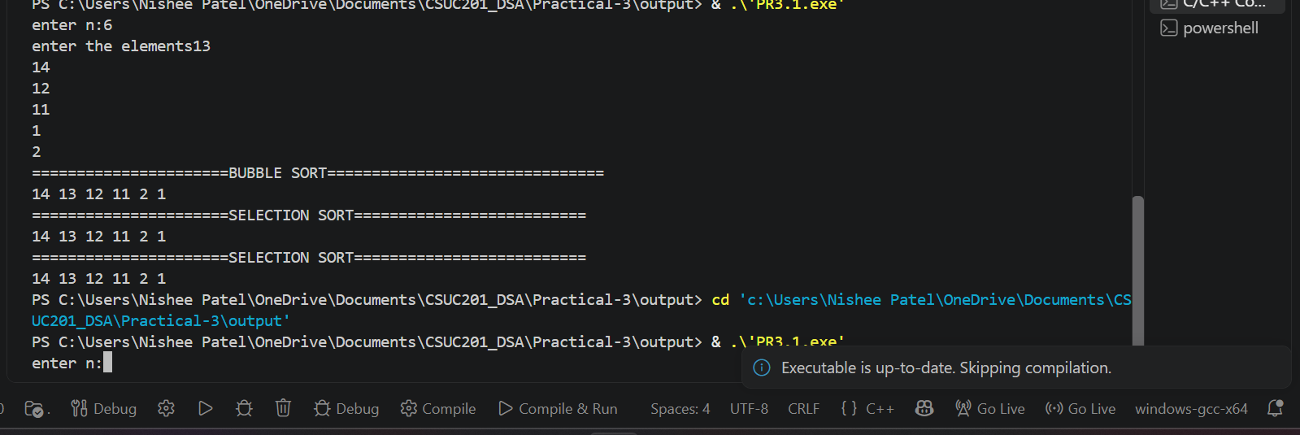

Error: Wrong loop condition caused incorrect sorting
Solution: corrected the loop boundaries and array indices.
Learning: learned that proper loop conditions and indexing are essential for accurate sorting.

Problem 2
A paint shop has buckets labeled with one of three colour codes — 0, 1, or 2 — but they are stored in a random order. The shop owner wants all 0s together, then all 1s, then all 2s, without using any extra storage. Given the list of colour codes, rearrange them in place and print the result. Describe the approach you used. Does your solution make more than one pass through the list? Can you think of a way to do it in exactly one pass?

Code:
https://github.com/nishee166/FDSA-Batch--B-SHP-.git

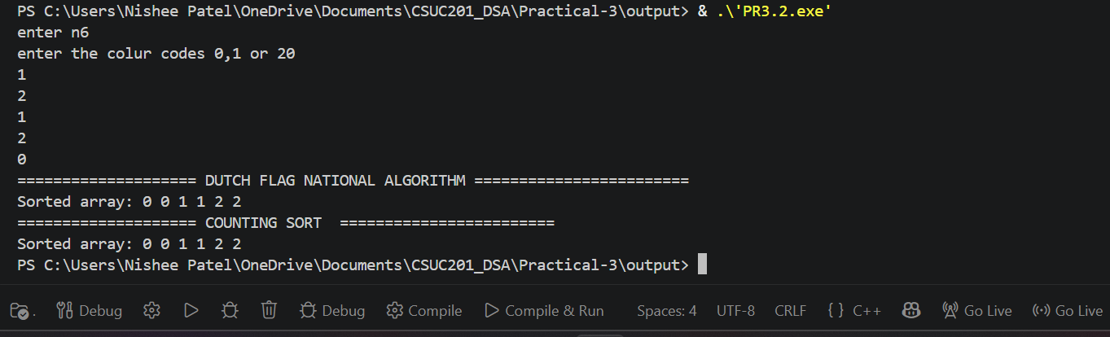

Error: Incorrect pointer movement caused some elements to be skipped
Solution: corrected the low, mid, and high pointer updates
Learning: learned how the Dutch National Flag algorithm can sort 0, 1, and 2 in-place efficiently in one pass.

Key Questions :

1. One of the three methods can detect early that the list is already sorted and
stop without doing any more work. Which method is it, how would you add that
detection, and why can the other two not do the same?
Solution:
Bubble Sort can stop early using a swapped flag; if no swap occurs, the list is already sorted.
2. If your solution makes two passes through the list, can you identify which
decision in your logic forces the second pass? Is there a way to restructure that decision
to eliminate it?
Solution:
The second pass is caused by separately counting and rearranging elements; the Dutch National Flag algorithm eliminates it using three pointers in one pass.

Conclusion:
In this practical, we implemented Bubble Sort, Selection Sort, Insertion Sort, and the Dutch National Flag algorithm. We learned to compare sorting techniques based on their working, efficiency, and number of passes.

