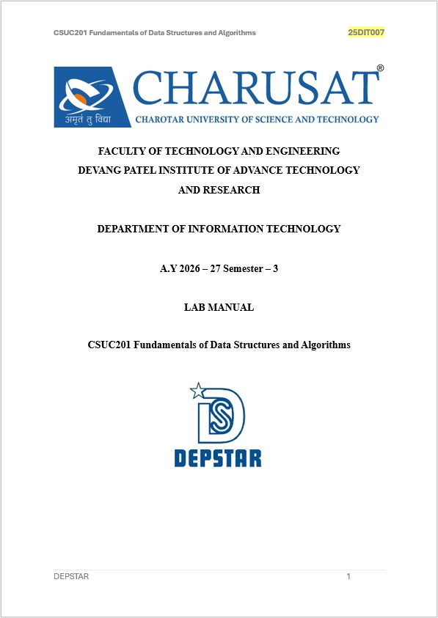

PRACTICAL – 7
Queue Implementation using Array and Linked List, with Structure Simulation

Practical Aim
To implement queue using array and linked list, and apply queue-based logic to number generation, and structure simulation problems.

Problem 1
A government office has a token counter that issues tokens to visitors. The counter can hold at
most n tokens at a time. New visitors join from one end and are served from the other end in the
order they arrived. If the counter is full, no new token can be issued, and if it is empty, no one
can be served. Given a sequence of join and serve operations, implement this fixed-capacity
token system and print the current front token after each operation. Report an error if an
operation cannot be performed. Describe how your solution tracks the front and rear of the queue. What happens to your front and rear pointers over time as join and serve operations keep happening, and does your solution handle the case where space appears to run out even though slots have been freed?

CODE LINK:
https://github.com/nishee166/FDSA-Batch--B-SHP-.git

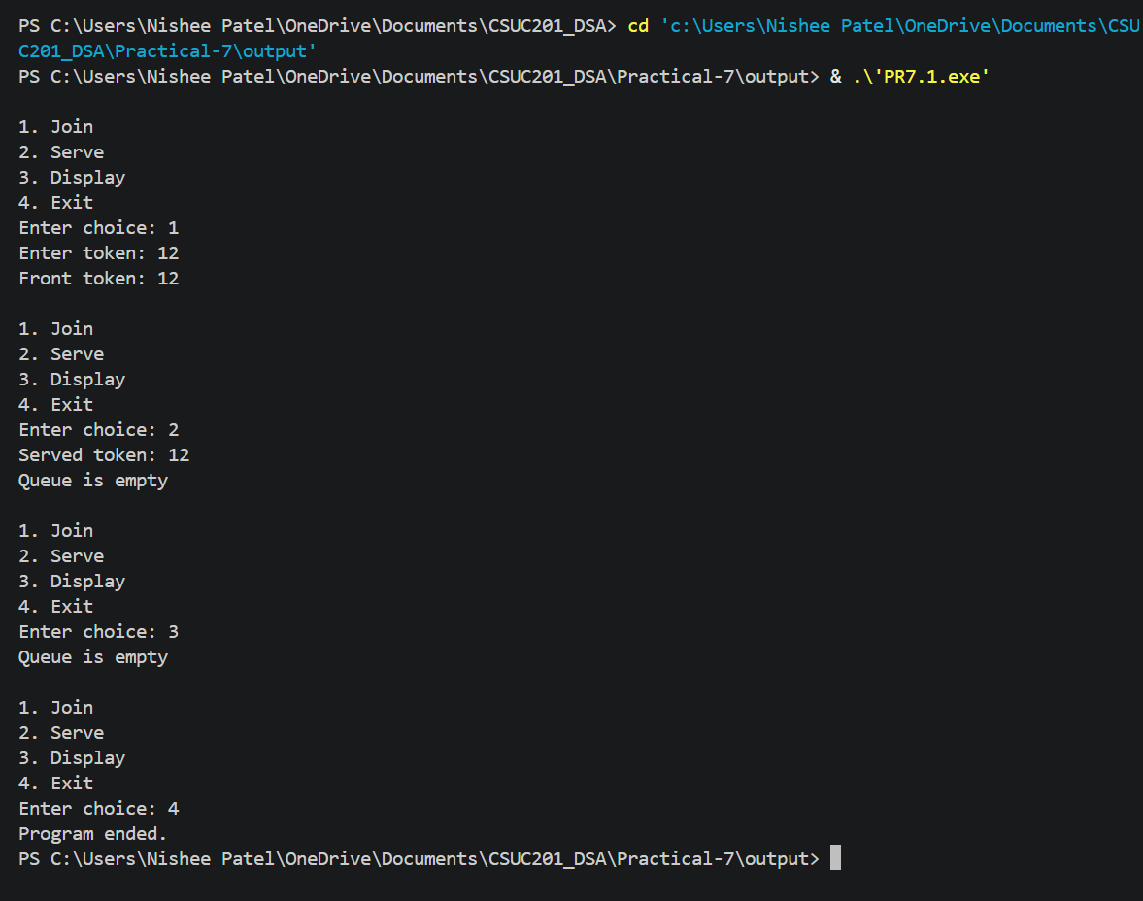
Error:
I initially forgot to handle the condition when the queue became full, which caused insertion beyond the array limit.
Learning:
I learned how front and rear manage insertion and deletion in an array queue.
Solution:
I added an overflow check before insertion and an underflow check before deletion.

Problem 2
A hospital emergency ward receives patients continuously and attends to them strictly in the
order they arrived, with no upper limit on how many can be waiting at once. New patients are
added at the back and the doctor always attends to the patient at the front. Given a sequence of
arrive and attend operations, implement this unlimited patient queue and print the current front
patient after each operation. Describe how your solution differs from Problem 1 in how it manages capacity. What happens in your solution when the attend operation is called on an empty ward with no patients waiting?

CODE LINK:
https://github.com/nishee166/FDSA-Batch--B-SHP-.git

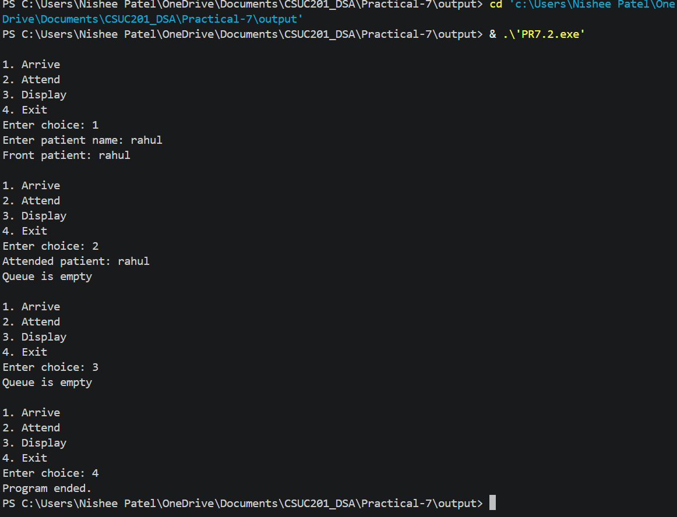
Error:
I initially forgot to update rear when the last patient was removed, which caused incorrect queue handling.
Learning:
I learned how front and rear pointers work with dynamically allocated nodes.
Solution:
I updated rear to nullptr whenever the queue becomes empty after an attend operation.

Key Questions :
Problem 1 :
A simple array queue eventually reports being full even when slots have been freed at the front. Explain why this happens structurally — not by tracing an example, but by describing what the front and rear pointers represent and what their movement pattern causes over time.
ANS:
A simple array queue uses front to point to the first active element and rear to point to the last inserted element. Both move forward as operations are performed. When elements are removed, front moves ahead, but the empty spaces before front are not reused. Therefore, rear can reach the end of the array and the queue may report full even though there are free spaces at the beginning. This problem can be solved using a circular queue.
Problem 2 :
Your linked list queue has no capacity limit. If arrive operations vastly outnumber attend operations over a long period, what real consequence would this have on the system, and where in your code is that consequence invisible?
ANS:
A linked list queue has no fixed capacity because new nodes are created dynamically whenever a patient arrives. If arrive operations are much more than attend operations, the number of nodes keeps increasing and the program may eventually use all available memory. This consequence is not visible as a fixed limit in the queue code because nodes are allocated using new; the actual limitation is the available system memory.

CONCLUSION:
The practical successfully implemented queue using array and linked list and applied queue-based logic to token and patient management. I learned about overflow and underflow, front and rear pointer management, fixed and dynamic capacity, and the limitations of simple array queues and linked-list queues.

