Comprehensive Retail eCommerce
Data Analysis Report

Final Internship Project

End-to-End eCommerce Data Analytics

Customer Analytics | Sales Forecasting | Website Analytics | Conversion Optimization | Pricing Experimentation

Prepared by
Nishant Kumar Nishee
B.Tech – Computer Science and Engineering
Centurion University of Technology and Management

1. Executive Summary
This comprehensive project integrates multiple analytical techniques
to evaluate the performance of a simulated retail eCommerce platform.
The analysis covers data strategy, customer segmentation, sales
forecasting, website performance, conversion rate optimization,
pricing experimentation, and cross-functional business analysis.
The integrated customer-level dataset contains 6,000
observations and combines customer segments, acquisition channels,
devices, website engagement, pricing conditions, purchase outcomes,
revenue, and estimated profitability.
The simulated platform achieved an overall conversion rate of
8.58% and a bounce rate of
35.87%. Total simulated revenue was
₹690,700.00, while total estimated profit was
₹273,700.00.
The analysis identified
Regular as the strongest segment
by revenue per customer,
Paid Ads as the highest-converting
traffic source, and Tablet as the
highest-converting device category.
Sales forecasting was evaluated using moving averages, linear
regression, and exponential smoothing. In the model-fit comparison,
Exponential Smoothing produced the lowest MAE.
Pricing analysis evaluated Control, Discount, and Premium strategies.
Premium generated the highest observed
estimated profit per visitor in the integrated simulation.
The findings demonstrate that eCommerce performance should be evaluated
through an integrated framework rather than through isolated KPIs.
Customer value, engagement, acquisition quality, pricing, conversion,
revenue, and profitability should be considered together when making
business decisions.

2. Introduction
Modern eCommerce platforms generate large volumes of data across
customer interactions, transactions, digital marketing channels,
devices, pricing experiments, and website behavior.
Analyzing these areas independently can provide useful information,
but stronger business decisions require an integrated analytical
approach.
This project combines the analytical methods developed throughout the
internship into a single end-to-end retail eCommerce analysis. The
project demonstrates how data can move from collection and preparation
to descriptive analysis, forecasting, experimentation, integrated
insights, and strategic recommendations.
The analysis uses simulated data for educational purposes. Therefore,
the findings demonstrate analytical methodology and business reasoning
rather than actual performance of a specific retailer.

3. Project Objectives
- Develop an integrated eCommerce analytics framework.
- Evaluate customer segments and behavioral differences.
- Analyze revenue trends and forecast future sales performance.
- Measure website engagement and conversion performance.
- Compare acquisition channels and device categories.
- Evaluate alternative pricing strategies using statistical testing.
- Identify relationships across multiple analytical dimensions.
- Translate analytical findings into actionable business recommendations.
- Identify future opportunities for advanced eCommerce analytics.

4. eCommerce Data Strategy
The data strategy is designed around the complete customer and business
journey. Data sources can include website analytics, transaction
records, customer profiles, marketing channels, pricing experiments,
product interactions, and operational systems.
The analytical process follows five major stages: data collection,
preparation, analysis, interpretation, and business action.
Core business KPIs include conversion rate, bounce rate, session
duration, revenue per customer, profit per customer, customer-segment
performance, traffic-source performance, device performance, forecast
error, and pricing performance.
In a production environment, these datasets could be integrated through
a centralized cloud data platform and refreshed automatically for
continuous reporting and decision support.

5. Dataset and Methodology
The final integrated dataset contains 6,000 customer/session
observations and 13 analytical variables.
The variables include customer segment, traffic source, device,
pricing group, price shown, session duration, pages viewed, bounce
status, purchase outcome, quantity, revenue, and estimated profit.
Python was used as the primary analytical environment. Pandas and NumPy
were used for data preparation and simulation. Matplotlib was used for
visualization. Scikit-learn was used for linear regression and error
metrics. Statsmodels was used for exponential smoothing and confidence
interval calculations, while SciPy was used for statistical hypothesis
testing.
The project combines descriptive analytics, segmentation, forecasting,
website analytics, statistical experimentation, correlation analysis,
and business interpretation.

5.1 Overall KPI Summary
KPI | Value
Total Customers / Sessions | 6,000
Total Purchases | 515
Overall Conversion Rate | 8.58%
Overall Bounce Rate | 35.87%
Average Session Duration | 192.01 sec
Average Pages Viewed | 2.90
Average Order Value | ₹1,341.17
Revenue per Customer | ₹115.12
Profit per Customer | ₹45.62
Total Revenue | ₹690,700.00
Total Estimated Profit | ₹273,700.00

6. Customer Segmentation and Behavioral Analysis
Customer segmentation was used to identify behavioral and financial
differences between High Value, Regular, Occasional, and At Risk
customers. Segment performance was evaluated using conversion,
engagement, revenue, and estimated profitability.
Customer_Segment | Customers | Purchases | Conversion_Rate | Avg_Session_Duration | Avg_Pages_Viewed | Total_Revenue | Total_Profit | Revenue_Per_Customer | Profit_Per_Customer
At Risk | 907 | 41 | 4.52 | 197.24 | 2.97 | 58100 | 23300 | 64.06 | 25.69
High Value | 1056 | 100 | 9.47 | 195.63 | 2.97 | 127000 | 50200 | 120.27 | 47.54
Occasional | 1489 | 122 | 8.19 | 194.37 | 2.95 | 165700 | 64900 | 111.28 | 43.59
Regular | 2548 | 252 | 9.89 | 187.27 | 2.82 | 339900 | 135300 | 133.4 | 53.1

Figure 1: Conversion Rate by Customer Segment
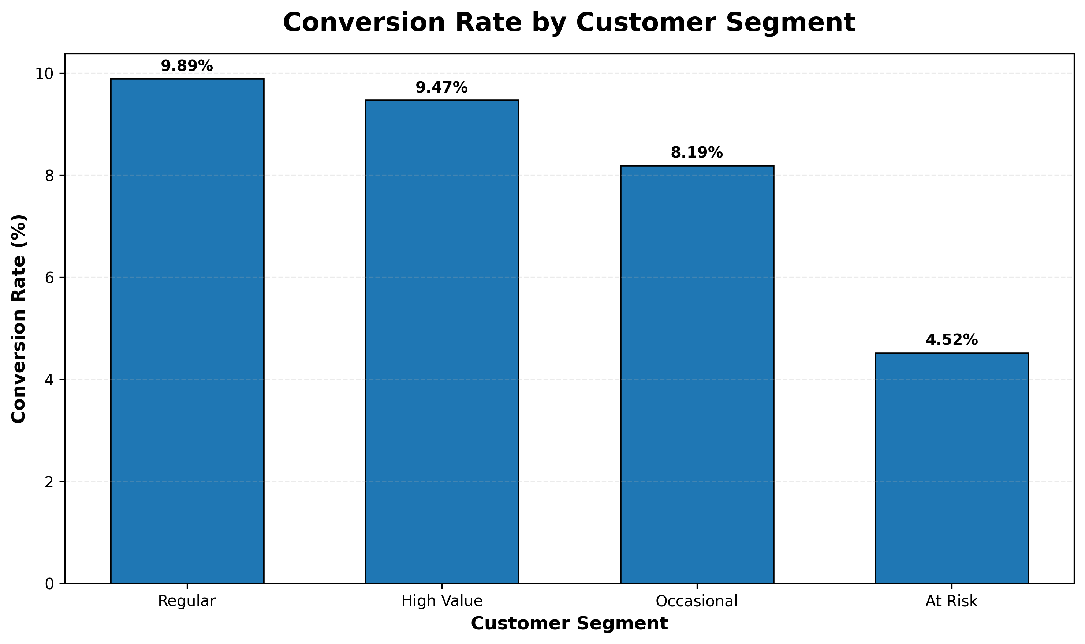
Figure 1: Conversion Rate by Customer Segment
Interpretation:
The chart compares purchase conversion across customer segments.
Regular produced the highest
observed conversion rate at
9.89%. This suggests
that customer groups exhibit different purchase behavior within the
simulation. In a real business setting, such differences could support
segment-specific marketing and retention strategies.

Figure 2: Revenue per Customer by Segment
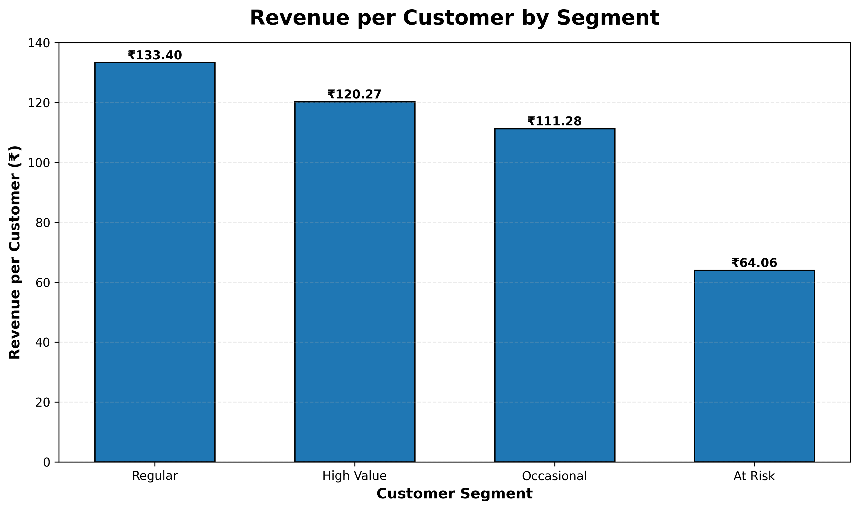
Figure 2: Revenue per Customer by Segment
Interpretation:
Regular generated the highest
observed revenue per customer at
₹133.40. Revenue per
customer complements conversion analysis because it focuses on economic
value rather than purchase probability alone.

Figure 3: Customer Segment Engagement
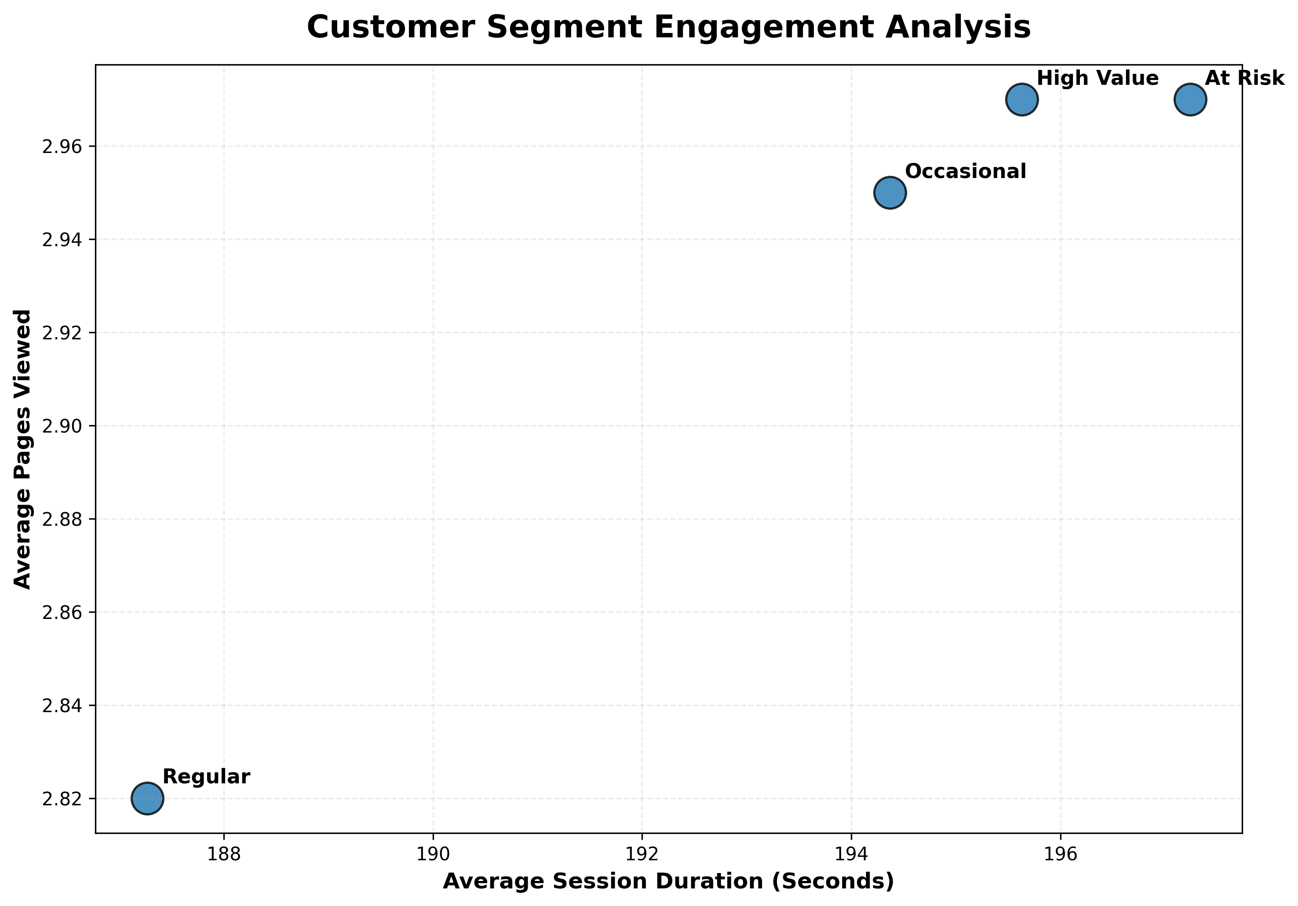
Figure 3: Customer Segment Engagement
Interpretation:
The scatter plot compares average session duration with average pages
viewed across customer segments. It provides an engagement perspective
that can be compared with conversion and revenue outcomes. Differences
are exploratory because the underlying dataset is simulated.

7. Sales Trend and Forecasting Analysis
Sales forecasting was performed using three analytical approaches:
a three-month moving average, linear regression, and exponential
smoothing.
The moving average reduces short-term fluctuations and makes the
underlying direction easier to observe. Linear regression estimates a
general trend over time, while exponential smoothing provides a
trend-sensitive forecasting approach that places greater emphasis on
recent observations.
Each method has limitations. Moving averages lag changing trends,
linear regression may not capture nonlinear or seasonal behavior, and
simple exponential smoothing models may not fully represent complex
seasonality. Therefore, forecasting methods should be validated using
out-of-sample data before production use.

Figure 4: Monthly eCommerce Sales Trend
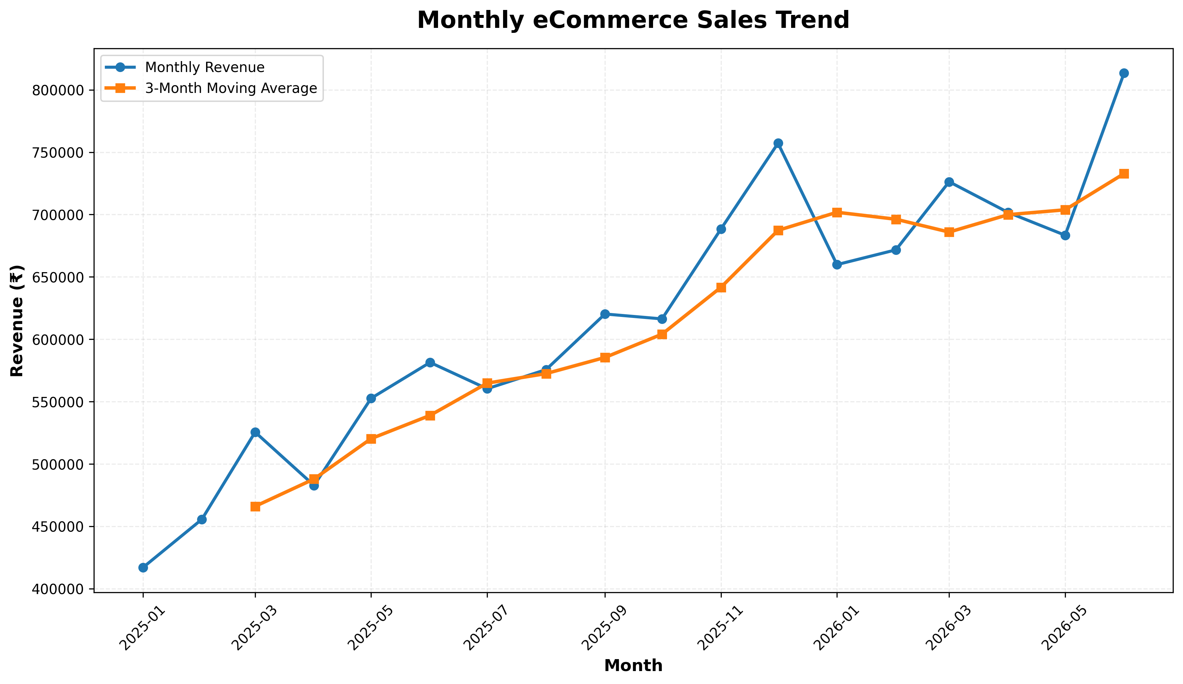
Figure 4: Monthly eCommerce Sales Trend
Interpretation:
The historical series shows the simulated movement of monthly revenue.
The three-month moving average smooths short-term variation and makes
the underlying sales direction easier to identify. Peaks and declines
should be investigated alongside promotions, seasonality, inventory,
and acquisition activity when real business data is available.

Figure 5: Six-Month Sales Forecast
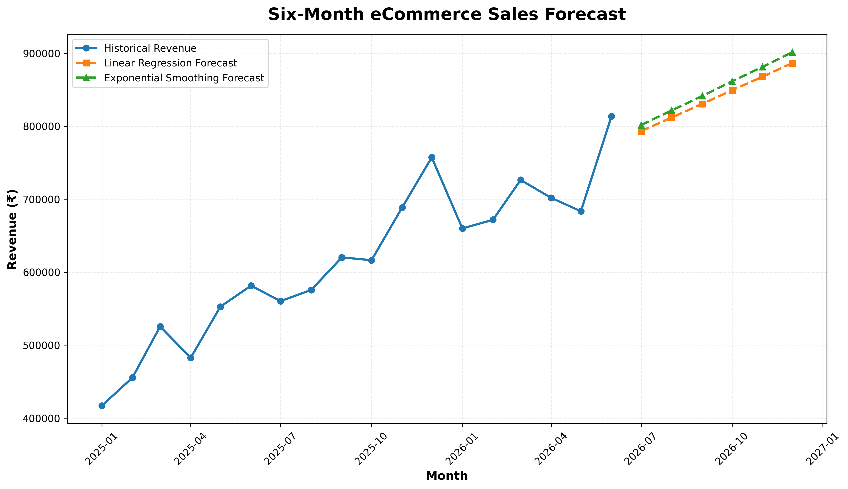
Figure 5: Six-Month Sales Forecast
Interpretation:
The chart compares future revenue estimates generated by linear
regression and exponential smoothing. Differences between the forecast
paths reflect the assumptions of each model. Forecasts should be treated
as planning estimates rather than guaranteed future revenue.
Method | MAE
Exponential Smoothing | 30366.71
Linear Regression | 31184.2
3-Month Moving Average | 32540.63

Figure 6: Forecasting Method Comparison
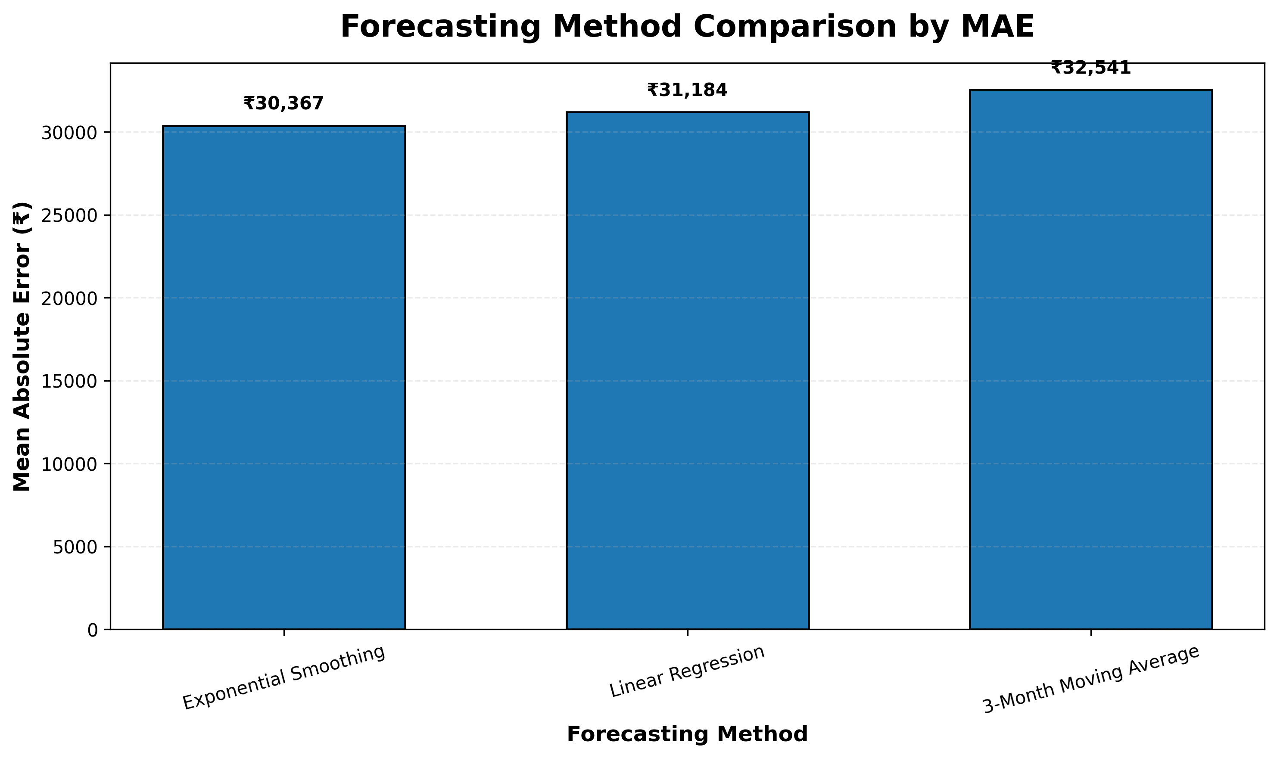
Figure 6: Forecasting Method Comparison
Interpretation:
The forecasting approaches were compared using Mean Absolute Error.
Exponential Smoothing produced the lowest in-sample MAE of
₹30,366.71. Lower MAE indicates closer fit to
the simulated observations, although robust production model selection
would require time-based holdout or rolling validation.

8. Website Analytics and Conversion Rate Optimization
Website analytics evaluates how visitors move through the digital
experience. The analysis focuses on funnel progression, bounce behavior,
traffic-source performance, device performance, and engagement.
These metrics help identify potential areas where website experience
and marketing efficiency can be improved.

Figure 7: Integrated Conversion Funnel
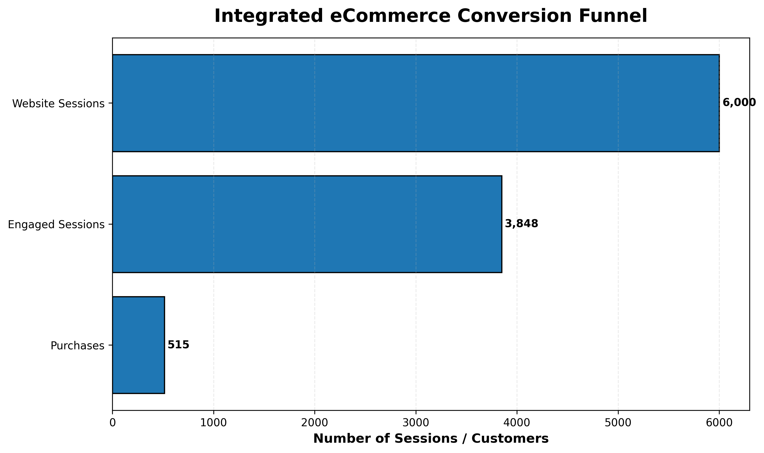
Figure 7: Integrated Conversion Funnel
Interpretation:
The funnel compares total sessions, engaged sessions, and completed
purchases. The largest decline between stages identifies where the
simulated customer journey loses the greatest number of users. In
practice, funnel drop-offs should be investigated using more granular
events such as product views, add-to-cart, checkout initiation, and
payment completion.

Figure 8: Conversion Rate by Traffic Source
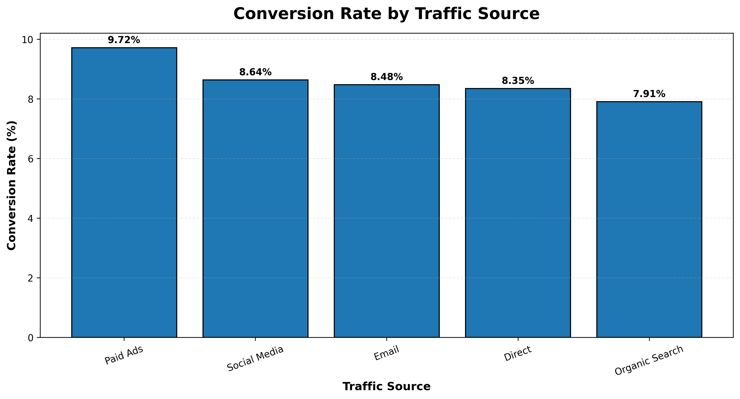
Figure 8: Conversion Rate by Traffic Source
Interpretation:
Paid Ads recorded the highest
observed traffic-source conversion rate at
9.72%. Acquisition
decisions should nevertheless consider traffic cost, volume, customer
quality, and profitability rather than conversion rate alone.

Figure 9: Bounce Rate by Traffic Source
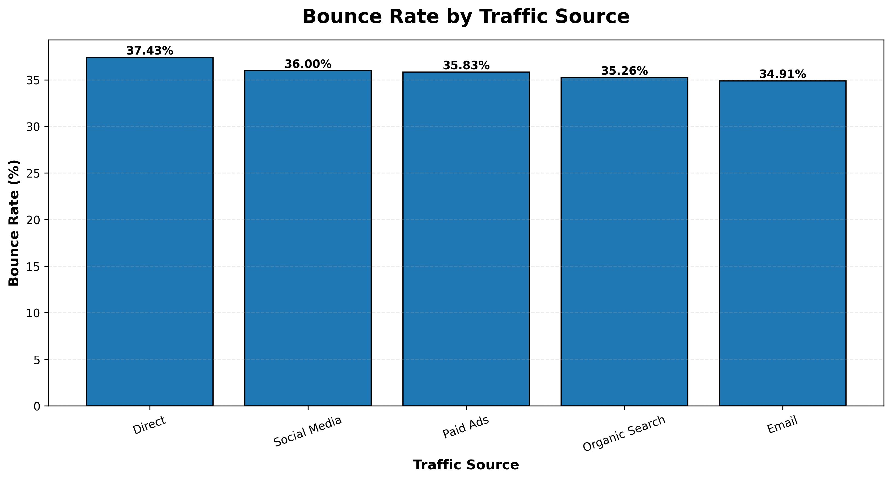
Figure 9: Bounce Rate by Traffic Source
Interpretation:
Direct produced the highest observed
bounce rate at 37.43%. A high
bounce rate can indicate weak landing-page relevance or low-intent
traffic, although the simulated nature of this project means the result
should be interpreted as a diagnostic example.

Figure 10: Conversion Rate by Device
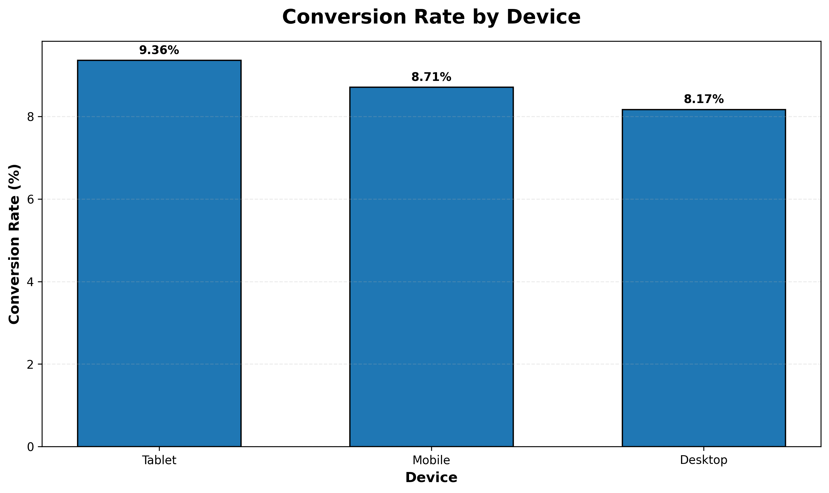
Figure 10: Conversion Rate by Device
Interpretation:
Tablet produced the highest observed
device conversion rate at
9.36%. Device differences
can help identify where responsive design, checkout usability, page
speed, or form design should be investigated.

Figure 11: Session Duration by Conversion Status
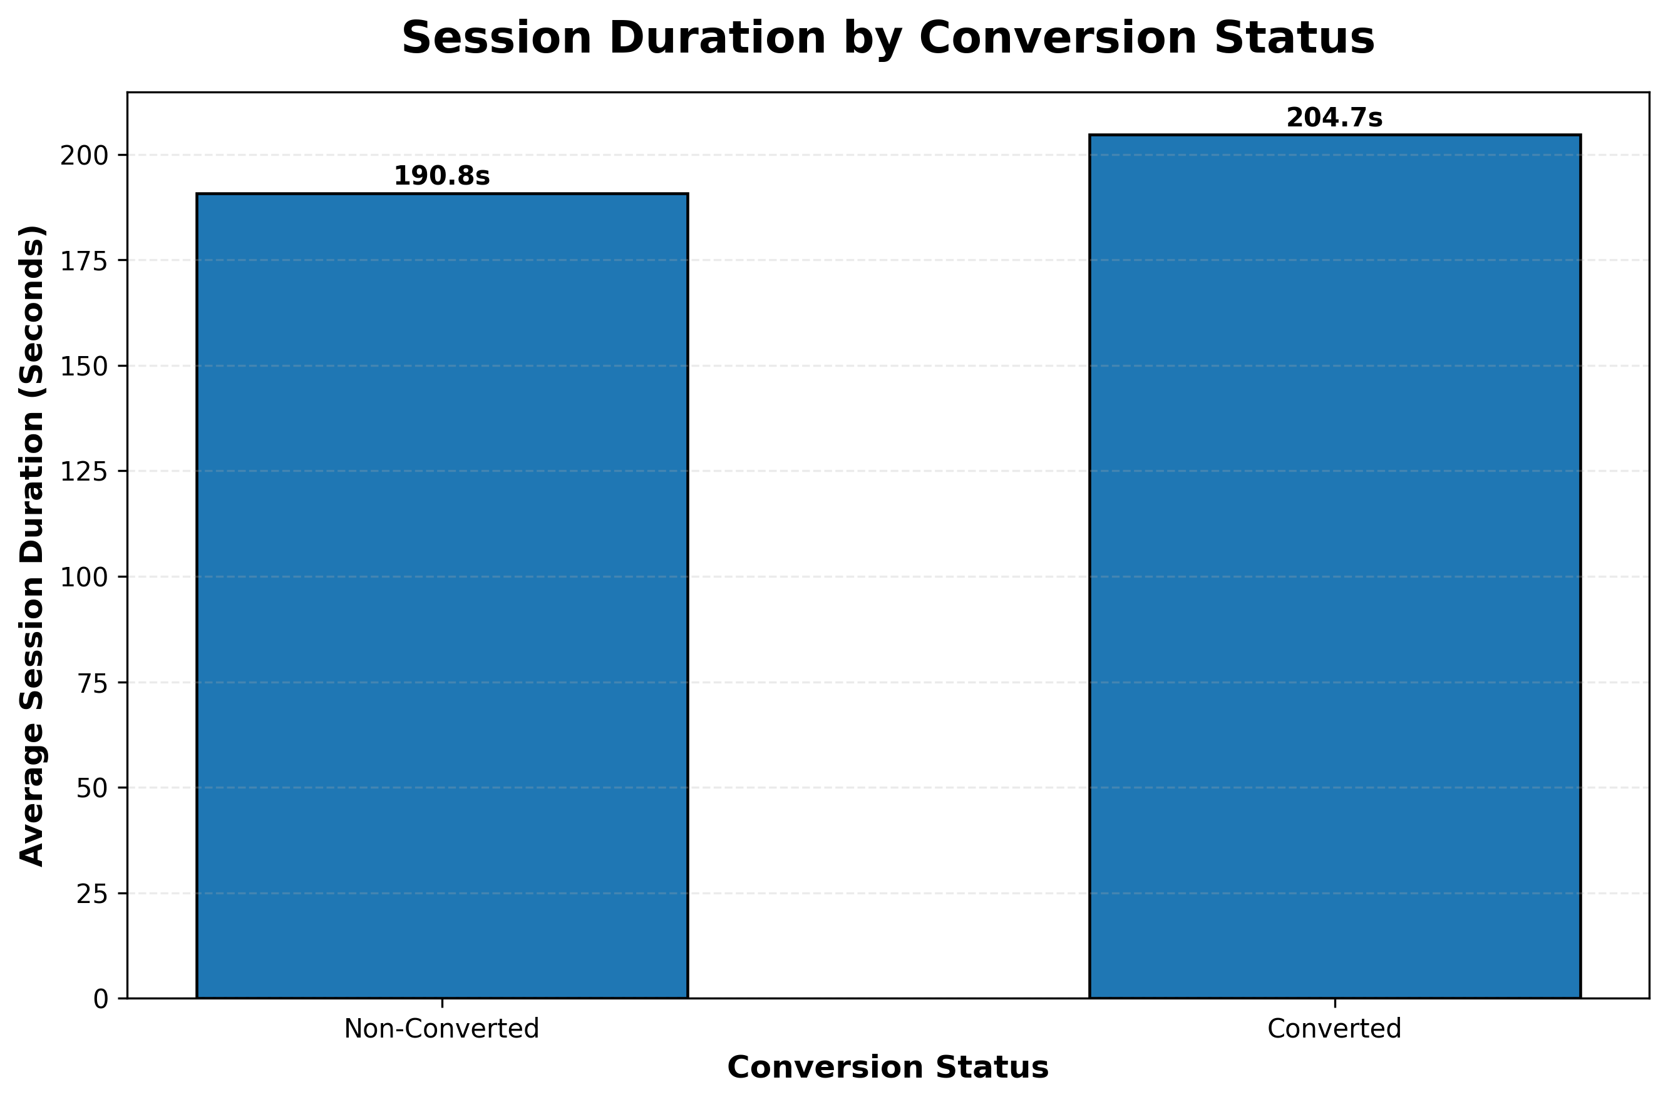
Figure 11: Session Duration by Conversion Status
Interpretation:
This chart compares average engagement between converted and
non-converted sessions. Engagement differences can provide useful
behavioral context, but they should not automatically be interpreted
as causal effects because purchase intention itself can influence
session behavior.

9. Pricing Strategy Evaluation
Control, Discount, and Premium pricing conditions were compared using
conversion and financial metrics. An overall chi-square test was used
to evaluate whether pricing group and purchase outcome were associated,
while Wilson confidence intervals were calculated for conversion rates.
Pricing_Group | Visitors | Purchases | Conversion_Rate | Total_Revenue | Total_Profit | Revenue_Per_Visitor | Profit_Per_Visitor
Control | 1954 | 172 | 8.8 | 220000 | 88000 | 112.59 | 45.04
Discount | 1954 | 192 | 9.83 | 233100 | 77700 | 119.29 | 39.76
Premium | 2092 | 151 | 7.22 | 237600 | 108000 | 113.58 | 51.63

The overall chi-square statistic was 8.9353, with a p-value of
0.011474.
At the 5% significance level, the analysis provides evidence of an
association between pricing condition and purchase outcome. This
supports further investigation of the individual pricing conditions
before making a rollout decision.

Figure 12: Pricing Conversion Rates with 95% Confidence Intervals
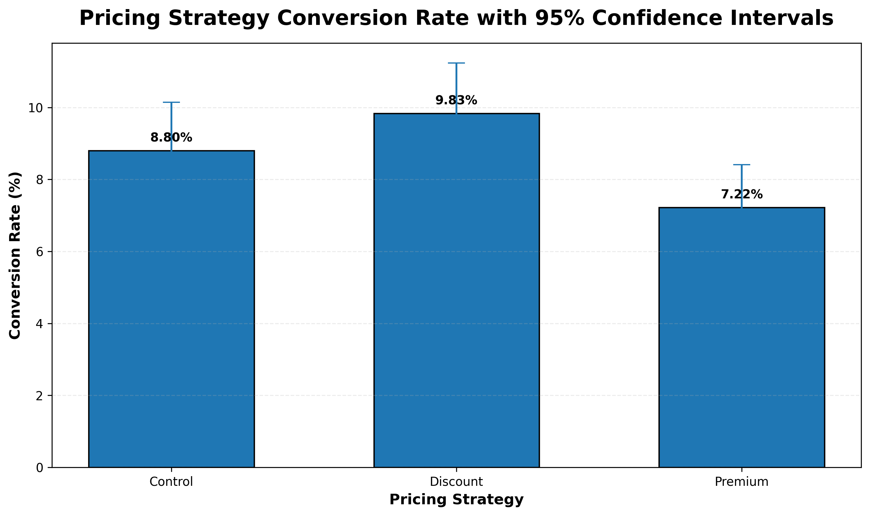
Figure 12: Pricing Conversion Rates with 95% Confidence Intervals
Interpretation:
Confidence intervals communicate uncertainty around the observed
conversion rates. They provide more context than point estimates alone
and help prevent overinterpretation of small numerical differences.

Figure 13: Estimated Profit per Visitor by Pricing Strategy
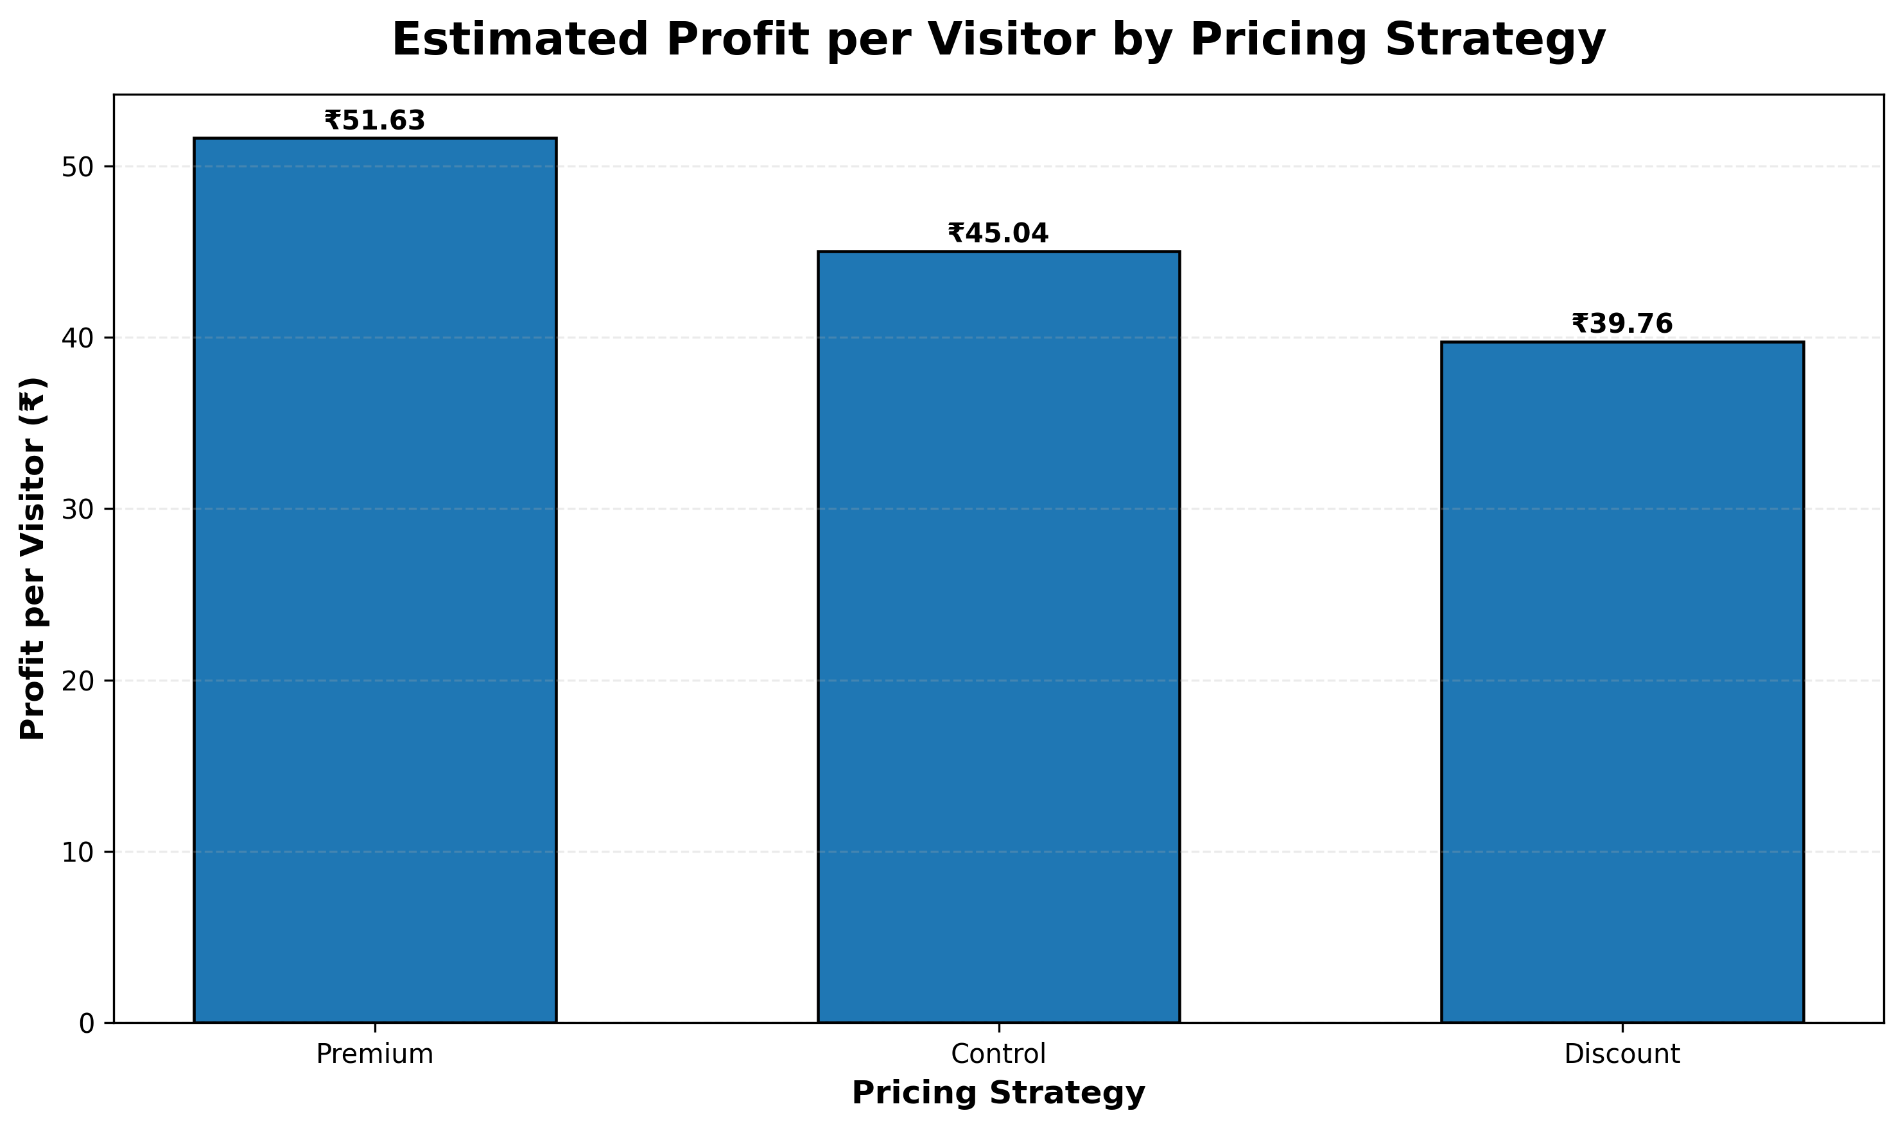
Figure 13: Estimated Profit per Visitor by Pricing Strategy
Interpretation:
Premium produced the highest observed
estimated profit per visitor at
₹51.63. This demonstrates why
pricing decisions should combine conversion performance with unit
economics and profitability.

10. Cross-Analysis and Integrated Findings
Cross-analysis connects individual analytical areas to identify patterns
that may not be visible in isolated summaries. Customer segment was
combined with pricing strategy, while traffic source was combined with
device category.
These combinations are exploratory and should be validated with larger
samples and controlled analysis before being treated as causal business
effects.

Figure 14: Customer Segment × Pricing Strategy
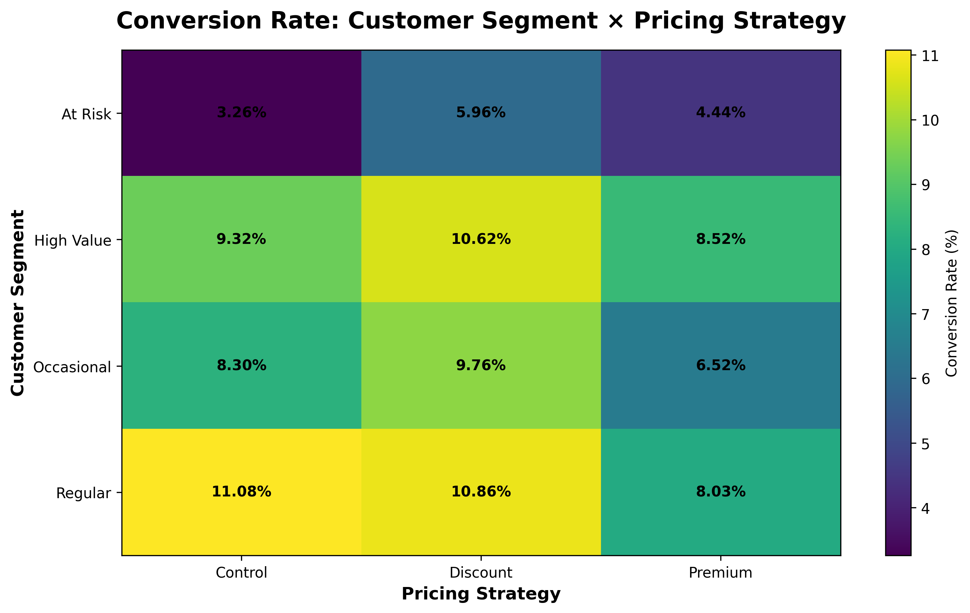
Figure 14: Customer Segment × Pricing Strategy
Interpretation:
The heatmap compares conversion performance across combinations of
customer segment and pricing strategy. The highest-profit combination
identified in the simulation was
Regular with
Control, producing estimated profit per
customer of ₹60.82.

Figure 15: Traffic Source × Device Conversion
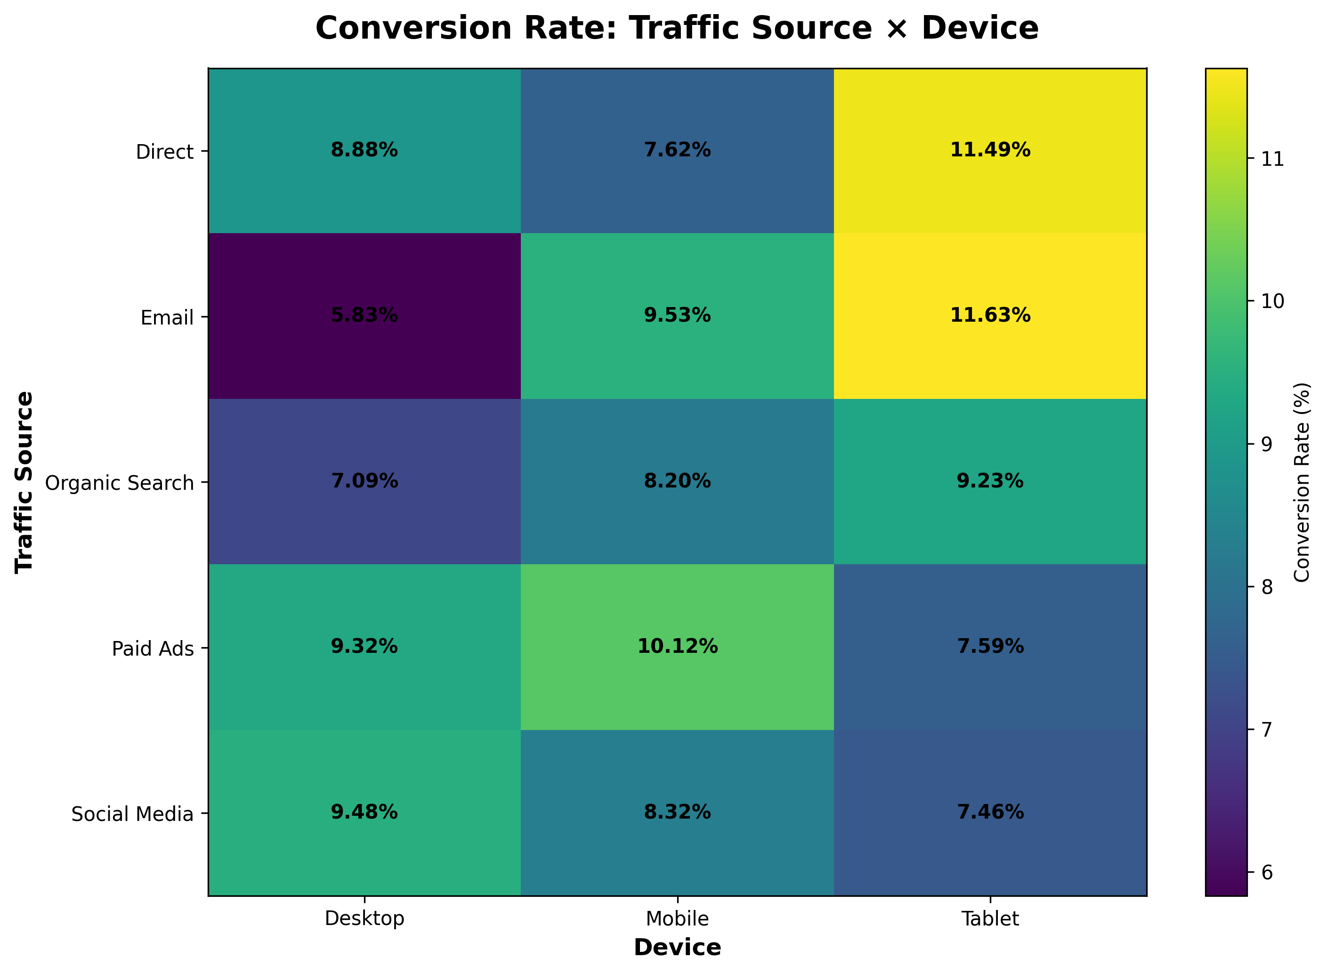
Figure 15: Traffic Source × Device Conversion
Interpretation:
The cross-analysis identified
Email traffic on
Tablet as the highest observed traffic-device
conversion combination at
11.63%. This type of analysis can
support more targeted acquisition and experience optimization.

Figure 16: Integrated KPI Correlation Matrix
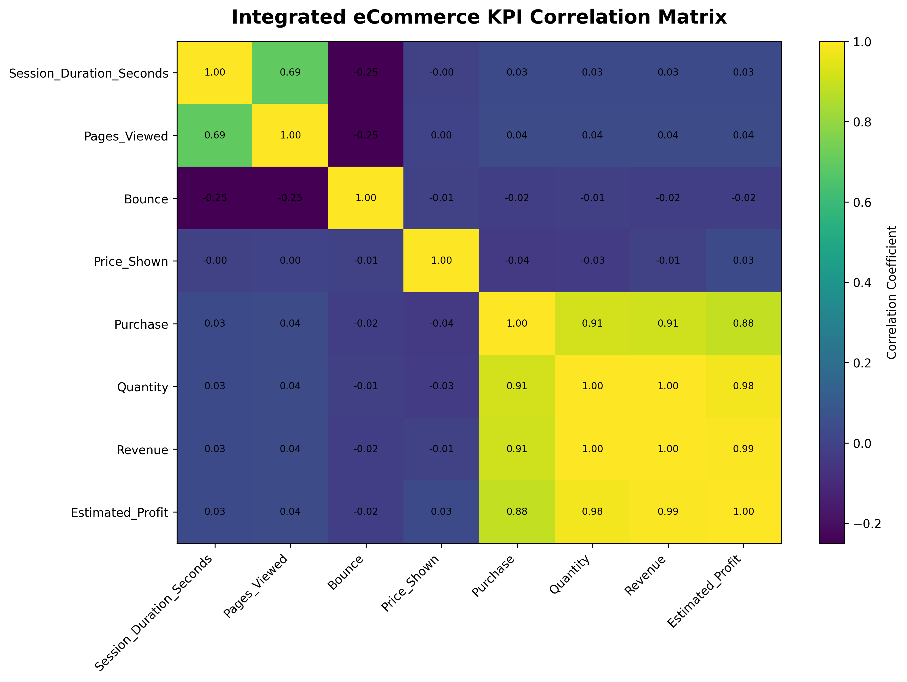
Figure 16: Integrated KPI Correlation Matrix
Interpretation:
The correlation matrix summarizes linear relationships among numerical
variables. Revenue, quantity, and profit are mechanically related to
purchase in this simulated dataset, so they should not be interpreted
as independent purchase drivers. Pre-purchase variables such as session
duration, pages viewed, bounce status, and price are more appropriate
for exploratory behavioral interpretation. Correlation does not
establish causation.

11. Key Integrated Findings
Area | Key_Finding
Customer Segmentation | Regular generated the highest revenue per customer at ₹133.40.
Traffic Source | Paid Ads achieved the highest traffic-source conversion rate at 9.72%.
Device Performance | Tablet recorded the highest device conversion rate at 9.36%.
Sales Forecasting | Exponential Smoothing produced the lowest MAE of ₹30,366.71 in the simulated forecasting comparison.
Pricing Strategy | Premium generated the highest estimated profit per visitor at ₹51.63.
Segment + Pricing Combination | Regular + Control produced the highest estimated profit per customer in the cross-analysis.
Traffic + Device Combination | Email + Tablet achieved the highest observed traffic-device conversion rate of 11.63%.

12. Strategic Recommendations
Business_Area | Recommendation | Expected_Business_Impact
Customer Strategy | Prioritize high-value customer segments with personalized offers, loyalty programs, and targeted retention campaigns. | Higher customer lifetime value
Marketing Acquisition | Allocate acquisition budgets using both traffic volume and conversion quality rather than relying on sessions alone. | Improved marketing efficiency
Website CRO | Reduce friction across the website journey by improving landing-page relevance, navigation, product discovery, and checkout usability. | Higher funnel progression
Device Optimization | Investigate lower-performing device experiences and optimize responsive layout, speed, forms, CTA visibility, and checkout. | Improved conversion experience
Sales Planning | Use forecast trends to support inventory, staffing, campaign, and revenue-planning decisions while monitoring forecast error. | Better operational planning
Pricing Strategy | Evaluate pricing using conversion, revenue per visitor, profit per visitor, and statistical evidence together. | Stronger profitability decisions
Customer Retention | Develop retention strategies for occasional and at-risk customers using re-engagement campaigns and relevant offers. | Improved retention
Experimentation | Validate major website and pricing changes through controlled A/B testing before broad deployment. | Lower decision risk

12.1 Recommendation Priorities
Priority | Action | Primary_Metric
High | Optimize high-drop-off and low-converting website experiences | Conversion Rate
High | Protect and grow high-value customer segments | Revenue per Customer
High | Validate the preferred pricing strategy through controlled testing | Profit per Visitor
Medium | Improve lower-performing acquisition channels | Traffic Conversion Rate
Medium | Use forecasting results for inventory and campaign planning | Forecast Error / Revenue
Medium | Develop retention strategies for at-risk customers | Retention / Repeat Purchase

13. Assumptions, Risks and Limitations
- The project uses simulated data and does not represent a specific retailer.
- Customer segments are simulated rather than learned from production customer records.
- Monthly sales trends contain simulated trend, seasonal, and random components.
- Forecasting MAE is primarily an in-sample comparison and not full production validation.
- Pricing conversion probabilities were predefined during simulation.
- Estimated profitability assumes a fixed unit cost.
- Refunds, taxes, shipping costs, and customer lifetime value are not modeled.
- Correlation analysis identifies association rather than causation.
- Cross-analysis results may be influenced by subgroup sample sizes.
- Real-world recommendations should be validated through controlled experiments and production data.

14. Future Directions
Future_Area | Potential_Application
Predictive Customer Churn | Identify customers likely to stop purchasing.
Customer Lifetime Value | Estimate long-term value of different customer groups.
Recommendation Systems | Provide personalized product recommendations.
Advanced Forecasting | Apply ARIMA, Prophet, or machine-learning forecasting models.
Dynamic Pricing | Adjust prices using demand, inventory, and customer behavior.
Real-Time Analytics | Track KPIs and anomalies using streaming dashboards.
Marketing Attribution | Measure contribution of multiple marketing touchpoints.
Cloud-Based Analytics | Deploy scalable analytics pipelines and dashboards in the cloud.

Future development could replace simulated data with real transaction,
website, marketing, and customer datasets. Predictive churn modeling,
customer lifetime value estimation, recommendation systems, advanced
time-series forecasting, dynamic pricing, real-time dashboards, and
marketing attribution could extend the analytical framework.
A cloud-based data architecture could also automate ingestion,
transformation, storage, modeling, and dashboard delivery at scale.

15. Conclusion
This comprehensive retail eCommerce analysis demonstrates how multiple
data analytics techniques can be integrated into a coherent
decision-support framework.
Customer segmentation identified differences in customer value and
behavior. Sales forecasting demonstrated how historical trends can
support forward planning. Website analytics highlighted the importance
of funnel performance, acquisition channels, devices, and engagement.
Pricing experimentation demonstrated the need to evaluate statistical
evidence alongside revenue and profitability. Cross-analysis then
connected these areas to generate broader business insights.
The central conclusion is that eCommerce performance should not be
managed through isolated metrics. Effective decision-making requires
an integrated view of customer behavior, acquisition quality, website
experience, demand trends, experimentation, revenue, and profitability.
Although the project is based on simulated data, the methodology
provides a practical blueprint that can be adapted to real retail
eCommerce datasets and production analytics environments.

16. References and Technical Resources
- Pandas Documentation – Data manipulation and analytical workflows.
- NumPy Documentation – Numerical computing and simulation.
- Matplotlib Documentation – Data visualization.
- SciPy Documentation – Statistical hypothesis testing.
- Statsmodels Documentation – Statistical analysis and time-series methods.
- Scikit-learn Documentation – Regression and model evaluation.

