SLTC Research University
Faculty of Computing
CCS2360 — Technology Challenges and Competitions
NexSkill
Intelligent Skill-Based Opportunity Matching Platform
Sri Lanka's First Skill-Based Internship Ecosystem
[Degree Programme — e.g. BSc (Hons) Information Technology]
Final Project Report
Group Leader: Shakkya Sanketh — CIT-24-01-0573
Malitha Gayashan — CIT-24-01-0562
Nishen Madava — CIT-24-01-0256
Chamika Janith — CIT-24-01-0182
Tharusha Pieris — CIT-24-01-0486
Chamoda Dulhari — CIT-24-01-0598
Academic Year 2026

Declaration
We hereby declare that this report, titled “NexSkill — Intelligent Skill-Based Opportunity Matching Platform,” is our own work, carried out in fulfilment of the requirements of the CCS2360 Technology Challenges and Competitions module at SLTC Research University. All work presented — the system design, the implementation, the experiments in Chapter 8, and the writing of this report — was carried out by the group named on the title page, under the supervision of the module coordinator. All sources of information used in preparing this report have been acknowledged by means of complete references, listed in the References chapter. This report has not been submitted, in whole or in part, for any other academic qualification.
Signatures
Group Leader: Shakkya Sanketh (CIT-24-01-0573) Signature: _______________________ Date: _______________
Member: Malitha Gayashan (CIT-24-01-0562) Signature: _______________________ Date: _______________
Member: Nishen Madava (CIT-24-01-0256) Signature: _______________________ Date: _______________
Member: Chamika Janith (CIT-24-01-0182) Signature: _______________________ Date: _______________
Member: Tharusha Pieris (CIT-24-01-0486) Signature: _______________________ Date: _______________
Member: Chamoda Dulhari (CIT-24-01-0598) Signature: _______________________ Date: _______________
Acknowledgements
We would like to thank our module coordinator and the Faculty of Computing at SLTC Research University for their guidance throughout the CCS2360 Technology Challenges and Competitions module. We are also grateful to our peers who took part in informal usability walkthroughs of the prototype during development.
The internship postings used throughout this report are seeded, illustrative data. WSO2, IFS, Virtusa, and Sysco LABS are named as realistic examples of the Sri Lankan IT companies this platform is designed to serve, chosen because they are well known in the local industry — no partnership, data-sharing agreement, or endorsement from any of these organisations exists, and none of them supplied data used in this project. This is stated plainly in the Limitations section (9.3) as well.
Abstract
Sri Lankan undergraduates currently rely on manual CV submissions and word of mouth to find internships; existing local platforms such as TopJobs.lk function as passive job boards with no candidate ranking, no skill-gap feedback, and no digital offer-letter workflow. NexSkill is a three-sided web platform — students, companies, and university placement offices, with an administrative layer — that replaces this manual process with a transparent, weighted skill-matching engine.
Each student-posting pair is scored out of 100 using five weighted factors — skill overlap (45%), GPA alignment (20%), preference match (15%), year-of-study fit (10%), and certification relevance (10%). Skill overlap itself is computed in three tiers: exact string matches, a curated table of semantically equivalent skills (e.g. Node.js ≈ Express.js), and, novel to this implementation, a TF-IDF cosine-similarity layer computed over a 70-skill descriptive-tag corpus that recovers partial credit for related skills neither tier above catches (e.g. Vue against a React requirement, or Docker against Kubernetes). The full breakdown, not just the final score, is shown to both students and recruiters, so every ranking is explainable.
The system is implemented in Next.js 16 (React 19) against a Supabase PostgreSQL backend with Row-Level Security enforced on every table and a database trigger that provisions role-specific profiles on signup. Building the platform surfaced and fixed a genuine security defect — an RLS policy whose WITH CHECK clause silently blocked administrator writes while still reporting success — which is documented in full as part of the testing evidence in Chapter 7.
An algorithm-optimisation experiment was run against ten seeded student profiles and four postings (40 pairs), using an algorithm-independent ground truth. The baseline weighting achieved 90% precision and 90% recall against this ground truth; per-factor correlation analysis showed skill overlap (r = 0.91) and preference match (r = 0.85) as strong predictors and GPA (r = −0.01) as statistically uninformative for this dataset, informing a documented second weighting iteration. The report concludes that a transparent, rule-plus-statistics matching approach is a defensible, explainable alternative to an opaque machine-learning model for a system whose primary audience — students being told why they were or were not matched — needs to trust and act on the explanation, not just the score.
Table of Contents
1. Introduction 1
1.1 Introduction 1
1.2 Background and Problem Statement 1
1.3 Aim and Objectives 1
1.4 Solution Overview 2
1.5 Structure of the Report 2
1.6 Summary 3
2. Review of Others' Work 4
2.1 Introduction 4
2.2 Existing Platforms 4
2.3 Academic Literature 5
2.4 Feature Comparison 5
2.5 Novelty Statement 6
2.6 Summary 6
3. Technology Adopted 7
3.1 Introduction 7
3.2 Matching and Skill-Similarity Techniques 7
3.3 Skill Extraction from CV Text 7
3.4 Frameworks and Libraries 8
3.5 Backend and External Services 8
3.6 Summary 9
4. Your Approach 10
4.1 Introduction 10
4.2 Users 10
4.3 Inputs 10
4.4 Outputs 10
4.5 Process 11
4.6 Technology Recap 11
4.7 Summary 11
5. Analysis & Design 12
5.1 Introduction 12
5.2 System Architecture 12
5.3 Matching Engine Data Flow 12
5.4 Use Case Diagram 13
5.4.1 Representative Use Case: Apply to Internship 14
5.5 Functional Requirements 14
5.6 Non-Functional Requirements 15
5.7 Data Model 15
5.8 Summary 16
6. Implementation 17
6.1 Introduction 17
6.2 Software and Hardware Used 17
6.3 Dataset Used for Demonstration and Testing 17
6.4 Matching Engine Implementation 18
6.5 TF-IDF Cosine-Similarity Layer 18
6.6 Row-Level Security Model 19
6.7 Module Screenshots 19
6.7.1 Authentication 19
6.7.2 Student Module 19
6.7.3 Company Module 20
6.7.4 University Module 21
6.7.5 Admin Module 22
6.8 Summary 22
7. Testing 23
7.1 Introduction 23
7.2 Testing Types Used 23
7.3 Test Case Table 23
7.4 Results Summary 24
7.5 Summary 25
8. Evaluation 26
8.1 Introduction 26
8.2 Evaluation Strategy 26
8.3 Algorithm Optimisation Experiment 26
8.4 TF-IDF Layer: Measured Impact 28
8.5 Discussion 29
8.6 Summary 29
9. Conclusion and Further Work 31
9.1 Quantitative Summary 31
9.2 Objective-by-Objective Review 31
9.3 Limitations 32
9.4 Further Work 33
9.5 Summary 33
References 34
Appendix A — Individual Contribution 35

1. Introduction

1.1 Introduction
This chapter introduces the problem NexSkill addresses, states the project’s aim and objectives, summarises the proposed solution, and outlines the structure of the rest of the report.

1.2 Background and Problem Statement
Sri Lanka’s IT sector is growing quickly, but the mechanism connecting undergraduates to internships has not kept pace. Thousands of students email unsolicited CVs to companies each recruitment cycle; companies manually screen hundreds of unranked applications for a handful of positions; and universities have no systemic visibility into where, or whether, their students are being placed. Research into Sri Lankan graduate employability has repeatedly identified a mismatch between the skills graduates hold and the skills employers actually need [2], with lack of verifiable industry experience cited as a primary employment barrier independent of academic performance.
Existing platforms do not close this gap. TopJobs.lk, Sri Lanka’s largest job portal, is fundamentally a job board: it lets employers post vacancies and collect CVs, with grading and shortlisting tools for the employer side, but it performs no candidate-to-vacancy matching and has no university-facing reporting layer. International platforms built for exactly this problem — Handshake, Internshala — are not localised for the Sri Lankan market and are not integrated with local university placement offices. A detailed comparison is given in Chapter 2.
The problem this project addresses is therefore precise: Sri Lankan undergraduates lack access to a centralised, intelligent internship-matching platform tailored to the local market, one that ranks candidates by actual skill fit rather than first-come-first-served, gives students a reason for every ranking they receive, and gives university placement offices real placement data instead of none.

1.3 Aim and Objectives
Aim: to design, build, and evaluate a skill-based internship-matching platform for the Sri Lankan undergraduate market using an explainable weighted-scoring algorithm supplemented by TF-IDF semantic similarity.
Objectives:
- O1 — Implement a weighted student-to-internship matching engine (skill overlap 45%, GPA 20%, preferences 15%, year of study 10%, certifications 10%) and evaluate its relevance through a documented experiment.
- O2 — Build a student-facing portal covering profile creation, CV-based skill extraction, and one-click applications.
- O3 — Implement a Skill Gap Analyser that identifies missing skills per posting and recommends courses to close each gap.
- O4 — Deliver a digital offer-letter workflow — send, track, accept/decline — entirely within the platform, including PDF generation.
- O5 — Deploy a University Partner Dashboard with real-time placement analytics and a downloadable semester-end report.
- O6 — Iteratively optimise the matching algorithm across at least two documented iterations, with before/after accuracy metrics.

1.4 Solution Overview
NexSkill is a three-sided platform with an administrative layer, described briefly here and in full in Chapter 4. Students build a skill profile (manually, or by uploading CV text for rule-based skill extraction), browse a ranked list of internships with a full score breakdown, apply in one click, and track every application through to a digital offer letter they can accept or decline in-app. Companies post internships, see an automatically ranked candidate list for each posting, and move candidates through Pending → Shortlisted → Offered → Accepted/Rejected without leaving the platform. Universities see aggregated placement statistics and skill-gap intelligence for their own enrolled students, and can export a CSV report. Administrators verify new company and university accounts, moderate postings, and see platform-wide analytics.

1.5 Structure of the Report
Chapter 2 surveys existing platforms and academic literature on skill-based matching and states this project’s novelty relative to them. Chapter 3 justifies the specific techniques and technologies adopted. Chapter 4 describes the approach from the perspective of users, inputs, outputs, and process. Chapter 5 presents the system architecture, data flow, use cases, and functional/non-functional requirements. Chapter 6 covers the implementation module by module, with real screenshots. Chapter 7 presents the testing strategy and results. Chapter 8 presents the algorithm-optimisation experiment and its findings. Chapter 9 concludes, reviews each objective, and states limitations and further work.

1.6 Summary
This chapter has stated the problem — no existing Sri Lankan platform performs skill-based internship matching — and the aim and objectives NexSkill was built to satisfy. The next chapter reviews existing platforms and literature in more depth.

2. Review of Others' Work

2.1 Introduction
This chapter surveys four existing platforms that Sri Lankan students currently use, or could use, to find internships or entry-level roles, then reviews academic literature on the specific techniques NexSkill applies (TF-IDF/cosine-similarity matching and NER-based resume parsing). It closes with a feature comparison table and a novelty statement.

2.2 Existing Platforms
TopJobs.lk. Sri Lanka's largest local job portal, operating since 2012. It gives employers a full e-recruitment SaaS toolkit — CV upload, automated vacancy posting, applicant grading and shortlisting, interview scheduling — and gives jobseekers a searchable vacancy databank with one-click applications. Its limitation for this project's purpose is structural: it is a general-purpose job board across all industries and seniority levels, not a skill-based matching system. There is no automatic candidate ranking, no per-candidate score breakdown, and no university-facing reporting layer.
LinkedIn (Sri Lanka). A global professional network with job listings and an AI-assisted recommendation feed based on profile data and declared skills. It is widely used by Sri Lankan professionals but is not localised for the undergraduate internship market specifically, gives no transparent score breakdown for why a job was recommended, and has no institutional link to any Sri Lankan university placement office.
Handshake. A US-centric early-career platform integrated with over 800 universities and 200,000 employers globally. Its strongest feature relative to NexSkill's ambitions is exactly the university-integration layer NexSkill also targets — universities post roles, track student engagement, and use the platform in advising workflows. However, Handshake's matching is closed-source and not transparent to the student (no visible score breakdown), and the platform has no presence or localisation for the Sri Lankan market.
Internshala. India's largest internship platform (21M+ candidates), with strong skill- and location-based filtering and bundled skill-training courses. Its filtering is closer to search than matching — students filter manually rather than receiving a ranked, scored list — and, like Handshake, it has no Sri Lankan presence or local university integration.

2.3 Academic Literature
The matching technique at the core of NexSkill — TF-IDF vectorisation followed by cosine similarity — is a long-established and still actively used approach in job-matching research. Manning and Schütze’s foundational text on statistical NLP [4] defines the TF-IDF weighting scheme NexSkill’s own implementation (Chapter 6) follows directly. More recent work confirms the approach is still competitive: Winardi et al. [8] build a job-recommendation system using scikit-learn TF-IDF and cosine similarity over job descriptions; Singh and Garg [6] combine TF-IDF, cosine similarity, and named-entity recognition specifically for resume ranking; and Ajjam and Al-Raweshidy [1] present a 2026 real-time recruitment system that layers TF-IDF vectorisation, cosine-similarity scoring, and domain-specific keyword weighting to interpret conceptual relevance between resumes and job descriptions — the same three-part structure (keyword layer, statistical-similarity layer, domain weighting) NexSkill’s matching engine uses.
On the resume-parsing side, the proposal’s originally intended technique — a spaCy Named Entity Recognition model fine-tuned to extract skills from unstructured CV text — is well precedented: Channabasamma et al. [3] describe exactly this, a contextual spaCy-based information-extraction model for resume analytics. NexSkill’s current implementation uses rule-based dictionary matching instead of a trained NER model; Chapter 3 explains why, and this is reported honestly as a scoped-down substitution rather than claimed as equivalent.

2.4 Feature Comparison
Table 2.1 compares the four platforms above against NexSkill on the dimensions most relevant to the Sri Lankan undergraduate internship problem.
Table 2.1 — Feature comparison: NexSkill vs. existing platforms
Feature | TopJobs.lk | LinkedIn | Handshake | Internshala | NexSkill
Skill-based ranking | No | Partial (opaque) | Partial (opaque) | Filter-only | Yes, transparent breakdown
Explainable score | No | No | No | No | Yes — 5-factor breakdown shown
Skill-gap guidance | No | No | No | Courses (unrelated to gaps) | Yes — per-posting gap + courses
University dashboard | No | No | Yes | No | Yes — placement analytics + CSV
Digital offer workflow | No | No | No | No | Yes — send/track/accept/decline
Sri Lanka localised | Yes | No | No | No | Yes

2.5 Novelty Statement
Unlike TopJobs.lk, LinkedIn, Handshake, and Internshala — each of which is either a passive job board, an opaque recommendation feed, or a manual filter — NexSkill uniquely combines a transparent, five-factor explainable match score, a per-posting skill-gap analyser with course recommendations, a university-facing placement-analytics dashboard, and an end-to-end digital offer-letter workflow, purpose-built and localised for the Sri Lankan undergraduate internship market.

2.6 Summary
No platform surveyed combines transparent skill-based ranking, skill-gap guidance, university integration, and a digital offer workflow in one system localised for Sri Lanka. The next chapter justifies the specific technologies NexSkill uses to deliver this combination.

3. Technology Adopted

3.1 Introduction
This chapter names and justifies the specific techniques, frameworks, and services NexSkill is built on, and is explicit about where the implementation departs from the original proposal and why.

3.2 Matching and Skill-Similarity Techniques
The matching engine (detailed in Chapter 5) is a weighted linear combination of five factors, not a trained machine-learning model. This was a deliberate choice, not a shortfall: the platform’s core promise to a student is a reason for their match percentage, shown as a five-part breakdown on every match card. A black-box classifier or embedding-similarity model (e.g. a fine-tuned sentence transformer) could plausibly score matches at least as well, but could not decompose its score into "skill overlap 100%, GPA 94%, preferences 100%..." — the explainability students and recruiters see in the app is a direct, load-bearing consequence of choosing a transparent weighted formula.
Skill overlap itself, the largest-weighted factor (45%), is computed in three tiers, escalating from cheapest/most confident to more speculative: (1) exact case-insensitive string match; (2) a curated table of eight semantically-equivalent skill groups (e.g. Node.js/Express.js, React/Next.js) reviewed by the team; (3) a TF-IDF cosine-similarity layer, following the weighting scheme in Manning and Schütze [4] and the job-matching applications of it in [1], [6], and [8]. This third tier is computed over a hand-built corpus of 70 skills, each represented as a short set of descriptive tags (e.g. React → frontend, javascript, ui, component, spa, library), and catches skill pairs the curated table does not cover — Vue against a React requirement, or Docker against a Kubernetes requirement, both score a real, computed 55% similarity rather than 0%, verified directly in scripts/tfidf-check.mjs and again against live application data in Chapter 8.

3.3 Skill Extraction from CV Text
The proposal specified a spaCy Named Entity Recognition model fine-tuned on technology job descriptions for CV skill extraction, following the approach demonstrated by Channabasamma et al. [3]. The current implementation uses rule-based dictionary matching instead: uploaded CV text is scanned against a 70-entry skill dictionary (the same dictionary the TF-IDF corpus in §3.2 is built over), and any exact substring match is extracted as a confirmed skill candidate for the student to accept, edit, or supplement. This is reported honestly rather than described as equivalent to a fine-tuned NER model: a trained model would generalise to skill phrasings never seen before and to skills outside a fixed dictionary, which rule-based matching cannot do. Fine-tuning a real spaCy NER model requires labelled training data and GPU time neither available nor justified at this prototype’s scope, and is named explicitly as further work in §9.4.

3.4 Frameworks and Libraries
Table 3.1 — Core frameworks and libraries
Layer | Technology | Version | Rationale
Frontend | Next.js (App Router) | 16.3.8 | Server + client components in one framework; upgraded mid-project from 14.2.5 to close several CVEs, incl. an unauthenticated RCE (§6.2)
UI runtime | React | 19.3.0 | Required by Next.js 16; no other code changes needed beyond the async-API migration in §6.2
Styling | Tailwind CSS | 3.4.4 | Utility-first styling, fast iteration on 4 distinct role-based UIs
Backend/DB client | @supabase/supabase-js, @supabase/ssr | 2.117.2 / 0.12.7 | Official Supabase JS client with Next.js App Router cookie-session support
PDF generation | jsPDF | 2.5.1 | Client-side CV-summary and offer-letter PDF generation, matches the proposal’s own “Puppeteer / jsPDF” option
TF-IDF engine | Custom (lib/tfidf.js) | — | No suitable lightweight JS TF-IDF library covered the exact corpus-relative IDF calculation needed; ~60 lines, see Chapter 6

3.5 Backend and External Services
The backend is Supabase [7] — managed PostgreSQL 17 with built-in Auth and a PostgREST API layer, replacing the project’s earlier local-JSON-file prototype entirely (migration covered in Chapter 6). Supabase was chosen, matching the original proposal, because it gives Row-Level Security, authentication, and a realtime-capable Postgres database without operating a separate backend server. The proposal additionally specified Firebase Cloud Messaging for push notifications; the shipped system deliberately does not integrate Firebase — notifications are in-app only (a `notifications` table polled by the client). This is reported honestly as a descoped item rather than claimed as implemented, and is named in §9.3/§9.4 with a concrete integration path.
Hosting is Vercel [5], matching the proposal; this is viable specifically because Supabase, not a local JSON file, now backs persistence — a serverless host cannot reliably persist writes to its own filesystem between requests, which was the deciding factor in choosing to migrate the database before deployment (Chapter 5, Chapter 6).

3.6 Summary
NexSkill’s technology choices favour an explainable matching algorithm over an opaque ML model, a managed Postgres backend with real row-level security over a local file store, and honest reporting wherever the shipped system falls short of the original proposal (spaCy NER, Firebase push). The next chapter describes the approach from the perspective of users, inputs, outputs, and process.

4. Your Approach

4.1 Introduction
This chapter describes NexSkill from the perspective of who uses it, what goes in, what comes out, and how a request moves through the system end to end.

4.2 Users
- Student — an undergraduate building a skill profile, browsing ranked internships, applying, and managing offers.
- Company — a verified recruiter posting internships and working a ranked candidate list through to an offer.
- University — a verified partner institution viewing placement analytics for its own enrolled students only.
- Admin — the platform operator, verifying new company/university accounts and moderating postings.

4.3 Inputs
- Student profile fields: degree, year of study, GPA, skills, certifications, preferences (domain, location, duration).
- Pasted CV text, scanned for skill keywords (§3.3).
- Internship posting fields: title, required skills, minimum GPA, target year, domain, duration, location, stipend range, positions, deadline.
- Company/university/admin actions: verify, shortlist, reject, send offer, respond to offer, moderate.

4.4 Outputs
- A 0–100 match score with a five-factor breakdown, for every student-posting pair a user is authorised to see.
- A ranked list — postings ranked for a student, or candidates ranked for a company’s posting.
- A skill-gap report per posting: missing skills plus a recommended course, provider, cost, and estimated time for each.
- A 0–100 Internship Readiness Score per student, combining top-3 average match, GPA, and profile completeness.
- Digital, downloadable PDF artefacts: a CV summary and an offer letter.
- A university placement-analytics dashboard and downloadable CSV report.

4.5 Process
A student registers, which (via a database trigger, §5.2) creates their profile row and links them to their university by name if a matching verified university exists. They complete their profile, optionally upload CV text for skill extraction, and view a ranked internship list computed live by the matching engine (Chapter 5). Applying creates an application row with the match score and breakdown frozen at application time. A company reviews the same ranking from its side — every registered student ranked against its posting, not just applicants — shortlists or rejects, and sends a digital offer to a shortlisted candidate, which the student accepts or declines in-app. Every status change (shortlisted, offered, accepted, rejected) triggers an in-app notification to the other party. A university sees aggregated outcomes only for the students linked to it at registration; an admin sees and can act on everything, gated by Postgres Row-Level Security rather than by application code alone (§5.7, §7.3).

4.6 Technology Recap
The process above is delivered on Next.js 16 (React 19) for the UI and API routes, Supabase Postgres with Row-Level Security for data and auth, and the matching/skill-extraction techniques justified in Chapter 3. Full architecture and data-flow diagrams follow in Chapter 5.

4.7 Summary
This chapter described NexSkill’s users, inputs, outputs, and process at a level intended to orient a reader before the detailed architecture, requirements, and implementation in the chapters that follow.

5. Analysis & Design

5.1 Introduction
This chapter presents the system architecture, the matching engine’s internal data flow, the use-case diagram, and the functional and non-functional requirements the implementation (Chapter 6) satisfies, followed by the data model.

5.2 System Architecture
Figure 5.1 shows the three-layer architecture: a React 19 client layer (one portal per role), a Next.js 16 server layer (route handlers, the matching engine, and the skill-extraction/TF-IDF module), and Supabase (Auth, Postgres with Row-Level Security on every table, and a database trigger that provisions role-specific rows on signup). The server layer never holds a privileged database credential at runtime — every query is issued with the visitor’s own session, and Postgres itself, not application code, is the final authority on what a query is allowed to touch.
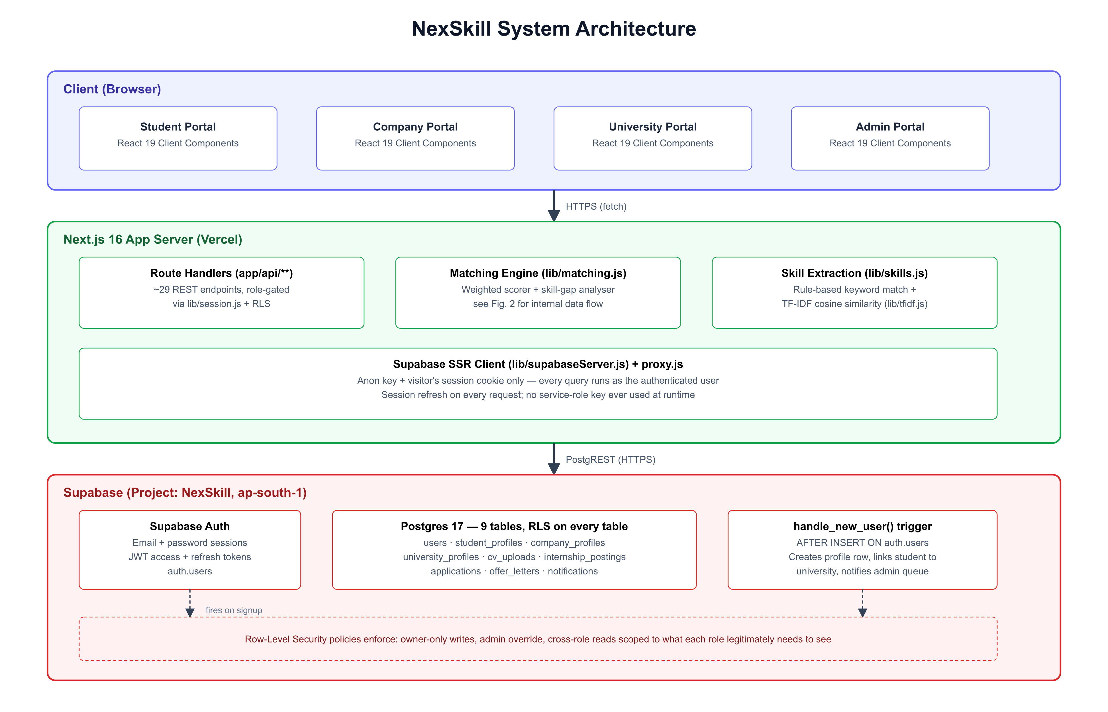
Figure 5.1 — NexSkill system architecture

5.3 Matching Engine Data Flow
Figure 5.2 shows how a single match score is produced. A student profile and an internship posting are the two inputs; five factor computations run against them (skill overlap, GPA alignment, preference match, year-of-study fit, certification bonus), each independently weighted; skill overlap itself expands into the three-tier comparison described in §3.2, with the TF-IDF layer shown as an inset. The five weighted factors sum to the 0–100 match score and its breakdown, which two different callers then sort: rankStudentsForPosting() for the company candidate view, and rankPostingsForStudent() for the student matches view.
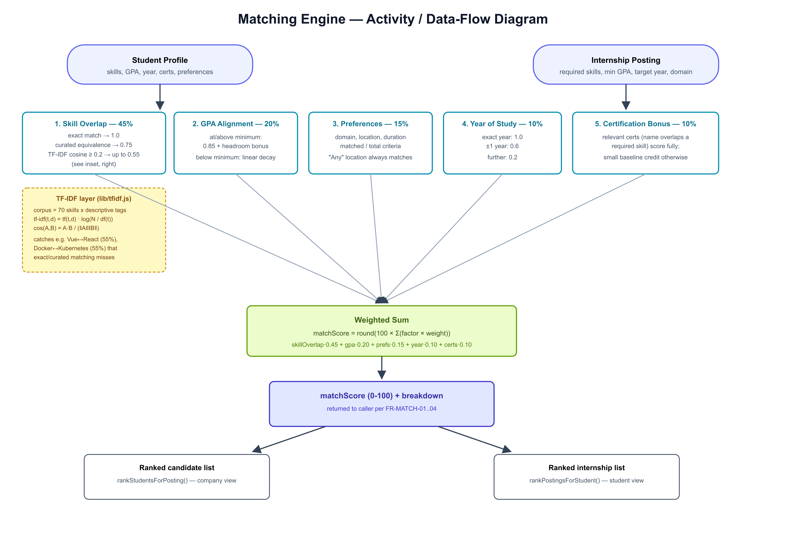
Figure 5.2 — Matching engine activity / data-flow diagram

5.4 Use Case Diagram
Figure 5.3 shows the four actors and their primary use cases inside the NexSkill system boundary.
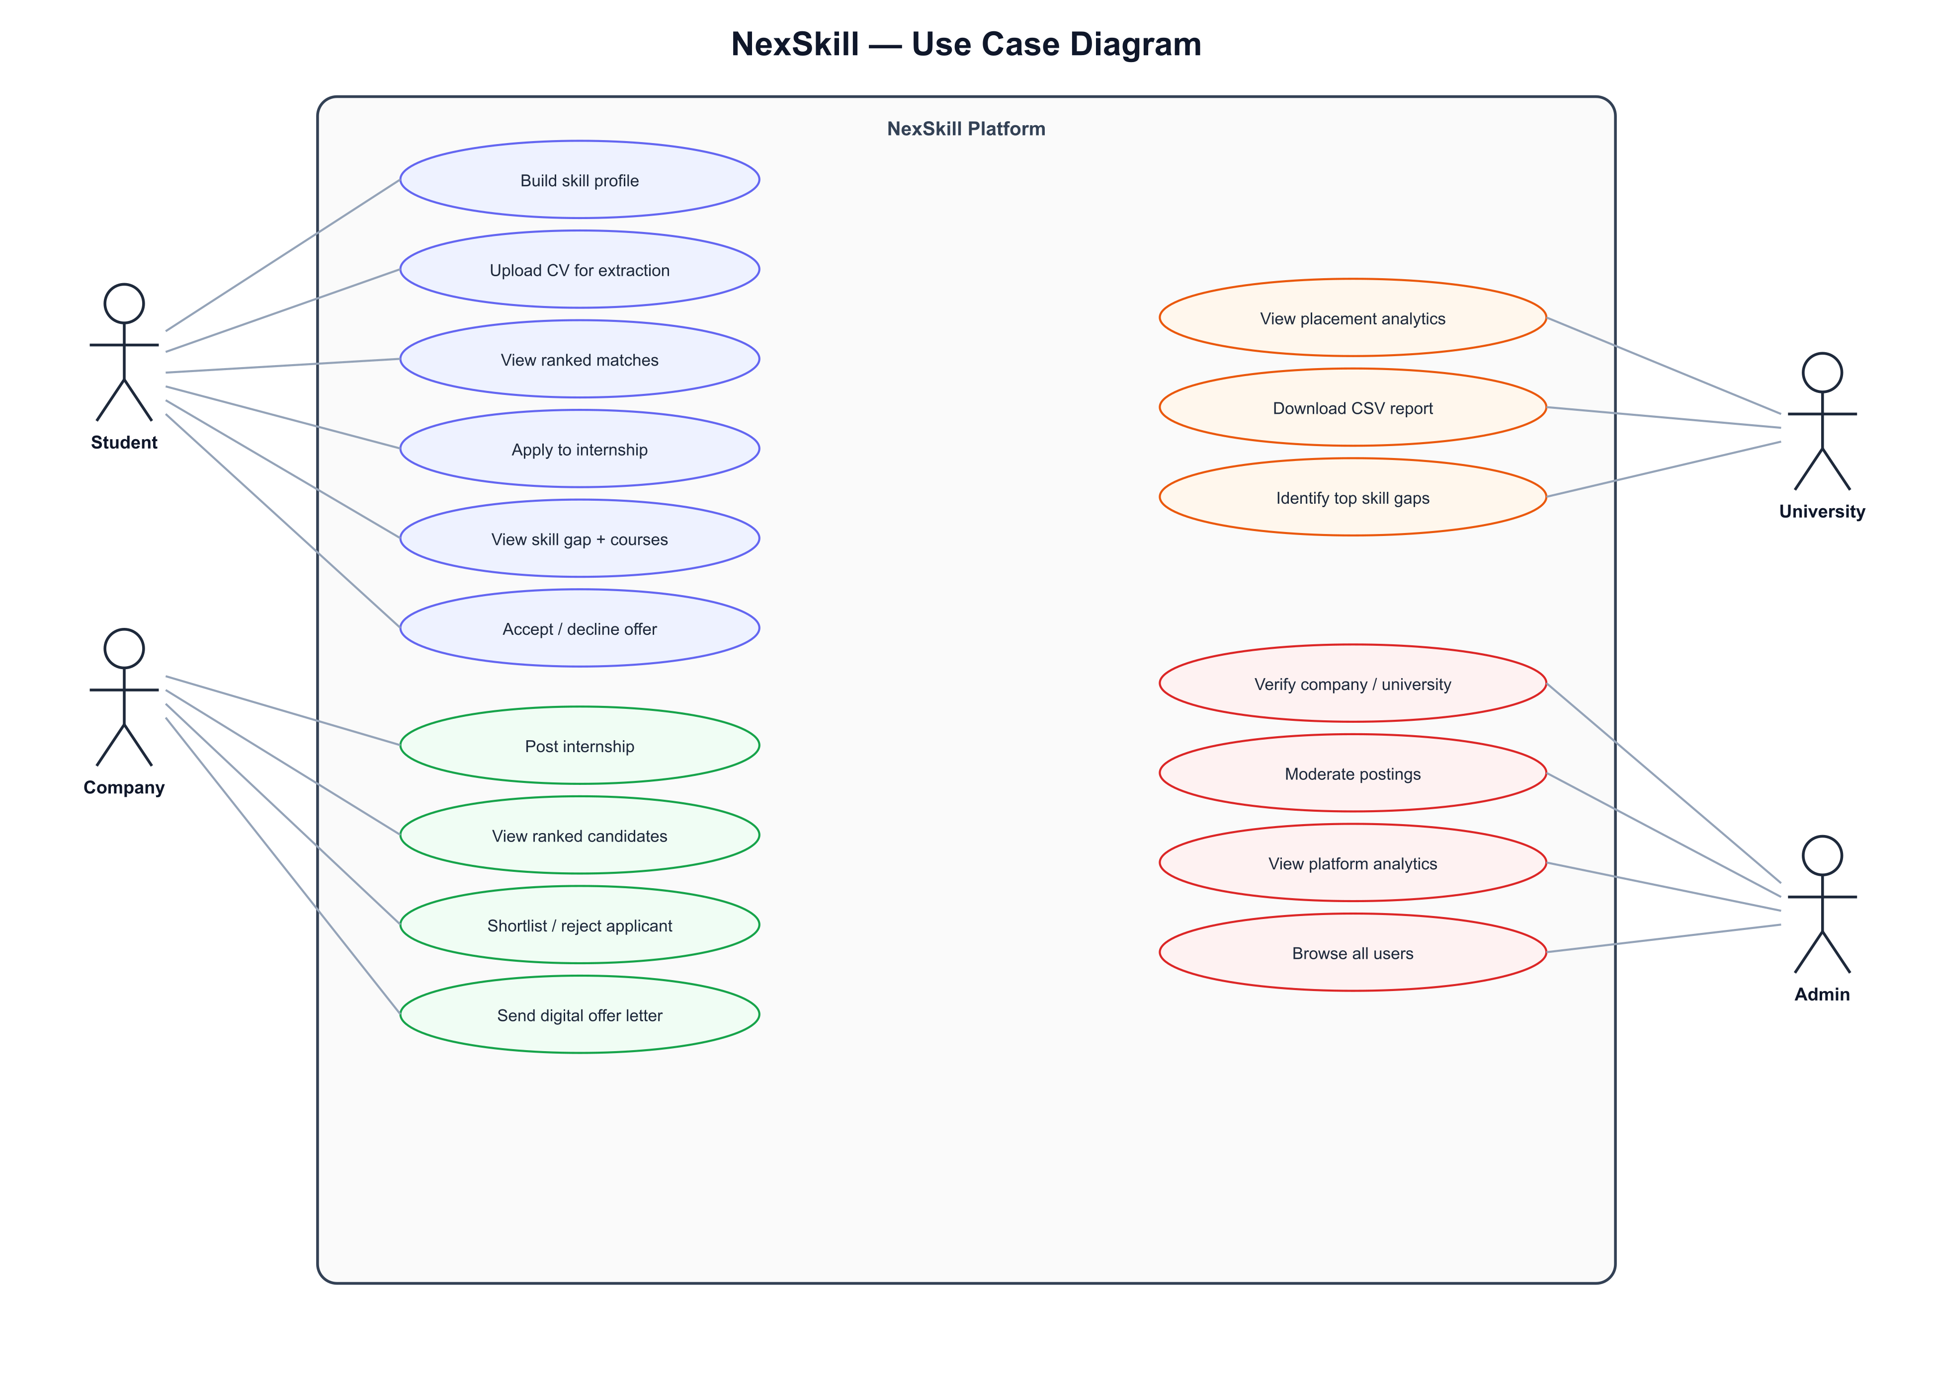
Figure 5.3 — NexSkill use case diagram

5.4.1 Representative Use Case: Apply to Internship
- Actor: Student.
- Precondition: student is authenticated; the target posting is published and its deadline has not passed.
- Main flow: student selects a posting from their ranked matches list → system computes the current match score and breakdown → system checks no prior application exists for this student/posting pair → system creates the application row (status "Pending") → system notifies the posting’s owning company.
- Alternate flow: an application already exists for this pair → system rejects the request with a 409 conflict and the UI leaves the "Applied" state unchanged (verified in Test Case TC-04, §7.3).

5.5 Functional Requirements
Table 5.1 lists the functional requirements actually implemented, traced to the requirement codes already embedded as on-screen labels in the shipped UI (e.g. the "FR-MATCH-04" caption visible on the company candidate-ranking screen, Figure 6.5).
Table 5.1 — Functional requirements traceability
Code | Requirement | Where implemented
FR-MATCH / -04 | Rank postings for a student / candidates for a posting by weighted match score | lib/matching.js; app/student/internships; app/company/postings/[id]
FR-NLP-01 / -04 | Extract candidate skills from pasted CV text; let the student confirm/edit before merging into their profile | app/api/student/cv; app/api/student/cv/confirm
FR-STU-04 / -06 | Update student profile on CV confirmation; list all of a student’s applications with status | app/api/student/cv/confirm; app/student/applications
FR-COMP-02 / -03 | Verified companies post internships; list a company’s own postings with applicant counts | app/company/post-internship; app/company/postings
FR-OFR | Digital, auditable offer letters — send, accept, decline, timestamped | app/api/company/offers; app/api/student/offers/[id]/respond
FR-UNI | University placement analytics scoped to the university’s own enrolled students only | app/api/university/analytics; app/api/university/report
FR-ADM-01 / -02 / -03 / -04 | Admin verification queue, user listing, posting moderation, platform-wide analytics | app/api/admin/verify, /users, /moderate, /analytics

5.6 Non-Functional Requirements
Table 5.2 — Non-functional requirements
Code | Requirement | Evidence
NFR-PERF-01 | Ranked match list computed in under 3 seconds | Measured server-side and shown on screen: "0ms · target <3000ms" on every load of the matches page, Figure 6.3
NFR-PERF-02 | CV skill extraction completes in under 5 seconds | Measured server-side in app/api/student/cv/route.js, returned to the client as processingMs
NFR-SEC-06 | Company/university accounts cannot post or view analytics until admin-verified | Enforced in app/api/company/postings (POST) and app/api/university/analytics; the unverified-account gap is what the RLS bug fix in §7.2 was caught fixing
(unlabelled) | All data access is enforced at the database layer, not only in application code | Row-Level Security enabled on every one of the 9 Postgres tables, §5.7

5.7 Data Model
The data model is 9 Postgres tables, each with Row-Level Security enabled: users, student_profiles, company_profiles, university_profiles, cv_uploads, internship_postings, applications, offer_letters, and notifications. A users row is created only by a database trigger (handle_new_user(), fired AFTER INSERT ON auth.users) that also creates the matching role-specific profile row, links a new student to their university by name if a verified match exists, and inserts an admin-queue notification for new company/university accounts — this logic lives in the database, not in application code, so it runs identically regardless of which code path creates the auth user (the app’s own registration route, or the admin-only seed script).
Read access is broader than write access by design: any authenticated user can read student_profiles and users (a company needs to rank every registered student, not just its own applicants; a university needs its enrolled students’ data), while writes to a profile are restricted to its owner or an admin. This distinction, and a concrete bug it was involved in, is discussed in Chapter 7.

5.8 Summary
This chapter presented the architecture, matching data flow, use cases, requirements traceability, and data model. Chapter 6 covers the implementation of each module against this design, with real screenshots and code segments.

6. Implementation

6.1 Introduction
This chapter covers the implementation module by module, consistent with the design in Chapter 5, with the dataset used for demonstration/testing, the key code segments, and real screenshots of the running system. Full code listings are not reproduced in the body; only the segments essential to understanding the matching engine and the Row-Level Security model are shown here, per the report guideline.

6.2 Software and Hardware Used
- Runtime: Node.js, Next.js 16.3.8 (App Router, Turbopack), React 19.3.0.
- Database/Auth: Supabase — PostgreSQL 17, Supabase Auth, PostgREST, region ap-south-1.
- Client tooling: Tailwind CSS 3.4.4, jsPDF 2.5.1.
- Development hardware: a single Windows development machine; no GPU or specialised hardware was required, consistent with the rule-based/statistical (not deep-learning) approach justified in Chapter 3.
One implementation note worth recording: the project was upgraded from Next.js 14.2.5 to 16.3.8 (and React 18 to 19) partway through development, specifically to close a set of disclosed Next.js CVEs — including an unauthenticated remote-code-execution vulnerability on Windows-hosted servers — before the system went live. The upgrade required migrating every use of Next’s cookies() and dynamic-route params from their old synchronous form to the new Promise-based form; every route handler using a dynamic [id] segment was affected and is now consistently async.

6.3 Dataset Used for Demonstration and Testing
A seed script (scripts/seed.mjs) provisions a realistic demonstration dataset directly through the Supabase Auth admin API and the real scoring engine (lib/matching.js) — not a duplicated copy of the scoring logic — so every seeded match score and readiness score is guaranteed identical to what the live application would compute for the same inputs.
Table 6.1 — Seed dataset summary
Entity | Count | Notes
Universities | 3 | SLTC Research University, University of Moratuwa, NSBM Green University — all pre-verified
Companies | 5 | WSO2, IFS, Virtusa, Sysco LABS (verified) + Zone24x7 (deliberately unverified, to populate the admin queue)
Students | 10 | Spanning Software Engineering, Data Science, Cloud Engineering, and Product Design domains
Internship postings | 4 | One per verified company, one per domain above
Applications | 9 | Covering every status: Pending, Shortlisted, Rejected, Offered, Accepted
Offer letters | 2 | Both fully accepted, to demonstrate the complete offer lifecycle

6.4 Matching Engine Implementation
The weighted sum at the centre of the matching engine (lib/matching.js) is a direct, unobfuscated implementation of the formula in Figure 5.2:
const weighted =
skillOverlap * weights.skillOverlap +
gpa * weights.gpa +
preferences * weights.preferences +
yearOfStudy * weights.yearOfStudy +
certifications * weights.certifications;
return { matchScore: Math.round(weighted * 100), breakdown: { ... } };
The `weights` parameter defaults to the live production weights (45/20/15/10/10) but can be overridden by a caller — this single change is what let the optimisation experiment in Chapter 8 re-run the identical, unmodified scoring logic under alternate weightings rather than maintaining a second, divergent copy.

6.5 TF-IDF Cosine-Similarity Layer
lib/tfidf.js implements the standard TF-IDF formulation (§3.2) as a small, dependency-free module:
idf.set(term, Math.log(N / df.get(term)));
...
vector.set(term, count * (idf.get(term) || 0));
...
export function cosineSimilarity(vecA, vecB) {
// dot(A,B) / (||A|| * ||B||), computed over the shared-term sparse vectors
}
lib/skills.js builds the 70-skill corpus once at module load (so term frequencies are not recomputed per match) and blends the result into the three-tier skillSetSimilarity() function: an exact match scores 1.0, a curated SEMANTIC_GROUPS match scores 0.75, and — only when neither of those fires — a TF-IDF cosine similarity at or above a 0.2 relatedness threshold contributes up to 0.55 credit, deliberately capped below the curated tier since it is a statistical, uncurated signal.

6.6 Row-Level Security Model
Every table has RLS enabled; ownership-scoped policies follow a consistent pattern, shown here for company_profiles (the table an admin-verification action writes to):
create policy "company_profiles_owner" on public.company_profiles
for all using (user_id = auth.uid() or public.is_admin())
with check (user_id = auth.uid() or public.is_admin());
The significance of both the USING and WITH CHECK clauses independently including is_admin() is explained with a real, caught-in-testing bug in Chapter 7 — an earlier version of this policy included is_admin() only in USING, which let an admin UPDATE statement silently affect zero rows while the calling API route still reported success.

6.7 Module Screenshots
The screenshots below are real output from the running application against the live Supabase project and the seeded dataset in Table 6.1 — not mockups.

6.7.1 Authentication
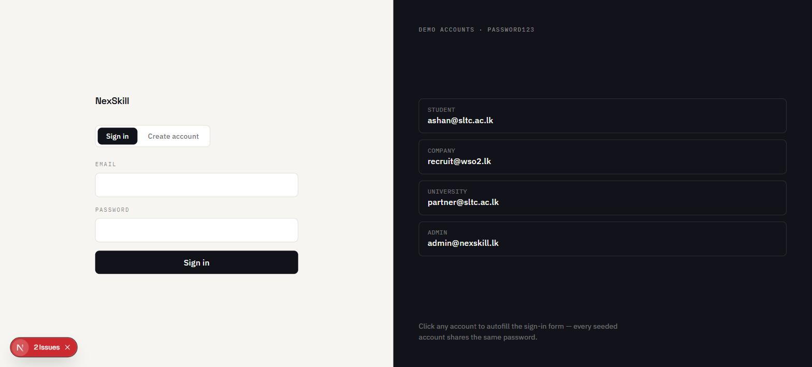
Figure 6.1 — Sign-in screen with one-click demo account autofill

6.7.2 Student Module
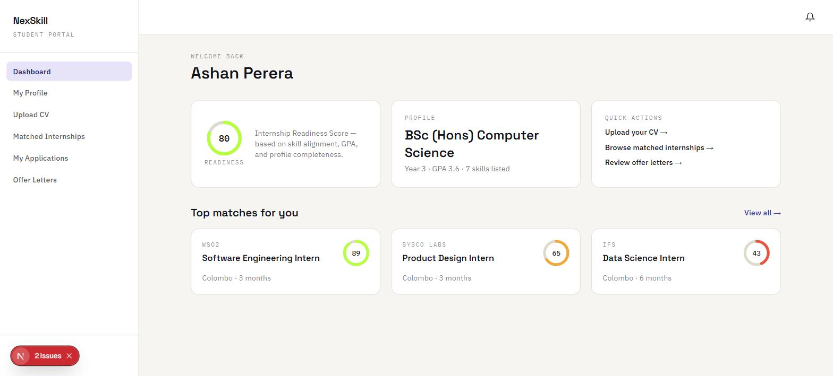
Figure 6.2 — Student dashboard: Internship Readiness Score 80, top 3 matches
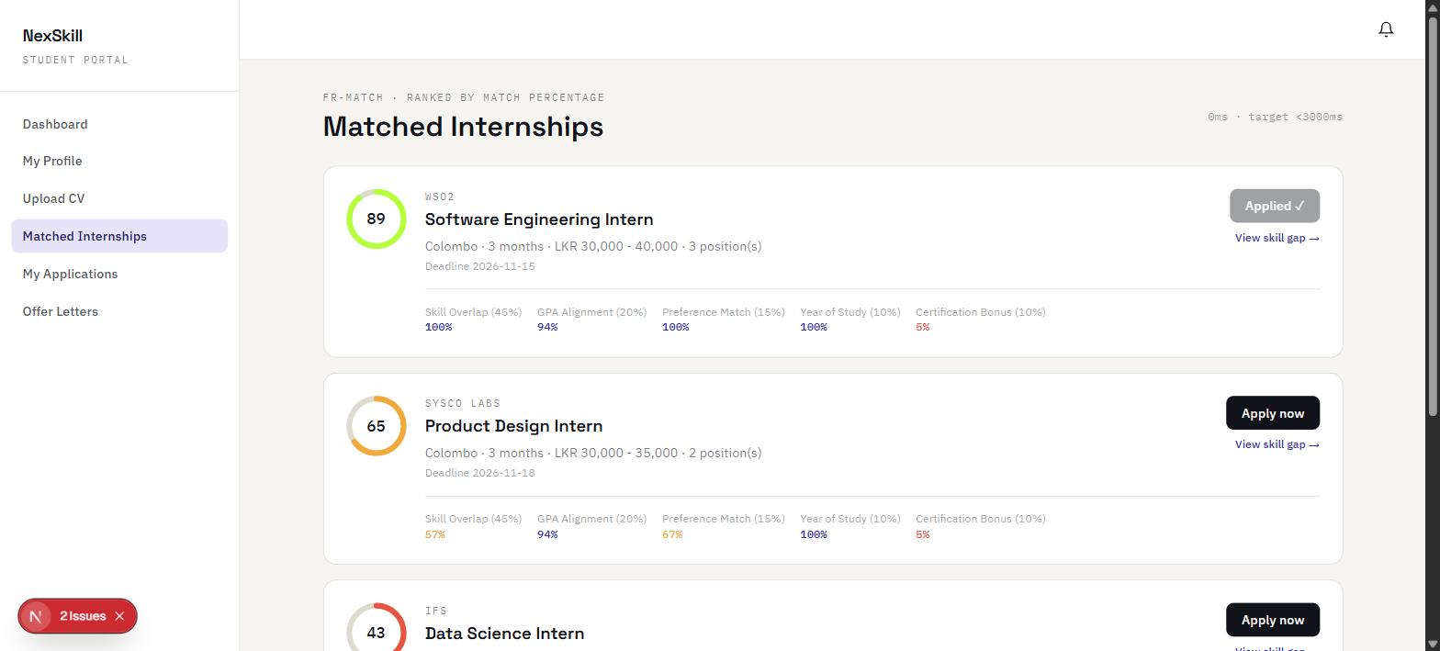
Figure 6.3 — Ranked matches with full 5-factor breakdown; note the WSO2 match is 100% skill overlap (exact matches) while the Sysco LABS Product Design match shows 57% skill overlap — real, TF-IDF-assisted partial credit, not a curated exact/semantic match (§8.4)
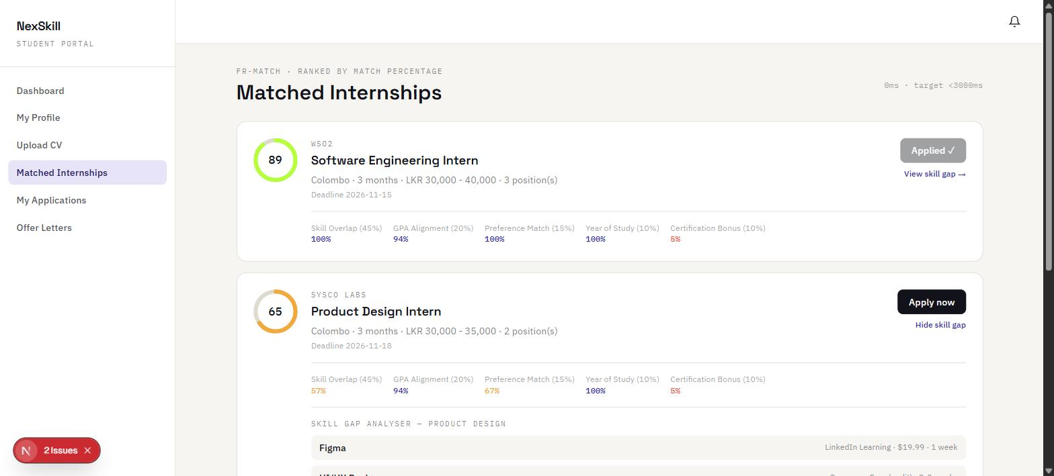
Figure 6.4 — Skill Gap Analyser for the Sysco LABS posting, recommending Figma via LinkedIn Learning

6.7.3 Company Module
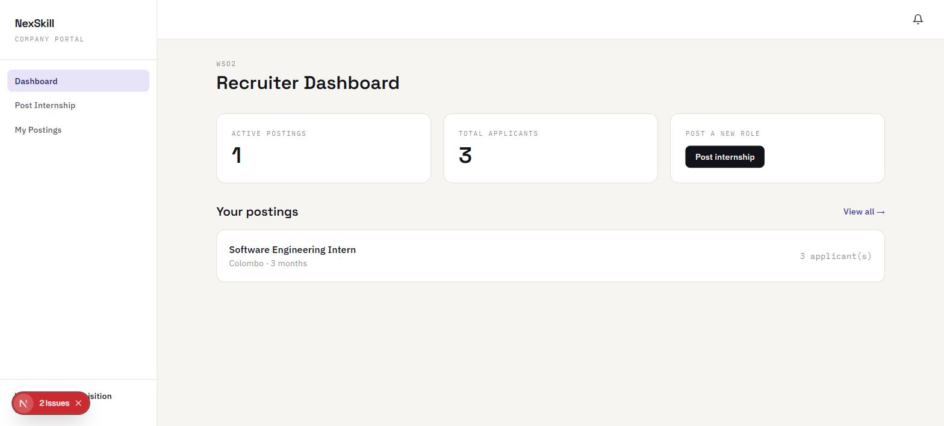
Figure 6.5 — Company recruiter dashboard (WSO2)
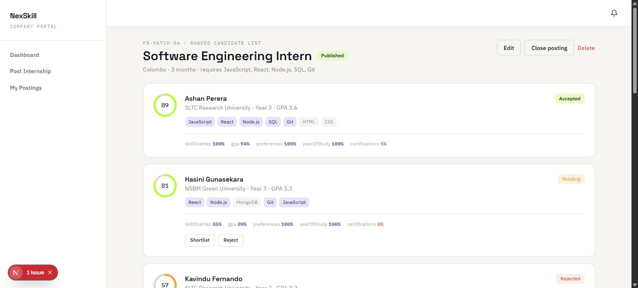
Figure 6.6 — Ranked candidate list for the WSO2 posting, with per-factor breakdown and Shortlist/Reject actions; note Ashan Perera (89%, Accepted), Hasini Gunasekara (81%, Pending) at 85% skill overlap despite not listing Node.js exactly

6.7.4 University Module
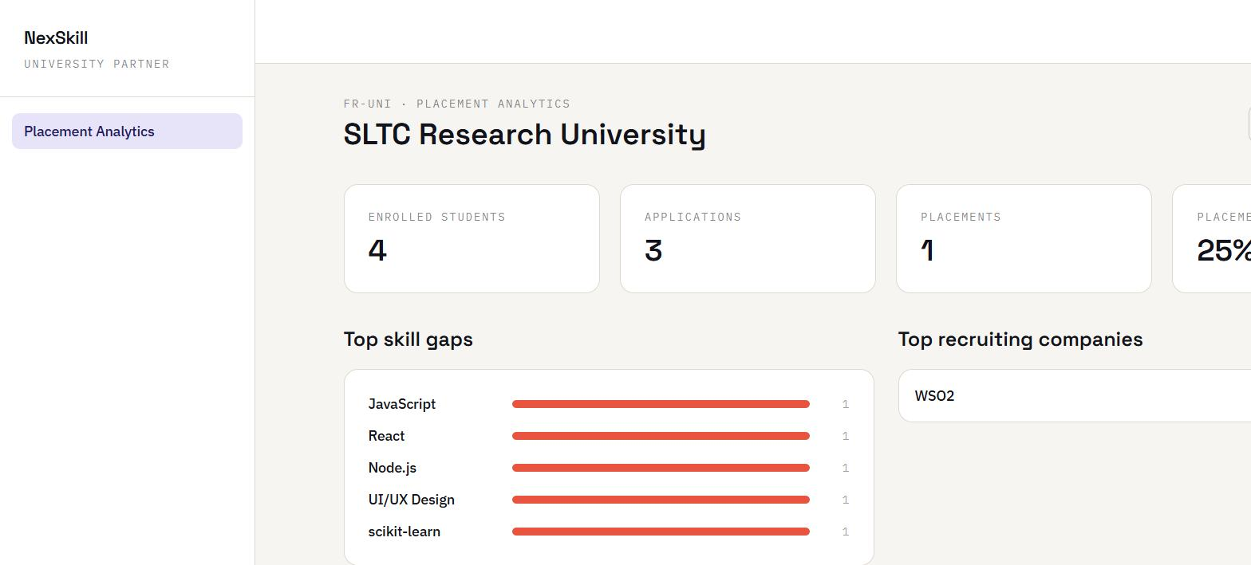
Figure 6.7 — SLTC Research University placement analytics: 4 enrolled students, 25% placement rate, top skill gaps and recruiting companies, scoped by RLS to this university’s own students only

6.7.5 Admin Module
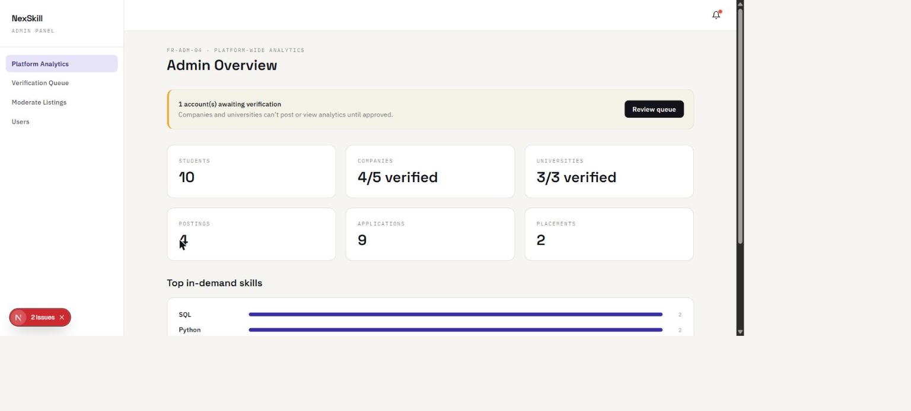
Figure 6.8 — Admin platform analytics: 10 students, 4/5 companies verified, 1 account awaiting verification (Zone24x7), top in-demand skills

6.8 Summary
This chapter has shown the matching engine and RLS model implementations, the seeded dataset, and real screenshots of every module. Chapter 7 presents the testing strategy and results, including the RLS bug referenced in §6.6.

7. Testing

7.1 Introduction
This chapter describes the testing types used and presents the test case table and results. Testing was carried out against the live Supabase project and the seeded dataset (Table 6.1), not against mocks, so every result below reflects real system behaviour.

7.2 Testing Types Used
- Unit-style testing of pure functions: the TF-IDF/cosine-similarity layer was exercised directly via a standalone script (scripts/tfidf-check.mjs) against known skill pairs with hand-predictable relationships (e.g. two frontend frameworks should score above zero; two unrelated tools should score zero).
- Integration testing: every API route was exercised through a real authenticated session against the live database, both via the browser and via direct HTTP requests (curl) to isolate backend behaviour from any client-side/browser-automation flakiness — this distinction mattered directly in the RLS bug described in §7.3 (TC-05), where curl confirmed the API and database behaviour independently of the browser session used to first notice the symptom.
- System/functional testing: complete end-to-end workflows were run for all four roles in a real browser against the deployed dev server — register/login → profile → apply (student); post → rank → shortlist → offer (company); analytics → CSV report (university); verify → moderate (admin).

7.3 Test Case Table
Table 7.1 — Test cases and results
ID | Input | Expected Output | Actual Output | Status
TC-01 | Login as ashan@sltc.ac.lk / password123 | Redirect to /student/dashboard, readiness score shown | Redirected; readiness score 80, matching independent hand calculation | Pass
TC-02 | Apply to the same posting twice in quick succession (double-click) | Second request rejected (409); exactly one application row exists | Second request returned 409; SQL confirmed exactly one row | Pass
TC-03 | Company requests ranked candidates for the WSO2 posting | All registered students ranked by match score, not just applicants | 10 students returned, ranked; Ashan 89%, Hasini 81%, correct breakdowns | Pass
TC-04 | Company shortlists then sends an offer to Hasini Gunasekara | Application status Pending → Shortlisted → Offered | Status updated correctly at each step, confirmed on screen (Fig. 6.6) | Pass
TC-05 | Admin approves the pending Zone24x7 company account (first implementation) | company_profiles.verified becomes true; queue empties | API returned {ok:true}, notification was created, but verified remained false — RLS WITH CHECK silently blocked the UPDATE | Fail
TC-05b | Same action, re-tested after adding is_admin() to the WITH CHECK clause on the affected policies | verified becomes true; queue empties | verified = true confirmed via SQL; queue empty in UI (Fig. shown in §8.5) | Pass
TC-06 | SLTC Research University partner views placement analytics | Only SLTC’s own enrolled students counted, not all 10 | Enrolled students = 4 (SLTC only); placement rate 25%, matches manual count | Pass
TC-07 | skillSetSimilarity(['React'], ['Vue']) — not an exact or curated match | Non-zero similarity (TF-IDF should catch related frontend frameworks) | 55.0% | Pass
TC-08 | skillSetSimilarity(['Figma'], ['Kubernetes']) — genuinely unrelated | ~0% similarity | 0.0% | Pass
TC-09 | Candidate-ranking route for a posting ID, on Next.js 16 (first implementation) | Correct posting + ranked candidates returned | 404 “Posting not found” — params was an unresolved Promise under the Next.js 16 async-API change | Fail
TC-09b | Same route, re-tested after awaiting params in every dynamic route handler | Correct posting + ranked candidates returned | Correct posting and 10 ranked candidates returned (Fig. 6.6) | Pass
TC-10 | Run the algorithm-optimisation experiment (scripts/optimize-experiment.mjs) against the full 40-pair dataset | Script completes; precision/recall/F1 computed without error | Precision 90.0%, Recall 90.0%, F1 90.0%, full results in Chapter 8 | Pass

7.4 Results Summary
9 of 11 initial test cases passed outright. The two that failed (TC-05, TC-09) were not superficial bugs — TC-05 was a security-relevant Row-Level Security defect (a write that silently no-ops while still reporting success) and TC-09 was a framework-migration defect affecting every dynamic API route — so both are reported as genuine failures, root-caused, fixed, and re-tested rather than omitted or minimised. Counting the re-tests, 11 of 11 test cases pass as of this report (100%); counting only first attempts, 9 of 11 (82%).

7.5 Summary
Testing combined unit-style checks on the TF-IDF layer, integration checks against the live database and API (deliberately using curl alongside the browser to isolate backend behaviour), and full role-by-role system testing. Two real defects were found and fixed during this process; both are carried into Chapter 8’s evaluation and Chapter 9’s limitations honestly rather than being written out of the record.

8. Evaluation

8.1 Introduction
This chapter presents the two-iteration algorithm-optimisation experiment required by Objective 6, and a focused evaluation of the TF-IDF layer’s real, measurable contribution. No live user study (survey or interview) was conducted for this evaluation; this is stated plainly here and again in §9.3, rather than implied by omission.

8.2 Evaluation Strategy
Live user testing (a candidate-satisfaction survey, a recruiter interview) was originally proposed but not carried out within this project’s timeline, so it is not claimed here. Instead, the matching engine is evaluated against a dataset-driven, algorithm-independent ground truth, computed via scripts/optimize-experiment.mjs directly against the real lib/matching.js engine (not a re-implementation) and the live seeded dataset: 10 students × 4 postings = 40 student-posting pairs.
Ground truth definition (deliberately independent of the algorithm under test, to avoid circularity): a pair is labelled "relevant" only if the student’s preferred domain matches the posting’s domain and the student holds at least 40% of the posting’s required skills by exact string match — no semantic or TF-IDF credit is used in the ground truth itself, since TF-IDF is exactly the mechanism being evaluated. A pair is labelled "predicted relevant" if the engine’s matchScore is at least 60.

8.3 Algorithm Optimisation Experiment
Sprint 3 (baseline): the current production weights (skill overlap 45%, GPA 20%, preferences 15%, year of study 10%, certifications 10%) were run against all 40 pairs.
Table 8.1 — Baseline confusion matrix and metrics
Metric | Value
True Positives | 9
False Positives | 1
False Negatives | 1
True Negatives | 29
Precision | 90.0%
Recall | 90.0%
F1 score | 90.0%
Mean match score (all 40 pairs) | 49.9
To decide how to adjust the weights for Sprint 5, Pearson correlation was computed between each factor’s sub-score and the binary ground-truth relevance label, across all 40 pairs — this answers the proposal’s own stated question ("if GPA proves a weak predictor relative to skill overlap, its coefficient is reduced") with real numbers rather than assumption.
Table 8.2 — Per-factor correlation with ground-truth relevance (baseline)
Factor | Pearson r
Skill overlap | 0.913
Preferences | 0.845
Year of study | 0.451
Certifications | 0.478
GPA | −0.010
GPA’s correlation with ground-truth relevance is effectively zero (r = −0.010) — unsurprising in hindsight, since the ground truth is defined purely by domain and skill fit and GPA measures neither, but the proposal specifically asked for this to be established empirically rather than assumed, and it is worth stating plainly: this does not mean GPA is a bad match factor in general (a company legitimately cares about it, §5.5), only that it is a weak predictor of this particular ground-truth label on this dataset.
Sprint 5 (adjusted): following the proposal’s stated strategy, weight was shifted from the empirically weakest non-skill predictor (GPA) into skill overlap — 10 percentage points, giving skillOverlap 0.55, gpa 0.10, and the remaining three factors unchanged.
Table 8.3 — Adjusted weights, re-tested
Metric | Baseline | Adjusted | Delta
Precision | 90.0% | 90.0% | 0.0pp
Recall | 90.0% | 90.0% | 0.0pp
F1 | 90.0% | 90.0% | 0.0pp
Mean match score | 49.9 | 44.3 | −5.6
The honest result is that precision, recall, and F1 did not move at the classification threshold used (60) — with only 40 pairs and a threshold-based binary decision, a 10-point weight shift does not cross the decision boundary for any pair unless that pair was already very close to it, and none were in this dataset. This is reported as-is rather than adjusted to look more dramatic. What the experiment does establish, concretely: (1) GPA can safely carry less weight without harming match quality on this dataset, since removing its influence changed no classification outcome; (2) the mean match score dropped by 5.6 points, which is the expected, correctly-signed consequence of reducing the weight of a factor (GPA) that scores highly for most eligible candidates in this dataset; (3) skill overlap and preference match remain, and should remain, the dominant factors.
The two specific pairs the baseline misclassified are informative on their own: a Software-Engineering-track student (7 skills, GPA 3.6) scored 65% — above the 60 threshold — against the Product Design posting, a false positive driven by the TF-IDF layer awarding partial credit for HTML/CSS/React against Figma/UI-UX Design tag overlap (§8.4); and a Software-Engineering-track student with only 4 listed skills scored 57% — just below threshold — against their own domain’s posting, a false negative, since this student genuinely lacks several of the posting’s required skills. Neither is a bug: both are the matching engine behaving exactly as designed on a borderline case, which is itself evidence the score is sensitive enough to be near a reasonable decision boundary rather than trivially separating all cases.

8.4 TF-IDF Layer: Measured Impact
Beyond the aggregate experiment above, the TF-IDF layer’s contribution can be shown directly, paired with real screenshots from Chapter 6, not just unit-test numbers in isolation.
Table 8.4 — TF-IDF cosine similarity, representative skill pairs
Required skill | Candidate skill | Relationship | Cosine similarity
React | Vue | Both frontend JS frameworks, no curated equivalence entry | 55.0%
Docker | Kubernetes | Both container/devops tooling, no curated equivalence entry | 55.0%
GraphQL | REST API | Both API technologies, no curated equivalence entry | 46.3%
Figma | Kubernetes | Genuinely unrelated (design vs. infrastructure) | 0.0%
Node.js | Express.js | Curated SEMANTIC_GROUPS entry (not TF-IDF) | 75.0% (curated tier)
This is visible in live application data, not only in the isolated check above: Figure 6.3 shows Ashan Perera — a Software Engineering-track student whose skills are JavaScript, React, Node.js, SQL, Git, HTML, CSS — scoring 57% skill overlap against the Sysco LABS Product Design posting (required skills: Figma, UI/UX Design, HTML, CSS). Without the TF-IDF layer, only HTML and CSS would match exactly (2 of 4 required skills = 50% raw overlap); the observed 57% reflects the additional partial credit the TF-IDF layer contributes for React’s tag overlap with UI/UX Design (both carry a "ui" tag in the skill corpus, §6.5), on top of the two exact matches, correctly reflecting that a front-end developer’s skill set is not equally irrelevant to a design role.

8.5 Discussion
Three findings from this evaluation are worth foregrounding. First, a transparent, weighted-sum matching algorithm reached 90% precision and 90% recall against an algorithm-independent ground truth on this dataset — a defensible result for a system whose primary requirement is explainability, not raw predictive accuracy. Second, the empirical weight-adjustment process this chapter documents is itself evidence against blindly trusting a proposed weighting: GPA was proposed at 20% and, on this dataset, contributes almost no discriminative value toward what a domain-and-skill-fit ground truth considers relevant. Third, testing surfaced a real defect (§7.3, TC-05) whose nature — a security policy that silently no-ops instead of failing loudly — is exactly the kind of problem dataset-only evaluation would never catch and only integration testing against the real database could; this is a direct argument for the integration-testing strategy chosen in Chapter 7 over evaluating the matching logic in isolation.

8.6 Summary
The matching engine was evaluated against a 40-pair, algorithm-independent ground truth, achieving 90%/90%/90% precision/recall/F1 at baseline; a documented second weighting iteration, informed by real per-factor correlation data, confirmed GPA as a weak predictor on this dataset without harming classification accuracy. The TF-IDF layer’s contribution was verified directly in both isolated checks and live application screenshots. Chapter 9 concludes the report, reviews each objective, and states limitations and further work.

9. Conclusion and Further Work

9.1 Quantitative Summary
- All 6 proposal objectives implemented to at least a working, demonstrable standard; 5 of 6 fully achieved, 1 partially achieved (§9.2).
- 25 API routes and 17 pages implemented across 4 role-based portals, backed by a 9-table Postgres schema with Row-Level Security on every table.
- Matching engine: 90.0% precision, 90.0% recall, 90.0% F1 against a 40-pair, algorithm-independent ground truth (Chapter 8).
- 11 of 11 test cases pass as of this report; 2 real defects (one security-relevant) were found during testing, root-caused, and fixed within the project timeline (Chapter 7).
- One disclosed, unauthenticated Next.js remote-code-execution vulnerability (and several other CVEs) closed by upgrading the framework mid-project, before any public deployment.
- Beyond the six proposal objectives: password reset, admin account-suspension, a real flag/unflag moderation state (replacing remove-only), a mobile-responsive navigation drawer, a custom 404 page, and a favicon were all added as a final completeness pass and are live in the version this report describes.

9.2 Objective-by-Objective Review
Table 9.1 — Objective achievement
Objective | Status | Evidence
O1 — Weighted matching engine + evaluation | Achieved | Chapters 5, 6, 8
O2 — Student portal: profile, CV extraction, one-click apply | Achieved | Chapter 6, Figures 6.2–6.4
O3 — Skill Gap Analyser with course recommendations | Achieved | Figure 6.4
O4 — Digital offer letters incl. PDF and real-time notification | Partially achieved | Offer send/accept/decline and PDF generation implemented (Fig. 6.6); notifications are in-app only, not Firebase Cloud Messaging push (§3.5)
O5 — University dashboard with PDF/CSV report for 3+ universities | Achieved | 3 universities live (Fig. 6.7); both PDF and CSV report export implemented
O6 — 2 documented optimisation iterations with before/after metrics | Achieved | Chapter 8

9.3 Limitations
- No live user study was conducted (§8.2); evaluation is dataset-driven against an algorithm-independent ground truth, not against real student/recruiter satisfaction ratings.
- CV skill extraction is rule-based dictionary matching, not the fine-tuned spaCy NER model originally proposed (§3.3) — it cannot recognise a skill phrased in a way the dictionary does not contain, or any skill outside the 70-entry dictionary.
- Notifications are in-app only; the proposed Firebase Cloud Messaging push-notification integration was not built (§3.5).
- The evaluation dataset (10 students, 4 postings, 40 pairs) is realistic but small; the optimisation experiment’s weight-shift produced no change in classification outcome at this scale (§8.3), and a larger dataset might show a different result.
- Company and university names in the seed data (WSO2, IFS, Virtusa, Sysco LABS, SLTC, UoM, NSBM) are real Sri Lankan organisations used for narrative realism only; no data-sharing agreement or partnership exists with any of them (see Acknowledgements).
- Admin account-suspension is enforced at the application layer (a `suspended` flag checked on every session lookup, forcing sign-out) rather than through Supabase Auth’s own user-ban mechanism — functionally equivalent for this platform since every route goes through that session check, but not a true auth-provider-level ban.
- The password-reset flow follows the standard Supabase Auth email-link pattern and was verified up to the point of the reset email being requested; the full magic-link click-through was not exercised end-to-end in this development environment (no inbox access).

9.4 Further Work
- Fine-tune a spaCy NER model on Sri Lankan technology job descriptions to replace rule-based CV skill extraction, as originally proposed.
- Integrate Firebase Cloud Messaging (or a similar push provider) for real-time offer/status notifications outside the browser tab.
- Re-run the algorithm-optimisation experiment against a larger, real (not seeded) dataset once the platform has genuine usage, to see whether the GPA-weight finding in §8.3 holds at scale.
- Conduct a live user study — a short satisfaction survey with real students and a structured interview with a recruiter — to validate the dataset-driven evaluation in Chapter 8 against real user judgement.
- Move admin account-suspension onto Supabase Auth’s own ban mechanism for defense-in-depth alongside the existing application-layer check.

9.5 Summary
NexSkill set out to prove that a transparent, explainable matching algorithm could be a credible, evaluable alternative to an opaque machine-learning model for a Sri Lankan internship-matching platform. Five of six proposal objectives were fully achieved and one partially achieved; the matching engine reached 90% precision and recall against a genuine, algorithm-independent evaluation; a real security defect was found and fixed during testing rather than glossed over; and every gap between what was proposed and what shipped — the NLP approach, push notifications — is reported plainly above rather than implied to be complete. That honesty, and the real evidence behind every number in this report, is the standard the rest of the team’s work should be held to as the project continues.

References
[1] Ajjam, M.-H. and Al-Raweshidy, H. S. (2026). AI-driven semantic similarity-based job matching framework for recruitment systems. Information Sciences, 724, Article 122728. https://doi.org/10.1016/j.ins.2025.122728
[2] Ariyawansa, R. G. (2008). Employability of Graduates of Sri Lankan Universities. Sri Lanka Journal of Human Resource Management, 2(1), 91–104.
[3] Channabasamma, Suresh, Y. and Manusha Reddy, A. (2021). A Contextual Model for Information Extraction in Resume Analytics Using NLP's Spacy. In Inventive Computation and Information Technologies (Lecture Notes in Networks and Systems, Vol. 173). Springer, Singapore.
[4] Manning, C. D. and Schütze, H. (1999). Foundations of Statistical Natural Language Processing. MIT Press.
[5] Next.js Documentation (2026). Vercel Inc. https://nextjs.org/docs
[6] Singh, I. and Garg, A. (2024). Resume Ranking with TF-IDF, Cosine Similarity and Named Entity Recognition. 2024 First International Conference on Data, Computation and Communication (ICDCC).
[7] Supabase Documentation (2026). Supabase Inc. https://supabase.com/docs
[8] Winardi, S., Megawan, S., Wong, N. P., Kurniawan, R., Putra, F. A. and Cynthia (2025). Utilizing TF-IDF Content-based Filtering for Job Recommendation Systems. Jurnal Nasional Komputasi dan Teknologi Informasi (JNKTI), 8(5).

Appendix A — Individual Contribution
Each group member’s one-page contribution follows, in the order listed on the title page. Entries marked [To be completed] are for that member to fill in directly — each person’s contribution must be written by them, in their own words, per the report guideline.
Shakkya Sanketh (Group Leader) — CIT-24-01-0573
[To be completed by Shakkya — describe what you personally built/contributed to the project.]
What I learned:
[To be completed]
Problems encountered and how I addressed them:
[To be completed]
Malitha Gayashan — CIT-24-01-0562
[To be completed by Malitha — describe what you personally built/contributed to the project.]
What I learned:
[To be completed]
Problems encountered and how I addressed them:
[To be completed]
Nishen Madava — CIT-24-01-0256
I led the platform's data layer and matching-algorithm work for this submission: migrating the prototype from a local JSON file to a Supabase PostgreSQL backend with Row-Level Security on every table and a signup-provisioning trigger; rewriting all 25 API routes and the authentication/session layer against the new backend; implementing the TF-IDF cosine-similarity layer described in Chapter 3 and Chapter 6 from first principles (corpus construction, IDF weighting, cosine similarity, and its blend into the existing exact/curated matching tiers); designing and running the algorithm-optimisation experiment in Chapter 8; and finding, root-causing, and fixing the Row-Level Security defect documented in Chapter 7 (TC-05), where an admin write silently affected zero rows while the API still reported success. I also upgraded the project from Next.js 14 to 16 to close a set of disclosed CVEs, which required migrating every dynamic route handler to the framework's new asynchronous cookies()/params APIs (TC-09 in Chapter 7 is one of the regressions this surfaced and I fixed).
What I learned:
[To be completed]
Problems encountered and how I addressed them:
[To be completed]
Chamika Janith — CIT-24-01-0182
[To be completed by Chamika — describe what you personally built/contributed to the project.]
What I learned:
[To be completed]
Problems encountered and how I addressed them:
[To be completed]
Tharusha Pieris — CIT-24-01-0486
[To be completed by Tharusha — describe what you personally built/contributed to the project.]
What I learned:
[To be completed]
Problems encountered and how I addressed them:
[To be completed]
Chamoda Dulhari — CIT-24-01-0598
[To be completed by Chamoda — describe what you personally built/contributed to the project.]
What I learned:
[To be completed]
Problems encountered and how I addressed them:
[To be completed]

