SLTC Research University
Faculty of Computing
CCS2360 — Technology Challenges and Competitions
NexSkill
User Manual
A step-by-step guide for students, companies, university partners, and administrators
Prepared to accompany the NexSkill Final Project Report
Academic Year 2026

Table of Contents
1. Introduction 3
1.1 About This Manual 3
1.2 Accessing the System 3
1.3 Demo Accounts 3
2. Getting Started 5
2.1 Creating an Account 5
2.2 Signing In 5
2.3 Resetting a Forgotten Password 5
2.4 Signing Out 5
2.5 Notifications 6
2.6 Using NexSkill on a Phone or Tablet 6
3. Student Portal 7
3.1 Overview 7
3.2 Dashboard 7
3.3 My Profile 7
3.4 Upload CV 7
3.5 Matched Internships 8
3.5.1 Skill Gap Analyser 9
3.6 My Applications 9
3.7 Offer Letters 10
4. Company Portal 11
4.1 Overview 11
4.2 Dashboard 11
4.3 Posting an Internship 11
4.4 Managing Postings and Candidates 12
5. University Portal 14
5.1 Overview 14
5.2 Placement Analytics Dashboard 14
5.3 Downloading a Placement Report 14
6. Admin Portal 15
6.1 Overview 15
6.2 Platform Analytics 15
6.3 Verification Queue 15
6.4 Moderate Listings and Users 16
7. Troubleshooting & FAQ 17
7.1 I signed up as a company/university but cannot post or view analytics. 17
7.2 My match scores seem too low. 17
7.3 I cannot sign in even though my password is correct. 17
7.4 I forgot my password. 17
7.5 A browser extension shows a warning in the console about mismatched attributes. 17

1. Introduction

1.1 About This Manual
This manual explains how to use every feature of NexSkill, a skill-based internship matching platform connecting students, companies, and university placement offices in Sri Lanka. It is written for a first-time user of each of the four role-based portals the system provides, and walks through each screen using real screenshots taken from the running application rather than mockups.
NexSkill has four distinct user roles, each with its own portal and navigation menu: Student, Company, University, and Admin. A single account belongs to exactly one role, decided at registration. This manual is organised by role — read the chapter for your own role, and treat the others as reference if you ever need to understand what another party sees.

1.2 Accessing the System
Open a web browser and navigate to the NexSkill URL provided by your instructor or deployment owner (for local development, this is normally http://localhost:3000). The landing page offers links to sign in or create an account.

1.3 Demo Accounts
The system ships with a seeded demonstration dataset and one pre-created account per role, each sharing the same password. These are provided for evaluation and testing — a live deployment would be reseeded or have these accounts removed.
Table 1.1 — Demo accounts
Role | Email | Password
Student | ashan@sltc.ac.lk | password123
Company | recruit@wso2.lk | password123
University | partner@sltc.ac.lk | password123
Admin | admin@nexskill.lk | password123
On the sign-in page, clicking any of the four demo-account cards shown on the right-hand panel autofills the email and password fields for that role — a convenience built specifically for evaluators who need to move between roles quickly (Figure 1.1).
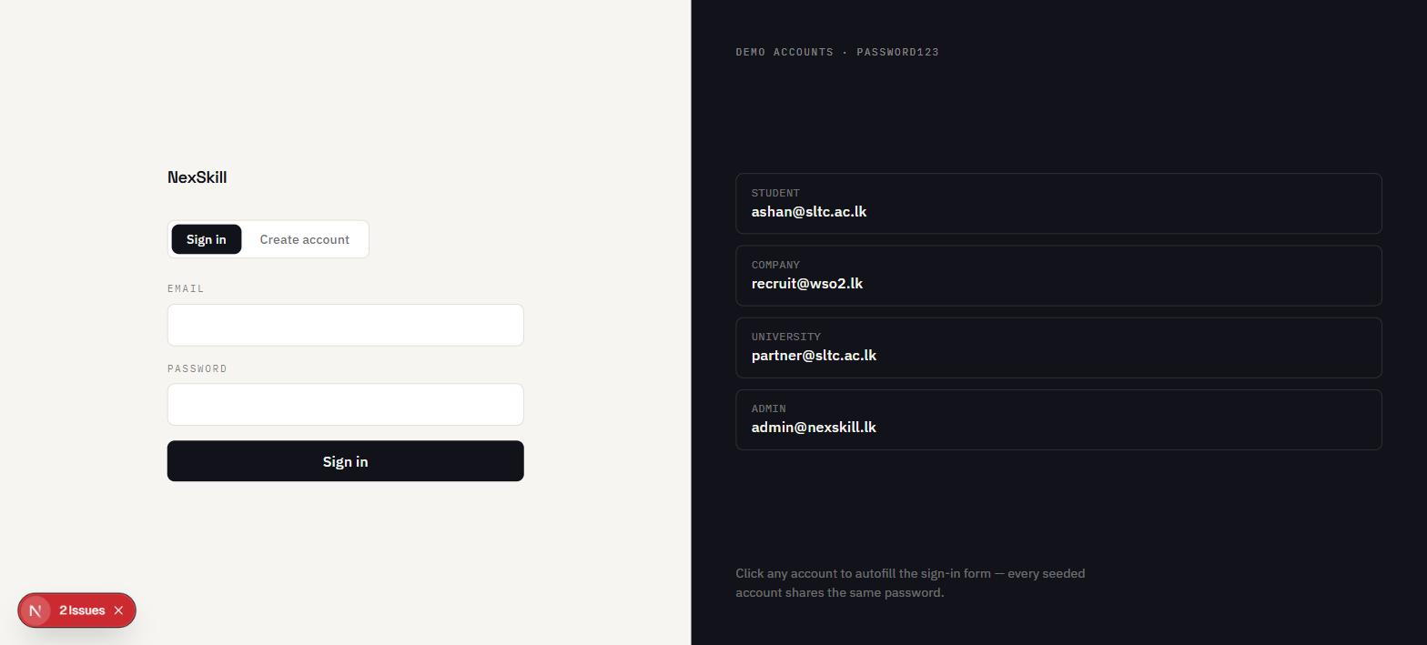
Figure 1.1 — Sign-in screen with one-click demo account autofill

2. Getting Started

2.1 Creating an Account
New users register from the same page used to sign in, by switching to the "Create account" tab. Registration asks for a role (Student, Company, or University — Admin accounts are not self-service and must be created directly in the system), a name, an email, a password of at least 6 characters, and one role-specific field:
- Student — the name of your university (free text, matched against the university partners on file).
- Company — your organisation’s name.
- University — the institution’s name.
Company and University accounts are not immediately active for posting internships or viewing analytics — they require an administrator to verify the account first (see Chapter 6, Verification Queue). Student accounts are active immediately after registration.

2.2 Signing In
Enter your email and password on the "Sign in" tab and submit. A successful sign-in redirects you to your role’s dashboard automatically — a student goes to /student/dashboard, a company to /company/dashboard, and so on. If your email or password is incorrect, an error message appears below the form and no redirect occurs.
If your account has been suspended by an administrator, sign-in is rejected with the message "This account has been suspended. Contact an administrator." — see §6.4 for the administrator-side suspension control.

2.3 Resetting a Forgotten Password
From the sign-in page, click "Forgot password?" next to the password field. Enter the email on your account and submit; if an account exists for that address, a password-reset email is sent via Supabase Auth. Follow the link in that email to reach the "Set a new password" screen, enter and confirm a new password, and submit. You are then redirected back to sign in with the new password.

2.4 Signing Out
Every role’s portal shows your name and a "Sign out" link at the bottom of the left-hand navigation sidebar. Clicking it ends your session and returns you to the sign-in page.

2.5 Notifications
A bell icon in the top-right corner of every portal opens a dropdown of in-app notifications — for example, a student is notified when an application is shortlisted or an offer is sent; a company is notified when a new application arrives; an admin is notified when a new company or university registers and needs verification. A red dot on the bell indicates unread notifications; clicking a notification marks it as read.

2.6 Using NexSkill on a Phone or Tablet
Below the tablet breakpoint, the left-hand navigation sidebar collapses behind a menu (☰) button in the header. Tapping it slides the sidebar in from the left with a dimmed backdrop; tapping the backdrop, a navigation link, or the close (✕) button dismisses it. All portal pages remain usable at phone width.

3. Student Portal

3.1 Overview
The Student Portal has six sections, listed in the left-hand navigation in the order you would typically use them: Dashboard, My Profile, Upload CV, Matched Internships, My Applications, and Offer Letters.

3.2 Dashboard
The dashboard is the landing page after sign-in. It shows your Internship Readiness Score — a single number out of 100 combining your top-3 match average (50% weight), GPA (30%), and profile completeness (20%) — alongside your top current matches, so you can see at a glance how ready you are to apply and where you currently stand (Figure 3.1).
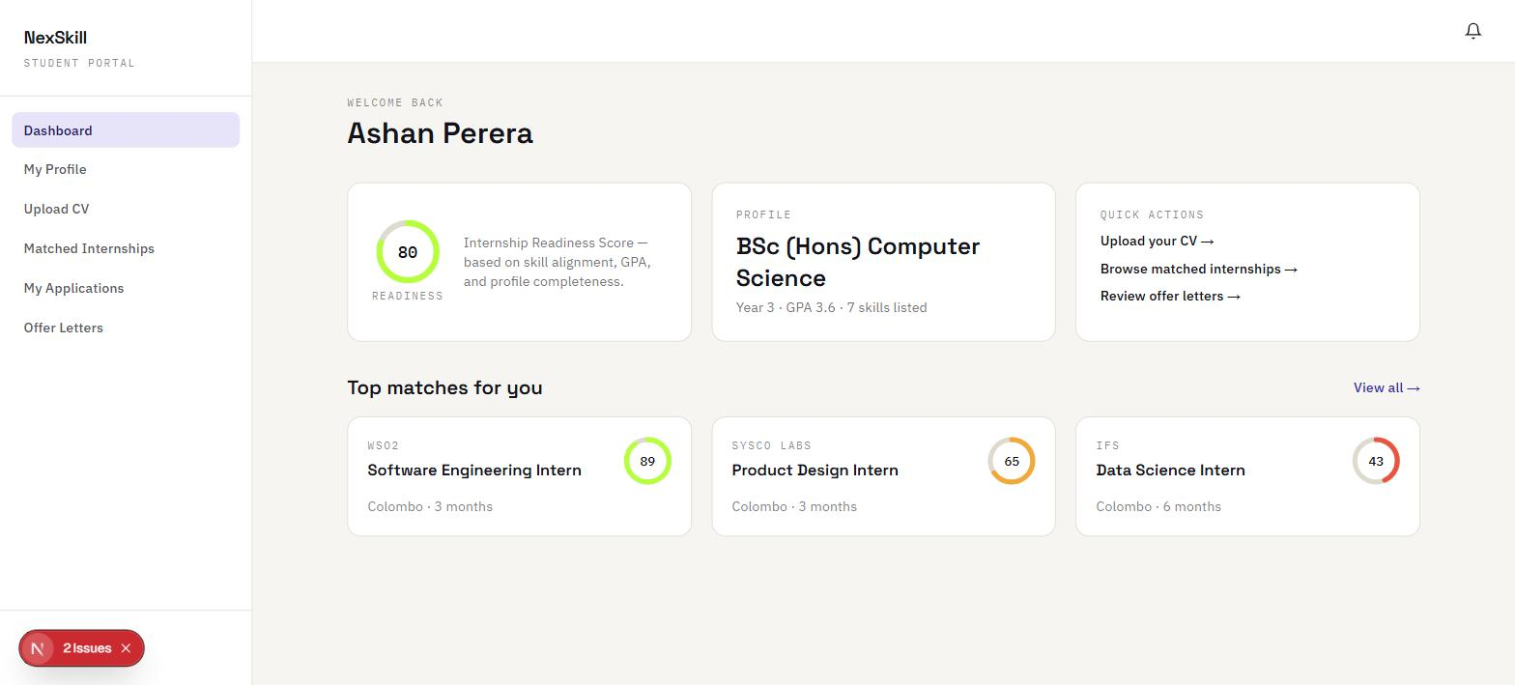
Figure 3.1 — Student dashboard showing Internship Readiness Score and top matches

3.3 My Profile
Before matching is meaningful, complete your profile: skills, GPA, year of study, preferred domain/location/stipend, and certifications. The matching engine reads this data directly — an incomplete profile produces lower, less accurate match scores, and also lowers the profile-completeness component of your readiness score.

3.4 Upload CV
Rather than typing every skill in by hand, you can upload a CV (or use the built-in "Use sample CV" button for a demonstration) and click "Extract skills." NexSkill scans the CV text against a dictionary of known technical skills and automatically adds every match it finds to your profile — a free-text, rule-based parser rather than a trained NLP model (see the Final Report, §9.3, for this design trade-off). Figure 3.2 shows a successful extraction of nine skills from a sample CV.
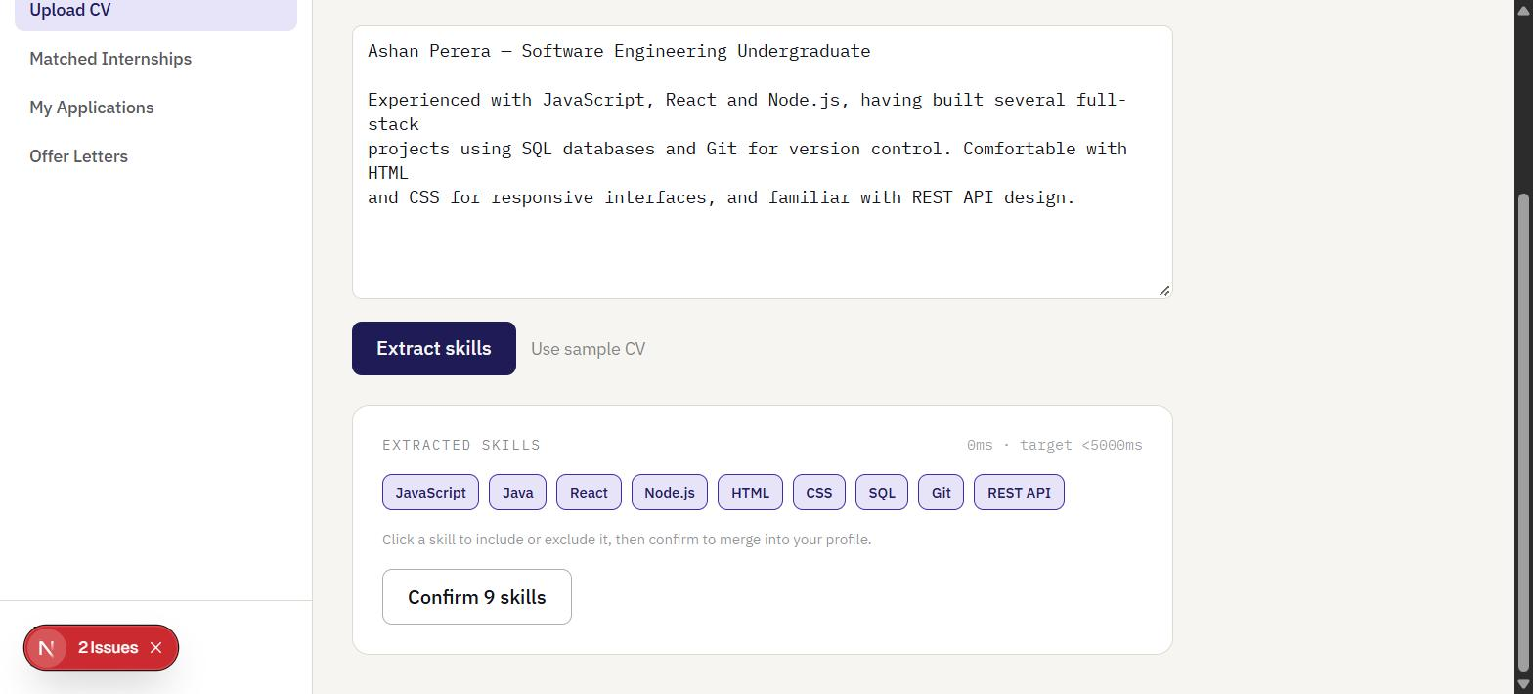
Figure 3.2 — CV upload and automatic skill extraction (9 skills found: JavaScript, Java, React, Node.js, HTML, CSS, SQL, Git, REST API)
Extracted skills are editable afterwards from My Profile — review them before relying on a match score, since the extractor can only recognise skills present in its dictionary.

3.5 Matched Internships
This page lists every published internship posting, ranked by match percentage, computed live against your current profile. Each card shows a match ring (the overall score), the posting’s title, company, location, duration, stipend, and deadline, and a breakdown of the five weighted factors behind the score — Skill Overlap (45%), GPA Alignment (20%), Preference Match (15%), Year of Study (10%), and Certification Bonus (10%) — so the ranking is never a black box (Figure 3.3).
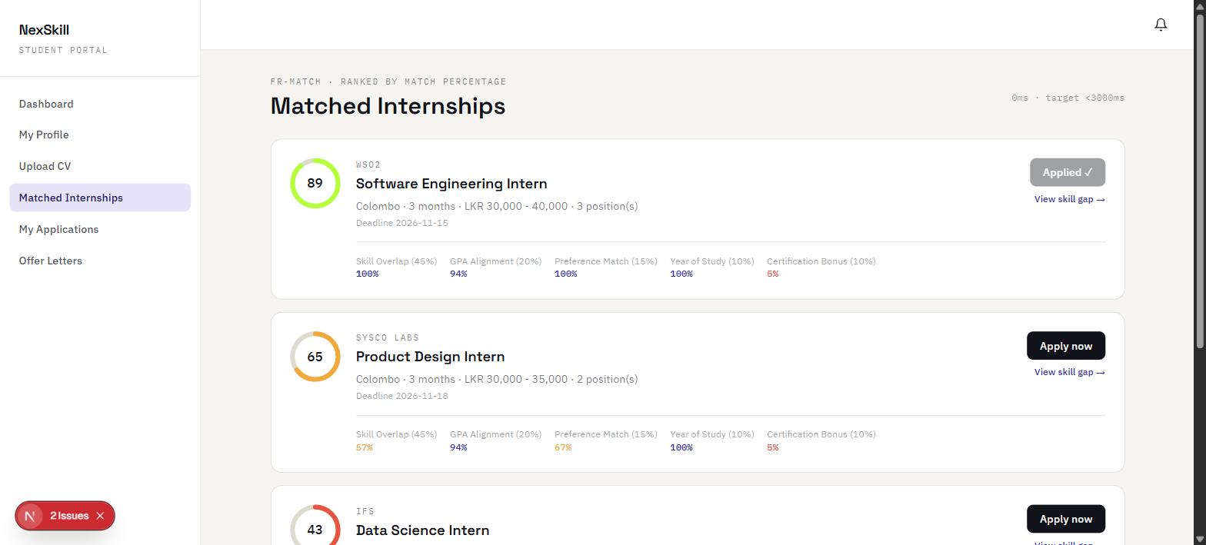
Figure 3.3 — Ranked matches with full 5-factor score breakdown
Click "Apply now" on any posting to submit an application immediately — there is no separate application form, since your profile already holds everything a recruiter needs to evaluate you. A posting you have already applied to shows "Applied ✓" in place of the button.

3.5.1 Skill Gap Analyser
Click "View skill gap →" under any posting to see exactly which required skills you are missing and a recommended course for each one — provider, estimated cost, and time commitment — so a low match score comes with a concrete next step rather than just a number (Figure 3.4).
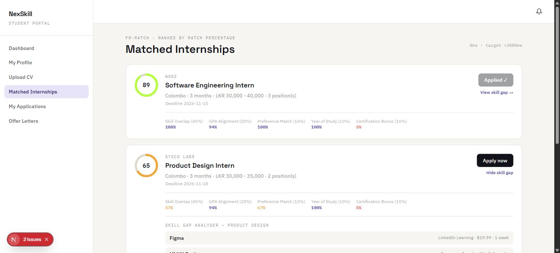
Figure 3.4 — Skill Gap Analyser recommending a course for a missing required skill

3.6 My Applications
This page tracks the status of every application you have submitted, moving through the pipeline Pending → Shortlisted/Rejected → Offered → Accepted/Declined as the recruiting company acts on it. Check back here (or watch the notification bell) to follow your application’s progress.

3.7 Offer Letters
When a company sends you a formal offer, it appears here with the internship title, company, and a status of Pending. Review the offer and click "Accept offer" or "Decline." Once accepted, a "Download PDF" link becomes available, generating a digital offer letter you can keep or submit to your university placement office (Figure 3.5).
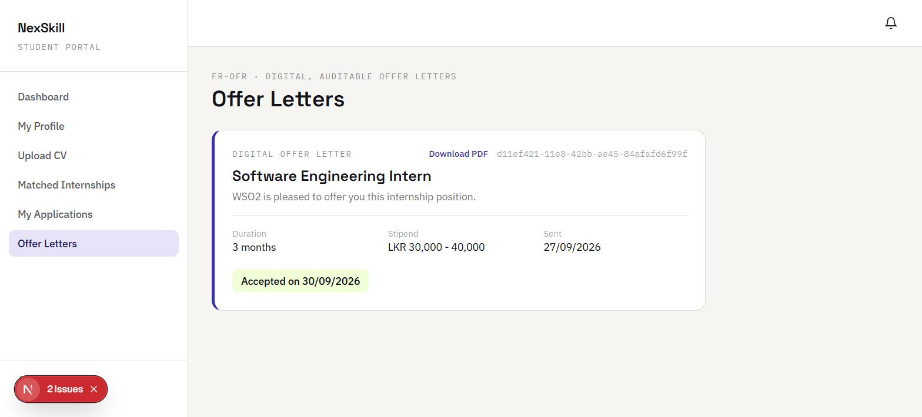
Figure 3.5 — Accepted offer with downloadable PDF offer letter

4. Company Portal

4.1 Overview
The Company Portal has three sections: Dashboard, Post Internship, and My Postings. A newly registered company account must be verified by an administrator (Chapter 6) before posting an internship or viewing analytics is possible.

4.2 Dashboard
The dashboard summarises your organisation’s activity on the platform — active postings, total applications received, and a quick view of recent candidate activity (Figure 4.1).
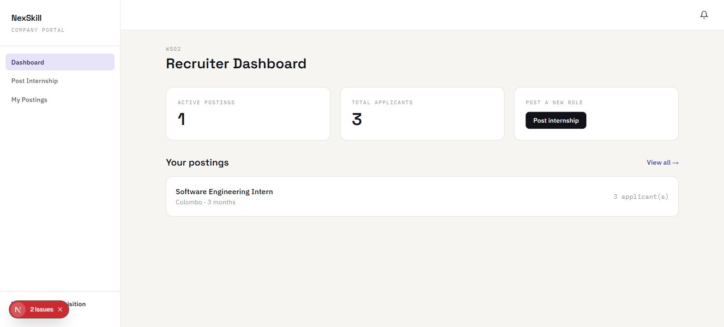
Figure 4.1 — Company recruiter dashboard

4.3 Posting an Internship
From "Post Internship," fill in the title, required skills (comma-separated — these drive the Skill Overlap factor for every student match), domain/category, minimum GPA, target year of study, duration, location, stipend range, and number of positions, then submit (Figure 4.2). The posting becomes visible to students immediately and is scored against every student profile the next time that student views Matched Internships.
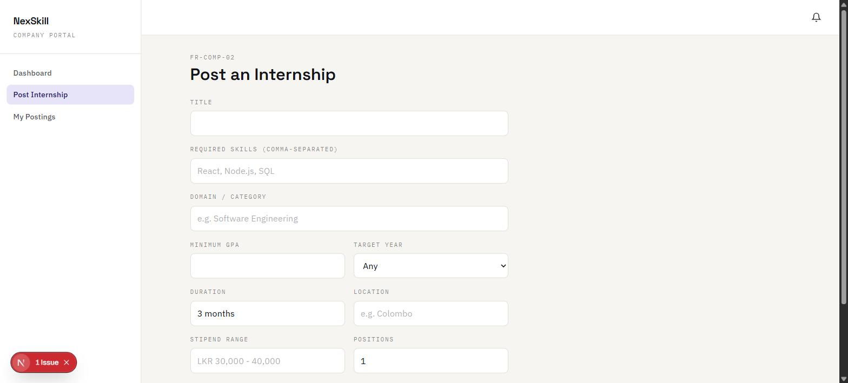
Figure 4.2 — Post an Internship form

4.4 Managing Postings and Candidates
"My Postings" lists every internship your organisation has posted. Opening a posting shows every candidate who has applied, ranked by match score with the same five-factor breakdown students see, letting you evaluate applicants on the platform’s own scoring rather than re-screening CVs by hand (Figure 4.3).
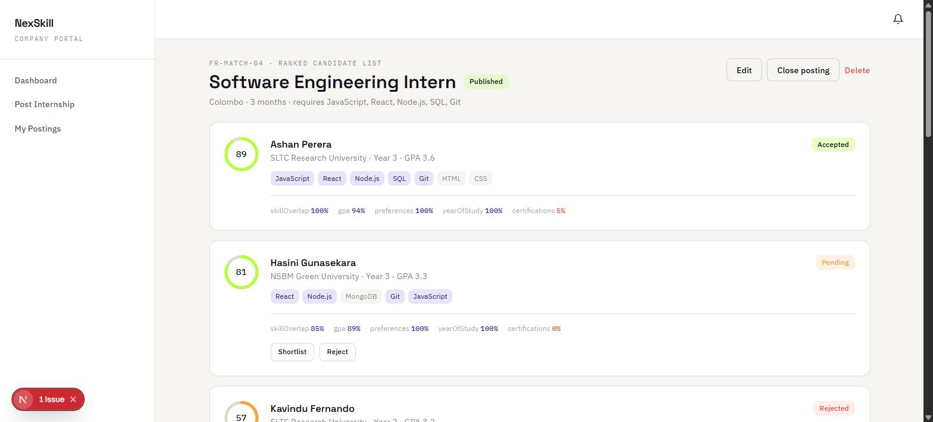
Figure 4.3 — Ranked candidate list with per-factor score breakdown and action buttons
Each candidate has action buttons that change with their application status:
- Pending — "Shortlist" moves the application forward, or "Reject" declines it.
- Shortlisted — "Send offer letter" generates and sends a digital offer to the student, or "Reject" declines it at this later stage.
Once an offer is sent, the student sees it in their own Offer Letters page (§3.7) and the application status updates to Offered, then to Accepted or Declined once the student responds.

5. University Portal

5.1 Overview
The University Portal has a single section, Placement Analytics, intended for a university’s career-services or placement office to monitor how its own enrolled students are performing on the platform.

5.2 Placement Analytics Dashboard
The dashboard shows enrolled-student counts, a placement rate, the most common skill gaps across your students (useful for deciding what workshops or courses to run), and the companies most frequently recruiting your students (Figure 5.1). Data is scoped automatically to students enrolled at your own university — a database-level Row-Level Security policy, not just a client-side filter, prevents one university from seeing another’s student data.
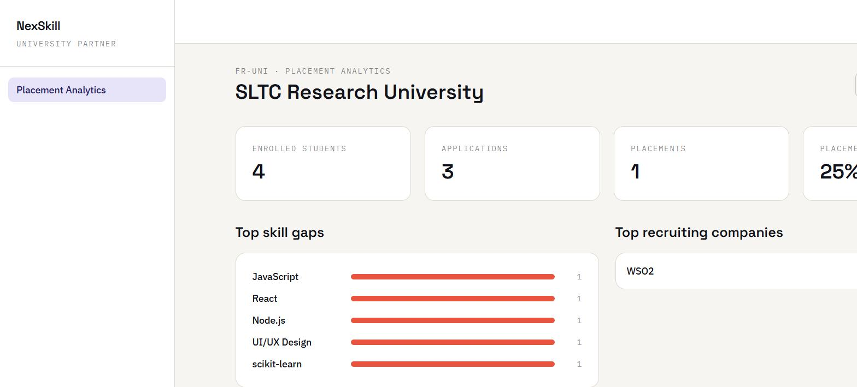
Figure 5.1 — University placement analytics dashboard

5.3 Downloading a Placement Report
Two export options are available from the dashboard: a CSV download for further analysis in a spreadsheet, and a "Download report (PDF)" button that generates a formatted, multi-section PDF — summary statistics, top skill gaps, top recruiting companies, and a paginated student list — suitable for sharing with university management or accreditation bodies directly from the browser.

6. Admin Portal

6.1 Overview
The Admin Portal has four sections: Platform Analytics, Verification Queue, Moderate Listings, and Users. Admin accounts are not self-service (§2.1) and must be provisioned directly.

6.2 Platform Analytics
The dashboard gives a platform-wide view: total students, how many companies are verified versus pending, accounts awaiting verification, and the most in-demand skills across all current postings (Figure 6.1).
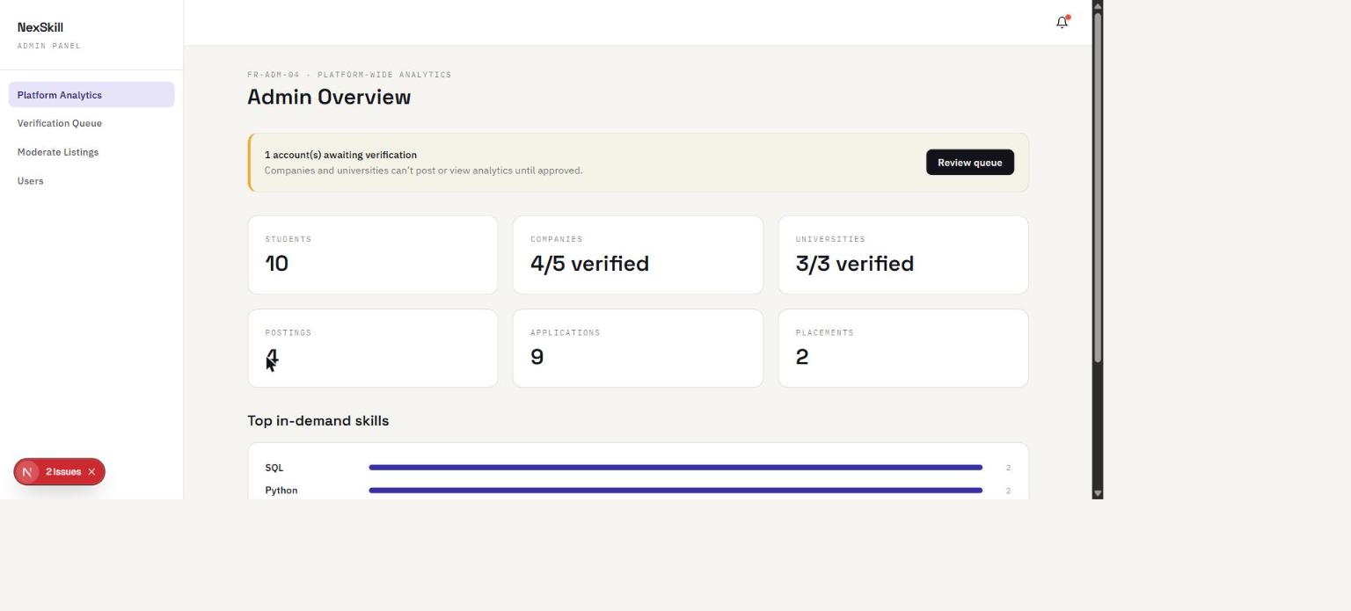
Figure 6.1 — Admin platform analytics dashboard

6.3 Verification Queue
New Company and University registrations appear here, each with "Approve" and "Reject" actions (Figure 6.2). Approving a company or university immediately unlocks the features that require verification — posting internships for a company, or viewing placement analytics for a university. Until approved, the account can sign in but those features remain locked.
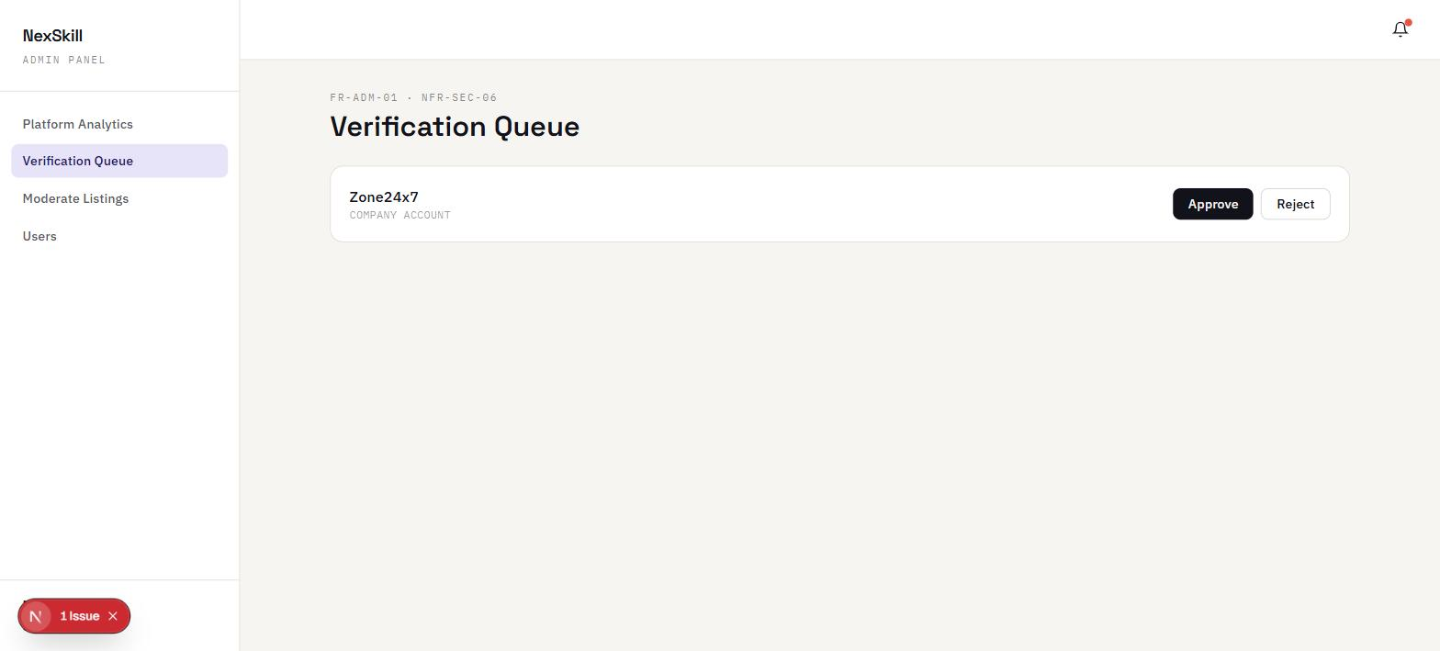
Figure 6.2 — Verification Queue with a pending company account

6.4 Moderate Listings and Users
"Moderate Listings" lets an administrator flag an internship posting as inappropriate or policy-violating — a flagged posting is hidden from students’ Matched Internships view while remaining visible to the admin for review, and can be unflagged to restore it — or remove it outright. "Users" lets an administrator suspend an account (the user is immediately signed out and blocked from signing back in, with the message described in §2.2) or restore it by unsuspending; an admin cannot suspend their own account or another admin’s account, as a safeguard against accidental lockout.

7. Troubleshooting & FAQ

7.1 I signed up as a company/university but cannot post or view analytics.
This is expected. Company and University accounts require administrator verification before these features unlock (§2.1, §6.3). Contact your platform administrator, or — on the demo dataset — sign in as admin@nexskill.lk and approve the account from the Verification Queue.

7.2 My match scores seem too low.
Match scores are only as good as your profile. Make sure your skills list is complete (use CV upload and extraction as a starting point, §3.4), and that your GPA, year of study, and preferences are filled in — all five factors feed the score, not skills alone. Use the Skill Gap Analyser (§3.5.1) on a specific posting to see exactly what is missing.

7.3 I cannot sign in even though my password is correct.
Your account may have been suspended by an administrator (§2.2, §6.4). The error message will say so explicitly; contact an administrator to have the account restored.

7.4 I forgot my password.
Use "Forgot password?" on the sign-in page (§2.3). If you do not receive the reset email, check that you registered with that exact address, and check your spam folder.

7.5 A browser extension shows a warning in the console about mismatched attributes.
This is a known, harmless artefact of certain browser extensions (such as ad- or privacy-blockers) injecting attributes into the page after the server renders it, which React flags as a hydration mismatch in the developer console. It does not indicate an application defect and is not visible to end users; it only appears in the browser’s developer console during local development.

