AutoProspect AI
Complete Development and Solution Documentation
Blueprint + Functional Specification + Technical Specification + Testing and QA Guide
Agentic Sales Intelligence Platform for Automotive Analytics Consulting
Prepared for: INTTRVU AI Innovation Hackathon 2026
Solution Owner: Nishikant Phapale
Date: 04 July 2026
Version: Production Ready

Document Control
Item | Details
Document Name | AutoProspect AI - Complete Development and Solution Documentation
Version | Production Ready
Primary Artifact | AutoProspect_AI_Hackathon.ipynb
Supporting Folder | docs/ and outputs/
Environment | Google Colab
LLM | OpenAI GPT-4o mini via Colab Secrets
Agent Count | 14 agents including live web research, evidence enrichment, critic validation, and LLM narrative enhancement
Status | Ready for final GitHub packaging after local freeze

Table of Contents
- Executive Summary
- Hackathon Requirement Interpretation
- Final Solution Outcome
- Business and Functional Specification
- Data Source Strategy and Live Web Research
- Agentic AI Design
- Technical Specification
- LLM Prompting and Runtime Proof
- Scoring Engine and Recommendation Logic
- Output Files and Business Interpretation
- Testing, QA, and Validation Evidence
- Demo and Reviewer Walkthrough
- How XYZ Research Analysts Can Use the Outputs
- Assumptions, Limitations, and Risks
- Future Enhancements and Productization Roadmap
- Appendices

1. Executive Summary
AutoProspect AI is a Google Colab-based Agentic AI Sales Intelligence Platform created for the INTTRVU AI Innovation Hackathon 2026. It helps XYZ Analytics Consulting identify, research, prioritize, and recommend Indian automotive companies that are strong prospects for analytics consulting offerings.
The solution combines structured product knowledge, a controlled automotive company universe, public data source mapping, controlled live web research, evidence enrichment, explainable opportunity scoring, critic validation, and GPT-4o mini powered business narrative enhancement.
Final Outcome
The final notebook analyzes 27 Indian automotive companies, enriches them using official websites and Google News RSS, generates evidence summaries, ranks companies, produces Top 15 target recommendations, creates business recommendation cards, calls GPT-4o mini for narrative enhancement, and exports a full set of final deliverables in the outputs/ folder.

Capability | Delivered Outcome
Company Research | 27 Indian automotive companies modeled and enriched
Live Web Research | 54 live evidence rows across 27 companies; 24 official website successes and 27 Google News RSS successes in final verification
Agentic AI | 14-agent workflow with explicit trace and shared state
LLM Usage | 15 GPT-4o mini calls for Top 15 narratives with request IDs and token proof
Business Output | Top 15 target companies, recommendation cards, sales pitch, discovery questions, and executive report
Review Evidence | Final QA files, runtime proof files, output artifacts, and architecture diagram

1.1 Why This Is Not Just a Static Notebook
The solution does not simply print a prewritten list of companies. It uses a seed company universe for reproducibility, then enriches that universe using live web evidence, calculates deterministic scoring, applies a validation layer, and calls GPT-4o mini to create fresh narrative outputs during each final run.
- Live web research fetches official company websites and Google News RSS results.
- Evidence enrichment summarizes fetched signals into company-level evidence summaries.
- GPT-4o mini runtime proof records request IDs, token usage, timestamp, and runtime session ID.
- Final QA verifies that all expected output artifacts are generated.

2. Hackathon Requirement Interpretation
The hackathon asks participants to build an AI-powered sales intelligence agent for XYZ Analytics Consulting. The expected solution must work in Google Colab, use product knowledge from the provided handbook, research Indian automotive companies, recommend Top 10-15 targets, provide business justification, and include architecture and source code.
Hackathon Expectation | How AutoProspect AI Delivers It
Google Colab final notebook | The final notebook is designed to run end-to-end in Google Colab using Runtime -> Restart session and run all.
AI-powered Sales Intelligence Agent | The solution performs research, pain detection, solution fit mapping, scoring, critic validation, recommendations, and narrative generation.
Agent framework flexibility | A custom lightweight Python agent orchestration pattern is used for reliability and transparency in Colab.
LLM usage | OpenAI GPT-4o mini is used through Colab Secrets, never hardcoded.
Data sources | Public source register includes company websites, LinkedIn, NSE/BSE, Moneycontrol, Screener, IBEF, SIAM, ACMA, ET Auto, Autocar Professional, Google News, and the handbook. Live fetch is implemented for official websites and Google News RSS.
Top 10-15 recommendations | Top 15 target companies are generated and exported.
Business recommendations | Recommendation cards include why selected, solution fit, expected value, KPIs, stakeholders, sales starter, and next action.
Architecture diagram | A generated PNG architecture diagram is exported and included in outputs.
Documentation and setup | README, docs, and this Word document explain setup, design, testing, and output usage.

2.1 Final Compliance Positioning
The strongest way to present the solution to judges is:
Positioning Statement
AutoProspect AI is a Colab-based, reproducible, agentic sales intelligence system that uses structured product knowledge, public source mapping, controlled live web research, explainable scoring, critic validation, and GPT-4o mini narrative enhancement to recommend the Top 15 Indian automotive prospects for XYZ Analytics Consulting.

3. Final Solution Outcome
The final product is a single Google Colab notebook supported by documentation and generated output artifacts. The reviewer can run the notebook, inspect the output folder, and review the final business artifacts.
Final Artifact | Purpose
AutoProspect_AI_Hackathon.ipynb | Main executable Colab notebook and product demonstration.
docs/ | Design, setup, architecture, scoring, recommendation, live research, and QA documentation.
outputs/ | Generated evidence, reports, recommendation files, architecture diagram, runtime proof, and QA artifacts.
README.md | GitHub landing page explaining how to run and review the solution.

3.1 End-to-End Workflow
Product Handbook
↓
Company Universe
↓
Public Source Register
↓
Live Web Research Agent
↓
Evidence Enrichment Agent
↓
Market Intelligence Agent
↓
Company Research Agent
↓
Pain Signal Detection Agent
↓
Solution Fit Agent
↓
Opportunity Scoring Agent
↓
Critic / Validation Agent
↓
Business Recommendation Card Agent
↓
GPT-4o mini Narrative Enhancement Agent
↓
Executive Report + Outputs

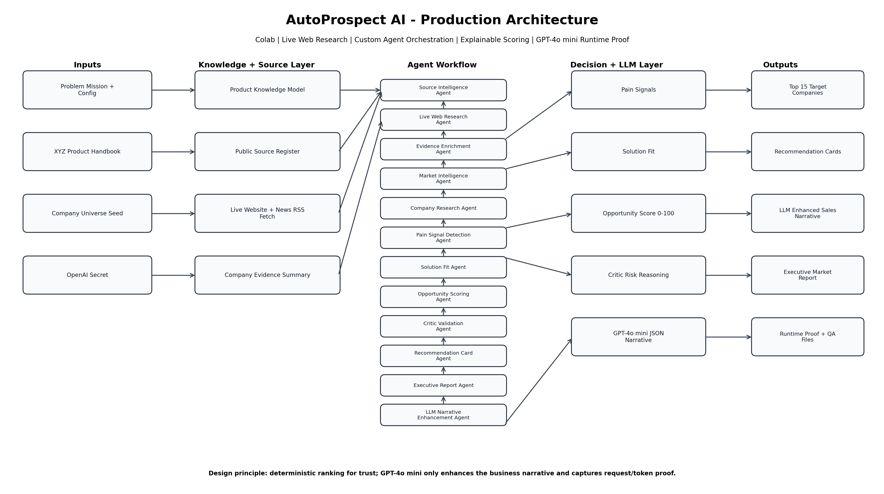
Figure 1: Production architecture for AutoProspect AI

4. Business and Functional Specification

4.1 Business Users and Personas
Persona | Need | How the Solution Helps
XYZ Research Analyst | Needs validated market and company intelligence. | Receives structured company evidence, source mapping, live web summaries, and report-ready outputs.
Sales Lead | Needs prioritized target accounts. | Receives Top 15 companies, opportunity score, priority bucket, and sales action guidance.
Pre-sales Consultant | Needs pitch and discovery material. | Receives business recommendation cards, stakeholder suggestions, discovery questions, and LLM-enhanced narratives.
Hackathon Reviewer | Needs to verify AI/agentic capability. | Can inspect agent trace, live evidence files, LLM runtime proof, and generated reports.
Developer / Maintainer | Needs reproducible run and code clarity. | Notebook is organized into sections, uses config, safe secrets, and output validation.

4.2 Functional Use Cases
Use Case | Description | Output
UC1: Load product knowledge | Structure XYZ offerings into machine-readable capability model. | product_knowledge.json
UC2: Create company universe | Prepare candidate list of Indian automotive companies. | company_universe.csv/json
UC3: Register sources | Map recommended public sources to research functions. | public_source_register.csv
UC4: Run live web research | Fetch official websites and Google News RSS. | live_web_research_evidence.csv
UC5: Enrich evidence | Summarize evidence by company. | company_live_evidence_summary.csv
UC6: Detect pain signals | Map company signals to likely business pain areas. | pain_signal_output.csv
UC7: Map solution fit | Recommend primary and secondary XYZ offerings. | solution_fit_output.csv
UC8: Score opportunities | Rank companies with deterministic scoring. | top15_target_companies.csv
UC9: Validate recommendations | Add critic reasoning and why-not risk. | critic_validation_output.csv
UC10: Generate recommendation cards | Produce sales-ready business cards. | top15_recommendation_cards.html/csv
UC11: Enhance with GPT-4o mini | Generate pitch, outreach angle, discovery questions, and caution note. | top15_llm_enhanced_recommendations.csv/json
UC12: Verify final package | Validate all output files and runtime proof. | final_quality_summary.json and final_deliverable_checklist.csv

4.3 Notebook Wireframe
The notebook itself acts as the user interface because the hackathon requires the final solution to run in Google Colab. The notebook is structured as a sequence of business-readable sections rather than only code blocks.
Notebook Section | What the Reviewer Sees
Title and Solution Approach | Problem statement, design intent, and high-level architecture.
Product Knowledge Design | Structured XYZ offering catalog.
Candidate Company Universe | 27 companies across OEMs, EV OEMs, Tier-1 suppliers, and component manufacturers.
Source Register and Live Web Research | Public source register, live fetch helper functions, live evidence, evidence summary.
Agent Workflow Foundation | Agent state, trace logging, and initial agents.
Opportunity Scoring Engine | Deterministic scoring and ranked pipeline.
Recommendation Cards | Business-ready prospect cards.
Executive Report and Architecture | Generated report and diagram.
GPT-4o mini Runtime Proof | Fresh LLM calls, request IDs, token usage, and LLM outputs.
Final QA | File validation, deliverable checklist, and final runtime verification.

5. Data Source Strategy and Live Web Research
The solution uses a hybrid data approach: a controlled seed dataset for reproducibility plus live web research for evidence enrichment. This is more reliable than uncontrolled scraping and more credible than a completely static notebook.

5.1 Source Categories
Source Category | Usage in Solution | Implementation Mode
Official company websites | Company overview, products, footprint, service/electric/manufacturing signals. | Live fetch and parse where accessible.
Google News RSS | Recent news headlines and trigger signals for each company. | Live RSS fetch.
LinkedIn company pages | Company profile and hiring signals. | Mapped as validation source; not scraped due login and automation restrictions.
NSE/BSE | Financial validation for listed companies. | Mapped as validation source; not aggressively scraped.
Moneycontrol / Screener | Financial profile, fundamentals, and ratios. | Mapped as validation source.
IBEF / SIAM / ACMA | Industry context for automotive and component ecosystem. | Mapped as industry research sources.
Economic Times Auto / Autocar Professional | Automotive business news. | Mapped as business news sources.
XYZ Product & Solutions Handbook | Warranty, Supply Chain, and Dealer Intelligence offering knowledge. | Structured as product_knowledge dictionary and exported JSON.

5.2 Live Web Research Design
The Live Web Research Agent performs controlled web access. It does not overload websites, does not require login, and does not fail the notebook if some pages block requests. It uses timeout, error handling, status capture, and source-level reporting.
- Fetch official company website URL from the company universe.
- Fetch Google News RSS results using the company name as a search query.
- Extract title, meta description, headings, and evidence snippets.
- Detect business keywords such as electric, EV, dealer, service, warranty, customer, supply chain, battery, manufacturing, expansion, and commercial vehicle.
- Capture fetch status, HTTP status, source name, source URL, source type, and error if any.
- Continue processing even when individual websites fail.

5.3 Final Live Research Outcome
Metric | Final Verification Result
Live evidence rows | 54
Unique companies covered by live evidence | 27
Google News RSS fetches | 27 successful rows
Official company website fetches | 24 successful rows, 3 failed rows
Evidence summary rows | 27
Conclusion | Live research and evidence enrichment were successfully executed for all 27 companies.

Why Three Website Failures Are Acceptable
In real-world web research, some websites can block automated requests, use dynamic rendering, have SSL/time-out issues, or apply bot protection. The solution is robust because it records these failures and still completes the workflow using available evidence.

6. Agentic AI Design
AutoProspect AI is agentic because it breaks the sales intelligence process into specialized decision-making units. Each agent has a role, input, processing logic, output, and trace entry. The workflow is not a single prompt asking an LLM for a result.
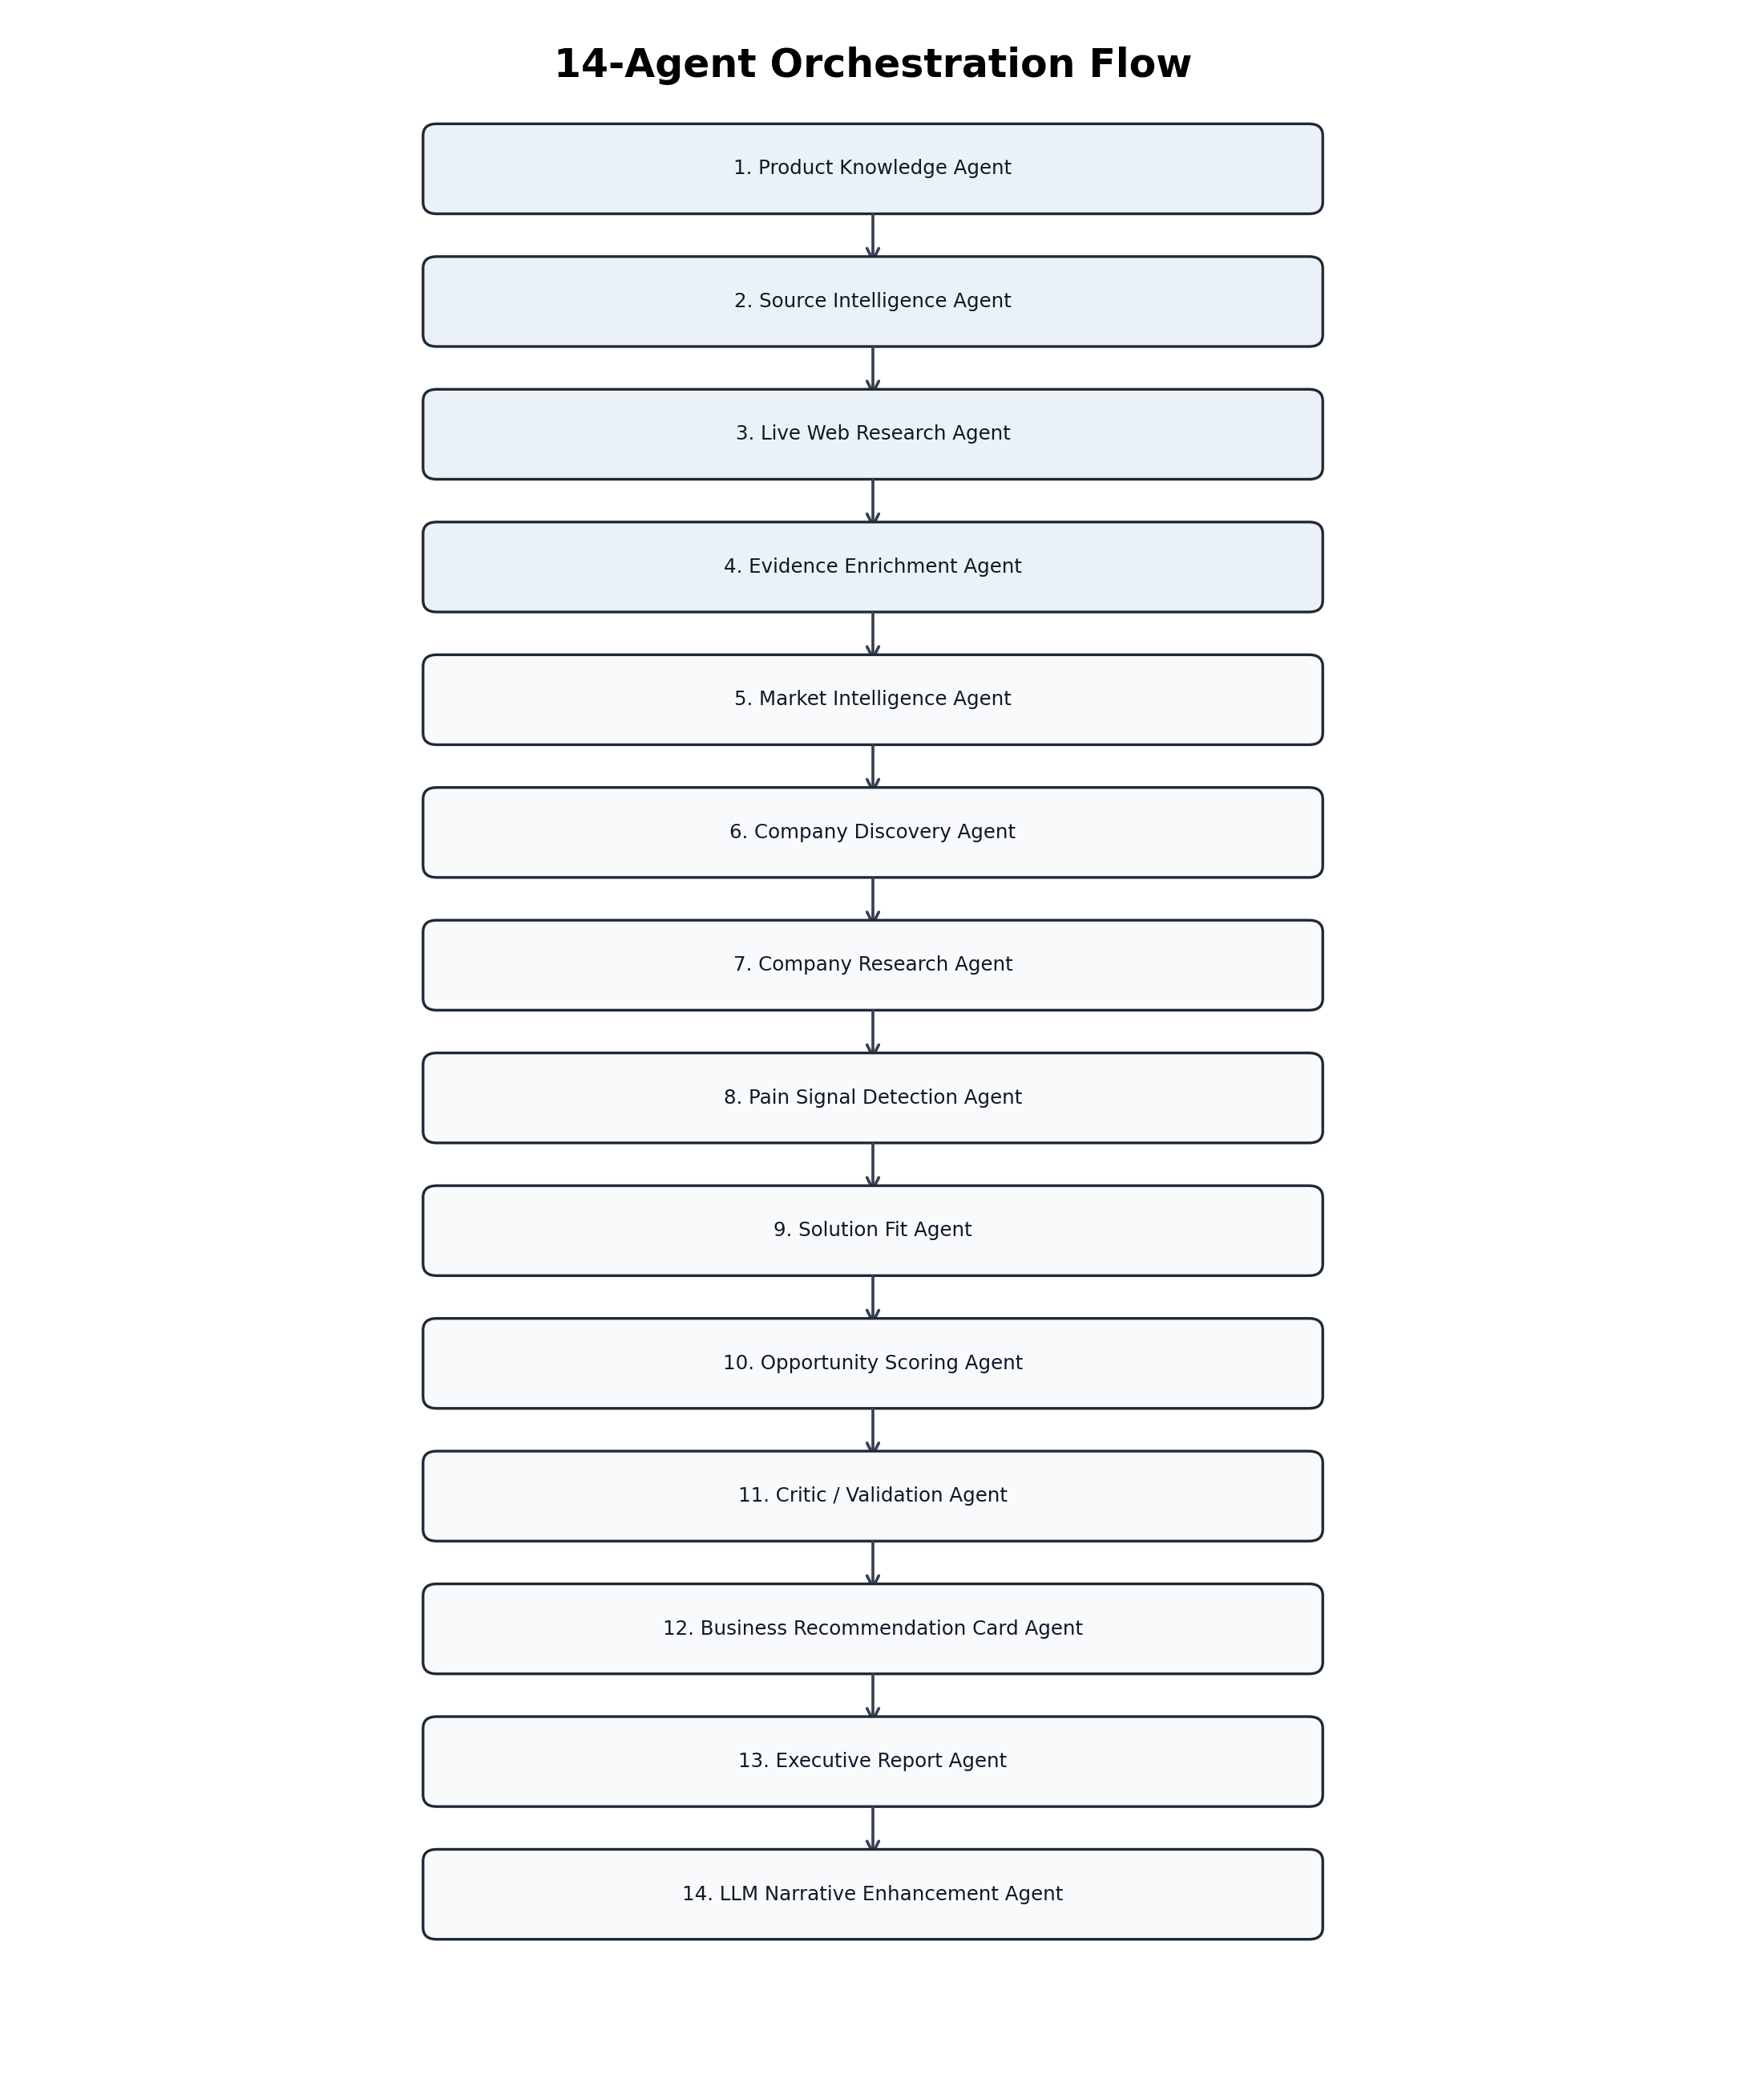
Figure 2: 14-agent workflow sequence
Agent | Purpose | Key Output
Product Knowledge Agent | Structures XYZ offerings from the handbook. | Product knowledge model
Source Intelligence Agent | Creates public source register and source usage model. | public_source_register_df
Live Web Research Agent | Fetches official websites and Google News RSS. | live_web_research_evidence_df
Evidence Enrichment Agent | Summarizes live evidence by company. | company_live_evidence_summary_df
Market Intelligence Agent | Captures automotive industry pressures. | Market intelligence summary
Company Discovery Agent | Loads and validates candidate company universe. | company_universe_df
Company Research Agent | Builds structured company profiles. | Company research table
Pain Signal Detection Agent | Detects warranty, supply chain, dealer, EV, and aftermarket pain signals. | pain_signal_df
Solution Fit Agent | Maps company pain signals to XYZ offerings. | solution_fit_df
Opportunity Scoring Agent | Scores and ranks companies. | opportunity_pipeline_df
Critic / Validation Agent | Adds why-not risk and confidence validation. | critic_validation_output.csv
Business Recommendation Card Agent | Creates sales-ready recommendation cards. | recommendation_cards_df
Executive Report Agent | Creates market research report and architecture summary. | executive_market_research_report.md
LLM Narrative Enhancement Agent | Uses GPT-4o mini to enhance pitch, justification, outreach, and discovery questions. | top15_llm_enhanced_recommendations.csv

6.1 Shared State and Trace Logging
Agents communicate through a shared Python dictionary called agent_state. This keeps the flow transparent and auditable. Every agent adds a trace entry with agent name, action, input summary, and output summary.
agent_state = {
"config": CONFIG,
"product_knowledge": product_knowledge,
"company_universe_df": company_universe_df,
"public_source_register_df": public_source_register_df,
"live_web_research_evidence_df": live_web_research_evidence_df,
"company_live_evidence_summary_df": company_live_evidence_summary_df,
"recommendation_cards_df": recommendation_cards_df,
"llm_enhanced_recommendations_df": llm_enhanced_recommendations_df,
"agent_trace": []
}

7. Technical Specification

7.1 Technology Stack
Component | Technology / Design
Execution Environment | Google Colab
Language | Python
Data processing | pandas, numpy, json
Visualization | matplotlib
Web research | requests, BeautifulSoup, RSS parsing
LLM | OpenAI GPT-4o mini through OpenAI Python SDK
Secret handling | Google Colab Secrets via OPENAI_API_KEY
Output formats | CSV, JSON, HTML, Markdown, PNG
Orchestration | Custom lightweight multi-agent workflow in Python

7.2 Configuration Design
The notebook uses a central CONFIG dictionary to control project identity, run mode, output folder, LLM settings, and live research limits. This makes the notebook easier to modify without changing individual functions.
CONFIG = {
"project_name": "AutoProspect AI",
"hackathon": "INTTRVU AI Innovation Hackathon 2026",
"client_company": "XYZ Analytics Consulting",
"industry_focus": "Indian Automotive Industry",
"target_company_count": 15,
"run_mode": "DEMO",
"use_llm": True,
"llm_provider": "OpenAI",
"model_name": "gpt-4o-mini",
"output_dir": "outputs",
"live_research_company_limit": 27
}

7.3 Error Handling and Reliability
- LLM key is checked safely. If missing, fallback output is generated; final submission should run with GPT-4o mini enabled.
- Web fetch failures do not stop the notebook; failures are captured in web_scraping_status_report.csv.
- All final artifacts are validated using file existence and file-size checks.
- Final runtime verification validates live evidence, LLM calls, token proof, agent trace, and final output files.
- The notebook can be restarted and run end-to-end, which is the strongest reproducibility test.

7.4 Security and Secret Handling
The OpenAI API key is never hardcoded. It is read from Google Colab Secrets using the secret name OPENAI_API_KEY. This protects the user and ensures the GitHub repository does not leak credentials.
from google.colab import userdata
OPENAI_API_KEY = userdata.get("OPENAI_API_KEY")
openai_client = OpenAI(api_key=OPENAI_API_KEY)

8. LLM Prompting and Runtime Proof

8.1 LLM Role in the Architecture
GPT-4o mini is used only for narrative enhancement. It does not decide the ranking. This separation is important for enterprise trust. The deterministic engine decides scores, while the LLM improves communication quality.
Task | Handled By
Company ranking | Deterministic scoring engine
Solution fit mapping | Rule-based agent logic using product knowledge and pain signals
Risk validation | Critic / Validation Agent
Executive pitch | GPT-4o mini
Outreach angle | GPT-4o mini
Discovery questions | GPT-4o mini
Runtime proof | LLM call log capturing request ID and token usage

8.2 Production Prompt Pattern
For each Top 15 company, the notebook creates a structured prompt payload. The prompt instructs the model to use only the provided context, avoid invented facts, and return valid JSON. This reduces hallucination risk and makes the output machine-readable.
System instruction:
You are a precise enterprise sales-intelligence assistant. Use only provided context. Do not hallucinate. Return valid JSON only.
User prompt pattern:
You are a senior B2B pre-sales strategist for an automotive analytics consulting company.
Use ONLY the provided context. Do not invent facts, financial numbers, customers, or news.
If something needs validation, mention it as a validation point.
Return ONLY valid JSON with these keys:
- executive_pitch
- enhanced_business_justification
- personalized_outreach_angle
- discovery_questions
- data_sources_to_validate
- caution_note
Context:
{company profile, scoring result, solution fit, business challenges, critic risk, source mapping, live evidence summary}

8.3 Runtime Proof
To prove that GPT-4o mini is actually being called during a fresh run, the notebook creates LLM runtime proof files. These files are more reliable than only checking spend on the OpenAI dashboard because dashboards may refresh slowly or use UTC filtering.
Runtime Proof Field | Meaning
runtime_session_id | Unique ID for each Run All session.
generated_at_utc | Timestamp when the call was made.
company_name | Company for which GPT-4o mini generated the narrative.
request_id | OpenAI API request identifier.
model | Model returned by OpenAI response.
prompt_tokens | Input tokens consumed.
completion_tokens | Output tokens generated.
total_tokens | Total token usage for the call.
status | Completed or fallback.

Final LLM Verification Rule
After Runtime -> Restart session and run all, the GPT-4o mini Runtime Proof section should show 15 completed calls, 15 request IDs, token totals greater than zero, and PASS status.

9. Scoring Engine and Recommendation Logic
The opportunity scoring engine is deterministic. This allows the ranking to be explained, reproduced, and challenged by a reviewer. The LLM does not alter the rank.
Dimension | Weight | Meaning
Pain Intensity | 25 | Strength of detected pain signals such as warranty, supply chain, dealer/service, EV, or aftermarket complexity.
Product Fit | 25 | How well XYZ offerings match the detected company challenges.
Market Relevance | 15 | Relevance of company segment to XYZ analytics offerings.
Growth / Investment Signal | 15 | Indicators such as EV expansion, production growth, capacity expansion, or investment.
Financial Capacity Proxy | 10 | Likely ability to sponsor consulting work based on scale and market presence.
Urgency / News Signal Proxy | 5 | Recent news, trigger events, or active business movement.
Data Readiness Likelihood | 5 | Likelihood that the company has usable operational data for analytics projects.

Score Range | Priority | Interpretation
80-100 | Hot | Strong target for immediate outreach.
70-79 | Warm | Good target; prepare discovery and validate triggers.
55-69 | Nurture | Keep in pipeline; requires more validation or timing.
Below 55 | Low Priority | Not a near-term priority.

9.1 Recommendation Card Logic
After scoring, each selected company is transformed into a recommendation card. The card is intentionally business-facing and can be used by sales or pre-sales teams.
- Rank, company name, segment, score, priority, and confidence
- Primary and secondary solution recommendation
- Why selected and expected business value
- Relevant KPIs and stakeholders
- Sales conversation starter and next action
- Critic or why-not risk to avoid overclaiming

10. Output Files and Business Interpretation
The outputs/ folder is the evidence and deliverables folder. It is significant because hackathon reviewers and XYZ analysts can inspect results without reading every code cell. It also proves the notebook was executed successfully.
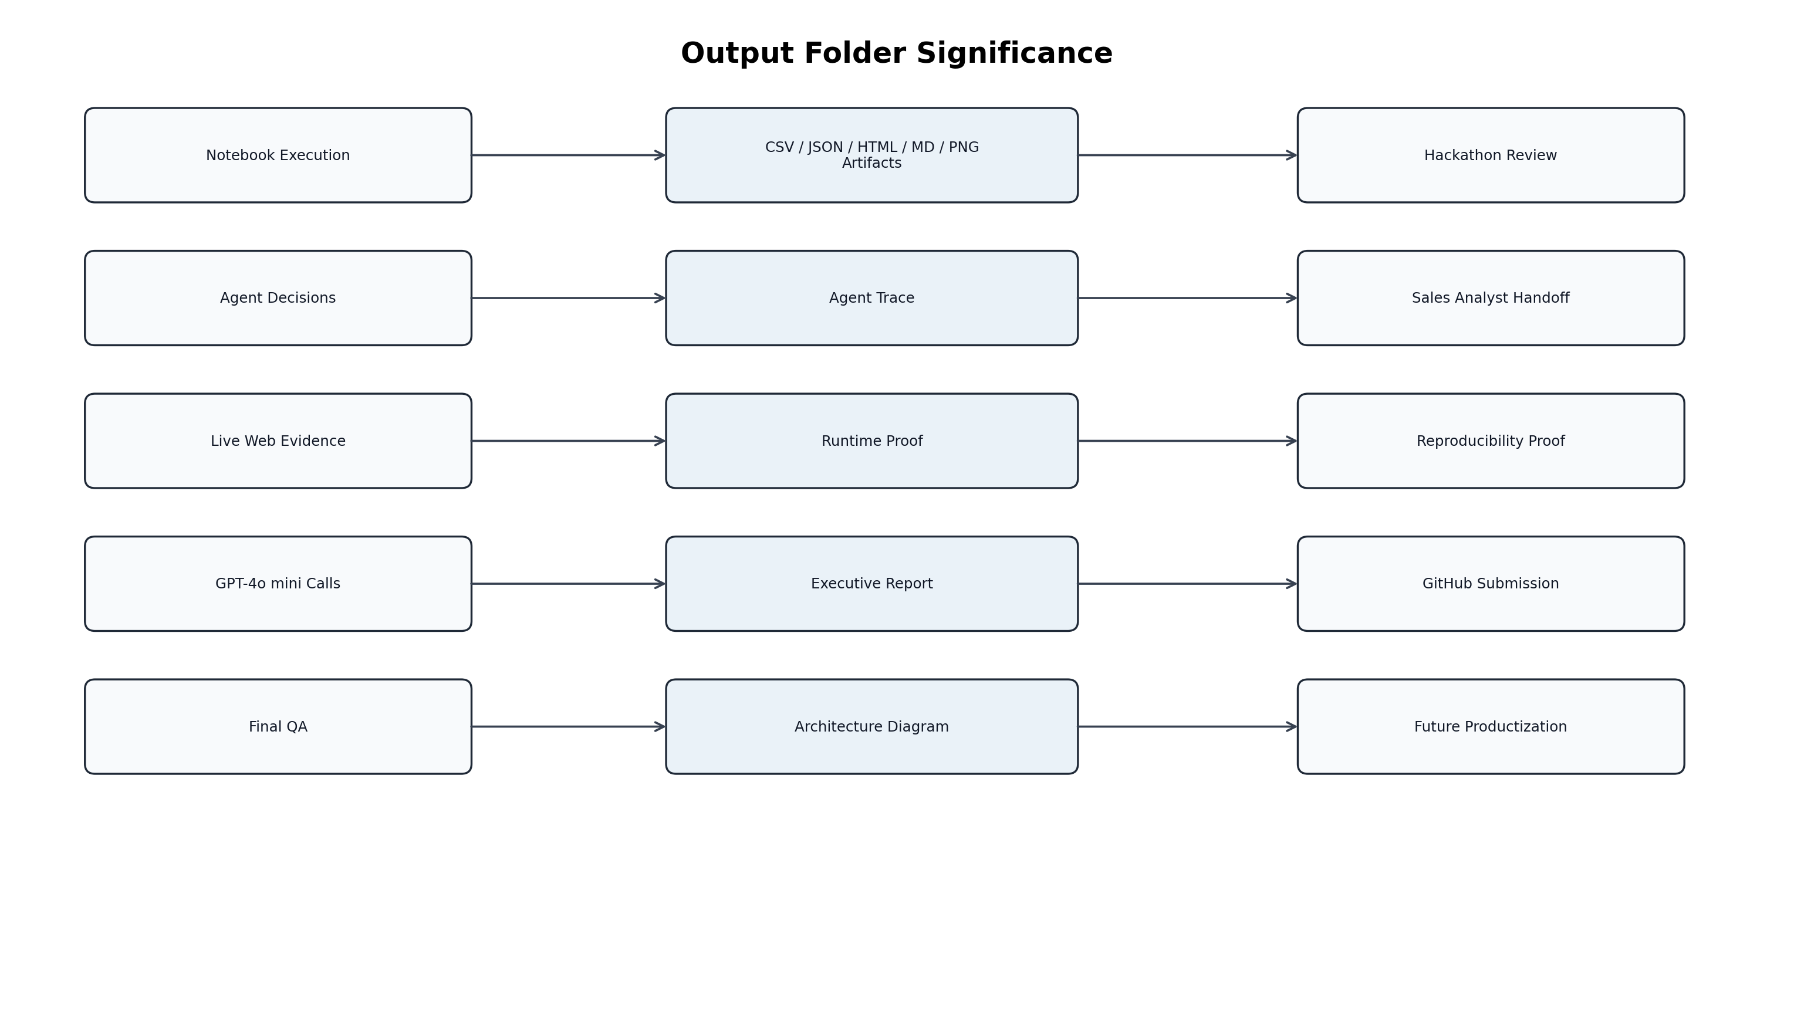
Figure 3: How output artifacts support review and business usage
Output File | Business / Technical Significance | How XYZ Analyst Uses It
product_knowledge.json | Structured catalog of XYZ offerings. | Validate how product handbook was converted into machine-readable knowledge.
company_universe.csv/json | Seed company universe. | Review candidate coverage and segment distribution.
public_source_register.csv | Source category register. | Understand which sources are used or mapped for validation.
live_web_research_evidence.csv | Raw evidence from official websites and Google News RSS. | Inspect source URLs, snippets, keywords, and fetch status.
company_live_evidence_summary.csv | Company-level evidence summary. | Quickly see live evidence per company before outreach.
web_scraping_status_report.csv | Success/failure summary for live fetches. | Understand reliability and source access issues.
top15_target_companies.csv | Final ranked target list. | Use as the initial sales/prospecting shortlist.
top15_recommendation_cards.html | Readable business cards. | Share with sales/pre-sales teams as account briefs.
top15_llm_enhanced_recommendations.csv/json | GPT-4o mini enriched narratives. | Use for executive pitch, outreach, and discovery call preparation.
llm_runtime_proof.csv/json | Proof of live GPT-4o mini API calls. | Verify fresh LLM execution and token usage.
executive_market_research_report.md/html | Full business report. | Use as a final research summary and leadership artifact.
architecture_diagram.png | Solution architecture visual. | Explain design during demo or review.
agent_trace_step9_6.json | Audit trail of agents. | Verify agentic flow and sequence.
final_quality_summary.json | QA summary. | Confirm final readiness.
final_deliverable_checklist.csv | Hackathon deliverable coverage. | Verify all required deliverables are complete.

10.1 Interpreting Final Business Output
The most important business output is the Top 15 target list, supported by recommendation cards and LLM-enhanced narratives. The ranking should be interpreted as a prioritized account list for further sales validation, not as an automatic sales decision.
- Hot prospects are strong candidates for immediate outreach.
- Warm prospects should be validated with recent triggers, budget, and stakeholder access.
- Nurture prospects should stay in the pipeline for later campaigns.
- Live evidence and source mapping should be used before final outreach.
- LLM-generated pitch should be reviewed by a human pre-sales consultant before sending externally.

11. Testing, QA, and Validation Evidence

11.1 Development Testing Performed
Test Area | Validation Performed | Result
Notebook execution | Runtime -> Restart session and run all. | No error in final run.
Live web research | Evidence files generated from official websites and Google News RSS. | 54 rows, 27 companies covered.
Web fetch reliability | Status report generated. | 24 website successes, 3 website failures, 27 Google News RSS successes.
LLM execution | GPT-4o mini called for Top 15 companies. | 15 LLM rows, 15 non-empty executive pitches.
LLM proof | Request ID, model, token usage, runtime session captured. | Stored in llm_runtime_proof.csv/json.
Agentic workflow | Agent trace checked. | 14 agents present in trace.
Output validation | Required files checked for existence and size. | Final QA designed to pass when all artifacts exist.
API key safety | Key read through Colab Secrets. | No hardcoded key.

11.2 Final Runtime Verification PASS Criteria
- All required output files exist and are non-empty.
- live_web_research_evidence.csv has more than zero rows.
- company_live_evidence_summary.csv covers all 27 companies.
- top15_llm_enhanced_recommendations.csv has 15 rows.
- llm_execution_mode equals GPT-4o mini.
- llm_runtime_proof.csv has 15 completed calls and token totals greater than zero.
- agent_trace_step9_6.json contains 14 agents including Live Web Research Agent, Evidence Enrichment Agent, and LLM Narrative Enhancement Agent.
- Final verification cell prints PASS.

11.3 What the OpenAI Dashboard Shows
During development, the OpenAI dashboard showed 15 requests, 12,036 tokens, and approximately $0.01 spend for the first confirmed run. In the production notebook, runtime proof inside the notebook is the preferred evidence because it captures request IDs and token usage for every fresh run.

12. Demo and Reviewer Walkthrough
During a demo, do not scroll randomly through the notebook. Present the story in a controlled sequence.
- Open the README or first notebook section and explain the problem.
- Show the architecture diagram.
- Show product knowledge: Warranty Analytics, Supply Chain Risk Prediction, Dealer & Field Service Intelligence.
- Show the company universe with 27 companies.
- Show source register and live evidence output.
- Show agent trace with 14 agents.
- Show opportunity scoring and Top 15.
- Open recommendation cards.
- Show GPT-4o mini runtime proof and LLM-enhanced narratives.
- Show final QA output and output files.
Suggested Demo Statement
This is not a chatbot. It is a controlled agentic workflow that simulates a pre-sales research team: it researches, enriches, detects pain, maps offerings, scores, validates, and generates business-ready recommendations.

13. How XYZ Research Analysts Can Use the Outputs
Analyst Activity | Recommended Output File | How to Use
Build account shortlist | top15_target_companies.csv | Start with rank, score, priority, and recommended solution.
Prepare account brief | top15_recommendation_cards.html | Use the card as a one-page sales/pre-sales brief.
Validate company facts | company_source_mapping_top15.csv | Check official website, financial portals, industry reports, and news sources before outreach.
Review recent signals | company_live_evidence_summary.csv | Use live headlines and evidence keywords for timely outreach triggers.
Draft outreach message | top15_llm_enhanced_recommendations.csv | Use executive pitch and personalized outreach angle as a draft, then human-review.
Prepare discovery call | top15_llm_enhanced_recommendations.csv | Use discovery questions and caution notes.
Report to leadership | executive_market_research_report.html | Share report summary and Top 15 rationale.
Audit AI run | agent_trace_step9_6.json and llm_runtime_proof.csv | Verify agent flow and LLM calls.

13.1 Human-in-the-Loop Usage
The solution should be used as a sales intelligence accelerator, not as a fully autonomous sales decision system. The recommended operational pattern is:
AutoProspect AI Output
↓
Research analyst validation
↓
Sales / pre-sales review
↓
Account-specific discovery call
↓
Proposal or pilot qualification

14. Assumptions, Limitations, and Risks
Area | Assumption / Limitation | Mitigation
Seed universe | Company list is curated for reproducible demo execution. | Future version can add dynamic discovery from public sources.
Live websites | Some websites may block automated access. | Failures are captured and Google News RSS provides alternate evidence.
Financial data | NSE/BSE/Moneycontrol/Screener are mapped but not aggressively scraped. | Analyst validates before external outreach.
LinkedIn | Not scraped because of login and automation limitations. | Kept as recommended validation source.
LLM output | GPT-4o mini can generate polished text but may need review. | Prompt restricts context and human review is recommended.
Scoring | Weights are deterministic assumptions. | Weights can be calibrated with historical conversion data.
Colab runtime | Outputs are temporary unless downloaded or saved. | Zip and upload outputs to GitHub after final run.

15. Future Enhancements and Productization Roadmap
Phase | Enhancement | Business Value
Phase 1 | Add live connectors for approved financial APIs. | More accurate financial capacity scoring.
Phase 2 | Add vector database / RAG for deeper source retrieval. | Better evidence-backed recommendations.
Phase 3 | Add Streamlit or web UI. | Easier business-user access beyond Colab.
Phase 4 | Add CRM export to Salesforce / HubSpot. | Convert recommendations into sales pipeline actions.
Phase 5 | Add feedback loop from sales outcomes. | Improve scoring weights using conversion data.
Phase 6 | Add scheduled news monitoring. | Identify new trigger events continuously.

16. Appendices

Appendix A: Folder Structure
autoprospect-ai-hackathon/
│
├── AutoProspect_AI_Hackathon.ipynb
├── README.md
├── docs/
│ ├── 01_Final_Blueprint_AutoProspect_AI.md
│ ├── 02_Development_Environment_Setup_Run_Guide.md
│ ├── 03_Product_Knowledge_Model.md
│ ├── 04_Company_Universe_Model.md
│ ├── 05_Agent_Workflow_Foundation.md
│ ├── 06_Opportunity_Scoring_Engine.md
│ ├── 07_Business_Recommendation_Cards.md
│ ├── 08_Executive_Report_Architecture.md
│ ├── 09_Live_Web_Research_and_LLM_Runtime_Proof.md
│ └── 10_Final_QA_and_GitHub_Packaging.md
└── outputs/
├── top15_target_companies.csv
├── top15_recommendation_cards.html
├── top15_llm_enhanced_recommendations.csv
├── live_web_research_evidence.csv
├── llm_runtime_proof.csv
├── executive_market_research_report.md
├── architecture_diagram.png
└── final QA and trace files

Appendix B: Final Run Instructions
- Open the final notebook in Google Colab.
- Add OPENAI_API_KEY in Colab Secrets and enable notebook access.
- Select Runtime -> Restart session and run all.
- Confirm that the GPT-4o mini Runtime Proof section shows 15 completed calls.
- Confirm that Final Runtime Verification prints PASS.
- Save the notebook.
- Download final notebook and outputs ZIP.
- Upload notebook, docs, and selected outputs to GitHub.

Appendix C: Glossary
Term | Meaning
Agentic AI | A workflow where specialized agents perform defined tasks and pass state across steps.
Seed universe | Controlled starting list of companies used for reproducible research.
Evidence enrichment | Process of turning raw website/news snippets into structured company evidence.
Deterministic scoring | Rule-based scoring that is repeatable and explainable.
Critic validation | A validation layer that challenges recommendations and identifies risk.
Runtime proof | Captured evidence that GPT-4o mini was called in the latest run.
Output artifact | A generated file used for review, reporting, or downstream business use.

Appendix D: Final Success Criteria
- Notebook runs end-to-end in Google Colab.
- No API key is hardcoded.
- Live web evidence is generated.
- 14-agent trace is produced.
- Top 15 target companies are produced.
- GPT-4o mini is called for all Top 15 companies and runtime proof is captured.
- Executive report, recommendation cards, architecture diagram, and final QA files are generated.
- GitHub repository contains notebook, README, docs, and selected outputs.

