**XYZ COLLEGE NETWORK**

1. Campus Network Analysis

XYZ College has 5 departments with networks of each: accounts, IT services, administration, lecturing, and students. Each network has 3 pcs and a switch. And the switches are connected to a router. star topology is used in the network. The IT services department has a web and email server.

2. Network Mapping:

webserver displays the college's name. Each department has its own Ip address. Different users can send email through the network too.

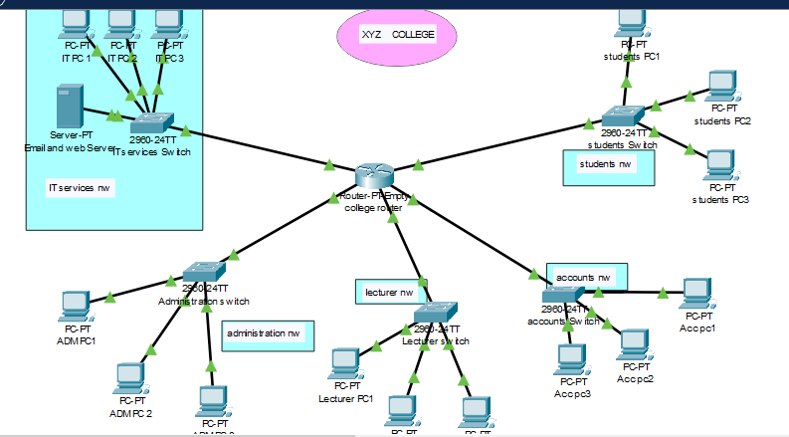

3. Attack Surface Mapping

The college network is using some older versions of switches that come with default configurations that lacked password protection. These default settings, often lacking passwords or using weak and well-known passwords, makes the devices vulnerable to unauthorized access.

4. Secure Access Controls

Switch configuration is changed and Each switch is given a name representing the network it is on and used "Cisco" as the username, and "password" as the password for all devices. The security of this network is passwords and encrypted password information.