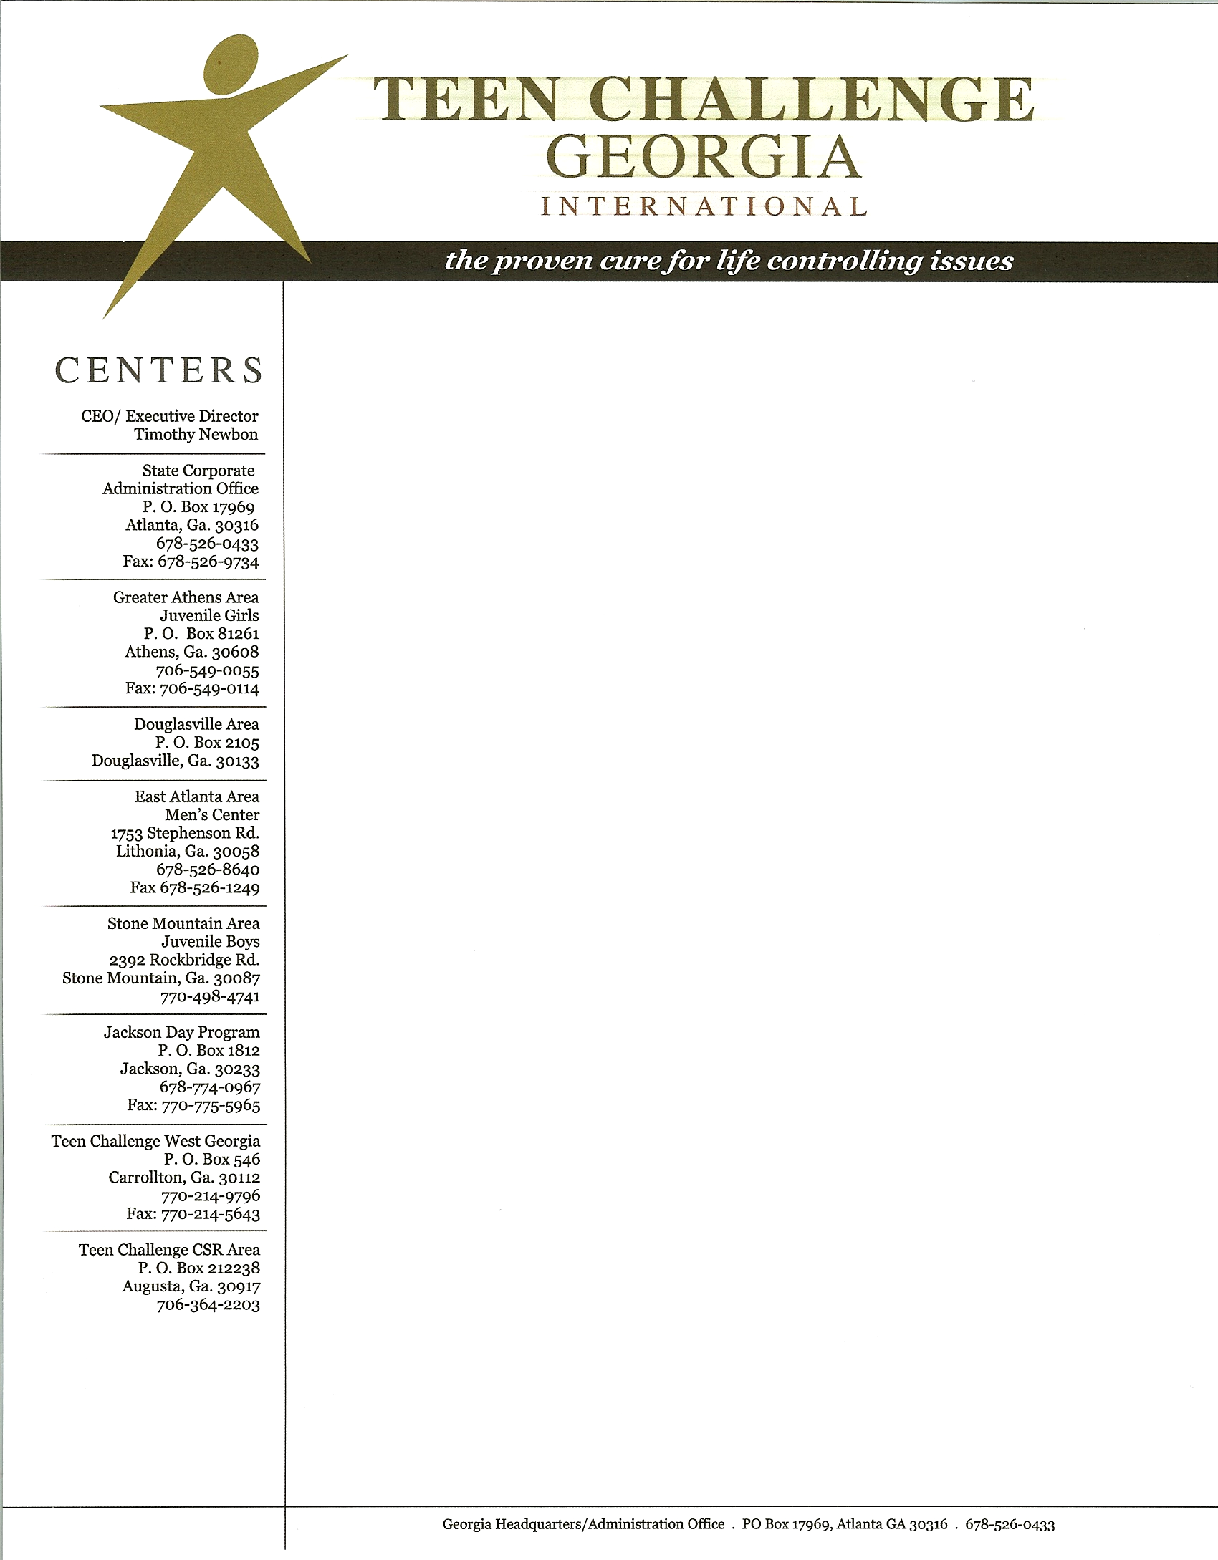

Mr. Cedric Horton

Dear Mr. Horton,

On behalf of the staff and board of directors of Teen Challenge Georgia International, Inc., thank you for your continued, generous support of this organization. Please use this document as a tax receipt for your last donation, which is described below.

If you have questions about this receipt, please contact us at 678-526-8640

Sincerely,

Tim & Barbara Newbon

Tim & Barbara Newbon
Teen Challenge Georgia Executive Directors

Donation of clothing and miscellaneous items that is valued at __________________

Date of Donation _October 28, 2010_

Teen Challenge Georgia International, Inc. is a 501(c)3 nonprofit organization, Federal Tax ID# 06-1573276

