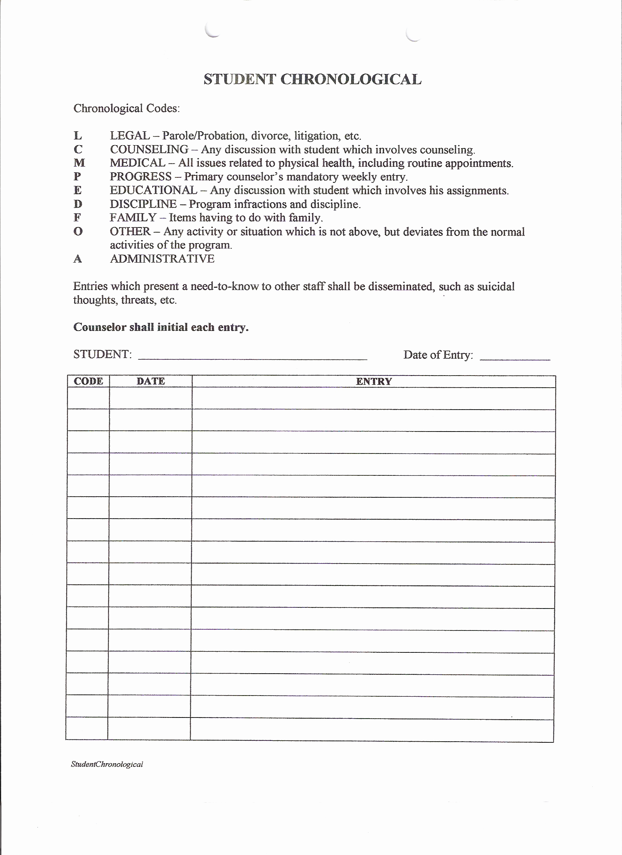
CODE | DATE | ENTRY

