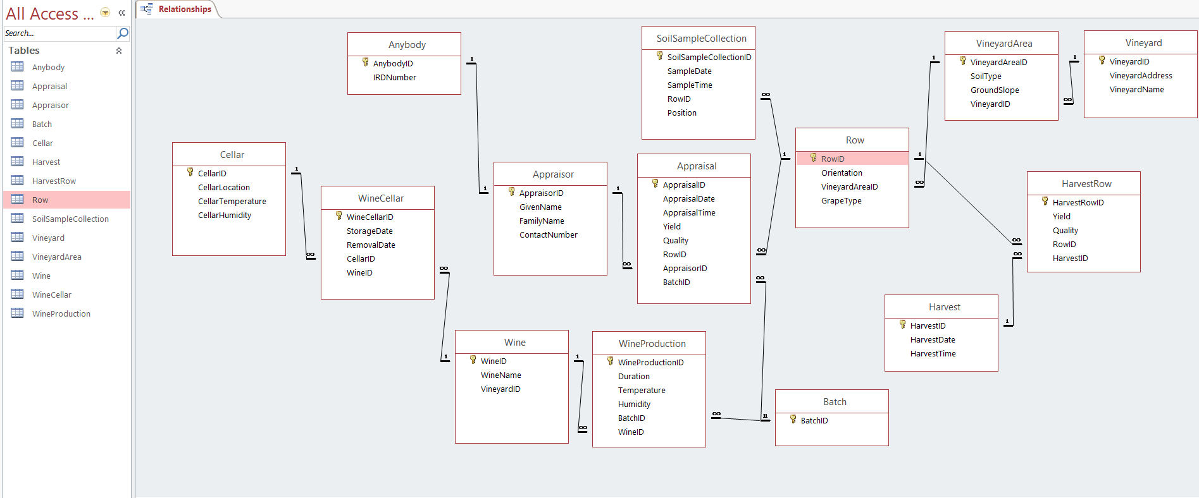

QUESTION 2

QUESTION 4

QUESTION 5

Assumption: Update loop is run every second.

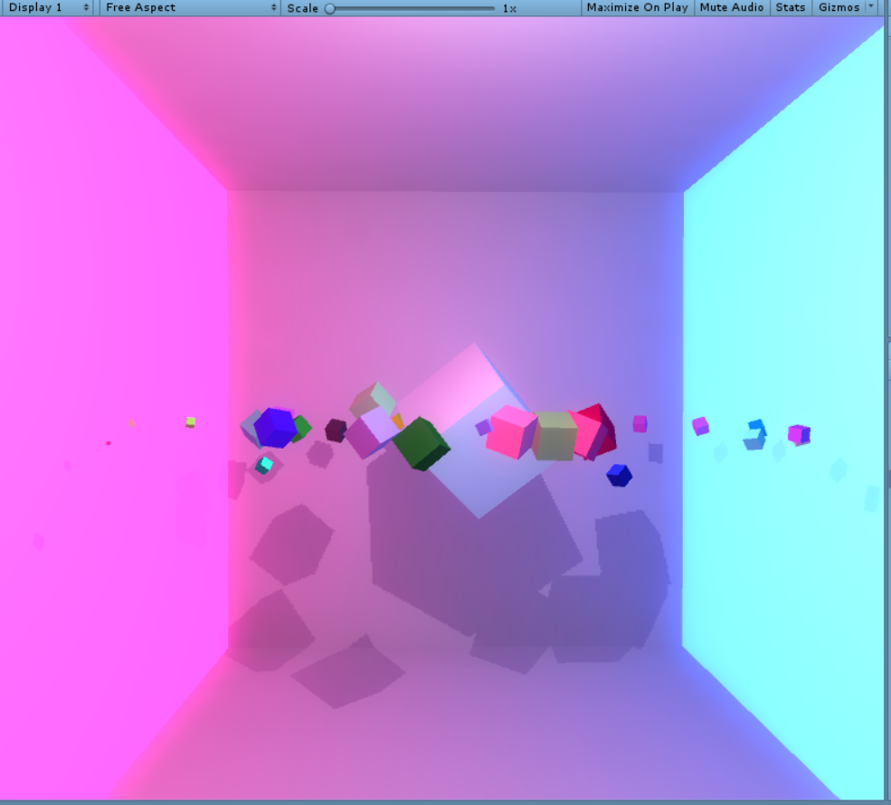

QUESTION 6