Business Analyst Portfolio Project
Customer Shopping Behavior Analysis
End-to-end analysis: Python data preparation → SQL business queries → Power BI dashboard

1. Project Overview
A leading retail company wanted to better understand its customers' shopping behavior in order to improve sales, customer satisfaction, and long-term loyalty. Management had noticed shifts in purchasing patterns across demographics, product categories, and sales channels, and wanted to know which factors — discounts, reviews, seasons, or payment preferences — drive consumer decisions and repeat purchases.
Business question: How can the company leverage consumer shopping data to identify trends, improve customer engagement, and optimize marketing and product strategies?
This project answers that question end to end: cleaning and transforming the raw dataset in Python, structuring it for business analysis in SQL, and visualizing the results in an interactive Power BI dashboard.

2. Dataset Summary
Metric | Detail
Records | 3,900 customer transactions
Columns | 18 (demographics, purchase details, shopping behavior)
Demographics | Age, Gender, Location, Subscription Status
Purchase details | Item Purchased, Category, Purchase Amount, Season, Size, Color
Behavioral fields | Discount Applied, Promo Code Used, Previous Purchases, Frequency of Purchases, Review Rating, Shipping Type
Data quality issue | 37 missing values in Review Rating

3. Data Preparation & Modeling (Python)
The raw Kaggle dataset was loaded into a Jupyter notebook with pandas and explored using df.info() and df.describe(include='all'). The following cleaning and feature engineering steps were applied:
- Missing data handling: rather than a blanket mean fill, missing Review Rating values were imputed with the median rating within each product category, so a clothing item's missing rating was filled from clothing medians, not footwear.
- Column standardization: all column names were converted to snake_case for readability and consistency.
- Feature engineering: created an age_group column by binning customer ages, and a purchase_frequency_days column.
- Text-to-numeric conversion: Frequency of Purchases (e.g. Weekly, Fortnightly, Quarterly) was mapped to a numeric day count (Weekly = 7, Fortnightly = 14, Monthly = 30, Quarterly/Every 3 Months = 90, Annually = 365) to make it usable in quantitative analysis.
- Redundancy check: discount_applied and promo_code_used were found to be identical across all rows, so promo_code_used was dropped and discount_applied was mapped to a binary numeric flag (Yes = 1, No = 0).
- Database integration: the cleaned DataFrame was loaded into PostgreSQL via a Python connection for structured SQL analysis.

4. SQL-Based Business Analysis
With the cleaned data in PostgreSQL, structured queries were run to answer specific business questions:

4.1 Revenue by Gender
Gender | Revenue (USD)
Female | 75,191
Male | 157,890
Male customers generated roughly double the revenue of female customers in this dataset.

4.2 High-Spending Discount Users
839 customers used a discount yet still spent above the average purchase amount ($59.76) — showing discounts are not always tied to lower-value baskets.

4.3 Top 5 Products by Average Rating
Product | Average Rating
Gloves | 3.86
Sandals | 3.84
Boots | 3.82
Hat | 3.80
Skirt | 3.78

4.4 Shipping Type Comparison
Shipping Type | Avg. Purchase Amount
Standard | $58.46
Express | $60.48

4.5 Subscribers vs. Non-Subscribers
Status | Customers | Avg. Spend | Total Revenue
Yes | 1,053 | $59.49 | $62,645
No | 2,847 | $59.87 | $170,436
Non-subscribers currently drive the bulk of total revenue simply due to volume, though average spend is nearly identical between the two groups — subscription status is not, on its own, a strong spend differentiator.

4.6 Discount-Dependent Products
Product | % Purchases Discounted
Hat | 50.0%
Sneakers | 49.7%
Coat | 49.1%
Sweater | 48.2%
Pants | 47.4%

4.7 Customer Segmentation
Segment | Customers
Loyal | 3,116
Returning | 701
New | 83
The customer base skews heavily toward Loyal, indicating a mature, retained customer pool with relatively little new-customer acquisition.

4.8 Top 3 Products per Category
Category | #1 | #2 | #3
Accessories | Jewelry (171) | Sunglasses (161) | Belt (161)
Clothing | Blouse (171) | Pants (171) | Shirt (169)
Footwear | Sandals (160) | Shoes (150) | Sneakers (145)
Outerwear | Jacket (163) | Coat (161) | —

4.9 Repeat Buyers & Subscription Likelihood
Subscription Status | Repeat Buyers (>5 purchases)
No | 2,518
Yes | 958
Most repeat buyers are not subscribers, suggesting purchase frequency alone does not predict subscription conversion — subscription is likely driven by other incentives.

4.10 Revenue by Age Group
Age Group | Total Revenue
Young Adult | $62,143
Middle-aged | $59,197
Adult | $55,978
Senior | $55,763
Revenue is fairly evenly distributed across age groups, with Young Adults contributing marginally the most.

5. Power BI Dashboard
An interactive Power BI dashboard was built to bring these findings together for stakeholders, with filters for Subscription Status, Gender, Category, and Shipping Type.
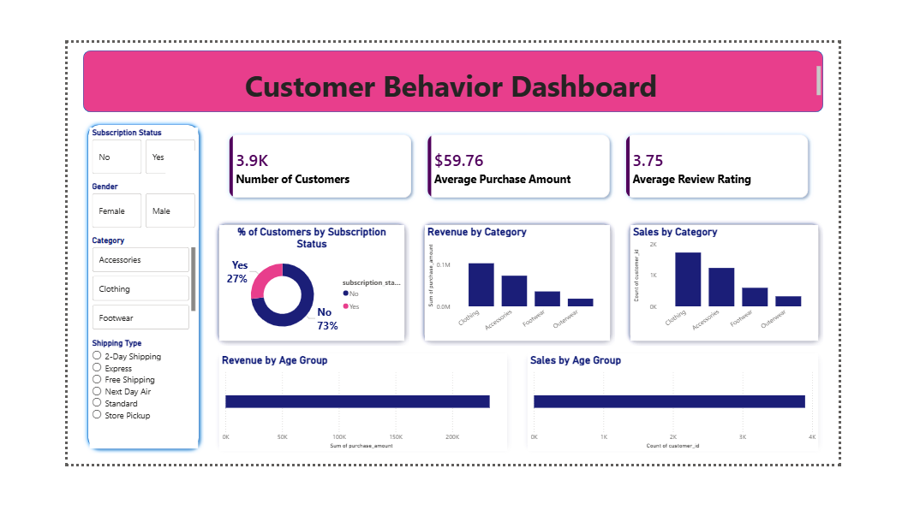
Headline KPIs: 3.9K customers, $59.76 average purchase amount, and a 3.75 average review rating. Only 27% of customers are subscribers, and revenue/sales are concentrated in the Clothing category, consistent with the SQL findings above.

6. Business Recommendations
- Boost subscriptions — promote exclusive benefits for subscribers, since only 27% of the base is currently subscribed despite comparable average spend to non-subscribers.
- Build customer loyalty programs — reward repeat buyers to convert them from Returning into the Loyal segment, and to nudge frequent non-subscribers toward subscribing.
- Review discount policy — several products (Hat, Sneakers, Coat) see roughly half of purchases discounted; balance the sales lift against margin impact.
- Prioritize product positioning — feature top-rated items (Gloves, Sandals, Boots) and top-selling items per category (Blouse, Pants, Jacket, Jewelry) in campaigns.
- Target marketing by segment — Male customers and Express-shipping users show higher spend; Young Adults contribute the most revenue by age group, making them a strong campaign focus.

7. Tools & Methodology Recap
Stage | Tool(s)
Data preparation & modeling | Python (pandas, Jupyter Notebook)
Structured business analysis | SQL (PostgreSQL)
Visualization & dashboard | Power BI
Reporting & presentation | Excel, PowerPoint / Gamma
Requirement & workflow tracking | Jira / Trello concepts, BPM/UML mapping

8. Conclusion
This project demonstrates the full business analyst workflow — from raw, messy transactional data through cleaning and feature engineering, structured SQL-based business questioning, and stakeholder-ready visualization. The result is a set of concrete, data-backed recommendations the retail company can act on to improve customer engagement, subscription conversion, and targeted marketing.

