Group 1 KronoDroid QDA: method, evidence and critical handoff to Group 3

Purpose and measured outcome
VERIFIED - This is a standalone technical handoff for Group 3's AI agent and human reviewers. It explains the completed binary KronoDroid QDA experiment, its provenance, configuration, failures, assumptions and limitations. The evidence appendix supplies every executed configuration value and all TRAIN/VAL/TEST results. The main report is available as a Word document, a self-contained HTML document and plain text; it is not a README deliverable.
VERIFIED - Successful source run: runs/group1_qda/kronodroid/20261029T080353_215967Z. The primary prespecified feature set is mi_top50, whose TEST accuracy is 0.8959720088752346 and macro F1 is 0.895972008117629. Separately, the overall feature set selected using VAL only is et_top50 with reg_param=0.1. Its TEST accuracy is 0.911247653183137, Malware F1 is 0.9128832300217792, and macro F1 is 0.9112163584445303. Reporting the validation winner does not erase the lower primary result.
VERIFIED - These results are below GROUP 3's LightGBM numbers: replication accuracy 0.9779 / Malware F1 0.979 and full_standardized accuracy 0.9834 / Malware F1 0.9842. No score has been inflated, rounded up or substituted with another group's result. We did not tune QDA after inspecting TEST to close the gap.
VERIFIED - The selected et_top50 model missed 757 of 6,206 Malware apps and falsely flagged 283 of 5,512 Benign apps on TEST; it correctly identified 5,449 Malware and 5,229 Benign apps. These errors remain material even though its ROC-AUC is 0.97042641736285. ROC-AUC describes probability ranking over thresholds, not the actual error count at the recorded predict decision rule. No new threshold was chosen after looking at these errors.

What Group 1 added and what Group 3 supplied
VERIFIED - Group 3 supplied the real-device data preparation, labels, split manifest, standardized features and ordered train-only feature rankings. Group 1 added the separate groups/group1_qda/kronodroid module, YAML-driven QDA search, frozen-model evaluation, outputs, tests and this reporting layer. Existing MalDroid code and all Group 3 artifacts remain separate. MalDroid is the older five-class experiment, not the dataset used for the new results.
VERIFIED - The repository contribution was committed and pushed as 9772db9acc81f878bd542b57022c919868340988 to nishikakhade7/CNS_Research-Project on branch grp1-qda-kronodroid, with commit author rudii246 <rudrakoli9207@gmail.com>. It contains the reviewed code, configurations, reports, prediction CSVs and successful/failed-run metadata. The four model.joblib files were intentionally not committed because model-file approval was not given. They exist locally. A clean clone can inspect metrics and predictions but cannot load these four frozen models from that commit. This is an explicit handoff limitation, not a claim that the models were shared.
VERIFIED - This report and its plots are a later documentation addition and are not part of the earlier commit unless separately committed. The reporting process does not write to the successful run or to runs/kronodroid or runs/real. The reporting audit records source hashes and checks them again after rendering.

What the pipeline actually did, in order
VERIFIED - First, it loaded kd05_features_scaled.parquet, kd04_split_manifest.parquet and kd06_feature_rankings.json. It checked dimensions, finite numeric features, SHA256-index validity and uniqueness, exact split/label counts, cross-artifact label alignment, source_dataset and ordered feature-list membership. The SHA256 index is unnamed; no assumption that its name is literally sha256 is made. Group 3's metric JSON is read only for provenance/comparison, not model selection.
VERIFIED - Second, it selected the original ordered lists mi_top50, mi_top30, mi_top100 and et_top50. It measured variance using TRAIN only and removed features only when that variance was exactly 0.0 (ddof=0). None of the four selected lists lost a feature. It did not infer that this guarantees full class covariance rank. No new split, scaler, imputer, ranking, SMOTE procedure or class weighting was fitted by Group 1.
VERIFIED - Third, each feature set ran the same eight reg_param candidates: [0.0, 0.01, 0.05, 0.1, 0.25, 0.5, 0.75, 1.0]. Each QDA fit saw TRAIN only. Each candidate was scored on VAL macro F1. An exact tied macro F1 would choose the larger reg_param. The original task specified this grid and candidate tie rule; they were not inferred from TEST.
VERIFIED - Fourth, the already-fitted winning candidate for each feature set was retained with no train+val refit. The overall winner was selected by VAL macro F1 before TEST. Exact cross-feature-set ties would follow the previously declared order mi_top50, mi_top30, mi_top100, et_top50. All four models and the selection summary were saved before the first TEST evaluation.
VERIFIED - Fifth, the final TRAIN/VAL/TEST metric sets were computed for each frozen winner. One predict call and one predict_proba call make up each winner's TEST evaluation; all TEST metrics, CSV rows and confusion plots reuse those arrays. No TEST result enters the ranking, constant filter, grid search, prior estimate or winner selection. ROC-AUC uses the class-1 probability, not a predicted label. The stored predictions use sklearn's predict decision rule; there is no custom tuned threshold.

Every assumption and convention, with its evidential limit
VERIFIED (declared assumption) - The authority for sample identity, source and target labels is Group 3's processed data contract. We checked consistency and hashes. NOT VERIFIED - We did not independently relabel apps, adjudicate upstream malware truth, reconstruct the raw CSV pipeline or verify the original dataset paper's every claim.
VERIFIED (declared assumption) - We accepted Group 3's existing split and TRAIN-only processing/ranking recipe. Source inspection supports the train-only claim. NOT VERIFIED - No independent raw-to-Parquet rebuild proves the historical execution of every upstream transformation; hashes establish artifact identity, not scientific ground truth.
VERIFIED (declared choice) - K=50 MI was designated primary by the user; the additional K values/ranking method and regularisation grid were likewise specified. Selection of the feature set itself uses VAL. Exact cross-set ties follow configured order, an implementation assumption declared before testing, rather than an unmentioned preference for whichever looks better on TEST.
VERIFIED (declared convention) - Variance is population variance (ddof=0); only exactly zero TRAIN variance is removed. This is not a near-zero tolerance filter, per-class filter or covariance-rank pruning step. Remaining feature order is unchanged. This preserves the specified lists except documented constants.
VERIFIED (declared convention) - priors=None and tol=0.0001 remain sklearn defaults. Empirical fitted priors are [0.47038818087071, 0.52961181912929], derived from TRAIN. We did not choose equal priors to force class balance. store_covariance=False is also the default. Seed=42 is recorded; QDA itself has no random_state parameter, and the new runner does not redo stochastic feature selection.
VERIFIED (declared convention) - Benign is 0 and Malware is 1; class 1 is positive. Confusion matrices use rows=true and columns=predicted, order [0,1]. Undefined precision/recall/F1 uses zero_division=0. Macro F1 is the unweighted mean over both classes, whereas Malware F1 is binary class-1 F1. TRAIN metrics are in-sample and cannot be advertised as held-out performance.
VERIFIED (environment choice) - The original sklearn 1.9.1 attempt failed on mi_top50/reg_param=0.0 before any TEST evaluation. Rather than skipping the failed candidate or removing it from the grid, the run stopped. Following user approval, a separate environment used sklearn 1.7.2, matching Group 3's documented sklearn version. The same YAML and runner were then used. This was an environment change in response to a compatibility/numerical failure, not proof that the older library is more accurate or scientifically superior.
VERIFIED - The final environment has Python 3.14.3, numpy 2.5.4, pandas 3.1.0, sklearn 1.7.2 and the complete package list in the appendix. Matching sklearn alone does not recreate Group 3's environment. The runner saves package versions but does not enforce the exact version set or compare a newly loaded input hash against an externally trusted lockfile; counts and schema alone do not fully freeze a dataset's values. Reproduction must use the recorded versions and hashes explicitly.
VERIFIED (reporting choice) - UTC timestamps and separate feature-set directories identify outputs. They are not experimental repetitions or performance estimates. Winning-candidate fit duration and all-candidate search duration are different measurements and are reported separately. Times were measured once on this machine; no claim about general hardware speed or statistical timing precision is made.
NOT VERIFIED (modelling assumption) - QDA's class-conditional Gaussian density assumption has not been established for these mixed permission/count/structural features. Standardisation does not demonstrate multivariate normality. The exact within-class feature dependencies behind the unregularised covariance warnings were not isolated. Binary detection performance does not establish family classification performance.
NOT VERIFIED (external validity) - No independent external dataset, deployment test, time-forward holdout, confidence interval, repeated-split study or probability calibration study was performed. We do not claim performance on future apps, emulator data, family labels or MalDroid from this experiment. The fixed split is not evidence of temporal generalisation.

Critical review: what is sound and what remains incomplete
VERIFIED - The 32 successful search records, twelve split-metric files, all eight rank-deficiency warning occurrences, configured values, provenance hashes and runtime fields are available for review. The 26 contract tests passed in the historical Step 6 run. Saved model class means and empirical priors were checked against TRAIN without refitting. Independently recomputed metrics from the four CSVs match their TEST JSONs exactly. These checks support the recorded numerical results and the implemented data contract; they do not prove all untested modelling assumptions.
VERIFIED (limitation) - The initial 1.9.1 failure and successful 1.7.2 warning behavior must remain visible. A non-failing old-library fit is not a mathematical cure for singular covariance. All selected models use positive regularisation and emitted no captured warnings, which is the actual observation; numerical stability under arbitrary perturbations was not demonstrated.
VERIFIED (limitation) - The tests protect the requested data contracts and path rejection behavior, but do not provide a complete end-to-end proof of warning capture, exactly-once evaluation across process restarts or failure recovery. The new-run guard prevents overwriting an existing directory; it does not prevent an operator from creating another timestamped run. No claims of a globally locked TEST dataset or immutable model object are made. 'Frozen' means retained without further fitting in this run.
VERIFIED (limitation) - The output guard checks resolved output directories and fixed protected roots. It does not grant operating-system immutability to Group 3 files or prevent unrelated processes from editing them. Missing/infinite features are rejected rather than silently repaired by Group 1. A candidate exception causes the run to stop and persist failure information; the implementation was not changed to silently continue after the failed first run.
VERIFIED (comparison limitation) - Group 3's stored F1 is Malware F1 rounded by their stage09_eval.py, not macro F1. Their replication model uses the same et_top50 feature identities but extra MinMax scaling, balanced class weights and LightGBM/early-stopping behavior. Their full model uses 475 features. Therefore, the observed gap is not a controlled experiment isolating only the choice of classifier. We do not invent statistical significance or claim a fair causal explanation for the gap.
VERIFIED (handoff limitation) - Without separately approved model files, another agent can audit results and regenerate report plots from committed artifacts but cannot load the original frozen estimator from Git. The models remain local. Retraining is not the preferred method for reviewing already reported TEST results; it can create another TEST evaluation. To extend the study after viewing this TEST, use a separately declared experiment and new evaluation protocol rather than presenting further tuning as an untouched-test result.

How Group 3's agent should review this work
VERIFIED - Start with the exact experiment YAML and runner under groups/group1_qda/kronodroid, then the successful run's input_provenance.json and selection_summary.json. Check hashes against the four input paths. Read the per-set reg_param_search.json before the TEST results to verify the selection rule. Distinguish the primary mi_top50 experiment from the overall VAL-selected et_top50 result. The appendix gives every configured value, chooser and purpose, exact warning text and all split metrics side by side.
VERIFIED - The reporting script build_handoff_report.py reads JSON and saved CSVs; it never imports the training runner or loads joblib models. It verifies saved predictions, selection maxima and source hashes, then writes twelve PNG/PDF figures, a combined plot PDF, a Word report, self-contained HTML, plain text and report_audit.json. The new ROC/precision-recall plots are retrospective visualisation only. They do not select another model or threshold, and no additional performance number is advertised from them.
VERIFIED (presentation choices) - The principal numeric rendering settings are in configs/handoff_report.json: score limits [0.0,1.0], PNG DPI 180, wide figure size [11,6.5] inches, double-panel size [14,6.5], confusion PDF size [7,6], overview size [18,20] with 3 columns, bar width 0.24, winner marker size 180, runtime axis headroom multiplier 1.8, legend/annotation font size 8, and base font size 10. Colours are recorded as exact hex values in that file. Fixed presentation conventions in the reporting source include circular search markers, star winner markers, gray dashed reference lines, a Blues count heatmap, integer warning counts and gray/white confusion annotation contrast. These are report-author presentation choices, not model hyperparameters. Full 0-to-1 score axes avoid exaggerating differences; exact numeric tables remain authoritative. Original confusion PNGs retain the original executed plotting settings, and are copied byte-for-byte; PDF versions are redrawn from stored counts. report_audit.json records input/output hashes and the full reporting configuration. DOCX archive/XML validity is checked; appearance in Microsoft Word is NOT VERIFIED by a GUI session.
VERIFIED - No experiment settings, predictions or original result files are changed to create this handoff. The README remains a repository reference; this Word/HTML/text description is the requested standalone deliverable. Any later publication of these new files requires a separate commit/push step.

Plot catalogue and interpretation
VERIFIED: Twelve figures below use existing JSON/CSV artifacts only. Newly drawn ROC and precision-recall curves are post hoc descriptive summaries of already saved probabilities. No fitting, model calls, threshold selection or new TEST evaluation occurred. Axis tick formatting is visual presentation; exact results remain in the tables and JSON. Every figure is saved as PNG and PDF in the Group 1 plots folder, with a combined PDF atlas.

01_validation_search
VERIFIED: all 32 VAL macro-F1 values come from reg_param_search.json. Stars identify each set's frozen winner. No TEST result appears in this selection plot.
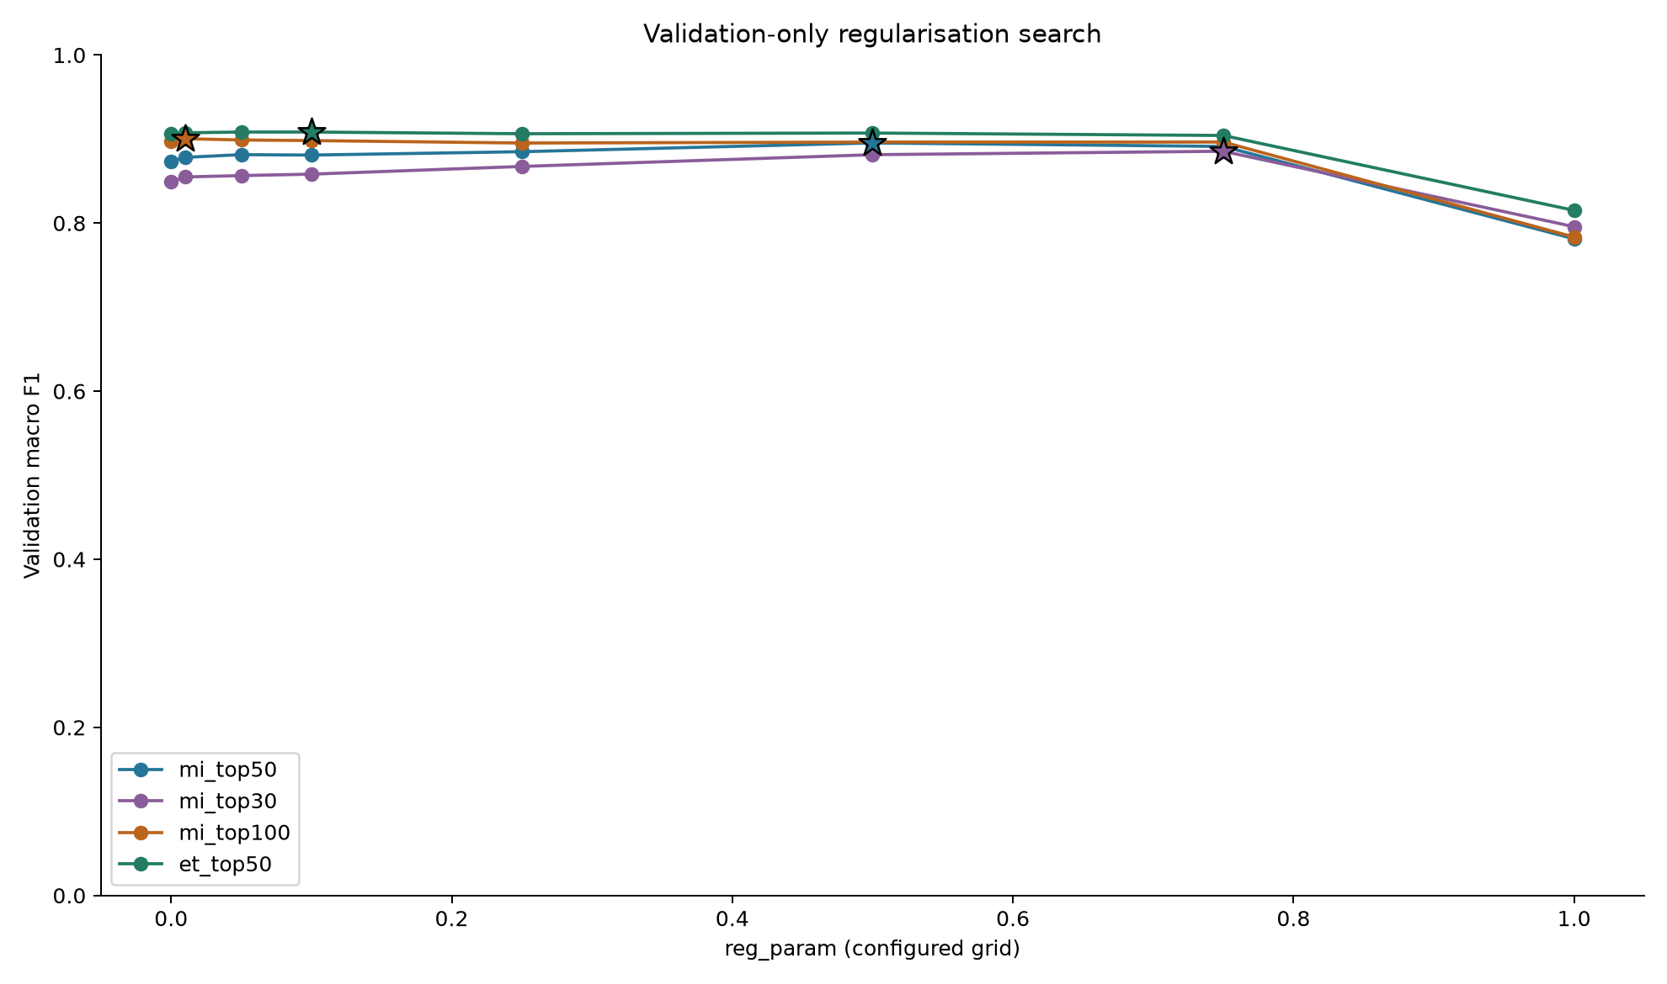

02_train_val_test_metrics
VERIFIED: accuracy and macro F1 from the twelve split-metric JSONs. TRAIN is in-sample; VAL was used for selection; TEST was evaluated after freezing. Full-height 0-to-1 axes avoid exaggerating differences; exact values are in the report tables.
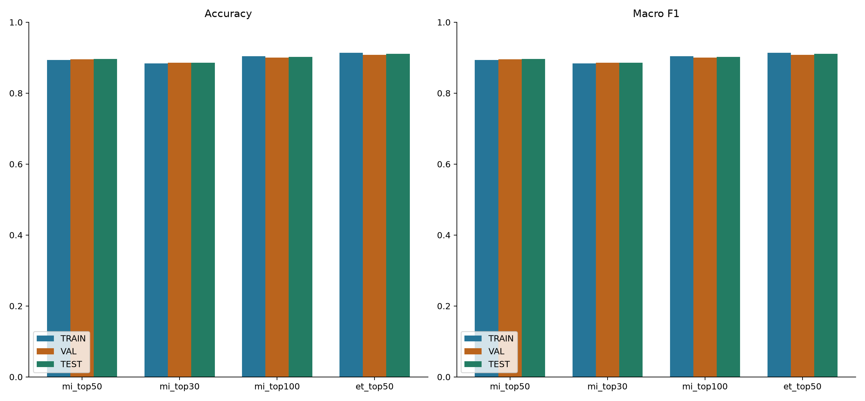

03_test_roc_curves
VERIFIED: curves computed only from saved TEST labels/probabilities, with no model calls. AUC values exactly match test_metrics.json. These retrospective curves were not used for selecting a model or threshold.
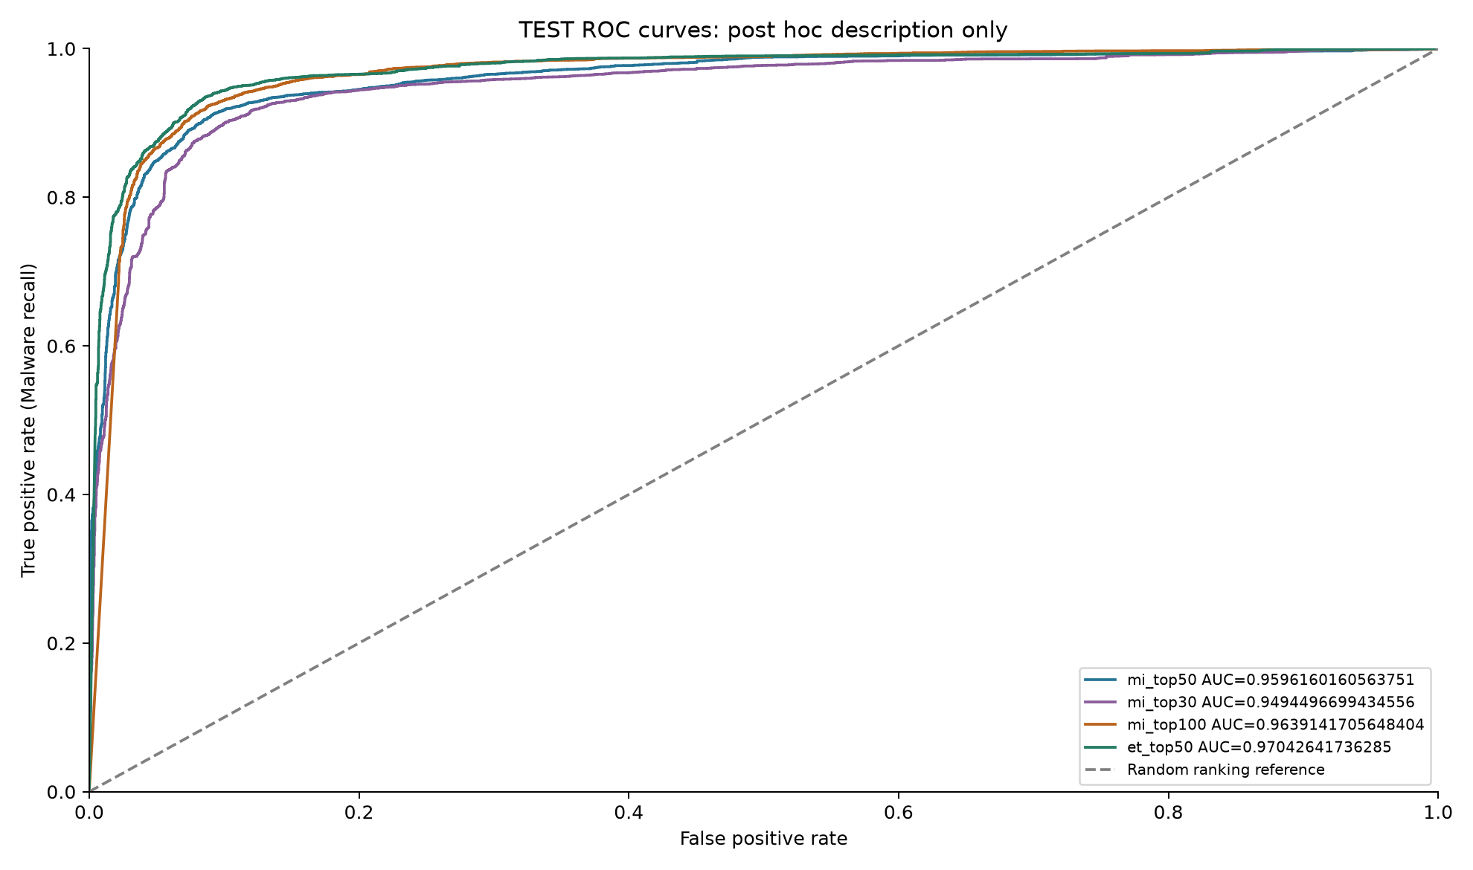

04_test_precision_recall_curves
VERIFIED: curves use saved TEST probabilities and labels only. No new average-precision result or threshold recommendation is introduced. The horizontal reference is the observed Malware prevalence, not a fitted classifier.
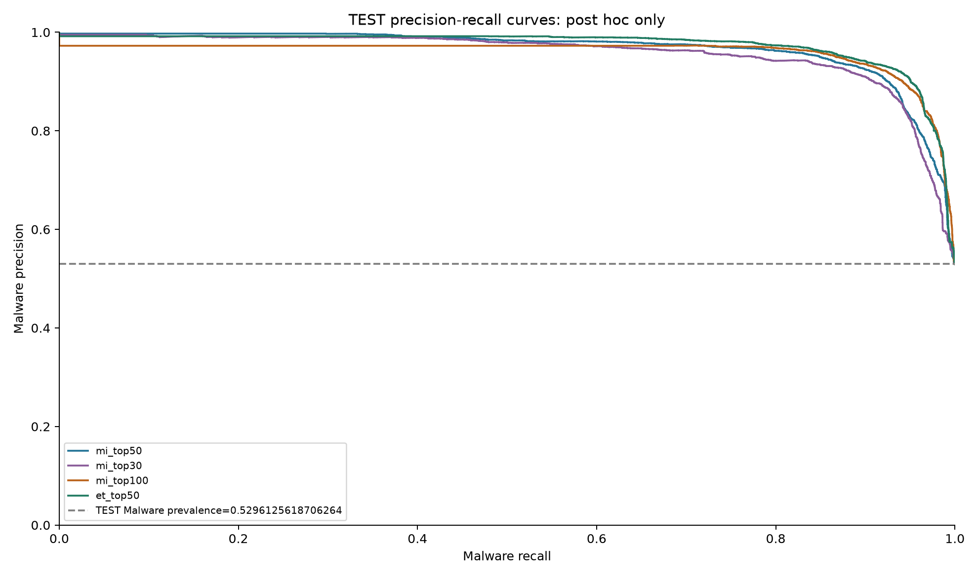

05_fit_and_search_runtime
VERIFIED: winning-candidate fit time and full search time are separate quantities copied from runtime.json. No retraining or fresh timing was performed. Measurements depend on this machine and include the documented search overhead.
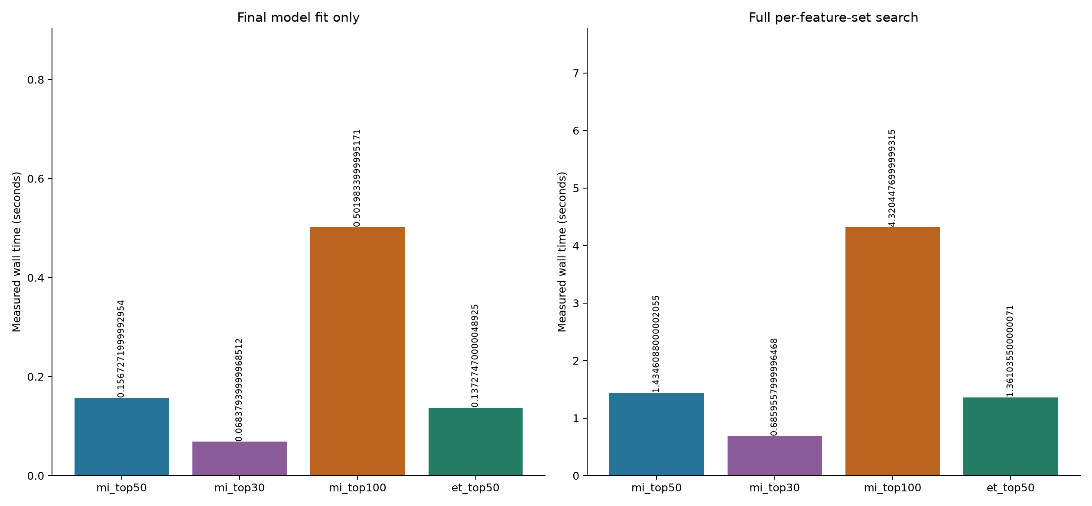

06_candidate_warning_counts
VERIFIED: eight LinAlgWarning occurrences: classes 0 and 1 at reg_param=0.0 for each set. Counts are copied from search JSON, not inferred from plotted scores. All other candidates and selected-model evaluations have empty warning lists.
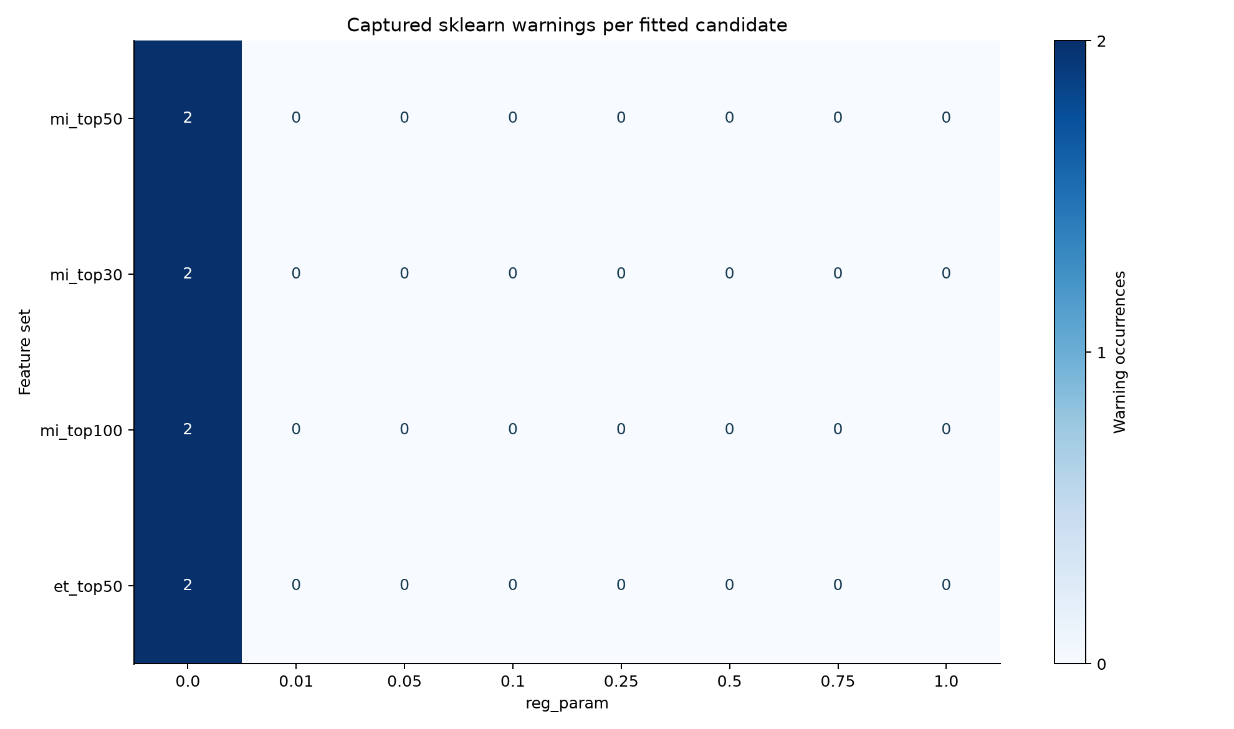

07_group3_comparison
VERIFIED: Group 3 values are their stored, four-decimal results, not ours. Different feature representations, class-weight treatment and model selection procedures prevent a controlled classifier-only comparison. No significance claim or test-driven tuning is made.
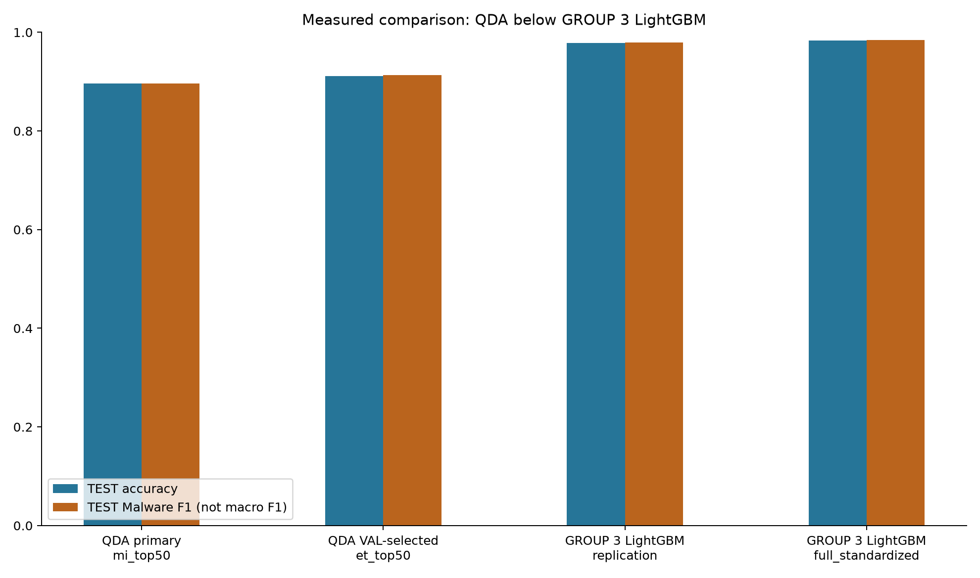

08_split_label_counts
VERIFIED: exact split/class counts from the executed config, checked against the actual split manifest. The chart depicts the supplied split, not a new random split.
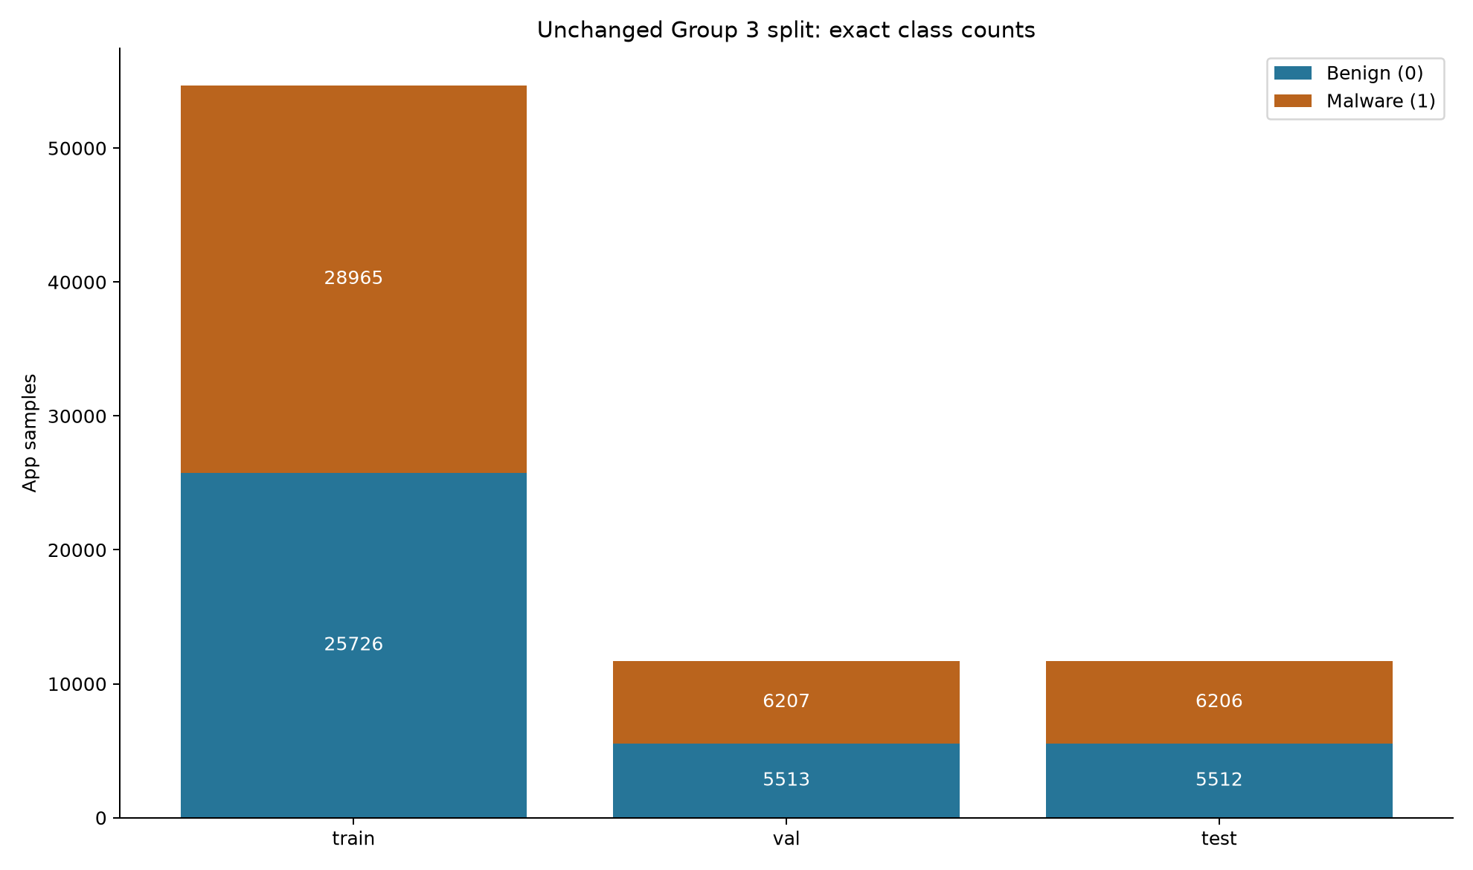

09_confusion_mi_top50
VERIFIED: original PNG copied byte-for-byte from the frozen run; PDF redrawn from its saved confusion counts. Rows=true, columns=predicted, order=[0,1]. No predictions were regenerated. mi_top50 counts: [[5250, 262], [957, 5249]]
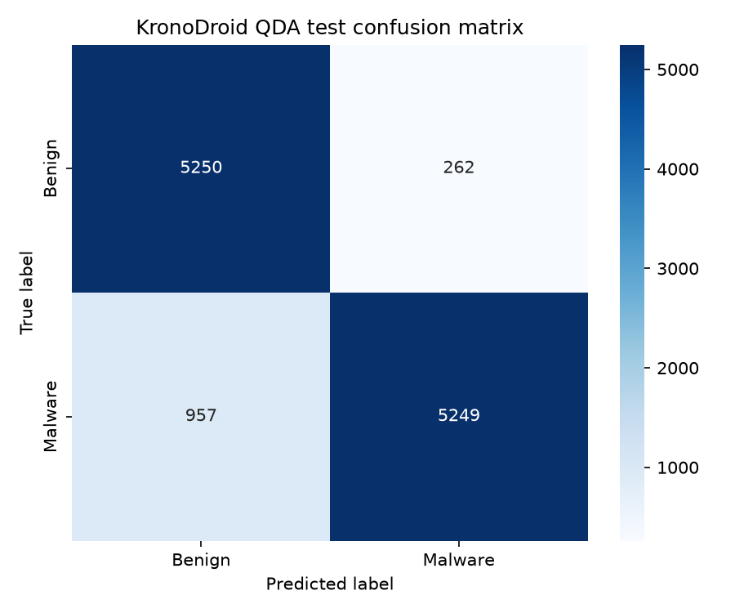

09_confusion_mi_top30
VERIFIED: original PNG copied byte-for-byte from the frozen run; PDF redrawn from its saved confusion counts. Rows=true, columns=predicted, order=[0,1]. No predictions were regenerated. mi_top30 counts: [[5185, 327], [1012, 5194]]
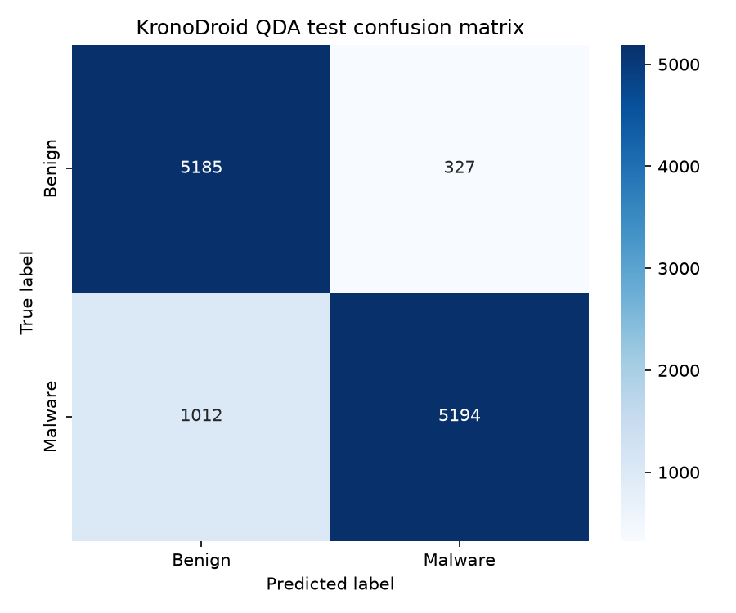

09_confusion_mi_top100
VERIFIED: original PNG copied byte-for-byte from the frozen run; PDF redrawn from its saved confusion counts. Rows=true, columns=predicted, order=[0,1]. No predictions were regenerated. mi_top100 counts: [[5271, 241], [901, 5305]]
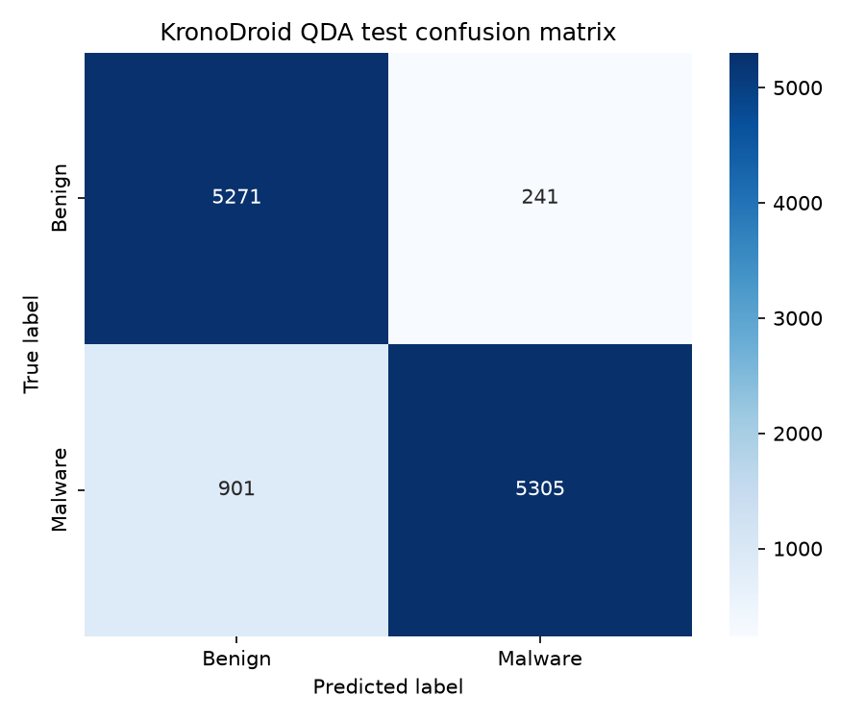

09_confusion_et_top50
VERIFIED: original PNG copied byte-for-byte from the frozen run; PDF redrawn from its saved confusion counts. Rows=true, columns=predicted, order=[0,1]. No predictions were regenerated. et_top50 counts: [[5229, 283], [757, 5449]]
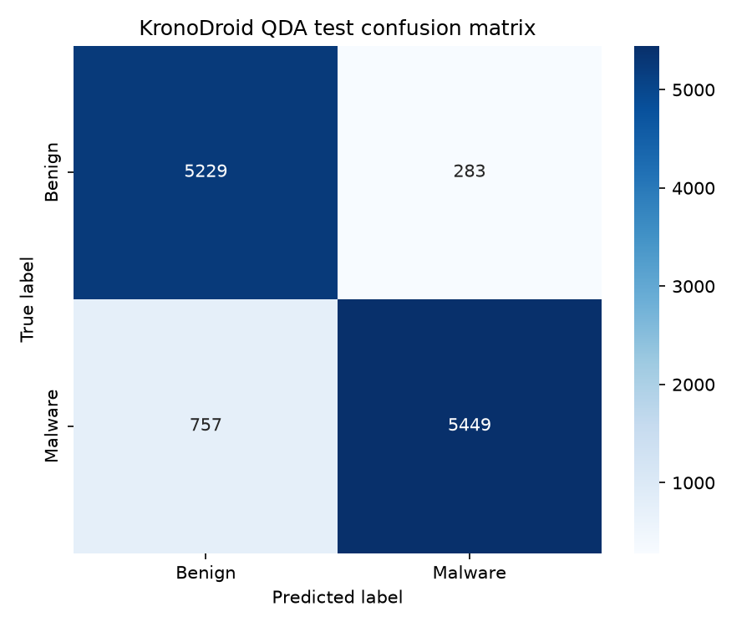

Exact ordered feature identities supplied to each frozen model
VERIFIED: These names are copied from selection_summary.json, in model input order. All four dropped-feature lists are empty. These lists come from Group 3 rankings; the report does not generate a new ranking.

mi_top50
{
"features_in_model_order": [
"nr_permissions",
"total_perm",
"dangerous",
"READ_PHONE_STATE",
"normal",
"mprotect",
"NrIntReceiversActions",
"NrServices",
"read",
"SYS_317",
"sigaction",
"ACCESS_WIFI_STATE",
"prctl",
"SYS_310",
"write",
"SEND_SMS",
"ioctl",
"fstatfs64",
"SYS_315",
"getpriority",
"uname",
"SYS_333",
"clone",
"TotalIntentFilters",
"signature",
"madvise",
"UFileSize",
"SYS_306",
"SYS_336",
"CFileSize",
"dup",
"SYS_305",
"_llseek",
"getsockopt",
"mmap2",
"writev",
"close",
"SYS_311",
"RECEIVE_BOOT_COMPLETED",
"setsockopt",
"lseek",
"nr_syscalls",
"getrlimit",
"fsync",
"WRITE_EXTERNAL_STORAGE",
"getuid32",
"SYS_329",
"futex",
"RECEIVE_SMS",
"socketpair"
],
"dropped_features": [],
"chosen_reg_param": 0.5,
"fitted_priors": [
0.47038818087071,
0.52961181912929
]
}

mi_top30
{
"features_in_model_order": [
"nr_permissions",
"total_perm",
"dangerous",
"READ_PHONE_STATE",
"normal",
"mprotect",
"NrIntReceiversActions",
"NrServices",
"read",
"SYS_317",
"sigaction",
"ACCESS_WIFI_STATE",
"prctl",
"SYS_310",
"write",
"SEND_SMS",
"ioctl",
"fstatfs64",
"SYS_315",
"getpriority",
"uname",
"SYS_333",
"clone",
"TotalIntentFilters",
"signature",
"madvise",
"UFileSize",
"SYS_306",
"SYS_336",
"CFileSize"
],
"dropped_features": [],
"chosen_reg_param": 0.75,
"fitted_priors": [
0.47038818087071,
0.52961181912929
]
}

mi_top100
{
"features_in_model_order": [
"nr_permissions",
"total_perm",
"dangerous",
"READ_PHONE_STATE",
"normal",
"mprotect",
"NrIntReceiversActions",
"NrServices",
"read",
"SYS_317",
"sigaction",
"ACCESS_WIFI_STATE",
"prctl",
"SYS_310",
"write",
"SEND_SMS",
"ioctl",
"fstatfs64",
"SYS_315",
"getpriority",
"uname",
"SYS_333",
"clone",
"TotalIntentFilters",
"signature",
"madvise",
"UFileSize",
"SYS_306",
"SYS_336",
"CFileSize",
"dup",
"SYS_305",
"_llseek",
"getsockopt",
"mmap2",
"writev",
"close",
"SYS_311",
"RECEIVE_BOOT_COMPLETED",
"setsockopt",
"lseek",
"nr_syscalls",
"getrlimit",
"fsync",
"WRITE_EXTERNAL_STORAGE",
"getuid32",
"SYS_329",
"futex",
"RECEIVE_SMS",
"socketpair",
"setrlimit",
"clock_gettime",
"fcntl64",
"READ_SMS",
"gettimeofday",
"SYS_339",
"munmap",
"GET_TASKS",
"pread",
"recvfrom",
"getdents64",
"SYS_316",
"fstat64",
"rt_sigprocmask",
"FilesInsideAPK",
"recv",
"WAKE_LOCK",
"wait4",
"ACCESS_NETWORK_STATE",
"epoll_ctl",
"flock",
"SYSTEM_ALERT_WINDOW",
"ACCESS_COARSE_LOCATION",
"CHANGE_WIFI_STATE",
"SYS_312",
"GET_ACCOUNTS",
"nr_custom",
"MOUNT_UNMOUNT_FILESYSTEMS",
"ACCESS_FINE_LOCATION",
"CHANGE_NETWORK_STATE",
"sigaltstack",
"fdatasync",
"custom_yes",
"NrIntServices",
"NrIntServicesActions",
"INTERNET",
"CHANGE_CONFIGURATION",
"WRITE_SETTINGS",
"VIBRATE",
"NrIntReceivers",
"RECEIVE_MMS",
"BROADCAST_SMS",
"fchmod",
"ACCESS_LOCATION_EXTRA_COMMANDS",
"DISABLE_KEYGUARD",
"WRITE_APN_SETTINGS",
"RECEIVE_WAP_PUSH",
"CALL_PHONE",
"READ_EXTERNAL_STORAGE",
"sched_yield"
],
"dropped_features": [],
"chosen_reg_param": 0.01,
"fitted_priors": [
0.47038818087071,
0.52961181912929
]
}

et_top50
{
"features_in_model_order": [
"READ_PHONE_STATE",
"SEND_SMS",
"ACCESS_WIFI_STATE",
"RECEIVE_BOOT_COMPLETED",
"WRITE_EXTERNAL_STORAGE",
"RECEIVE_SMS",
"READ_SMS",
"nr_permissions",
"SYSTEM_ALERT_WINDOW",
"GET_TASKS",
"dangerous",
"total_perm",
"getpriority",
"SYS_333",
"getrlimit",
"ACCESS_NETWORK_STATE",
"WAKE_LOCK",
"setrlimit",
"ACCESS_FINE_LOCATION",
"GET_ACCOUNTS",
"ACCESS_COARSE_LOCATION",
"fsync",
"SYS_339",
"CHANGE_WIFI_STATE",
"uname",
"socketpair",
"fstatfs64",
"normal",
"sigaction",
"MOUNT_UNMOUNT_FILESYSTEMS",
"write",
"read",
"sysinfo",
"recvfrom",
"signature",
"sigaltstack",
"getsockopt",
"SYS_315",
"NrIntReceiversActions",
"SYS_317",
"mprotect",
"prctl",
"futex",
"clone",
"FilesInsideAPK",
"SYS_329",
"setsockopt",
"epoll_ctl",
"READ_EXTERNAL_STORAGE",
"clock_gettime"
],
"dropped_features": [],
"chosen_reg_param": 0.1,
"fitted_priors": [
0.47038818087071,
0.52961181912929
]
}

Evidence appendix: exact settings, provenance and results

Scope and input provenance
VERIFIED - This new module consumes Group 3 artifacts without modifying their pipeline. It does not import or alter the existing five-class MalDroid implementation. The task is Benign (0) versus Malware (1), kronodroid_real_device only. All paths in this document are repository-relative unless stated otherwise.
VERIFIED - Input digests from input_provenance.json, independently rechecked while writing this report:
Input | Path | SHA256
features | runs/kronodroid/artifacts/kd05_features_scaled.parquet | dc55adc63f0ae38d6cc5728c69eaf2699c1ab17fa8e1367bcbbcff4a80f0386c
manifest | runs/kronodroid/manifests/kd04_split_manifest.parquet | 9f4047a3fad0188760b105e60bc31f4d46c4cc16489bc7c106ff903c262ba219
rankings | runs/kronodroid/artifacts/kd06_feature_rankings.json | d70a46502b422dd36ac44fc29017fe3a8499d92b3ae4abfa7de6818275b547e5
group3_metrics | runs/kronodroid/metrics/kd09_eval_metrics.json | bcdb7a3053978f10d8dc3b1583483187c37160b3d61da82fdd24dc489335743c
VERIFIED - kd05 has 78,129 rows and 477 columns: 475 numeric features plus split and label_binary. SHA256 IDs are the unique, unnamed index (index.name is None), not a feature column. IDs, splits and binary labels match kd04. Feature values contain no missing or infinite entries. Neither duplicates nor IDs spanning splits were found. Each ranking is a complete ordering of 475 unique features; all six top-K lists match ranking prefixes and exist in kd05.
VERIFIED - Split and label counts, cross-checked from the actual Parquets (not newly generated splits):
Split | Benign (0) | Malware (1) | Total
train | 25726 | 28965 | 54691
val | 5513 | 6207 | 11720
test | 5512 | 6206 | 11718
Total | 36751 | 41378 | 78129
VERIFIED - pipeline/kronodroid/stage05_preprocess.py applies log1p to nonnegative dynamic count-like columns and fits StandardScaler on TRAIN only. It fills missing upstream values with zero before preprocessing; Group 1 does not repeat that operation. stage06_selection.py fits its MinMax selection representation, ExtraTrees and mutual information on TRAIN only. Group 1 consumes their existing ordered lists and standardized kd05 values without re-ranking or re-scaling. These preprocessing claims are verified from source and consistency checks, not by independently rebuilding Group 3 artifacts from raw apps.

Every stage and methodological choice
VERIFIED - Chooser attribution: User = original task or explicit subsequent approval; Group 3 = supplied pipeline and artifacts; sklearn = installed library defaults; Implementation = routine implementation choice documented in PLAN.md or configuration before TEST evaluation.
Stage / choice | Value or behavior | Who chose it | Why
Setup | Separate branch grp1-qda-kronodroid; separate module under groups/group1_qda/kronodroid | User | Preserve the existing MalDroid work and Group 3 artifacts
Environment | Python 3.14.3; sklearn 1.7.2; full versions below | Implementation, user approved version change | Use Group 3 documented sklearn version after first run failed; selected before any TEST prediction
Data contract | 78,129 rows; 475 features; unnamed SHA256 index | Group 3; verified by Group 1 | Fail on unexpected artifacts rather than silently adapt
Labels | Benign=0, Malware=1 | User / Group 3 | Binary real-device detection only
Split | TRAIN 54,691 / VAL 11,720 / TEST 11,718; no re-split | Group 3; user required reuse | Keep assignments and holdouts fixed
Feature sets | mi_top50 primary; mi_top30, mi_top100, et_top50 comparisons | User | Prespecified K and ranking methods, not selected using TEST
Preprocessing | Use kd05 directly; no added scaling, imputation, resampling or class weighting | User / implementation | Consume existing train-only standardized data; QDA uses default empirical priors
Constant filter | TRAIN variance == 0.0, ddof=0; preserve retained order | User; implementation chose variance definition | Drop only globally constant TRAIN features; none dropped in the four fitted sets
Estimator | sklearn.discriminant_analysis.QuadraticDiscriminantAnalysis | User | QDA only
Regularisation grid | [0.0, 0.01, 0.05, 0.1, 0.25, 0.5, 0.75, 1.0] | User | Prespecified regularisation search
Installed QDA defaults before grid search | {"priors": null, "reg_param": 0.0, "store_covariance": false, "tol": 0.0001} | sklearn defaults, user required priors/tol defaults | Only reg_param is overridden, using the configured grid; other constructor settings remain default
Priors | priors=None; fitted proportions [0.47038818087071, 0.52961181912929] | sklearn / TRAIN counts | Empirical class proportions; not balanced priors
Random seed | 42; QDA has no random_state argument | User | Record seed; no new stochastic ranking or split is generated
Candidate selection | Largest VAL macro F1; exact ties choose larger reg_param | User | Use validation only; prefer greater regularisation on a tie
Feature-set selection | Largest VAL macro F1; exact ties use mi_top50, mi_top30, mi_top100, et_top50 order | User chose VAL selection; implementation chose cross-set tie order | Declare deterministic tie order before TEST, keeping primary first
Failures and warnings | Capture every warning occurrence; record candidate failure and stop | User stop rule / PLAN.md | Do not hide rank deficiency or silently skip failed candidates
Freeze | Keep winning candidate fitted on TRAIN only; no train+val refit | User | Retain the model selected on VAL
TEST | One evaluation per frozen feature-set winner, after all selections | User | Use one predict and one predict_proba call per winner; reuse arrays for all metrics and plots
Metrics | Accuracy, balanced accuracy, Malware precision/recall/F1, macro F1, ROC-AUC, confusion matrix | User | Report class-specific and overall performance
Metric conventions | Positive label 1; confusion order [0,1]; zero_division=0; AUC uses class-1 probability | User / implementation | Explicit label orientation and undefined-metric behavior
Output guard | Resolve paths; reject runs/kronodroid and runs/real and descendants; constrain output to runs/group1_qda/kronodroid | User / implementation | Protect Group 3 and avoid overwriting existing runs
Output layout | UTC timestamp root; root selection/provenance; one subdirectory per feature set | User / implementation | Keep four sets of models and metrics unambiguous
Runtime | Winning candidate fit call alone; feature-set search separately; outer all-set search separately | User / implementation | Do not confuse search wall time with final-model training time
Verification | 26 pytest cases passed in 3.75s on Python 3.14.3 / pytest 9.2.0 | User / implementation | Check leakage contracts, feature exclusions, guards and ties without model execution
Write-up | Exact JSON values, warning disclosure, assumptions and critical audit | User | Make limitations and provenance reviewable
Delivery | No commit or push yet; request approval, including model.joblib separately | User | Push only approved branch to nishikakhade7/CNS_Research-Project
VERIFIED - The following complete configuration inventory supplies every YAML value, including reporting settings and filenames. Contract values are Group 3 facts checked by Group 1; input paths point to their supplied files. The selection/grid/seed choices above are user-specified except the declared cross-set tie rule. Reporting mechanics are implementation choices. The source YAML is groups/group1_qda/kronodroid/configs/qda_kronodroid.yaml; the executed snapshot is the final run's config_used.yaml. Fixed protected paths are deliberate code safety invariants rather than configurable escape routes.
Config key | Exact value | Chooser | Purpose
random_seed | 42 | User; sklearn supplies asserted defaults | Prespecified experiment and documented default checks
inputs.features | "runs/kronodroid/artifacts/kd05_features_scaled.parquet" | User / Group 3 | Read supplied artifacts; do not rebuild them
inputs.manifest | "runs/kronodroid/manifests/kd04_split_manifest.parquet" | User / Group 3 | Read supplied artifacts; do not rebuild them
inputs.rankings | "runs/kronodroid/artifacts/kd06_feature_rankings.json" | User / Group 3 | Read supplied artifacts; do not rebuild them
inputs.group3_metrics | "runs/kronodroid/metrics/kd09_eval_metrics.json" | User / Group 3 | Read supplied artifacts; do not rebuild them
contract.rows | 78129 | Group 3 facts / implementation validation | Enforce the verified input schema, identity and labels
contract.feature_count | 475 | Group 3 facts / implementation validation | Enforce the verified input schema, identity and labels
contract.index_name | null | Group 3 facts / implementation validation | Enforce the verified input schema, identity and labels
contract.id_pattern | "^[0-9a-fA-F]{64}$" | Group 3 facts / implementation validation | Enforce the verified input schema, identity and labels
contract.split_column | "split" | Group 3 facts / implementation validation | Enforce the verified input schema, identity and labels
contract.label_column | "label_binary" | Group 3 facts / implementation validation | Enforce the verified input schema, identity and labels
contract.manifest_id | "sample_id" | Group 3 facts / implementation validation | Enforce the verified input schema, identity and labels
contract.manifest_label | "label_binary_raw" | Group 3 facts / implementation validation | Enforce the verified input schema, identity and labels
contract.source_column | "source_dataset" | Group 3 facts / implementation validation | Enforce the verified input schema, identity and labels
contract.source_value | "kronodroid_real_device" | Group 3 facts / implementation validation | Enforce the verified input schema, identity and labels
contract.canonical_label_column | "label_binary_canonical" | Group 3 facts / implementation validation | Enforce the verified input schema, identity and labels
contract.labels.0 | "Benign" | Group 3 facts / implementation validation | Enforce the verified input schema, identity and labels
contract.labels.1 | "Malware" | Group 3 facts / implementation validation | Enforce the verified input schema, identity and labels
contract.forbidden_features | ["split", "label_binary", "sha256", "sample_id", "label_binary_raw", "label_binary_canonical", "family_label", "MalFamily_raw", "Package", "source_dataset", "Class", "label_canonical", "dup_group"] | Group 3 facts / implementation validation | Enforce the verified input schema, identity and labels
contract.forbidden_suffix | "__scaled" | Group 3 facts / implementation validation | Enforce the verified input schema, identity and labels
contract.split_names.train | "train" | Group 3 facts / implementation validation | Enforce the verified input schema, identity and labels
contract.split_names.val | "val" | Group 3 facts / implementation validation | Enforce the verified input schema, identity and labels
contract.split_names.test | "test" | Group 3 facts / implementation validation | Enforce the verified input schema, identity and labels
contract.split_counts.train | 54691 | Group 3 facts / implementation validation | Enforce the verified input schema, identity and labels
contract.split_counts.val | 11720 | Group 3 facts / implementation validation | Enforce the verified input schema, identity and labels
contract.split_counts.test | 11718 | Group 3 facts / implementation validation | Enforce the verified input schema, identity and labels
contract.label_counts.train.0 | 25726 | Group 3 facts / implementation validation | Enforce the verified input schema, identity and labels
contract.label_counts.train.1 | 28965 | Group 3 facts / implementation validation | Enforce the verified input schema, identity and labels
contract.label_counts.val.0 | 5513 | Group 3 facts / implementation validation | Enforce the verified input schema, identity and labels
contract.label_counts.val.1 | 6207 | Group 3 facts / implementation validation | Enforce the verified input schema, identity and labels
contract.label_counts.test.0 | 5512 | Group 3 facts / implementation validation | Enforce the verified input schema, identity and labels
contract.label_counts.test.1 | 6206 | Group 3 facts / implementation validation | Enforce the verified input schema, identity and labels
contract.ranking_methods | ["mutual_info", "extra_trees_importance"] | Group 3 facts / implementation validation | Enforce the verified input schema, identity and labels
contract.top_k_sets.mi_top30.method | "mutual_info" | Group 3 facts / implementation validation | Enforce the verified input schema, identity and labels
contract.top_k_sets.mi_top30.k | 30 | Group 3 facts / implementation validation | Enforce the verified input schema, identity and labels
contract.top_k_sets.mi_top50.method | "mutual_info" | Group 3 facts / implementation validation | Enforce the verified input schema, identity and labels
contract.top_k_sets.mi_top50.k | 50 | Group 3 facts / implementation validation | Enforce the verified input schema, identity and labels
contract.top_k_sets.mi_top100.method | "mutual_info" | Group 3 facts / implementation validation | Enforce the verified input schema, identity and labels
contract.top_k_sets.mi_top100.k | 100 | Group 3 facts / implementation validation | Enforce the verified input schema, identity and labels
contract.top_k_sets.et_top30.method | "extra_trees_importance" | Group 3 facts / implementation validation | Enforce the verified input schema, identity and labels
contract.top_k_sets.et_top30.k | 30 | Group 3 facts / implementation validation | Enforce the verified input schema, identity and labels
contract.top_k_sets.et_top50.method | "extra_trees_importance" | Group 3 facts / implementation validation | Enforce the verified input schema, identity and labels
contract.top_k_sets.et_top50.k | 50 | Group 3 facts / implementation validation | Enforce the verified input schema, identity and labels
contract.top_k_sets.et_top100.method | "extra_trees_importance" | Group 3 facts / implementation validation | Enforce the verified input schema, identity and labels
contract.top_k_sets.et_top100.k | 100 | Group 3 facts / implementation validation | Enforce the verified input schema, identity and labels
selection.feature_sets | ["mi_top50", "mi_top30", "mi_top100", "et_top50"] | User; sklearn supplies asserted defaults | Prespecified experiment and documented default checks
selection.primary | "mi_top50" | User; sklearn supplies asserted defaults | Prespecified experiment and documented default checks
selection.metric | "macro_f1" | User; sklearn supplies asserted defaults | Prespecified experiment and documented default checks
selection.candidate_tie | "larger_reg_param" | User; sklearn supplies asserted defaults | Prespecified experiment and documented default checks
selection.feature_set_tie | "configured_order" | Implementation, declared in plan | Deterministic exact cross-set ties
selection.zero_variance | 0.0 | User; sklearn supplies asserted defaults | Prespecified experiment and documented default checks
selection.variance_ddof | 0 | Implementation | Population variance for exact constant filtering
qda.reg_param_grid | [0.0, 0.01, 0.05, 0.1, 0.25, 0.5, 0.75, 1.0] | User; sklearn supplies asserted defaults | Prespecified experiment and documented default checks
qda.expected_defaults.priors | null | User; sklearn supplies asserted defaults | Prespecified experiment and documented default checks
qda.expected_defaults.tol | 0.0001 | User; sklearn supplies asserted defaults | Prespecified experiment and documented default checks
metrics.positive_label | 1 | Implementation within user output requirements | Explicit metrics, file layout, serialization or plotting
metrics.confusion_labels | [0, 1] | Implementation within user output requirements | Explicit metrics, file layout, serialization or plotting
metrics.zero_division | 0 | Implementation within user output requirements | Explicit metrics, file layout, serialization or plotting
metrics.probability_atol | 1e-12 | Implementation within user output requirements | Explicit metrics, file layout, serialization or plotting
metrics.probability_rtol | 1e-12 | Implementation within user output requirements | Explicit metrics, file layout, serialization or plotting
output.directory | "runs/group1_qda/kronodroid" | Implementation within user output requirements | Explicit metrics, file layout, serialization or plotting
output.timestamp_format | "%Y%m%dT%H%M%S_%fZ" | Implementation within user output requirements | Explicit metrics, file layout, serialization or plotting
output.json_indent | 2 | Implementation within user output requirements | Explicit metrics, file layout, serialization or plotting
output.filenames.model | "model.joblib" | Implementation within user output requirements | Explicit metrics, file layout, serialization or plotting
output.filenames.config | "config_used.yaml" | Implementation within user output requirements | Explicit metrics, file layout, serialization or plotting
output.filenames.versions | "package_versions.json" | Implementation within user output requirements | Explicit metrics, file layout, serialization or plotting
output.filenames.seed | "random_seed" | Implementation within user output requirements | Explicit metrics, file layout, serialization or plotting
output.filenames.search | "reg_param_search.json" | Implementation within user output requirements | Explicit metrics, file layout, serialization or plotting
output.filenames.train | "train_metrics.json" | Implementation within user output requirements | Explicit metrics, file layout, serialization or plotting
output.filenames.val | "val_metrics.json" | Implementation within user output requirements | Explicit metrics, file layout, serialization or plotting
output.filenames.test | "test_metrics.json" | Implementation within user output requirements | Explicit metrics, file layout, serialization or plotting
output.filenames.predictions | "test_predictions.csv" | Implementation within user output requirements | Explicit metrics, file layout, serialization or plotting
output.filenames.confusion | "confusion_matrix.png" | Implementation within user output requirements | Explicit metrics, file layout, serialization or plotting
output.filenames.runtime | "runtime.json" | Implementation within user output requirements | Explicit metrics, file layout, serialization or plotting
output.filenames.warnings | "evaluation_warnings.json" | Implementation within user output requirements | Explicit metrics, file layout, serialization or plotting
output.filenames.provenance | "input_provenance.json" | Implementation within user output requirements | Explicit metrics, file layout, serialization or plotting
output.filenames.selection | "selection_summary.json" | Implementation within user output requirements | Explicit metrics, file layout, serialization or plotting
output.filenames.status | "run_status.json" | Implementation within user output requirements | Explicit metrics, file layout, serialization or plotting
output.prediction_columns.id | "sha256" | Implementation within user output requirements | Explicit metrics, file layout, serialization or plotting
output.prediction_columns.truth | "true_label" | Implementation within user output requirements | Explicit metrics, file layout, serialization or plotting
output.prediction_columns.prediction | "predicted_label" | Implementation within user output requirements | Explicit metrics, file layout, serialization or plotting
output.prediction_columns.probability | "prob_malware" | Implementation within user output requirements | Explicit metrics, file layout, serialization or plotting
plot.backend | "Agg" | Implementation within user output requirements | Explicit metrics, file layout, serialization or plotting
plot.figsize | [6, 5] | Implementation within user output requirements | Explicit metrics, file layout, serialization or plotting
plot.dpi | 150 | Implementation within user output requirements | Explicit metrics, file layout, serialization or plotting
plot.cmap | "Blues" | Implementation within user output requirements | Explicit metrics, file layout, serialization or plotting
plot.format | "d" | Implementation within user output requirements | Explicit metrics, file layout, serialization or plotting
plot.title | "KronoDroid QDA test confusion matrix" | Implementation within user output requirements | Explicit metrics, file layout, serialization or plotting
plot.xlabel | "Predicted label" | Implementation within user output requirements | Explicit metrics, file layout, serialization or plotting
plot.ylabel | "True label" | Implementation within user output requirements | Explicit metrics, file layout, serialization or plotting

Environment and failed first attempt
VERIFIED - The first attempt at runs/group1_qda/kronodroid/20261029T075104_307506Z used scikit-learn 1.9.1 and failed on mi_top50, reg_param=0.0 with LinAlgError: The covariance matrix of class 0 is not full rank. Increase the value of reg_param to reduce the collinearity. Its search JSON records FAIL with no warnings; its run status records no TEST evaluations started or completed. No candidate was silently skipped. The user approved changing versions, and a separate .venv-sklearn172 environment was created before the successful run. The original .venv and failure artifacts were retained. The successful run uses the same experiment YAML and runner; model settings and splits were not changed. Only sklearn and its resolved dependency set differ between the environments. This matches Group 3's documented sklearn version, not their entire environment.
VERIFIED - Successful-run versions from package_versions.json; pip check reported No broken requirements found. Python: 3.14.3.
Package | Exact version
cloudpickle | 3.1.2
colorama | 0.4.6
contourpy | 1.4.0
cycler | 0.12.1
fonttools | 4.68.0
iniconfig | 2.3.1
joblib | 1.6.0
kiwisolver | 1.5.1
matplotlib | 3.11.2
numpy | 2.5.4
packaging | 26.3
pandas | 3.1.0
pillow | 13.0.0
pip | 25.3
pluggy | 1.7.0
pyarrow | 26.0.0
Pygments | 2.21.0
pyparsing | 3.3.3
pytest | 9.2.0
python-dateutil | 3.0.0
PyYAML | 6.0.3
scikit-learn | 1.7.2
scipy | 1.18.1
seaborn | 0.13.2
six | 1.17.0
threadpoolctl | 3.7.0
tzdata | 2026.6
VERIFIED - The environment's local requirements.lock.txt and version JSON also reside inside .venv-sklearn172. Virtual environments are local setup artifacts. Portable version provenance is saved in the run's package JSON. The runner records versions but does not enforce sklearn 1.7.2 itself; use the pinned environment when reproducing.

Selection results and full validation search
VERIFIED - Values below are copied from selection_summary.json and each set's reg_param_search.json. No model was refit after candidate selection; there were no exact winning-score ties. Dropped-feature lists are empty for every fitted feature set.
Feature set | Requested K | Retained K | Dropped names | Chosen reg_param | VAL macro F1
mi_top50 | 50 | 50 | [] | 0.5 | 0.8953924153109059
mi_top30 | 30 | 30 | [] | 0.75 | 0.8854936767818297
mi_top100 | 100 | 100 | [] | 0.01 | 0.9004263014711802
et_top50 | 50 | 50 | [] | 0.1 | 0.9083442627959617
VERIFIED - All 32 candidate search records, with no rounding. Fit warnings are counted here and reproduced below:
Set | reg_param | VAL macro F1 | VAL accuracy | Status | Warning count
mi_top50 | 0.0 | 0.8732195940260367 | 0.8732935153583617 | PASS | 2
mi_top50 | 0.01 | 0.8782028435741736 | 0.8782423208191126 | PASS | 0
mi_top50 | 0.05 | 0.8814504633120189 | 0.8814846416382253 | PASS | 0
mi_top50 | 0.1 | 0.8809256337561517 | 0.8809726962457338 | PASS | 0
mi_top50 | 0.25 | 0.8849386222693192 | 0.8849829351535836 | PASS | 0
mi_top50 | 0.5 | 0.8953924153109059 | 0.8953924914675768 | PASS | 0
mi_top50 | 0.75 | 0.8912018449394541 | 0.8912116040955631 | PASS | 0
mi_top50 | 1.0 | 0.7812589814587642 | 0.7819112627986348 | PASS | 0
mi_top30 | 0.0 | 0.8490574236957346 | 0.8494880546075085 | PASS | 2
mi_top30 | 0.01 | 0.8549001568402651 | 0.8552047781569966 | PASS | 0
mi_top30 | 0.05 | 0.8565236026164815 | 0.8568259385665529 | PASS | 0
mi_top30 | 0.1 | 0.8582314608643378 | 0.8585324232081911 | PASS | 0
mi_top30 | 0.25 | 0.8674032478996144 | 0.8675767918088737 | PASS | 0
mi_top30 | 0.5 | 0.8813847234812493 | 0.8813993174061433 | PASS | 0
mi_top30 | 0.75 | 0.8854936767818297 | 0.8854948805460751 | PASS | 0
mi_top30 | 1.0 | 0.7957121474693898 | 0.796160409556314 | PASS | 0
mi_top100 | 0.0 | 0.8970094342833627 | 0.8970136518771331 | PASS | 2
mi_top100 | 0.01 | 0.9004263014711802 | 0.9004266211604095 | PASS | 0
mi_top100 | 0.05 | 0.8988887172419504 | 0.8988907849829352 | PASS | 0
mi_top100 | 0.1 | 0.8981997059403233 | 0.8982081911262798 | PASS | 0
mi_top100 | 0.25 | 0.8952692506942989 | 0.8953071672354949 | PASS | 0
mi_top100 | 0.5 | 0.8963729271788656 | 0.8964163822525597 | PASS | 0
mi_top100 | 0.75 | 0.896407585543205 | 0.8964163822525597 | PASS | 0
mi_top100 | 1.0 | 0.7833489690859436 | 0.7842150170648464 | PASS | 0
et_top50 | 0.0 | 0.9059784263459237 | 0.9060580204778157 | PASS | 2
et_top50 | 0.01 | 0.9074420942638093 | 0.9075085324232082 | PASS | 0
et_top50 | 0.05 | 0.9083294734542277 | 0.9083617747440274 | PASS | 0
et_top50 | 0.1 | 0.9083442627959617 | 0.9083617747440274 | PASS | 0
et_top50 | 0.25 | 0.9063133793203866 | 0.9063139931740615 | PASS | 0
et_top50 | 0.5 | 0.9071665434261063 | 0.9071672354948805 | PASS | 0
et_top50 | 0.75 | 0.9042488094450648 | 0.9042662116040956 | PASS | 0
et_top50 | 1.0 | 0.8151281910515558 | 0.8156143344709897 | PASS | 0

Exact TRAIN / VAL / TEST results
VERIFIED - Each table is copied from that feature set's train_metrics.json, val_metrics.json and test_metrics.json. TRAIN metrics are in-sample, not a generalisation estimate. Macro F1 averages both classes; Malware F1 refers to class 1 only. ROC-AUC uses the class-1 predict_proba column, not hard labels. Confusion rows are true labels, columns predicted labels, both ordered [Benign (0), Malware (1)].

mi_top50
VERIFIED - Saved metrics:
Metric | TRAIN | VAL | TEST
accuracy | 0.8932365471466969 | 0.8953924914675768 | 0.8959720088752346
balanced_accuracy | 0.8966891671286183 | 0.8985938621401073 | 0.8991308682500712
malware_precision | 0.9544847103215156 | 0.9525713247319644 | 0.9524587189257848
malware_recall | 0.838391161746936 | 0.8445303689382955 | 0.8457943925233645
malware_f1 | 0.8926792508316944 | 0.8953031596925705 | 0.8959631304941538
macro_f1 | 0.8932336681625502 | 0.8953924153109059 | 0.895972008117629
roc_auc | 0.959649490516445 | 0.9591424005319121 | 0.9596160160563751
confusion_matrix | [[24568, 1158], [4681, 24284]] | [[5252, 261], [965, 5242]] | [[5250, 262], [957, 5249]]
n_samples | 54691 | 11720 | 11718

mi_top30
VERIFIED - Saved metrics:
Metric | TRAIN | VAL | TEST
accuracy | 0.8840577060211003 | 0.8854948805460751 | 0.8857313534732889
balanced_accuracy | 0.8872346001849096 | 0.888418051730095 | 0.8888034462178322
malware_precision | 0.9407387204862464 | 0.9382093316519546 | 0.9407715993479442
malware_recall | 0.833592266528569 | 0.8390526824552924 | 0.8369320012890751
malware_f1 | 0.8839303692042979 | 0.88586494301752 | 0.8858190500554276
macro_f1 | 0.8840575664764526 | 0.8854936767818297 | 0.8857312860662312
roc_auc | 0.9499436827513641 | 0.9491804467265167 | 0.9494496699434556
confusion_matrix | [[24205, 1521], [4820, 24145]] | [[5170, 343], [999, 5208]] | [[5185, 327], [1012, 5194]]
n_samples | 54691 | 11720 | 11718

mi_top100
VERIFIED - Saved metrics:
Metric | TRAIN | VAL | TEST
accuracy | 0.9037135909016109 | 0.9004266211604095 | 0.9025430960914832
balanced_accuracy | 0.9067434184944342 | 0.9034885278263884 | 0.9055475657482084
malware_precision | 0.9581287454088536 | 0.9553668232743043 | 0.9565452578434908
malware_recall | 0.8555843259105818 | 0.851780248106976 | 0.8548179181437319
malware_f1 | 0.9039576873974102 | 0.9006047185077932 | 0.9028250510551395
macro_f1 | 0.9037129689370098 | 0.9004263014711802 | 0.9025422756131569
roc_auc | 0.9658234827802413 | 0.9645021561146785 | 0.9639141705648404
confusion_matrix | [[24643, 1083], [4183, 24782]] | [[5266, 247], [920, 5287]] | [[5271, 241], [901, 5305]]
n_samples | 54691 | 11720 | 11718

et_top50
VERIFIED - Saved metrics:
Metric | TRAIN | VAL | TEST
accuracy | 0.9133495456290798 | 0.9083617747440274 | 0.911247653183137
balanced_accuracy | 0.9156776014458978 | 0.9107366974280602 | 0.9133393721699166
malware_precision | 0.9563710345866928 | 0.9522466960352423 | 0.9506280530355897
malware_recall | 0.8763680303814949 | 0.8706299339455453 | 0.8780212697389623
malware_f1 | 0.9146233808348496 | 0.9096111765696011 | 0.9128832300217792
macro_f1 | 0.9133302519023436 | 0.9083442627959617 | 0.9112163584445303
roc_auc | 0.9731562844647906 | 0.9710228538132301 | 0.97042641736285
confusion_matrix | [[24568, 1158], [3581, 25384]] | [[5242, 271], [803, 5404]] | [[5229, 283], [757, 5449]]
n_samples | 54691 | 11720 | 11718

Runtime
VERIFIED - Seconds copied directly from per-set runtime.json. Final model time is the retained winning candidate's fit call on TRAIN alone, with no refit. Per-set search includes candidate fits, VAL prediction/scoring, warning capture and search logging; it excludes TEST. Root all-set search is outer-loop wall time, additionally including per-set preparation/metadata overhead, not a sum of final model fit times.
Set | Final-model fit seconds | Feature-set search seconds
mi_top50 | 0.1567271999992954 | 1.4346088000002055
mi_top30 | 0.06837939999968512 | 0.6859557999996468
mi_top100 | 0.5019833999995171 | 4.3204476999999315
et_top50 | 0.13727470000048925 | 1.361035500000071
VERIFIED - Root total_all_feature_sets_search_seconds: 8.569824500000323. These are measurements from this machine and environment, not portable speed guarantees.

Every sklearn warning and its meaning
VERIFIED - There were eight captured sklearn warning occurrences in the successful search: one for each class at reg_param=0.0 in each feature set. All are LinAlgWarning, from sklearn/discriminant_analysis.py, line 1024 in the installed 1.7.2 environment. Each search JSON preserves the full local source path, category, message and line number. Exact messages, including repeated occurrences:
Feature set | reg_param | Category | Exact message
mi_top50 | 0.0 | LinAlgWarning | The covariance matrix of class 0 is not full rank. Increasing the value of parameter reg_param might help reducing the collinearity.
mi_top50 | 0.0 | LinAlgWarning | The covariance matrix of class 1 is not full rank. Increasing the value of parameter reg_param might help reducing the collinearity.
mi_top30 | 0.0 | LinAlgWarning | The covariance matrix of class 0 is not full rank. Increasing the value of parameter reg_param might help reducing the collinearity.
mi_top30 | 0.0 | LinAlgWarning | The covariance matrix of class 1 is not full rank. Increasing the value of parameter reg_param might help reducing the collinearity.
mi_top100 | 0.0 | LinAlgWarning | The covariance matrix of class 0 is not full rank. Increasing the value of parameter reg_param might help reducing the collinearity.
mi_top100 | 0.0 | LinAlgWarning | The covariance matrix of class 1 is not full rank. Increasing the value of parameter reg_param might help reducing the collinearity.
et_top50 | 0.0 | LinAlgWarning | The covariance matrix of class 0 is not full rank. Increasing the value of parameter reg_param might help reducing the collinearity.
et_top50 | 0.0 | LinAlgWarning | The covariance matrix of class 1 is not full rank. Increasing the value of parameter reg_param might help reducing the collinearity.
VERIFIED - All other search warning lists are empty. All four evaluation_warnings.json files have empty TRAIN, VAL and TEST lists. The selected candidates are regularised and emitted no captured fit or evaluation warnings.
VERIFIED (library diagnostic) - Rank deficiency means a class covariance matrix is not considered full rank under sklearn's tolerance. A feature can vary across TRAIN yet be constant within one class, and feature dependencies can also reduce covariance rank. Dropping only globally constant features does not guarantee full rank. Regularisation stabilises QDA's covariance estimate; it does not switch to another classifier.
NOT VERIFIED - We did not isolate which exact feature dependencies caused each class's warning, test multivariate Gaussian goodness of fit, or prove the unregularised candidates numerically reliable. A finite validation score is not proof of stable covariance inversion. The selected regularised candidates have no captured warnings; this is not a proof that their modelling assumptions hold.
VERIFIED - Separate setup/verification messages: pip initially encountered sandbox network restrictions and cache-deserialisation warnings; approved downloads and installation succeeded. A setup import of Matplotlib could not write its default user cache and used a temporary cache; the final run set MPLCONFIGDIR to the writable .venv-sklearn172/matplotlib-cache. Post-run CSV consistency verification emitted four Pandas4Warning messages that float_precision is deprecated. Those came from the verification command, not model fitting/evaluation, and did not alter outputs. No warnings were reported by the Step 6 pytest run.

Comparison with GROUP 3 LightGBM
VERIFIED - Group 3 numbers below are copied from their kd09_eval_metrics.json; they are NOT Group 1 QDA results. Their pipeline/kronodroid/stage09_eval.py uses binary precision/recall/F1 with sklearn's default positive label 1 and rounds all four metrics to four decimal places before writing JSON. We preserve that stored precision and do not invent underlying digits. Our values remain full JSON values.
Owner / model | Feature representation | TEST accuracy | TEST Malware F1
Group 1 QDA primary mi_top50 | 50 MI features, Group 3 standardized kd05 | 0.8959720088752346 | 0.8959631304941538
Group 1 QDA VAL-selected et_top50 | 50 ET features, Group 3 standardized kd05 | 0.911247653183137 | 0.9128832300217792
GROUP 3 LightGBM replication | Same et_top50 identities, additional TRAIN-fitted MinMax | 0.9779 | 0.979
GROUP 3 LightGBM full_standardized | All 475 standardized features | 0.9834 | 0.9842
VERIFIED - QDA scored lower on this held-out split. Both tracks consume the shared KronoDroid split; stage08_train.py confirms Group 3 replication uses et_top50, adds MinMax scaling and trains LightGBM with balanced class weights and VAL early stopping. Their full model uses all 475 standardized features. Our et_top50 uses the same feature identities but not the extra MinMax representation, class weights, estimator or early-stopping procedure. This is a measured comparison, not a controlled isolation of the effect of the classifier alone. No QDA settings were changed after inspecting TEST results.
NOT VERIFIED - We did not independently rerun Group 3 LightGBM or validate the published Random Forest benchmark. The cited benchmark entry is external attribution and is not a result of this QDA work. We do not claim statistical significance or that one model will always outperform another.

Explicit assumptions and limitations
- VERIFIED (declared assumption) - Treat Group 3's processed artifacts and label mapping as the input authority; hashes and cross-artifact agreement were checked. NOT VERIFIED - Upstream labels were not independently audited against app behavior, and Group 3's raw preprocessing was not rerun.
- VERIFIED (declared assumption) - Exact floating-point equality defines a score tie; larger reg_param wins within a feature set. Exact cross-set ties follow the prespecified configured order. No tie epsilon or TEST metric participates in selection.
- VERIFIED (declared convention) - Undefined precision/recall/F1 uses zero_division=0. Both classes occur in every split. Positive label is Malware=1; default empirical priors are used rather than forced balanced priors.
- VERIFIED - Binary detection only; family_label is not used in X or y. No family model was attempted. Emulator data is not used. MalDroid is a different five-class dataset, and its results are not directly comparable.
- VERIFIED - One fixed supplied split and one successful QDA run were used. No confidence intervals, repeated-split validation, probability calibration study or external deployment evaluation was performed. NOT VERIFIED - Generalisation to future apps, temporal drift, emulator apps or other datasets.
- NOT VERIFIED - QDA's class-conditional multivariate Gaussian assumption was not established. Permission flags and transformed counts do not become Gaussian simply because they are standardized.
- VERIFIED - The existing MalDroid README claims guards for both Group 3 output directories, while its train_qda.py guards only runs/real. That pre-existing inconsistency was disclosed and left unchanged at the user's direction. The new KronoDroid guard protects both paths and its rejection behavior is tested.
- VERIFIED - The new output guard protects its write destinations; it does not globally make Group 3 files immutable to unrelated processes. This run reads those inputs and verifies their hashes before/after use. The one-evaluation rule is enforced for each winner within a run; the CLI does not prevent someone manually launching a completely new run later. Do not rerun TEST to tune this experiment.

Artifacts and reproduction
VERIFIED - Root artifacts: config_used.yaml, package_versions.json, random_seed, input_provenance.json, selection_summary.json, runtime.json, run_status.json. Each feature-set subdirectory contains:
- model.joblib
- config_used.yaml
- package_versions.json
- random_seed
- reg_param_search.json
- train_metrics.json
- val_metrics.json
- test_metrics.json
- test_predictions.csv
- confusion_matrix.png
- runtime.json
- evaluation_warnings.json
VERIFIED - Model payload keys: model, features (ordered retained names), dropped_features, classes. Classes are [0,1]. SHA256 IDs in test_predictions.csv come from the unnamed kd05 index, exported as sha256; remaining columns are true_label, predicted_label, prob_malware. Each CSV contains 11,718 unique test IDs matching the manifest. Recomputing TEST metrics from the saved CSV exactly matched all numeric JSON metrics and the confusion matrix; that check did not call the models again.
VERIFIED - Read-only validation and Step 6 test commands used the 1.7.2 environment:
.\.venv-sklearn172\Scripts\python.exe groups/group1_qda/kronodroid/src/run_qda_kronodroid.py --config groups/group1_qda/kronodroid/configs/qda_kronodroid.yaml --validate-only
.\.venv-sklearn172\Scripts\python.exe -m pytest groups/group1_qda/kronodroid/tests/test_kronodroid_qda.py -v
VERIFIED - Actual Step 6 output:
platform win32 -- Python 3.14.3, pytest-9.2.0
collecting ... collected 26 items
============================= 26 passed in 3.75s ==============================
VERIFIED - Tests cover real split separation, deliberate duplicate-ID rejection, all six top-K subsets/order and metadata exclusion, missing/reordered feature-list rejection, both protected output paths including normalized traversal, refusal before mkdir, TRAIN-only constant filtering and selection tie rules. An autouse fixture makes any QDA fit/predict/predict_proba call fail the test, so pytest does not reevaluate TEST.
VERIFIED (historical command) - The successful training/evaluation command was run once in the new environment. This command performs TEST evaluation; it is recorded for provenance, not an instruction to rerun it during report review:
$env:MPLCONFIGDIR = Join-Path (Get-Location) '.venv-sklearn172/matplotlib-cache'
.\.venv-sklearn172\Scripts\python.exe groups/group1_qda/kronodroid/src/run_qda_kronodroid.py --config groups/group1_qda/kronodroid/configs/qda_kronodroid.yaml
VERIFIED - To recreate a separate environment later, install exact name==version entries from this run's package_versions.json using Python 3.14.3; keep that JSON with the report. No requirement to copy or commit a virtual environment. The present results already exist and can be reviewed from JSON/CSV without training.

