**Departmental Units**

**Ecological TA**

**Ecological TA**

Ecological TA: There are ten ecological TA battalions which are sponsored by various state governments. TA Battalions use technical expertise of the respective State Forest Department (SFD), for afforestation related activities, Soil Conservation to promote the environment.

**IOC**

**Indian Oil Corporation**

During national emergency and natural calamities these Territorial Army personnel are embodiment in which they are liable to perform the assigned duties. The TA personnel of these units perform the same task which they do in their parent department i.e. in IOC

**Railways**

**Indian Railways**

During national emergency and natural calamities these Territorial Army personnel are embodiment in which they are liable to perform the assigned duties. The TA personnel of these units perform the same task which they do in their parent department i.e. in Railways

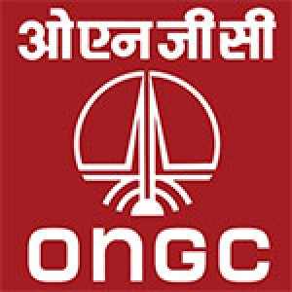**ONGC**

**Oil and Natural Gas Corporation**

During national emergency and natural calamities these Territorial Army personnel are embodiment in which they are liable to perform the assigned duties. The TA personnel of these units perform the same task which they do in their parent department i.e. in ONGC