**Prominent Personalities**

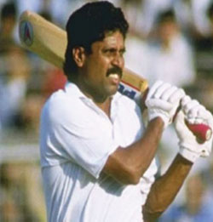**Kapil Dev**

**Kapil Dev**

Granted Honorary Rank of Lieutenant Colonel in TA on 24 September 2008 in infantry battalions  (TA) PUNJAB. The Indian Cricket team under his able Captaincy lifted the CovetedPrudential One Day International World Cup in 1983. On  23rd July  2002, he was awarded “ Wisden Indian  Cricketer of the Century”.

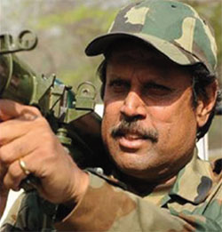**Lt Coy (Hony) Kapil Dev**

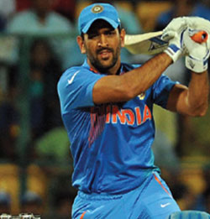**MS Dhoni**

**MS Dhoni**

Granted the Honorary Rank of Lieutenant Colonel in TA on 02 September 2011 in Infantry Battalion (TA) PARA. An international figure representing India for over 10 years in Cricket. Shri MS Dhoni led the Indian Cricket Team to maiden T-20 World Cup in 2007 and in ODI World Cup in 2011.

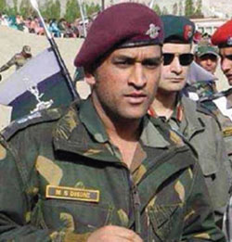**Lt Col (Hony) MS Dhoni**

**Kapil Mohan**

**Kapil Mohan**

Commissioned on 20 May 1959, and has participated in 1965 and 1971 Indo-Pak wars. He was Chairman & Managing Director of Mohan Meakin Limited. Awarded Himachal Ratna by the Government of Himachal Pradesh in 2001.

**Designation**

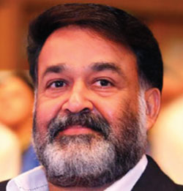**Mohanlal**

**Mohanlal**

Granted Honorary Rank of Lieutenant Colonel in TA on 19 May 2009 in Infantry Battalion (TA) MADRAS. He has toiled through the unpredictable world of cinema in Kerala since 1977 to build a reputation as an artist of immense talent

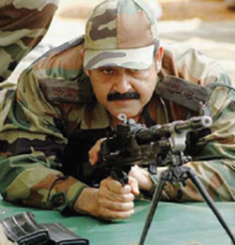**Lt Col (Hony) Mohanlal**

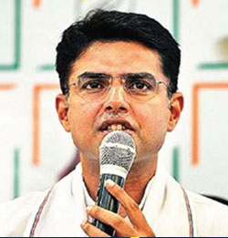**Sachin Pilot**

**Sachin Pilot**

Commissioned on 06 Sep 2012 and posted to Inf Bn (TA) SIKH. He was Hon'ble Minister of State of Government of India.

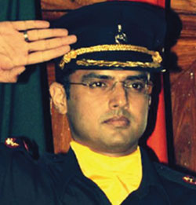**Lt Sachin Pilot**

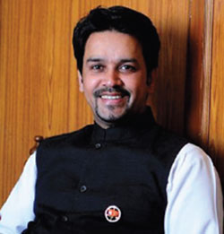**Anurag Singh Thakur**

**Lt Anurag Singh Thakur**

Commissioned on 29 July 2016 and posted to Inf Bn (TA) SIKH. He is a Hon’ble Member of Parliament.

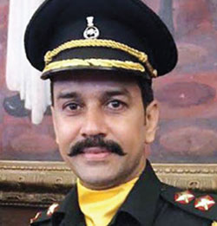**Lt Anurag Singh Thakur**

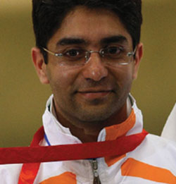**Abhinav Bindra**

**Abhinav Bindra**

Granted Honorary Rank of Lieutenant Colonel in TA on 02 September 2011 in 124 Infantry Battalion (TA) SIKH. Shri Abhinav Bindra, the brightest star among a new breed of talented Indian Shooters, won the first individual Gold Medal at the Olympics in 2010 and also won Gold Medal in Men's 10 meter Air Rifle event at the 2014 Commonwealth Games in Glasgow, Scotland.

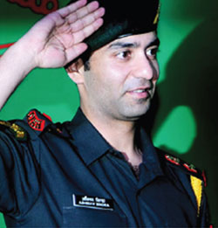**Lt Col (Hony) Abhinav Bindra**

**Birender Singh**

**Birender Singh**

Served in Burma as a Regular Army officer in the Second World War. Commissioned in TA on 31st Aug 1950 and was Union Minister of Agriculture from Jan 1980 to Dec 1984.

**Capt Rao**

**KP Singh Deo**

**Brig KP Singh Deo**

Commissioned in Independent India's first Air Defence Territorial Army Regiment on 01 Jun 1971, the 144 ADTA. Participated in 1971 Indo-Pak war. Appointed Honorary Aide-de-Camp to the President of India in 1994.Awarded Ati Vishisht Seva Medal in 1994 for his services as a TA Officer. He was Minister of State for Defence from Jan 1983 to Dec 1984 and Minister of Information & Broadcasting from Jan 1993 to Sep 1995.

**Designation**

**Brig SS Sawant**

**Brig SS Sawant**

Commissioned on 01 Jun 1993 with antedate seniority from 13 Jun 1978 and posted to 109 Inf Bn (TA) MARATHA LI. The Officer retired as Deputy Director General TA (Inf). He was Member of Parliament.

**Designation**