**TA DAY**

**TERRITORIAL ARMY 70TH RAISING DAY**

Territorial Army (TA) celebrated its 70th Raising Day on 09 October 2019. As per tradition, the TA fraternity led by ADG TA, Maj General DA Chaturvedi, PVSM, AVSM,

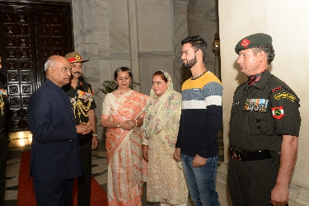

SM called on the President Shri Ram Nath Kovind on 09 Oct 2019 and paid respect to the Supreme Commander of the Armed Forces. The President interacted with offrs and veer naries. As a run up to the Raising Day several events were organised all across the country. TA Marathon was organised at 30 locations across the country to promote a healthy life style.

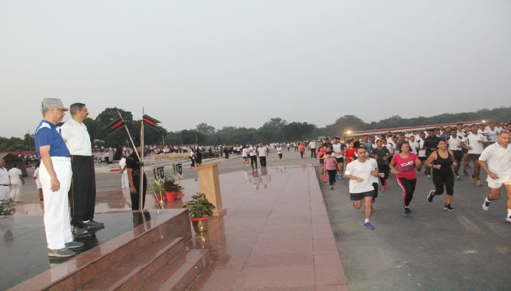

The event consisted of 21km, 10km, and 5km run categories, culminating with distribution of medallion and certificates to all who participated and completed the run as a token of appreciation.

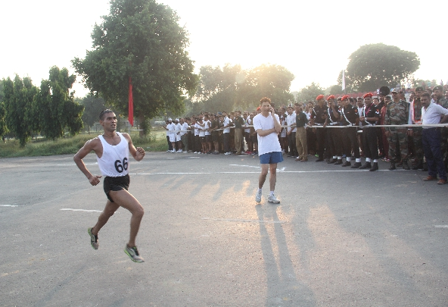

The event consisted of 21 km, 10 km and 5 km run categories, culminating with distribution of medallion and certificates to all who participated and completed the run as a token of appreciation.

On 12th and 13th Oct 2019 the Territorial Army Symphony Band enthralled spectators and tourists at India Gate with melodious and scintillating tunes. The Territorial Army Symphony raised in 2009, consists of more than 40 musicians from all over the country playing Brass, Strings and Indian classical instruments. This symphony band is a representation of ‘Unity in Diversity’ which is the essence of ‘Territorial Army’ also popularly known as the ‘Citizens’ Army’.

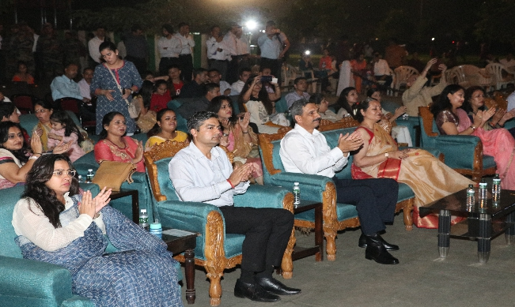

The fusion of Indian traditional with western music enthralled the crowd which had congregated in large numbers drawn by the scintillating performance of the band. The harmonious music at the backdrop of the monumental India Gate watched by thousands of enthralled music lovers added a patriotic fervor to the entire event and was a fitting tribute to the memories of all the gallant soldiers who sacrificed with their lives to safeguard our great Nation.

Territorial Army has a rich history having achieved many glorious feats in the past wars of 1962, 1965 and 1971. The Territorial Army have displayed outstanding grit and courage in operations and in combating terrorism in both J&K and North East garnering numerous awards including 01 Ashok Chakra, 01 Param Vishisht Seva Medal, 01 Kirti Chakra, 06 Ati Vishist Seva Medal, 05 Vir Chakra, 05 Shaurya Chakra, 01 Yudh Seva Medal, 01 Bar to Sena Medal, 78 Sena Medal, 28 Vishist Seva Medal, 01 Uttam Jeevan Raksha Medal, 17 Mentioned -in- Despatches, 280 Chief of the Army Staff Commendation Cards, 103 Vice Chief of the Army Staff Commendation Cards and 832 GOC-in-C Commendation Cards.

The preceding year had been an eventful year for the organisation wherein with exemplary professionalism and devotion the organisation had committed towards serving the Nation better.

The commitment and professionalism of the Departmental TA units have always been impeccable. Their relentless support to the National effort be it the Railways or the Oil sector, have always been commendable and admirable.

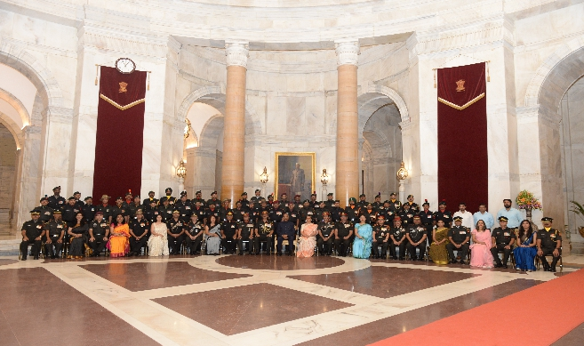

**The President of India, Shri Ramnath Kovind interaction with Territorial Army fraternity at Rashtrapati Bhawan on the occasion of 70th Raising Anniversary of Territorial Army on 09 October 2019.**