<https://github.com/Microsoft/landcover>

Followed the steps mentioned in the GitHub link and downloaded all the files.

Resolved the errors faced and finally was able to create an active session.

Then ran the website on the local host 8080.

Explored the datasets used in the website.

Finally, as the Africa area is being considered, I used ESRI World satellite image data.

Once the local host runs, the landing page is obtained and once the datasets and the models are chosen and the start server is selected and then the web tool gets connected.

So, when the shift+click action is performed a tile is selected and then the land covers are shown and there is a Download option from this tif or png images can be downloaded.

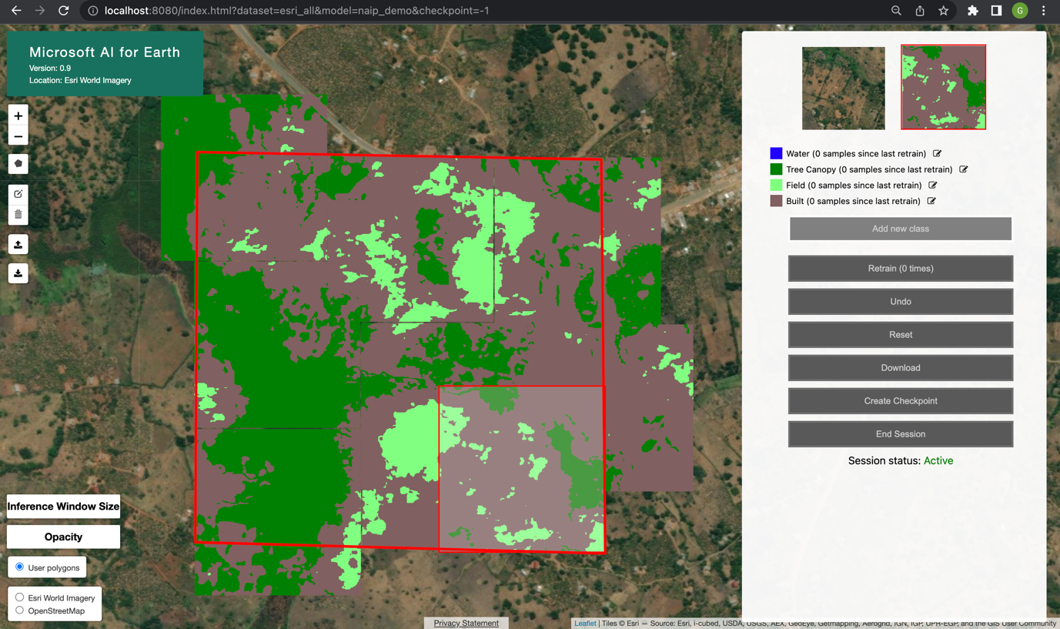

Water is not being correctly classified as seen below.

While water is labelled blue, in the below example, it can be seen that water is identified as Green label which represents Tree.

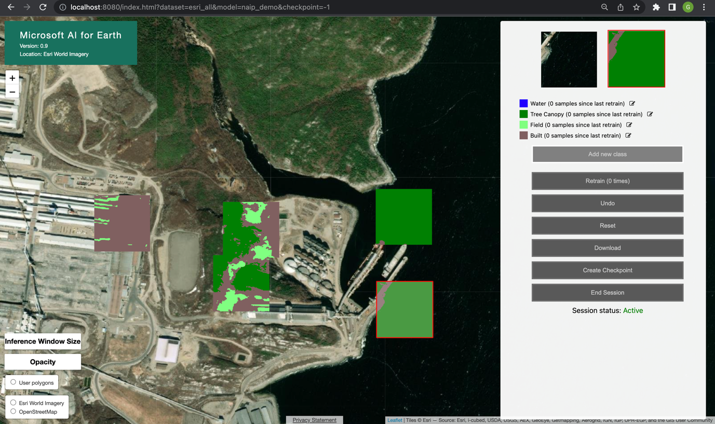

So I tried a lot of exploring how to input an image and then obtain the output labels directly but haven’t clearly understood one.

So, when researching I found on the same Github link, someone had created this as an issue.

I had tried the things mentioned in there but wasn’t clear of the process and so haven’t got any desired result.