Assignments Module – 6 (Core Java)

- W.A.J.P to Take three numbers from the user and print the greatest number.
Ans:
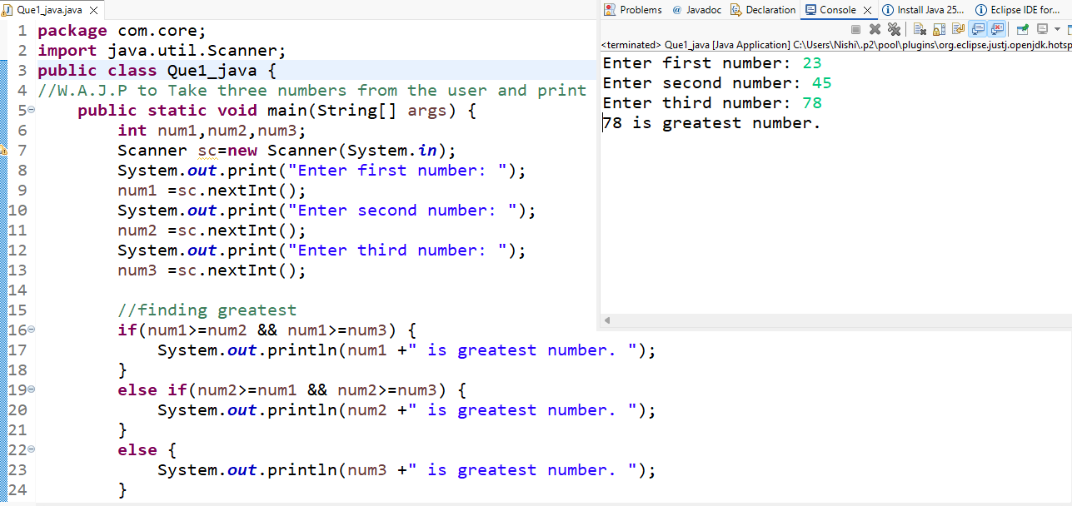
- W.A.J.P in Java to display the first 10 natural numbers using while loop.
Ans:
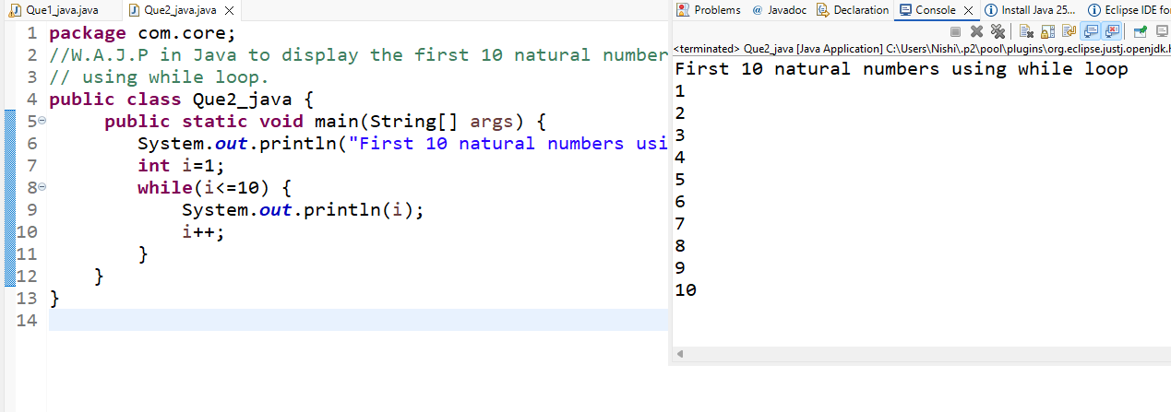

- W.A.J.P to find factorial for Given Number.
Ans:
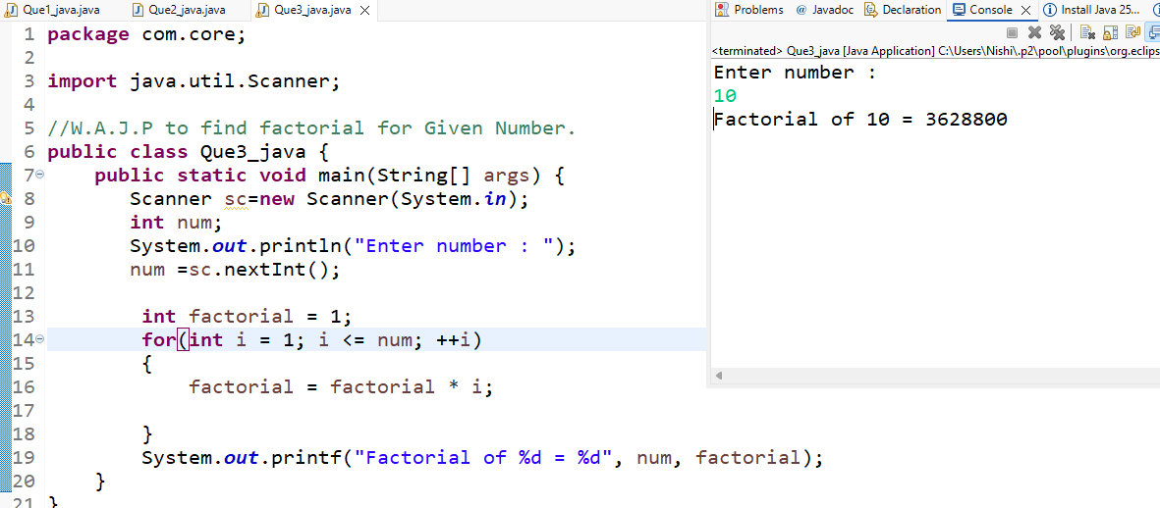
- W.A.J.P to check given number is Prime or not?
Ans:
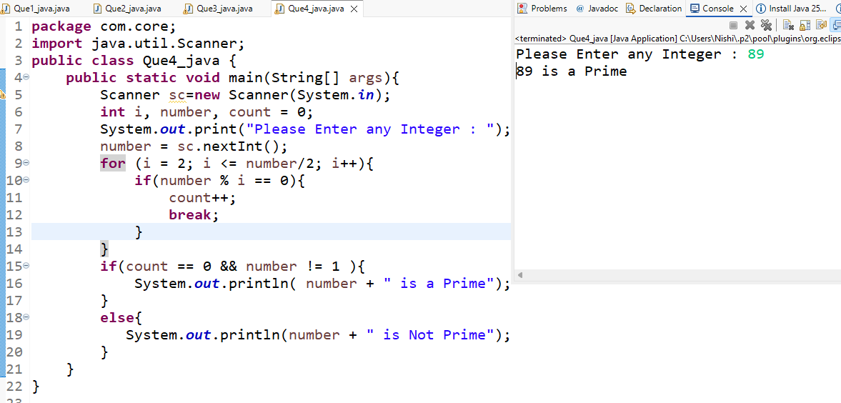
- W.A.J.P to check given number is Armstrong or not?
Ans:
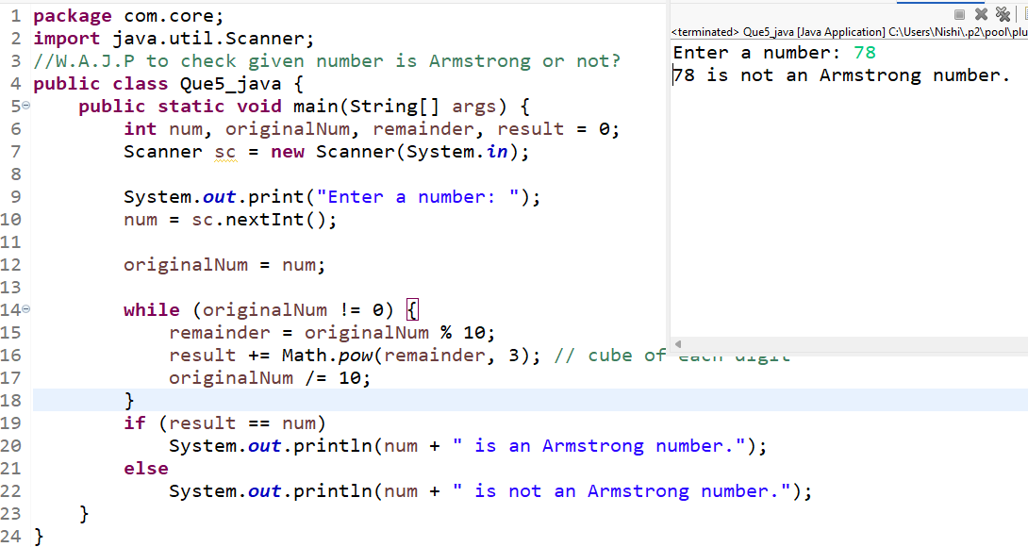
- W.A.J.P for create Fibonacci Series.
Ans:
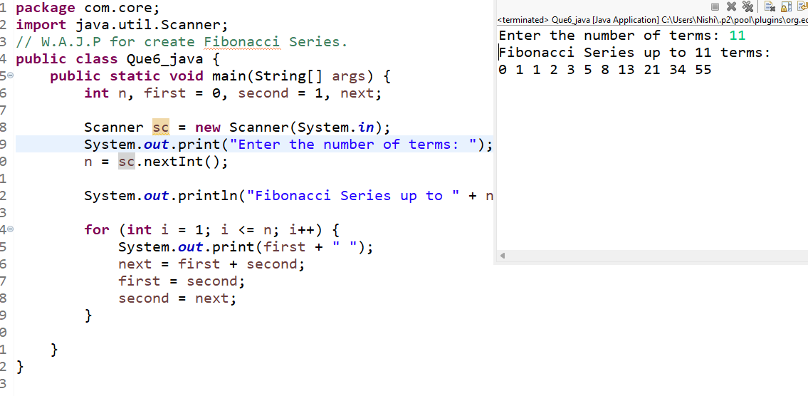
- W.A.J.P to Print pattern Given Below.

1)
1
12
123
1234
12345

Ans:
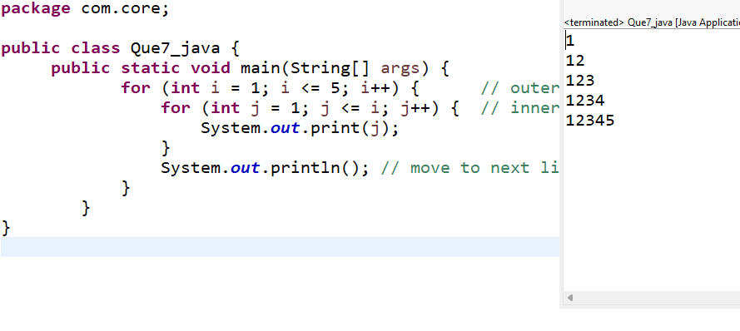
2)
1
12
123
1234
12345
Ans:
3)
1
01
101
01010
101010
Ans:
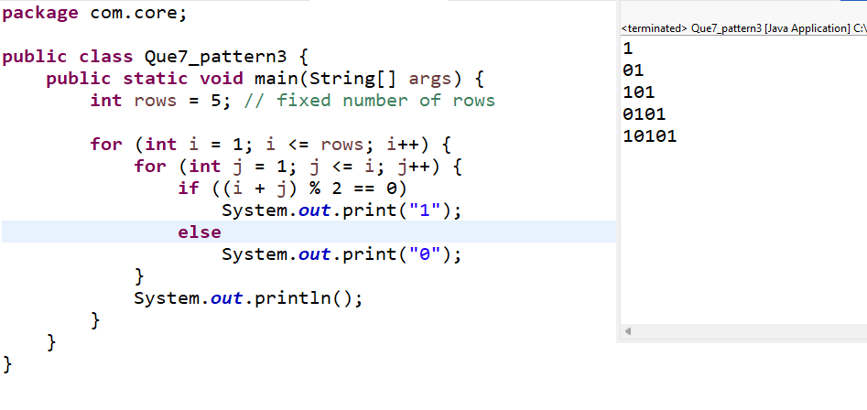
4)
1
2 2
3 3 3
4 4 4 4
Ans:
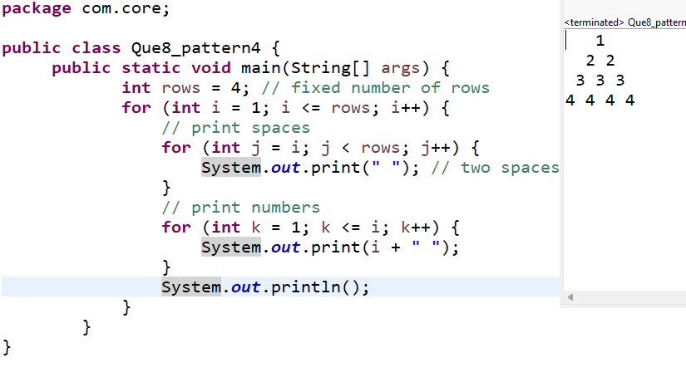
5)
*
* * *
* * * * *
* * *
*
Ans:
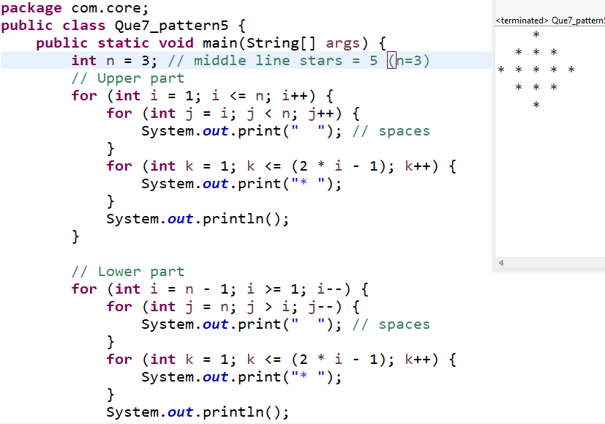

- WAP to compute the sum of the first 100 prime numbers.
Ans:
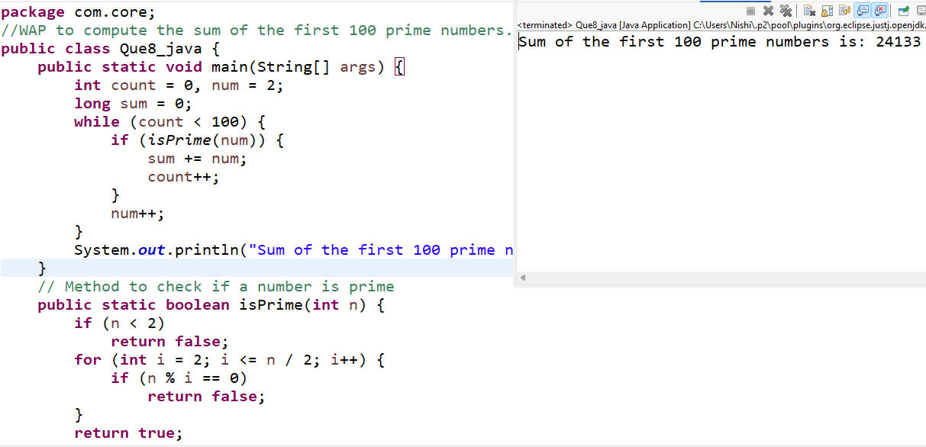
- WAP to sum values of an array.
Ans:
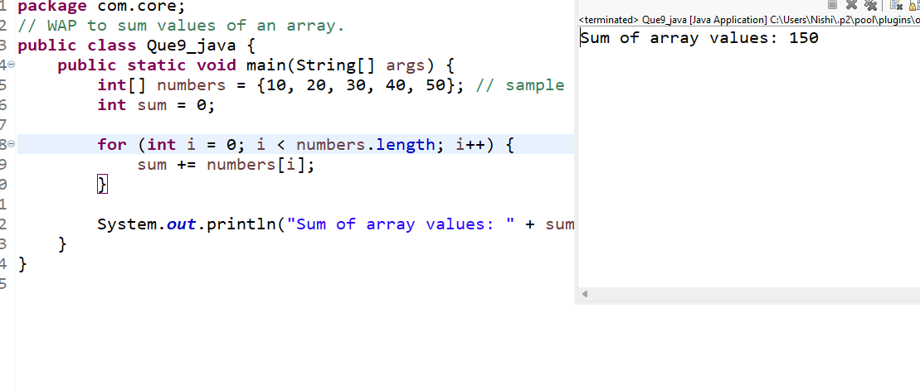
- WAP to calculate the average value of array elements.
Ans:
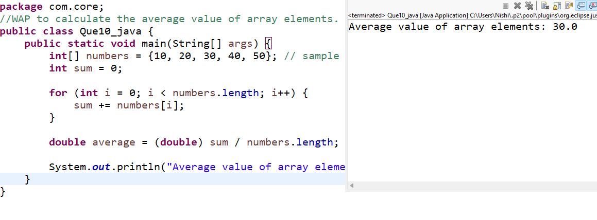
- WAP to find the index of an array element.
Ans:
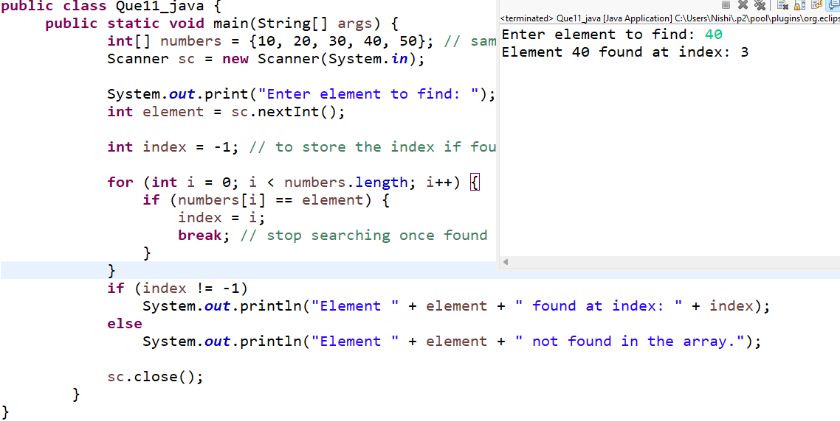
- WAP to find the maximum and minimum value of an array.
Ans:
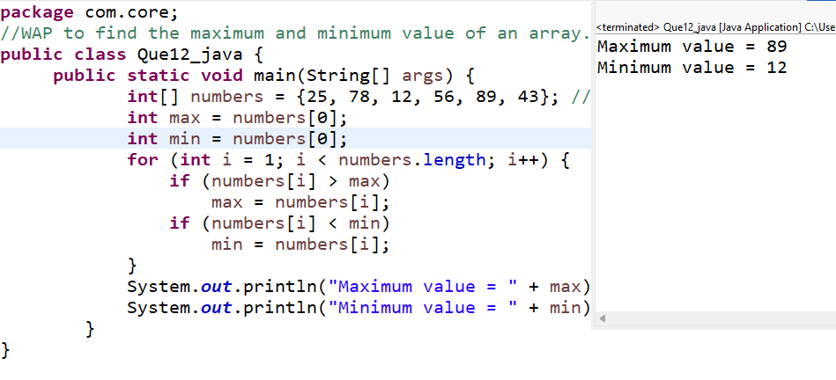
- WAP to Compare Two String.
Ans
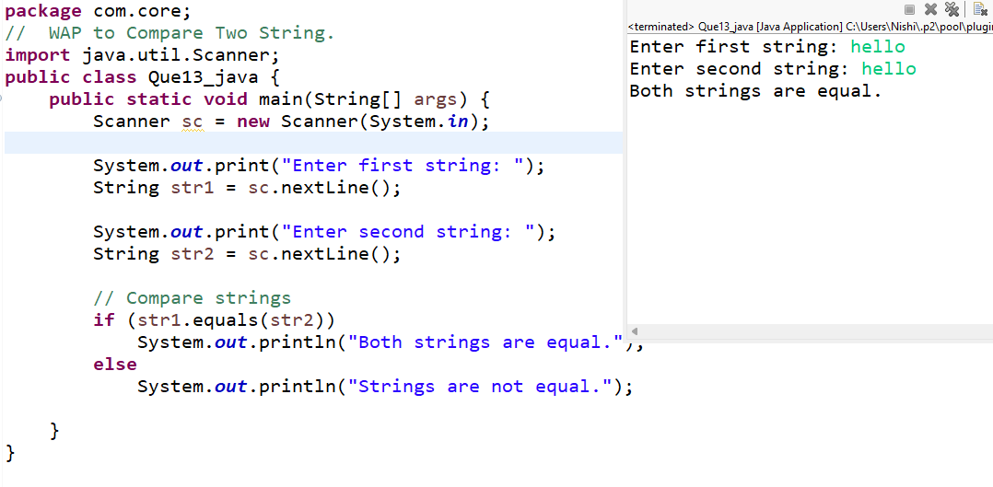
- WAP to concatenate a given string to the end of another string.
Ans:
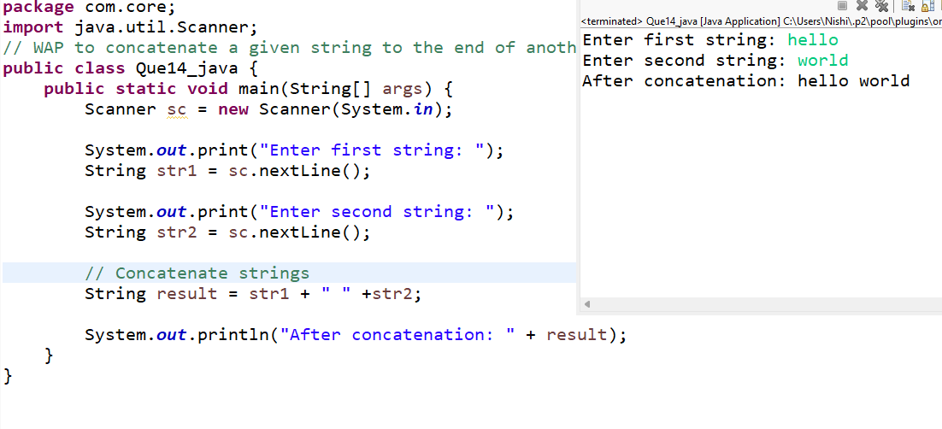
- WAP to demonstrate try catch block.
Ans:
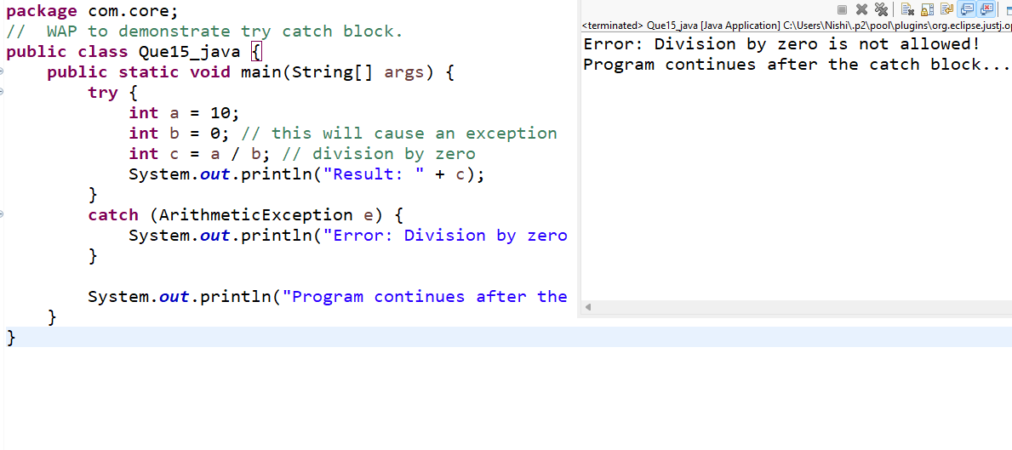
- WAP to demonstrate multiple catch blocks
Ans:
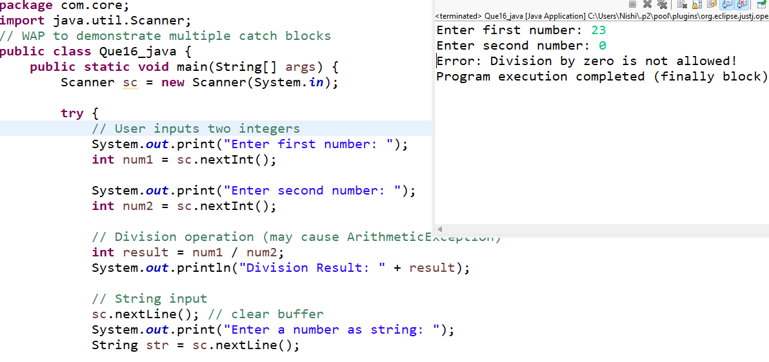
- WAP to create one thread by implementing Runnable interface in Class.
Ans:
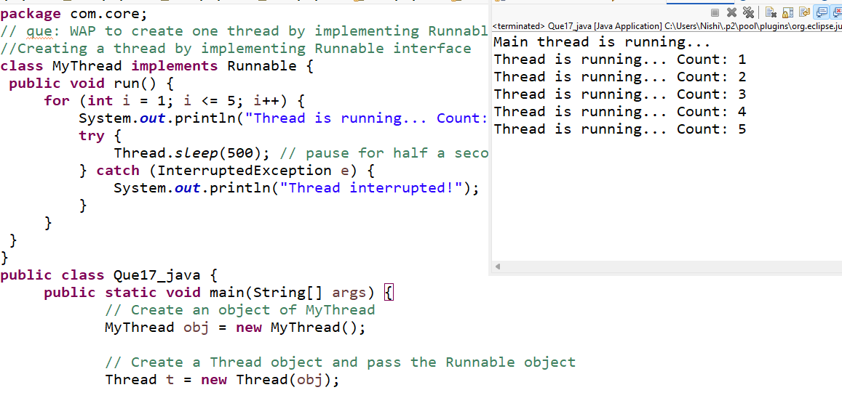
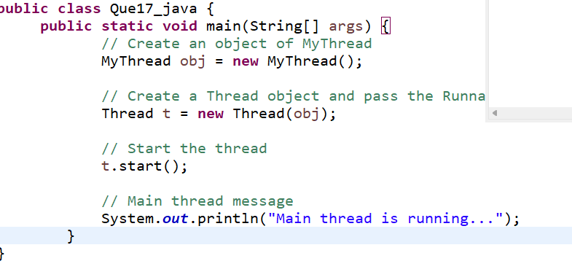
- WAP to create one thread by extending Thread class in another Class.
Ans:
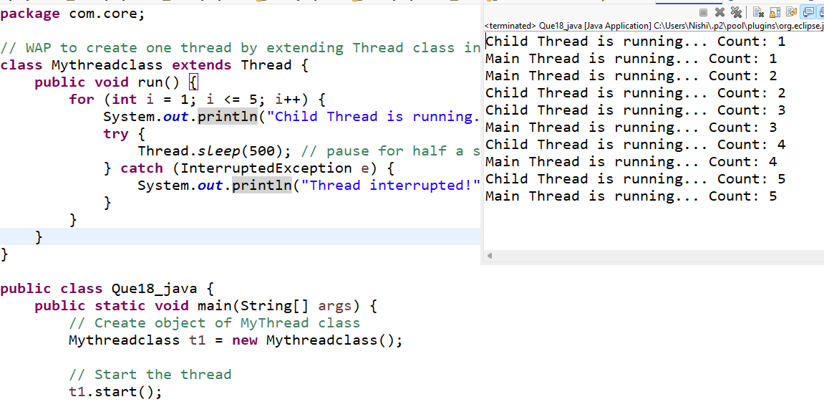
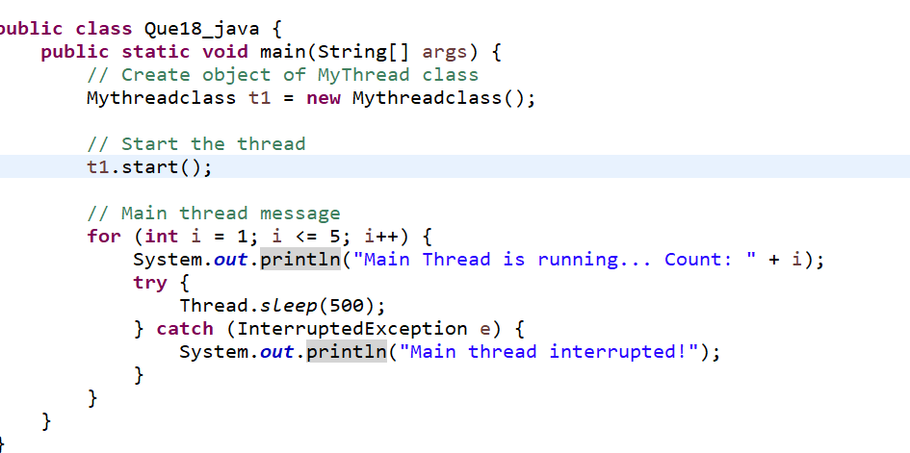
- WAP to iterate through all elements in an array list.
Ans:
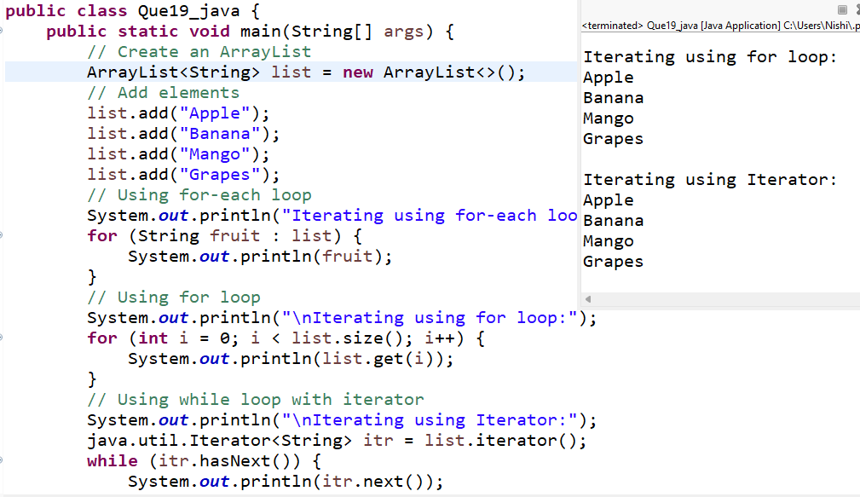
- WAP to update specific array element by given element.
Ans:
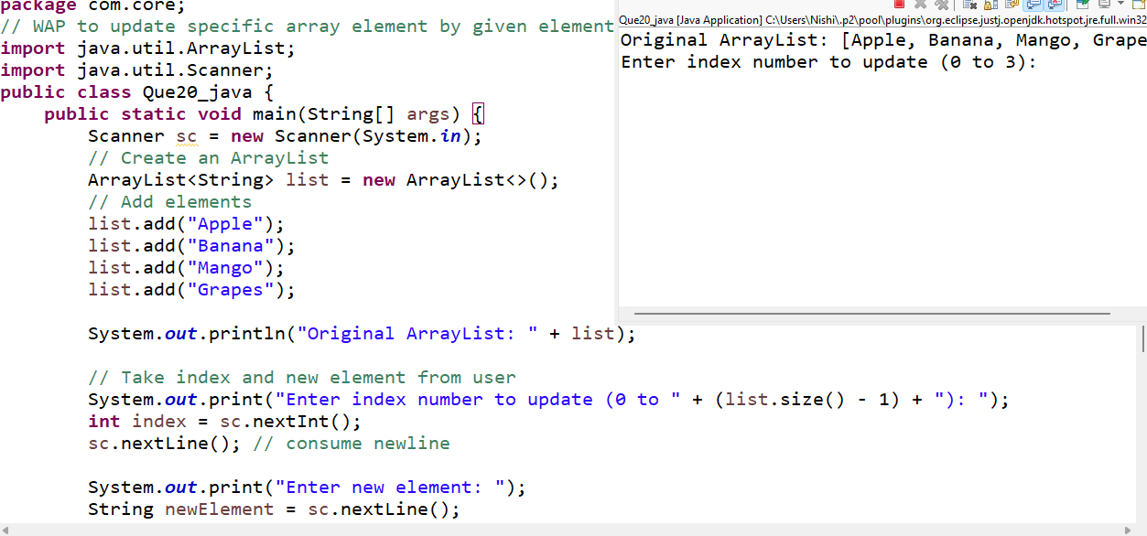
- WAP to remove the third element from a array list.
Ans:
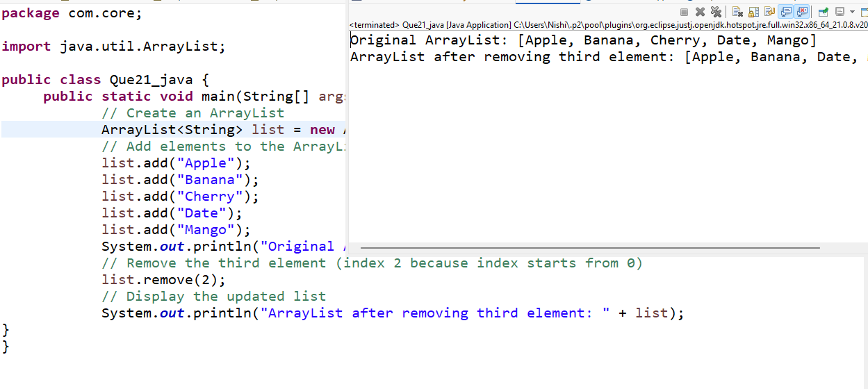
- WAP to Copy one array into another
Ans:
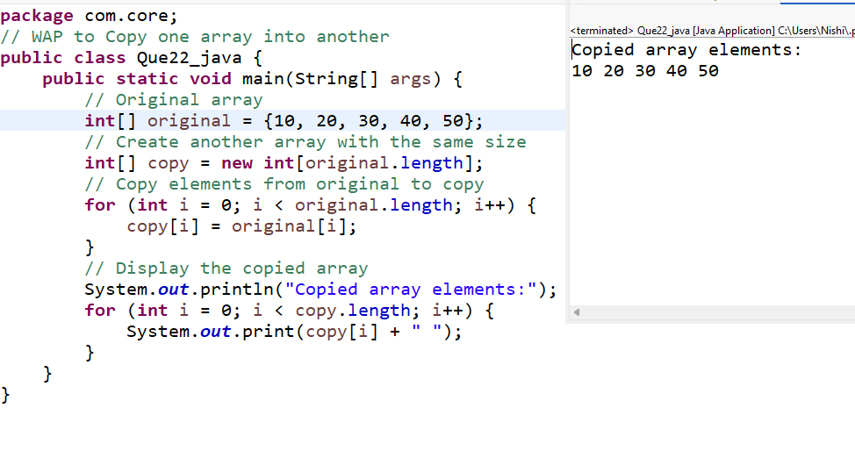
- WAP to reverse an array of integer values.
Ans:
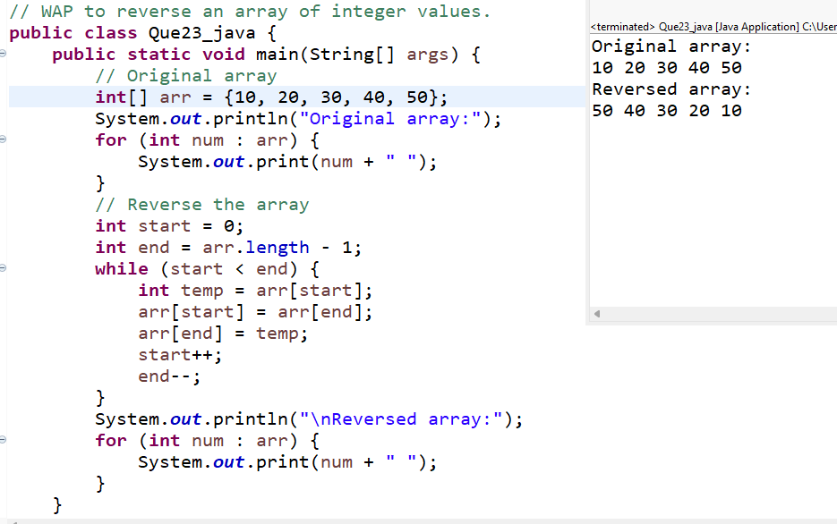
- WAP to find the second largest element in an array.
Ans:
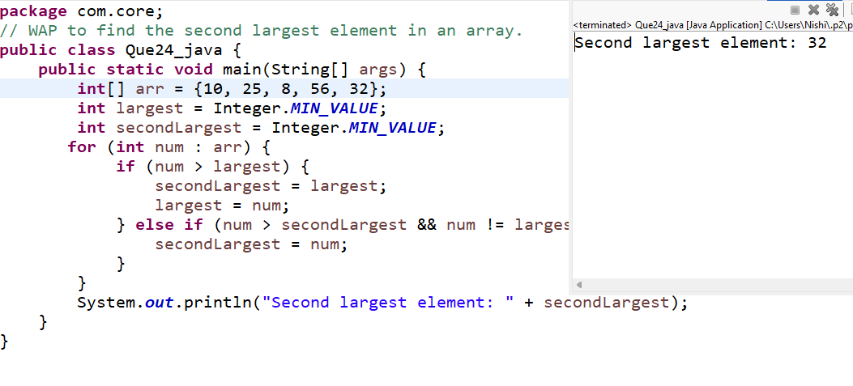
- W.A.J.P. Create an abstract class 'Parent' with a method 'message'. It has two subclasses each having a method with the same name message' that prints "This is first subclass" and "This is second subclass" respectively.
Call the methods 'message' by creating an object for each subclass.
Ans:
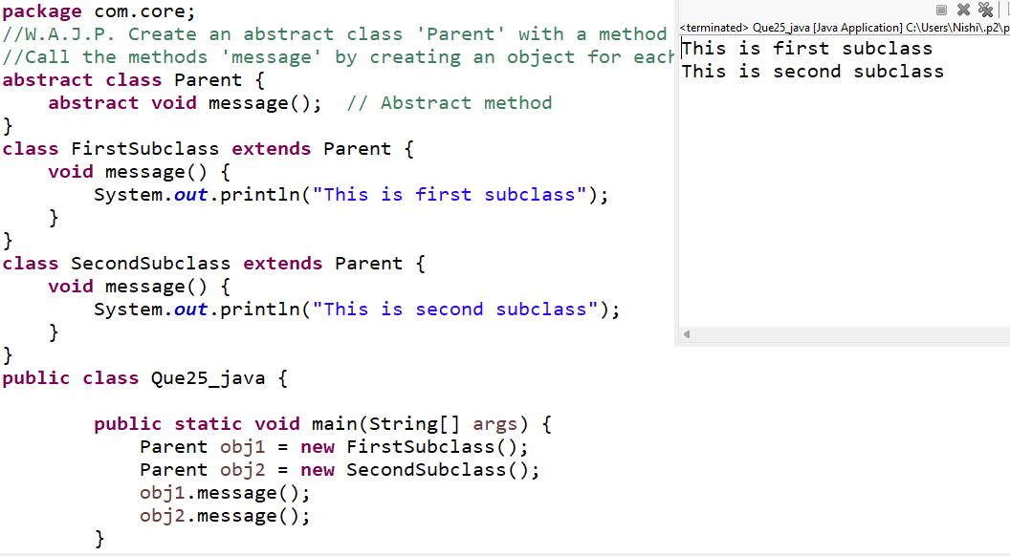
- W.A.J.P. which will ask the user to enter his/her marks (out of 100). Define a method that will display grades according to the marks entered as below:
Marks Grade
91-100 AA
81-90 AB
71-80 BB
61-70 BC
51-60 CD
41-50 DD
<=40 Fail
Ans:
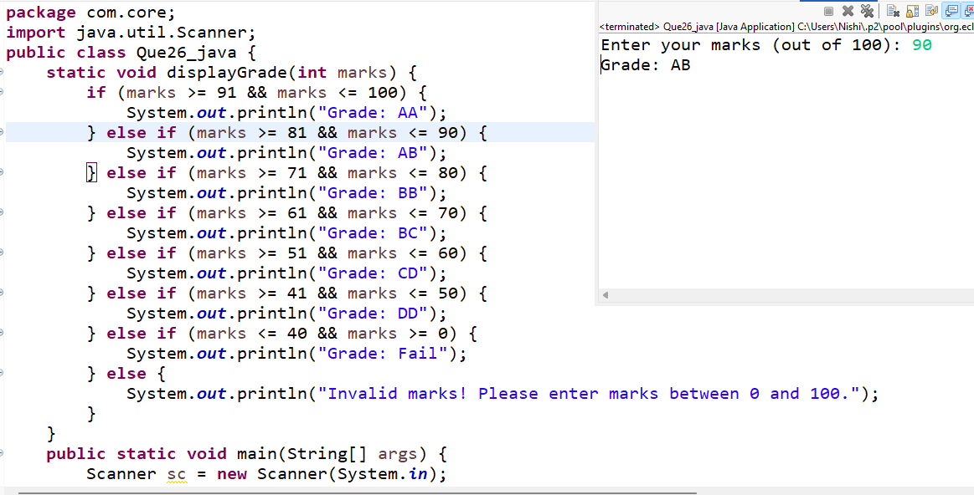

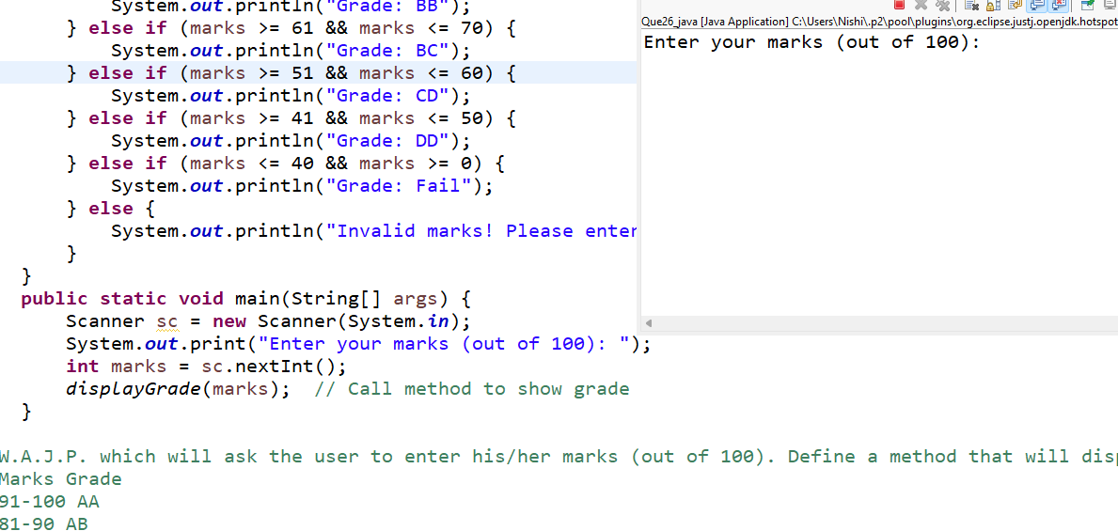

- W.A.J.P. to create a custom exception if Customer withdraw amount which is greater than account balance then program will show custom exception otherwise amount will deduct from account balance.
Account balance is:2000 Enter withdraw amount:2500
Sorry, insufficient balance, you need more 500 Rs.To perform this transaction.
Ans:

