Module – 7 (Selenium Webdriver)
- W.A.J.Script for Locating links by linkText() and partialLinkText()
Ans:
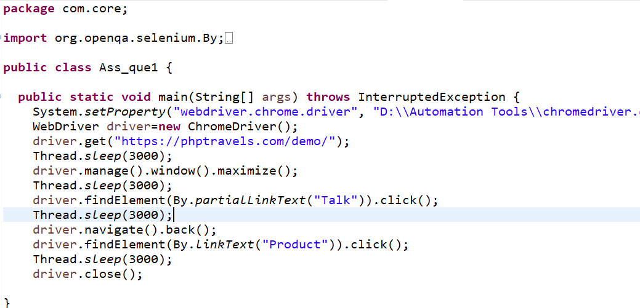
- W.A.J.Script for Selecting multiple items in a drop dropdown
Ans:
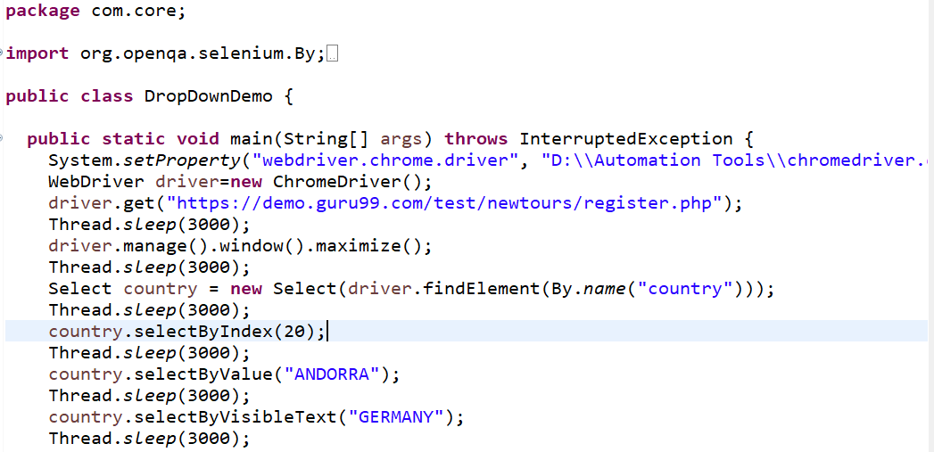
- W.A.J. script to use different methods to manage the windows-alerts and pop ups.
Ans:
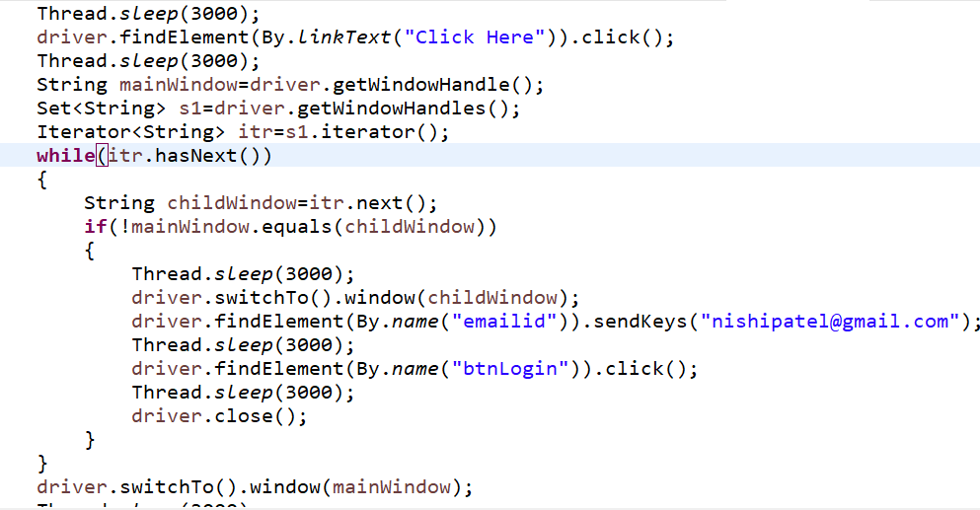
- W.A.J.script to register your self in Gmail.
Ans:

- W.A.J. Script To perform the radio button to select one by one in loop https://demo.automationtesting.in/Register.html

Ans:
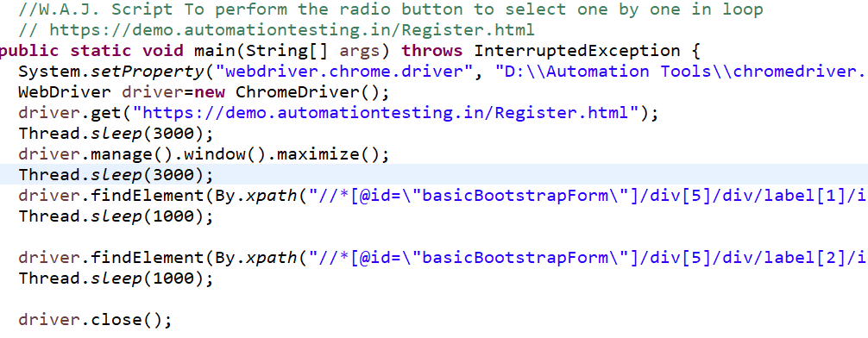

- W.A.J.Script To write a script for drop down. https://demo.automationtesting.in/Register.html

Ans:
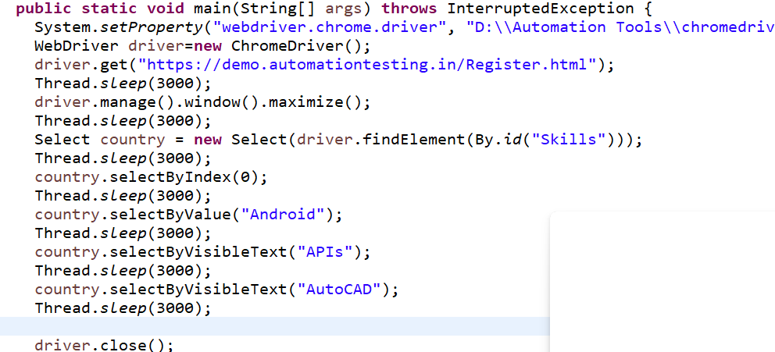

W.A.J.Script To use Mouse and Keyboard event using Action class
1. Mouse Hover Event

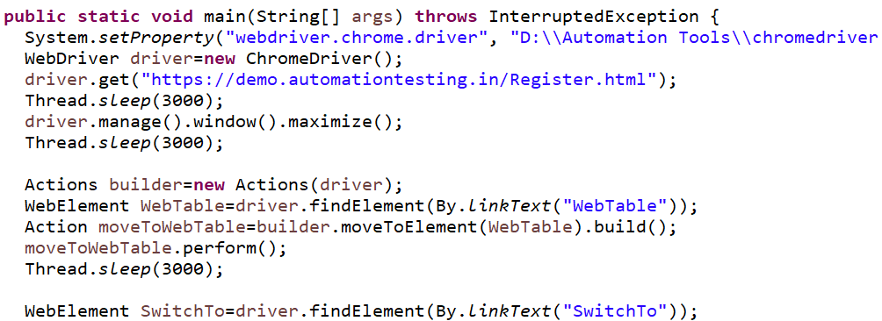
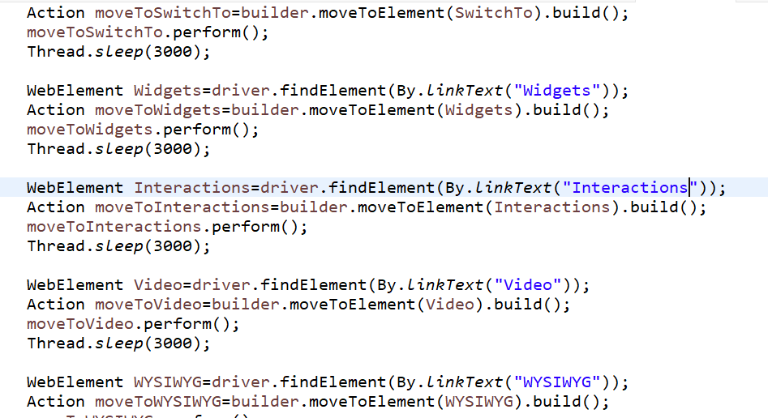

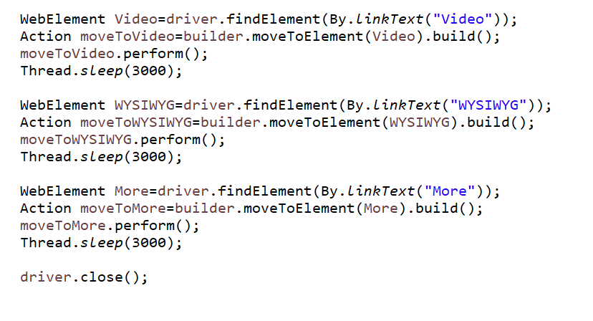

- W.A.J. Script How to handled Alert in selenium https://demo.automationtesting.in/Alerts.html

Ans:

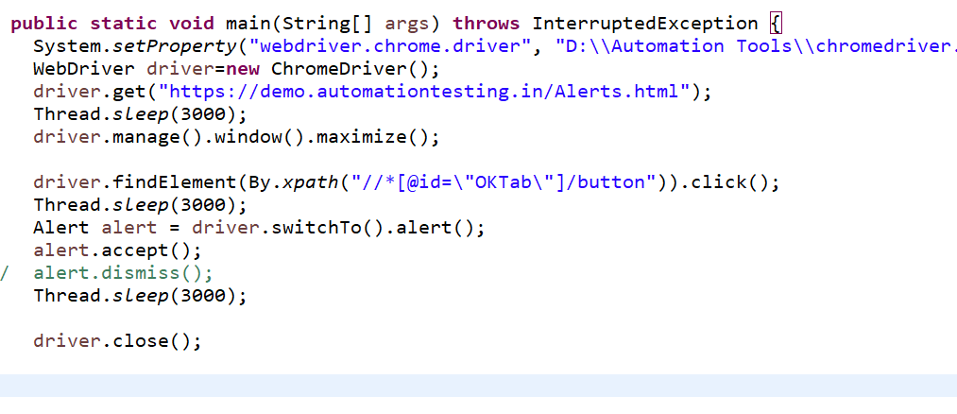

- W.a.junit program to handled Assert class with all method to check its pass or fail
Ans:
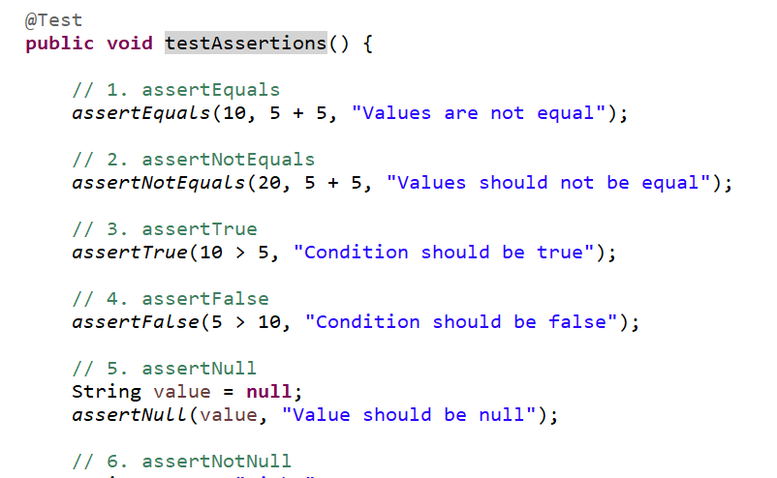
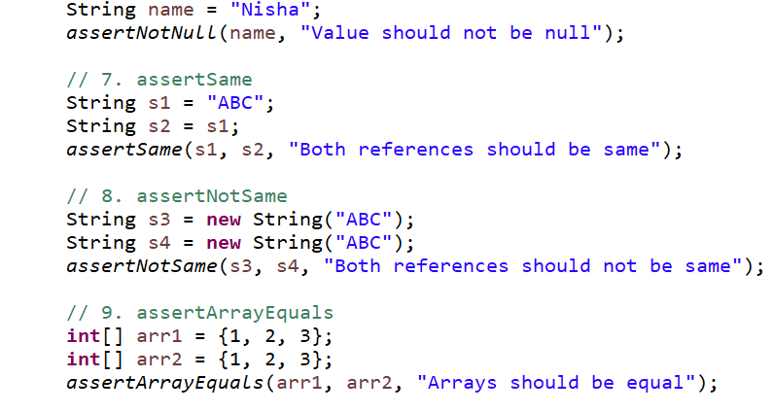
- W.a. junit program to perform test with webdriver to login process of facebook
Ans:
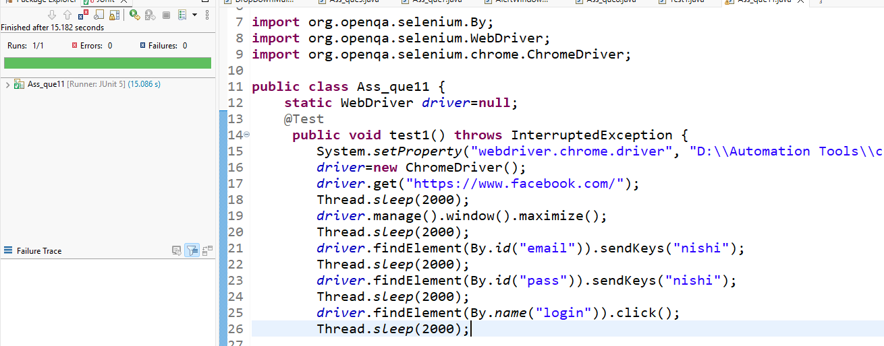
- W.a. junit program to check gmail login using with @before,@after,@Test
Ans:
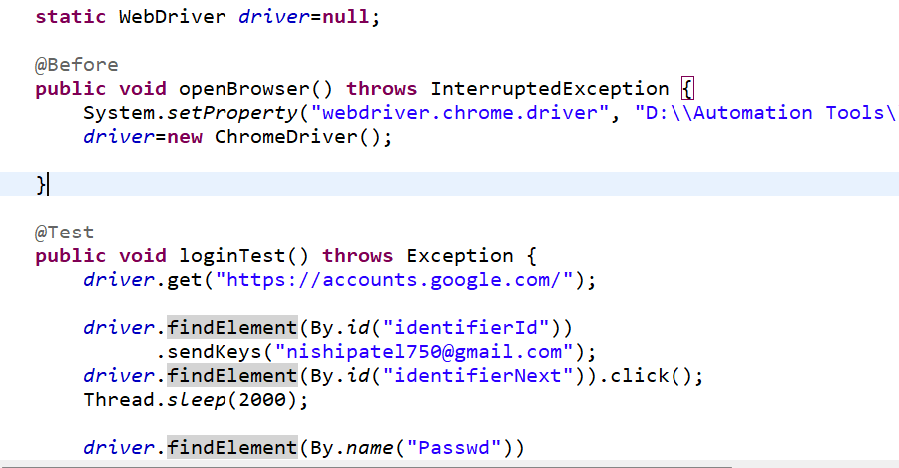
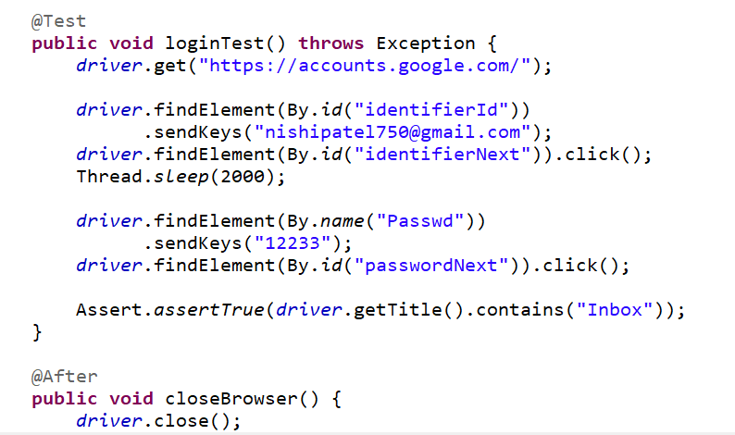
- W.a. TestNG program to perform test with webdriver to login processof facebook
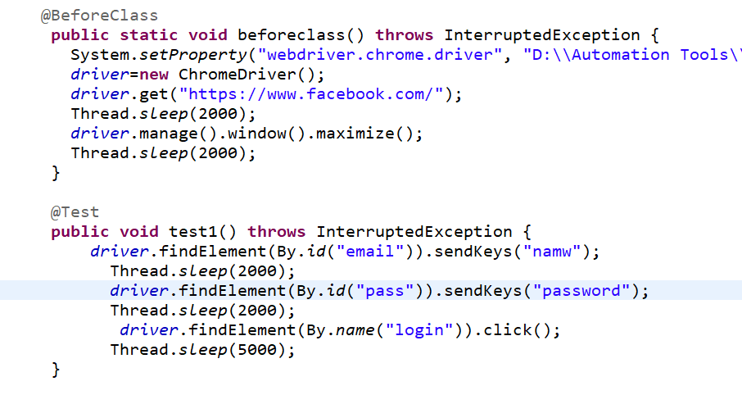
Ans: 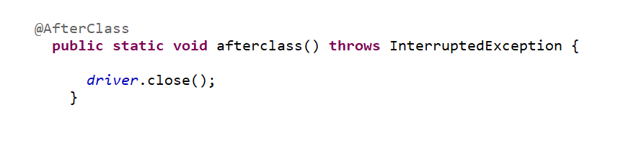
- W.a. TestNG program to check gmail login using with @beforetest,@aftertest,@Test
Ans:
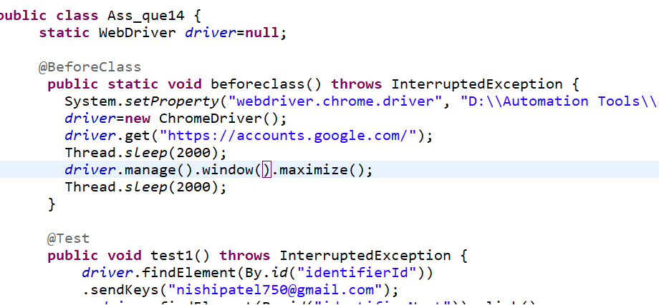
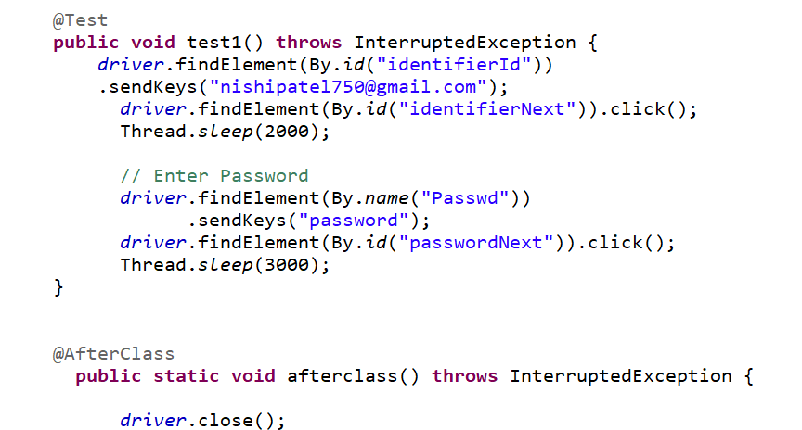

- W.a. TestNG program to create group with testing.xml file
Ans:
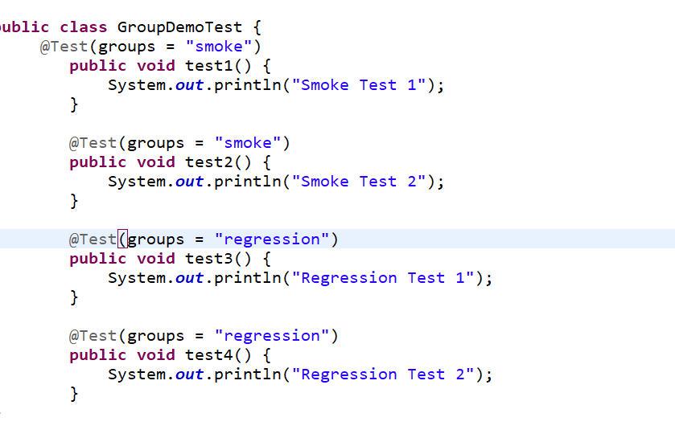
- w.a. TestNG program to create dataprovider.
Ans:
