A Mid-Term Report on
Job Recommendation and Resume
Screening System Using Natural Language Processing


Submitted at:
Birat Multiple College, Biratnagar, Morang
Submitted by:
Bibek Karki(29777/078)
Bijesh Regmi(29778/078)
Nisip Sigdel(29783/078)
BSC.CSIT VII Semester
Birat Multiple College, Biratnagar, Morang

JULY, 2025

ABSTRACT
This study proposes an intelligent system designed to optimize job search and recruitment processes through advanced resume screening and personalized job recommendations. Leveraging Natural Language Processing (NLP) techniques—including BERT (Bidirectional Encoder Representations from Transformers), lemmatization, vectorization, and Cosine Similarity—the system processes both resumes and job descriptions to ensure precise semantic matching. For job seekers, resumes are preprocessed through lemmatization to normalize text, NER based entity labeling and vectorization to emphasize key terms. For recruiters, job descriptions follow the same processing pipeline. The system then applies Cosine Similarity to compare candidate resumes with job descriptions, generating ranked lists of job opportunities for applicants and top candidates for recruiters. Additionally, a feedback mechanism enables recruiters to provide evaluations, which are used to iteratively refine future resume on job seeker’s side. By unifying contextual understanding, text normalization, and semantic similarity into a single framework, the system enhances the accuracy, efficiency, and fairness of the job-candidate matching process.
Keyword: Natural Language Processing (NLP), Resume Screening, vectorization, Cosine Similarity, Candidate Evaluation, resume parsing

Table of Content

SN | Topics | Page Number
0 | Abstraction | i
1 | Introduction | 1
1.2 | Statement of the Problem | 1
1.3 | Objectives | 2
1.4 | Scope and Limitation  1.4.1 Scope  1.4.2 Limitation | 2
1.5 | Development Methodology | 3
1.6 | Report Organization | 3
2 | Background Study and Literature Review | 4
2.1 | Background Study | 4
2.2 | Literature Review | 5
3 | System Analysis | 6
3.1.1 | Requirement Analysis | 6
3.1.2 | Feasibility Study | 8
3.1.3 | Analysis | 10
4 | System Design | 12
4.1 | Design | 12
4.2 | Algorithm Details | 15
5 | Implementation and Testing | 16
5.1 | Implementation | 16
5.2 | Testing | 17
5.3 | Result Analysis | 19
6 | Conclusion And Future Recommendation | 19
6.2 | Future Recommendation | 20
7 | References | 21

CHAPTER 1: INTRODUCTION
  - Introduction
In today’s competitive job market, both job seekers and recruiters face numerous challenges in finding the right match. Candidates often struggle to identify opportunities that align with their skills and experience, while recruiters face difficulties in efficiently screening large volumes of resumes to find qualified applicants. This mismatch not only slows down the hiring process but also increases the risk of overlooking potential talent due to inefficient or biased screening methods.
We believe that the integration of intelligent technologies into the recruitment process can significantly improve the efficiency, fairness, and accuracy of job-candidate matching. With the growing availability of job-related data and advancements in Natural Language Processing (NLP), we see an opportunity to address the existing gaps through automation and semantic analysis.
Our proposed system leverages NLP techniques—such as lemmatization, BERT (Bidirectional Encoder Representations from Transformers), vectorization, and Cosine Similarity—to create a robust framework for resume screening and personalized job recommendations. By analyzing both resumes and job descriptions through the same semantic pipeline, the system ensures meaningful matching based on skills, qualifications, and experience rather than simple keyword overlaps.
Additionally, the system features a feedback mechanism that allows recruiters to provide constructive input on candidate resumes. This feedback can help job seekers identify and address shortcomings in their profiles, ultimately improving their chances of securing relevant employment. In a world where the job market is rapidly evolving, such a system can empower both job seekers and employers by making the hiring process more data-driven and less prone to human bias.

1.2. Statement of the Problem
The current recruitment process is inefficient, biased, and heavily reliant on manual or keyword-based resume screening, which often fails to capture the true relevance between candidates and job roles. This leads to missed opportunities for job seekers and increased workload for recruiters. The issue is more severe in regions with limited access to career guidance, like parts of Nepal. There is a need for an intelligent system that can semantically match resumes with job descriptions, reduce bias, and offer feedback to help candidates improve. This study is focused on:
i. What are the limitations of existing resume screening and job recommendation systems in providing accurate and meaningful matches?
ii. How can the use of Natural Language Processing (NLP) techniques to improve the recruitment process by semantically understanding both resumes and job descriptions?
iii. How effective is the integration of such techniques in enhancing resume-job matching and reducing bias?

1.3. Objectives
The primary objective of this project is to develop a job recommendation and resume screening system utilizing Natural Language Processing to enhance the efficiency, accuracy, and fairness of the recruitment process in a single platform.
The specific objectives of the study are listed below:
i. To develop an automated, NLP-powered system for accurate and unbiased matching between candidate resumes and job descriptions, enhancing efficiency in the recruitment process.
ii. To provide personalized job recommendations for candidates and enable recruiters to give feedback for iterative resume improvement.

1.4 Scope and Limitation
1.4.1 Scope
The possible scope of the system includes:
1.Platform: The system is accessible via web application , allowing user to login in using internet connection
2.Users: The system has three user roles: Admin, Job seeker, Recruiter
3. Resume Screening: The user can upload their resume, which will be parsed and relevant information will be extracted.
4.Manage Profile: The user have the abality to create and manage their own profiles including personal information, resume data and job description
5. Job searching: The user can view relevant jobs with their resume and can apply for the jobs directly from the website
6.Talent seeking: The User can post the job application and view the submission in their job posting.
5.Feedback: The system provides a feedback mechanism for direct feedback to the job seekers
1.4.2 Limitation
Though the project covers a range of features, it still has the following limitaitons:
1. The system is based on web only, and there no mobile application.
2. The application requires an active internet connection.
3. The system favors English language and primarily, potentially hindering individuals who are more comfortable with other languages.
1.5 Development Methodology
For our project we have selected the evolutionary prototyping model as it allows us to develop our work in repeatable manner, allowing us to continuously improve. Each new version of the prototype brings new and improved features and functionality
The prototyping model methodology involves building an initial prototype with basic functionality. This model helps to visualize the representation of the final product. By collecting feedback from initial testing, we can identify the potential improvements and address many issues based on the feedback. Additional improvements will be made continuously until the final product that satisfies all the requirement.
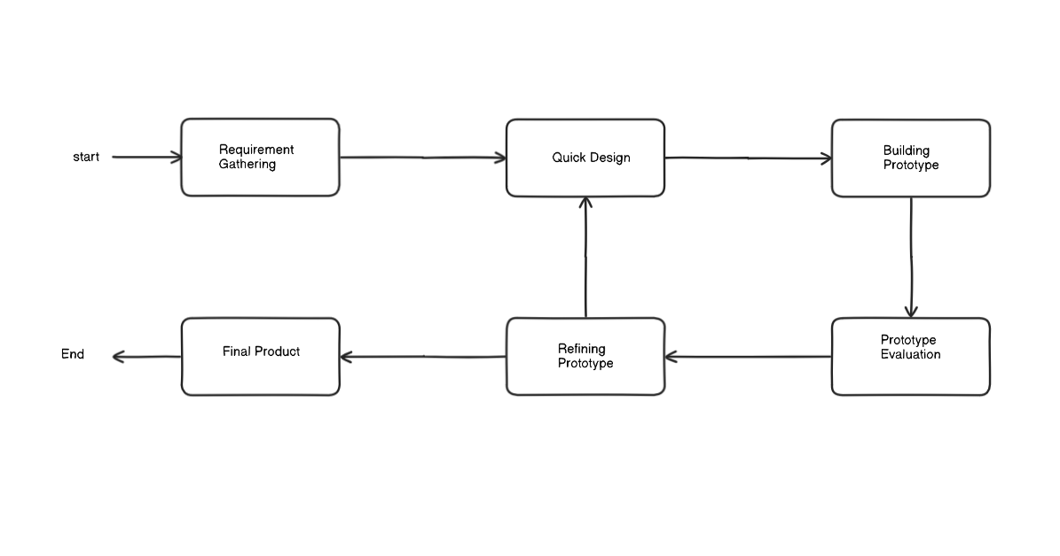
Fig: Prototyping Model
1.6 Report Organization
Chapter 1 provides and overview of the project, introducing its significance and addressing the identified problem. The chapter outline the objectives, defines the scope and limitations,
Presents the chosen development methodology and provides an overview of the report organization
In Chapter 2, the background study includes fundamental theories, concepts and terminologies related to the project. The literature review offers a comprehensive overview of similar or relevant projects, theories and findings by other researchers, establishing a context for the project
Chapter 3 focuses on system analysis exploring in-depth requirements through function and non-functional aspects. It includes a feasibility study analysis covering technical, operational, economic, and schedule aspect. The structural approach, ER diagrams, process modeling using DFD are detailed.
Chapter 4 moves to the design phase, presenting the database design, transformation of ER to relations. The chapter also discuss the user interface design and algorithm details.
Chapter 5 includes the practical aspects of the projects. It describes the tools used in the implementation phase such as programming language, framework, data manipulation and visualization, design tools etc. Includes the implementation details of modules and algorithms developed thus far. Testing is also covered with details on unit testing and results.
The final chapter, Chapter 6 draws conclusions based on the findings and outcome of the project. It also outlines potential future recommendation for further enhancement or expansion for the project, bringing the report to a comprehensive close.
2. Background Study and Literature Review
2.1. Background Study
Traditional recruitment methods—both manual and automated—exhibit considerable inefficiencies. Human screeners often face high application volumes, leading to inconsistent evaluations and unconscious bias influenced by names, educational institutions, or formatting styles [1], [2]. This results in potentially strong candidates from non-traditional or underserved backgrounds being overlooked [3].In Nepal, some platforms have introduced ATS features to digitize hiring, including auto-generated job descriptions and AI-driven applicant ranking. However, these systems primarily rely on exact keyword matching, often missing semantic nuances, synonyms, and context. Consequently, many job seekers receive no responses, and recruiters still conduct much of the screening manually [4], [5].
Commercial job portals tend to offer basic filters—such as location, keywords, or salary—but lack deep semantic search capabilities. Additionally, these systems risk reinforcing existing societal biases embedded in historical hiring data [6], [7]. The situation is especially challenging in regions of Nepal with limited access to career guidance and digital infrastructure, leaving many competent candidates disconnected from meaningful opportunities [5].
There is a growing demand for an intelligent, bias-aware system that can semantically match resumes with job descriptions and offer personalized feedback to job seekers, improving both fairness and efficiency in recruitment.
2.2. Literature Review
Recent advancements in Natural Language Processing (NLP) have shown promise in transforming recruitment workflows. NLP enables automated systems to understand, interpret, and process human language in resumes and job descriptions more accurately than traditional keyword-based methods. In [8], researchers highlight how NLP improves candidate-job matching by capturing contextual and semantic information, reducing the shortcomings of rule-based and keyword-only systems.
Resume parsing—critical for digitizing and structuring unformatted resume data—has also seen significant evolution. The study in [9] evaluates various machine learning techniques used for parsing resumes and highlights the challenges in handling non-standard resume formats, ambiguous section headings, and varied terminology. These limitations affect the accuracy of candidate profiling and shortlisting.
To improve job-resume alignment, matching algorithms now integrate deep learning and attention mechanisms. The work in [10] explores state-of-the-art models that consider both job requirements and candidate experience as structured entities and apply embedding techniques to achieve semantic similarity. These methods outperform traditional ranking techniques by learning from real-world hiring data and adapting to industry-specific language.
However, the rise of automated hiring systems has raised ethical concerns regarding bias and fairness. Study [11] critically examines how machine learning models can encode and perpetuate social biases related to gender, ethnicity, and socioeconomic background. The authors advocate for fairness-aware algorithms, transparent data use, and regular bias audits in hiring systems to ensure equitable outcomes.
Together, these studies form a foundation for building intelligent, fair, and context-aware recruitment platforms—especially relevant for regions like Nepal, where manual processes and lack of semantic filtering remain major limitations.

CHAPTER 3: System Analysis
3.1 System Analysis
3.1.1. Requirement analysis
The goal of the proposed system is to bridge the gap between job seekers and recruiters by providing intelligent, accurate, and personalized job-candidate matching. To achieve this, both functional and non-functional requirements must be carefully analyzed and defined.
i. Functional Requirements
1. User Roles:
a. Job seeker:
- Create and manage profile
- Upload and update resume
- Search and view job opening
- Apply for jobs
- Receive feedback
b. Recruiter:
- Create and manage profile
- Upload and update job posting
- View job applications
- View resumes
- Provide feedback
c. Admin:
- Create, monitor and manage user profile
- Create, update and edit the job application
- Communication with users
2.System Roles:
- Platform for users
- Resume and Job Description Input
- Similarity Matching
- Feedback Mechanism
- Result Presentation

Use Case Diagram
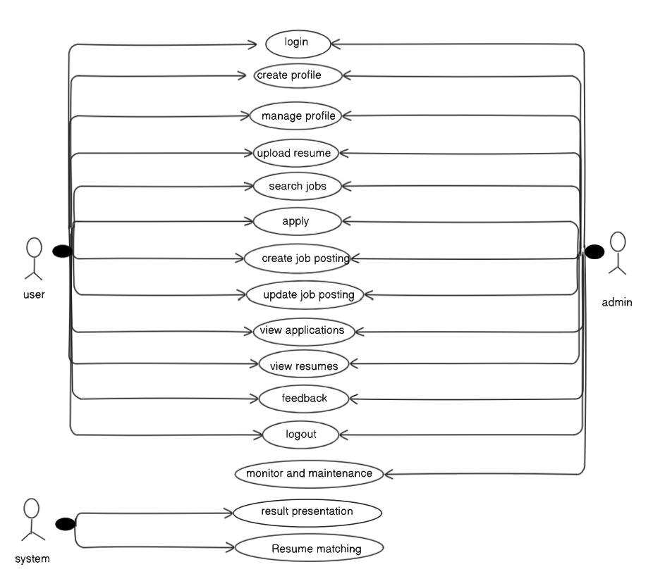
Fig: Usecase Diagram

Use case Description

Actor | User case | User case Description
User | Create profile | Users can register and create their profile
User | login | User can login using their credentials
User | Manage profile | User can update their profile like name, profile,etc
User | Upload resume | User can upload their resume.
User | Update resume | User can update their resume
User | View resume | User can view their or other user’s resume
User | View jobs | User can view the available jobs
User | Apply for jobs | Use can apply for jobs
User | Post jobs | User can post new jobs
User | Update jobs | User can update the existing job
User | Feedback | User can send and receive feedback
User | Logout | User can logout
Admin | Manage User | Admin can manage user such as creating, deleting and updating the user and their details
Admin | Monitor and maintenance | Admin can monitor the overall system performance and have ability to do maintenance
System | Resume Matching | System can match the resume with job description and provide a ranked list based on similarity
Fig: Usecase Description
ii. Non-Functional Requirements
- These ensure the system performs reliably, efficiently, and securely.
a. Usability
- The system must have a simple, intuitive UI for both job seekers and recruiters.
- Responses and results should be easy to understand, even for non-technical users.
b. Performance
- The system should respond within a few seconds for standard-sized documents. It must support concurrent users without noticeable performance degradation.
d. Accuracy
- The use of NER and vectorization must ensure a high level of matching accuracy.
- Matching algorithms should be validated using relevant metrics
e. Security and Privacy
- Resume and job data must be securely stored and accessible only to authorized users.
- Feedback should be confidential and used responsibly to improve the system.
f. Maintainability
- The system should be well-documented, allowing future updates or model enhancements.
3.1.2. Feasibility Study
i. Technical Feasibility
The proposed system is technically feasible, given the availability and maturity of the technologies required. The key components—Natural Language Processing (NLP), semantic similarity analysis, and machine learning—are widely supported by modern libraries and frameworks. Some of the technologies and tools include:
- NER(Name Entity Recognization ) for semantic understanding of words
- IF-IDF for vectorization
- Cosine Similarity for semantic comparison.
- Python as the primary programming language due to its robust support for data science and NLP
- Node/ExpressJs for backend server and React for frontend development.
ii. Operational Feasibility
The proposed system is operationally feasible and can be easily integrated into existing recruitment workflows. The system is designed to serve two user groups:
- Job Seekers, who upload resumes and receive personalized job recommendations.
- Recruiters, who input job descriptions and receive ranked lists of qualified candidates.
The interface will be user-friendly and require minimal training. Additionally, the feedback system allows recruiters to guide applicants in improving their resumes, making the system interactive and valuable in the long run.
iii. Economic Feasibility
From an economic perspective, the system is feasible with a relatively low cost of development and maintenance:
- Development Tools: Most of the required tools and frameworks (e.g., Python, Scikit-learn, Spacy library) are open-source and freely available.
- Infrastructure: Initial development can be done using free or low-cost cloud resources. For deployment, a basic server would suffice.
- Manpower: A small team of developers with experience in NLP and web development can build the product.

iv. Schedule Feasibility
- The project has been carefully broken down into manageable phases with clearly defined deliverables and timelines.
- Each phase targets specific milestones and have deliverables.
- Additionally, the final few weeks are reserved for preparing comprehensive documentation, internal reviews, final presentation, and submission.
- With proper planning, task distribution, and time management, the system can be successfully designed, implemented, tested, and delivered within the given academic schedule.
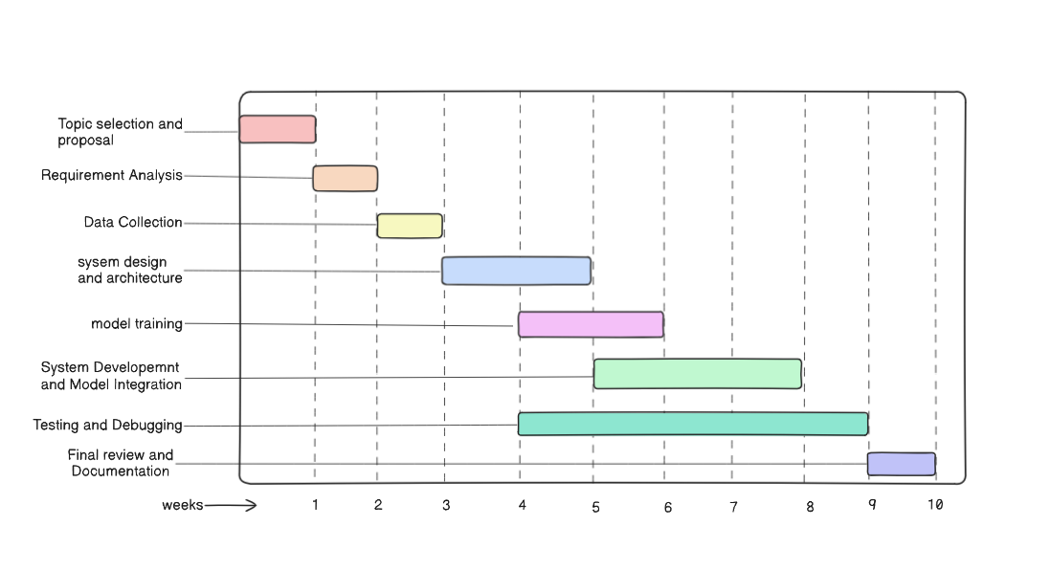
Fig: Gantt Chart
3.1.3 Analysis
This system follows structural approach, with data modeling using ER diagram and process modeling using DFD.
i) Entity Relationship (ER) Diagram
An Entity-Relationship (ER) diagram is a visual representation of the data model that depicts the relationships between entities withing a system. It is commonly used in database design to illustrate the structure of a database and how different entities interact with each other. Entities represent objects or concepts about which data is stored. Attributes represent characteristics or properties of entities. Relationships represent connections or associations between entities. The ER diagram of our proposed system is given below:
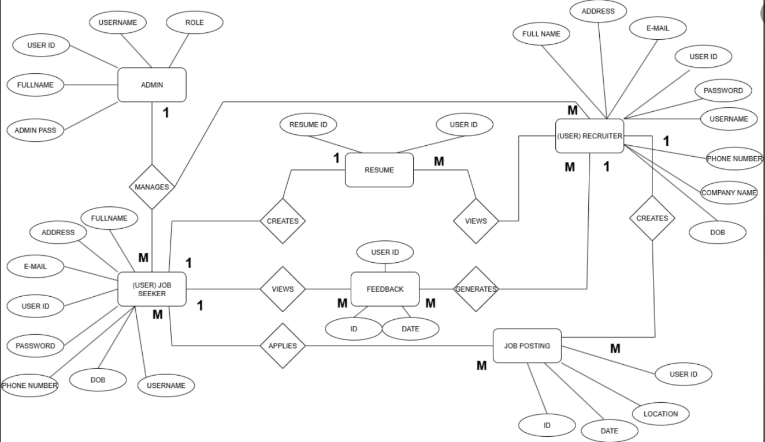
Fig: ER Diagram

ii)Data flow Diagram
A Data Flow Diagram (DFD) is a graphical representation of how data moves through a system. It shows the flow of information between processes, data stores, external entities, and data flows. DFDs help visualize system operations and are commonly used in system analysis and design to understand and document system requirements.
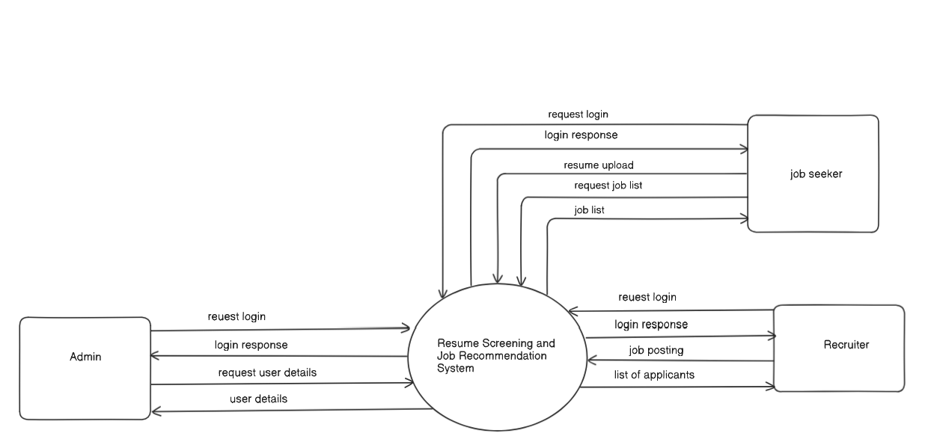
Fig: Context Diagram

Chapter 4: System Design
4.1 Design
4.1.1 System Architecture Design
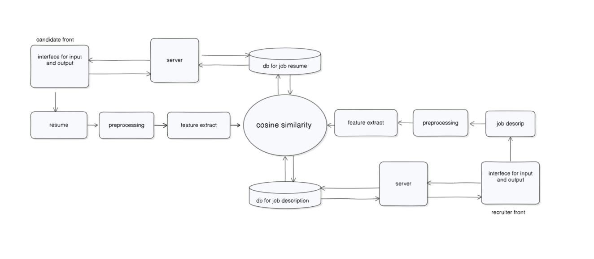
Fig:System architecture Design of Job Recommendation and Resume screening system
This diagram illustrates the architecture of a our system using cosine similarity for ranking resumes against job descriptions. The system is divided into two main user interfaces: the candidate front and the recruiter front. Candidates upload their resumes through the input interface, which are then sent to the server for preprocessing (such as text cleaning and normalization) and feature extraction. Simultaneously, recruiters submit job descriptions through their interface, which undergo similar preprocessing and feature extraction. The extracted features from both resumes and job descriptions are stored in their respective databases. These features are then compared using cosine similarity to determine how well each resume matches the job description. The similarity results are processed by the server and sent back to the respective interfaces, allowing recruiters to view ranked candidates and candidates to receive feedback. This system automates and enhances the resume screening process, improving recruitment efficiency and relevance.
4.1.2 Interface Design
The overall ui design of our system is as follows:

i) Homepage
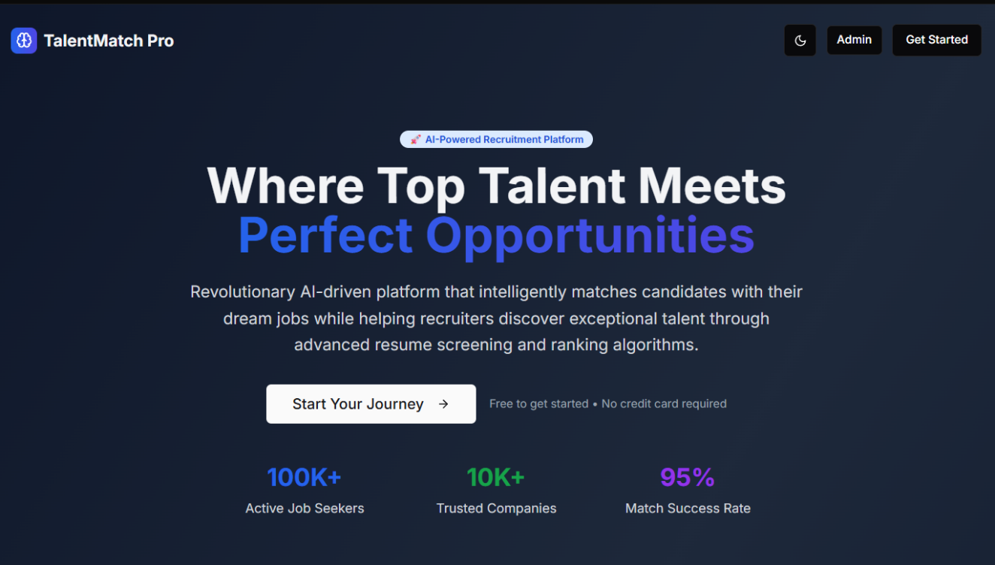
ii)User selection page
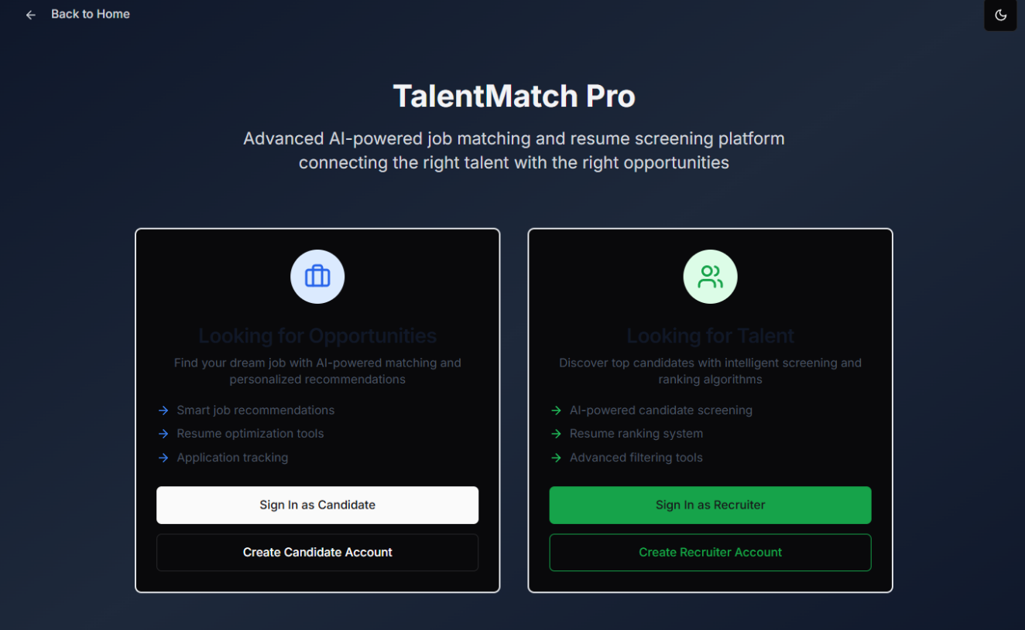

iii)Login Page
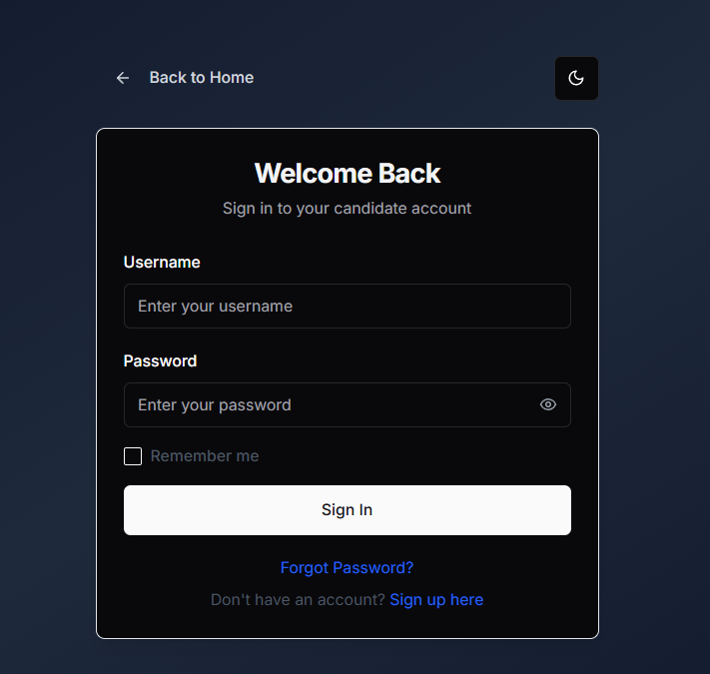

iii)User Registration Page
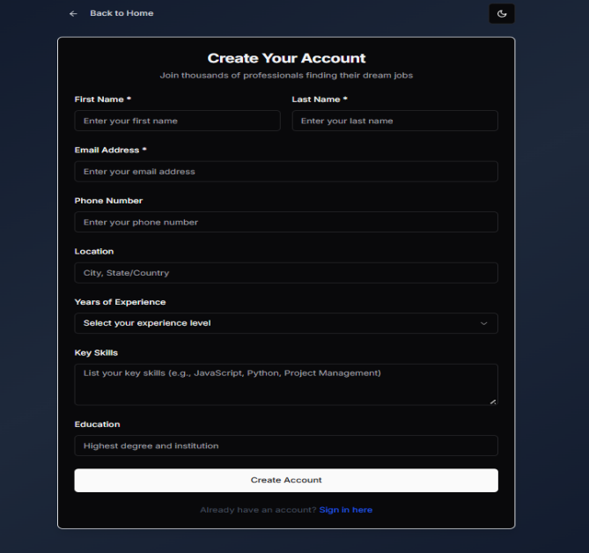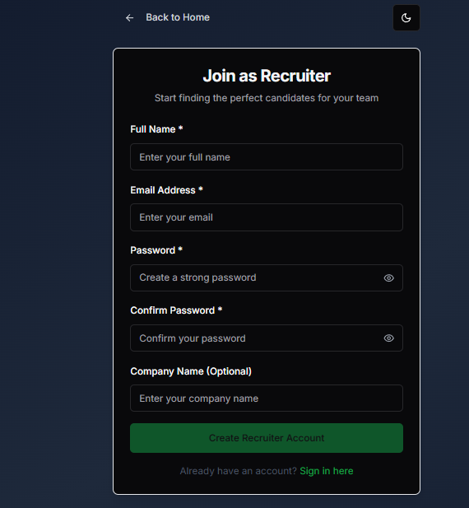

iv)User Dashboard
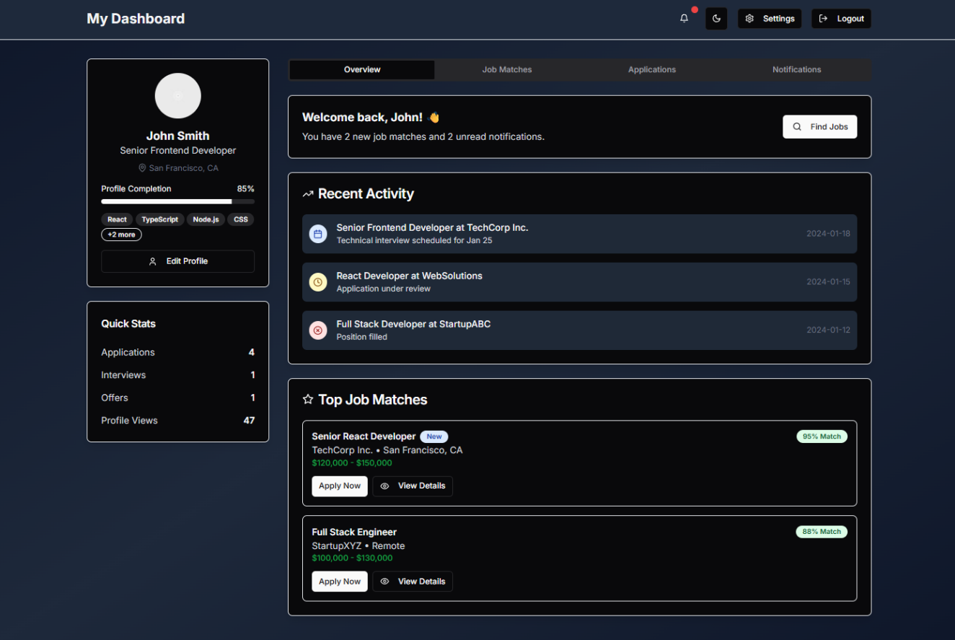

4.2 Algorithm Details
The system employs a multi-stage pipeline to process resumes and job postings, extract relevant information, and perform intelligent matching. This algorithm leverages a combination of text extraction, natural language processing (NLP), and information retrieval techniques.
The system integrates several key algorithmic components to achieve its functionality:
- Data Acquisition and Text Extraction: This initial phase focuses on converting various document formats (primarily PDFs) into raw, readable text. It utilizes PDFPlumber for extracting text from machine-readable PDFs, prioritizing its layout preservation capabilities. For scanned or image-based PDFs, Tesseract OCR (accessed via PyTesseract) serves as a fallback, converting image data into text, often with pre-processing steps like de-skewing for accuracy. The output of this stage is a unified raw text string for each document.
- Text Pre-processing and Feature Extraction: Once raw text is obtained, spaCy is heavily employed for linguistic processing. This involves:
- Tokenization, Lowercasing, and Stop Word Removal: Breaking text into individual units, standardizing case, and removing common, semantically weak words.
- Lemmatization: Reducing words to their base forms (e.g., "running" to "run") to reduce dimensionality and improve consistency.
- Named Entity Recognition (NER): Leveraging spaCy's models to identify and classify entities like PERSON, ORG, GPE, DATE, and PRODUCT. This is crucial for structured information extraction.
- Skill and Keyword Extraction: Beyond general NER, domain-specific rules or lexicons are used to explicitly identify technical and soft skills relevant to the context.
- Structured Data Population: The extracted information from NER and keyword identification is then used to populate a predefined JSON schema for each resume and job posting, enabling structured data access.
Chapter 5: Implementation and Testing
5.1 Implementation
5.1.1 Tools Used
a) Programming Language
- HTML: HTML 5 is the latest web standard with semantic elements, multimedia support, canvas for graphics, and enhanced form features, enhancing web development
- CSS3: CSS is a cascading style sheet used to style the visual presentation of HTML documents on the web.
- JavaScript: JavaScript is a versatile dynamic programming language used for web development, enabling interactive and dynamic features, enhancing user experience and efficient web development.
- Tailwind: Tailwind is a css framework that follows class based approach to cs writing, making writing css easy, intuitive and fast.
- Python: Python is a high level dynamic programming language used in various fields such as ai and machine learning s that makes working with machine learning models and data processing easy.
- NodeJS: NodeJS is a JavaScript runtime environment that uses chrome’s v8 engine to run JavaScript on the server, it’s single threaded nature and support of event driven approach makes it suitable for real time application
- PostgreSQL: PostgreSQL (or Postgres) is a powerful open-source relational database management system (RDBMS). It uses SQL to manage structured data in tables with rows and columns, and supports complex queries, transactions, and data integrity. Known for its stability, extensibility, and support for advanced features like JSON data types, custom functions, and full-text search, PostgreSQL is widely used in enterprise and web applications where data consistency and reliability are critical.
b) Configuration Management Tool
Git: Git is a popular version system used in software configuration management tool. It allows to track and keep record of a document or file allowing user to go back and forth between version, allow to make copies of the file and merger various file.
GitHub: GitHub is a repository hosting platform for git repository, allowing user to
store and manage the source code. It keeps track of changes made to the codebase overtime allowing use to view the entire version history of a project
c) Drawing Tool
Draw.io: Draw.io, is a free and versatile online diagramming tool that allows users to create a wide range of diagrams, flowcharts, and other visual representations. It supports collaborative editing. Integration with various cloud platforms and provides an intuitive interface for creating and customizing diagrams. We used it for drawing ER diagrams and Data Flow Diagrams
5.2 Testing
5.2.1 Test Cases for Unit Testing
Unit testing is a software testing technique where individual components or functions of a program are tested in isolation to ensure they work as expected. Each test checks a small, specific piece of code—usually a function or method—by providing inputs and verifying the output or behavior. It helps catch bugs early, improves code reliability, and makes future changes safer. Below are the few unit testing for our project developed thus far.
Test Case 1: UI testing
1)Form validation Testing:
a) User login Test:
SN | Test Input | Expected output | Actual output | Result
1 | Login with valid username and password | Login success | Redirected to user profile dashboard | Test  Successful
2 | Login with invalid username and password | Login  unsuccessful | Invalid username and password | Test  Successful
3 | Some field are empty  E.g. username:user123  Password: | Login Unsuccessful | Empty field error | Test  Successful
4 | All field are empty  E.g. username:  Password: | Login Unsuccessful | Empty field error | Test  Successful

b) User registration Test:
SN | Test Input | Expected output | Actual output | Result
1 | All field empty | Registration unsuccessful | Focus of empty field | Test  Successful
2 | Registration with already registered email | Registration unsuccessful | Email is already registered | Test  Successful
3 | Registration with already registered username | Registration unsuccessful | Username is already taken | Test  Successful
4 | Registration with unique email and username | Registration successful | Redirected to user dashboard | Test  Successful

Test Case 2: Resume parsing Test
SN | Test Input | Expected output | Actual output | Result
1 | Text base pdf resume into  Text extraction module | Text content from resume | Actual content of resume | Test  Successful
2 | Image based pdf resume into Text extraction module | Text content from resume | Actual content of resume | Test  Successful
3 | Image of pdf | Not a accepted format | Format not accepted | Test  Successful
4 | Resume in word file into  Text extraction module | Text content from resume | Actual content of resume | Test  Successful
5 | Extracted text from resume  Into lemmatization module | Lemmatized text | All the text into their base form | Test  Successful
6 | Lemmatized text string into NER | Ideal Resume-specific entities | Correctly identify labeled entities in Json format | Test  Successful

5. 3 Result Analysis
The result indicate that our system is robust in handline user login functionalities with secure and user-friendly UI, with appropriate message displayed for various scenarios like invalid input, incomplete forms, etc. The user registration process is safeguard again common issues such as duplicate information and credentials. The developed text extraction process and NLP-pipeline also works as intended as it accept resume in format such as pdf, docx but reject images. The extracted text are properly lemmatized and NER also produces labeled entities as expected.
All the test cases marked as “Test Successful” demonstrate that thus developed parts of the system behaves as expected according to defined requirement.

CHAPTER 6: CONCLUSION AND FUTURE RECOMMENDATION
6.1 Conclusion
In concluding the current phase of our NLP-based Job Recommendations and Resume Screening System, we have successfully laid the groundwork for a powerful and intelligent platform aimed at enhancing the recruitment experience for both job seekers and employers. So far, we have developed the basic frontend UI and implemented core resume parsing features, including text extraction, lemmatization, named entity recognition (NER), and initial vectorization. These foundational components mark a critical step toward building a system that can understand and process unstructured resume data in a meaningful way.
The progress made in natural language processing and data preprocessing has equipped us with valuable technical insights. Throughout the process, we adopted a modular development approach to ensure that future enhancements such as job-to-resume similarity checking, user profile management, and intelligent recommendations can be integrated seamlessly. Although the backend logic, similarity algorithms, and complete frontend workflows remain under development, the current achievements provide a solid platform for continued innovation and expansion.
6.2 Future Recommendation
Looking ahead, the next phase of this project should focus on building the complete backend infrastructure and integrating the vectorization-based similarity checking system for matching resumes with job descriptions. This will involve fine-tuning algorithms for semantic similarity, likely using models like TF-IDF, word embeddings, or transformer-based sentence encoders.
In addition, implementing the backend logic for user authentication, resume storage, job postings, and recommendation delivery is essential. Enhancing the frontend to include dashboards for employers and job seekers will provide a more interactive and user-friendly experience.

7.Referemces
[1] P. Cappelli, “Got a Minute? If So, Spend It Looking at Resumes,” ERE May 3, 2012
[2] “Problems with Resume Screening – What You Should Do Instead?” WeCreateProblems, retrieved 2025.
[3] “Exploring Bias in AI-Driven Resume Screening: A Fairness Analysis and Mitigation Approach,” Anushka Mishra, SSRN, Feb. 14, 2025.
[4] B. Ghimire et al., “Analyzing the Cognitive Approach of Nepali Youth Job Seekers towards Online Recruitment,” The Harvest, vol. 3, no. 1, 2024.
[5] S. Shrestha, “An Analysis of the Nepalese Recruitment Industry,” LinkedIn, 2025.
[6] K. Wilson and A. Caliskan, “Gender, Race, and Intersectional Bias in Resume Screening via Language Model Retrieval,” arXiv, July 2024.
[7] “National Origin Discrimination in Deep-learning-powered Automated Resume Screening,” S. Li et al., arXiv, July 2023.
[8] A. Patel and R. Patel, “Natural Language Processing (NLP) in Recruitment,” Arabian Journal for Science and Engineering, vol. 49, 2024.
[9] A. Dubey and H. Sharma, “Resume Parser Analysis Using Machine Learning and Natural Language Processing,” Academia.edu, 2024.
[10] H. Liu et al., “Deep Semantic Matching for Job-Resume Matching,” arXiv preprint arXiv:2109.06501, 2021.
[11] P. Raghavan et al., “Mitigating Bias in Algorithmic Hiring: Evaluating Claims and Practices,” arXiv preprint arXiv:1906.09208, 2019.

