**Load Generator Calculator (Calculation) In LoadRunner**

Hi Viewers,  
  
If we want to calculate a how many load generators you need to configure (use) for a particular test.  
  
Based on the some of the following criteria we need to follow.nly when e  
  
1. How we are running Vuser as Thread or process  
2. RAM size   of the LG's  
3. Size of the Script and Variables declaration in that particular script  
4. Depends on disable and enable logs. and if we are enabling send messages  when error occur + Extends logs  
  
  
Apart from the above steps and one more option is available in load Runner  
  
i.e Load Generator Calculator.

[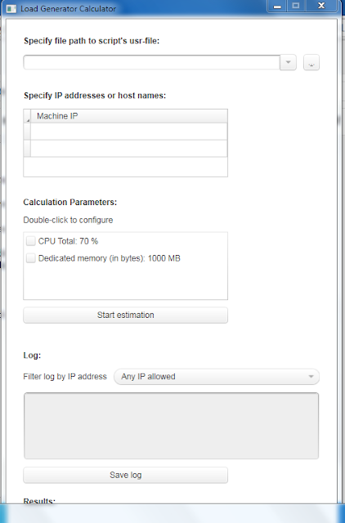](http://2.bp.blogspot.com/-A1GPQwXMTkQ/VeXpEzDeywI/AAAAAAAAAEQ/MAwn0qY3rJM/s1600/lg.PNG)

provide the necessary details in above filed so that you

 will get details