# Assignment 2: SQL Review

For all SQL query questions, take screenshots of your results and save your queries in a .sql file.

Check the assignment folder for the two database files.

### Part 1: Basic queries with SELECT

1. Using the order_details table, find the revenue (price * quantity) earned on each order. **5 marks**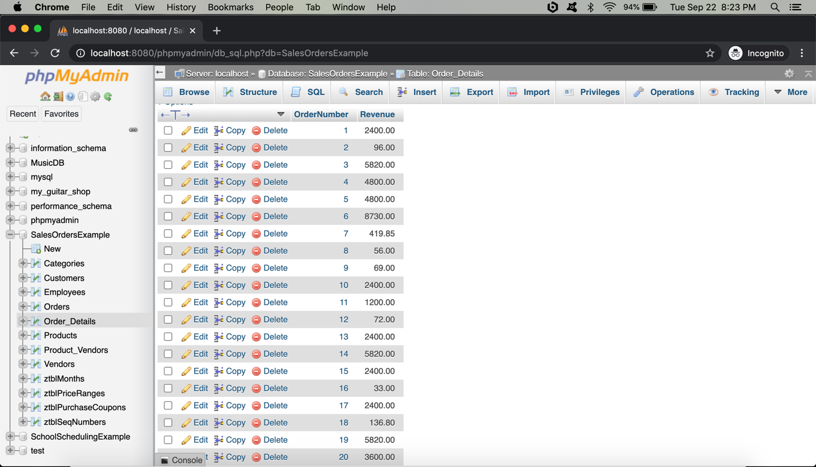
2. Using the employees table, find the age of each employee in years and order from youngest to oldest. NOTE: You do not have to account for leap years. **5 marks  
   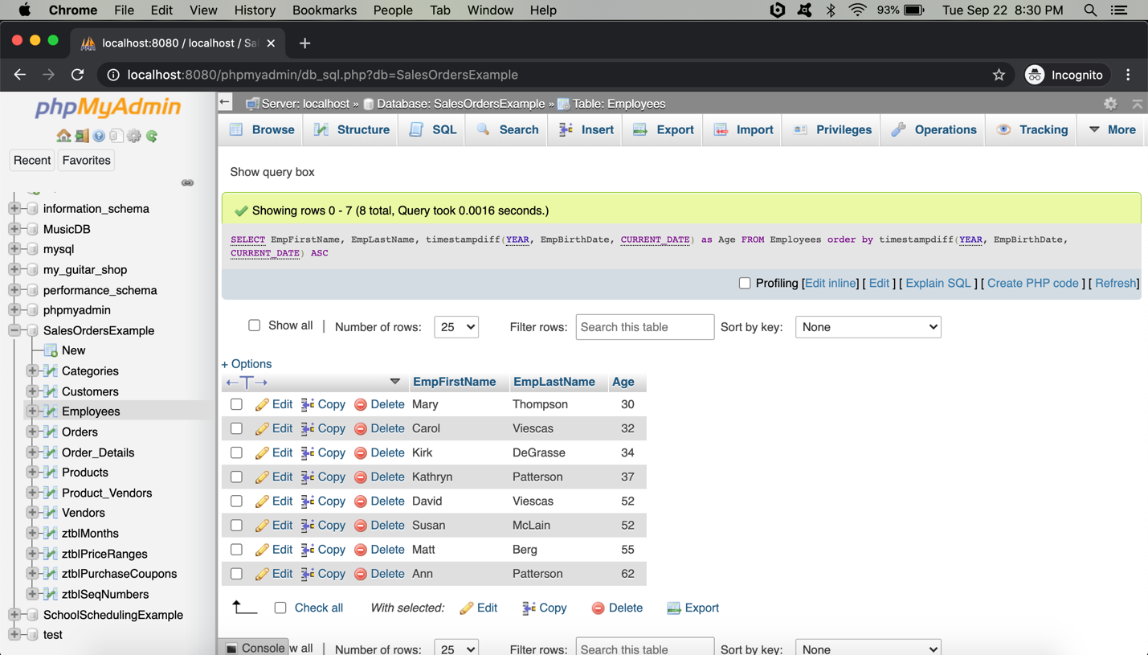**

***Part 1 Total: 10 marks***

### Part 2: Conditional queries

1. Using the employees table, find all employees with a first name that contains an 'r' and a last name that does not contain a 'p'. **5 marks**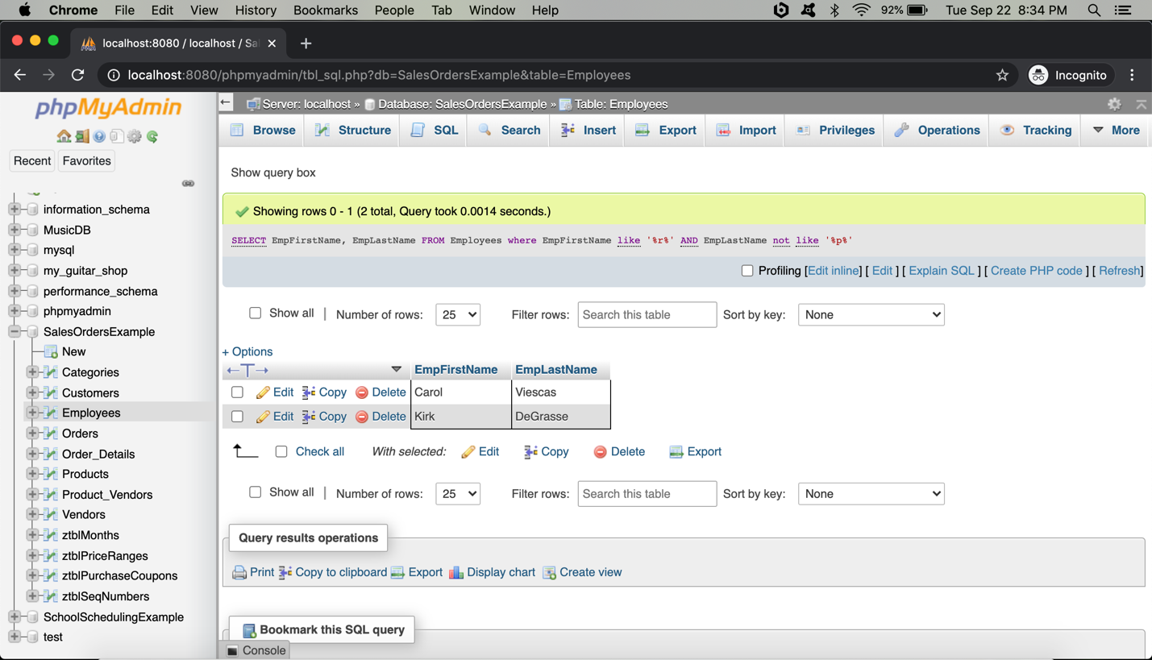

***Part 2 Total: 5 marks***

### Part 3: Database Design

1. Explain what is wrong with the following table and how you would fix it. **5 marks**

|  |  |  |  |  |
| --- | --- | --- | --- | --- |
| CompanyName | Address | Email | Products | Phone |
| Telle. Co | 12 Dirk St | Rep@telle.com | Computer, Phone, USB cables | 519-555-4410 |
| Barba. Co | 133 Shep St | Rep@barb.com | Hair care, Shampoo, Dye, Combs | NULL |

***Part 3 Total: 5 marks*  
Problem : Company Name should has Primary Key**

**Solution :Will alter table and add Primary Key (Company_ID)Problem : Product column has many data.   
  
Solution : Will create new product table with Product_ID (Primary Key) , Clint_ID(Foreign Key) Category (eg: Teachnology), Product_Name (Computer)  
  
Problem : Phone Number has NULL Value   
Solution : Alter table and will apply Phone column NOT NULL and will set default value 0-000-000-0000 so if phone number is not available it will allow us to enter data.**

### Part 4: Joins

1. Find the first name and last name of all customers who have ever ordered a helmet. **HINT**: Use the keyword **DISTINCT.** **5 marks**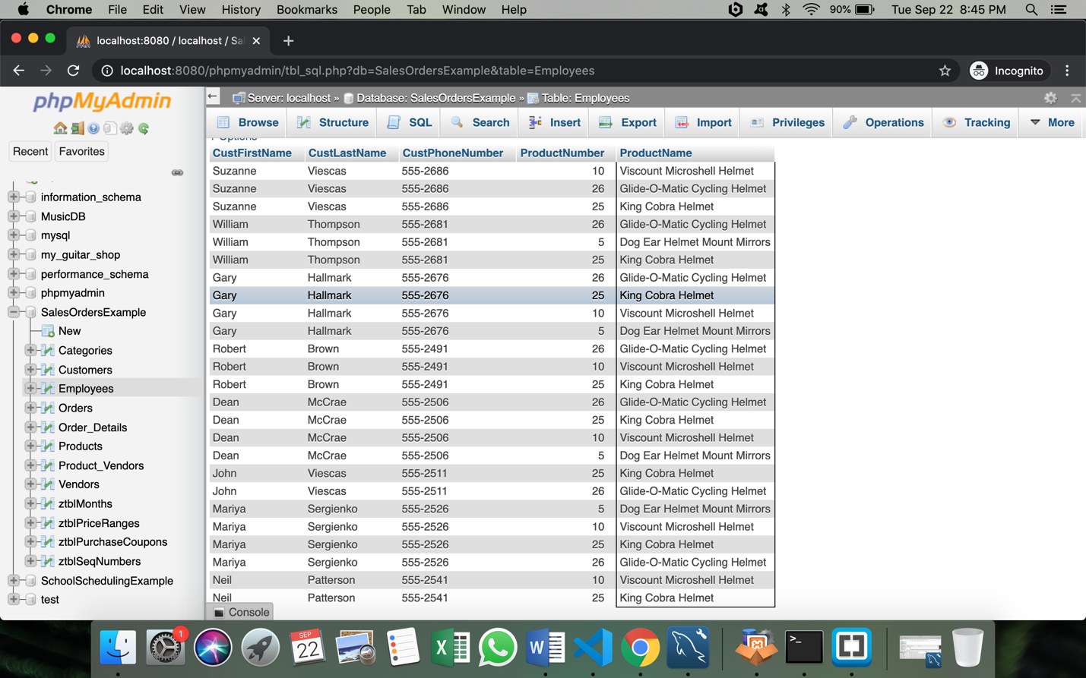
2. Display the last name of all customers who have the same last name as an employee. **5 marks**

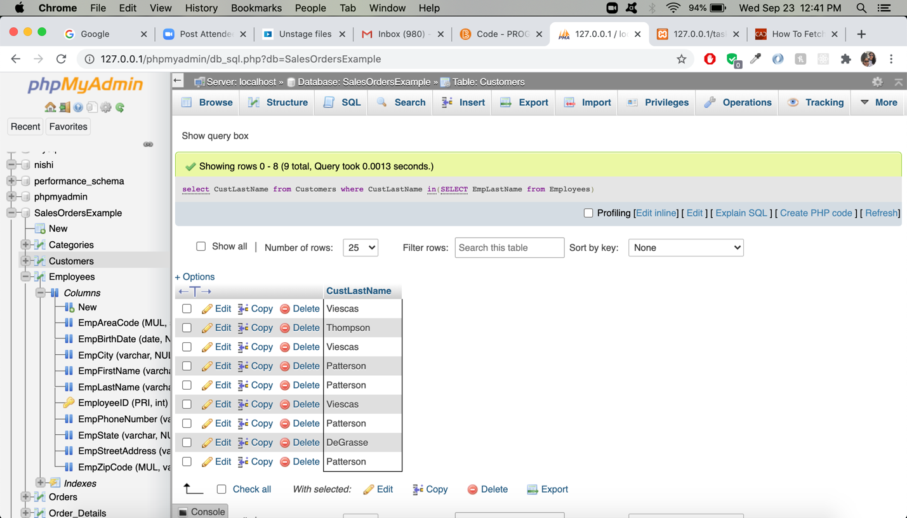

***Part 4 Total: 10 marks***

### Part 5: Aggregate Functions

1. Find the combined total value (QuantityOrdered*QuotedPrice) of all orders made by customers from the state of 'OR' **5 marks**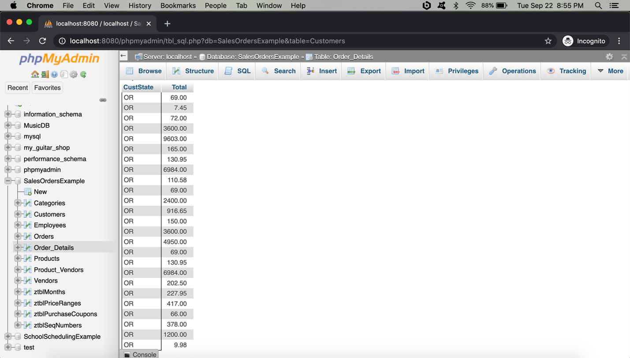

***Part 5 Total: 5 marks***