Assignment 3: Events, Virtual Page Views and Social Actions

Part 1: Events

Answers for part 1 and 2 require screenshots, there are samples on the last page of the assignment.
- Create a new event that triggers if you clicked a button with a class “clickTest” 2 marks
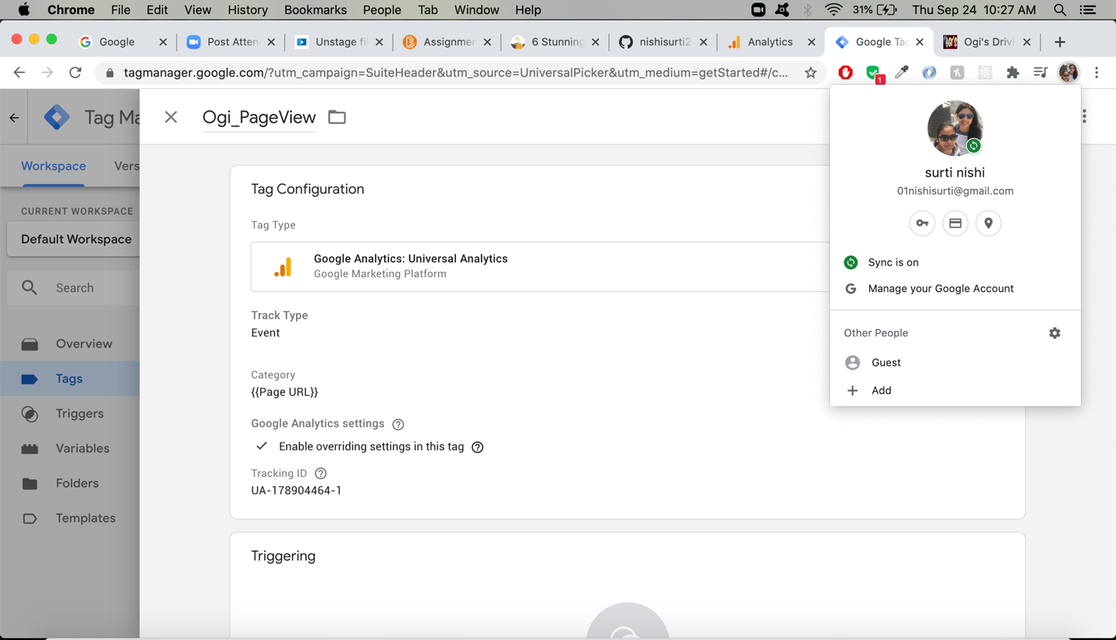

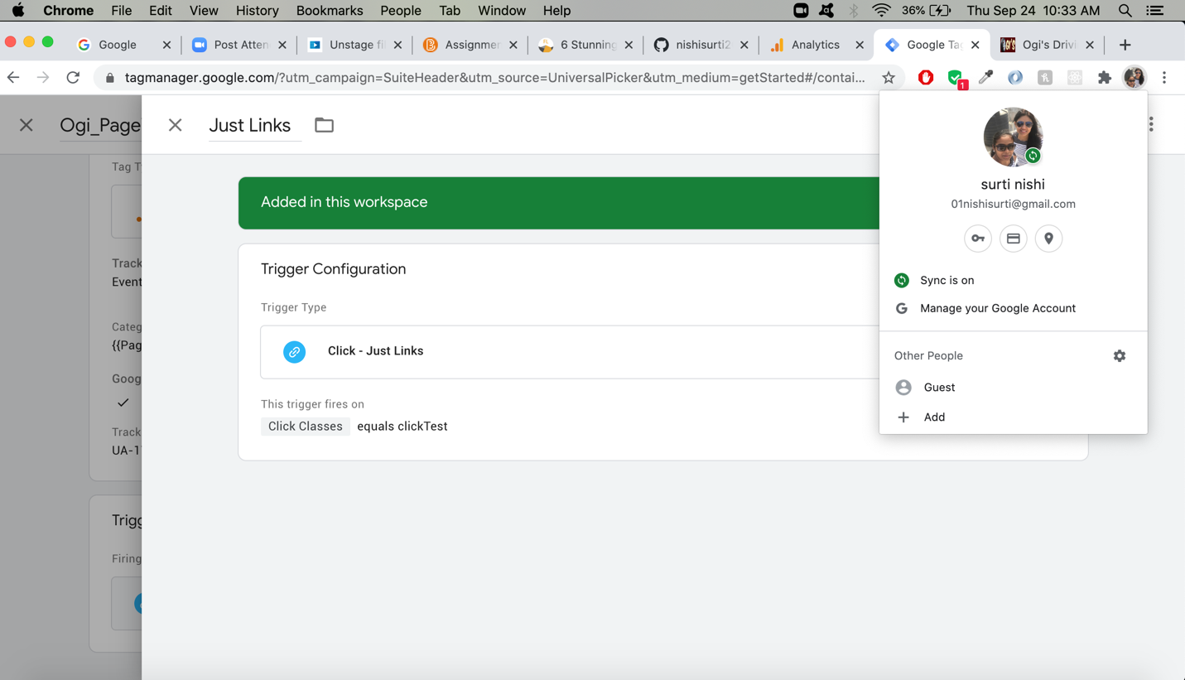
- Create a new event that triggers if you watch a complete YouTube video on your site, it should not trigger if you just start it without finishing 2 marks

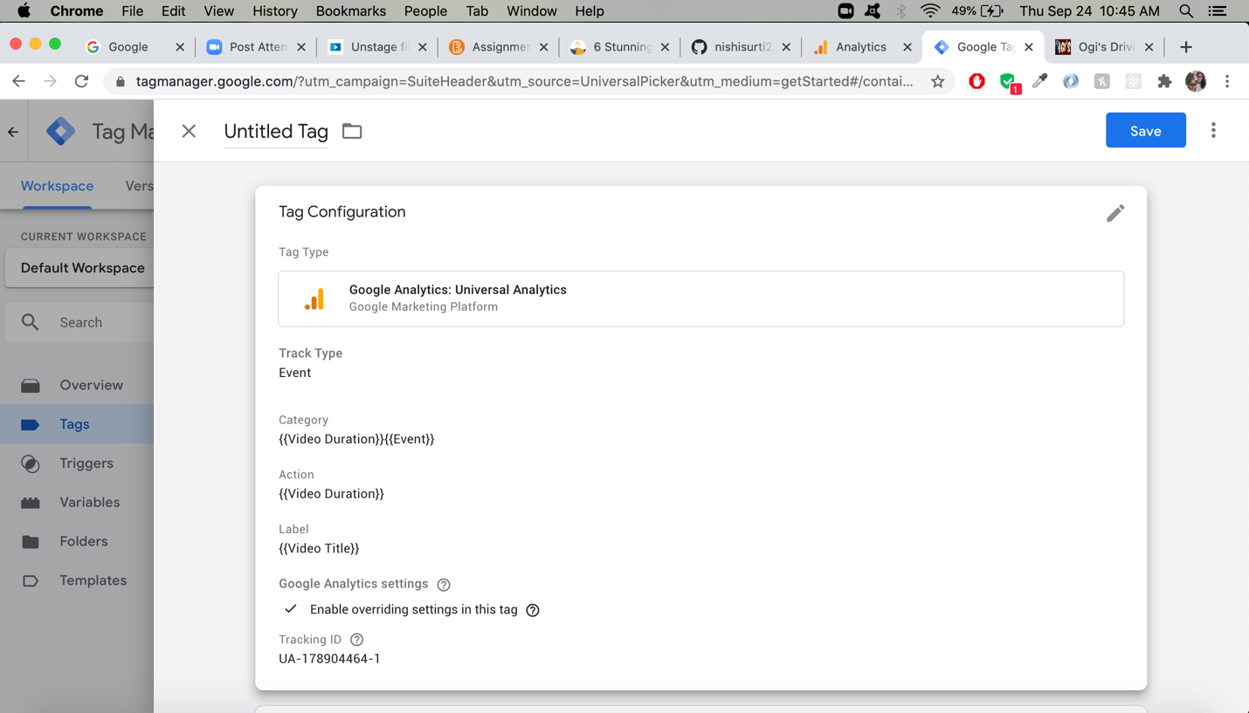
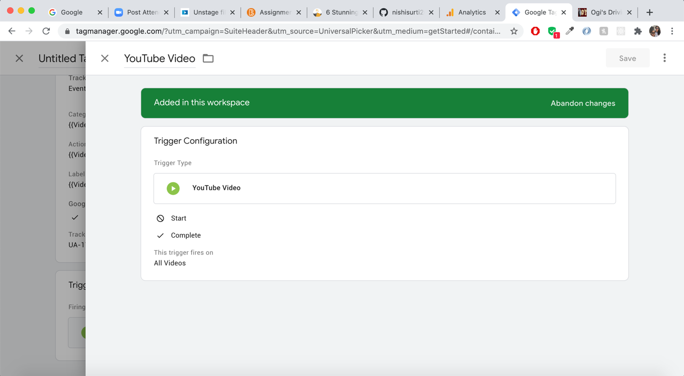
- Create a new event that triggers if the user scrolls all the way down a page 2 marks
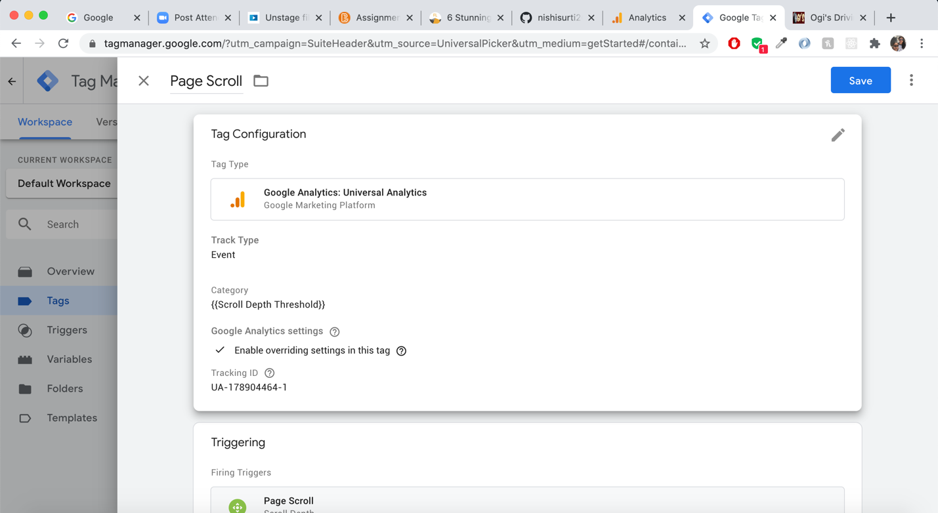
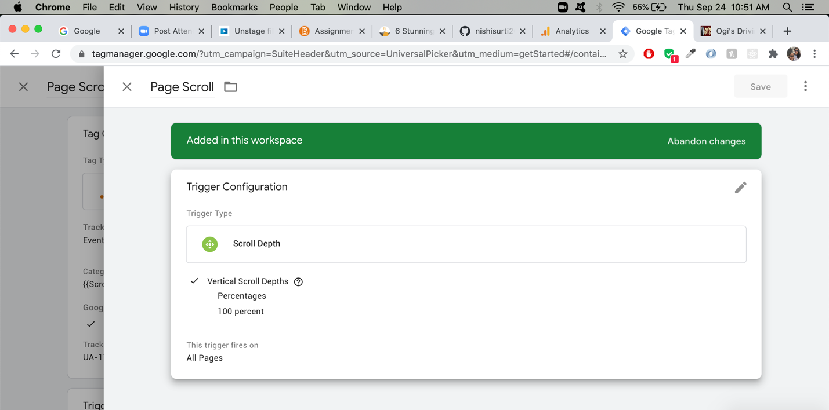NOTE: Question 2 and 3 are answered in the textbook using an old method, you do NOT need any external scripts to do this anymore
Part 1 Total: 6 marks

Part 2: Virtual Page Views

- Imagine your website is a Single Page Application. When the user clicks a button, it allows them to search your database. This does not bring up a new page but you want to track it like a pageview. Create a virtual page view that allows you to do this. 2 marks

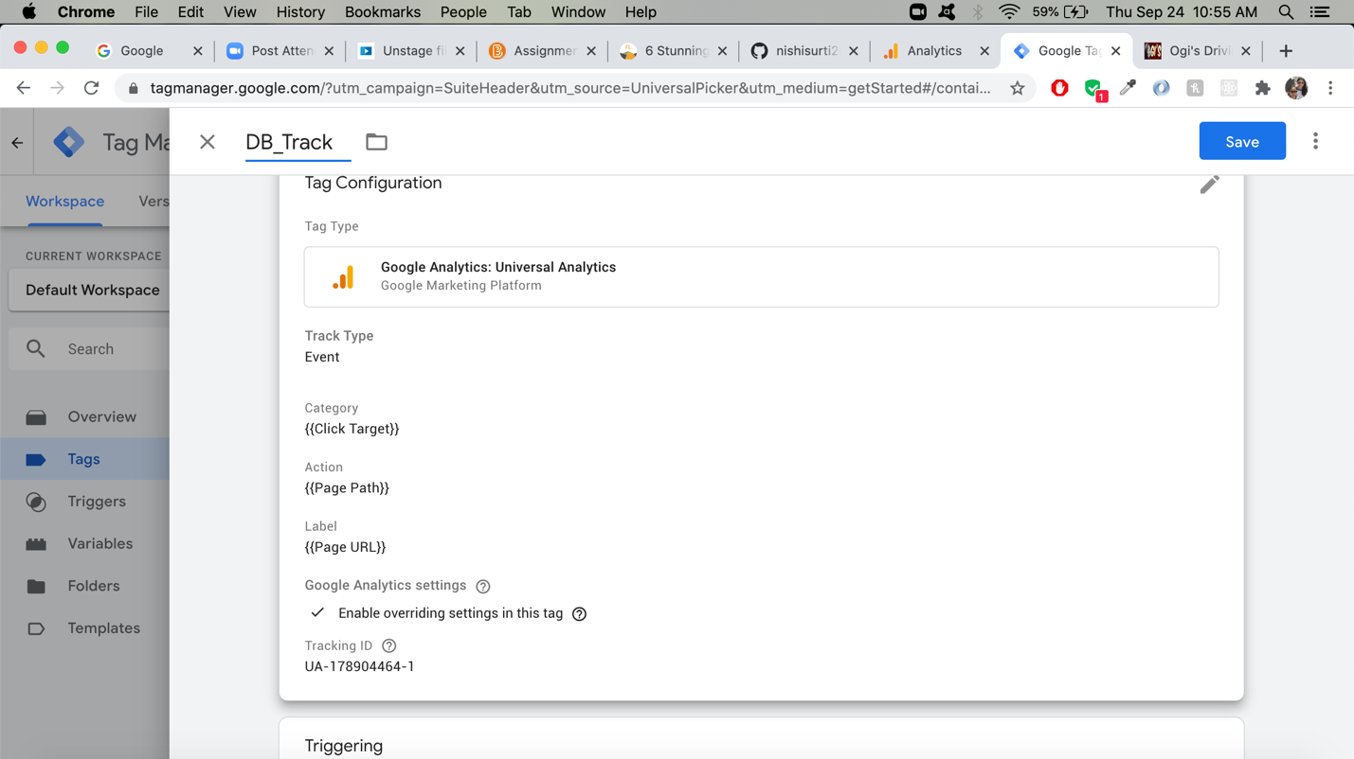

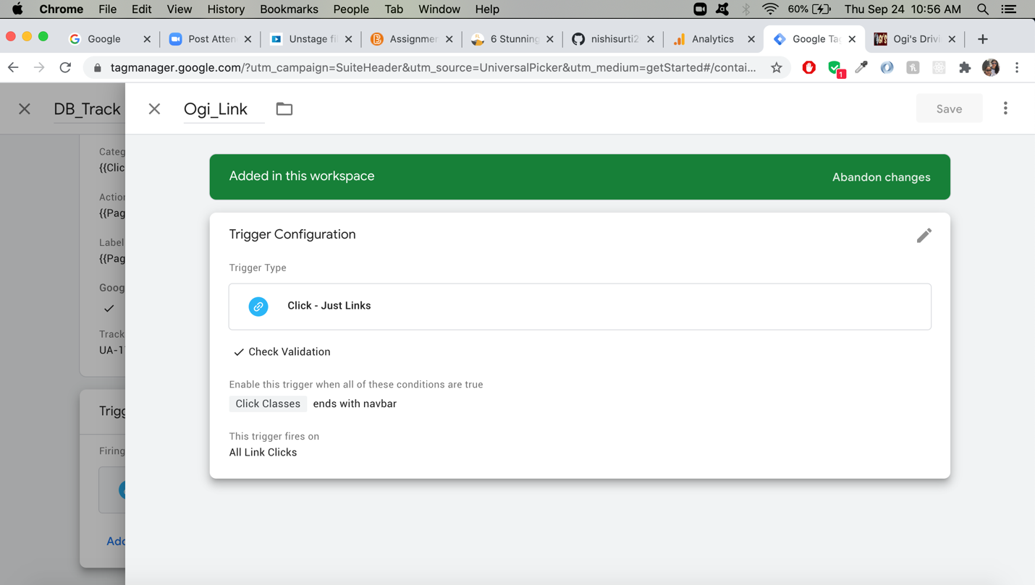
Part 2 Total: 2 marks

Part 3: Analysis

- For some reason, your boss really wants you to have an auto-playing YouTube video on the company homepage. Should watching this video count as user engagement? Explain how you would deal with it in Google Analytics. 2 marks

No, an auto-play video is not cunted as user engagement. We can apply click engagement on video to keep the track of user activity. For an example, if user paused or resumed video.
Part 3 Total: 2 marks

Example Screenshots:
1)
